Real Time Optimization of Sour Gas Processing Unit via Sulfur Dioxide Emissions Predictive Model

A. Eren Vedina,*, Pelin Dologlua, Mert Akcina , Aygul Karimovab , Kemal Burçak Kaplana, Aysegul Senerc, Osman Karanc

aSOCAR Turkey, Data Science and Analytics, Istanbul 34485, Türkiye

bSOCAR STAR Oil Refinery, Process Engineering, Aliaga, Izmir 35800, Türkiye

cSOCAR STAR Oil Refinery, Process Excellence, Aliaga, Izmir 35800, Türkiye

eren.vedin@socar.com.tr

Abstract

Sour gas processing in refineries, for the separation of H2S from off-gases, is an important process in terms of environmental concerns. Thus, combustion fuel can be used in furnaces as energy source, after processing. However, disturbances such as sulfur content fluctuations in crude-oil feed, plant operating policy updates such as operating capacity, and process related variations in the plant variables such as absorber temperature and pressures cause sudden SO2 emission peaks in the furnaces. This is avoided by excess amine supply, resulting in higher steam consumption in amine regeneration unit (ARU), eventually leading to economic losses. This study focuses on the development of a real-time optimization architecture to calculate optimum amine flow rate both to account for plant constraints and profitability issues. Based on the architecture, decision tree based predictive model for refinery furnace emissions has been established to deliver in-advance warning for feedforward plant control tasks. The architecture also employs several empirical sub-models to estimate sulphur fraction in the streams, for the real-time integration by eliminating the laboratory analysis at high frequency. The approach is implemented on the actual plant through Python Programming Language and implements the control actions at 30 minute frequency, which is significantly smaller than the time constant of the plant, by changing amine feed after the algorithm predicts the emission increase. It has been observed that the model predicts an emission increase from 1 hour to 4 hours in advance.

**Keywords**: Decision Tree Algorithm; Emission Reduction; Real Time Optimization; Sour Gas Processing; Amine Reduction Unit.

* 1. Introduction

The fuel gas in the refinery is composed of a mixture of off-gases and natural gas. The mixture is primarily used as the energy source for the furnaces and boilers. In line with the growing emphasis on the environmental and the economic concerns, it is of paramount importance to monitor the chemical content of the fuel within this system to ensure acceptable emission rates. A major pollutant from the process is sulphur dioxide (SO2) and caused by emissions from furnace stacks when hydrogen sulphide (H2S) is burnt, unless removed from the off-gas by sour gas processing plant. Thus, the performance and the management of the plant is important for environmental concerns. Studies indicate localized increase in environmental SO2 concentration in the atmosphere which can even contribute to acid rain when those plants fail to achieve their task properly. Therefore, continuous monitoring of emissions and optimization of related proceses are crucial for human health (Abdelrasoul et al, 2010) to ensure production under legal constraints. A significant fraction of the studies in the literature employ thermodynamic and kinetic equations (Feng et al., 2023) for the optimization tasks. On the other hand, those are limited to a narrow operating regime or dynamic optimization for small-scale processes. These algorithms are feasible, especially in systems where all components entering and exiting the absorber system can be tracked. In such solutions, optimization can be solved by kinetic equations or mass-energy balance equations by using physicochemical information of all streams which are entering or leaving the absorber system (Nordenkampf et al., 2003).

Machine learning based algorithms, benefiting from historical patterns and plant management policies, on absorber column and amine regeneration column show a promising tool for the task. In parallel with more sophisticated mechanistic formulations, the optimization computations are carried out by considering important column variables including composition, pressure, and temperature of streams entering and leaving the units. These methods are generally effective for optimizing processes composed of several units. While this approach is practical, the prediction accuracy is highly dependent on measured variables and increases once higher number of sensors are implemented, in general (Curreri et al., 2021).

This study, a novel optimization architecture, benefiting from advanced machine learning algorithms at different temporal scales, for the implementation to the actual plant is proposed. The architecture is operationally desirables as it ensures a coordinating decision making through integrating several small scale subprocesses with individual inferential sensors and local control and management architectures. The approach is implemented on the sour gas processing plant to process the off-gases from Crude Distillation Unit (CDU), Hydrocracking Unit (HCU), Diesel Hydrotreating Unit (DHT) and Delayed Coking Unit (DCU) which are processed in a SGP and UGP.

* 1. Materials and Methods
     1. Refinery Sour Gas Process Description

In the refinery, crude oil distillation, hydrocracking and thermal cracking are major sources H2S emission. Off-gases from those are processed in SGP and UGP units, where H2S are separated for emission management. In the former, gases from the CDU, HCU, and DHT undergo a purification process using MDEA in the amine scrubber column to eliminate H2S from sour off-gas; whereas the latter employs the off-gas from DCU with a similar process flow diagram and plant objective. All rich MDEA which have absorbed sulphur content of off-gasses is processed in Amine Reduction Unit (ARU) and recycled as lean MDEA. A simplified flow diagram is shown in the Figure 1.

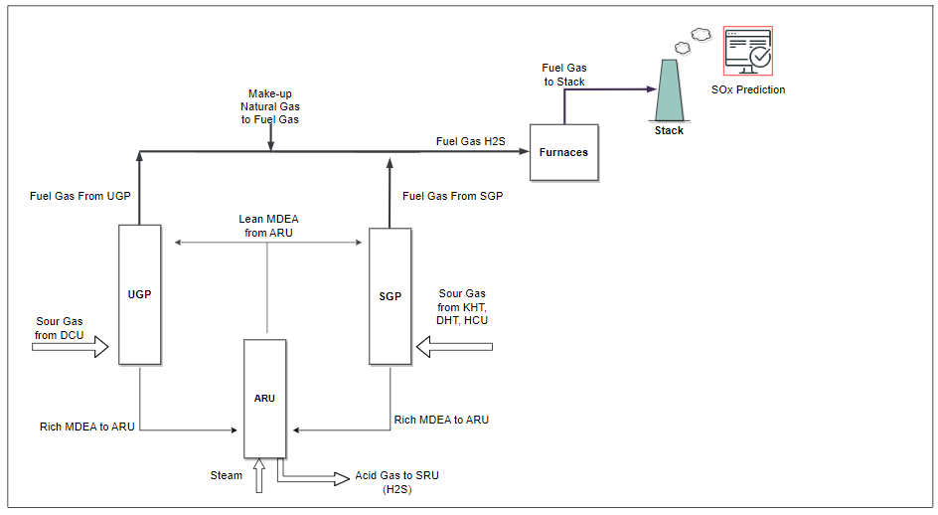

Figure 1: Simplified process flow diagram of sour gas process and furnaces

* + 1. Inferential Sensor Design and Integration

With current limitations in laboratory analysis of H2S and many other streams in the plant, due to few sample collection locations, oscillations in plant variables in daily routine, and delayed feedback with few measurement capabilities under work load, a real-time decision making policy development based on laboratory measurements is practically challenging. Moreover, H2S analysis for petroleum fractions with high sulphur content is a difficult task, in our case. Thus, an inferential approach, integrated to large scale optimization problem, has been developed to avoid aforementioned issues through development of empirical formulations including the variables shown in Fig. 2.

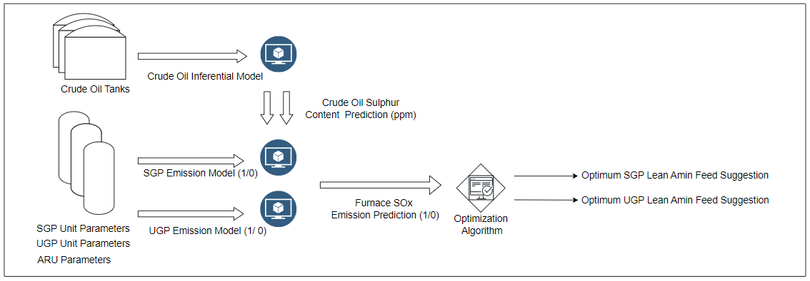

Figure 2: Inferential sensor and optimization architecture

*2.2.1 Crude Oil Sulphur Inferential*

An inferential sensor is designed to estimate the inlet sulphur content, which has been driven by the crude oil sulphur fraction. However, crude oil is a mixture from several tanks whose sulphur contents are included in the formulation to account for the blending effect.

*2.2.2 Furnace Emission Models of SGP and UGP Units*

Decoupled emission models were developed for the SGP and the UGP units as they might operate at different regimes despite similar process architecture. Those models predict whether absorber column operations in these two plants will suffer from an increase in emissions in the furnaces. In the modeling phase, a binary decision tree architecture was used to forecast the existence of emission increase.

* + 1. Unbalanced Data and Decision Tree Model Selection

Due to the high emission data scarcity, several data sampling formulations have been implemented to avoid typical problems arising from training on an imbalanced data. Moreover, MDEA nutrition was mostly consumed in excess. To eliminate the effect of excess MDEA feeding over the optimization model, emission models progressed through the classification methods. In this way, furnace emissions were modeled to predict their occurrence rather than their quantity in ppm levels. These models were then incorporated into an integrated optimization model to find the optimal MDEA feed. Oversampling and undersampling methods under such a complex dataset delivered a small prediction accuracy with high number of false alarms, in our case.

A decision tree algorithm is trained based on one-year of historical data. Models were trained to predict the occurrence of emissions in real-time by examining the historical process data from the past year, through defining a binary target to represent emission increase in all furnaces. MDEA properties like temperature, concentration, flow, crude oil properties like sulphur, capacity, and absorber columns properties as temperature and pressure were used in models. During model training progress, to prevent incorrect learning caused by the post-increase process conditions and the increased MDEA feed in response to high emissions data cleaning was applied. The data 4 hours prior to the emission increase and the first 8 hours data which includes higher MDEA feed due to increased emission levels, were excluded from the training dataset.

To stay on the safe side in optimization, regulatory limits of furnace emissions were not used during the model training phase. Distribution curves of SO2 emission levels of all furnaces have been calculated and statistical process limits have been set for each furnace, which are significantly below the legal limits.

* + 1. Decision-making architecture

High emission alarm forecasts which are generated in a decentralized manner from SGP and UGP furnace emission models were progressed in the coordinated decision-making architecture in Fig. 3. The control actions are implemented on the plant with a 30 minute frequency, which is calculated based on the average time constant of process variables and their interactions, in order to calculate optimum MDEA feed for these units.

The optimization algorithm operates in three decomposed stages. In the first stage, the directions of MDEA flow change based on emission predictions are calculated. In the second stage, the decision to implement at current time step or the next one is calculated to balance the control action frequency considering the impact of the previously implemented decisions. Thus, a wiser decision might be probable after delayed impacts are settled in the plant although 30-minute calculation frequency is required when delayed impact is not the case. Finally, the last stage calculates the extent of change to deliver optimal MDEA flow rate. Overall decision making information flow diagram is shown in Figure 3.a and real time optimization timing as in figure 3.b.

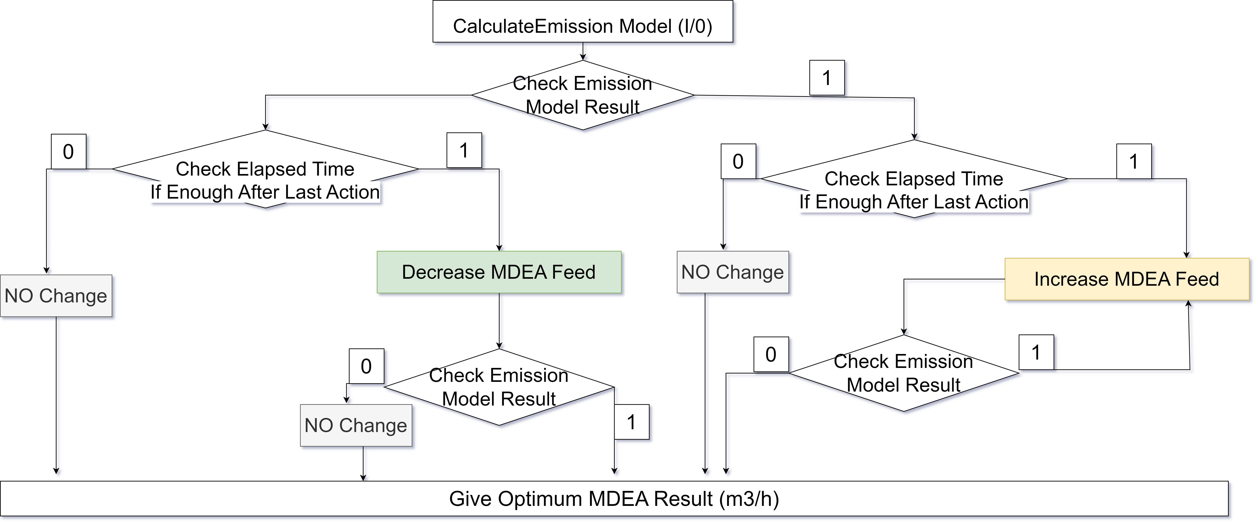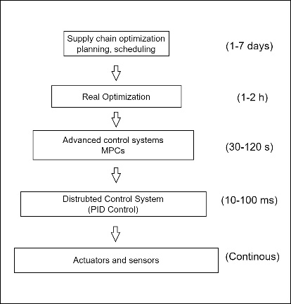

Figure 3.a: Optimization flow diagram 3.b: Optimization algorithm time scales

* 1. Results and Discussion

Sulfur emissions have consistently posed a concern in refinery processes. Additionally, given the growing emphasis on sustainability, the removal of sulfur from refinery processes has become notably sensitive in the current era. Consequently, numerous articles in the literature address sulphur prediction and amine optimization processes. On the other hand, this study differs from other articles in the way it deals with optimization.

In Figure 4, one of the emission increase and recommendations from the optimization model regarding amine increase and decrease are observed. The number of consolidated furnaces with high emissions can be seen instantly at the top of the chart. It is observed that emissions increased three times in all furnaces during this period. The lower graph illustrates the calculated optimal MDEA flow during this timeframe. Optimal MDEA values show an increase before emission spikes and a subsequent decrease after the emissions drop. This graph represents the period when the optimization models were activated but their results were not yet implemented. As a result, the model's performance could be tested, demonstrating its ability to predict emissions.

Figure 5 shows the actual MDEA flows and MDEA optimization results for 2 months after the optimization model was put into operation. When the results are examined, it is seen that there is general parallelism between MDEA flow and optimization. Additionally, when examining the trends, it's noticeable that the model consistently advises reducing the actual MDEA during long-term decreasing trends of MDEA.

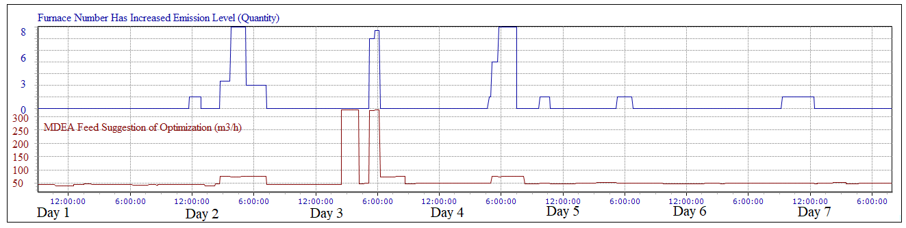

Figure 4: Optimization algorithm results in case of high emission period

Conversely, during periods when MDEA needs to increase, the model promptly recommends a rapid rise in MDEA.

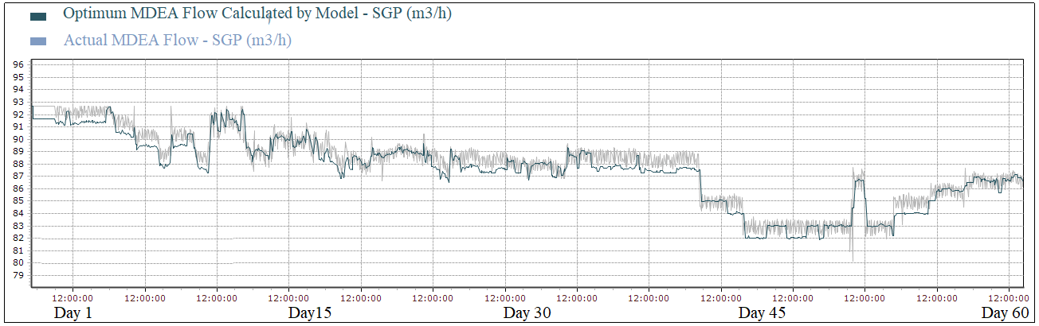

Figure 5: Optimum and actual MDEA feed results

* 1. Conclusion

In this article, the sour gas processing system, has been optimized through the amine feed. The optimization model was developed based on three inferential models: the crude oil sulfur prediction inferential model, and SGP and UGP furnace emission prediction models. By developing these models independent of the analysis results, that enabled the real-time optimization of the amine feed, allowing for an instant response to observed increases in sulphur levels in the system. As a result of monitoring it has been that furnace emission increase can be detected in 1-4 hours in advance.

References

Guerreiro, C. B., Foltescu, V., & De Leeuw, F. (2014). Air quality status and trends in Europe. *Atmospheric environment*, *98*, 376-384. https://doi.org/10.1016/j.atmosenv.2014.09.017.

Bolhàr-Nordenkampf, M., Friedl, A., Koss, U., & Tork, T. (2004). Modelling selective H2S absorption and desorption in an aqueous MDEA-solution using a rate-based non-equilibrium approach. Chemical Engineering and Processing, 43(8), 701–715.

Abdelrasoul, A., Al-Hadad, A., Khan, A. R., & Khan, A. R. (2010). Oil Refineries Emissions Impact on Urban Localities Using AERMOD. American Journal of Environmental Sciences, 6(6), 505-515. https://doi.org/10.3844/ajessp.2010.505.515.

Li, Z., Feng, X., & Yang, M. (2023). Absorption mechanism-based approach for synthesis of refinery desulfurization solvent network. *Journal of Chemical Engineering*, 27(3), 123-145.

Curreri, F., Patanè, L., & Xibilia, M.G. (2021). "Soft Sensor Transferability between Lines of a Sulfur Recovery Unit." IFAC-PapersOnLine, 54(7), 535-540. https://doi.org/10.1016/j.ifacol.2021.08.415.