Geospatial Modelling and Optimisation of Direct Air Capture and its Energy Supply Options for Cost-Effective Deployment

Marwan Sendi, a,b Mai Bui, b,c Niall Mac Dowell, b,c, Paul Fennella,*

aDepartment of Chemical Engineering, Imperial College London SW7 2AZ, London, UK

bThe Sargent Centre for Process Systems Engineering, Imperial College London, London SW7 2AZ, UK.

cCentre for Environmental Policy, Imperial College London, London SW7 2NE, UK. London.

*[p.fennell@imperial.ac.uk](mailto:p.fennell@imperial.ac.uk)

Abstract

To meet the emissions reduction targets outlined in the Paris Agreement, removing billions of tons of carbon dioxide from the atmosphere is crucial, particularly for addressing hard-to-abate emissions such as agriculture and aviation. Direct Air Capture and Storage (DACS) stands out as a promising technology for carbon dioxide removal (CDR), owing to its modular design and ease in monitoring, reporting and verification of emissions. However, given its energy-intensive nature, high cost and sensitivity to regional climate variations, optimising its performance is essential. In this study, we introduce a modelling optimisation framework for geospatial assessment of DACS process configurations coupled with different energy sources, considering the impact of both temporal and spatial variations on the techno-economic performance of DACS. The framework is applied to industrial DACS technologies utilising solid sorbents and powered by conventional (i.e., nuclear and natural gas) and renewable (i.e., solar and wind) energy sources. By identifying the least-cost DAC system configurations and their corresponding environmental metrics (such as CO2 removal efficiency, land requirements, and water footprint) for different regions, our findings offer valuable insights for decision-makers and project developers. This work serves as a guide to identify suitable regions and system configurations for the cost-effective deployment of DACS technology.

**Keywords**: Carbon dioxide removal (CDR), direct air carbon capture and storage (DACCS), geospatial analysis, techno-economic assessment (TEA), life-cycle assessment (LCA).

* 1. Introduction

Achieving Paris Agreement emissions targets economically and realistically requires large-scale carbon dioxide removal (CDR) from the atmosphere (Rogelj et al., 2018; Royal Society and Royal Academy of Engineering, 2018). CDR plays a crucial role in offsetting residual GHG emissions from hard to decarbonise sectors, such as agriculture or aviation. Direct Air Capture and Storage (DACS) emerges as a promising CDR method, offering the advantage of no biophysical limits and enabling immediate CO2 removal from the atmosphere with permanent storage (Chiquier et al., 2022; Matter et al., 2016; Smith et al., 2016). Additionally, DACS benefits from well-established monitoring, reporting, and verification (MRV) protocols, streamlining the issuance of CDR credits (Mac Dowell et al., 2022). This can attract the necessary investments for rapid technology deployment required to achieve the Paris Agreement targets.

Direct air capture (DAC or DACS when storage is included) is an energy-intensive process. Thus, large-scale DACS deployment would require significant additional demand for low-carbon and cheap energy for the energy transition (Erans et al., 2022). Furthermore, we showed in our previous work that DAC process performance is influenced by regional climate variations, impacted by daily and seasonal fluctuations in ambient air temperature and relative humidity (Sendi et al., 2022).

Building on our earlier findings, this study introduces a geospatial modelling framework to evaluate the techno-economic and environmental performance of various DAC configurations and energy supply options. The goal is to identify the most energy and cost-effective DAC systems based on regional technology performance while accounting for temporal and spatial variations in DAC process performance. We apply this framework to determine the least-cost DAC systems for industrial DAC processes based on amine-functionalised sorbents coupled with different conventional (i.e., nuclear and fossil fuel) and renewable (i.e., solar and wind) energy sources.

* 1. Methods

We model the solid-based DAC unit based on an industrial DAC unit. In this unit, the adsorption bed, shaped like rectangular frames with a certain thickness, contains the sorbent material. The unique shape of the adsorption bed led us to model it using a combination of detailed 1-D and 2-D adsorption models. The 1-D model is applied when gas flows perpendicular to the bed frame. In contrast, the 2-D model is used when material concentration and temperature variations across the frame's plane influence the process performance. More information regarding the adsorption model is found in our recent publication (Sendi et al., 2022). Additionally, our adsorption model integrates a binary CO2/H2O isotherm specifically developed for DAC applications (Young et al., 2021).

The resulting rigorous DAC model yielded a set of partial differential equations, which we discretised using finite volumes. To mitigate non-physical oscillations, we applied the van Leer flux limiter only for the 1-D model, as the 2-D model did not exhibit such oscillations. MATLAB was utilised to implement and solve the resulting time-dependent ordinary differential equations. The rigorous DAC model served as the foundation for constructing simplified surrogate models that describe DAC process performance under varying ambient conditions (i.e., temperature and relative humidity). These surrogate models were then employed to estimate hourly DAC process performance for two adsorption cycle configurations — vacuum-pressure temperature swing adsorption (VTSA) and steam-assisted VTSA (SA-VTSA) — using hourly temperature and relative humidity profiles across different regions.

The regional hourly DAC process data was input into a Mixed Integer Linear Programming (MILP) optimisation model based on the Resource Technology Network (RTN) framework. This model integrates components related to energy generation, conversion, and storage. Dependent variables that influence the regional techno-economic performance of DAC systems were incorporated, including weighted average capital cost (WACC), solar irradiation, and wind speed. The MILP model, implemented in Pyomo, was solved using CPLEX to identify the least-cost DAC system configuration for different spatial nodes based on regional technology performance. The mathematical formulation of the MILP is shown in Equation 1. Also, the levelised cost of DAC (LCOD) is defined in Equation 2.

|  |  |  |
| --- | --- | --- |
|  | **min** total annual system cost (*TAC*)  **s.t.** annual CO2 removal (TAP)  mass and energy balance  process constraints | (1) |
|  |  | (2) |

Moreover, key environmental metrics are calculated for the least-cost DAC system, including lifecycle greenhouse gasses (GHG) emissions, water footprint and land requirements. Equation 3 shows how total lifecycle GHG emissions () is calculated, which is the sum of the annual GHG emissions from different technologies normalised by. Total water footprint and land requirements are calculated using similar equations. Equation 4 defines CO2 removal efficiency () based on . Finally, MATLAB was utilised for visualisation.

|  |  |  |
| --- | --- | --- |
|  |  | (3) |
|  |  | (4) |

* 1. Results and discussion

Least-cost DAC system configurations have been identified for different regions based on conventional (i.e., nuclear and fossil fuel) and renewable (i.e., solar and wind) energy sources. **Figure 1**a shows the levelised cost of DAC (LCOD) for the least-cost DAC system supplied by renewable energy with energy storage systems. In this case, the least-cost DAC system configuration is regionally dependent on the DAC regional performance, which is affected by regional climate and weather conditions and the regional availability of renewable energy resources. For instance, regions with high direct normal irradiation (DNI) resources, which also experience drier climates, such as parts of the USA, the Middle East, and Australia, show relatively lower LCOD. This is because DAC energy requirements are lower in drier climates, and in these regions, concentrated solar power (CSP) can provide a relatively cheaper heat source. These results can assist in pinpointing regions where DAC deployment could be economically favourable.

Furthermore, **Figure 1**b showcases an optimised system configuration at specified coordinates. In this example, the optimised system employs the SA-VTSA cycle, utilising CSP for high-temperature (HT) heat generation in the form of high-pressure steam (HPS). An installed capacity of 2.07 m2 heliostat mirrors is required to capture 1 ktCO2pa (kilotons of CO2 per annum). Normalised energy flows reveal that the CSP needs to generate 3.1 MWhth of HT heat per tCO2. This HT heat is used to generate electricity for DAC (0.4 MWhel per tCO2) in steam turbines (ST), which expand HPS to low-pressure steam (LPS). The remaining LPS and HT heat fulfil low-temperature (LT) heat requirements for DAC (2.3 MWhth per tCO2) in the form of LPS. HT and LT thermal heat storage with installed capacities of 3.58 and 2.49 MWhth, respectively, are needed to increase the DAC plant capacity factor to 93% and lower the system cost. Other environmental performance metrics can also be identified. In this case, the system can produce 0.54 tons of water per tCO2, have a total land footprint of 25 km2 per MtpaCO2, and achieve a CO2 removal efficiency of 93% throughout the project lifecycle.

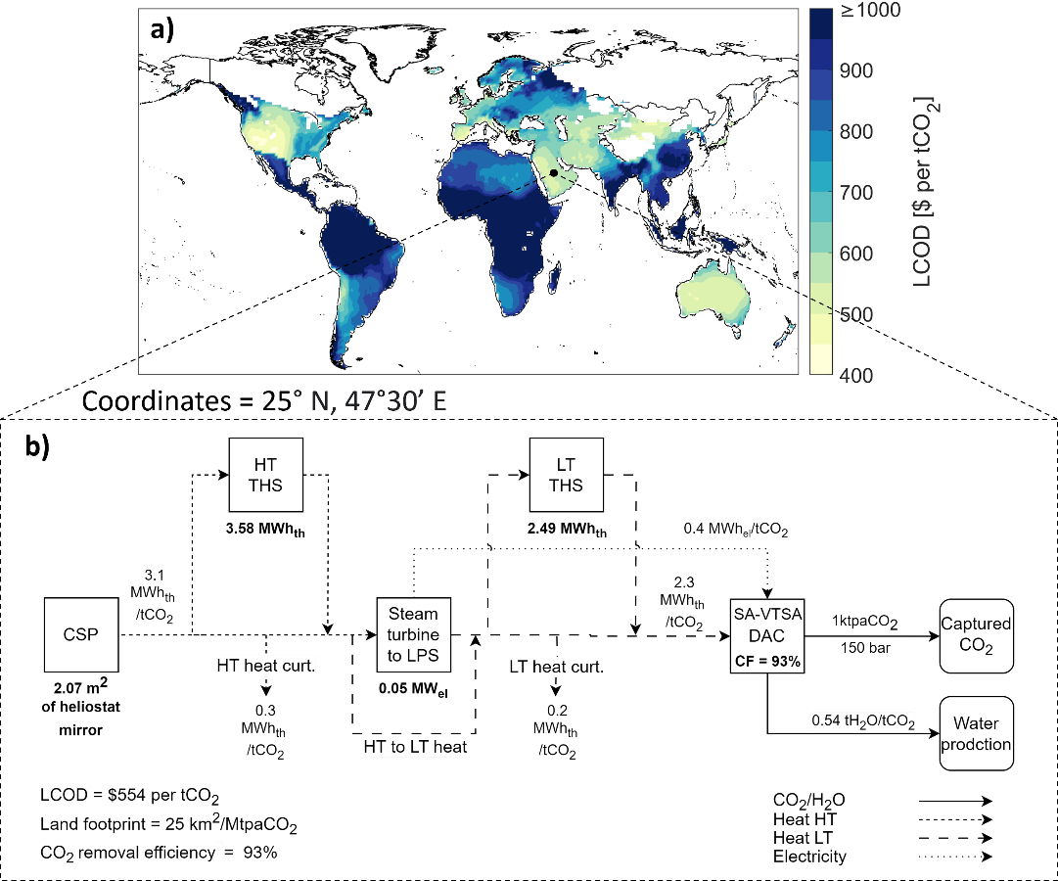

**Figure 1** **a)** regional levelised cost of DAC (LCOD) for least-cost DAC system powered by renewable energy with energy storage. **b)** optimised DAC system configuration for coordinates (25°N, 47°30’E) showing required installed capacity for different technologies and normalised energy flows. **Abbreviation:** concentrated solar power (CSP), thermal heat storage (THS), high-temperature (HT), low-temperature (LT), low-pressure steam (LPS), curtailment (curt.), steam-assisted vacuum-pressure temperature swing adsorption (SA-VTSA), capacity factor (CF), tpaCO2 (tons per annum of CO2).

* 1. Conclusions

In this work, we developed a comprehensive framework to evaluate DAC processes and their energy supply, accounting for regional techno-economic performance across various technologies. This framework considers both spatial and temporal variations in DAC process performance influenced by climate and weather conditions. It serves as an adaptable tool for conducting techno-economic and environmental assessments of different DAC system configurations in diverse regions, facilitating the identification of optimal regional configurations. The insights derived from this research are invaluable for decision-makers and project developers seeking to identify suitable regions and DAC system configurations for the cost-effective deployment of DAC technology.

References

Chiquier, S., Patrizio, P., Bui, M., Sunny, N., & Mac Dowell, N. (2022). A comparative analysis of the efficiency, timing, and permanence of CO2 removal pathways [10.1039/D2EE01021F]. *Energy & Environmental Science*, *15*(10), 4389-4403. <https://doi.org/10.1039/D2EE01021F>

Erans, M., Sanz-Pérez, E. S., Hanak, D. P., Clulow, Z., Reiner, D. M., & Mutch, G. A. (2022). Direct air capture: process technology, techno-economic and socio-political challenges [10.1039/D1EE03523A]. *Energy & Environmental Science*. <https://doi.org/10.1039/D1EE03523A>

Mac Dowell, N., Reiner, D. M., & Haszeldine, R. S. (2022). Comparing approaches for carbon dioxide removal. *Joule*, *6*(10), 2233-2239. <https://doi.org/10.1016/j.joule.2022.09.005>

Matter, J. M., Stute, M., Snæbjörnsdottir, S. Ó., Oelkers, E. H., Gislason, S. R., Aradottir, E. S., Sigfusson, B., Gunnarsson, I., Sigurdardottir, H., Gunnlaugsson, E., Axelsson, G., Alfredsson, H. A., Wolff-Boenisch, D., Mesfin, K., Taya, D. F. d. l. R., Hall, J., Dideriksen, K., & Broecker, W. S. (2016). Rapid carbon mineralisation for permanent disposal of anthropogenic carbon dioxide emissions. *Science*, *352*(6291), 1312-1314. <https://doi.org/10.1126/science.aad8132>

Rogelj, J., Popp, A., Calvin, K. V., Luderer, G., Emmerling, J., Gernaat, D., Fujimori, S., Strefler, J., Hasegawa, T., Marangoni, G., Krey, V., Kriegler, E., Riahi, K., van Vuuren, D. P., Doelman, J., Drouet, L., Edmonds, J., Fricko, O., Harmsen, M., . . . Tavoni, M. (2018). Scenarios towards limiting global mean temperature increase below 1.5 °C. *Nature Climate Change*, *8*(4), 325-332. <https://doi.org/10.1038/s41558-018-0091-3>

Royal Society and Royal Academy of Engineering. (2018). Greenhouse gas removal. In: Royal Society London.

Sendi, M., Bui, M., Mac Dowell, N., & Fennell, P. (2022). Geospatial analysis of regional climate impacts to accelerate cost-efficient direct air capture deployment. *One Earth*, *5*(10), 1153-1164. <https://doi.org/10.1016/j.oneear.2022.09.003>

Smith, P., Davis, S. J., Creutzig, F., Fuss, S., Minx, J., Gabrielle, B., Kato, E., Jackson, R. B., Cowie, A., Kriegler, E., van Vuuren, D. P., Rogelj, J., Ciais, P., Milne, J., Canadell, J. G., McCollum, D., Peters, G., Andrew, R., Krey, V., . . . Yongsung, C. (2016). Biophysical and economic limits to negative CO2 emissions. *Nature Climate Change*, *6*(1), 42-50. <https://doi.org/10.1038/nclimate2870>

Young, J., García-Díez, E., Garcia, S., & van der Spek, M. (2021). The impact of binary water–CO2 isotherm models on the optimal performance of sorbent-based direct air capture processes [10.1039/D1EE01272J]. *Energy & Environmental Science*. <https://doi.org/10.1039/D1EE01272J>