Screening of solvents for perovskite solar cells using reverse engineering approach

Luis Eduardo Ramirez Cardenasa*, Rachid Ouaretb, Lea Schwersenzc, Vincent Gerbaudb, Markus Kohlstädtc, , Sophie Thiebaud-Rouxa, Ivonne Rodríguez Donisa

aLaboratoire de Chimie Agro-Industrielle, Université de Toulouse, INRAE, INP, France

bLaboratoire de Génie Chimique, Université de Toulouse, CNRS, INP, UPS, France

cUniversity of Freiburg, Freiburg Materials Research Center, Stefan Meier Str 21, D-79104, Germany.

[luiseduardo.ramirezcardenas@toulouse-inp.fr](mailto:luiseduardo.ramirezcardenas@toulouse-inp.fr)

Abstract

Perovskite solar cells are a promising technology in the field of photovoltaics but the use of dimethylformamide, a highly toxic solvent, to solubilize all type of precursors, still limits their production to larger solar modules. The search of alternative solvents relies primarily on trial-and-error approaches due to the complex relationship between solvent and device performance. In this work we propose a Computer-Aided Molecular Design reverse engineering to find substitutes for dimethylformamide using COSMO-RS. Solubility experiments of the best candidates suggest an effect from steric hindrance of the solvent molecule and the degree of polarization around the molecule.

**Keywords**: Reverse engineering, COSMO-RS, Perovskite solar cells

* 1. Introduction

Perovskite solar cells (PSC) are a promising alternative to current silicon based solar cells due to its increase in power conversion efficiency (PCE) over the last two decades and all-solution based fabrication (NREL, 2023). Existing technologies depend greatly on dimethylformamide (DMF), in spite of its good performance, having a high toxicity makes their use in the industry dangerous under standard conditions (Gardner et al., 2016). The process to build PSC is composed by two steps. First, the perovskite precursors are solubilized by the solvent, usually via the formation of complexes. Then, the second step concerns deposition of PSCs active layer through a controlled crystallization process by solvent evaporation. The search of alternative solvents requires an understanding of the interactions between solvents and perovskite precursors.

Most studies aimed at replacing these toxic solvents have used the classic “trial and error” methodology, based on the researcher's expertise consuming time and resources (Ying et al. 2023). Solvent screening can be improved by using a Reverse Engineering approach based on Computer Aided Molecular Design (CAMD) for many applications in chemical engineering fields. The CAMD methodology starts by defining a set of physicochemical properties and target values related to the main solvent functionalities. It is then followed by the screening of existing solvents or the design of new molecular structures which better meet these requirements. In this work, Reverse Engineering is used for the substitution of DMF in the solubilization step of the triple cation lead perovskite Cs0.05FA0.85MA0.10PbI2.90Br0.10. Identification of solvents having similar solvencypower to DMF is done using the σ-potential profile computed by COSMO-RS and FPCA to assess similarity. Further solvent screening is based on Lewis basicity of best solvents via the Gutmann’s donor number (DN). Physicochemical properties related to the crystallization step are then considered. To discriminate potential solvents, a global performance function aggregating difference between property values and requirements is used and helps establish a list of solvents that are further tested for the solubilization of the perovskite precursors.

* 1. Methodology
     1. Reverse Engineering

Reverse Engineering is a 3-phase process (Heintz et al., 2014). The first phase, the intelligence phase, consists of an in-depth understanding of the mechanisms involved in the process enabling the definition of a list of solvent functionalities, which will be further described by target physico-chemical properties. Compliance with these requirements by the solvent candidates is assessed using a global performance function ($GlobPerf$). In the next search phase, two steps can be considered: 1) assessing the global performance of existing molecules; 2) designing molecular structures using a CAMD tool where the properties are calculated using predictive models. Performance functions for a large database of existing molecules are computed during the assessment step, allowing the identification of chemical families and groups having a beneficial impact on matching the target properties. These groups can be further used in the design step using the CAMD tool. The last phase encompasses the selection of the reverse engineering most promising solvents to be tested experimentally, and deals with the selection of the best candidates, either pure components or mixtures.

For this work the search of substitution solvents for DMF is done using the evaluation of existing molecules. In the intelligence phase, a database including ~ 5000 molecules was created taking COSMO-RS’ database as reference. Furthermore, the list of solvent functionalities is defined along with the related physicochemical properties. In the search phase, comparison of each molecule’s solvency power to DMF is done thanks to the reduction of the entire σ-potential computed with COSMOtherm into a 2D space using Functional Principal Component Analysis (FPCA). The distance of each molecule from DMF into the 2D space is then combined with the Donor Number (DN) allowing the preliminary identification of the best candidates. The solvent choice phase for further experimental test is based on the molecules having the better $GlobPerf$ (max is 1). It depends on a performance function for each target property ${Perf}_{P}$, depending of the property value x and the target value P. Tol parameter helps accounting for uncertainty of predicted values (Heintz et al., 2014). Performance equals val value when P-x = tol.

$GlobPerf= \frac{\sum_{p=1}^{np}{W_{P}*{Perf}_{P}}}{\sum_{p=1}^{np}{W_{P}}}$ (1) where: (2)

* + 1. *COSMO-RS σ-potential dimensionality reduction with FPCA*

COSMO-RS is a predictive model, able to calculate interactions between molecules in a fluid state, combining statistical thermodynamics and quantum mechanics to predict thermodynamic properties without experimental data (Eckert and Klamt, 2002). COSMO-RS takes as input a COSMO file generated from a geometrical optimization of a molecule in a cavity surrounded by a virtual perfect conductor. The surface polarization of the cavity is obtained. This surface is then divided into several segments, which are stored as a histogram, called σ-profile, representing the number of segments as a function of the surface charge. Positive polarizations (red zones) are caused by the presence of electronic density around an atom. From the σ-profile, interactions between all the segments can be calculated resulting in a molecular descriptor curve called σ-potential, which indicates how likely a molecule is to have a good interaction with certain surface charge value. Molecules having similar σ-potential curves have comparable solvency power. This characteristic is used to identify substitution solvents for DMF. Comparison of the σ-potential curve of the molecules with that of DMF is done with FPCA (Ramsay, 2009). The results of FPCA are obtained using FPCA package implemented in R (Gajardo and B. Satarupa, 2021).

* + 1. *Gutmann’s Donor Number*

The Gutmann’s donor number (DN) indicates the Lewis basicity of a solvent, and is defined as the negative enthalpy value for the formed adduct between a Lewis base and a standard Lewis acid. Experimental measurement of DN is expensive and time-consuming. For the purposes of solvent screening, we have implemented the DN calculation method proposed by Smiatek (2019) based on molecular orbital LUMO and HOMO energy values of the molecules, computed with Turbomole (2019).

* + 1. *Experimental testing of solvent candidates for perovskite precursors*

The solubility tests were carried out by mixing precursor salts with the respective test solvents to yield 1.45 M solutions. The mixtures were stirred at room temperature for one hour and further diluted with solvent to 1.2 M and further to 0.15 M and 0.1 M by adding the suitable volume when the mixtures were not fully dissolved. Additionally, mixtures set to 0.1 M concentration were heated and stirred at 90°C for 1 h. All solutions were visually inspected for complete dissolution of the precursor salts.

* 1. Results and Discussion
     1. *Parametrization of the evaluation of existing molecules*

Table 1 displays the list of technical functionalities of the ideal solvent along with the associated physico-chemical properties. Target values “*P*” in Eq. (2) were set based on the best solvent’s properties reported in literature for different perovskites (Jiang et al., 2023). A smooth decrease of ${Perf}_{P}$ is allowed by “*tol*” when the computed value of the property “x” is outside of the target range (Table 1). The weight of the property in the $GlobPerf$ Eq. (1) is considered *via* the weighting parameter $W_{P}$. In this work, good candidates were identified by comparing the σ-potential curves taking that of DMF as reference. DN is also considered for this functionality due to its strong relationship with the solvent’s ability to form adducts. COSMO-RS is the only computational tool used for computing all physico-chemical properties reported in Table 1.

Table 1. Solvent properties, target values and used models

|  |  |  |  |  |
| --- | --- | --- | --- | --- |
| Functionality | Property | Target value (P) | $W_{P}$ (eq.2) | Parameters |
| Solvency power | Distance of σ-potential curve | D < 50 | 4 | Val =0.8 Tol=25 |
| Gutmann’s donor number | 18 < DN <30 | 4 | Val =0.5 Tol=1 |
| Liquid state | Boiling temperature (K) | 333 < BP <473 | 2 | Val=0.8, Tol=10 |
| Vapor pressure (mbar) | 0.8<VP < 120 | 2 | Val=0.5, Tol=5 |
| Density (kg/m3) | 800 < ρ < 1300 | 1 | Val=0.5,Tol=0.1 |
| Transport property | Viscosity (cP) | 0.8< μ < 2 | 1 | Val=0.5,Tol=0.2 |
| Surface tension (Mn/m) | 35 < ST < 45 | 1 | Val=0.8, Tol=2 |

* + 1. *Parametrization of the evaluation of existing molecules*
       1. Comparison of candidates using the of σ-potential curves and DN

The σ-potential curves are represented in a multidimensional space corresponds to a matrix having 5000 molecules (rows) $×$ 61 columns (values ranging between -0.03 to +0.03 e/Å²). The data reduction of original data space using FPCA captures 99.5% of the total variation in a 2D space. Display of all molecules in the FPCA 2D space creates a simple visual categorization, that allows to differentiate them according to their polarity more easily than the σ-potential curves. Figure 1 displays the position of the best 15 solvents having a low distance with respect to the DMF position. Their respective σ-potential curves appear in figure 2.

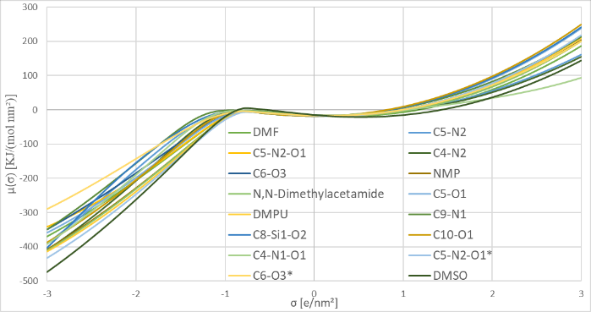Table 2 displays the best candidates having a $GlobPerf$ > 0.5 and ranks them by the distance values. NMP and N,N-Dimethylacetamide candidates have been cited in literature for PSC manufacturing as good solvents for precursors solubilization. Pure dimethyl sulfoxide (DMSO) is not capable to dissolve organic-inorganic perovskites (Jiang et al., 2023). Indeed, only binary mixtures DMSO-DMF have shown good PCE values. New substitution solvents were found from our study, with lower distance than DMSO to DMF and a suitable DN. Most of the new candidates contain similar atoms to DMF mainly nitrogen and oxygen in a linear or cyclic molecular structure. Substitution of nitrogen atom by sulphur atom has also been explored but studied molecules, for instance, Dimethylthioformamide, is not suitable to be used as solvent but as additives to retard the crystallization phase of the active layer (Hamill et al., 2020). Other new candidates contain only nitrogen or oxygen atoms belonging to a different chemical family. Due to confidential reasons, only the main atoms (type and number) are reported in table 2 for the new candidates. Candidate C5-N2 has $GlobPerf$ = 1 as DMF. NMP is the second better solvent reported in literature but its main drawback, apart its high toxicity, is its high boiling point, which alongside of low vapor pressure, are the main cause of low $GlobPerf$ for candidates with distance < 50.

Figure 2 σ-potential curves of the candidate solvents

Figure 1 Candidate solvents position in the FPCA space.

* + - 1. 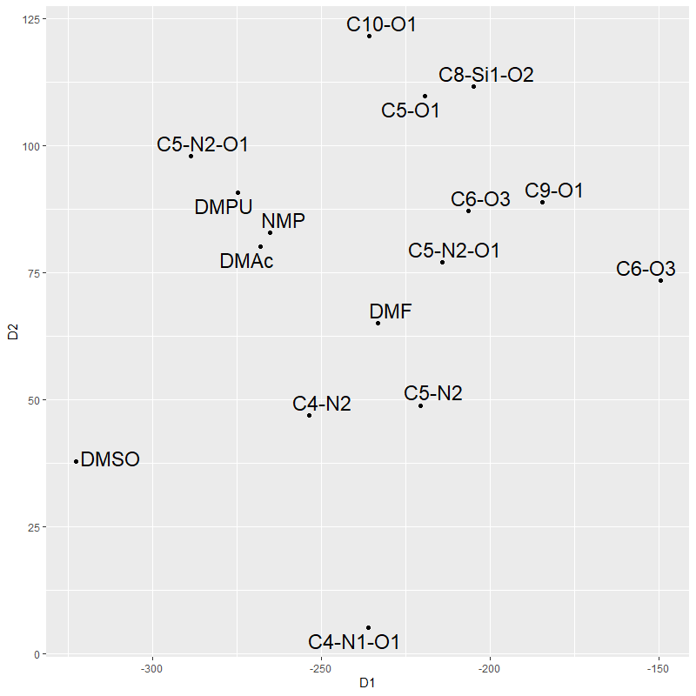Solubility experiments with the perovskite Cs0.05FA0.85MA0.10PbI2.90Br0.10

Ten solvents (italic) were selected in Table 2 for the solubility tests. Among the top three $GlobPerf$ candidates (C5-N2, C5-O1, C4-N1-O1), only one, C5-N2, dissolved the perovskite precursors, questioning the relevance of the $GlobPerf$ ranking. Even so, this methodology is well suited for an initial solvent screening from a large database although other less performant candidates passed the solubility test.

Experimental observations could be explained by considering extra atomic features of the chemical structures, that were not considered during reverse engineering, like steric access to polarized areas. Typical precursor solubilizing solvents are small molecules (DMF, NMP, DMSO) providing an accessible red zone (fig 3 a), b), c)) with polarization values superior to 0.01 e/Å². Three other molecules could solubilize the perovskite precursors at different concentrations. The highest concentration was achieved by N,N-dimethylacetamide (DMAc) at 1.2 M. DMAc has a small size, comparable to DMF, with an exposed red zone which facilitates the electronic interaction with the perovskite precursors. The second highest concentration was obtained for C5-N2-O1*, with a value of 0.3 M. The lower concentration can be explained by a more hindered red zone (Fig.3e)). The best candidate, C5-N2, resulted in the lowest concentration of 0.1 M. Two red zones are found in C5-N2 (Fig 3f)) but only the most outer nitrogen could interact with the perovskite precursors. Nevertheless, this most accessible nitrogen generates a weak surface charge of 0.01 e/Å² around it (Fig4), decreasing its solubilization power.

Table 2. Results of the search phase

|  |  |  |  |  |  |  |  |  |
| --- | --- | --- | --- | --- | --- | --- | --- | --- |
| Solvent candidates | D | DN | BP  (K) | VP  (bar) | Ρ  (kg/m3) | μ  (Cp) | ST  (Mn/m) | $$GlobPerf$$ |
| DMF | 0 | 25.1 | 153 | 5.16 | 948 | 0.92 | 35.8 | 1 |
| ***C5-N2*** | 20 | 29.3 | 444 | 0.77 | 862 | 1.77 | 35.1 | **1** |
| C5-N2-O1 | 22 | 30.8 | 494 | 0.3 | 1068 | 4.08 | 41 | 0.7419 |
| ***C4-N2*** | 27 | 24.8 | 400 | 5.4 | 1012 | 2.19 | 38 | **0.9678** |
| ***C6-O3*** | 34 | 25.4 | 435 | 3.15 | 969 | 6.80 | 29.5 | **0.9324** |
| NMP | 36 | 27.8 | 475 | 0.11 | 1048 | 2.67 | 41.4 | 0.9304 |
| ***N,N-dimethylacetamide*** | 37 | 28.0 | 438 | 0.72 | 904 | 2.16 | 36.6 | **0.9751** |
| ***C5-O1*** | 46 | 28.2 | 351 | 129 | 887 | 0.76 | 36.6 | **0.9954** |
| DMPU | 48 | 31.7 | 519 | 0.08 | 1063 | 6.09 | 43.8 | 0.5656 |
| C9-N1 | 54 | 19.2 | 443 | 1.34 | 907 | 2.87 | 36.6 | 0.8457 |
| ***C8-Si1-O2*** | 54 | 2.8 | 431 | 2.66 | 904 | 6.16 | 39.7 | **0.9314** |
| C7-N2-S1 | 56 | 23.4 | 498 | 0.12 | 1105 | 8.55 | 35.4 | 0.7944 |
| ***C10-O1*** | 56 | 29.3 | 449 | 1.44 | 948 | 2.80 | 36.6 | **0.9292** |
| ***C4-N1-O1*** | 59 | 22.8 | 350 | 53.9 | 1064 | 1.46 | 41.2 | **0.9882** |
| ***C5-N2-O1\**** | 64 | 30.6 | 449 | 1.4 | 927 | 2.98 | 36.6 | **0.9163** |
| ***C6-O3\**** | 84 | 19.6 | 431 | 5.37 | 995 | 6.28 | 27.6 | **0.8561** |
| DMSO | 93 | 29.8 | 189 | 1.45 | 1.135 | 2.89 | 43.5 | 0.8688 |

The remaining tested solvents were not capable to solubilize the precursors even at high temperature. Four different atomic features were identified for these solvents. Case 1: C5-N2-O1 and C8-Si-O2 have inaccessible red zones hindered by methyl groups around them (Fig.3k) and Fig.3h)) which makes it impossible for these molecules to correctly interact with the salts and solubilize them. Case 2: C5-O1 (Fig3i)) and C4-N1-O1 (Fig.3m)), have small, slightly flat, in-cycle red zones reducing their field of interaction with the precursors. Case 3: C6-O3* has an accessible red zone but the big size of the molecule would hinder other solvent molecules approaching the precursors decreasing its solubility power. Case 4: two candidates, C6-O3 (Fig.3g)) and C4-N2 (Fig.3j)), formed a solution of both dissolved and not dissolved perovskite precursors. C6-O3 is a long chain that has 17 conformers, from which 6 of them have a long red zone that would be capable of surrounding some of the perovskite precursors allowing C6-O3 to dissolve them to some extent. C4-N2 has an in-cycle red zone that, unlike C5-O1 and C4-N1-O1, has a higher electronic density due to the inductive effect of its methyl group, and the mesomeric effect of the neighbor N, less electronegative than an oxygen.

|  |  |
| --- | --- |
| c)  d)  e)  i)  h)  g)  k)  f)  b)  a) |  |
| Figure 3. COSMO surface of candidate molecules  l)  j)  m) | Figure 4. σ-profiles of candidate molecules |

According to the experimental results, neither the FPCA distance nor the calculated DN correlate with the solubility power. But they remain useful as initial screening criteria. Accessibility and polarity of the solvent’s red zone seems to be a decisive factor for the perovskite precursor solvation. The inclusion of these two criteria could improve the solvent screening specially for solubilisation process without the formation of complexes. That is the case of gama-valerolactone, which has been recently reported as capable to solubilize MAPbI3 (Chalkias et al., 2023). To further test this hypothesis, a combination of FPCA distance and red zone availability is being tested.

* 1. Conclusions

We proposed a reverse engineering methodology to find alternative solvents for a triple-cation perovskite using COSMO-RS σ-potential and an in-silico calculation of the DN. Using reverse engineering on a database of ~5000 molecules helped screening candidates for further experimental solubility testing of 10 molecules. A 2D visual representation of solvents from the σ-potential indicative of their polarity was produced. Experiments found three suitable solvents, not proposed previously for this system, which will be further tested in the fabrication step of solar cells. Access to polarized areas and steric hindrance were shown to impact the solubilization process of perovskite precursors. Further work will be carried out to determine the contribution of solvent red zone availability to the dissolution of the perovskite precursors. Proven right this methodology could then be easily extended any molecule.

**Acknowledgments**

This work has benefited from state aid managed by the French National Research Agency (ANR) under the project ANR-21-CE05-0031-01 as well as the “Investissements d’Avenir” program with the reference ANR-18-EURE-0021.

References

Best Research-Cell Efficiency Chart https://www.nrel.gov/pv/cell-efficiency.html (2023)

BIOVIA COSMOtherm, Release 2022; Dassault Systèmes. http://www.3ds.com

D.A. Chalkias, A. Mourtzikou, G. Katsagounos, A.N. Kalarakis, E. Stathatos, 2023, Development of Greener and Stable Inkjet-Printable Perovskite Inks for All-Printed Annealing-Free Perovskite Solar Mini-Modules Manufacturing, Small Methods, 7, 2300664

J. C. Hamill, O. Romiluyi, S. A. Thomas, J. Cetola, J. Schwartz, M. F. Toney, P. Clancy et Y.-L. Loo, 2020, Sulfur-Donor Solvents Strongly Coordinate Pb²+ in Hybrid Organic-Inorganic Perovskite Precursor Solutions, J. Phys. Chem., 124, 14496-14502

F. Eckert, A. Klamt, 2002. Fast solvent screening via quantum chemistry: COSMO-RS approach. AIChE Journal 48, 369–385

A. Gajardo, B. Satarupa, 2021, fdapace: Functional Data Analysis and Empirical Dynamics

K.L. Gardner, J.G. Tait, T. Merckx, W. Qiu, U.W. Paetzold, L. Kootstra, M. Jaysankar, R. Gehlhaar, D. Cheyns, P. Heremans, J. Poortmans, 2016, Nonhazardous Solvent Systems for Processing Perovskite Photovoltaics, Adv. Energy Mat., 6, 1600386

J. Heintz, J.-P. Belaud, N. Pandya, M. Teles Dos Santos, V. Gerbaud, 2014. Computer aided product design tool for sustainable product development. Computers & Chemical Engineering 71, 362

Z. Jiang, B. Wang, W. Zhang, Z. Yang, M. Li, F. Ren, T. Imran, Z. Sun, S. Zhang, Y. Zhang, Z. Zhao, Z. Liu, W. Chen, (2023), Solvent Engineering Towards Scalable Fabrication of High-Quality Perovskite Films for Efficient Solar Modules, Journal of Energy Chemistry, 80, 689

J.O. Ramsay, G. Hooker, S. Graves, 2009, Functional Data Analysis with R and MATLAB, Springer New York

J. Smiatek, 2019, Enthalpic contributions to solvent–solute and solvent-ion interactions: Electronic perturbation as key to the understanding of molecular attraction, J. Chem. Phys., 150, 174112

TURBOMOLE V7.4 2019, a development of University of Karlsruhe and Forschungszentrum Karlsruhe GmbH, 2007, TURBOMOLE GmbH, since 2007; available from [turbomole.com](http://www.turbomole.com).