Dynamics of dibenzyl toluene hydrogenation and dehydrogenation reactors: design and simulation
Pietro Deloguª, Elena Barbera^{b}, Andrea Mio^{c,e}, Alberto Bertucco^{b,d}, Maurizio Fermeglia^{c,e *}
a. SERICHIM, Italy
b. Department of Industrial Engineering (DII), University of Padova, Italy
c. Department of Engineering and Architecture (DIA), University of Trieste, Italy
d. Centro Studi “Levi Cases” for Energy Economics and Technology, University of Padova, Italy
e. Center for Energy, Environment and Transport Giacomo Ciamician, University of Trieste, Italy
Corresponding Author: maurizio.fermeglia@units.it
Abstract
Long-distance transport and long-term storage of H₂ can be realized with Liquid Organic Hydrogen Carriers (LOHC) based on a two-step cycle: (1) hydrogenation of the LOHC molecule (i.e., H₂ is covalently bound to the LOHC) and (2) dehydrogenation after transport and/or storage. Since the (optimal) LOHC is liquid at ambient conditions and shows similar properties to crude oil-based liquids (e.g. diesel and gasoline), its handling and storage is realized by well-known processes; thus, a stepwise adaptation of the existing crude oil-based infrastructure is technically possible. LOHC show economic advantages compared to compressed H₂ and liquid H₂ for long-term storage/long distance transport applications. The energetic efficiency of the systems depends on the dehydrogenation step. In this paper we will consider the details of thermodynamic and kinetic fundamentals of hydrogenation and dehydrogenation of a typical LOHC, namely Perhydro-Dibenzyl-Toluene. The fundamental chemical equilibrium expressions as a function of temperature and the catalytic kinetic expression for the reaction speed at different conditions are evaluated for the design of a dehydrogenation Continuous Stirred Tank Reactor. A process simulator (Aspen Plus v. 14.1™) is used to simulate the reactor at different operating conditions, focusing on the dynamic response of the reactor to any change in temperature, pressure, and inlet flow rate. The results obtained from the steady state simulation show a good agreement with experimental literature data. The results from dynamic simulation show that the time response of the reactor is compatible with the H₂ production variations needed by fuel cells used for transportation.
  - Introduction
In recent years, liquid organic H₂ carriers (LOHCs) have received a lot of interest as a viable alternative for the efficient, affordable, and secure storage of H₂. Catalytic hydrogenation attaches H₂ to an organic carrier molecule in LOHC systems to produce an H₂-rich storage liquid that mimics a fuel. At room temperature, the latter may be handled and transported utilizing the existing petroleum infrastructure. After that, a catalytic dehydrogenation process is employed for on-demand H2 release at the time and location of energy or H₂ demand. Among the possible LOHC molecules, the dibenzyl toluene (H0-DBT) and the perhydro-dibenzyl toluene (H18-DBT) have achieved significant interest. DBT is made up of many isomers in both its H₂-rich (HX-DBT) and H₂-lean (H0-DBT) forms. DBT has been used extensively as a heat transfer fluid since the 1960s. [1-4] A H₂ capacity of up to 6.2 weight percent, or a volumetric H₂ content of 56 gH2/L, is provided by the LOHC system H0-DBT/H18-DBT[5]. LOHC, and particularly DBT, show economic advantages compared to compressed H₂ (CGH) and liquid H₂ (LH) for long-term storage/long distance transport applications [3]. Hurskainen et al. [6]. showed the advantages of using LOHC in terms of CAPEX and net H2 payload with respect to GH2 trailers and in terms of lifetime with respect to trucks (table 1).
An example of the possibility of LOHC-based H₂ transport for future international commerce of chemically bonded H₂ is a tanker ship of the Suezmax class that is loaded with H18-DBT. Based on the Lower Heating Value (LHV) of the chemically bonded H₂, its 150,000 metric tons of liquid load would thus contain 9,300 metric tons of H₂, or 309.9 GWh of energy [5]. This indicates that a feasible alternative for the future is LOHC-based transcontinental H₂ trade from wind- or sun-rich regions to industrialized nations that today import a large amount of energy is a realistic option for the future.

Table 1: Comparison of different H₂ carriers [6]: LOHC tanker trailer is 36000 l; GH₂ trailer is 2 x 200 bar steel bottle ISO20 containers; Advanced GH₂ trailer is ISO40 HC 350 bar composite.

 | Truck | LOHC tanker trailer | GH₂ trailer | Advanced GH₂ trailer
Investment cost | 180 k€ | 140 k€ | 530 k€ | 420 k€
Lifetime | 8 years | 15 years | 15 years | 15 years
Fixed O&M |  | 4% of CAPEX | 2% of CAPEX | 2% of CAPEX
Net H₂ payload |  | 2000 kg (1400 kg net) | 400 kg | 900 kg
Unloading & loading time |  | 1 h + 1 h | 1 h + 1 h | 1h + 1 h

The introduction of global emission pricing [7] and growing electricity costs as well as an increase in the demand for electricity (for example, battery vehicle mobility) will make the import of LOHC-bound H₂ appealing already in the short to medium term [3, 8, 9].
The development of the hydrogenation/dehydrogenation equilibrium and kinetic models of the H0-DBT/H18-DBT system is the focus of the current investigation. Understanding equilibrium and kinetic data is essential for sizing of the reversible hydrogenation/dehydrogenation processes. The energetic efficiency of the systems depends on the dehydrogenation step [10]. With the obtained models, the simulation of a Continuous Stirred Tank Reactor (CSTR) for the dehydrogenation process is performed and finally some preliminary results for the dynamic behaviour of the CSTR are shown.
  - The rection schema
H0-DBT is hydrogenated via a sequential, step-by-step process [11]. One outside benzyl ring is hydrogenated to create H6-DBT in the first stage, and the second outer benzyl ring is hydrogenated to form H12-DBT in the second step. The middle ring is hydrogenated to generate H18-DBT in the last and rate-limiting hydrogenation step. The equivalent H6-DBT, H12-DBT, and H18-DBT fractions are made up of the appropriate isomers since H0-DBT is a combination of many of them. The reactions that take place in a catalytic hydrogenation / dehydrogenation reactor of perhydro dibenzyl toluene can be summarized, both from a kinetic and thermodynamic point of view, in three fundamental steps (Figure 1) [8]. Experimental determination of the hydrogenation /dehydrogenation equilibrium of the LOHC system H0/H18 dibenzyl toluene have been recently reported using innovative methods based on 13C-NMR and GC-FID [12]. There are three phases in the system: (1) catalytic solid adsorbing reagents and products.; (2) liquid phase consisting mainly of tricyclic compounds and solubilized H₂ and (3) gaseous phase containing essentially H₂ and tricyclic compounds as a function of their vapor pressure in relation to the composition of the liquid phase and temperature.
Figure 1: Proposed reaction scheme for hydrogenation and dehydrogenation [8].
It can be assumed, as a first approximation, that phase and adsorption equilibria can be ideal. As a result, chemical equilibrium relationships can be represented by the following expressions:
$K_{3}=\frac{c_{L2}^{e}p_{H_{2}}^{3}}{c_{L3}^{e}}$ ; $K_{2}=\frac{c_{L1}^{e}p_{H_{2}}^{3}}{c_{L2}^{e}}$; $K_{1}=\frac{c_{L0}^{e}p_{H_{2}}^{3}}{c_{L1}^{e}}$where $c_{Li}^{e}=\frac{n_{Li}^{e}}{V_{liq}}$ is the equilibrium liquid-phase molar concentrations of tricyclic compounds.
The pressure of H₂ is given by the difference between the total pressure and the sum of the partial pressures of the tricyclics:
$p_{H_{2}}=P_{tot}-\sum_{i}{P_{i}^{0}(T)\frac{n_{Li}^{e}}{\sum_{k}{n_{Lk}^{e}}}}$ (1)
but for sake of simplicity, given the low vapour pressure of these components (about 0.1 bar at a temperature of 290 °C), in the following reference is made only to the H₂ pressure. The kinetics of each of the reactions taking place in the solid phase between the species adsorbed on the catalyst can be described by the following general equation:
$r_{3}\left[\frac{moli}{g_{cat}h}\right]=k_{3}{c_{cat}c}_{L3}-k_{-3}c_{cat}c_{L2}p_{H_{2}}^{q}$ (2)
and similar for reactions 1 and 2. The exponent is the reaction order for H₂ q. Since the concentration of the catalyst appears in all equations with the same exponent, these can be simplified into the form.
$r_{3}\left[\frac{moli}{g_{cat}h}\right]=c_{cat}\left(k_{3}c_{L3}-k_{-3}c_{L2}p_{H_{2}}^{q}\right)=\frac{m_{cat}}{V_{liq}}\left(k_{3}c_{L3}-k_{-3}c_{L2}p_{H_{2}}^{q}\right)$ (3)
The material balance of a CSTR reactor is given by:
$\frac{d\underline{n}}{dt}=\underline{f}-\underline{u}+ V_{liq} \underline{\underline{v^{T}}} \underline{r}= \underline{0}$ (4)
This form can be employed to all the specific reactions. As far as H₂ is concerned, the overall equation is:
$\frac{{dn}_{H_{2}}}{dt}= f_{H_{2}}- u_{H_{2}}+3m_{cat}\left[\left(k_{3}c_{L3}-k_{-3}c_{L2}p_{H_{2}}^{q}\right)+\left(k_{2}c_{L2}-k_{-2}c_{L1}p_{H_{2}}^{q}\right)+\left(k_{1}c_{L1}-k_{-1}c_{L0}p_{H_{2}}^{q}\right)\right]=0$ (5)
Hydrogen pressure and hold-up are related to each other according to the volumes of the phases present in the reactor:
$n_{H_{2}}=\frac{p_{H_{2}}V_{gas}}{RT}$ (6)
Given the similarity of the liquid compounds present in the reactor, they can be assigned a density and an average molecular weight that are the same for all, so that it can be calculated from the volume of liquid $N_{tot}$
$N_{tot}=\frac{V_{liq}\overline{ρ}}{\overline{PM}}$ (7)
while the total molar output flow rate must be equal to the sum of the feed flow rates
$U=\sum{f_{i}}$ (8)
The closure constraint at 1 of the summation of molar fractions present in the liquid phase also applies.
Considering now the degree of freedom analysis, we have a total of 19 variables and 9 equations, so the system has 10 degrees of freedom. These can be saturated in various ways, but essentially the variables that could be fixed are feed rates (5), the volumes of the 3 phases (3), H₂ pressure (1), temperature (1), for a total of 10 variables. The parameters of the model consist of the 3 rate constants of the direct reactions, the 3 equilibrium constants for the counter-reactions, and the H₂ pressure exponent. Their estimation has been done starting from the experimental data of Dürr et al [12].
The dependence of the equilibrium constants on the temperature of the three reactions considered has been approximated by the equations.
$K_{i}=exp\left(-\frac{∆G_{r}\left(T\right)}{RT}\right)$ (9)
${∆G}_{r}\left(T\right)=\frac{T}{T°}{∆G}_{r}\left(T°\right)+{∆H}_{r}\left(T°\right)\left(1-\frac{T}{T°}\right)+{∆C}_{p}\left(T-T°\right)-T{∆C}_{p}\ln{\frac{T}{T°}}$ (10)
whose adaptive parameters are ${∆G}_{r}\left(T°\right), {∆H}_{r}\left(T°\right)$ e ${∆C}_{p}$. Given the substantial identity of the 3 reactions involved in the model, a single value was used for ${∆H}_{r}\left(T°\right)$ e ${∆C}_{p}$, while we have identified a specific value of ${∆G}_{ri}\left(T°\right)$ for each reaction. The reference temperature was 493 K. Figure 2 shows the comparison between experimental [12] and calculated degree of hydrogenation (DoH) data. It can be seen how the model developed is able to reproduce the available experimental trends and can therefore be used to describe the thermodynamics in the kinetic model of the reaction.
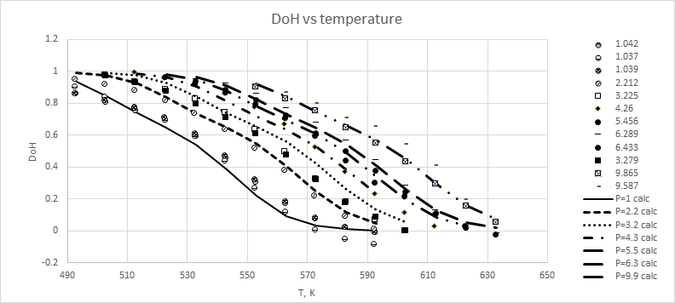
Figure 1: hydrogenation of DBT: experimental and calculated data for DoH.
The best estimation of the parameters of a kinetic model requires the availability of the evolution of the composition of the reactant system under conditions of constant temperature. Jorschick et al. [13] measured data of the composition of the reactants at constant temperature as a function of time. They used Pt on alumina as a catalyst 0.3% by weight at a single concentration of 3 g/100 g, at 30 bar absolute H₂ pressure and temperatures between 201 and 311 °C. They measured the flow of H₂ needed to maintain the pressure constant and calculated the degree of hydrogenation. Using the data of [12] combined with those of [13], we estimated the values of $k_{i}$ and q.
Figure 3 shows the comparison between experimental values and calculated DoH curves obtained with the equilibrium and kinetic constant derived as reported above and implemented in a batch reactor of Aspen Plus v. 14.1™ process simulator. The results obtained from the simulation show a good agreement with experimental literature data [12,13], thus allowing to state that the reactions implemented in Aspen Plus v. 14.1™ reliably describe the process of interest.
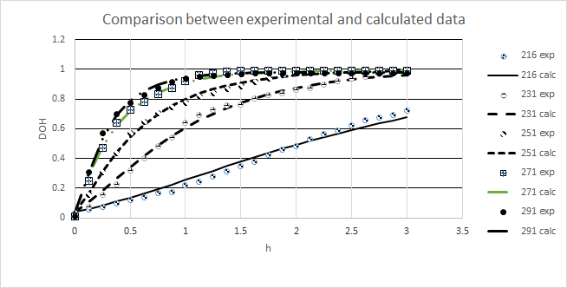
Figure 3: dehydrogenation of DBT: experimental and calculated data for DoH
  - The CSTR process simulation
The output H₂ pressure from the CSTR must be such that it can be fed to a fuel cell (around 4 bar). To obtain a high conversion at this pressure, it is necessary to operate at elevated temperatures, but not to exceed 300 °C, where the decomposition of dibenzyl toluene to volatile compounds become important. A temperature of 291 °C was used in the analysis and consequently it is necessary to supply the heat necessary to raise the temperature of the incoming flow up to 291 °C and the reaction heat. This heat is generated by burning some of the H₂ produced. The heat to be provided for one mole of LOHC is about 38 kcal. The CSTR model available in Aspen Plus v. 14.1™ was used to simulate the dehydrogenation reactions using the equilibrium and kinetic equations developed above. We have also evaluated the transition dynamics of the CSTR between two different power demands. The model calculates the time it takes to reach the new steady state conditions starting from a steady state condition taken as a reference one and the change in the composition of the liquid effluent, taken at the same total molar flow rate as the feed.
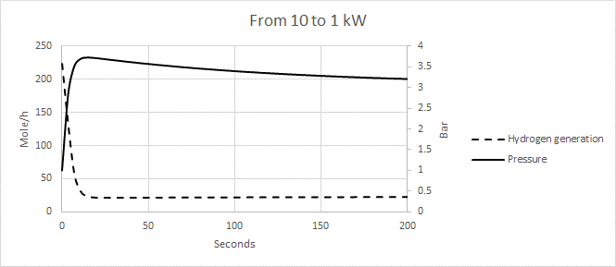
Figure 4: H₂ flow rate (blue) and pressure initial changes (orange) as a function of time.
The time to reach steady state is about 5 seconds. However, this only affects the internal conditions of the reactor, as both the LOHC supply and the H₂ withdrawal are constant from the beginning of the variation. In a first phase, the system produces more of the H₂ withdrawn, and this leads to an increase in pressure; This is then compensated until the steady state is reached. As an example, figure 4 shows the H₂ flow rate and pressure profiles as a function of time for a change in the H₂ request from 10 kW to 100 kW.
  - Conclusions
The main result of this paper is the development of equilibrium and kinetic expressions and parameters from literature experimental data for describing hydrogenation and dehydrogenation of DBT LOHC. All chemical reactions occurring in the processes have been considered, including direct and reverse reactions. The expressions for the reactions’ rate developed compare well with the experimental data of DoH. The reactions’ rate expression has been used in the simulation of a steady state CSTR and for the dynamic simulation of a transient for the same CSTR.
References
1. P. Preuster, C. Papp, P. Wasserscheid, Liquid Organic Hydrogen Carriers (LOHCs): Toward a Hydrogen-free Hydrogen Economy. Accounts of Chemical Research, 2017. 50(1): p. 74-85.
2. P.M. Modisha, C.N.M. Ouma, R. Garidzirai, P. Wasserscheid, D. Bessarabov, The Prospect of Hydrogen Storage Using Liquid Organic Hydrogen Carriers. Energy & Fuels, 2019.
3. M. Niermann, S. Drünert, M. Kaltschmitt, K. Bonhoff, Liquid Organic Hydrogen Carrier (LOHC) – Techno-economic analysis of LOHCs in a defined process chain. Energy & Environmental Science, 2019.
4. P.T. Aakko-Saksa, C. Cook, J. Kiviaho, T. Repo, Liquid organic hydrogen carriers for transportation and storing of renewable energy–Review and discussion. Journal of Power Sources, 2018. 396: p. 803-823.
5. N. Brückner, K. Obesser, A. Bösmann, D. Teichmann, W. Arlt, J. Dungs, P. Wasserscheid, Evaluation of Industrially Applied Heat‐Transfer Fluids as Liquid Organic Hydrogen Carrier Systems. ChemSusChem, 2014. 7(1): p. 229-235.
6. M. Hurskainen, J. Ihonen, ”Techno-economic feasibility of road transport of hydrogen using liquid organic hydrogen carriers”, International Journal of hydrogen energy, Vol. 45 (56), 2020, pagg. 32098-32112.
7. State and Trends of Carbon Pricing 2023, in © World Bank. https://openknowledge.worldbank.org/items/58f2a409-9bb7-4ee6-899d-be47835c838f
8. P. Runge, C. Sölch, J. Albert, P. Wasserscheid, G. Zöttl, V. Grimm, Economic comparison of different electric fuels for energy scenarios in 2035. Applied Energy, 2019. 233: p. 1078-1093.
9. D. Teichmann, W. Arlt, P. Wasserscheid, Liquid Organic Hydrogen Carriers as an efficient vector for the transport and storage of renewable energy. International Journal of Hydrogen Energy, 2012. 37(23): p. 18118-18132.
10. Asif F., Hamayun M.H., Hussain M., Hussain A., M. Maafa I.M., Park Y-K., Performance Analysis of the Perhydro-Dibenzyl-Toluene Dehydrogenation System—A Simulation Study, Sustainability 2021, 13, 6490.
11. G. Do, P. Preuster, R. Aslam, A. Bösmann, K. Müller, W. Arlt, P. Wasserscheid, Hydrogenation of the liquid organic hydrogen carrier compound dibenzyltoluene – reaction pathway determination by 1H NMR spectroscopy. React. Chem. Eng., 2016. 1(3): p. 313-320.
12. S. Dürr, S. Zilm, M. Geißelbrecht, Karsten Müller, P. Preuster, A. Bösmann, P. Wasserscheid, Experimental determination of the hydrogenation/dehydrogenation - Equilibrium of the LOHC system H0/H18-dibenzyltoluene, International Journal of Hydrogen Energy, Volume 46, Issue 64, 2021, 32583-32594, ISSN 0360-3199, https://doi.org/10.1016/j.ijhydene.2021.07.119.
15. H.Jorschick, P. Preuster, S. Durr, A. Seidel, K. Muller, A. Bosmann, P. Wasserscheid, Hydrogen Storage Using a Hot Pressure Swing Reactor. Energy & Environmental Science, 2017.

