Hybrid modelling based on model order reduction and machine learning, and its application for thermal cracking furnace
Jin Ma,ª Meihong Wang,^{b,}* Wenli Du,ª Feng Qianª
ªKey Laboratory of Smart Manufacturing in Energy Chemical Process, Ministry of Education, East China University of Science and Technology, Shanghai 200237,China
^{b}Department of Chemical and Biological Engineering, The University of Sheffield, Sheffield S1 3JD, UK
Corresponding author Email: Meihong.wang@sheffield.ac.uk
Abstract
High-fidelity modelling is fundamental in simulation, control and optimization of chemical processes. However, high-fidelity model is usually of strong nonlinearity, multivariable coupling and strong system constraints, which requires high computational demand. Developing a multi-dimensional model with lower computational demand poses a critical challenge. Our research will combine reduced order models (ROM) with machine learning to address the challenge. ROM is the projection of a multidimensional system into a low-dimensional subspaces, whereas machine learning is used to overcome the limitation of ROM applying to nonlinear and multi-physics models. A three-step framework is proposed. Firstly, adaptive sampling strategy is adopted to collect the “fewer but better” snapshots calculated by full order model with high computational demand. Then, proper orthogonal decomposition is adopted to generate reduced bases. Finally, relying on exposed polynomial structure, learning a physics-based ROM. The proposed method is demonstrated in thermal cracking furnace. Numerical case studies show that the proposed method can accurately predict temperature, velocity and species concentration profiles in cracking furnace. The optimisation of the oxygen content in the fuel gas of thermal cracking furnace is performed. The results show that the computation demand can be reduced significantly while ensuring the optimisation accuracy.
Keywords: hybrid modelling, thermal cracking furnace, reduced order models, machine learning, computational demand, optimisation
  - Introduction
    - background
High-fidelity modelling is fundamental in simulation, control and optimization of chemical processes. In recent decades, beneficial from the development of computational fluid dynamic (CFD) technology, the detailed three-dimensional high-fidelity models coupled mass, heat transfer and reactions were established for solving various physical information of process such as temperature, pressure and species concentration field, which is important for equipment design and parameter optimization. However, the dimensional of CFD models involving complicated physiochemical phenomena explodes to several million degrees as the models become more detailed. When high-fidelity model needs to be repeated calculations in optimization and design, three is a tradeoff between expensive computational resources and accuracy.
    - Literature review
In such situation, lots of various simplified methods is proposed to address this problem. Several works focus on the reduction of process mechanisms, which would lead to excellent performance with constraint conditions. For example, the Hottel zone method for simplifying the calculation of radiative heat transfer in thermal cracking furnace (Joo et al., 2000). Improvements based on first-principles models are not trivial, a long trial-and-error process is required to match the improved model to the detailed model under specific conditions. Another approach used to cut computational cost is model order reduction. The classical generation of reduced order model (ROM) is on the basis of proper orthogonal decomposition (POD) and Galërkin projection. Cutillo et al. (2023) developed a low computational cost ROM based on POD-Galërkin to predict the statement of methanation reactor. Since ROM is derived by projecting the full order model onto a low-dimensional subspace, it is precise for linear models. However, it still makes the numerical solution computationally expensive for nonlinear models. The upgraded model order reduction methods combined POD with discrete empirical interpolation method (DEIM) is usually selected to address this problem by evaluating the nonlinear problems at only fewer interpolation points.
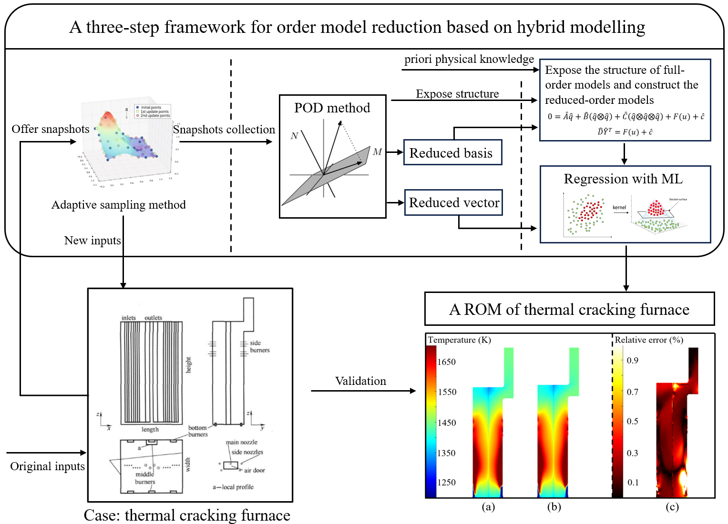
Fig.1 Framework of the proposed ROM approach for thermal cracking furnace
Bizon and Continillo (2020) applied the POD/DEIM method to optimize the design of a non-isothermal hybrid catalyst pellet and reduced the calculation cost. Bremer et al. (2016) employed the POD/DEIM method for model order reduction of non-linear model of catalytic tubular reactors. One of the drawbacks of POD/DEIM is not a significant reduction in computational efficiency, because a more accurate ROM often involves more interpolation points. The challenge of model order reduction for nonlinear models can also be solved using existing machine learning methods. Lee et al., (2021) built ROM using POD integrated machine learning for 500 MWe tangentially fired pulverized coal boiler. However, ROM constructed with machine learning have poor extrapolation performance. Another effective method to address the mentioned challenge is hybrid modelling (Swischuk et al., 2020), which combines first principles knowledge and machine learning to improve model accuracy and reliability of the model.
    - Novelty of this study
In this work, a three-step framework for commercial-scale CFD model with combustion process is proposed based on model order reduction and hybrid modelling approaches, providing an accurate and effective solution for data-driven modelling of commercial-scale steady-state processes. The constructed nonintrusive ROM exploits hard-earned data to the maximum extent possible and show a good predictive performance in the face of complex nonlinear and multivariate coupled problems. We show the implementation of this framework. First, adaptive sampling strategy is adopted to collect the “fewer but better” snapshots calculated by full order model with high computational cost. Then, POD method is adopted to generate the reduced bases. Finally, relying on exposed polynomial structure, learning a physics-based ROM for high-fidelity model. The model developed by proposed framework can be applied for cracking furnace to design, performance prediction, operation control and process optimization. The novel contributions of this study are as follows:
(1) Reduced the reliance on the amount of data using two measures: improved adaptive sampling methods and hybrid modelling.
(2) Hybrid modelling is used as a substitute for a generic off-the-shelf machine learning approach, the prior knowledge is extracted to correlate the inputs and outputs, thus improving model extrapolation performance.
(3) Developing a ROM of ethylene cracking furnace to significantly increase computational efficiency and save time cost with minimal loss of model fidelity.
  - Methodology
    - Proper orthogonal decomposition (POD)
The POD approach used to develop projection-based ROM has been widely adopted in physical fields approximation in geomechanics, aerospace, and other fields. In this work, a collection of the snapshots of full order model is given using high-fidelity CFD model developed in Fluent®, and POD is used to produce the basis via these snapshots.
Consider the nonlinear equations $G\left(q,u\right)=0$ with state vector $q∈R^{dn_{x}}$ and input $u∈R^{m}$. These equations can be solved under the specific input $u$, that is, the operating condition, and the solution (state vector $q$) are available. Information of the process can be obtained by processing state vector $q$. In order to acquire the ROM in a low-dimensional subspace, a reduced basis $V_{r}=[v_{1},v_{2},…v_{r}]$need to be defined and satisfied:
$$\tilde{q}=\sum_{i=1}^{r}{v_{i}{\hat{q}}^{i} }$$ | (1)
Where $\tilde{q}$ is the approximation of state vector $q$, and $\hat{q}={[{\hat{q}}^{1},{\hat{q}}^{2},…{\hat{q}}^{r}]}^{T}$ is the vector projected from the state vector $q$ to the $r$- dimensional subspace, typically called reduced vector, and in general, $r≪dn_{x}$. A set of state vectors solved by corresponding inputs is called a snapshot. The $n$ snapshots and their corresponding inputs are collected and used to generate the matrices $Q=[q_{1},q_{2},…q_{n}]∈R^{dn_{x}×n}$ and $U=[u_{1},u_{2},…u_{n}]∈R^{m×n}$. The tall and skinny matrix $Q$ is called snapshot matrix and contain snapshots as its columns. POD approach is implemented by computing the SVD of the snapshot matrix and obtain the reduced basis.
    - Adaptive sampling method
Snapshots used for ROM have a significant impact on the accuracy of ROM, as POD methods can’t describe details beyond the training data. In the reduced order model problem, considering the cost of high-fidelity model for more extensive snapshots may not be computationally affordable, adaptive sampling method is adopted, which is to reduce the time cost of data collection by analysing known snapshots to reduce unnecessary sampling. Considering the Eq. 1, prediction quality of the ROM is subject to the influence of the reduced basis and the reduced vector. The influence of reduced basis and reduced vector is quantified in different methods. The sample space is fitted to the influence using off-the-shelf machine learning methods to guide the next new snapshot. The next sample is selected as the largest quantified influence given as Eq. 2.
$$u_{new}={argmax}_{u^{pre}∈P}f_{NN}(u^{pre})$$ | (2)
The new sample is added to the initial set, and the adaptive sampling process is repeated until $maxI^{b}<ϵ^{b}$, where $ϵ^{b}$ is tolerance criterion defined by user.
    - Learning physics-based reduced order model
For the nonlinear equations $G\left(q,u\right)=0$ in CFD model, it can be decomposed into polynomial structure in mathematics. Qian et al. (2019) derivate the polynomial structures of Navier-stokes equation by convert terms and transformed dependent variables. Consider the governing equation discrete nonlinear equation rewritten in polynomial form:
$$0=Aq+B\left(q⨂q\right)+C\left(q⨂q⨂q\right)+f(u)+c$$ | (3)
The governing equations in polynomial form is projected into the defined low-dimensional subspace by the established reduced basis $V_{r}$. The approximation of state vector $q$, ${q≈V}_{r}\hat{q}$, is introduced. The equation is then left multiplied by the transpose of $V_{r}$, generating the ROM is written as
$$0=\hat{A}\hat{q}+\hat{B}\left(\hat{q}⨂\hat{q}\right)+\hat{C}\left(\hat{q}⨂\hat{q}⨂\hat{q}\right)+F(u)+\hat{c}$$ | (4)
The unknown operators $\hat{A}$, $\hat{B}$, $\hat{C}$ are combined in the matrix $\hat{D}$, and the term including reduced vector $\hat{q}$ are combined in the vector $\hat{Y}$. The governing equation in low-dimensional subspace is then written as Eq. 5.
$$\hat{D}{\hat{Y}}^{T}=F(u)+\hat{c}$$ | (5)
In order to eliminate the operator $\hat{D}$ of output, POD approach is used twice to reduce the order of ${\hat{Y}}^{T}$ from ${r+r}^{2}+r^{3}$ to $r$, and the training data that used to generate the reduced basis $V_{r}$ is used again to generate the reduced basis of ${\hat{Y}}^{T}$ shown in Eq. 6. The governing equation in low-dimensional subspace is transformed into the Eq. 7.
$${\hat{Y}}^{T}≈vr×{\hat{Y_{hat}}}^{T}$$ | (6)
$${\hat{Y_{hat}}}^{T}={\hat{D_{hat}}}^{(-1)}F(u)+{\hat{c}}_{hat}$$ | (7)
Where $\hat{D_{hat}}=\hat{D}×vr∈R^{r×r}$ is a square matrix that can be inverted in practical applications. This form is the same as multioutput support vector machine (MSVM), and this method is adopted to regression the relationship between ${\hat{Y_{hat}}}^{T}$ and input $u$.
  - Application for thermal cracking furnace
    - Cracking furnace full order model and numerical method
A steady-state solver of the commercial CFD software ANSYS Fluent® is used to produce training data (snapshots) of published thermal cracking furnace (Hu et al., 2015). Standard $k$-$ε$ method is applied as turbulence model, Discrete Ordinates model was used to calculate the radiation source term, and eddy dissipation concept is used to couple GRI 3.0 chemical reaction mechanisms. The semi-implicit method for pressure-linked equations (SIMPLE) algorithm for pressure-velocity coupling is selected to solve the nonlinear governing equations for the conservation of mass momentum, energy, radiation and species based on finite volume method.
The nonlinear governing equations discretized implicitly by a second-order upwind scheme, turn into a series of equations for the specific dependent variables in every computational cell. For a spatial discretization with $n_{x}$ cells and $d$ dependent variables, the partial differential equations composed of steady-state governing equations lie in a $dnx$-dimensional system of nonlinear equations.
    - Model validation and results
The high-fidelity thermal cracking furnace CFD model was run with 278,397 divided grids, and each set of steady state data was run for 20-30 hours in a computer with 64 cores CPU and 128G RAM, and a total of 40 sets of data were obtained for training and validation. The ROM of the thermal cracking furnace has been established using the proposed framework and its predicted longitudinal section temperature of the furnace is shown below. The results show a very good agreement between the temperature calculated by high-fidelity CFD model and predicted by the ROM.
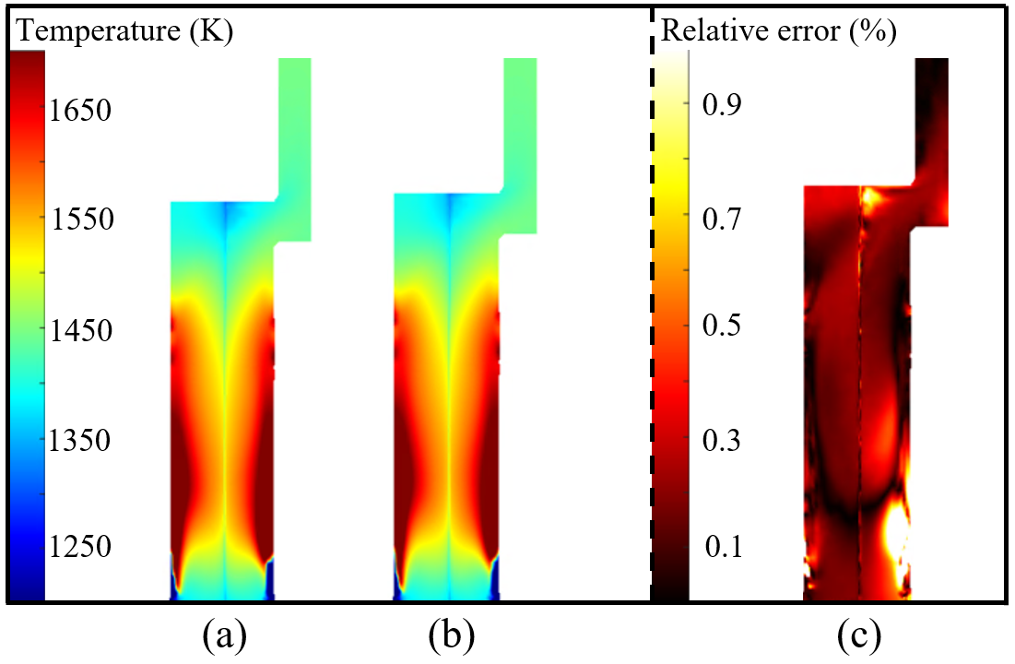
Fig2. (a) Temperature of High-fidelity model (b) temperature of ROM and (c) relative error.
    - Case study on optimisation of the oxygen content
Turbulence in the cracker results in irregular mixing of air and fuel. It is necessary to increase the air flow rate to avoid the generation of CO. In practice, the excess air factor for thermal cracking furnace is determined empirically and is generally set at 1.1 (i.e. 1.1 times the amount of oxygen required for complete combustion of the fuel). The ROM developed by the proposed framework allows for a fast prediction of the outlet CO content at different fuel flow rates to determine the optimal excess air coefficient.
The optimal excess air coefficient of 1.086 was determined using a high-fidelity full-order model with the condition of the fuel flow rate 11,000 kg/h. A total of 24 runs were performed, requiring more than 20 days to perform the calculation. In contrast, the optimal excess air coefficient of 1.088 can be quickly obtained in less than 15 minutes using the ROM.
  - Conclusion
In this paper, we propose a three-step framework for model order reduction based on POD and machine learning. Firstly, an adaptive sampling strategy is used to collect "fewer but better" snapshots computed from the high-fidelity CFD model. Then, POD is performed to generate the reduced basis. Finally, a polynomial structure of the model mechanism is derived to learn the physical-based ROM for the high-fidelity model. The proposed method is applied to the thermal cracking furnace. Very good agreement between the high-fidelity CFD model and ROM validates the proposed methodology. A case study of oxygen content optimization is carried out and this demonstrated that the proposed method can significantly reduce the computational demand.
References
EJ. Joo, KH. Lee, MY. Lee, SW. Park, 2000, CRACKER-A PC based simulator for industrial cracking furnaces, Computers & Chemical Engineering, 24(2e7), 1523e8.
EA. Cutillo, E. Mancusi, K. Bizon, P. Bareschino, G. Continillo, 2023, A Reduced Order Model for the Prediction of the Dynamics of a Methane Reactor, Computer Aided Chemical Engineering, Volume 52, Pages 1199-1204, ISSN 1570-7946, ISBN 9780443152740. https://doi.org/10.1016/B978-0-443-15274-0.50191-8.
K. Bizon, and G. Continillo, 2020, Optimal Design of a Non-isothermal Hybrid Catalyst Pellet based on POD-DEIM Reduced-order Methodology, Computer Aided Chemical Engineering, Volume 48, Pages 271-276, ISSN 1570-7946, ISBN 9780128233771. https://doi.org/10.1016/B978-0-12-823377-1.50046-X.
J. Bremer, P. Goyal, L. Feng, P. Benner, K. Sundmacher, 2016, Nonlinear Model Order Reduction for Catalytic Tubular Reactors, Computer Aided Chemical Engineering, Volume 38, Pages 2373-2378, ISSN 1570-7946, ISBN 9780444634283. https://doi.org/10.1016/B978-0-444-63428-3.50400-8.
W. Lee, K. Jang, W. Han, KY. Huh, 2021, Model order reduction by proper orthogonal decomposition for a 500 MWe tangentially fired pulverized coal boiler, Case Studies in Thermal Engineering, Volume 28, 101414, ISSN 2214-157X. https://doi.org/10.1016/j.csite.2021.101414.
R. Swischuk, B. Kramer, C. Huang, K. Willcox, 2020, Learning Physics-Based Reduced-Order Models for a Single-Injector Combustion Process, AIAA J, 58. https://doi.org/10.2514/1.J058943.
E. Qian, B. Kramer, A. Marques, K. Willcox, 2019, Transform & Learn: A Data-Driven Approach to Nonlinear Model Reduction, AIAA Aviation and Aeronautics Forum and Exposition, 2019-3707. https://doi.org/10.2514/6.2019-3707.
G. Hu, CM. Schietekat, Y. Zhang, F. Qian, 2015, Impact of Radiation Models in Coupled Simulations of Steam Cracking Furnaces and Reactors, Industrial & Engineering Chemistry Research, 54 (9), 2453-2465. https://doi.org/10.1021/ie5042337.

