Impact of Industrial Waste Heat Recovery on Heat and Electricity Marginal Costs in an Energy Community

Cédric Terriera*, Dorsan Lepoura, François Maréchala

a EPFL Valais Wallis, IPESE, Rue de l'Industrie 17, 1950 Sion, Switzerland

* cedric.terrier@epfl.ch

Abstract

Sector coupling is seen as one of the keys to improve energy efficiency within urban centers. In this perspective, residential energy system coupled with industrial waste heat recovery via district heating network is a promising solution. However, it also implies the coordination between systems design since a decision taken in one subsystem directly affects the decision-making of other subsystems. The aim of this paper is to demonstrate the sector coupling within an energy community containing an industrial site. The problem is formulated as a renewable energy hub with investment and operation decisions. Each building is modeled individually and the Dantzig-Wolfe decomposition is applied to optimize the district-scale problem. The industrial site is modeled as a heat source with fixed capacity and temperature. The marginal cost analysis demonstrates the spillover effect of waste heat availability on the profitability of PV panels, therefore engendering a self-consumption competition.

**Keywords**: Renewable energy hub, district heating network, marginal cost, MILP

* 1. Introduction

The building sector represents 19% of the CO2, eq emissions worldwide and is therefore one of the largest contributors to global warming (IRENA 2021). Integrating renewable capacities in the built environment becomes a prerequisite to the energy transition. In this perspective, the European parliament emphasized in 2018 the role of energy communities at promoting a high penetration of renewable energy in urban systems(EU Parliament 2018). They improve the self-consumption of local resources by coupling distributed energy sources and enhance energy efficiency by supplying multiple services to the consumers. Energy communities are usually considered at the neighborhood scale with a majority of residential buildings, therefore neglecting the synergy potential with the industrial sector, responsible for 23% of the CO2, eq emissions worldwide (IRENA 2021). It is estimated that industrial waste heat recovery could reduce the energy consumption of cities by up to 26%(Raluca-Ancuta Suciu, 2019). Therefore, besides service coupling, there is as well a need for sector coupling to maximize energy efficiency. The aim of this paper is to analyze energy carriers and sectorial couplings within an energy community composed of a residential area and an industry site. A marginal cost analysis is conducted to understand the dynamics of the system.

* 1. Methodology
     1. Overview of the problem formulation

The open-source decision support tool REHO (Renewable Energy Hub Optimizer) is used to model the district energy system (Lepour et al., 2023). The latter is defined as a set of buildings connected to the same low-voltage electricity grid and the same district heating network (DHN). Demands for services, such as space heating and domestic electricity, are evaluated for each building and are supplied by energy conversion units and energy carriers purchased from the utility grids (electricity, gas, heat). The investment into energy units and their operation is optimized with a mixed integer linear programming formulation. At the building scale, the choice of conversion units includes air-water heat pumps, gas boilers, electrical heaters, thermal tanks, lithium-ion batteries and PV panels. When a building is connected to the DHN, the model considers the installation cost of underground pipes and heat exchangers. At the district scales, the energy units include a battery and a centralized heat pump connected to the DHN.

The energy system is constrained by energy and mass balances and heat cascade. Equation 1 represents the energy equilibrium between imports and exports at the building level ${\dot{E}}_{b,l,p,t}^{gr}$ and energy exchanges with the grids ${\dot{E}}_{l,p,t}^{tr}$. A positive symbol represents an import of energy and a negative one an export. In addition, capacity constraints are applied to consider the maximal connection power with the grid (Eq. 2). Within the low-voltage grid, buildings are allowed to exchange energy carriers to maximize the self-consumption of renewable energy and respect the capacity constraints.

|  |  |
| --- | --- |
| $$\sum_{b∈B}{{(\dot{E}}_{b,l,p,t}^{gr+}-{\dot{E}}_{b,l,p,t}^{gr-})∙d_{p}∙d_{t}=(E_{l,p,t}^{tr+}-E_{l,p,t}^{tr-}) ∀l∈L, ∀p∈P, ∀t∈T }$$ | (1) |
| $${\dot{E}}_{l,p,t}^{tr±}≤{\dot{E}}_{l,p,t}^{tr max} ∀l∈L, ∀p∈P, ∀t∈T$$ | (2) |

The objective function is the total costs (TOTEX), being the sum of the operating (OPEX) capital costs (CAPEX). The OPEX corresponds to the purchase and sale of energy carriers on the energy layers $L$ (Eq. 3). The CAPEX encompasses fixed and variable investment cost into energy units (Eq. 4). Replacement costs are considered when a unit has to be replaced over the project horizon $n$. The investment is annualized with an interest rate $i$. Typical periods ($P$) are considered to reduce the problem complexity. More details on the problem formulation are given in the following thesis (Middelhauve, Luise, 2022).

|  |  |
| --- | --- |
|  | (3) |
|  | (4) |

* + 1. Dantzig-Wolfe Decomposition and Linking Constraints

To reduce solving time, the Dantzig-Wolfe decomposition is applied to the original formulation. The latter is split in several small problems fast to solve. Building energy systems are modeled in sub-problems (SPs). They provide system configurations to a master problem (MP) that ensure an optimal integration of the configurations in the district energy system. The latter considers linking constraints, such as capacity constraints (Eq. 2) and energy balances (Eq. 1) with the grids, as well as energy units at the district scale. The dual values of the linking constraints are inserted in the OPEX of the SPs (Eq. 5) and is similar to a micro-grid tariff of energy. This formulation is a reduced cost. The iteration loop terminates once the reduced cost of all SPs becomes positive, meaning that no additional configuration can improve the MP objective function.

|  |  |
| --- | --- |
|  | (5) |

* + 1. District Heating Network Modeling

The DHN cost considers two investments: the costs of pipes and the cost of delivering heat to the buildings, either with a direct heat exchange or with a heat pump. The latter are modeled with fixed and variable costs like the rest of energy units. However, the piping cost follows a highly non-linear function (Eq. 6 and 7). The diameter of the pipes $d_{b}^{dhn}$ is a square root function of the heat delivered and the length $L$ of the DHN is a decision variable depending on the number of buildings connected to the network. Therefore, to keep the linearity of the model some reformulations are performed by taking advantage of the structure of the Dantzig-Wolfe decomposition. First, the problem is initialized by enforcing the buildings to supply their heating demand from the DHN. The result is an associated piping cost calibrated to the demand of the buildings. These costs are then linearized with fixed and variable costs and used in the SPs. In a second step, the MP collects the SPs configurations, where the DHN heat load of the buildings becomes a parameter. Therefore, it allows the MP to calculate the piping costs based on a linear combination of configurations. Finally, the DHN length between building is assumed constant and is calculated with Eq. 7, where n is the number of buildings and K a shape factor equal to 0.4. More information is available in this thesis (Girardin, 2012).

|  |  |
| --- | --- |
|  | (6) |
|  | (7) |

* + 1. Application

The case study is a neighborhood with a mix of 75 residential buildings, offices and industries. Three district heating networks are considered with supply and return temperatures of 80/70°C, 45/35°C and 16/14°C. Water is used as an energy carrier. A geothermal heat pump at the district scale closes the DHN heat balance with a ground source at 8°C. Weather data are clustered in 10 typical days and 2 extreme periods. The electricity retail and feed-in tariffs are respectively 0.25/0.1 CHF/kWh and the natural gas tariff is 0.14 CHF/kWh. These values are taken from the mean tariffs in Switzerland over the last 3 years. Industrial waste heat is modeled by a heat capacity constraint as stated in Eq. 2 and is assumed to be free of charge since the piping costs are already considered. For low and medium temperature DHN, decentralized heat pumps are necessary to elevate the temperature of the heat to the one of the buildings hydraulic systems. The latter is 65°C for old buildings and 41.5°C for recent ones.

* 1. Results and Discussion

The following analysis looks at the impact of DHN temperatures and waste heat availability on investment and operation design. Figure 1 is showing costs and PV integration as a function of the heat available from the industry, expressed by the ratio between the waste heat power and the heat demand peak power from the district.

Among the three DHN designs, the CAPEX remains relatively constant. Industrial waste heat decreases the capacity of the centralized heat pump, but this investment is relatively low compared to the piping investment. In addition, concerning the low and medium temperature DHN, the need for distributed heat pumps makes the CAPEX decrease negligible (respectively 0.2% and 9.6%). This drop is larger for the high temperature DHN (17.6%) due to the low COP of the heat pump requiring a large capacity.

The analysis is highly contrasting regarding the OPEX. Without waste heat recovery, the high temperature design is twice more expensive than the low temperature one. This is mainly due to the COP of the centralized heat pump, varying by a factor 8. The poor performance of the high temperature DHN is partly compensated by a higher investment into PV panels to access cheap and renewable electricity (Figure 1b). The OPEX and PV penetration are highly sensitive to waste heat availability and the sensitivity increases with the temperature of the DHN. It appears that waste heat and renewable electricity from PV panels are acting like too competing energy sources. Therefore, the highest the exergy content of the waste heat source, the lower the profitability of PV integration. This trend is as well visible from the end use of renewable electricity. Electricity exports are increasing (+12.3%) together with the share of waste heat available due to the low electricity self-consumption within the district. In conclusion, the sector coupling between industry and residential energy system generates a loss of profitability for certain investments, such as the ones in PV panels. It should be noted that the higher the exergy efficiency, the lower are the investment and operation decision change. Therefore, the risks for the residential sector are mitigated.

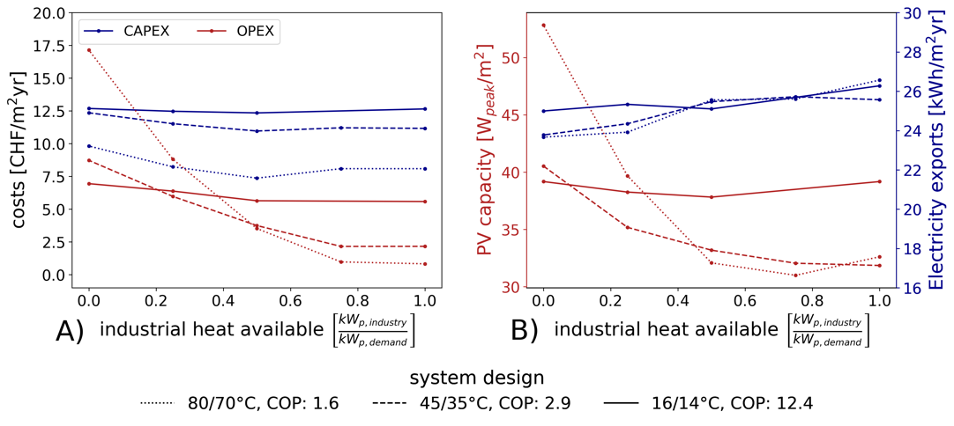

Figure 1: Costs and PV integration metrics with respect to waste heat recovery availability.

Beside reducing computational time, the decomposition approach provides insightful measurements of the system dynamics described previously. The dual values of the energy balances (Eq. 1) are the price signals sent by the district energy system to the buildings. Figure 2 shows their values, being the marginal cost of heat and electricity. Each figure is showing the 10 typical days one after the other. In Figure 2a, no waste heat is available. The marginal cost of electricity oscillates between the retail and feed-in tariff, depending on whether the district is on net import or export of electricity. The synergies between the two energy carriers are clear since the two profiles are highly correlated. The marginal cost of heat considers as well the efficiency of the system since its value is proportional to the COP of the heat pumps, thus to the temperatures of the DHN.

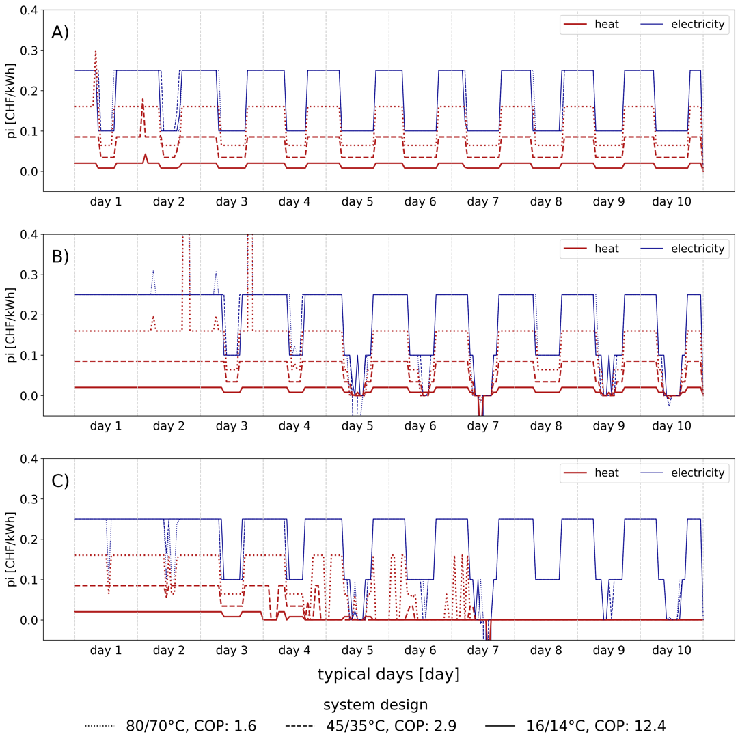

Figure 2: Dual values of the energy and capacity constraints for a) no waste heat, b) no waste heat and electrical capacity of 400 kW, c) 0.5 $\frac{kW_{p, industry}}{kW_{p, demand}}$ waste heat and electrical capacity of 400 kW

The second scenario presented in Figure 2b is similar to the first one, but a capacity constraint of 400 kW has been set on the electricity grid. This constraint decreases the investment into PV panels, therefore making the system net importer over the first two typical days. In addition, the profiles depict positive and negative peaks whenever the

system is reaching the maximal capacity of the electrical grid. It is worth mentioning that for some time steps the electricity marginal cost is negative. It means that the system is decreasing its TOTEX if it consumes more electricity, because it avoids changing configuration.

Finally, a last scenario is built to demonstrate the impact of waste heat recovery (Figure 2c). It possesses the same electrical capacity and has a heat capacity of 0.5 $\frac{kW_{p, industry}}{kW_{p, demand}}$. The electricity marginal cost has a similar profile than in the second scenario. However, the heat profile is uncorrelated to the electricity tariff over the last 4 typical days. This is due to the waste heat competing with renewable electricity, therefore screening the influence of electricity on the heat marginal cost. The outcome is serious. It means that cross-sectorial coupling is reducing cross-energy carrier coupling. In other words, if the waste heat is due to inefficient processes, not only the industry will sell its inefficiency to the residential sector, but it will also reduce the energy efficiency of the residential energy system.

* 1. Conclusion

The aim of this paper was to demonstrate the sectorial and energy carriers coupling between a residential energy system and an industry delivering waste heat. The energy community is modeled as an energy hub being connected to a district heating network and to electricity and natural gas grids. The Dantzig-Wolfe decomposition is applied on the problem to reduce computational time. This method is based on the use of dual variables. Interestingly, the dual values of the energy balances and grid capacity constraints provide a physical meaning on the dynamics of the system. They inform on the availability of cheap renewable electricity and on the saturation of energy grids. Moreover, they demonstrate the synergies occurring between energy carriers based on the correlation between energy carriers’ marginal costs. Without waste heat recovery, the marginal cost of heat is correlated to the one of electricity. However, with the integration of waste heat in the system the correlation between the two drops, especially with waste heat at high temperature. It demonstrates the competition between renewable electricity from the PV panels and waste heat recovery. Therefore, the paper highlights the importance of well-designed sector coupling to prevent a spillover effect of industrial inefficiencies on the residential sector. Further work could be accomplished on the modeling of the industry site and its integration in a nested decomposition accounting for both industrial processes and urban planning in a single optimization.

References

1. Girardin, L., 2012. A GIS-based Methodology for the Evaluation of Integrated Energy Systems in Urban Area. EPFL. https://doi.org/10.5075/epfl-thesis-5287
2. Internation Renewable Energy Agency, 2021. World Energy Transitions Outlook.
3. Lepour, D., Terrier, C., Middelhauve, L., 2023. Renewable Energy Hub Optimizer (REHO).
4. Middelhauve, Luise, 2022. On the role of districts as renewable energy hubs. EPFL.
5. Parliament, E., 2018. DIRECTIVE (EU) 2018/ 2001 OF THE EUROPEAN PARLIAMENT AND OF THE COUNCIL - of 11 December 2018 - on the promotion of the use of energy from renewable sources 128.
6. Raluca-Ancuta Suciu, 2019. Fifth generation district energy systems for low carbon cities. EPFL.