Combining automated machine learning and molecular simulation to advance the discovery of COF-based membranes for acid gas separation
Bingru Xinª, Minggao Feng^{b}, Min Cheng^{c}, Zhongde Dai^{d}, Li Zhouª, Yiyang Daiª*, Xu Jiª*
ªCollege of Chemical Engineering, Sichuan University, Chengdu 610065, China
^{b}Department of Chemistry and Materials Innovation Factory, University of Liverpool, Liverpool L7 3NY, UK
^{c}BYD Company Ltd, No 5. Xiusha Road, Kenzie Town, Pingshan District, Shenzhen, Guangdong, 518122, P.R China
^{d}College of Carbon Neutrality Future Technology, Sichuan University, Chengdu 610065, China
* Corresponding Authors:Yiyang Dai: daiyy@scu.edu.cn ; *Xu Ji: jxhhpb@163.com
Abstract
Due to the rapid increase in the number of covalent organic frameworks (COFs), there is a need for efficient methods to quickly assess the properties of these materials. In this study, we used a combination of automated machine learning (ML) and molecular simulations to investigate the membrane permeability and selectivity of 811 curated COFs for acid gas (H₂S and CO₂) separation. An automated ML model was developed to directly predict membrane permeability based on 20 features obtained through fast computation. Next, we analysed the feature weights using SHAP and found that pore size and structural features had the highest correlation with gas permeability. Based on the feature knowledge and ML model we screened 69,840 hypothetical COFs (hCOFs) to obtain high-performance COFs without the need for expensive molecular simulations. Finally, the separation performance of COF/polymer mixed matrix membranes (MMMs) was evaluated under a ternary gas mixture system. This integrated approach of artificial intelligence and molecular simulations accurately and efficiently advances the discovery of high-performance COF membrane materials for acid gas separation and provides valuable insights for experimental and computational work.
Keywords: Covalent organic framework (COF), Machine learning, Molecular simulation, Acid gas separation, Membranes separation
  - Introduction
In the realm of fossil fuels, natural gas is widely recognized as the most environmentally beneficial alternative due to its minimal emission of pollutants during the combustion process. However, to optimize the efficiency of methane utilization, it is crucial to eliminate acid gas (H₂S, CO₂) from natural gas. Membrane separation method is a promising technology with the advantages of small footprint, low energy consumption and easy operation. The choice of membrane material is crucial to the performance of membrane separation. Covalent organic frameworks(COFs) are widely used in gas membrane separation applications as popular porous materials in recent years (Yuan et al., 2019).
For the study and characterization of material properties, traditional experimental methods are time-consuming and labor-intensive. In recent years, with the rapid development of computer technology, high-throughput computational screening (HTCS) methods for rapid study of large-scale material properties through molecular simulation (MS) can overcome the limitations of traditional experimental methods to a certain extent. In our previous work, the helium purification properties of 688 COFs were investigated by molecular simulation, and five high-performance COFs were finally obtained by the synergistic screening strategy of both He/CH₄ and He/N₂ systems (Feng et al., 2022).With the increasing amount of material in the database, traditional MS-based high-throughput methods require expensive computational costs. As an alternative, machine learning (ML) is increasingly popular for understanding complex structure-property relationships, predicting material properties, and expediting material discovery. Many researchers are now utilizing ML and molecular simulation (MS) to assess the performance of new materials. Cheng et al. screened adsorbents with high iodine adsorption performance from more than 12,020 MOFs by MS and constructed structure-property relationships by ML(Cheng et al., 2023). On the other hand, Onder Aksu and Keskin used ML and MS to explore the CH₄/H₂ separation performance of COFs(Onder Aksu and Keskin, 2023).
Although there are already several approaches on combining ML and MS for material screening, combining the interpretability of the models to quickly screen large amounts of data is a challenge. To the best of our knowledge, no systematic methodology has been developed to integrate model interpretability into the screening process of COFs. Therefore, the main goal of this study is to combine an automated ML and MS approach while integrating the chemical insights obtained from model interpretability for the rapid screening of COF materials in a large amount of chemical space, and ultimately to investigate and obtain high-performance COFs for acid gas membrane separation.
  - Methodology
This section describes the proposed workflow combining interpretable ML and MS for COF membrane discovery for acid gas separation in natural gas, as shown in Figure. 1.
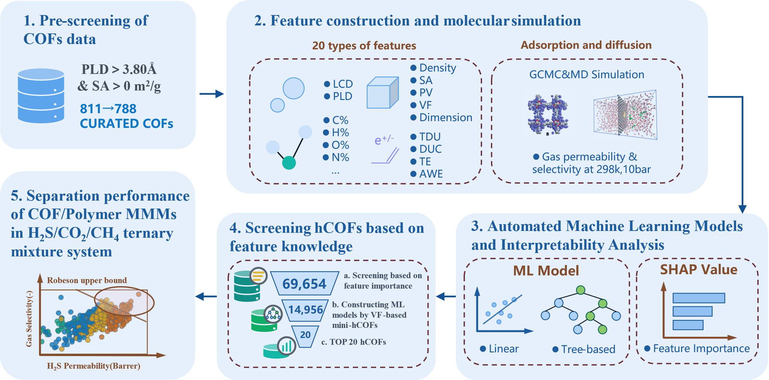
Figure 1. Workflow for interpretable ML-assisted discovery of innovative COF-based membranes with high performance.
The workflow is (1) Structural pre-screening of the CURATED-COFs database to exclude COFs with pore limiting diameter smaller than 3.80 Å (CH₄ kinetics diameter). (2) Extract pore size, structural, atomic, and chemical property descriptors from COFs to be used as feature inputs for ML models. The feature dimension was 20 dimensions. The results of GCMC and MD simulations at 10 bar and 298 k were used as predictive properties. (3) The regression and tree models for predicting gas permeability were trained using the automated machine learning tool TPOT. Chemical insights were obtained by calculating SHAP values. (4) High-throughput permeability prediction using feature knowledge and machine learning for a large number of hCOFs. (5) Finally, molecular simulation of ternary gas mixtures under real conditions is performed for high-performance COFs to obtain optimal COF materials.
    - Datasets and Features
In this work, we choose two databases, CUTARED-COFs (Ongari et al., 2019) and hCOFs,(Mercado et al., 2018) as candidate materials. The former is an automatic recognition grabbing of the current experimentally synthesized COFs with several 788. The latter is the computer-virtual synthesized COFs with number up to 69654. COFs with PLD less than 3.8Å were excluded from the calculation. All features are listed in Table 1.
Table 1. List of features of COFs used for ML model
Descriptor type | Feature |  | Unit
Pore size descriptors | Largest cavity diameter (LCD) |  | Å
 | Pore limiting diameter (PLD) |  | Å
Structure descriptors | Density (ρ) |  | g/cm³
 | Surface area (SA) |  | m²/g
 | Pore volume (PV) |  | cm³/g
 | Void fraction (VF) |  | -
 | Dimensions (D) |  | -
Atomic descriptors | C% | H% | -
 | N% | O%
 | S% | Halogen %
 | Metalloid % | Metal %
 | Nitrogen-to-Oxygen (N-to-O)
Chemical property descriptor | Total degree of unsaturation (TDU) |  | -
 | Degree of unsaturation per carbon (DUC)
 | Total electronegativity (TE)
 | Atomic weighted electronegativity (AWE)
    - Molecular Simulation & Calculation of Membrane
The adsorption (N_{i}) and diffusion (D_{i}) characteristics of all CURATED-COFs were evaluated by GCMC with MD for three single-component gases (H₂S, CO₂, CH₄) at 298k, 10 bar. Along with the N_{i} properties, the D_{i} of gas molecules through the COFs’ pores are calculated for membrane-based gas separations. After obtaining the molecular simulation data on the permeability of COFs, the gas permeability of the mixed matrix membrane can be calculated by combining it with the permeability data of the experimental polymers based on Maxwell's theoretical permeation model. Detailed computational parameters for molecular simulations and membrane calculations can be found in our previous work. (Feng et al., 2022)
    - Automated Machine Learning and Interpretable Analysis
Four sets of descriptors are used as input features to construct a ML model. The Tree-based Pipeline Optimization Tool (TPOT), an automated machine learning tool, is employed for this purpose.(Olson and Moore, 2019) To ensure reliable results, the data is divided into an 80% training set and a 20% test set, with stratified sampling implemented to maintain consistent feature distribution. To prevent overfitting, a 50% discount cross-validation is utilized. The effectiveness of the model is evaluated using four metrics: coefficient of determination (R²), root mean square error (RMSE), mean absolute error (MAE), and Spearman's rank correlation coefficient (SRCC). Shapley additive explanations(SHAP) analysis is an effective tool for machine learning model interpretability(Yang et al., 2022). In this model, all features are regarded as "contributors" to the predicted value, leading to the computation of SHAP values. The selection of the best machine learning algorithm, as determined by TPOT, varies depending on the prediction tasks at hand. For each ML model, we utilize the corresponding SHAP interpreter, specifically the tree-based explainer and the linear-based explainer.
  - Results
    - Structure-Performance Analysis
Based on the data obtained from GCMC and MD simulations, the gas permeability of the COF membrane was calculated. Figure 2. shows the separation performance of H₂S/CH₄ (a.) and CO₂/CH₄ (b.) for COF membranes at 298k and 10 bar, respectively. The color gradient in the figure represents the size of the void fraction. Like polymers, COF membranes exhibit a trade-off between permeability and selectivity, with only a few COFs approaching the Robeson upper bound. The classification of COF gradients based on void fraction demonstrates the positive impact of high VF on membrane performance. This finding can be further validated through subsequent interpretable ML techniques.
Figure 2. H₂S permeability and H₂S/CH₄ selectivity (a), CO₂ permeability and CO₂/CH₄ selectivity (b) of COF membranes at 10bar, 298K. The VF indicates void fraction.
    - ML Model Prediction
The model input comprised 19-dimensional features by excluding features with a Pearson correlation coefficient exceeding 0.9. Figure 3a demonstrates the direct construction of ML model for predicting H₂S permeability, which is superior to predicting adsorption and diffusion first and then calculating gas permeability. Subsequently, we explored the extent to which features contribute to the prediction model. Figure 3b shows the order of importance of the features used to predict H₂S permeability (displaying only the top six). Pore size and structure descriptors are the most important descriptor types, while atomic and chemical descriptors contribute to a lesser extent. Void fraction is the most contributing feature in all models. Consistent findings were observed in experimental studies on the effect of porosity and pore size on the membrane effectiveness of porous materials (Ying et al., 2022).
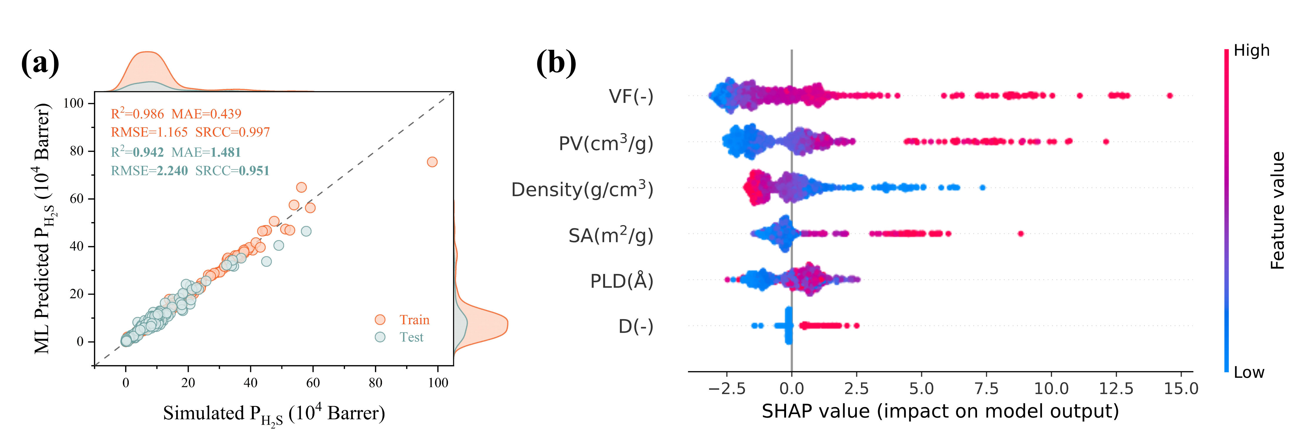
Figure 3. Marginal distribution scatter plots of H₂S permeability predicted by ML compared with molecular simulation results and SHAP feature importance distribution.
    - Rapid screening of hCOFs
Using the previously acquired key features, we have successfully pre-screened hCOFs, resulting in the identification of 14,956 potential candidate COFs (cCOFs). We then uniformly sampled cCOFs based on VF to obtain 500 mini-cCOFs for molecular simulation calculations and merged them with the data of CURATED-COFs for a total of 1300 data points to construct ML models. The MSE of the H₂S permeability prediction test is 2.45, and the R² is 0.953, which indicates the high prediction accuracy of the ML models. Figure 4 shows the "permeability-selectivity" distribution of hCOFs obtained for training and prediction, where the orange data represents the data used to participate in training the model in cCOFs, and the blue data points represent the COFs data obtained from ML prediction.
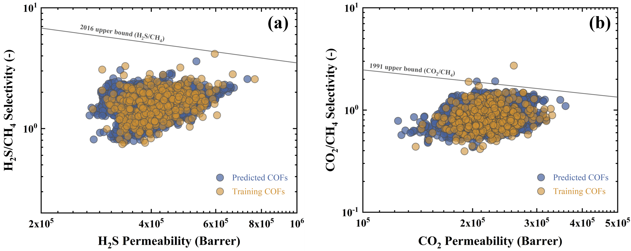
Figure 4. H₂S/CH₄ & CO₂/CH₄ permeability-selectivity distributions obtained from hCOFs database after ML projection.
    - TOP COFs
Finally, we selected 20 advanced COFs designed for single-component gas separation and evaluated their performance under real operating conditions with ternary mixtures. Our research revealed that JUC-551-2 was the top-performing COF and other TOP COFs are shown in Table 2 and Figure 5.
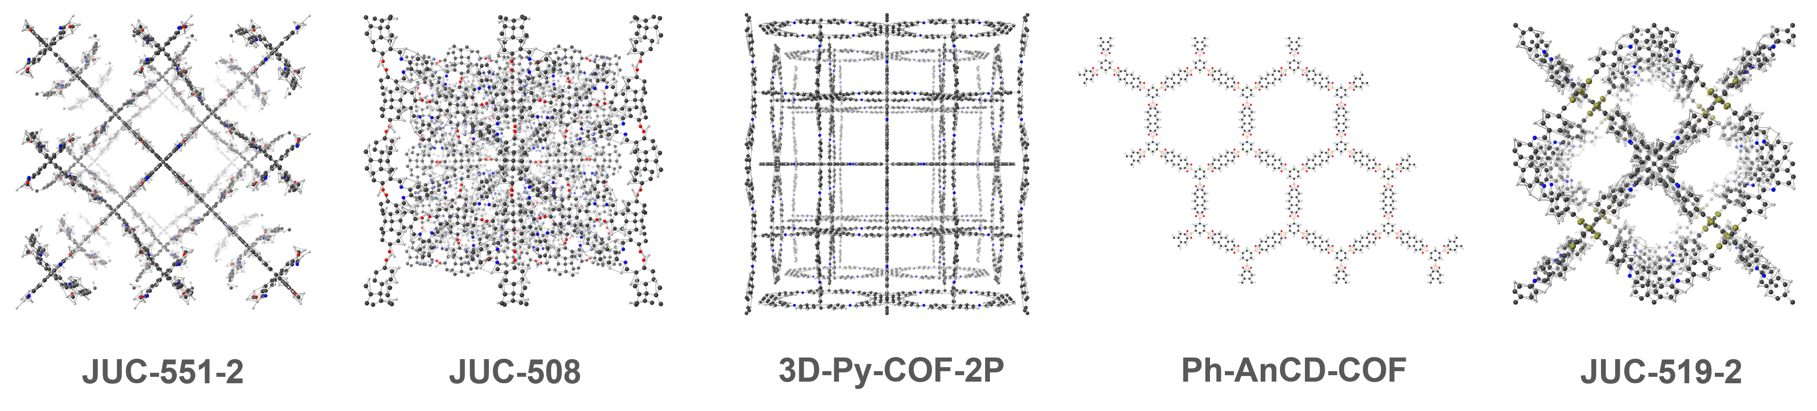
Figure 5. Structure of TOP-5 CURATED-COFs for acid gas separation of the membrane.
Table.2 Separation performances of the Top-5 CURATED-COFs
COFs | PLD  (Å) | VF  (-) | Di  (-) | $$P_{H_{2}S}$$  (Barrer) | $$P_{{CO}_{2}}$$  (Barrer) | $$S_{H_{2}S/CH_{4}}$$  (-) | $$S_{{CO}_{2}/CH_{4}}$$  (-)
JUC-551-2 | 10.1 | 0.91 | 3D | 4.19×10⁵ | 3.02×10⁵ | 5.46 | 3.93
JUC-508 | 8.9 | 0.87 | 3D | 6.01×10⁵ | 1.85×10⁵ | 5.19 | 1.60
3D-Py-COF-2P | 12.3 | 0.91 | 3D | 5.31×10⁵ | 2.88×10⁵ | 4.23 | 2.29
Ph-AnCD-COF | 21.1 | 0.91 | 2D | 3.70×10⁵ | 2.30×10⁵ | 4.70 | 2.92
JUC-519-2 | 8.9 | 0.89 | 3D | 3.83×10⁵ | 3.12×10⁵ | 3.54 | 2.90
To further enhance separation performance, we explored the potential of combining the top five COFs with six different polymers, resulting in the development of MMMs. This approach successfully boosted the permeability of the polymer membranes, without compromising their selectivity.
Conclusions
In this work, the performance of COF-based membranes for acid gas separation is systematically investigated. The workflow combining automated ML and MS shows well the exploration process of high-performance COF materials. Interpretability helps to extract the necessary feature knowledge helping us to quickly explore the material space in the unknown chemical space. The method provides an integrated working idea for future experimental discovery and design of optimal COF-based membranes.
References
Cheng, M., Zhang, Z., Wang, S., Bi, K., Hu, K., Dai, Z., Dai, Y., Liu, C., Zhou, L., Ji, X., Shi, W., 2023. A large-scale screening of metal-organic frameworks for iodine capture combining molecular simulation and machine learning. Front. Environ. Sci. Eng. 17, 148.
Feng, M., Cheng, M., Deng, J., Ji, X., Zhou, L., Dang, Y., Bi, K., Dai, Z., Dai, Y., 2022. High-throughput computational screening of Covalent−Organic framework membranes for helium purification. Results Eng. 15, 100538.
Li, H., Chang, J., Li, S., Guan, X., Li, D., Li, C., Tang, L., Xue, M., Yan, Y., Valtchev, V., Qiu, S., Fang, Q., 2019. Three-Dimensional Tetrathiafulvalene-Based Covalent Organic Frameworks for Tunable Electrical Conductivity. J. Am. Chem. Soc. 141, 13324–13329.
Mercado, R., Fu, R.-S., Yakutovich, A.V., Talirz, L., Haranczyk, M., Smit, B., 2018. In Silico Design of 2D and 3D Covalent Organic Frameworks for Methane Storage Applications. Chem. Mater. 30, 5069–5086.
Olson, R.S., Moore, J.H., 2019. TPOT: A Tree-Based Pipeline Optimization Tool for Automating Machine Learning, in: Hutter, F., Kotthoff, L., Vanschoren, J. (Eds.), Automated Machine Learning, The Springer Series on Challenges in Machine Learning. Springer International Publishing, Cham, pp. 151–160.
Onder Aksu, G., Keskin, S., 2023. Advancing CH 4 /H 2 separation with covalent organic frameworks by combining molecular simulations and machine learning. J. Mater. Chem. A.
Ongari, D., Yakutovich, A.V., Talirz, L., Smit, B., 2019. Building a Consistent and Reproducible Database for Adsorption Evaluation in Covalent–Organic Frameworks. ACS Cent. Sci. 5, 1663–1675.
Yang, J., Tao, L., He, J., McCutcheon, J.R., Li, Y., 2022. Machine learning enables interpretable discovery of innovative polymers for gas separation membranes. Sci. Adv. 8, eabn9545.
Ying, Y., Peh, S.B., Yang, H., Yang, Z., Zhao, D., 2022. Ultrathin Covalent Organic Framework Membranes via a Multi‐Interfacial Engineering Strategy for Gas Separation. Adv. Mater. 34, 2104946.
Yuan, S., Li, X., Zhu, J., Zhang, G., Van Puyvelde, P., Van Der Bruggen, B., 2019. Covalent organic frameworks for membrane separation. Chem. Soc. Rev. 48, 2665–2681.

