Supply chain optimization for biopropane production in Brazil
Larissa Thais Bruschi,^{a*} Luiz Alexandre Kulay,ª Moisés Teles dos Santosª
ªDepartment of Chemical Engineering, Polytechnic School, University of São Paulo, Av. Prof. Luciano Gualberto, Trav. 3, 380, São Paulo, 05508-900, Brazil
larissabruschi@usp.br
Abstract
The present work proposes an optimization model for the supply chain design for biopropane production in Brazil, aiming to identify trade-offs and aid the decision-making process. The proposed model is a mixed integer linear programming formulation, considering a maximum net present value as the objective function. The model considers the feedstock availability, location and purchasing costs; the multiple technological routes with their average yield, raw materials, and utilities, potential production and storage facilities location, with their capacities, capital and operational costs; and the market location and demands; as well as taxes and the logistic between the layers. Using a case study covering São Paulo and Paraná regions, the analysis showed the influence of biopropane prices and feedstock costs on net present value. The optimized network determined glycerin dehydration as the preferred conversion route due to its higher biopropane yield and lower costs compared to other methods. The study also reveals two production and storage centers strategically located near feedstock sources, emphasizing the complex relations between location decisions, taxes, and efficient supply chain management.
Keywords: biopropane, optimization, supply chain
  - Introduction
Renewable fuels can be an alternative to fossil fuels, aiding the supply of the growing world demand for energy and mitigating the emissions of greenhouse gases. Biopropane (propane from renewable feedstocks) is a potential candidate to compete in the decarbonized fuel market due to its variety of raw materials and technological routes (Menezes et al., 2022). Brazil has a great potential for producing biopropane, because of its agricultural capacity and diversity of feedstocks. Among the known feasible production routes for biopropane, are the hydrotreatment of vegetable oils (in which biopropane is a byproduct), the gasification of lignocellulosic materials followed by Fischer Tropsch synthesis and the dehydration of glycerin (Johnson, 2019). The diverse technological processes and feedstocks appeal to multi-scale systems engineering approaches, which can model the distribution of feedstocks, biofuel production technologies and analyze supply chains, to meet regional and national biofuels economies. The real-world deployment of renewable fuels projects requires careful evaluation of decisions along the entire project value chain. In this sense, optimization techniques have been extensively applied. Kostin et al. (2018) explored the supply chain of ethanol production from sugarcane in Brazil using a mixed integer linear programming (MILP) formulation to maximize the net present value (NPV). The authors identified optimal strategies to allocate new biorefineries, compared with the current supply chain, considering the cultivation areas of sugarcane in different regions, production plants, storage facilities, transportation modes, and final markets. In some studies, more than one criterion is required to support better decisions. In the study of Tesfamichael et al. (2023), a multi-objective modeling was developed, covering an environmental monetary indicator, based on life cycle analysis, together with economic objective functions of maximizing profits and minimizing investment costs, in the supply chain for biodiesel and bioethanol production from biomass. As results, the refineries are mainly situated near biomass sources, rather than areas with high biofuel demand. The optimized planning indicates the use of a raw material in the first production years and later incorporate another biomass. Theozzo and Teles dos Santos (2021) evaluated the design of forest biomass biorefinery in Brazil, using a MILP framework interconnecting forest, production, storage, and market decisions. A case study on eucalyptus biorefinery in Brazil has shown that taxes policies and transportation costs were the largest NPV detrimental factors and highlighted that non-technical parameters, such as prices and taxes, significantly impacted decisions along the entire supply chain. In the present work, an optimization model is proposed for the supply chain design for biopropane production in Brazil, aiming to identify trade-offs and aid the decision-making process. The proposed model is a MILP formulation, considering a maximum net present value as the objective function. A case study for biopropane production in the São Paulo and Paraná region was analyzed. The conversion technologies considered in the model were hydrogenation of vegetable oils, dehydration and gasification. The feedstocks included were soybean and sunflower, glycerin, sugarcane bagasse, rice husk and soybean straw.
  - Methodology
A previous work (Theozzo and Teles dos Santos, 2021) is expanded and adapted to represent the Brazilian supply chain for biopropane production. The MILP formulation model is divided into four decision layers: feedstock, production, storage and market. In the feedstock layer, the constraints represent the purchase of raw material, considering its type (set B), availability, location (set O) and prices. A set for each period (set T) is included in the model, to capture uncertainties in prices and in feedstocks availabilities along time in future works, as well as changes in products demand, as covered in this study. The purchased flowrate of feedstock b, from location o, FB_{o,b,t}^{buy}, is equivalent to the amount of material processed in the conversion facilities (set P) (FP_{p,b,t}), presented in Eq. (1), and accounted in the overall costs, affecting the NPV.
$$\sum_{o∈O}{{FB}_{o,b,t}^{buy}}=\sum_{p∈P}{{FP}_{p,b,t}} ∀\left(b∈B,t∈T\right)$$ | (1)
In the production layer, the conversion technology (set Z) is defined as a binary variable, coupled with the location of the facility p (y_{p,z}). To produce biopropane, some inputs are used by the technology besides the feedstock, as chemicals (set I), electricity, hot and cold utilities (set U). Each input cost is summed as the operational cost, for each period. The investments costs are related to the decision variable of the facility and are included in the NPV function. The maximum installed capacity of the production facility is fixed, but the model is flexible to operate with a capacity less or equal to the maximum. The biopropane (set G) produced in facility p, by the technology z (FG_{p,z,g=prop,t}) can be transferred directly to the market m, FG ^{p_m}_{p,m,g=prop,t}, or can be sent to a warehouse s, FG ^{p_s}_{p,s,g=prop,t}, presented in Eq. (2), while coproducts , also defined by the set G, are sold, free on board, from the production location, summed in the revenue value.
$$\sum_{z∈Z}{{FG}_{p,z,g=prop,t}}=\sum_{m∈M}{{FG}_{p,m,g=prop,t}^{p_m}}+\sum_{s∈S}{{FG}_{p,s,g=prop,t}^{p_s}} ∀(p∈P, t∈T )$$ | (2)

The transportation costs of the biopropane from the production facility to the market or the storage facility are accounted in the overall costs for each period. For the biopropane sold to the market, taxes related to origin and destiny of the product, are accounted, and reflect on the selling price. In the storage layer, the facilities are defined with a binary variable (y_{s}), and a mass balance constraint, represents the biopropane storage in each period considering the amount of product received from the production center, the transference between storage centers, and the amount sold to the markets. For the market layer, the product g sold to each market m (FM_{m,g,t}^{market}) must be less or equal to its demand (F_{m,g,t}^{dem}), for each period, presented in Eq. (3).
$${FM}_{m,g,t}^{market}≤F_{m,g,t}^{dem} ∀( m∈M,g∈G, t∈T)$$ | (3)

The profit (L_{t}) accounts for the revenue less the cost for each period, and taxes are considered. For the NPV equation, Eq. (4), the profit is discounted by an interest rate (int_rate), and the investment cost of production (C^{invest_P}) and storage (C^{invest_S}) are incident only in the first period of operation.
$$NPV=\sum_{t∈T}{\frac{L_{t}}{{\left(1-int_rate\right)}^{t}}}-\left(C^{invest_P}+C^{invest_S}\right)$$ | (4)

The optimization model was developed using Python language and the Pyomo software package. For solving the problem, the Gurobi (Gurobi Optimization, 2023) solver was used, with the Branch and Bound method.
  - Case study
As a preliminary case study, the model was applied to the region of São Paulo because of its economic relevance (gas demand, population size, and industrial relevance in Brazil). The conversion route used in the model was the hydrotreatment of vegetable oils and the feedstock was soybean, the most available oilseed in the region. For the feedstock used in the model, 26 localities were covered, representing 64 % of the soybean produced by the region. For the market layer, a scenario of substitution of a fraction of the liquefied petroleum gas (LPG) demand of a typical year in São Paulo was used, considering 7 locations. The optimization outcomes indicated that, only a small portion of the regional demand could be substituted by biopropane, even when using all the soybeans available. To accurately represent the potential and viability of biopropane production in Brazil, the model was expanded to incorporate a broader range of feedstocks, regions and conversion technologies.
Therefore, the proposed model was applied to a case study to substitute 10 % of the LPG demand from the capital of São Paulo and Paraná (set M) by biopropane. The demand has an increase of 1.4 % by year, following a Brazilian government energy forecast (EPE, 2022). The set O included the biggest producers of each feedstock in the regions, soybean and sunflower, glycerin, sugarcane bagasse, rice husk and soybean straw, covering 25 localities. 4 localities in each region were included in the set P, as possible production centers, geographically distributed in the state, as well as 3 localities as possible storage centers. The model solved had 222,814 equations, 77,083 continuous variables and 30 binary variables. The binary variables are the representation of the 3 technologies coupled with 8 possible locations to install the production facilities, accounting 24 variables, and 6 variables representing the possible locations to install the storage facility. The superstructure is illustrated in Figure 1, showing examples of the objects in each set.
Figure 1: Superstructure of the optimization model
The results of a sensitivity analysis, presenting the influence of variation in biopropane selling price, and the variation in the feedstock costs in the NPV, are showed in the Figure 2.
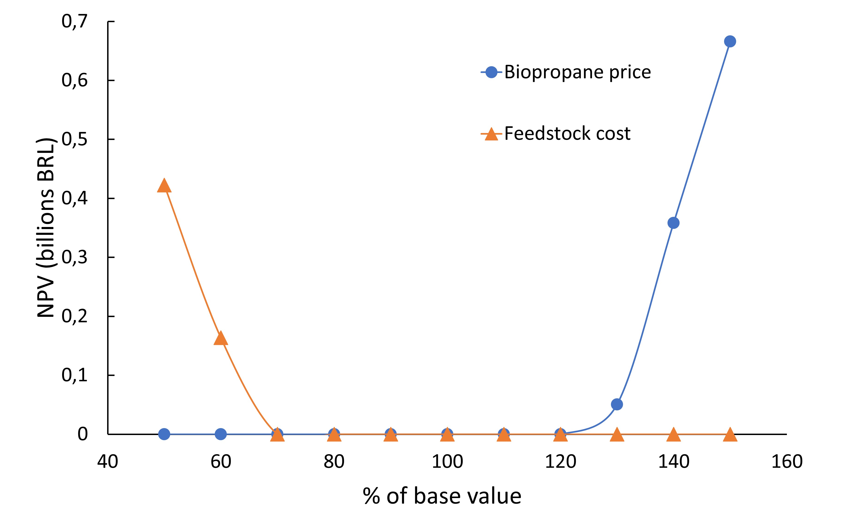
Figure 2: NPV dependence in variation of biopropane price and feedstock costs
For the current prices of all the feedstocks, products, capital and operational costs, the supply chain evaluated was not feasible. However, when the biopropane selling prices increase, from 130 % in relation to the base value, the NPV of the networks exceed 50 million reais. Observing the results for the variation in feedstock costs only, the project became feasible when the feedstock costs are lower than 60 % of the base value, presenting the significant influence of the raw materials on biofuel prices. For transportation costs, a sensitivity analysis was realized, but even for costs lower than 50 % of the base value, the projects were not viable and the results were not included in the figure. Although variations in biopropane prices and feedstock costs had a major impact on NPV, the technology route selected, as result of the optimization, was the same for all scenarios: glycerin dehydration. Considering the scenario of the current prices and the biopropane selling price representing 130 % of the base value, the NPV breakdown of the optimized network is presented in Figure 3.
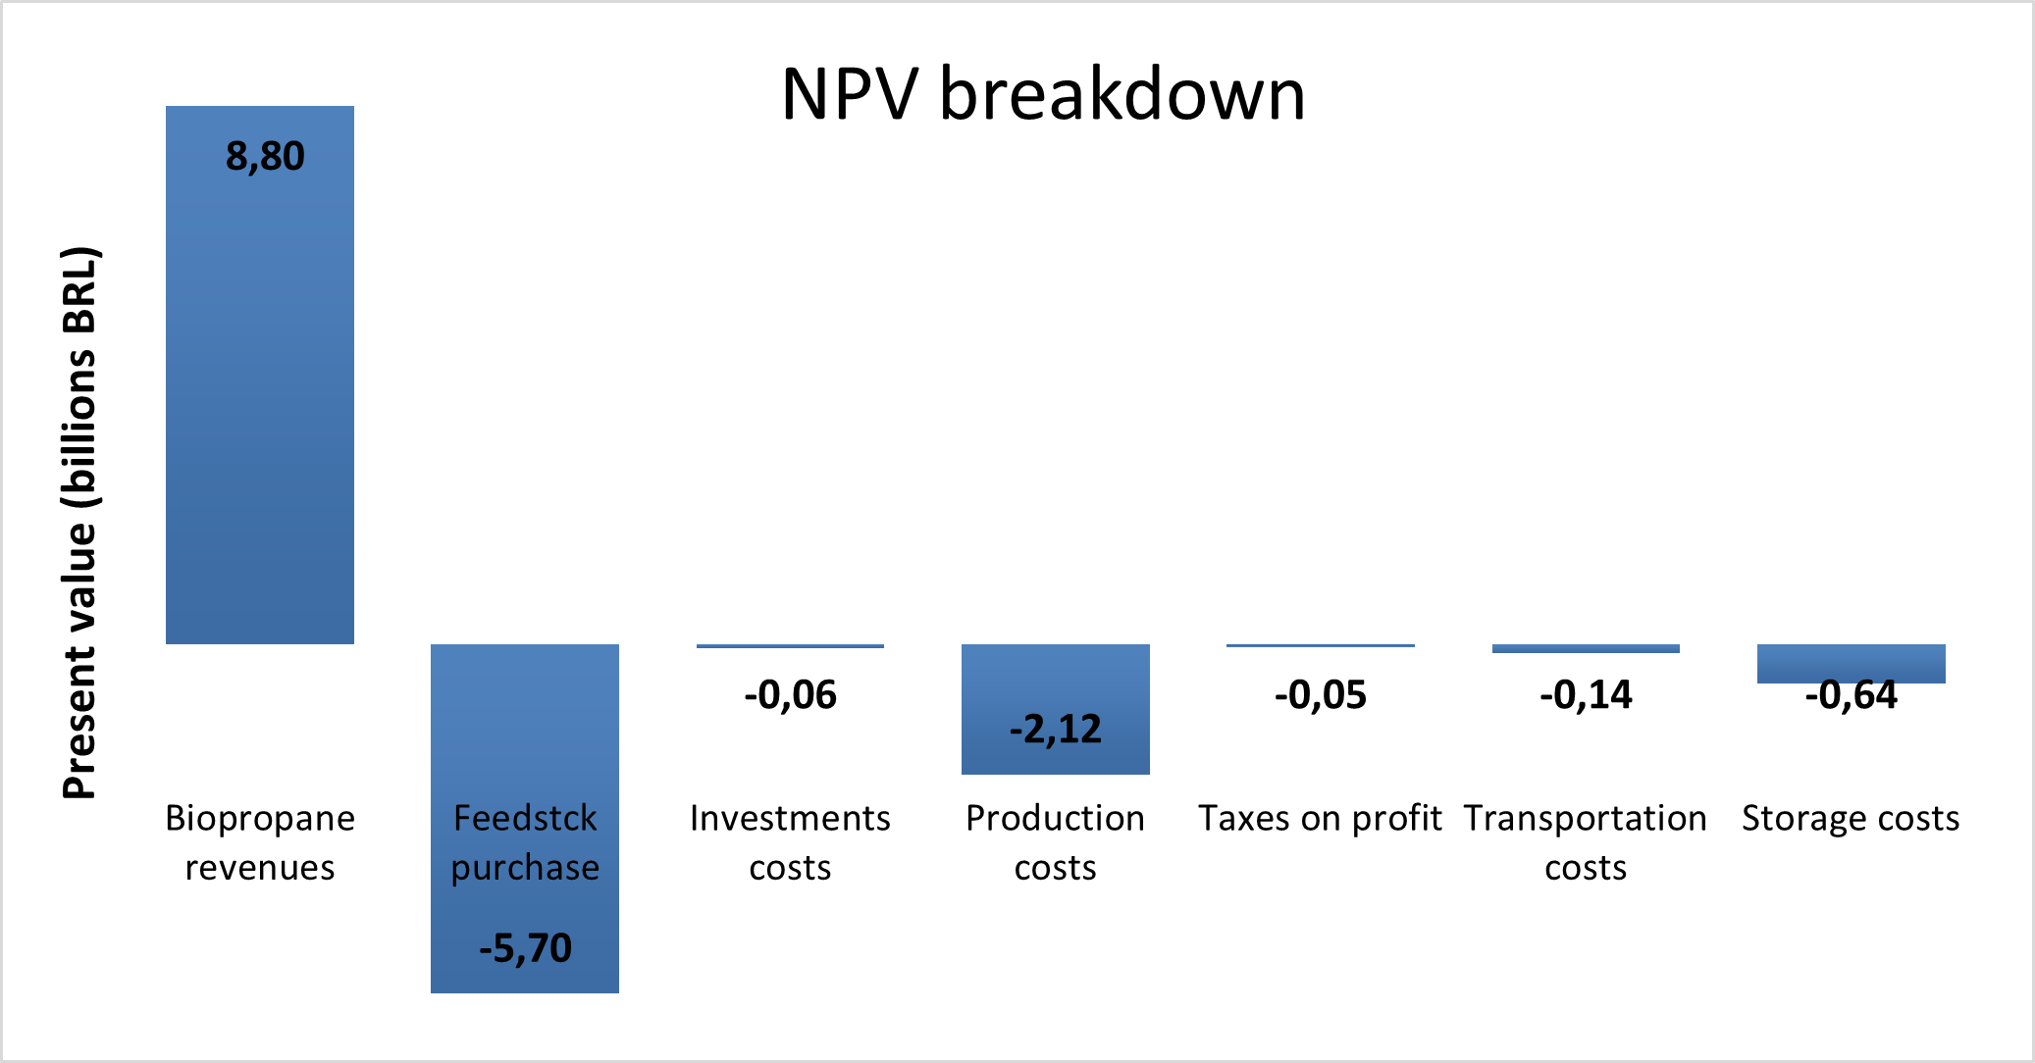
Figure 3: NPV breakdown for the scenario of biopropane selling price of 130 % of the base value, and glycerin dehydration conversion route as a result of the optimization
The feedstock purchase, for the glycerin dehydration technology chosen by the optimization, is the major negative factor of the NPV for the scenario; this is due to the relatively low yield of the process. The optimized network presented the installation of 2 production facilities, both using the dehydration of glycerin as conversion technology. Although this conversion route has the highest biopropane yield when compared to hydrogenation and gasification: 30 % in mass of biopropane (Johnson, 2019), large quantities of feedstock are still needed to supply the demand. Besides the dehydration product yield, the glycerin costs are lower than the oilseed costs (feedstock for the hydrogenation route), making the dehydration route more attractive than the hydrogenation, even considering the profits from the sale of green diesel, the main product of the conversion by the hydrogenation route. When comparing the dehydration to the gasification, although the raw materials are cheaper than the glycerin, the biopropane yield is lower, close to 1 %, making the process unfeasible. The production costs are the second negative portion of the NPV, and represent the electricity, hot and cold utilities and hydrogen purchases. The optimized network is shown in Figure 4, with the installation of 2 production centers (P), and 2 storage centers (S). The NPV of the network, considering a time horizon of 20 years, is 50.6 million reais.
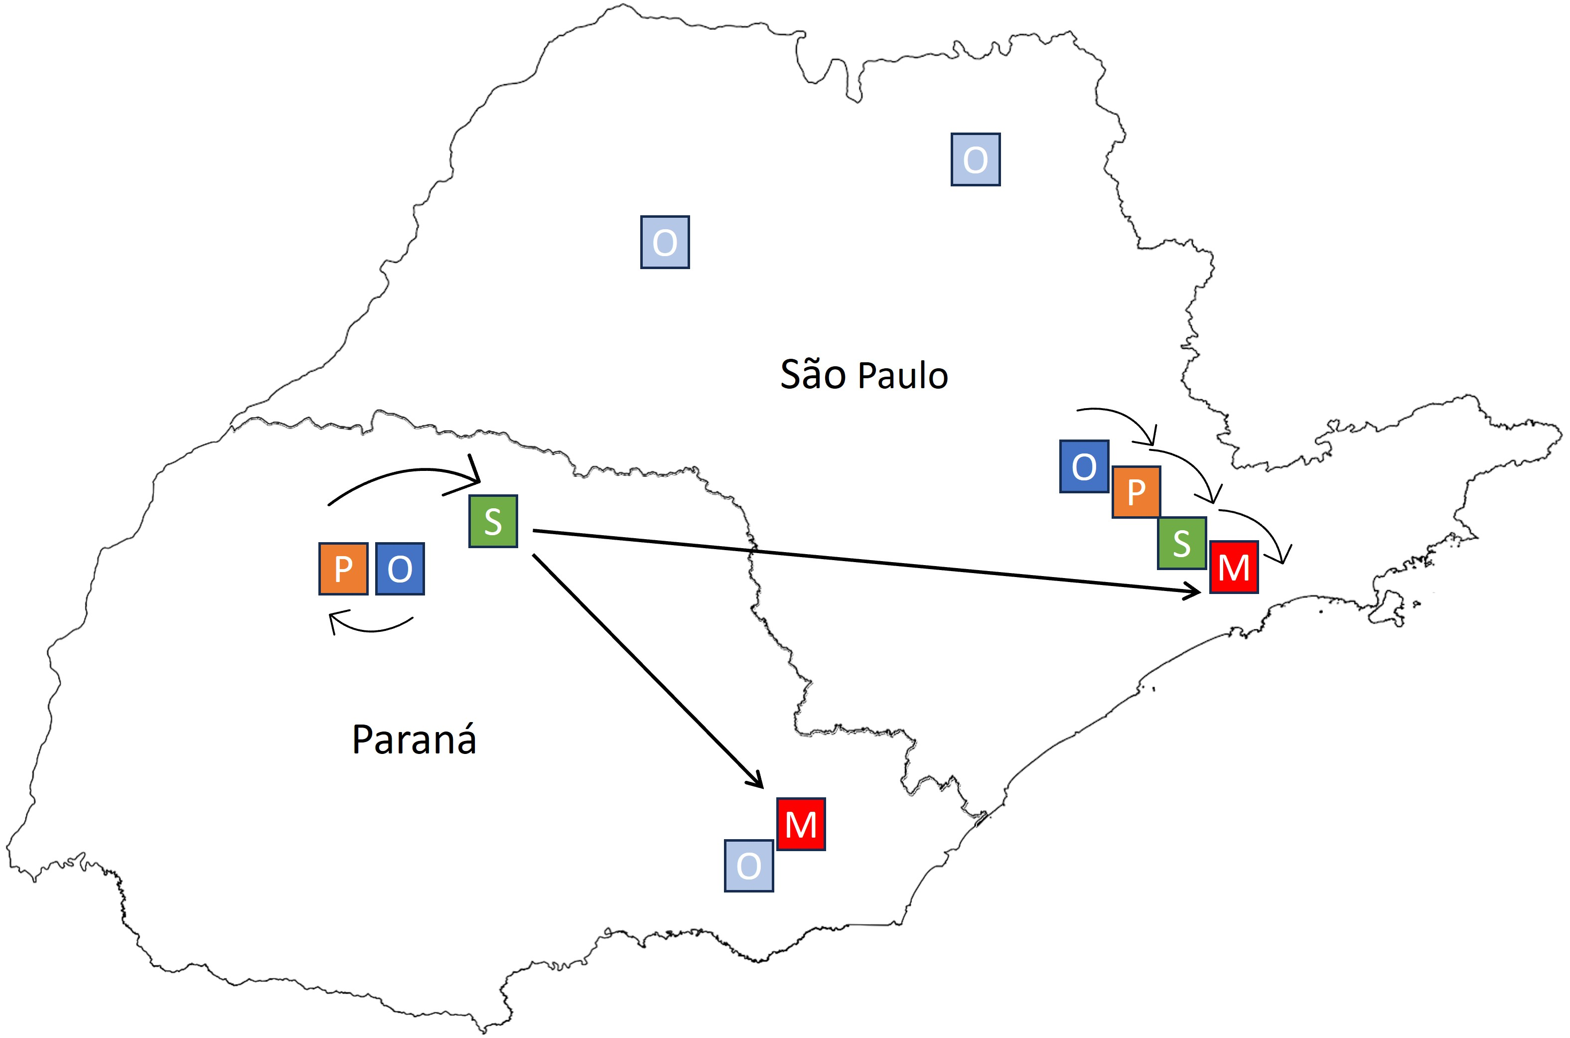
Figure 4: Optimized network for the biopropane production in São Paulo and Paraná (O: source location of feedstock purchased, P: production facility location, S: storage facility location, M: market location)
The feedstock origins (O) presented in Figure 4 are the locations where glycerin is available. The optimized network presented the production center (P) close to the location of feedstock (O) and the storage center (S), for both regions, minimizing transportation costs. The supply chain to meet the São Paulo demand receive biopropane from the Paraná storage center, instead of transporting the feedstock from distant locations or installing another production center inside the region. This occurs because the biopropane produced in São Paulo is insufficient to meet the local market, demanding the transportation from another region. Installing a new production facility is not feasible, since in the model a fixed maximum capacity and fixed investments were adopted, indicating that even installing a production facility that does not operate at the maximum capacity, the investment costs will represent an unnecessary charge. The taxes on product sales also influence the supply chain decision, as the product sales taxes between Paraná and São Paulo are lower than the internal sales taxes of each region, making the biopropane transportation from Paraná more advantageous than internal transportation in São Paulo.
  - Conclusions
A MILP optimization model was developed to evaluate the design of the biopropane supply chain in Brazil, considering factors such as feedstock availability, conversion technologies, storage, market demand, and associated costs. By applying the model to a case study in São Paulo and Paraná regions, the analysis demonstrates the impact of biopropane prices and feedstock costs on the NPV. The results showed the glycerin dehydration as the optimal conversion route, due to its higher biopropane yield compared to other technologies, and due to glycerin prices lower than the other materials. The optimized supply chain illustrates two production and storage centers, emphasizing proximity to feedstock sources and markets, demonstrating the intricate relationship between location decisions, taxes, and efficient supply chain management. As future works some points can be highlighted: expanding the feedstock availability and market demand to the whole country, evaluate the uncertainties associated with the model parameters and add the installed production capacity associated with a variable investment cost. The supply chain optimization model revealed that biofuel projects, such as biopropane production, can face financial challenges due to high production and logistics costs, despite its environmental advantages, highlighting the complexity of balancing economic strategic decisions when implementing biorefinery projects.
References
A. Kostin, D. H. Macowski, J. M. T. A. Pietrobelli, G. Guillén-Gosálbezc, L. Jiménez, M. A. S. S. Ravagnani, 2018, Optimization-based approach for maximizing profitability of bioethanol supply chain in Brazil, Computers and Chemical Engineering, 115, 121-132.
B. Tesfamichael, L. Montastruc, S. Negny, 2023, Developing a Comprehensive Decision Support Optimization Model for Biofuel Supply Chain. Computer Aided Chemical Engineering, 52, 3307-3312.
B. Theozzo, M. T. dos Santos, 2021, A MILP framework for optimal biorefinery design that accounts for forest biomass dynamics, Computers and Chemical Engineering, 146, 107201.
E. Johnson, 2019, Process Technologies and Projects for BioLPG, Energies, 12, 250.
EPE (Empresa de Pesquisa Energética), 2022, Estudos prospectivos sobre oferta, demanda, investimentos e o abastecimento de GLP no Brasil, Ministry of Mines and Energy. Available at: https://www.epe.gov.br/. Acessed in: 12 Jan. 2023.
Gurobi Optimization, LLC. Gurobi Optimizer Manual. 2023. Available at: https://www.gurobi.com. Accessed in: 28 Nov. 2023.
N. A. Menezes, I. L. C. Cunha, M. T. dos Santos, L. Kulay, 2022, Obtaining bioLPG via the HVO Route in Brazil: A Prospect Study Based on Life Cycle Assessment Approach, Sustainability, 14, 15734.

