Heterogenous electrolysis plants as enabler of efficient and flexible Power-to-X value chains

Michael Mocka*, Isabell Viedta, Hannes Langea, Leon Urbasa

aTU Dresden, Chair of Process Control System and Process Systems Engineering Group, Helmholtzstr. 14, 01069 Dresden, Germany

E-Mail: michael.mock@tu-dresden.de Abstract

Abstract

The Power-to-Ammonia (PtA) value chain is an important enabler of sector coupling and integration of renewable energy in the process industry. The PtA pathway typically uses   
90-96 % of the incoming fluctuating energy to produce green hydrogen using electrolyzer systems [1]. Hence to optimize the energy efficiency, flexibility, adaptability to fluctuating energy and cost of the PtA process, the correct choice of electrolysis technology is important. Each electrolysis technology has certain advantages and disadvantages in handling a fluctuating energy input [2]. The use of modular and heterogenous electrolysis systems, consisting of different types and sizes of electrolyzers, can utilize these advantages while counteracting the disadvantages. The project eModule researches a possible transfer of modular plant concepts, defined in the VDI/VDE/NAMUR 2776 standard for the process industry, to enable a fast, efficient, and flexible scale-up of electrolyzer systems.

For that purpose, this paper evaluates different modular electrolyzer configurations in a flexible PtA value chain. A monolithic electrolyzer configuration, consisting of electrolyzers of same size and technology, is simulated and used as a benchmark. Different heterogenous plant configurations and corresponding process control strategies for energy integration are created and simulated in MATLAB/Simulink. Metrics for energy efficiency, flexibility, and adaptability to fluctuating energy input are defined and compared. It is shown that the use of modular heterogenous electrolyzer systems enable a more efficient green hydrogen and ammonia production, while making the system more flexible and adaptable to a fluctuating energy input. The advantages of using modular heterogenous electrolyzer configurations in the PtA value chain are quantified, and upcoming techno-economic evaluations can show the economic potential of such plants.

**Keywords**: Power-to-X (PtX), Power-to-Ammonia (PtA), Heterogenous electrolysis, Co-simulation, Modular plants

* 1. Motivation

In the efforts to counteract climate change, the production of low-emission hydrogen has emerged as a key technology. This can enable sector coupling, increase energy security, and support the decarbonization of process chains that cannot be electrified. For the chemical process industry, the production of green hydrogen by coupling renewable energy with water electrolysis systems enables the direct integration of fluctuating energy into value chains, currently depending on fossil fuels. One example of such a value chain is the global ammonia production, having used around 60 % of the 53 Mt of industrial hydrogen in 2022, based mostly on fossil fuels [3].

To improve the alternative production route of the Power-to-Ammonia (PtA) value chain, electrolysis systems for green hydrogen production must become more efficient and flexible. Around 90 – 96 % of incoming fluctuating energy in the PtA process are typically consumed during the production of green hydrogen [1]. Improvements to the electrolysis systems therefore have a major impact on the overall consumption of the process chain. The use of the modular plant concepts, defined in the VDI 2776 and VDI/VDE/NAMUR 2658 standard for the process industry, might offer advantages for efficiency, flexibility, and adaptability to fluctuating energy. Project eModule researches the transfer of this concept for electrolysis systems. The different electrolysis technologies have certain advantages and disadvantages in handling a fluctuating energy input, which might be combined through use of modularization [2].

* 1. Methods

This paper researches the potential use of modular, heterogeneous electrolysis plants. Different electrolyzer configurations with identical nominal power input and varying technology combinations are proposed. The technologies under consideration are the alkaline electrolysis (AEL), the proton exchange membrane electrolysis (PEMEL) and the high temperature electrolysis (HTEL). Metrics for specific energy consumption, system efficiency and flexibility are defined to compare the heterogenous configurations and a benchmark configuration with a single electrolyzer technology. The resulting metrics are calculated and compared for two energy input scenarios. The potential of each heterogenous electrolyzer configuration for the use in a flexible PtA value chain is evaluated. Furthermore, the ability to follow the incoming energy fluctuations and the ability to provide the necessary hydrogen for a flexible ammonia synthesis loop is examined.

* + 1. Heterogenous electrolyzer configurations in PtA value chains

The Power-to-Ammonia value chain is represented by a Haber-Bosch synthesis loop, connected to the electrolyzer configurations. An ammonia production of 5000 ${kg}/h$  is set as a nominal production, which amounts to a necessary hydrogen feed of around 980 ${kg}/h$  at nominal load. Furthermore the ammonia synthesis loop can be operated flexibly down to 20 % of nominal production capacity with a load change rate of 20 $\%/h$  [4]. To reach the necessary hydrogen production the electrolyzer configurations are set to an estimated necessary power of 55 MW. The distribution of this power to different technologies is approximated from work on hybrid electrolysis for green steel production and the resulting configurations are collected in Table 1 [5].

Table 1: Electrolyzer configurations with respective power per electrolyzer technology

|  |  |  |  |  |
| --- | --- | --- | --- | --- |
|  | *Unit* | AEL | PEMEL | HTEL |
| Benchmark Configuration | *MW* | 55 | 0 | 0 |
| Configuration 1 | *MW* | 22 | 33 | 0 |
| Configuration 2 | *MW* | 33 | 0 | 22 |
| Configuration 3 | *MW* | 0 | 33 | 22 |

* + 1. Definition of metrics

The energy efficiency of the different configurations for the simulated scenario can be defined by the specific energy consumption of the system in ${kWh}/{{Nm}_{H_{2}}^{3}}$, in Eq. (1):

|  |  |
| --- | --- |
| $$E_{spec,sys} = \frac{P_{cons}}{V_{H_{2},prod}}$$ | (1) |

with $P_{cons}$ as the electrical power consumption in $kWh$ and $V_{H_{2},prod}$ as the produced hydrogen flow in ${Nm}^{3}$ over the simulated time.

Using the specific energy consumption, the system energy efficiency in % can be calculated in relation to the lower heating value of H2 (.), according to Eq. (2):

|  |  |
| --- | --- |
| $$η_{sys} = 100 \% ∙ \frac{{LHV}_{H_{2}}}{E_{spec,sys}}$$ | (2) |

Flexibility parameters of electrolyzer technologies, identified and collected by Lange et al., are used to calculate the Expected Unserved Flexible Energy ($EUFE$) of a portfolio of flexible energy resources, adapted from Gussain et al. [2, 6]. Further parameters for high temperature electrolysis have been adapted from Posdziech et al. [7].

The EUFE sums up the absolute difference between the wanted power input and the realizable power consumption of the system in $kWh$, according to Eq. (3).

|  |  |
| --- | --- |
|  | (3) |

* 1. Implementation

The defined configurations are simulated in MATLAB/Simulink using existing dynamic models. The models are based on available literature and evaluated by comparing the simulated output with given information on manufacturer data sheets. The efficiency metrics are calculated in MATLAB/Simulink, using the simulated energy consumption and hydrogen production. The implemented parameters used for the flexibility calculation are collected in Table 2. It is assumed, that the system is already heated and producing, so heat ramp-up and start‑up times can be neglected.

Table 2: Flexibility parameters of electrolysis technologies adapted from [2, 7]

|  |  |  |  |  |
| --- | --- | --- | --- | --- |
|  | *Unit* | AEL | PEMEL | HTEL |
| Load Flexibility | *%* | 20 – 100 | 0 – 160 | 50 – 125 |
| Load gradient, start-up | *%/s* | 10 | 10 | 0,1 |
| Load gradient shut-down | *%/s* | 10 | 40,6 | 3 |

Within the technologies, all electrolyzers are operated at the same load, to prevent feed maldistribution. When a load change occurs, all available electrolyzers start-up with their respective load gradient. A hierarchical system has been implemented, designating which technology shall preferentially receive the power in case of partial load. HTEL is preferred to take most of the wanted load and to run as a base load. AEL is secondly favored, while PEMEL will be shut down first, if the entire capacity is not needed. Furthermore, if overcapacity is used, the system will automatically lower the load to nominal capacity, while other technologies ramp-up. This approach ensures that no electrolyzer remains in overcapacity for extended periods, contributing to a reduction in degradation.

Two energy input scenarios are simulated, shown in Figure 1. Scenario A changes the input in 15-minute steps in line with the resolution of available energy in the German energy market [8]. The power plateaus are selected in such a way that the following scenarios during the electrolyzer operation are covered, while the results are still comparable:

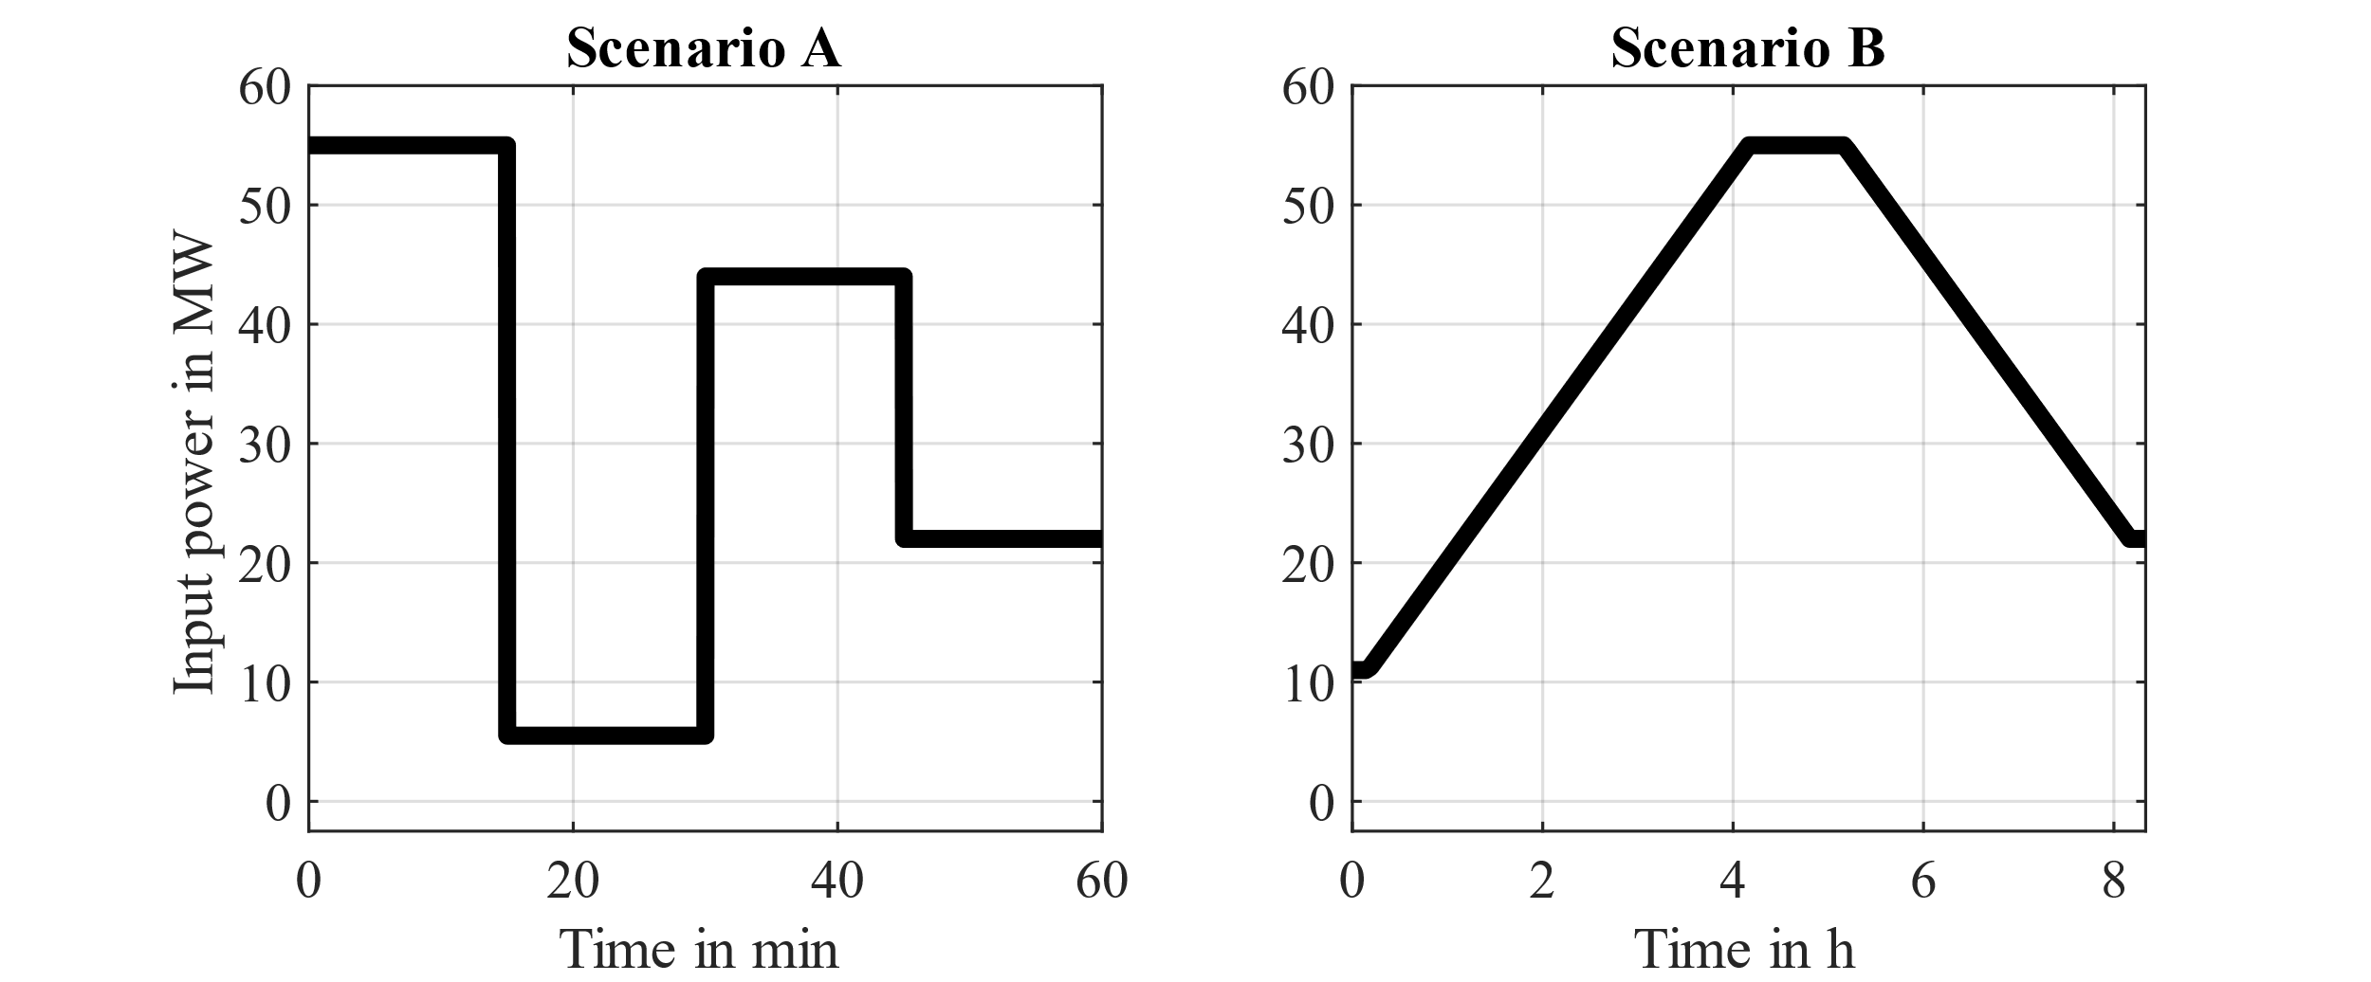  
Figure 1: Simulated power input scenarios

* Ramp-up to full load & to partial load
* Ramp-down to achievable partial load & to unachievable partial load
* Ramp-up and ramp-down at 20 $\%/h$   to follow the load change rate of the ammonia synthesis loop (Scenario B)
  1. Results

The achievable flexibility margins of the chosen scenarios are shown in Figure 2. The benchmark configuration and configuration 2 have limitations in their available power range due to the minimum load of the AEL and HTEL technologies. Configurations 1 and 3 can achieve the entire necessary load range and beyond due to the high range of the used PEMEL.

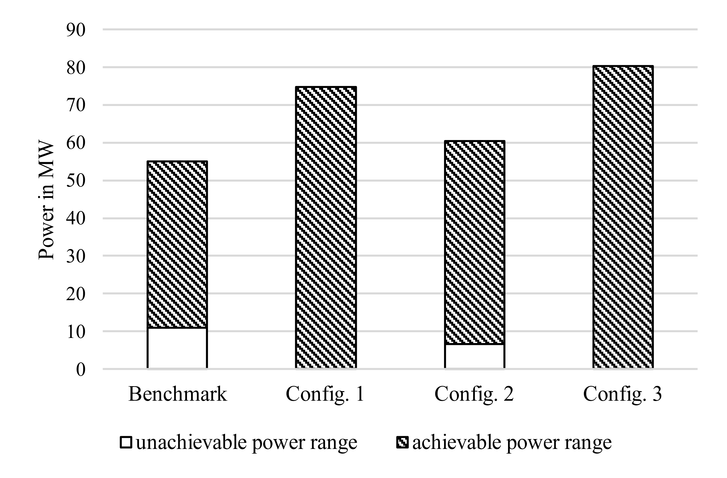  
Figure 2: Flexibility margins with achievable and unachievable power ranges

The calculated efficiencies are compiled in Table 3, alongside the EUFE values corresponding to the simulated energy input scenarios. Configuration 2 has the highest efficiency at 72,46 % vs. LHV, followed by configuration 3 with 71.43 % vs. LHV. This is primarily attributed to the utilization of HTEL electrolyzers, which have a comparably low specific energy consumption if a high temperature feed is available. The benchmark configuration and configuration 1 also exhibit similar efficiencies, with 66,67 % vs. LHV for the benchmark and 65,8 % vs. LHV for configuration 1.

The EUFE values for scenario A vary strongly between the configurations. Configurations 1 and 3 show similar EUFE values at around 200 kWh, which are mainly contributed during initial start-up. The benchmark configuration and configuration 1 show much larger values. This is due to the unachievable partial load, which cannot be reached and therefore adds to the EUFE. Configuration 2 has the highest EUFE value at 5309 kWh, much larger than the rest. In comparison to the benchmark configuration, this happens because of the low ramp-up rate of the HTEL, which cannot be counteracted by the AEL. Configuration 3, which also must deal with the slow ramp‑up of the HTEL, can reduce the EUFE value by using the PEMELs overload capacity to reach the necessary power quickly and reducing the input power of the PEMEL gradually, while the HTEL is still ramping up.

Scenario B shows similar and much lower EUFE values along all configurations. Configurations 2 and 3 share the same value, because no overload capacity is needed for the ramp-up rate of the ammonia synthesis loop and the lower load limit is always reached. The benchmark configuration and configuration 1 show slightly higher EUFE values. This is identified as a slight overshooting of the power consumption due to the high load change rates, compared to the HTEL in configurations 2 and 3. If the simulation and the control strategies are operated at a higher resolution, this value will further be reduced.

Table 3: Resulting efficiency metrics for the configurations and EUFE for input scenario A & B

|  |  |  |  |  |  |
| --- | --- | --- | --- | --- | --- |
|  | *Unit* | Benchmark | Config. 1 | Config. 2 | Config. 3 |
| $$E_{spec,sys}$$ | $$\frac{kWh}{{Nm}_{H_{2}}^{3}}$$ | 4,5 | 4,56 | 4,14 | 4,2 |
| $$η_{sys}$$ | $$\%$$ | 66,67 | 65,8 | 72,46 | 71,43 |
| $$EUFE A$$ | $$kWh$$ | 1561 | 172 | 5309 | 243 |
| $$EUFE B$$ | $$kWh$$ | 172 | 121 | 67 | 67 |

In conclusion the combination of technologies can enhance the efficiency of electrolyzer systems while also providing a high range of flexibility. The right choice of technology and power distribution strategy is particularly important if a flexible system with sudden changes in energy input and low load operation is needed.

* 1. Discussion & Outlook

The presented results provide initial insights into the benefits of heterogeneous electrolysis systems for efficiency and flexibility of PtX value chains. However, further investigations are necessary to demonstrate the manageability of the overall system and the economic possibilities. Advanced metrics to demonstrate the flexibility of the overall system beyond energy consumption must be defined.

The defined scenarios and calculated flexibility margins in Figure 2 do not fully grasp the technological limitations and possibilities in their entirety yet. The use of HTEL electrolyzers is only feasible, if a high temperature feed is available. In case of the PtA process chain, process energy is available but the possible capacity of HTEL must be adjusted to the size of the ammonia synthesis loop.

Furthermore, overload capacity can be used in some electrolyzer systems but is often limited in frequency and duration to prevent degradation. Additionally, instead of controlling all electrolyzers in one technology with the same power input, single stack control can reduce the load range, by shutting down single electrolyzers instead of electrolyzer groups.

For upcoming work more sophisticated power control strategies and process control strategies of combined electrolyzer systems shall be developed, implemented, and tested. The initial setup and power distribution of heterogenous electrolyzer plants shall be optimized and include the available high temperature feed of follow-up processes. Beyond that, economic optimizations of electrolyzer systems shall be considered.

New methods and metrics to include the inherent dynamics of different electrolyzer technologies into the efficiency and flexibility calculation shall also be developed, implemented, and tested. The first steps of developing the necessary dynamic process models for all electrolyzer technologies are already on-going and suitable process control strategies for distributed electrolysis systems are in preparation.

**Acknowledgments**:  
We would like to thank the German Federal Ministry of Education and Research and the project management organization Jülich for their financial support within the framework of the eModule research project (FKZ 03HY116A) of the H2Giga lead platform. Furthermore, the P2O-Lab of the Technical University of Dresden is thanked for its support.

References

[1] K. H. Rouwenhorst, A. G. Van der Ham, G. Mul, and S. R. Kersten, “Islanded ammonia power systems: Technology review & conceptual process design,” *Renew. Sustain. Energy Rev.*, vol. 114, p. 109339, 2019.

[2] H. Lange, A. Klose, W. Lippmann, and L. Urbas, “Technical evaluation of the flexibility of water electrolysis systems to increase energy flexibility: A review,” *Int. J. Hydrog. Energy*, vol. 48, no. 42, pp. 15771–15783, May 2023, doi: 10.1016/j.ijhydene.2023.01.044.

[3] I. International Energy Agency, “Global Hydrogen Review 2023,” 2023, doi: https://www.iea.org/reports/global-hydrogen-review-2023.

[4] M. Mock, H. Lange, I. Viedt, K. R. Gopa, J. Mädler, and L. Urbas, “Dynamic operation for the effective use of green hydrogen in Power-to-X value chains,” in *33rd European Symposium on Computer Aided Process Engineering*, vol. 52, A. C. Kokossis, M. C. Georgiadis, and E. Pistikopoulos, Eds., in Computer Aided Chemical Engineering, vol. 52. , Elsevier, 2023, pp. 1267–1272. doi: https://doi.org/10.1016/B978-0-443-15274-0.50202-X.

[5] Sunfire GmbH, “Hybrid Electrolysis for green steel production: Increasing efficiency in integrated steel works.” Mar. 2022. [Online]. Available: https://dwv-info.de/them enbroschueren/hybrid-electrolysis-for-green-steel-production/

[6] D. Gusain, M. Cvetković, and P. Palensky, “Quantification of operational flexibility from a portfolio of flexible energy resources,” *Int. J. Electr. Power Energy Syst.*, vol. 141, p. 107466, Oct. 2022, doi: 10.1016/j.ijepes.2021.107466.

[7] O. Posdziech, K. Schwarze, and J. Brabandt, “Efficient hydrogen production for industry and electricity storage via high-temperature electrolysis,” *Int. J. Hydrog. Energy*, vol. 44, no. 35, pp. 19089–19101, Jul. 2019, doi: 10.1016/j.ijhydene.2018.05.169.

[8] “Stromerzeugung und -verbrauch in Deutschland - SMARD Strommarktdaten.” [Online]. Available: https://www.smard.de/home