DAF Turbidity Removal Dynamics Model Employing LSTM Networks with Monte Carlo Dropout

ªUniversity of Campinas, Cidade Universitária Zeferino Vaz Av. Albert Einstein, 500, Zipcode 13083-852, Campinas-SP, Brazil
flaviovs@unicamp.br
Abstract
Dissolved Air Flotation (DAF), a well-established technology, is still not fully comprehended despite its longstanding use. The complex nature of DAF limits deterministic model development, impeding optimization endeavors. This study explores an alternative approach by leveraging deep learning algorithms, specifically Long Short-Term Memory networks (LSTMs). LSTMs, proficient at discerning intricate time-series patterns from extensive datasets, are employed to construct empirical models for turbidity removal in a laboratory-scale DAF prototype. Additionally, a Bayesian approximation using Monte Carlo Dropout (MCD) is introduced to gauge uncertainty derived from information gaps in the database. The results showed that MCD-LSTM can predict the overall dynamics with errors within ±0.7 and ±1.3 Nephelometric Turbidity Units (NTU) for training and test datasets, respectively. The prediction errors for unseen data hinted at the potential for inference enhancement by incorporating new input variables.
Keywords: dissolved air flotation, long short-term memory, Monte Carlo Dropout.
  - Introduction
Water, crucial for human development, exists worldwide in diverse forms. Despite its apparent abundance, only about 3% of Earth's water has low dissolved solids, suitable for consumption and industry. Additionally, only 13% of fresh water is readily available in aquifers, rivers, and lakes, while most are locked in glaciers. This scarcity amplifies the significance of accessible water resources (Glantz, 2018).

Regulatory agencies in each country propose diverse regulations to maintain potability standards and mitigate potential adverse effects from water consumption. These regulations specify the responsibilities of handling the water supply and set acceptable standards for biological, chemical, and physical parameters.

In terms of physical aspects, the primary variable under analysis is turbidity, characterized as an indirect measure of the concentration of colloidal or suspended particles in the fluid. Turbidity can influence the optical and organoleptic aspects of water, the development of gastrointestinal diseases (Morris et al., 1996; Schwartz, 2000), setbacks in the final quality of products in industrial processes, and potential equipment deterioration. Thus, efficient separation techniques are essential to mitigate these possible problems.

One promising separation method is dissolved air flotation (DAF), a technology known for several decades with records dating back to the 1960s in Finnish clarification units. Although it has been employed for a long time, a comprehensive description of the phenomena involved in DAF is still not entirely understood. Various theories have been proposed (Edzwald, 1995; Fukushi et al., 1995), but the complexity of the system hinders the attainment of deterministic models that are easily applicable. Simulations based on computational fluid dynamics (CFD) have been proposed with great results (Rodrigues and Béttega, 2018; Rybachuk and Jodłowski, 2019). However, they demand high computational effort and time, hindering potential optimization projects and implementation of model-based automatic process control strategies.

Given this impasse, empirical modeling employing deep learning emerges as a potential alternative for constructing a mathematical model capable of representing the FAD process due to the greater ease of obtaining experimental data on important operational parameters. However, few studies have been developed within this paradigm (Souza et al., 2021), indicating a promising research area.

In this work, we aim to investigate the performance of Long Short-Term Memory networks (LSTMs), architectures developed to learn intricate time-series patterns from a large volume of data, to model DAF dynamics. Furthermore, a Bayesian approximation using Monte Carlo Dropout (MCD) was introduced to quantify uncertainty from the lack of information from the whole state space. These algorithms were utilized to determine empirical models for turbidity removal in a DAF prototype at a laboratory scale.
  - Materials and Methods
    - DAF prototype
Figure 1 depicts the DAF prototype developed in the Laboratory of Chemical Systems Engineering (LESQ) at the Chemical Engineering Faculty, University of Campinas, Brazil. This pilot plant was utilized in this work to gather data on the dynamics of turbidity removal under different inlet flows, inlet turbidity, saturation pressure, and recycle flow. The operational range of these variables is detailed in Table 1.

The raw effluent is initially introduced into the coagulation/flocculation tank for pretreatment. It is then transferred to the flotation tank, where it combines with the recycle flow containing microbubbles generated by the needle valve. This stream is regulated by an automated stepper motor, adjusting the valve according to the desired flow rate. Part of the clarified water is diverted to a sand filter and redirected to the saturation tank. This vessel promotes high-pressure air saturation of the water used in the recycle flow.
Table 1 - Input variables value investigation space.
Variable | Range | Unit
Inlet flow | 1.1 - 1.6 | L/min
Inlet turbidity | 15.2 - 40.4 | NTU
Saturation pressure | 3.5 - 6.0 | bar
Recycle flow | 0.25 - 0.36 | L/min
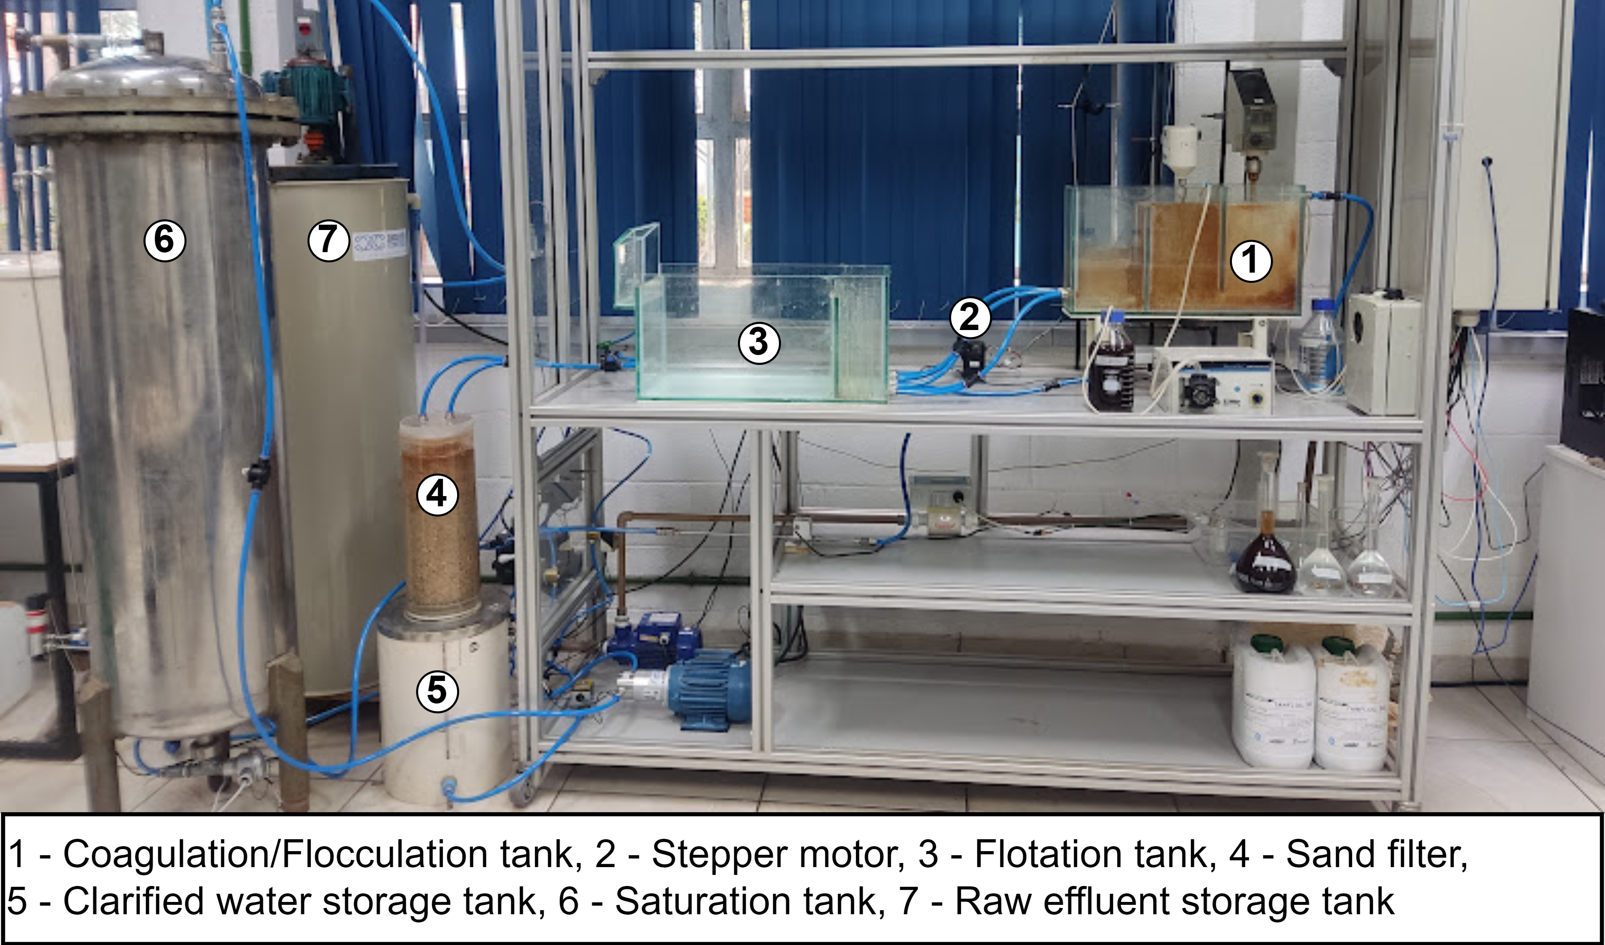
Figure 1 - DAF prototype
The raw effluent was synthesized using red latosol soil, a prevalent type of clay found in São Paulo/Brazil, replicating typical conditions in water treatment facilities. In the physical-chemical stage, sodium aluminate 1% (v/v) and tannin SG 5% (v/v) solutions were employed to neutralize the charged suspended particles and to promote the formation of larger flocs for subsequent separation in the flotation tank. Jar tests determined the flow rates of these solutions for a 21 NTU sample, the mean value of most experimental runs.
The data acquisition rate of the SCADA system was configured at 1 s. However, due to the sluggish system dynamics, the data employed in the models were discretized into 1-minute intervals, using an average of 60 samples to determine the values of all variables. The entire database spanned 38 hours, containing a total of 2,280 data points.
    - Development of the MCD-LSTM networks

Python was used to build the MCD-LSTM models using Tensorflow and Keras functional API. The latter enables the inclusion of the dropout layer during the inference phase. The selected input variables for the models include inlet flow, inlet turbidity, recycle flow, pressure, temperature of the recycle stream, water level in the saturation tank, and outlet turbidity in previous timesteps. The target output was the outlet turbidity in future steps.

The database was normalized between -1 and 1 to avoid biased models, and it was sequentially split into training and test datasets using a 4/1 proportion, respectively. The loss function employed for the optimization stage was selected as the mean squared error.

In this study, the periods of the input variables ranged from 1 to 10 min, while the output time series ranged from 1 to 5 min. For each temporal pair, 250 models were trained using Optuna, an easy-to-use hyperparameter optimization framework for automating the search process. The successive halving pruning method was employed to suppress suboptimal configurations and early-stopping with zero-improvement threshold and 10-fails tolerance to halt the training stage when overfitting was detected. The selected search space for the hyperparameters is summarized in Table 2.

According to Gal and Ghahramani (2015), using dropout regularization in deep neural networks during both training and inference steps allows for an interpretation resembling a Bayesian approximation termed MCD. This method involves deriving mean estimates and predictive uncertainty through k stochastic forward passes, conducted concurrently to minimize computational time effectively. This study employed a hundred forward passes to calculate the quantities mentioned above.
Table 2 - Search space for hyperparameters using the Optuna optimization framework.
Variable | Range
Neurons | 7-700
Dropout rate | 0.1-0.5
Learning rate | 10⁻⁷-10⁻²
L1 | 10⁻⁵-10⁻¹
L2 | 10⁻⁵-10⁻¹
  - Results and Discussions
The best-performing MCD-LSTM network explored in this study was comprised of 165 neurons, a 45.8% dropout rate, L1 and L2 norms set at 1.1∙10⁻⁵ and 9.2∙10⁻⁵ respectively, an initial learning rate of 8.5∙10⁻³, and utilized two previous data samples to predict a single future step. The results highlighted increasing errors as more extended frame data was used. Moreover, similar trends were observed for models forecasting over longer prediction horizons.
The dropout rate of 45.8% potentially indicates over-parametrization, a concern that can impact the model's generalization capabilities. To address this issue, we implemented the optimization framework Optuna as a measure to mitigate the potential effects of over-parametrization. However, it is important to note that despite employing Optuna, complete immunity from the impact of over-parametrization cannot be guaranteed.
The determination of an appropriate dropout rate lacks a universal guideline, but pertinent literature often recommends values ranging from 0.3 to 0.5 for complex tasks. Srivastava et al (2014) highlighted that a dropout rate of 0.5 appears to approach optimality across a diverse spectrum of networks and tasks.
Figure 2 illustrates the predictions using the training dataset. It is noticed that there is a high correlation between the predicted and the real data, and this is within the uncertainty boundaries for most of the prediction horizon. The most significant errors and uncertainty boundaries occurred in transition points between experimental runs, corresponding to drastic changes in the input conditions that can carry uncorrelated information within the recurrent layers. Excluding these points, the trained data error was approximately ±0.7 NTU. Thus, the trained model could predict the outlet turbidity within reasonable errors, indicating a good training phase.

Figure 3 shows the generalization performance using the test dataset. The predictions for unseen data captured the overall dynamics trend, but they were slightly off for most of the runs, even when the uncertainty boundaries were considered. Similar to the training stage, the most significant errors were calculated during the changes between experimental runs and reached an absolute maximum of 2.8 NTU. Excluding the transitions between runs, the test errors were within ±1.3 NTU, considerably higher than the training errors. A similar trend was observed by Souza et al (2021) in which the generalization test for their DAF prototype model using sliding window and feedforward neural networks was 2.5 times greater than the training errors.
 | 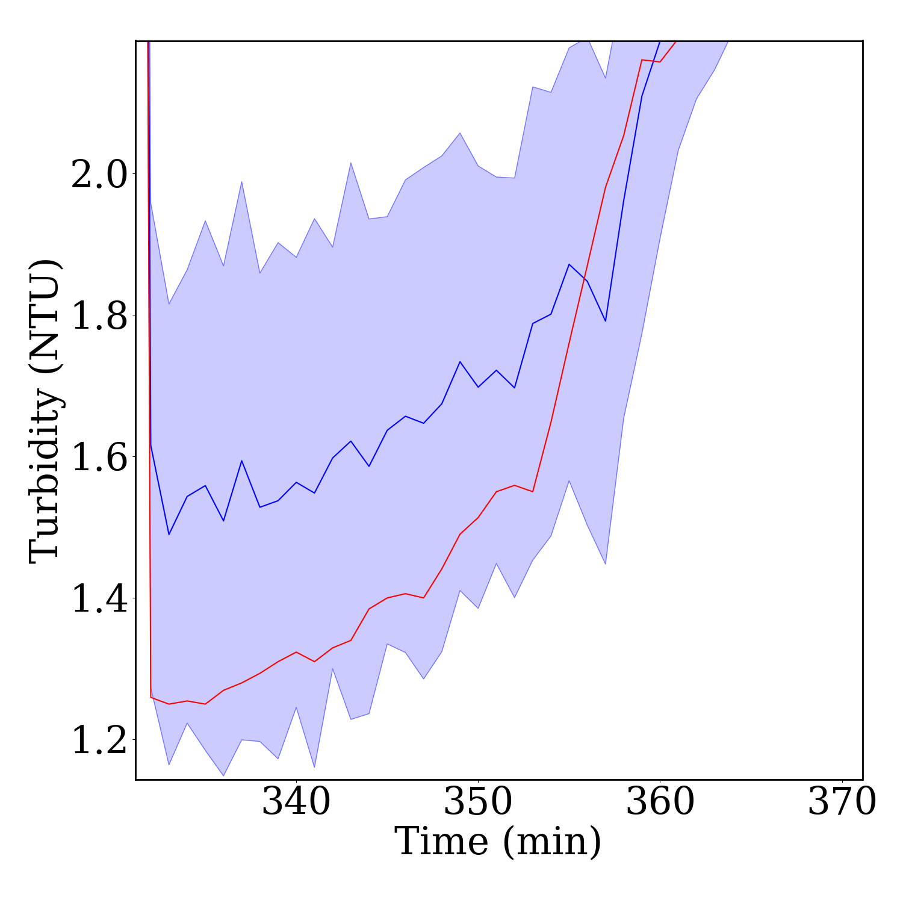
- Whole training dataset | - Zoom
Figure 2 - Predictions of MCD-LSTM using the training dataset.
- Whole test dataset | - Zoom
Figure 3 - Predictions of the MCD-LSTM model using the test dataset.
Although the results were worse than expected, it illustrates that MCD-LSTM forecasts the data dynamics. This observation could indicate that some important input variables for the process, such as post-flocculation pH and treatment-solutions flow rates, could be introduced into the model to aggregate more information about the previous stage, as well as optical information concerning the bubble concentration and size in the flotation tank.
  - Conclusions
The MCD-LSTM networks to predict turbidity removal in a DAF system revealed intriguing potential and limitations. The results showcased promising outcomes in capturing the overall dynamics of turbidity removal within the training dataset. However, the model exhibited higher prediction errors when faced with unseen data, indicating a need for additional input variables. The discrepancies in predictions suggested a potential avenue for enhancing predictive accuracy by enriching the model with more comprehensive input features. Despite the slightly suboptimal results in forecasting unseen data, MCD-LSTM could be viable for predicting complex DAF processes.
Acknowledgments
The authors thank the National Council for Scientific and Technological Development (CNPq) grant number 141165/2021-9.
References
J.K. Edzwald, 1995. Principles and applications of dissolved air flotation. Water Science and Technology 31. https://doi.org/10.1016/0273-1223(95)00200-7
K. Fukushi, N. Tambo, Y. Matsui, 1995. A kinetic model for dissolved air flotation in water and wastewater treatment. Water Science and Technology 31. https://doi.org/10.1016/0273-1223(95)00202-X
Y. Gal, Z. Ghahramani, 2015. Dropout as a Bayesian Approximation: Representing Model Uncertainty in Deep Learning.
M.H. Glantz, 2018. Water security in a changing climate, World Meteorological Organization.
R.D. Morris, E.N. Naumova, R. Levin, R.L. Munasinghe, 1996. Temporal variation in drinking water turbidity and diagnosed gastroenteritis in Milwaukee. American Journal of Public Health 86, 237–239. https://doi.org/10.2105/AJPH.86.2.237
J.P. Rodrigues, R. Béttega, 2018. Evaluation of multiphase CFD models for Dissolved Air Flotation (DAF) process. Colloids and Surfaces A: Physicochemical and Engineering Aspects 539, 116–123. https://doi.org/10.1016/j.colsurfa.2017.12.015
Y. Rybachuk, A. Jodłowski, 2019. Mathematical model of dissolved air flotation (DAF) based on impulse conservation law. SN Applied Sciences 1, 541. https://doi.org/10.1007/s42452-019-0560-y
J. Schwartz, 2000. Drinking water turbidity and gastrointestinal illness in the elderly of Philadelphia. Journal of Epidemiology & Community Health 54, 45–51. https://doi.org/10.1136/jech.54.1.45
A.C.O. Souza, N.L. Ferreira, F.V. Silva, 2021. Empirical modeling of turbidity removal in a dissolved air flotation system: application of artificial neural networks. Water Supply 21, 3946–3959. https://doi.org/10.2166/ws.2021.152
N. Srivastava, G. Hinton, A. Krizhevsky, I. Sutskever, R. Salakhutdinov, 2014. Dropout: A Simple Way to Prevent Neural Networks from Overfitting. Journal of Machine Learning Research 15, 1929–1958.

