Neural Ordinary Differential Equations Auto-Encoder for Fault Detection in Process Systems
Umang Goswami,ª Jyoti Rani,ª Hariprasad Kodamana^{a,b}
ªDepartment of Chemical Engineering, Indian Institute of Technology, Delhi-110016, India
^{b}Yardi School of Artificial Intelligence, Indian Institute of Technology, Delhi-110016, India
kodamana@iitd.ac.in
Abstract
With the advent of Industry 4.0, there has been a paradigm shift in the operations of the manufacturing and industrial sectors. The fourth Industrial revolution has compelled the industries to integrate Machine Learning with its core processes. Over the years, data-driven approaches have been a key contributor to the smooth functioning of a process plant. In the proposed work, Neural ordinary differential equations Auto-encoder being a special class of neural networks are utilized for fault detection. The proposed methodology consists of a neural network coupled with an ordinary differential equation solver. The neural network is used to parameterize the derivatives of the hidden states and results in a continuous transformation of the states. For time series processes, the methodology proves to be of greater use because of its inherent ability of extrapolating the values for a particular time step. The proposed methodology was validated for the Tennessee Estman process and yielded better results when compared to the different deep learning-based models used for time series predictions in LSTM and its variants, and machine learning framework such as Dynamic Principal Component Analysis (DPCA).

Keywords: Fault Detection, Neural ordinary differential equations Auto-Encoder, fault detection, Tennessee Eastman Process.
1. Introduction
The incorporation of Machine Learning into traditional methods has significantly enhanced the efficiency of the chemical process industries. This advancement has not only financially benefited manufacturing units but also emphasized the importance of health and safety for individuals, contributing to the seamless operation of process units. Machine Learning and Deep Learning techniques introduce data-driven strategies to address the challenges of non-linearity and non-Gaussian patterns in time-series data (Goswami et al, 2023). This adaptable approach ensures smoother operation of process systems and aids in identifying any deviations from normal patterns during plant operations.

Traditional neural network methodologies such as Auto-encoder, LSTM networks and Machine learning techniques such as the Principal Component Analysis (PCA) and Dynamic Principal Component Analysis (DPCA) have been extensively used by the researchers to identify the faults present in the process systems at their point of occurrence. This has also led to other algorithms based on graphs (Goswami et al, 2023), and forward-forward algorithms (Kumar et al, 2023) to step in to the domain of fault detection. The methods vary from each other and bring their own inherent characteristics to make the process run free of hindrances. Taking into account the work done by previous researchers, we have formulated a novel fault detection framework which instead of the traditional neural networks utilizes the Neural Ordinary Differential Equation Auto-encoder (NODEAE) at its core. Neural Ordinary Differential Equations (NODEs) are a special type of neural network framework which continuously parameterizes the hidden states of the neural network by deploying a differential equation solver. This parametrization of the hidden states helps NODE operate in a continuous depth manner which distinguishes it from the state-of-the art neural networks (Chen et al, 2018). Conceptually, NODEAE is an extension to the residual networks which take input and its transformation to the next layer. This brings in a continuity to the data transformation. NODEs leverage this idea and couple it with the differential equation solver to obtain the value at the subsequent time steps. NODEs are trained with adjoint sensitivity method providing them the ability of adaptive evaluation and viewing the overall neural network as an ordinary differential equation and the output obtained at the end is the solution of the ordinary differential equation. The schematic of the proposed workflow is shown in Figure 1.

The proposed study is structured as follows: NODEAE is discussed in detail in Section 2. The fault detection framework is defined in section 3 and Section 4 holds the results and discussions of the proposed study followed by conclusion in Section 5.

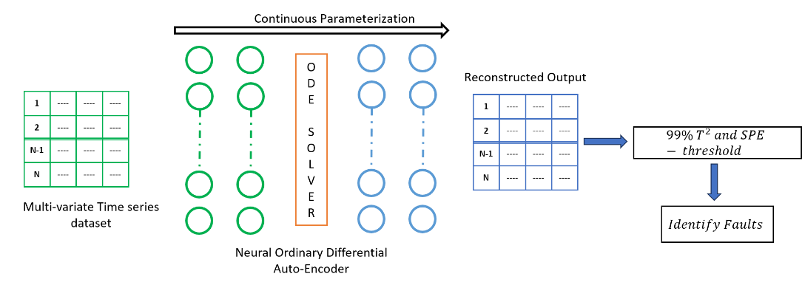
Figure 1: A schematic of the proposed workflow.

2. Neural Ordinary Differential Equation Auto-Encoder (NODEAE)
  - Mathematical Formulation
Throughout various industries, particularly in chemical processing, neural network-based algorithms have become integral tools for detecting faults and are applied in other fields as well. Neural networks are composed of interconnected models, featuring neurons organized into hidden layers. Here, the input is processed by being multiplied with the network's weights, yielding specific outputs. Building on traditional neural networks, residual networks introduce an innovation where not only the input is processed, but also its transformed version is carried forward to subsequent layers. This method, where input and its transformation are continuously added, forms a continuous function that closely aligns with numerical solutions similar to those derived from Euler's method.
An advanced development in this area is the integration of traditional neural networks with differential equation solvers. In NODEs, the derivatives produced by the network's hidden states are dynamically shaped by the differential equation solver. This integration allows for flexibility in choosing different differential solvers based on the application, including Euler’s method, the Runge-Kutta method, and the VODE solver. The choice of solver enables neural networks to effectively predict outcomes at various time steps. This predictive capability is particularly useful for data interpolation and extrapolation at specific points, enhancing the network's applicability and accuracy in complex modelling scenarios.
Residual Networks as discussed above form a base to the formation of the proposed NODEAE. Equation (1) throws light on the working of the encoder section of the proposed NODEAE method, where an input k(t) at time t is along with its transformation in $f\left(k_{t},w_{t}\right)$ is used calculate the output at the next time-step.
$$k_{t+1}=k\left(t\right)+f\left(k_{t},w_{t}\right) (1)$$
On adding, infinite number of layers to the network, the step size become infinitesimally small and thus can be modelled in continuous time domain as shown in equation (2), where $w$ represents the weights of the network and $\frac{dk(t)}{dt}$ represents the change of network activations $k$ with respect to time $t$.
$$\frac{dk(t)}{dt}=f(k\left(t\right),t,w) (2)$$
In the forward pass of the proposed model, the output $k(T)$ can be calculated by solving equation (3), where $T$ is equivalent to the number of discrete layers in a traditional neural network.
$$k\left(T\right)=k\left(0\right)+ \int_{t=0}^{T}{\frac{dk\left(t\right)}{dt}} \left(3\right)$$
On solving the forward pass equations, the latent features are extracted and are fed to the decoder section of the network, which contains couple of hidden layers to transform the output. There are certain challenges also associated when operating with the differential equation solvers, as it is difficult to solve the second order differential equation during backpropagation as it incurs a memory cost and also induces some numerical errors. The loss function $L$ as shown in equation (4) is resultant formulation of the solution of the ODE solver.
$L\left(k(t_{1})\right)=L(ODESolve(k\left(t_{0}\right),f,t_{0},t_{1},w)) \left(4\right)$
To optimize the loss function, we need its derivative with respect to the neural network parameters or weights. We also need to understand how the loss gradient value changes at each time instant and this quantity is called the adjoint, which can be seen in equation (5) and (6).
$$a\left(t\right)= -\frac{∂L}{∂k\left(t\right)} \left(5\right)$$
On substituting the loss value in equation (4), we can obtain adjoint value as shown in equation (6).
$$\frac{∂a(t)}{∂t}= -\frac{{a\left(t\right)}^{T}∂f(k\left(t\right),t,w)}{dk} \left(6\right)$$
Once the adjoint is known, we can compute $k(t)$ backwards in time starting from the final value of time. This is done in order to compute the loss derivative with respect to the neural network parameters. With the help of adjoint, now a single ode solver can be called and a single vector is considered which is formed by the concatenation of adjoint, partial derivatives and the original state. Equation (7) shows the loss value with respect to the parameters and utilizes both the original state and the adjoint function.
$$\frac{∂L}{∂w}= -\int_{t_{1}}^{t_{0}}{{a(t)}^{T}\frac{df(k\left(t\right),t,w)}{dw}}dt \left(7\right)$$
The vector Jacobian products obtained in equations (6) and (7) can be used to evaluate the final output in the dynamic space.
    - Fault Detection Framework
The fault detection framework of the proposed methodology consists of two major steps; the initial step being the offline modelling and the next step being online monitoring. In the offline modelling, the model is trained on a Normal Operating Range (NOR) of the process data to ensure that the model is able to capture all the patterns of the fault-free data. The detailed steps of the Offline Modelling are as follows:
- Consider a multi-variate time-series process data of dimension $n×m$, where $n$ represents the number of time-steps and $m$ represent the number of process parameters/variables.
- Once, the data is obtained it can be normalized by any of the normalization techniques. In our case, we have used the Standard Scaler technique.
- The scaled data is then passed through the model, where the encoder section of the network captures the training data and a differential equation solver is utilised to continuously parameterize the hidden states.
- Once the model is trained, the T² and SPE statistics are calculated for the fault free region applying 99% as the fault tolerant limit. The 99% is chosen as the cut-off to reduce the number of false alarms during a process.
Similar, to the Offline modelling, the online monitoring steps, where the faults are identified are described below:
- Consider, a new normalized sample during the course of a process.
- The proposed NODEAE model is then applied to test the new sample.
- If the new sample exceeds the fault tolerant limit of 99%, the sample is marked as faulty, otherised it is marked as normal.
  - Validation Experiments
    - Tennessee Eastman Process Dataset
The Tennessee Eastman Process dataset serves as a benchmark validation tool for testing fault detection methods in process control. It represents a simulated industrial process that is intricate in nature, featuring four feed streams with variable concentrations. Key components of the process include a reactor unit, condenser, compressor, and a stripping section. This simulated setup is detailed across 22 distinct datasets, where one dataset is designated as fault-free and the rest represent various types of faults. The Tennessee Eastman Process data is characterized by a diverse range of fault conditions, including step changes, random variations, sticking, slow drifts, unknown, and constant valve positions. In total, the dataset encompasses 52 variables, of which 41 are process measurements, capturing the operational state of the process, and 11 are control or manipulated variables, used to adjust the process conditions.
    - Experimental Validation
The NODEAE module consists of an encoder and a decoder as discussed in Section 2. In the encoder section, we considered 52 neurons at the input, followed by 27 at the second hidden layer, followed by a Euler ODE solver, and 8 neurons in the latent space. The decoder section then consists of 27 neurons followed by 52 neurons at the output layer.
.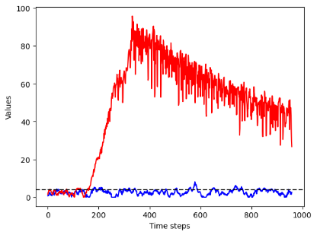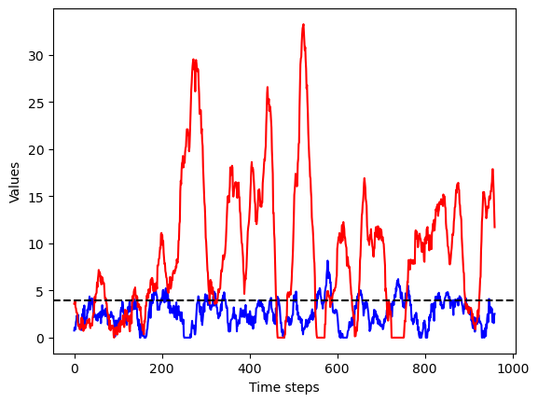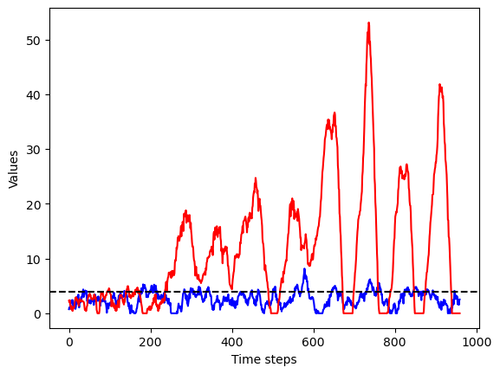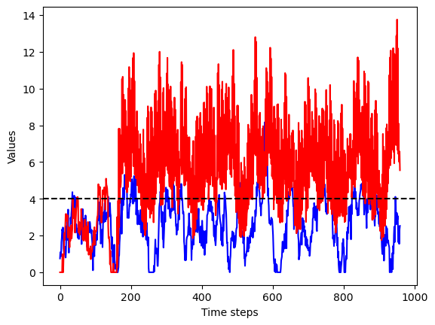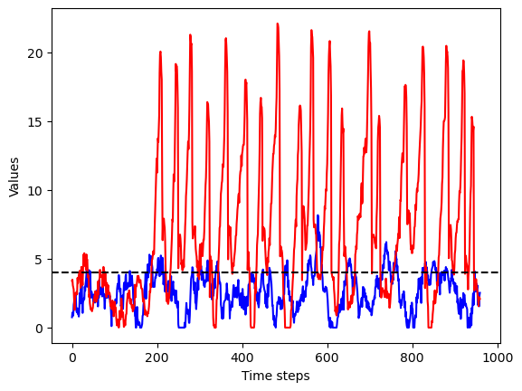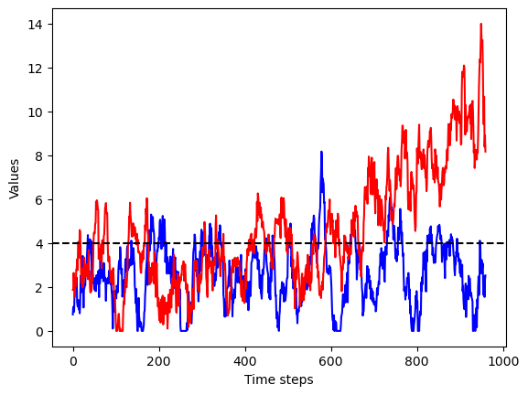Figure 2: Different types of faults reconstructed through the proposed methodology.
- Fault 06 ()()
(b) Fault 08
(c) Fault 13
(d) Fault 14
(e) Fault 17
(f) Fault 21
The proposed methodology was validated on various types of faults. For our analysis, we utilised various faults such as Fault 06 (step type), fault 08 (Random Variation), fault 13 (sticking), fault 14 (slow drift), fault 17 (Unknown) and fault 21 (constant value position). Our methodology was able to demarcate various types of faults as shown in Figure 2. The red curve shows the fault behaviour of different types of faults, whereas the blue curve gives an idea about the Normal Operating Region of the Tennessee Eastman data.
On comapring the proposed methodology, with its machine and deep learning counterparts based on the T² and SPE statistics it was found that the the average Missed Detection Rate (MDR) and False Alarm Rate (FAR) turned out to be the lowest for the proposed methodolgy because of its intrinsic quality to continuously parameterize the hidden state and exploring time depth domain. Table 1 gives a clear indication of the same.
Table 1: Comparison of Proposed Methodology with Baselines based on average values of faults.
Methodology | Missed Detection Rate (MDR) | False Alarm Rate (FAR)
LSTM | 0.25 | 0.40
LSTM-AE | 0.12 | 0.28
DPCA | 0.30 | 0.35
NODEAE | 0.02 | 0.10

  - Conclusions
The NODEAE approach integrates conventional neural network frameworks with ordinary differential equation solvers, transforming the discrete hidden layers typically found in neural networks into a continuous time-domain representation. This enables the model to interpolate and extrapolate effectively across different time steps. Applied to fault detection in Euclidean spaces, the NODEAE methodology was rigorously tested using the well-established Tennessee Eastman dataset, encompassing a range of fault scenarios. When compared with similar models, the NODEAE demonstrated superior performance, evidenced by its notably lower Missed Detection Rate (MDR) and False Alarm Rate (FAR) values.

References

Goswami, U., Rani, J., Kumar, D., Kodamana, H., & Ramteke, M. (2023). Energy Out-of-distribution Based Fault Detection of Multivariate Time-series Data. In Computer Aided Chemical Engineering (Vol. 52, pp. 1885-1890). Elsevier.

Goswami, U., Rani, J., Kodamana, H., Kumar, S., & Tamboli, P. K. (2023). Fault detection and isolation of multi-variate time series data using spectral weighted graph auto-encoders. Journal of the Franklin Institute, 360(10), 6783-6803.

Kumar, D., Goswami, U., Kodamana, H., Ramteke, M., & Tamboli, P. K. (2023). Variance-capturing forward-forward autoencoder (VFFAE): A forward learning neural network for fault detection and isolation of process data. Process Safety and Environmental Protection, 178, 176-194.

Chen, R. T., Rubanova, Y., Bettencourt, J., & Duvenaud, D. K. (2018). Neural ordinary differential equations. Advances in neural information processing systems, 31

