Implementation of Model Predictive Control into the Rigorous Simulator of the Fuel Cell System
Masanori Oshima ª, Sanghong Kim ^{b*}, Shigeki Hasegawa ^{a, c}, Ibuki Sakata ^{b}, Ken-Ichiro Sotowa ª, Motoaki Kawase ª
ªDepartment of Chemical Engineering, Kyoto University, Nishikyo-ku, Kyoto 615-8510, Japan
^{b}Department of Applied Physics and Chemical Engineering, Tokyo University of Agriculture and Technology, Naka-cho, Koganei-city, Tokyo 184-8588, Japan
^{c}Hydrogen Fundamental Development Div., Hydrogen Factory, Toyota Motor Corporation, Aichi, 471-8571, Japan
sanghong@go.tuat.ac.jp
Abstract
Polymer electrolyte fuel cell (PEFC) is a developing technology with a potential to contribute to carbon neutrality. To expedite the development of PEFC, a rigorous simulator of an integrated PEFC system called FC-DynaMo was built by Hasegawa et al. FC-DynaMo allows us to evaluate the performance of the overall FC system based on the detailed specifications covering microscopic to macroscopic levels, such as catalyst activity, properties of proton exchange membrane (PEM), detailed dynamics of valves and pumps, and geometrical shapes of pipes. On the contrary, the simulation results of the optimal operation of FC-DynaMo will clearly show a requirement for each specification that provides a solid guideline for the development of each part of the system. However, the operation of FC-DynaMo using simple rule-based and proportional-integral (PI) control algorithms of the default control system is far from the optimal operation. In this paper, the default control method in FC-DynaMo is replaced by model predictive control (MPC), one of the optimal control methods. The MPC system reduced the offset to approximately zero and the settling time by 86.0 seconds. At the same time, the overheating of the cell was suppressed by the constraint on the coolant temperature at the cell outlet. Such an operation slows down degradation of the membrane and leads to save the lifespan of the PEM.
Keywords: Polymer electrolyte fuel cell (PEFC), Model predictive control (MPC), Rigorous simulation.
  - Introduction
Hydrogen has been paid attention to as a replacement for fossil fuels to realize a carbon-neutral society. Polymer electrolyte fuel cell (PEFC), a technology for power generation using hydrogen, can potentially reduce a large amount of carbon dioxide released into the atmosphere considerably.
The power generation system using PEFC comprises many parts, and many researchers and engineers have developed them to improve the overall power-generation performance. In most cases, each part is developed separately since integrated assessment of all the parts takes much cost. To successfully develop PEFC using this strategy, a solid requirement for every part is essential. However, determining such a requirement is nearly impossible when considering only a limited number of parts. It is necessary to take the overall system into consideration.
To achieve this, a simulator of an integrated PEFC system, FC-DynaMo, has been developed by Hasegawa et al. (2021 and 2022a). The target system of FC-DynaMo consists of the general components: the FC stack, the auxiliary systems for H₂ supply, air supply, and cooling, and the electric power system. Moreover, FC-DynaMo was validated with the extensive experimental data obtained using a state-of-the-art fuel cell electric vehicle (FCEV), 2nd-generation MIRAI (Takahashi & Kaneko, 2021). Hence, it reproduces the dynamics of the overall power generation system of the FCEV in a wide operating range.
In FC-DynaMo, simple control methods, such as proportional-integral (PI) control and on-off control, are used for setpoint tracking of the net power generated in the FC system (Hasegawa et al., 2022b). However, such a control system is not suitable for the simulator since the behaviour of FC systems is highly complex (Yang et al., 2022). FC-DynaMo also reproduces the complexity; it exhibits nonlinear dynamics and has 675 state variables and 11 input variables. Hence, considerable improvement in control performance is expected by replacing the existing control methods with more advanced control methods, such as model predictive control (MPC) (Morari & H. Lee, 1999).
There are no less than 255 papers on implementing MPC into the FC system in simulation according to the keyword search using “fuel cell,” “model predictive control,” and “simulation” as keywords on Web of Science on September 6th, 2023. However, the simulation models in such papers targeted fewer components than FC-DynaMo, and most of them have not been validated using the data obtained from the actual FC system, as shown in the following examples. The model by Goshtasbi & Ersal (2020) lacks several components, including H₂ recycle flow, and the total number of states in the model is one-seventeenth of that of FC-DynaMo. Panos et al. (2012) ignored the dynamics of auxiliary components, such as valves and pumps, though they are included in FC-DynaMo. Vrlić et al. (2021) built a simulation model of an FC system based on the data obtained using an actual FCEV. However, the auxiliary systems are not considered in their simulation model. Hence, FC-DynaMo is more rigorous and inclusive than the simulation models considered in these papers. Implementing MPC into FC-DynaMo is expected to provide deeper insights into the optimal operation of the highly complex FC system.
In this research, the default control system of FC-DynaMo is replaced by an MPC system. The MPC system uses the true process model as the prediction model. Moreover, a constraint on the coolant temperature at the cell outlet was considered to prevent the overheating of the cell. The performance of the MPC system is validated in a simulation case study.
  - Process model
The process of interest in FC-DynaMo is shown in Figure 1. The air from the atmosphere is compressed and cooled down before it is supplied into the cell. All the compressed air is supplied to the cathode of the cell when the air bypass valve is completely closed; otherwise, some portion of air is directly emitted to the atmosphere with the purged H₂ and the air from the cathode outlet. This reduces the H₂ concentration of the emitted gas. H₂ is supplied to the anode through the three injectors. The electrochemical reaction between H₂ and O₂ occurs in the stack, and the coolant system removes the generated heat.
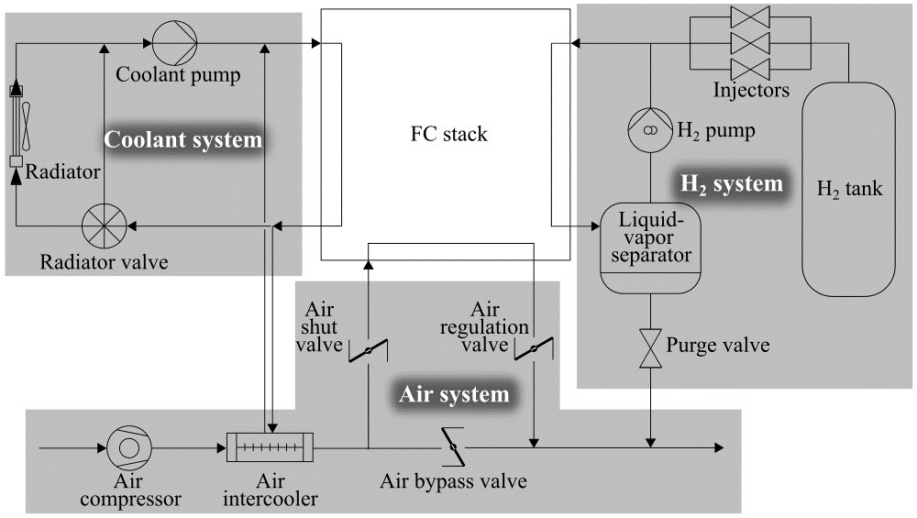
Figure 1: The process flow diagram of the FC plant considered in FC-DynaMo.
Table 1: The definition of the input variables $u$ of the FC plant model.
Variables | Corresponding element in u
Hydrogen pump rotational speed [rpm] | u₁
Air compressor motor torque [N m] | u₂
Air regulation valve opening [-] | u₃
Air bypass valve opening [-] | u₄
Air shut valve opening [-] | u₅
Three-way valve opening in the coolant system [-] | u₆
Radiator fan rotational speed [rpm] | u₇
Water pump rotational speed [rpm] | u₈
FC stack current [A] | u₉
The number of open hydrogen injectors [-] | u₁₀
Hydrogen purge valve state [-] | u₁₁
The unreacted H₂ is separated from the water generated in the stack using the liquid-vapor separator. The gas from the liquid-vapor separator is recycled to the inlet of the anode.
The plant model of FC-DynaMo is a nonlinear state-space model, that is,
$$x\left(t+Δt_{PL}\right)=F\left(x\left(t\right),u\left(t\right),d\left(t\right)\right), y\left(t\right)=g\left(x\left(t\right)\right),$$ | (1)
where $Δt_{PL}$ is the sampling period of the plant model: 16 ms. The states, output, inputs, and measured disturbances are expressed as $x$, $y$, $u$, and $d$, respectively. The output $y$ is the net power of the FC system, which is given by subtracting the power consumed in the auxiliary systems from the gross power generated in the FC stack. The definition of all the elements of the input vector $u$ is listed in Table 1. The state vector $x$ has 675 elements, such as the coolant temperature $T_{c,out}$ at the outlet of the cathode and the cell voltage.
  - Control methods
    - Method 1: Existing control method
In FC-DynaMo, proportional-integral (PI) control and on-off control are mainly used in a cascade structure, as in Figure 2. The control objective is the setpoint tracking of the net power $y$. Primary controller $C_{1}$ determines the setpoint $x_{set}^{'}$ of the sub-state variables $x'$ using PI control and heuristic rule-based control. The definition of $x'$ is shown in Table 2. Note that all the elements of the sub-state vector $x'$ are included in the state vector $x$. In the secondary controller $C_{2}$, the manipulated variables $u$ are determined from $x_{set}^{'}$ and $x'$ by PI and on-off controllers.
    - Method 2: Model predictive control method
To improve the overall performance of the system, MPC is introduced. MPC optimizes the current and future $u$ every control periods. The outline of the optimization problem is
$$P1: \min_{{\left\{u\left(t_{0}+iΔt_{MPC}\right)\right\}}_{i=0}^{N_{C}-1}}{ J=\sum_{t=t_{0}+Δt_{MPC}}^{t_{0}+N_{P}Δt_{MPC}}{{\left(y\left(t\right)-y_{ref}\left(t|γ\right)\right)}^{2}}}$$ | (2)
subject to
$T_{c,out}\left(t\right)<95 ℃, t=t_{0}+Δt_{MPC},⋯,t_{0}+N_{P}Δt_{MPC},$ | (3)
where $Δt_{MPC}$ is $5Δt_{PL}=0.080 ms$, $N_{P}$ and $N_{C}$ are positive integers such that $N_{P}≥N_{C}$, and $t_{0}$ is the current time. The variable $y_{ref}$ in Eq. (2) is reference trajectory defined as
$$y_{ref}\left(t|γ\right)=\left(1-γ^{t-t_{0}}\right)y\left(t_{0}\right)+γ^{t-t_{0}}y_{set}\left(t\right),$$ | (4)
where $γ∈[0,1)$ is a parameter that determines the response speed of MPC. In Eq. (3), the upper limit constraint of $T_{c,out}$ is introduced to prevent the temperature in the cell from rising above 95 ℃.
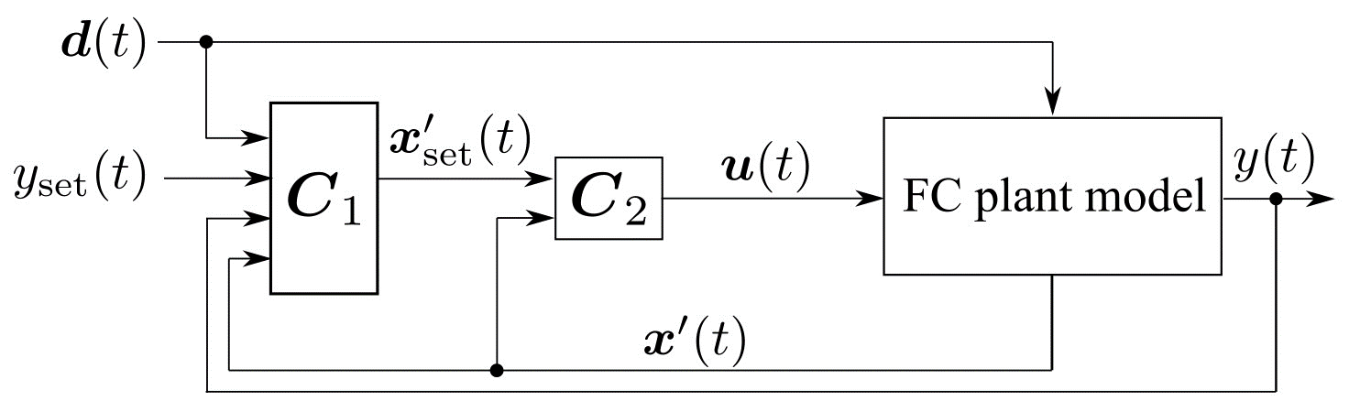
Figure 2: The default control system of FC-DynaMo.
Table 2: The definition of the sub-state vector $x'$.
Variables | Corresponding element in x'
Pressure at FC cathode inlet [kPa] | x'₁
Air flowrate to FC cathode inlet [NL/min] | x'₂
Air flowrate to air compressor [NL/min] | x'₃
Air flowrate at air bypass valve [NL/min] | x'₄
H₂ partial pressure at FC anode outlet [kPa] | x'₅
H₂ flowrate at hydrogen pump [NL/min] | x'₆
Injector outlet pressure [kPa] | x'₇
Liquid-water volume in liquid-vapor separator [m³] | x'₈
FC cathode inlet coolant temperature [℃] | x'₉
FC cathode outlet coolant temperature [℃] | x'₁₀

However, the optimization problem P1 is mixed-integer programming, which requires a high computational burden to be solved because $u_{10}$ and $u_{11}$ are discrete variables. To solve this, P1 is modified as follows. An additional constraint, that is,
$${\left[u_{10}\left(t\right), u_{11}\left(t\right)\right]}^{⊤}=C_{on/off}\left(u_{9}\left(t\right), x_{set,7}^{'}\left(t\right), d\left(t\right), x\left(t\right)\right)$$ | (5)
is introduced, where $x_{set,7}^{'}$ is the setpoint of the injector outlet pressure $x_{7}^{'}$, and $C_{on/off}$is the on-off controller of the method 1. Moreover, the discrete optimized variables $u_{10}$ and $u_{11}$ are replaced with $x_{set,7}^{'}$. Therefore, the modified optimization problem P2 is
$$P2: \min_{{\left\{{\left[u_{1}\left(t_{0}+iΔt_{MPC}\right),⋯,u_{9}\left(t_{0}+iΔt_{MPC}\right),x_{set,7}^{'}\left(t_{0}+iΔt_{MPC}\right)\right]}^{⊤}\right\}}_{i=0}^{N_{C}-1}}{ J}$$ | (6)
subject to Eqs. (3) and (5).
In the actual implementation of MPC into FC-DynaMo, the problem P2, instead of P1, is solved to obtain ${\left\{u_{m}\right\}}_{m=1}^{9}$ and $x_{set,7}^{'}$. Then, $u_{10}$ and $u_{11}$ are calculated using Eq. (5).
  - Simulation case study
The methods 1 and 2 were compared in the setpoint change simulation of $y$. The controller parameters in the method 1 were set equal to their default values. In the method 2, $N_{P}$, $N_{C}$ and $γ$ were set to 100, 1, and 0.852. The value of $y_{set}$ was changed stepwise from 0 to 95 kW at $t=$ 10 s. The simulation results are shown in Figure 3. At $t=$ 200 s, $y$ was equal to $y_{set}$ in the method 2 but below $y_{set}$ in the method 1. Offset in $y$ occurred only in the method 1 of the existing control method. The reason for this was further studied by introducing method 3. In the method 3, only the inner control loop of the existing control method is used without changing the parameters of $C_{2}$, and $x_{set}^{'}$ was set to $x^{'}\left(200\right)$ in the method 2 of MPC. The simulation result of the method 3 is shown in Figure 3, as well. Figure 3 shows that the method 3 eliminated offset. Thus, the default control method can also provide offset-free operation without using the outer controller $C_{1}$.
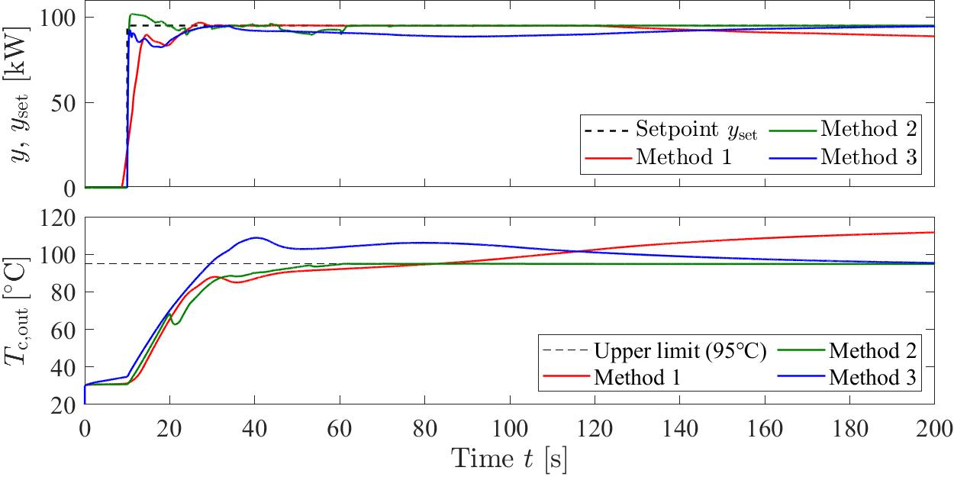
Figure 3: Time series plots of the net power $y$ and the coolant temperature $T_{c,out}$ at the cathode outlet of the cell.
However, the result of the method 3 was still different from that of the method 2 using MPC. The settling time of the method 3 was 86.0 s longer than that of the method 2; the former and latter were 145.6 s and 59.6 s, respectively. Note that the range of $y$, within which the system was regarded as settled, was set to 95 ±2.5 kW.
The benefits of MPC in the method 2 are attributed to the constraint on $T_{c,out}$. In both the methods 1 and 3, $T_{c,out}$ became higher than 95 ℃, and the overheating of the cell that decreases the power-generation performance of the cell occurs. Therefore, MPC provided the best setpoint-tracking performance of $y$.
  - Conclusions
The MPC system was newly implemented into FC-DynaMo, the most rigorous simulator of the integrated PEFC system as far as the authors know. The MPC system was compared with the two control methods: the default control method and the modified default control method, where the state variables are controlled to the steady-state values realized by MPC with a part of the default control method. The upper constraint of the coolant temperature at the cell outlet of MPC prevented the decrease in the power generation performance by overheating in the cell, which occurred in the other two methods. As a result, the proposed MPC system provided the best performance in terms of the offset and the settling time.
References
A. Goshtasbi & T. Ersal. 2020. Degradation-conscious Control for Enhanced Lifetime of Automotive Polymer Electrolyte Membrane Fuel Cells. Journal of Power Sources, 457, 227996.
S. Hasegawa, Y. Ikogi, S. Kim, M. Kageyama, & M. Kawase. 2022. Modeling of the Dynamic Behavior of an Integrated Fuel Cell System Including Fuel Cell Stack, Air System, Hydrogen System, and Cooling System. ECS Transactions, 109(9), 15–70.
S. Hasegawa, M. Kimata, Y. Ikogi, M. Kageyama, M. Kawase, & S. Kim. 2021. Modeling of Fuel Cell Stack for High-Speed Computation and Implementation to Integrated System Model. ECS Transactions, 104(8), 3–26.
S. Hasegawa, Y. Miyamoto, S. Kim, Y. Ikogi, M. Kageyama, & M. Kawase. 2022. Model-Based Development of Fuel Cell Stack and System Controllers. Computer Aided Chemical Engineering, 49, 1123–1128.
M. Morari & J. H. Lee. 1999. Model Predictive Control: Past, Present and Future. Computers & Chemical Engineering, 23(4–5), 667–682.
C. Panos, K. I. Kouramas, M. C. Georgiadis, & E. N. Pistikopoulos. 2012. Modelling and Explicit Model Predictive Control for PEM Fuel Cell Systems. Chemical Engineering Science, 67(1), 15–25.
T. Takahashi & Y. Kaneko. 2021. Development of New Fuel Cell System. EVTeC 2021, 20214292.
M. Vrlić, D. Ritzberger, & S. Jakubek. 2021. Model-Predictive-Control-Based Reference Governor for Fuel Cells in Automotive Application Compared with Performance from a Real Vehicle. Energies, 14(8), 2206.
B. Yang, J. Li, Y. Li, Z. Guo, K. Zeng, H. Shu, P. Cao, & Y. Ren. 2022. A Critical Survey of Proton Exchange Membrane Fuel Cell System Control: Summaries, Advances, and Perspectives. International Journal of Hydrogen Energy, 47(17), 9986–10020.

