Optimal control of an integrated sorption-reaction unit for ammonia synthesis

Carl Sengobaa, Markus Illnera, Jens-Uwe Repkea

aTechnische Universität Berlin, Process Dynamics and Operations Group, Straße des 17. Juni 135, Berlin D-10709, Germany

c.sengoba@tu-berlin.de

Abstract

Long-term chemical storage of renewable hydrogen in ammonia is a potential building block in a carbon-free energy system. An integrated reactive adsorption column for ammonia synthesis may allow for an intensified and flexible process. To investigate this, we present a pseudo-homogeneous pressure-driven phase model representing the integrated unit. Using an operation schedule, the control trajectory is sequentially optimized by means of time-invariant parameters obtaining a single-pass conversion of YH2 = 76 %. Back-reaction of ammonia in presence of the catalyst and the need for a subsequent cryogenic separation unit may however be detrimental to the efficiency of the overall process design.

**Keywords**: pressure-driven modeling, process intensification, sorption-enhanced catalysis, ammonia production

* 1. Introduction

Hydrogen will play a crucial role in the transition towards a decarbonized energy system. While its molecular properties (e.g.: density, diffusivity) currently complicate hydrogen storage and transport, ammonia (NH3) is a viable candidate substance for chemical hydrogen storage. Developing a renewable, resource-efficient, and flexible NH3 synthesis process is thus desirable to advance the utilization of green hydrogen. The major advantages of process flexibility, required for coping with volatile electricity supply, and increased efficiency (evasion of the limiting chemical equilibrium) could be achieved by cyclic sorption and desorption (Smith, 2021) of the product NH3 as compared to a recycle in the traditional Haber-Bosch process.

* 1. Methods

In this study, we employ a dynamic pressure-driven model of a reactive adsorption column. To this end, a (partial differential algebraic equation) PDAE representing the 1-D dynamic pseudo-homogeneous phase model (Palys, 2018)is incorporated by reaction and sorption kinetic models available in the literature (Smith, 2021). Further, a cyclic batch operation schedule is proposed, i.e., a valve activation schedule: pressurization, reaction/absorption and desorption, which is realised by temporal switching of the boundary conditions at the inlet and outlet as described in the simulation of (pressure swing adsorption) PSA beds (Moon, 2016).

The PDAE is spatially discretized via orthogonal collocation on finite elements to result in a DAE, which permits the usage of gradient-based optimization methods. To handle the expected stiffness of the equation system the gProms®modelling environment is used. The defined operation recipe restricts the control space of the DAE to a set of time-invariant recipe parameters (Löwe, 2001). Based on the developed model, several (optimal control problems) OCPs to maximize the hydrogen conversion, NH3 purity and the units’ productivity are formulated. Thus, the goal is to identify optimal recipe parameters for this recycle-less (i.e., single-pass) NH3 synthesis reactor.

* 1. Results and Discussion

To evaluate the potential for improvement in single-pass conversion for the integrated reactor-sorption system, a sensitivity study is performed. Here, the inlet pressure during pressurization pH and the outlet pressure during desorption pL are varied from 20-100 bar and 2–12 bar, respectively. The inlet composition is set to a stoichiometric H2/N2 molar ratio along with a uniform temperature over the whole domain of T = 573 K. The results of the simulation campaign are shown in Figure 1.

We calculate a maximum achievable single-pass conversion of the integrated sorption-reaction unit of YH2 = 76 % at a time averaged outlet ammonia molar fraction of xNH3,out= 59 % at pH = 100 bar and pL = 2 bar. Integration with a gradient-free optimization algorithm in MATLAB® results in the same, yet trivial, optimal recipe parameters.

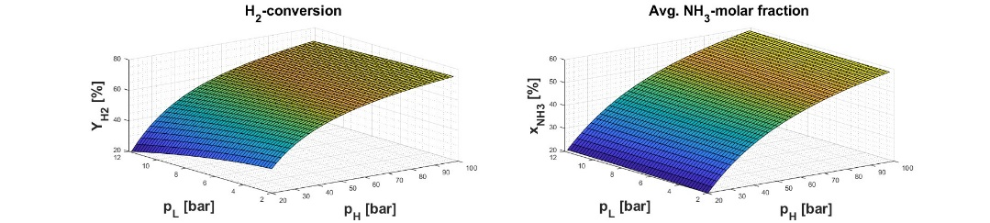The simulations indicate that sorbent material integration enables a single-pass H2-conversion well beyond the chemical reaction equilibrium. Sensitivity studies on both the temperature window and the reaction/sorption kinetic models are conducted to define the performance targets for catalyst and sorbent material development. In general, fast adsorption/desorption kinetics at a high sorbent working capacity allow for a high feed throughput and conversion. However, a large sorption hysteresis (effectively decreasing the working capacity of the sorbent), back-reaction in the presence of the catalyst, and sorbent/catalyst material interactions could occur. All these effects would be detrimental to the conversion performance of the integrated reaction-sorption unit.

**Figure 1.** Calculated reactor single-pass conversion (left) and average molar fraction ammonia molar fraction at the outlet (right) for varying inlet (pH) and outlet pressures (pL)

* 1. Conclusions

This study presents a pressure-driven PDAE model for a novel reactive adsorption process for ammonia synthesis. Sensitivity studies regarding both material parameters and the operating window allowed us to examine the achievable conversion, purity and productivity performance of the integrated unit. Restriction of the control space via an operation recipe formulation enabled us to solve an OCP. Mathematical reformulation of the operation recipe is one possible way to render a broader range of numerical optimization methods, e.g., simultaneous methods, applicable to the OCP. Further, the presented model would allow for training of a data-driven regression model, which can be employed in a dynamic real-time optimization (D-RTO) framework.

Including information about the performance from integrated catalyst-sorbent unit experiments to the rate-based model would provide further insight. However, the first OCP studies results already show an encouraging reactor unit performance, in the light of flexible and demand-responsive NH3 production.

**Acknowledgement**

Funded by the European Union. Views and opinions expressed are however those of the author(s) only and do not necessarily reflect those of the European Union. Neither the European Union nor the granting authority can be held responsible for them. Grant agreement No 101058643.

References

[1]: C. Smith and L. Torrente-Murciano, 2021, Exceeding Single-Pass Equilibrium with Integrated Absorption Separation for Ammonia Synthesis Using Renewable Energy—Redefining the Haber-Bosch Loop. Adv. Energy Mater. 2021, 11, 2003845

[2]: M. J. Palys, A. McCormick, E. L. Cussler and P. Daoutidis, 2018, Modeling and Optimal Design of Absorbent Enhanced Ammonia Synthesis, Processes 2018, 6, 91

[3]: D.-K. Moon, D.-G. Lee and C.-H. Lee 2016, H2 pressure swing adsorption for high pressure syngas from an integrated gasification combined cycle with a carbon capture process, Applied Energy 2016, 183, 760-774

[4]: <https://www.siemens.com/global/en/products/automation/industry-software/gproms-digital-process-design-and-operations.html>

[5]: K. Löwe, 2001. Theoretische und experimentelle Untersuchungen über das Anfahren und die Prozeßführung energetisch und stofflich gekoppelter Destillationskolonnen. Ph.D. thesis, TU Berlin, Berlin, Germany

[6]: https://de.mathworks.com/products/matlab.html