Limestone calcined clay cement (LC3) concrete made using Saudi clays: A case study

Marwan Abdulqader,a Hammad Raza Khalid,a,b,* Mohammed Ibrahim,c Saheed Adekunle, a,b Mohammed Al-Osta,a,b Shamsad Ahmada,b

aDepartment of Civil and Environmental Engineering, King Fahd University of Petroleum & Minerals, Dhahran 31261, Saudi Arabia

bInterdisciplinary Research Center for Construction and Building Materials, King Fahd University of Petroleum and Minerals, Dhahran 31261, Saudi Arabia

cApplied Research Center for Metrology, Standards and Testing, King Fahd University of Petroleum and Minerals, Dhahran, 31261, Saudi Arabia

*Corresponding author email: [hammad.khalid@kfupm.edu.sa](mailto:hammad.khalid@kfupm.edu.sa)

Abstract

The production of Portland cement (clinker) results in an enormous amount of CO2 emission. Clinker substitution with supplementary cementitious materials (SCMs) is a promising technology for reducing the CO2 footprint of concrete industry. Substitution of clinker with calcined clays along with limestone results in a ternary blend known as limestone calcined clay cement (LC3). This paper reports the use of local Saudi clays to prepare LC3 concrete. Different clays were sourced from local quarry sites. The collected clay samples were characterized to find their mineralogical composition. Following, clays were crushed, sieved, calcined, and used for clinker substitution along with limestone and gypsum to prepare LC3 samples. Different clay substitution levels were used to prepare a series of LC3 samples. The fresh, mechanical, and durability properties of prepared LC3 samples were studied. The obtained results revealed the potential of Saudi clays to achieve higher clinker replacements (up to 50%).

**Keywords**: LC3, Calcined clays, Supplementary cementitious materials (SCMs), Clinker substitution, Green cement.

* 1. Introduction

Portland cement is the main binder in concrete, which has a high CO2 footprint (Andrew 2017). Efforts are being made to reduce cement content in concrete. A promising and immediate solution is to use supplementary cementitious materials (SCMs) to partially replace cement, as no alternative is currently available to put cement out of the picture (Ahmadi and Shekarchi 2010; Juenger et al. 2019). Different SCMs such as coal fly ash, blast furnace slag, natural pozzolan, and calcined clays can be used for cement replacement up to certain levels. Fly ash is the by-product of coal power generation while slag comes from blast furnaces, and both have limited supplies. Natural pozzolan is available at specific localities. Therefore, the focus of this study is naturally occurring kaolinite clays which can be calcined at moderate temperature to get good reactivity. Calcined clays are substituted along with limestone powder to make a ternary blend, referred to as LC3. Calcined clays have shown promising mechanical and durability characteristics, desirable for concrete. An increasing number of papers have focused on such clays (Scrivener 2015; Vizcaíno Andrés et al. 2015). In this study, Saudi clays were studied for clinker replacement at different levels. The mechanical and durability properties of concrete made using different clays were studied.

* 1. Experimental

Two Saudi clay samples, white (WC) and yellow (YC) were collected from the Eastern province of Saudi Arabia. One Ukrainian clay (UC) was also used for the sake of comparison. Collected clay samples were crushed and ground to pass a 150 µm sieve. Following, ground clays were calcined at 850 ℃ for 3 h to convert kaolin to metakaolin. Type I Portland cement, conforming to ASTM C150, was used. Limestone powder (LSP) was used at a clay-to-LSP ratio of 2:1. A water/binder ratio of 0.4 was used for all the samples. Eventually, the paste samples (25 mm cubes) with clinker substitution levels of 30, 50, and 70 wt.% were made. Samples were cured under water for up to 7, 28, and 90 days, followed by compression testing (Fig. 1). After 28 days of curing, 3 samples from each batch were exposed to a 5% sulfate solution for durability measurements.

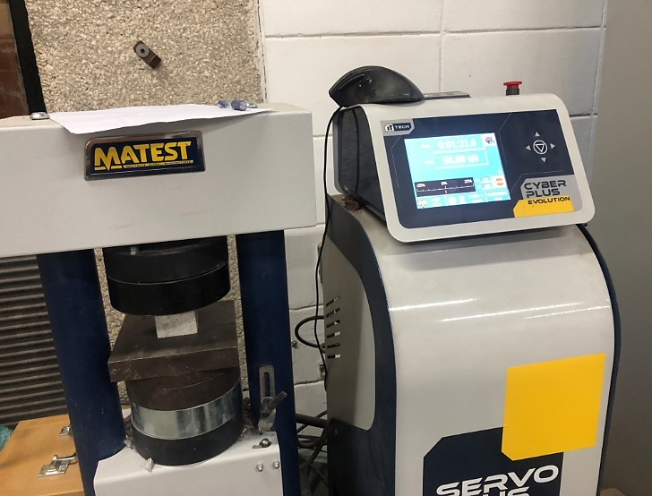

Fig. 1. Compression testing of paste samples

* 1. Results and discussion

The compressive strength of all the samples is plotted in Fig. 2. It is evident that the control samples showed higher strength compared to the LC3 samples. The strength of LC3 samples at 50% replacement was about 56, 42, and 40 MPa for white, yellow, and Ukrainian clay, respectively, compared to about 76 MPa for the control sample. Despite the reduction in strength, the achieved strength values of LC3 samples can still give structural-grade concrete. Moreover, this lower strength of LC3 samples was potentially due to the low fineness of clays (particle size < 150 µm) which resulted in lower reactivity. In contrast, cement generally has an average particle size of 45 µm.

The durability of samples against sulfate exposure is shown in Fig. 3. It can be seen that almost all the sulfate-exposed samples showed comparable compressive strength to their respective control samples (unexposed). This shows the high sulfate resistance of these samples. Hence, clay-substituted binders can be used in sulfate-rich environments.

Fig. 2. Compression strength of paste samples

Fig. 3. Compression strength of sulfate-exposed paste samples

* 1. Conclusions

Two Saudi clays were studied in this work to replace clinker partially. Mechanical strength and sulfate resistance were studied. The results have shown that the clay samples have less strength than control samples, potentially due to their low reactivity because of the larger particle size. The reduction in particle size by fine grinding can help in achieving higher strength. Furthermore, all the samples exhibited high resistance to sulfate exposure.

Acknowledgment

The authors would like to acknowledge the support provided by the KFUPM under grant INCB2314.

References

Ahmadi B, Shekarchi M (2010) Use of natural zeolite as a supplementary cementitious material. Cem Concr Compos 32:134–141. https://doi.org/10.1016/j.cemconcomp.2009.10.006

Andrew RM (2017) Global CO2 emissions from cement production. Earth System Science Data Discussions 1–52. https://doi.org/10.5194/essd-2017-77

Juenger MCG, Snellings R, Bernal SA (2019) Supplementary cementitious materials: New sources, characterization, and performance insights. Cem Concr Res 122:257–273. https://doi.org/10.1016/j.cemconres.2019.05.008

Scrivener K (2015) Calcined Clays for Sustainable Concrete

Vizcaíno Andrés LM, Antoni MG, Diaz AA, et al (2015) Effect of fineness in clinker-calcined clays-limestone cements. Advances in Cement Research 27:546–556. https://doi.org/10.1680/adcr.14.00095