Modeling of Carbon Offsetting Industries for Performance Prediction of Emissions Trading Systems

Soo Hyoung Choi

Division of Chemical Engineering, Clean Energy Research Center, Jeonbuk National University, 567 Baekje-daero Deokjin-gu, Jeonju, 54896, S. Korea

soochoi@jbnu.ac.kr

Abstract

A mathematical programming approach is suggested to predict the environmental impact of carbon offsetting by emissions trading systems under various circumstances. The proposed method is to simulate industries that seek to minimize the cost of reduction and/or offsetting of carbon emissions minus the value of retained carbon credits. Case study indicates that reduction of net emissions can be promoted by emissions trading systems if rightly operated. The necessary conditions are industrial abilities to reduce emissions and/or capacities for extension of sequestration, correct issuance of carbon credits, proper policies on allowances, and rational rules on carryovers.

**Keywords**: carbon offset, carbon credit, emissions trading system

* 1. Introduction

Carbon offsetting means to compensate for carbon emissions by earning or purchasing carbon credits, which are issued by governmental organizations as reward for carrying out or investing in projects that contribute to reducing atmospheric carbon dioxide (Wikipedia, 2023a). Typical carbon offset projects include forestry, renewable energy, energy conservation, and conversion of waste to energy (Jennifer L, 2023). If carbon credits are correctly evaluated for these projects, and the total amount of carbon credits is limited to the total capacity of carbon sequestration, net zero emissions can be attained. However, carbon neutrality defined as such only guarantees a steady state of carbon cycle, at which the concentration of atmospheric carbon dioxide can still be high, if emissions and sequestration are equally large. Therefore, rigorous carbon cycle impact assessment is necessary in order to correctly evaluate carbon credits for various carbon offset projects (Choi, 2023). Carbon credits basically represent allowances for emissions, and can be sold and bought in carbon markets (Wikipedia, 2023b). Speculation is that, as the government reduces allowances, their price increases, until the industry is forced to reduce emissions rather than to offset them. However, carbon markets are geared towards offsetting (Frank, 2023). In this work, the effectiveness of carbon markets is investigated in terms of carbon cycle dynamics (Choi and Manousiouthakis, 2022).

The emissions trading system (ETS) facilitates the process industry’s achievement of carbon neutrality. The root reason is that companies can offset their emissions by purchasing carbon credits even if they emit more than the allowances allocated by the government. The only obstacle seems to be the future price of carbon credit, if available, which is expected in general to increase as carbon neutrality is approached (Tiseo, 2023). This prediction is reasonable because, after carbon neutrality is achieved, the government can no longer allow offsets more than the capacity of sequestration attained up to that time. The ETS differs from country to country, but generally, the total allowances are reduced every year, and a fixed amount of allowance is additionally placed on the market if the price of carbon credit increases over a certain preset value. If the price of carbon credit is significantly higher than the cost of carbon capture, companies will prefer reduction to offset. Besides, surplus credits, if any, can be sold for profits. However, most companies prefer carryover to the next year in order to prepare for an uncertain future. Carryover rules also differ from country to country. If not allowed, excessive supplies will lower the price, weakening the driving force for reduction. If unlimited, accumulated allowances will lead to insecure carbon neutrality. The effects of carryover rules are also evaluated in this work.

In order to get ETS to properly work, carbon credits should be evaluated to represent actual decrease in net emissions. Evaluation of direct reduction is straightforward, but assessment of indirect reduction is apt to cause duplicate credits. Actually, over-crediting is known to be happening (Gurgel, 2022). Credits should be correctly issued for increase in sequestration also. Forestry is essential because fundamental sequestration is being performed by forests (Norman, 2023). However, the problem is that credits are issued not only for afforestation, but also for stopping deforestation (Greenfield, 2023). As an alternative to forestry, direct air capture (DAC) is in business (Twidale et al., 2023). However, from a technical point of view, unlike its name, it indirectly captures carbon after released into the air. Therefore, DAC should confront low efficiency, hence strong skepticism (Shelton-Thomas and DiFelice, 2023). Nonetheless, in this work, it is assumed that carbon credit is equivalent to decrease in net emissions.

* 1. Proposed Method

A model is proposed in order to simulate emissions trading that affects carbon cycle as shown in Fig. 1. The emitter represents the entire group of carbon positive industries, and the absorber represents the entire group of carbon negative industries. Therefore, the emitter should reduce emissions and/or buy credits from the absorber in order to satisfy the requirements from the government. For more simplicity, it is assumed that the government buys all surplus credits at market price, i.e., $d=u+w+z-y$. Then, the emitter’s behavior for a given period can be modeled as a mathematical program, which minimizes the total expenses minus the final value of retained carbon credit. The proposed formulation is as follows:

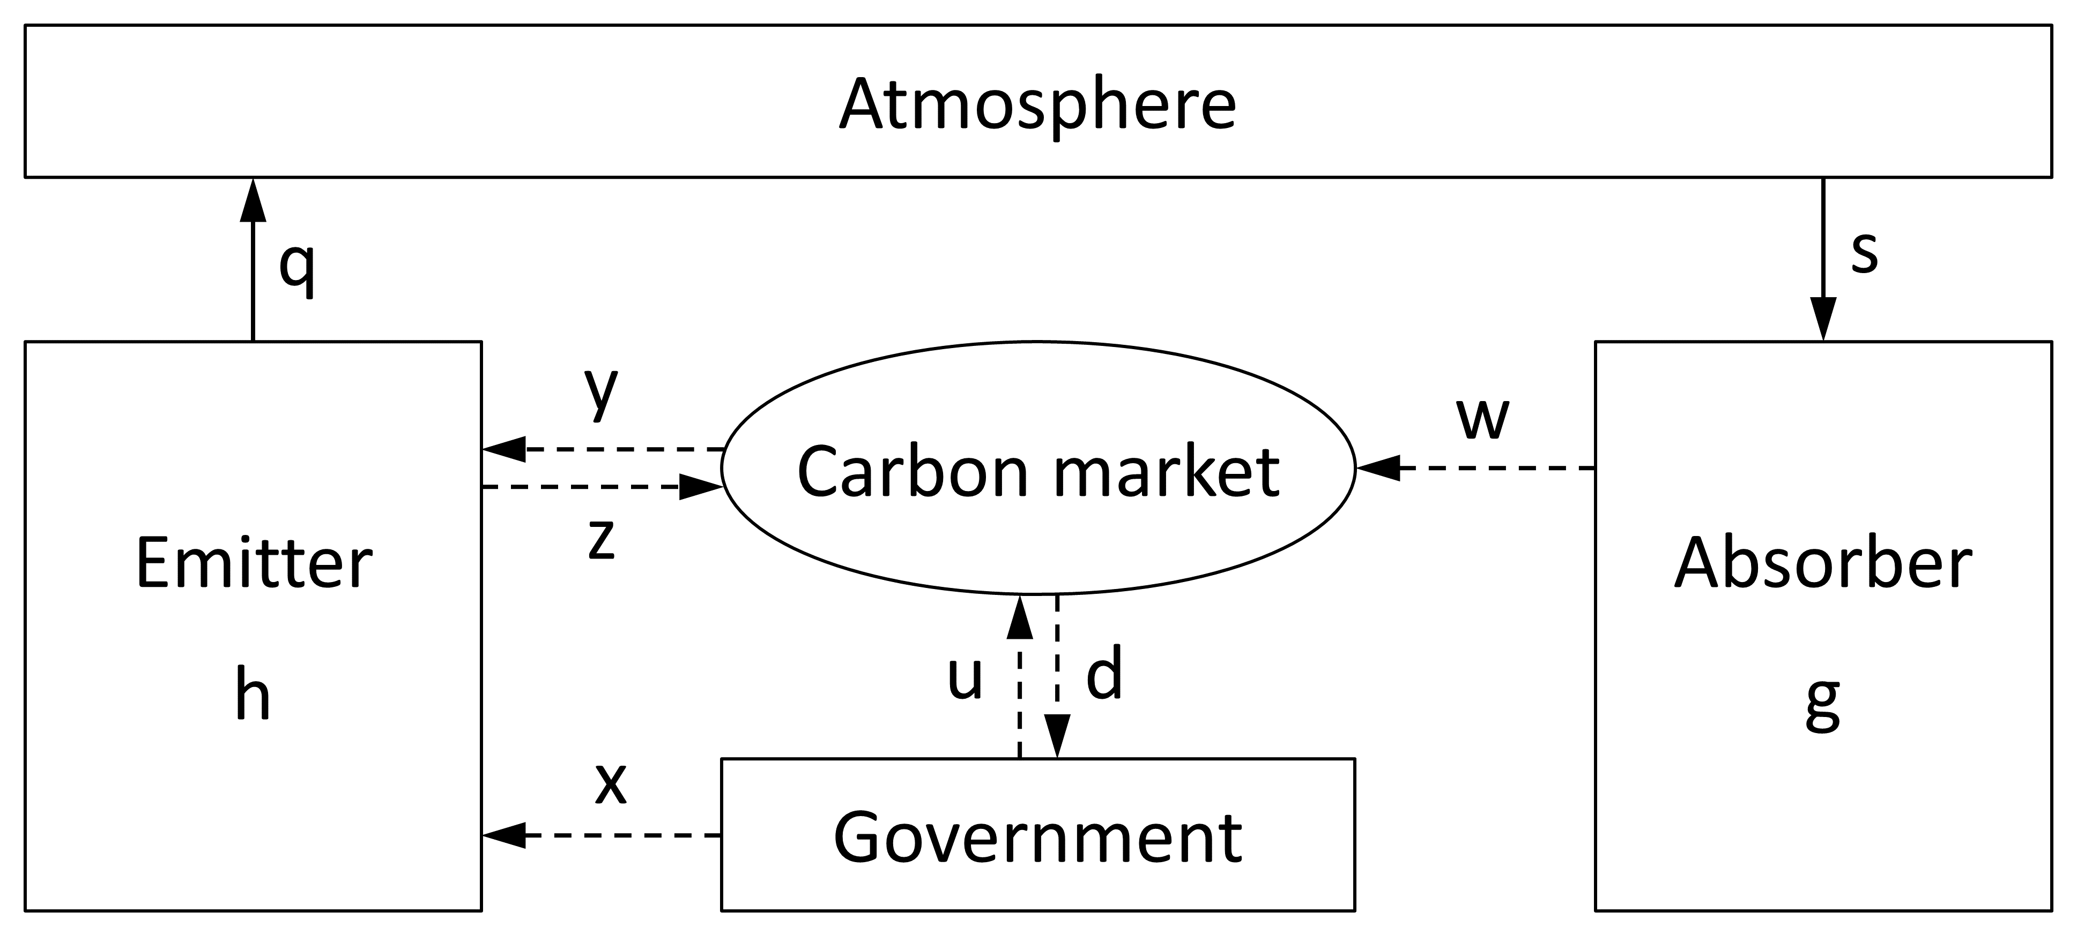

Figure 1. Carbon (solid) and credit (dashed) flow model.

|  |  |
| --- | --- |
| $$\min{\sum_{i=1}^{n}{\left[c_{i}\left(q_{0}-q_{i}\right)+p_{i}\left(y_{i}-z_{i}\right)\right]-p_{n}h_{n}}}$$ | (1) |

subject to

|  |  |
| --- | --- |
| $x_{i}=r_{x} x_{i-1}$, $x_{0}=q_{0}$ | (2) |
| $h_{i}=h_{i-1}+x_{i}+y_{i}-z_{i}-q_{i}$, $h_{0}=0$ | (3) |
| $g_{i}=g_{i-1}+s_{i}-w_{i}$, $g_{0}=0$ | (4) |
| $$p_{i}\left(x_{i}+u_{i}\right)=c_{i} q_{i}$$ | (5) |
| $$q_{i}≥r_{q} q_{i-1}$$ | (6) |
| $s_{i}-s_{i-1}≤b_{s}$, $s_{0}=0$ | (7) |
| $$h_{i}-h_{i-1}≤b_{h}$$ | (8) |

where

$c_{i}=$ average cost for reduction of emissions in the $i$-th year

$p_{i}=$ average price of carbon credit in the $i$-th year

$q_{i}=$ amount of emission in the $i$-th year

$s_{i}=$ amount of absorption in the $i$-th year

$u_{i}=$ carbon credit supplied by the government in the $i$-th year

$w_{i}=$ carbon credit sold by the absorber in the $i$-th year

$x_{i}=$ carbon credit allotted to the emitter for the $i$-th year

$y_{i}=$ carbon credit bought by the emitter in the $i$-th year

$z_{i}=$ carbon credit sold by the emitter in the $i$-th year

The proposed optimization problem is a nonconvex nonlinear program, because $p_{i}$’s are unknowns, while $c_{i}$’s, $r_{x}$, and $r_{q}$ are constants. All variables and parameters are nonnegative, and can be normalized so that $q_{0}=1$ can be used. For maximum simplicity, it is assumed in this work that the emitter buys the absorber’s credit, and the government buys the emitter’s credit, i.e., $w_{i}=y_{i}$ in (4). Equation (5) represents a carbon price model which is obtained from the assumption that the reference price is equivalent to the cost of reduction, and the change factor is proportional to the industrial demand, $q_{i}$, and inversely proportional to the governmental supply, $x_{i}+u_{i}$, i.e., $p_{i}≈c_{i} q_{i}\text{/}\left(x_{i}+u_{i}\right)$, where $u_{i}$ is a manipulated variable for the government to control the market price, which is omitted in this work, i.e., $u_{i}=0$. Net emissions can be calculated by .

* 1. Case Study

Consider a governmental plan for reduction of emissions by 30% in 5 years. The allowances are to be reduced by 7% every year. The cost of carbon capture is assumed to be constant so that $c_{i}=1$ can be used. The suggested parameter values are listed in Table 1. Case 1 is designed to use reduction only, and case 2 to use offset only. Case 3 uses both. In cases 1–3, carryover is unlimited. In case 4, it is assumed that carryover is limited to the same amount as sales. In case 5, carryover is not allowed. The proposed mathematical program is solved by MATLAB’s fmincon. For numerical stability, 10−8 is used for 0, and 108 for ∞ as parameter values in Table 1.

Table 1. Parameters for case study

|  |  |  |  |  |
| --- | --- | --- | --- | --- |
| Case | $$r_{x}$$ | $$r_{q}$$ | $$b_{s}$$ | $$b_{h}$$ |
| 1 | 0.93 | 0.90 | 0 | ∞ |
| 2 | 0.93 | 1 | 0.10 | ∞ |
| 3 | 0.93 | 0.95 | 0.05 | ∞ |
| 4 | 0.93 | 0.95 | 0.05 | $$z_{i}$$ |
| 5 | 0.93 | 0.95 | 0.05 | 0 |

The results of simulation are shown in Figs. 2 and 3. Case 1 indicates that excessive allowance causes decrease in the carbon price, and ends up failing to achieve target reduction of emissions. Case 2 indicates that deficient reduction causes rapid increase in the carbon price. Cases 1–3 indicate that if carryover is unlimited, net emissions may suddenly increase at last. Case 4 shows the best performance, which suggests that it is necessary to properly limit carryovers in order to ultimately minimize net emissions. Case 5 indicates that it is not desirable to completely prohibit carryovers.

* 1. Conclusions

Case study indicates that the effectiveness of ETS depends on governmental policies and industrial capabilities. Excessive allowances would worsen the carbon cycle, and deficient allowances would threaten the industrial economy. Unlimited carryovers would endanger carbon neutrality, and extreme limitation might delay its achievement. These issues also need optimization, and extension of the proposed method is suggested as future work.

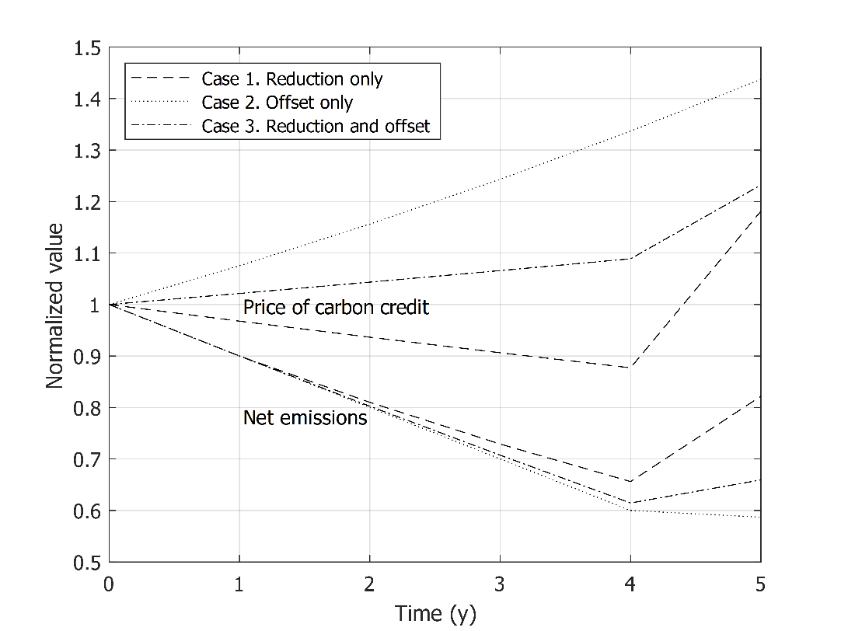

Figure 2. Predicted carbon price and net emissions for reduction and/or offset cases.

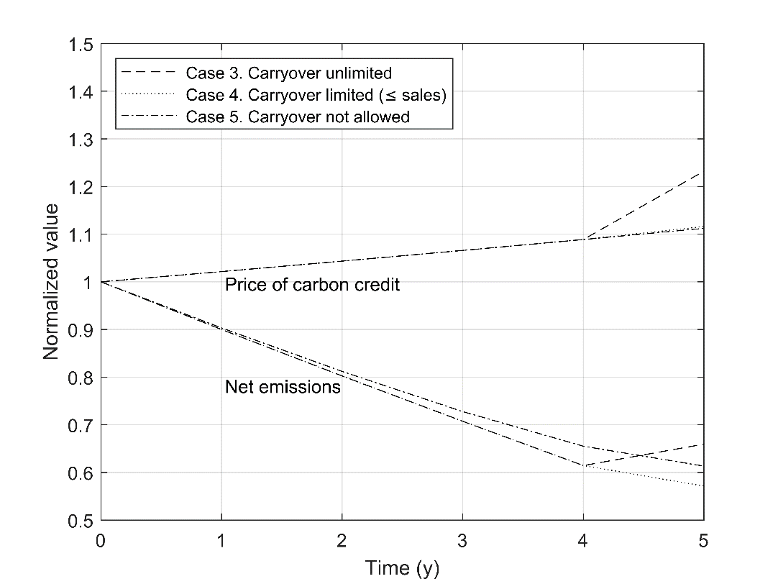

Figure 3. Predicted carbon price and net emissions for different carryover rules.

Acknowledgement

This work was supported by National Research Foundation of Korea (NRF) funded by Ministry of Science and ICT (MSIT) (Grant No. 2022R1F1A1062901).

References

S. H. Choi, 2023, Modeling of carbon offset networks for process systems to achieve net zero emissions, Computer Aided Chemical Engineering, 52, 1083-1088, <https://doi.org/10.1016/B978-0-443-15274-0.50173-6>

S. H. Choi and V. I. Manousiouthakis, 2022, Modeling the Carbon Cycle Dynamics and the Greenhouse Effect, IFAC-PapersOnLine, 55-7, 424-428, <https://doi.org/10.1016/j.ifacol.2022.07.480>

Jennifer L, 2023, How Do Carbon Offsetting Projects Work? CarbonCredits.Com, <https://carboncredits.com/how-do-carbon-offsetting-projects-work/>

P. Greenfield, 2023, Revealed: more than 90% of rainforest carbon offsets by biggest certifier are worthless, analysis shows, The Guardian, <https://www.theguardian.com/environment/2023/jan/18/revealed-forest-carbon-offsets-biggest-provider-worthless-verra-aoe>

S. Frank, 2023, Does carbon offsetting do more harm than good? Carbon Market Watch, <https://carbonmarketwatch.org/2023/07/06/does-carbon-offsetting-do-more-harm-than-good/>

A. Gurgel, 2022, Carbon Offsets, MIT Climate Portal, <https://climate.mit.edu/explainers/carbon-offsets>

C. Norman, 2023, Kreye, M. How Forests Store Carbon, Penn State Extension, <https://extension.psu.edu/how-forests-store-carbon>

O. Shelton-Thomas and M. DiFelice, 2023, Direct Air Capture: 5 Things You Need to Know About This Climate Scam, Food & Water Watch, <https://www.foodandwaterwatch.org/2023/01/19/direct-air-capture-climate-scam/>

I. Tiseo, 2023, Forecast carbon offset prices 2030-2050, by scenario, Statista, <https://www.statista.com/statistics/1284060/forecast-carbon-offset-prices-by-scenario/>

S. Twidale, V. Volcovici, S. Jessop, and P. Henderson, 2023, Insight: Facing brutal climate math, US bets billions on direct air capture, Reuters, <https://www.reuters.com/world/us/facing-brutal-climate-math-us-bets-billions-direct-air-capture-2023-04-18/>

Wikipedia, 2023a, Carbon offsets and credits, <https://en.wikipedia.org/wiki/Carbon_offsets_and_credits>

Wikipedia, 2023b, Carbon emission trading, <https://en.wikipedia.org/wiki/Carbon_emission_trading>