Technical Analysis of Ammonia Converter Catalyst Installation in Ammonia 1B PT Pupuk Kujang Plant
Zulkarnaen Arsadduddin
PT Pupuk Kujang, Jalan Jenderal Ahmad Yani 39, Karawang 41373, Indonesia
arzadd@gmail.com
Abstract
Selecting suitable catalyst for ammonia converter is crucial, as it can significantly affect the ammonia production as well as enthalpy generated from the reaction. A study case regarding technical selection of catalyst needs to be done in PT Pupuk Kujang. Throughout 17 years of operation, the ammonia reactor catalyst of Kujang 1B plant has never been replaced. Within that time interval, the performance of the ammonia reactor was declining. Operational data shows that the average volume fraction of NH3 products in 2008 was 15.18%, while the average for the last three years was 13.44%.
There are three types of catalysts that are commonly used in the time being, namely iron-based catalysts in the form of magnetite (Fe-M) and wustite (Fe-W), as well as ruthenium supported by graphite carbon (Ru/C). In this research, the author simulated ammonia synthesis according to the scheme of PT Pupuk Kujang Cikampek Ammonia Unit IB with a production capacity of 1000 tons/day. During 17 years of operation, Kujang 1B ammonia plant has been using the Fe-M catalyst in the ammonia reactor. Simulations were conducted using Aspen Plus© by reviewing catalyst variations, reactor inlet temperatures, cold shot opening, and optimization of operating conditions based on the Response Surface Methodology (RSM).
The simulation results conducted on PT Pupuk Kujang Cikampek Unit Ammonia IB scheme and operating conditions show that the wustite catalyst generates more ammonia products than Ru/C and magnetite. In the optimization, the reactor inlet temperature conditions for Ru/C, magnetite, and wustite catalysts are 360.4°C; 386.1°C; and 377.7°C with ammonia products of 1140.98 tons/day, 1099.00 tons/day and 1151.94 tons/day, as well as a mass enthalpy of 42.44 kcal/kg, 61.61 kcal/kg, and 52.35 kcal/kg. Variation of cold shot opening has no significant effect on the ammonia product, but there is an optimum point at 48% opening.
Keywords: ammonia converter, catalyst, magnetite, ruthenium, wustite.
  - Introduction
Ammonia is a raw material in the manufacture of fertilizers, refrigerants, and some derived chemical compounds. In Indonesia, ammonia is mostly produced by fertilizer companies, one of which is PT Pupuk Kujang Cikampek. This plant has two ammonia production units with a capacity of 330,000 tons/year each. The newest production unit, the Kujang 1B ammonia plant, was built in 2005 under Kellogg Brown & Root license. The ammonia synthesis process takes place in three packed bed type reactors with one intercooler. In addition, heat utilization is also available in the form of feed heating in the annulus and cold shot to control the temperature in the reactor.

Throughout 17 years of operation, the ammonia reactor catalyst has never been replaced. Within that time interval, the performance of the ammonia reactor was declining. Operational data shows that the average volume fraction of NH3 products in 2008 was 15.18%, while the average for the last three years was 13.44%. In addition, the cold shot valve is no longer opened to the inlet of reactor bed 1 because the bed temperature is pretty low. In 2008, the cold shot valve opened at 16.61%, while in 2022 the flow was closed (0.00% opening). If a cold shot is flowing, the reactor temperature will drop and reduce the amount of reaction in the ammonia reactor. Operational data also shows a decrease in energy at the reactor output flow rate. Data for 2008 indicates that the outlet must be cooled with a boiler feed water (BFW) flow rate of 89 tons/hour, while in 2022 it only requires 69 tons/hour.
There are three types of catalysts that are commonly used in the time being, namely iron-based catalysts in the form of magnetite (Fe-M) and wustite (Fe-W), as well as ruthenium supported by graphite carbon (Ru/C). Throughout 17 years of operation, Kujang 1B ammonia plant has been using the Fe-M catalyst in the ammonia reactor. The synthesis reaction of ammonia with Fe-M was conducted at operating conditions of 350-525ºC and a pressure of 100-300 bar (Liu, 2014). This catalyst is quite active and inexpensive, but the reaction is inhibited by NH3.
In this research, the author simulated ammonia synthesis according to the scheme of PT Pupuk Kujang Cikampek Ammonia Unit IB with a production capacity of 1000 tons/day. Simulations were conducted using Aspen Plus© by reviewing catalyst variations, reactor inlet temperatures, cold shot opening, and optimization of operating conditions based on the Response Surface Methodology (RSM).
  - Research Methods
The type of this research is dry research using software. The research was begun by simulating the process of the ammonia 1B plant using the Aspen Plus© software. Furthermore, the model that has been made is validated and analyzed to observe the operating conditions using several types of catalysts.
    - Research Tools and Materials
This research used Aspen Plus © V11.0 (UGM academic license) software and
Minitab 19.
    - Research Procedure
The research was conducted in a process simulation by limiting the fixed variables and independent variables. Kinetic base, field data, and assumptions were used to facilitate calculations. The response surface methodology method in Minitab 19 was utilized to optimize operating conditions.
      - Description of Process
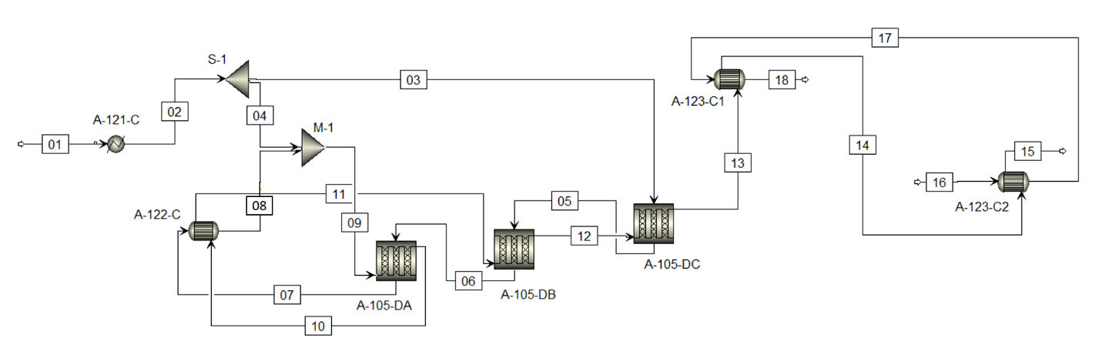
Figure 2.1. The Simulation of Ammonia Synthesis with PT Pupuk Kujang Unit IB Scheme with Aspen Plus©

Figure 2.1 shows the simulation of ammonia synthesis based on the scheme and operating conditions at PT Pupuk Kujang Cikampek Ammonia Unit IB. The reactor consists of a pressure shell and basket with three fixed bed reactors. Kinetically, there are only two beds because there is no intercooler between beds 2A (A-105-DB) and 2B (A-105-DC). The inlet gas flow A-105-D is divided into two, namely the feeds flow that enters through the annulus and the cold shot flow which serves to control the temperature of the reactor bed 1 (A-105-DA). The feed will go through the annulus on the three reactor beds and be heated in the intercooler (A-122-C) on the side of the tube. The cold shot is combined with the tube side A-122-C output current to the A-105-DA. The A-105-DA outlet moves towards the A-122-C shell side for cooling before entering A-105-DB. The product outlet from A-105-DC is cooled through the Ammonia Converter Effluent (A-123-C1/C2) which also serves to generate steam at the ammonia plant 1B.
      - Field Data and Assumptions
The thermodynamic model chosen is Peng-Robinson because it is used to calculate non-ideal gas mixtures (Tripodi et al., 2018). Incoming feed conditions are adjusted based on the latest data at PT Pupuk Kujang Cikampek Unit Ammonia IB. Feed enters the Ammonia Feed Reactor (A-121-C) at a temperature of 56°C and a pressure of 144.6 kg/cm2G. The feed flow rate was 4.2 m3/hour with a composition of 22.93% N2, 66.83% H2, 1.25% NH3, 5.23% CH4, and 3.76% Ar. The A-121-C outlet is set at 240°C. This is because there is still feed heating in the annulus and intercooler; hence the temperature entering the reactor is in the reaction temperature range of 350-525°C for Fe-based catalysts and 325-450°C for Ru/C (Liu, 2014). The product flow contains high energy; hence it is utilized for steam generation in A-123-C1 and A-123-C2. In this research, the BFW inlet temperature to A123-C2 used was 128°C with a pressure of 130 kg/cm2G. The length of the A-105-DA reactor is 5.78 meters, while the width is 2.55 meters. The A-105-DB reactor is 5.75 meters long and 2.55 meters in diameter. The A-105-DC reactor has a length of 5.80 meters and a diameter of 2.55 meters. The heat transfer coefficient for the three reactors is 5 Btu/hour.ft.°F according to the rule of thumbs for gas reactions (Couper et al., 2010). The approach temperature specification for the heat exchanger for fluids is at least 10°C (Turton, 2013); hence the approach temperature is chosen at 10°C.
The ammonia synthesis cycle has a broad scope and variables, hence assumptions must be employed. Assumptions employed in this research are as follows:
- Cycle based on steady state.
- Pressure drop in the heat exchanger, mixer, splitter, and reactor is extremely small, hence it can be neglected.
      - Kinetic Models
The reaction for the formation of ammonia is shown in Equation (1) (Brown et al., 2014). The ammonia formation reaction is a complex heterogeneous catalytic reaction, in which N₂, H₂ and NH₃ adsorption or desorption occurs on the surface of the catalyst.
$N_{2}+{3H}_{2}$ ↔${2NH}_{3} ∆H°=-46 kJ{mol}^{-1}$ | (1)
The kinetic modeling of the reaction for NH₃ formation was conducted using the Langmuir-Hinshelwood-Hougen Watson (LHHW) approach. The driving force of this reaction is the fugacity of each component raised to the power of the exponent for an alternating reaction. The LHHW approach is shown in Equation (2) (Tripodi et al., 2018).
(2)
$r=\frac{\left(k_{0 }e^{-\frac{Ea}{RT}}\right)\left(K_{for}\prod_{r}{}f_{r}^{vr}-K_{rev}\prod_{p}{}f_{p}^{vp}\right)}{{\left(\sum_{i}{}K_{i}\prod_{i}{}f_{i}^{vi}\right)}^{e}}$ | (2)
Many previous researches have represented the reaction of ammonia formation with Fe-based catalysts, namely magnetite and wustite with the Temkin equation shown in Equation (3) (Dyson and Simon, 1968). The gas phase reaction the activity of the component a_{i} is expressed as a fugacity function (f_{i}).
$$\frac{dη}{dτ}=k_{for}\left[({K_{a})}^{2}a_{N2}\left(\frac{{a_{H2}}^{2,25}}{{a_{NH3}}^{1,5}}\right)-\left(\frac{{a_{NH3}}^{0,5}}{{a_{NH3}}^{0,75}}\right)\right]$$ | (3)
$$a_{i}=\frac{f_{i}}{P^{Θ}}$$ | (4)
$$f_{i}=ϕ_{i}y_{i}P$$ | (5)
Equation (3) cannot represent the reaction kinetics of the Ru/C catalyst. This is due to differences in inhibitors; hence a modification of the Temkin equation is necessary so that it can be applied to Ru/C catalysts. Modification of the Temkin equation for the Ru/C catalyst with the LHHW approach is shown in Equation (6) (Rossetti et al., 2006).
$$\frac{dη}{dτ}=k_{for}\frac{{a_{N2}}^{0,5}\left[\left(\frac{{a_{H2}}^{0,375}}{{a_{NH3}}^{0,25}}\right)-\frac{1}{K_{a}}\left(\frac{{a_{NH3}}^{0,5}}{{a_{NH3}}^{0,75}}\right)\right]}{1+K_{H2}({a_{H2})}^{0,3}+K_{NH3}({a_{NH3})}^{0,2}}$$ | (6)
Kinetic data in the form of Ea values based on experimental results at temperatures of 400-460ºC with Fe-M and Fe-W catalysts of 47.5 and 44.9 kcal/mol and k₀ values of 3.23 x 10⁹ and 7.47 x 10⁸ kmol s⁻¹ kg_{cat}⁻¹ (Pernicone et al., 2003). Ru/C catalyst kinetics data has been validated in a simulation conducted by Tripodi et al., (2018) with an Ea value of 23 kcal/mol and k₀ of 426 kmol s⁻¹ kg_{cat}⁻¹. To implement the data in Aspen Plus©, the pre-exponential factor was corrected by considering the density of the catalyst being equal to 0.59 g cm⁻³ (Ru/C), 2.8–2.9 g cm⁻³ (magnetite) and 3.25 g cm⁻³ (wustite) (Tripodi et al., 2018).
      - Optimization Method with RSM
Response Surface Methodology (RSM) is a statistical calculation tool used for modeling and analyzing problems. The response it resulted is affected by parameters that can be controlled. The objective is to optimize by developing a model with the response surface method. RSM uses a sequential procedure where the first step is to decide the boundaries of the experimental area by identifying the range for each parameter. Next, the tool will design and plan the experiment using the appropriate DOE RSM approach.
  - Results and Discussions
    - Validation
This research compares Fe-M, Fe-W, and Ru/C catalysts. The scheme used is in accordance with PT Pupuk Kujang Cikampek Unit Ammonia IB which uses Fe-M catalyst. For validation purposes, the simulations with Fe-M catalyst were compared with the field data. The simulation results indicate a difference of 0.08% - 3.94%, hence the simulation model already represents the conditions in the field and can be used for further evaluation.
    - The Comparison of Simulation Results on Three Catalyst
The operating conditions in the simulation are in accordance with the PT Pupuk Kujang Cikampek Unit IB scheme, namely the inlet pressure at A121-C is 144 kg/cm²G, the temperature is 56°C and the flow rate is 4.2 m³/hour. Figure 3.1. shows the volume fraction profile of ammonia in each bed for the three types of catalysts. Based on Figure 3.1., ammonia conversion with Fe-based catalyst in bed 1 increases significantly. This indicates that the reaction is running rapidly. Meanwhile, the conversion in bed 2 and bed 3 shows a slower rate of formation. This is because the increasing volume fraction of ammonia will increase the inhibitory activity of Fe catalysts by ammonia. Meanwhile, the formation rate with the Ru/C catalyst in bed 1 is slower. This is due to the inhibition of the Ru/C catalyst by H₂ where the volume fraction was high at the beginning of the reaction, thus affecting the formation rate. According to Figure 3.1, the higher the temperature, the higher the ammonia volume fraction. However, ammonia formation does not occur at an overly high temperature because the reaction goes beyond the reaction temperature range. At outlet bed 3, the highest percentage of ammonia volume fraction was produced by the Fe-W catalyst of 15.86%. This result indicates that Fe-W has better catalytic activity compared to Fe-M and Ru/C in the PT Kujang Fertilizer Ammonia Unit 1B scheme.

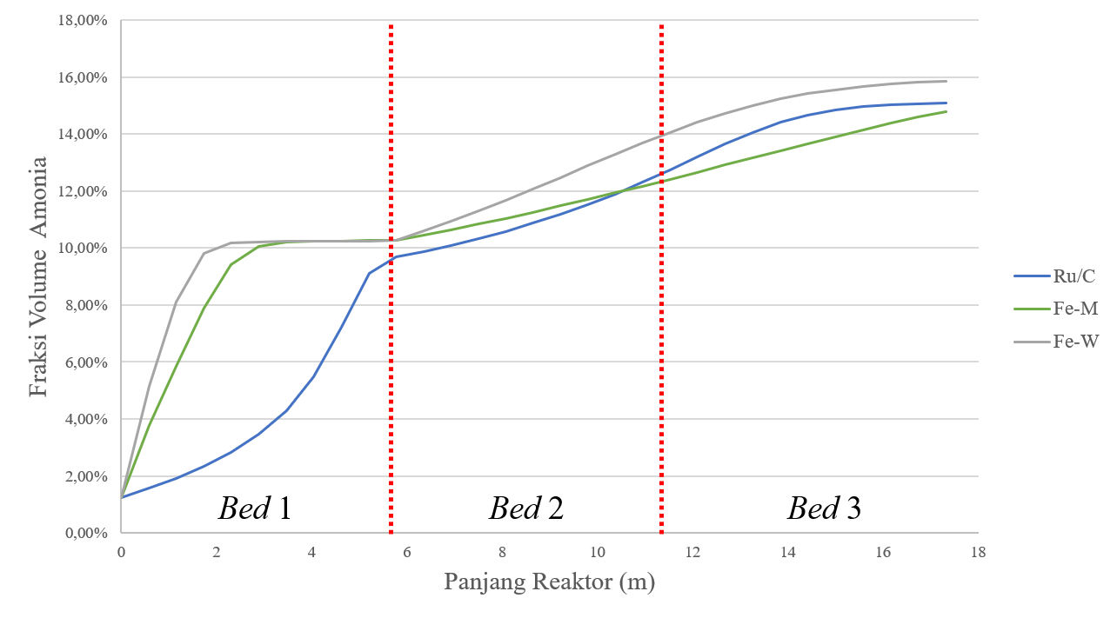
P = 144,6 kg/cm²G
Figure 3.1 Changes in Ammonia Concentration toward Reactor Length with Catalyst Variations

    - The Analysis of Inlet Temperature Sensitivity toward Volume Fraction, Ammonia Product, and Mass Enthalpy Product
Response surface analysis (RSM) method is used to determine the temperature of incoming feed reactor which produces the optimum volume fraction, ammonia product, and mass enthalpy. Based on the optimization conducted with Minitab 19, the results showed that the Fe-W catalyst produced the most product of 1151.91 tons/day and a mass enthalpy of 52.35 kcal/kg. These results are obtained at a current 09 temperature of 377.7°C.
    - The Analysis of Wustite Cold Shot Opening Variations toward Ammonia Product
The simulation was tried on the catalyst that gave the most ammonia conversion and products, namely the Wustite-type Fe-based catalyst. The operating conditions used were adjusted to the operational conditions with A-121-C exit temperature at 140°C with 144.6 kg/cm₂G pressure. The higher the fraction that enters the annulus bed 3, the less the opening in the cold shot. The chart shows that opening a cold shot has no significant effect on the product. However, there is one optimum point that generates the maximum product, which is 1176.19 tons/day at the inlet fraction to the annulus bed 3 of 52% or the opening of a cold shot of 48%. After reaching the optimum condition, the product will decrease if the opening of the cold shot is increased.
  - Conclusion
The simulation results conducted on PT Pupuk Kujang Cikampek Unit Ammonia IB scheme and operating conditions show that the wustite catalyst generates more ammonia products than Ru/C and magnetite. In the optimization, the reactor inlet temperature conditions for Ru/C, magnetite, and wustite catalysts are 360.4°C; 386.1°C; and 377.7°C with ammonia products of 1140.98 tons/day, 1099.00 tons/day and 1151.94 tons/day, as well as a mass enthalpy of 42.44 kcal/kg, 61.61 kcal/kg, and 52.35 kcal/kg. Variation of cold shot opening has no significant effect on the ammonia product, but there is an optimum point at 48% opening.
References
Brown, D. E. et al. (2014) ‘The genesis and development of the commercial BP doubly promoted catalyst for ammonia synthesis’, Catalysis Letters, 144(4), pp. 545–552. doi: 10.1007/s10562-014-1226-4.
Couper, J. R. et al. (2010) Chemical Process Equipment. 2nd edn, Process Technology. 2nd edn. Burlington, United States of America: Butterworth-Heinemann. doi: 10.1515/9783110712445-007.
Dyson, D. C. and Simon, J. M. (1968) ‘A kinetic expression with diffusion correction for ammonia synthesis on industrial catalyst’, Industrial and Engineering Chemistry Fundamentals, 7(4), pp. 605–610. doi: 10.1021/i160028a013.
Hagen, S. et al. (2003) ‘Ammonia synthesis with barium-promoted iron-cobalt alloys supported on carbon’, Journal of Catalysis, 214(2), pp. 327–335. doi: 10.1016/S0021-9517(02)00182-3.
Kalaivanan, R., Ganesh, N. V. and Al-mdallal, Q. M. (2020) ‘Case Studies in Thermal Engineering An investigation on Arrhenius activation energy of second grade nanofluid flow with active and passive control of nanomaterials’, Case Studies in Thermal Engineering, 22(November), p. 100774. doi: 10.1016/j.csite.2020.100774.
Kowalczyk, Z. et al. (1998) ‘Effect of potassium and barium on the stability of a carbon-supported ruthenium catalyst for the synthesis of ammonia’, Applied Catalysis A: General, 173(2), pp. 153–160. doi: 10.1016/S0926-860X(98)00175-6.
Liu, H. (2014) ‘Ammonia synthesis catalyst 100 years: Practice, enlightenment and challenge’, Cuihua Xuebao/Chinese Journal of Catalysis, 35(10), pp. 1619–1640. doi: 10.1016/S1872-2067(14)60118-2.
Liu, H. et al. (2020) ‘Development and application of wüstite-based ammonia synthesis catalysts’, Catalysis Today, 355, pp. 110–127. doi: 10.1016/j.cattod.2019.10.031.
Pernicone, N. et al. (2003) ‘Wustite as a new precursor of industrial ammonia synthesis catalysts’, Applied Catalysis A: General, 251(1), pp. 121–129. doi: 10.1016/S0926-860X(03)00313-2.
Smith, J. M., Van Ness, H. C. and Abbott, M. M. (2005) Introduction to Chemical Engineering Thermodynamics. 7th edn. Boston: McGraw-Hill.
Tripodi, A. et al. (2018) ‘Process simulation of ammonia synthesis over optimized Ru/C catalyst and multibed Fe + Ru configurations’, Journal of Industrial and Engineering Chemistry, 66, pp. 176–186. doi: 10.1016/j.jiec.2018.05.027.
Turton, R. (2013) Analysis, Synthesis, and Design of Chemical Processes Fourth Edition, Journal of Chemical Information and Modeling.
Yoshida, M. et al. (2021) ‘Economies of scale in ammonia synthesis loops embedded with iron- and ruthenium-based catalysts’, International Journal of Hydrogen Energy, 46(57), pp. 28840–28854. doi: 10.1016/j.ijhydene.2020.12.081.

