A Nash equilibrium approach to supply chain design of oligopoly markets under uncertainty
Asimina Marousiª, Karthik Thyagarajan^{b}, Jose M. Pinto^{b}, Lazaros G. Papageorgiou ª, Vassilis M. Charitopoulos ^{a*}
ªDepartment of Chemical Engineering, Centre for Process Systems Engineering, University College London, Torrington Place, London WC1E 7JE, UK
^{b}Linde Digital Americas, 10 Riverview Drive, Danbury CT 06810, United States
v.charitopoulos@ucl.ac.uk
Abstract
An increased interest has been observed by the process systems community for the integration of game theoretic principles to the design and operation problems, especially of supply chains. This integration can achieve a better insight to the problem at hand and at the same time build resilience. In this work we aim to further increase the stability of a supply chain design problem by taking into account uncertainty. An oligopoly Nash bargaining game is proposed under a scenario-based approach in order to fairly allocate the profit among the members of a duopoly industrial gas market. The nonlinearity stemming from the Nash objective is linearised by a piecewise SOS2 linear approximation resulting in an MILP class. The design of the scenario-based approach is compared with that of the deterministic case for a number of sampled uncertainty realisations. Results suggest that the scenario-based approach can better leverage the capacity potential of the duopoly while guaranteeing higher profits and maintaining the market share of the initial market.
Keywords: game theory, Nash bargaining, supply chain optimisation, uncertainty, scenario- based optimisation.
  - Introduction
The study of supply chains under a game theoretic framework has met an increasing interest in the process systems engineering community (Marousi and Charitopoulos (2023)). Depending on the structure of the game and the timing of the decision making among the players, supply chains can be represented either as competitive or cooperative games. Competitive games are commonly modeled as Stackelberg games which result in bi-level or tri-level programming problems (Florensa et al. (2017)). On the other hand, when the total payoff of a game is to be allocated fairly among the players of the game, various egalitarian or utilitarian schemes can be employed. The Nash bargaining fairness scheme is commonly utilised for the profit allocation in supply chains since the relevant market share of the stakeholders in the status quo market is maintained. However, the main drawback of this method is that it results in a nonlinear objective function. Researchers in the past decades have approximated the Nash bargaining objective via separable programming and piecewise-linearisation in various applications (Ortiz-Gutiérrez et al. (2015), Charitopoulos et al. (2020)). Game theory has been insightful in cases where the supply chain stakeholders have conflicting objectives. Recently, Marousi et al. (2023a) have introduced a cooperative approach where manufacturers and customers of industrial gas oligopoly markets are players of the game. The former aim to maximise their profit while the latter maximise their savings by signing various contracts in a multi-periods deterministic model.
Even though supply chain design problems are inherently uncertain, especially in the case of multi-period considerations, most of the research in the field focuses on deterministic approaches (Barbosa-Póvoa et al. (2018)). Zamarripa et al. (2013) studied the problem of supply chain strategic planning as multi-objective game where the different strategies of the stakeholders were represented by different scenarios. While Zamarripa and co-authors study both a cooperative and competitive case, Hjaila et al. (2017) focused on a Stackelberg game when examining the operation of multi-echelon supply chains under uncertain competition. Different scenarios for the expected payoff were generated using the Monte Carlo sampling method. Following the Stackelberg approach, Gao and You (2019) developed a two-stage stochastic mixed-integer bi-level programming (MIBP) model in search of the optimal design and operation of multi-enterprise supply chains.
  - Problem statement
We consider the problem of a two-echelon oligopoly supply chain in multi-period framework. The problem was initially proposed as a static game in Charitopoulos et al. (2020) and extended in a multi-period framework under contractual agreements in Marousi et al. (2023b). Here, we investigate the impact of exogenous uncertainty on the fair profit allocation in an industrial gas market. The firms of the market are assumed to be acting rationally and have an estimate of the other firms’ information. Customers can be assigned to firms via contractual agreements and can be re-allocated at the end of a contract’s duration. Previous results of the authors have suggested that employing the Nash bargaining fairness scheme can provide significant profit increase for the oligopoly firms compared to the status quo, while at the same time maintaining the initial market structure (Charitopoulos et al. (2020), Marousi et al. (2023a,b)).
    - Model formulation outline
The overall optimisation problem is formulated as a MILP with key features including: (i) contract formulation, (ii) plant production shortcut model, (iii) inter-firm swap agreements, (iv) inventory levels, (v) electricity service cost. Given the planning horizon of P time periods, the number of firms F, producing I products at known plant capacities, the allocation of existing and new customers C with deterministic demand and delivery costs is to be optimized. We consider two sources of uncertainty in the model, one affecting the pricing of the contracts K and the other the expected electricity price. In this work we are following a risk-neutral two-stage scenario-based approach (Li and Grossmann (2021)).
    - Two-stage scenario-based approach
In the first-stage stochastic problem the allocation of the customers is decided along with the planning of the supply of the supply chain in terms amount of production, swaps between firms, outsourcing of production to spot market and inventory levels, which correspond to the here and now decision variables. The second stage decisions account for the operation of the Air Separation Unit (ASU) of the oligopoly firms. Let $π_{pfs}$ be the profit of a firm f in a time period p and a scenario s is given by Eq.(1), where $Rev_{fps}$ corresponds to the revenue, $EC_{fps}$to the electricity cost and $SC_{fp},IC_{fp}, AFC_{fp}$ the service, inventory and acquisition/forfeit costs respectively. It can be observed that only the first two terms of the profit calculation in Eq. (1) are scenario dependent.

$$π_{fps}=Rev_{fps}-EC_{fps}-SC_{fp}-IC_{fp}-AFC_{fp}, ∀f,p,s$$ | (1)
In order to clarify how uncertainty affects the examined supply chain we need to give a more detailed description of the terms $Rev_{fps}$ and $EC_{fps}$ in Eq. (2) and (3). The revenue of the firm is dictated by the selling price $P_{icfpks}$ and the selected contract $W_{cfkp}$, the former being the uncertain parameter and the later a binary here and now variable for the customer allocation. In this study we consider deterministic customer demands $D_{icfkp}$. For a detailed description of the product price with respect to the different contracts we refer the reader to Marousi et al. (2023b).
$$Rev_{fps}=\sum_{ick}{P_{icfpks}W_{cfkp}D_{icfkp}}, ∀f,p,s$$ | (2)
Since ASU are energy intensive industries converting atmospheric air to gas and liquid products, electricity consumption dominates the operating cost of the process (Mitra et al. (2014)). To achieve more favourable electricity prices, industrial gas firms are often part of demand side response schemes. A fixed electricity price $EP_{ps}$ is agreed with the energy system operator within pre-specified electricity consumption tiers. In the case of over or under-consumption of energy outside those limits a penalty $a$ is imposed on the electricity price. The electricity consumption is a wait and see decision and is derived using an ASU short-cut model, it is divided into the energy consumption within the specified consumption tiers $θ_{fps}$ , over-consumption above the tiers $δ_{fps}^{+}$ and under-consumption $δ_{fps}^{-}$. Parameter $OT$ in Eq. (3) corresponds to the operating time of the ASU unit for the decided time period duration.
$$EC_{fps}=EP_{ps}OT(θ_{fps}+(1+a)\left(δ_{fps}^{+}+δ_{fps}^{-}\right)), ∀f,p,s$$ | (3)
For the scenario-based model we account for 5 equiprobable scenarios for different perturbations (low-medium-high) of the nominal product price and electricity price as displayed in Table 1.
Table 1Perturbation of uncertain parameters in examined scenarios.
Uncertain parameter | Scenario 1 | Scenario 2 | Scenario 3 | Scenario 4 | Scenario 5
$$P_{icfpks}$$ | Medium | High | High | Low | Low
$$EP_{ps}$$ | Medium | Low | High | Low | High
    - Fair objective function
For the fair profit allocation between the oligopoly firms the Nash bargaining fairness scheme is selected and represented for each scenario in Eq. (4). However, Eq. (4) corresponds to a non-convex polynomial equation whose order depends on the number of firms. A separable programming approach is well studied in the literature for the Nash bargaining scheme following a logarithmic transformation resulting in Eq. (5) (Marousi and Charitopoulos (2023)).
$Ψ_{s}=\prod_{f}{\left(π_{fs}-π_{fs}^{sq}\right)} ∀s$ | (4)
$Φ_{s}= \ln{Ψ_{s}}=\sum_{f}{\ln\left(π_{fs}-π_{fs}^{sq}\right)} ∀s$ | (5)
Given the probability of a scenario realization $p_{s}$, the scenario-based Nash bargaining objective can be formulated in Eq. (6).
$Φ^{'}=\sum_{s}{p_{s}Φ_{s}}=\sum_{s}{p_{s}}\left(\sum_{f}{\ln\left(π_{fs}-π_{fs}^{sq}\right) }\right)$ | (6)
Despite the logarithmic transformation the overall problem class remains as MINLP which can be computationally challenging in large scale multi-period problems. To this end, a SOS2 piecewise linearisation for n breakpoints is performed resulting in Eq. (7) and the additional constraints in Eq. (8), (9).
$\tilde{Φ}=\sum_{fs}{p_{s}}\left(\sum_{fn}{\ln\left({\tilde{π}}_{fsn}-π_{fs}^{sq}\right)λ_{fsn} }\right)$ | (7)
$\sum_{n}{λ_{fsn}}=1 ∀f,s$ | (8)
$π_{fs}=\sum_{n}{{\tilde{π}}_{fsn}λ_{fsn}} ∀f$ | (9)
The objective function for the deterministic case can be similarly derived as suggested by the authors in Marousi et al. (2023b).
  - Case study
For the purpose of this paper, a duopoly case study is examined from an industrial liquid market. The market is comprised of 2 firms and 97 customers. At the status quo, Firm A serves 44 customers and Firm B 37, while there are 16 free customers that allow a market share growth. The selected time horizon is 8 years discretised in 32 quarterly periods. We examine three contracts of 1 year, 2 years and 3 years duration that result in different pricing schemes. Note that the contracts are binding and cannot be terminated before the predefined duration. The computational experiments were carried in an Intel®Core™i9-10900K CPU @ 3.70GHZ machine using GAMS Studio v.44.4 with Gurobi v10.0 with 20 threads. The optimality gap was set to 1%. The number of grid points for both the deterministic and the scenario-based model was selected as n=500. The original MINLP problem for both models was solved using BARON (Sahinidis (1996)), however no convergence was achieved for 5 days running time.
The aspects that are of interest in this study are how the introduction of scenarios affects the here and now decisions and if the scenario-based model can result in a more favorable market allocation for different uncertainty realisations.
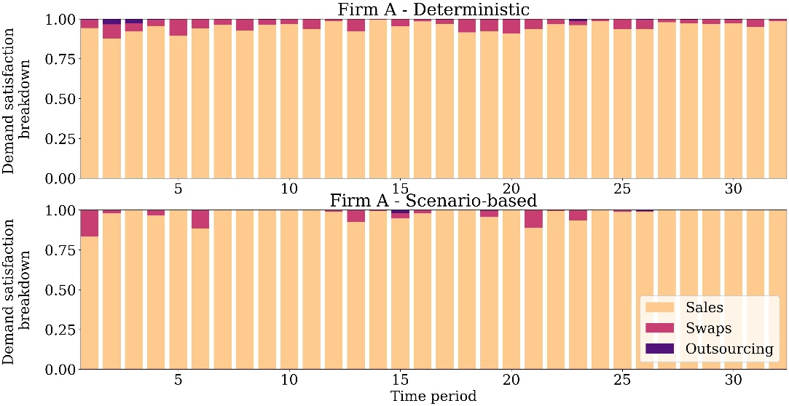Figure 1 Demand satisfaction breakdown for Firm A for the Deterministic and Scenario-based models.
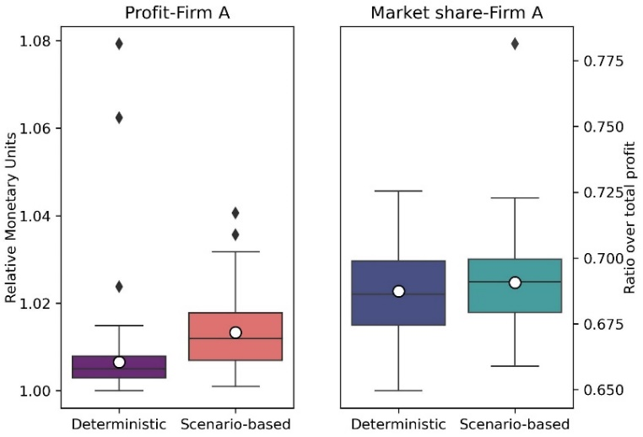
The first aspect is evaluated in Figure 1 where the demand satisfaction breakdown is displayed for Firm A and the different models. It can be observed that in the solution of the deterministic model Firm A is acquiring product from Firm B via swaps in all the examined time horizon ranging from 3 to 10% of the total demand to be covered. For three time periods Firm A refers to the spot market to cover the allocated demand at a significantly higher cost. One of the modeling assumptions is that swap amount between firms should be balanced at predefined time periods in the examined time horizon (Marousi et al. (2023b)). Hence the use of the spot market does not necessarily imply that the capacity of the duopoly is not sufficient, but rather that under the deterministic customer allocation the full potential of the capacity is not fully captured. On the contrary, the scenario-based solution results in a customer allocation in which Firm A relies in fewer periods to swaps and almost no outsourcing is taking place.
Figure 2 Profit (left) and market share (right) of Firm A for the Deterministic and Scenario-based models for Monte Carlo samples.
To further evaluate the acquired solutions for the two models, we have generated 100 uncertainty samples using Monte Carlo simulation by allowing a perturbation of 20% of the nominal prices. For fixed customer and contract allocation, the statistical results for the profit in terms of Relative Monetary Units (RMU) and market share of Firm A are presented in Figure 2. The deterministic customer allocation results in tighter profit distribution with a median of 1.005 RMU, however for 3 samples the profit peaked at 1.02, 1.06 and 1.08 RMU. For the scenario-based allocation there is a wider interquartile range around the median of 1.01 RMU which suggest a higher flexibility of the model. Apart from the outlier values, the profit of Firm A is higher for the scenario-based customer allocation. Even for a small number of selected scenarios the extra flexibility introduced in the model is beneficial for the firm. Since the aim is to maintain a fair profit allocation, it is important to evaluate the market share allocation. In the status quo market, Firm A hold 80% of the market in terms of profit. The Nash bargaining solution results in a decreased market share for Firm A for both models. Nevertheless, Firm A maintains the dominance over the market since for the deterministic model the median market share is 68.6% and 69.1% for the scenario-based model. There is only a single uncertainty realisation at which the scenario-based model can reach a 72.5% market share. Despite the outliers detected in the profit for the deterministic model, there are no outliers for the market share, suggesting that the profit of Firm B was analogously high in those samples.
  - Conclusions
Even though the use of game theoretic principles is widely used for the supply chain design problems, the consideration of uncertainty is very limited in the process systems engineering literature. This paper examines the effect of a scenario-based approach on the Nash bargaining game for profit maximisation in a duopoly industrial gas supply chain. The scenario-based design is juxtaposed with the deterministic one for a number of sampled uncertainty realisations. Results indicate that the scenario-based approach proposes a more efficient customer allocation in terms of capacity planning and thus achieving higher profits. At the same time the fairness of the profit allocation is safeguarded since the market share of the initial market is overall maintained.
Acknowledgements: The authors gratefully acknowledge financial support from EPSRC grants EP/V051008/1, EP/T022930/1 and EP/V050168/1.
References
A. P. Barbosa-Póvoa, C. da Silva, A. Carvalho, 2018. Opportunities and challenges in sustainable supply chain: An operations research perspective. Eur. J. Oper. Res. 268, 399-431.
V. M. Charitopoulos, V. M. Dua, J. M Pinto, and L. G. Papageorgiou, 2020. A game-theoretic optimisation approach to fair customer allocation in oligopolies. Opt. Eng. 21, 1459–1486.
C. Florensa, P. Garcia-Herreros, P. Misra, E. Arslan, S. Mehta, I. E. Grossmann, 2017. Capacity planning with competitive decision-makers: Trilevel MILP formulation, degeneracy, and solution approaches. Eur. J. Oper. Res. 262(2).
J. Gao, and F. You, 2019. A stochastic game theoretic framework for decentralized optimization of multi-stakeholder supply chains under uncertainty. Comput. Chem. Eng. 122, 31–46.
K.Hjaila, L. Puigjaner, , J. M. Laínezand and A. Espuña, 2017. Integrated game-theory modelling for multi enterprise-wide coordination and collaboration under uncertain competitive environment. Comput. Chem. Eng. 98, 209–235.
M. N. Koleva, A.J Calderón, D. Zhang, C.A Styan, L. G. Papageorgiou, 2018. Integration of environmental aspects in modelling and optimisation of water supply chains. Sci. Total Environ. 636, 314–338.
C. Li and I.E. Grossmann 2021. A review of stochastic programming methods for optimisation of process systems under uncertainty. Front. Chem. Eng. 2, 34.
A. Marousi, V. M. Charitopoulos, 2023. Game theoretic optimisation in process and energy systems engineering: A review. Front. Chem. Eng., 5, 1-13.
A. Marousi, J. M. Pinto, L. G. Papageorgiou, V. M. Charitopoulos, 2023a. Multi-period optimisation of oligopolies with contracts: A cooperative approach to customer fairness. Comput. Aided Chem. Eng. 52, 1603-1608.
A. Marousi, K.Thyagarajan, J. M. Pinto, L. G. Papageorgiou, V. M. Charitopoulos, 2023b. A multi-period game-theoretic approach to market fairness in oligopolies. arXiv:2311.10655 [math.OC].
S. Mitra, J. M. Pinto, I. E. Grossmann, 2014.Optimal multi-scale capacity planning for power-intensive continuous processes under time-sensitive electricity prices and demand uncertainty. Part I: Modeling, Comput. Chem. Eng. 65,89-101.
R. A., Ortiz-Gutiérrez, S. Giarola, N. Shah, F. Bezzo, 2015. An approach to optimize multi-enterprise biofuel supply chains including nash equilibrium models. Comput. Aided Chem. Eng. 37, 2255–2260.
N. V Sahinidis., BARON: A general purpose global optimization software package, J. Glob Opt., 8:201-205, 1996.
M. A. Zamarripa, A. M. Aguirre, C. A. Méndez, and A. Espuña,, 2013. Mathematical programming and game theory optimization-based tool for supply chain planning in cooperative/ competitive environments. Chem. Eng. Res. Des. 91, 1588–1600.

