**A Genetic Algorithm-Based Design for Hydrogen Pipeline Infrastructure with Real Geographical Constraints**

Joseph Hammond,a Manou Rosenberg,b Solomon Brown,a*

*aDepartment of Chemical & Biological Engineering, University of Sheffield, Sheffield, S1 3JD, England, UK*

*bCurtin Centre for Optimisation and Decision Science, Curtin University, Perth, Australia*

*\*s.f.brown@sheffield.ac.uk*

**Abstract**

As industries grapple with net-zero constraints, increasing attention is directed at new hydrogen pipeline infrastructures that benefit from economies of scale and shared-use between producers and consumers. However, uncertainties in the design and cost of new infrastructure deters investment and, in turn, obstructs the progress of carbon-intensive sectors achieving net-zero targets (DESNZ, 2023).

Accurate pipeline routing is a key stage when determining optimised infrastructure in network design models, such as AENI (Ejeh, 2023a). Routing needs to handle costly-to-cross areas, significantly impacting the capital and operational costs. This typically requires the traversal of complex environments, which can be represented as obstacles of two types: 1) hard obstacles that cannot be traversed, such as protected areas; and 2) soft obstacles that can be traversed with a higher financial cost, such as densely populated areas and difficult terrains. Previous attempts at modelling the routing of pipeline infrastructures have evaded hard obstacles (Heijnen et al., 2013), but none yet demonstrate a capability to design a path with considerations of penetrable but resistant (soft) obstacles.

In this paper, we propose a two-step pipeline design methodology for a hydrogen network within an industrial cluster. A graph-based genetic algorithm (Rosenberg et al., 2021) defines the topological arrangement of new pipeline infrastructure in the presence of geographical constraints without using predefined corridors. Then, we apply a state-of-the-art MINLP model to define the dimensions based on commercially available sizes, with the objective of minimising the network’s capital and operational costs.

This paper’s novelty is defined by its approach to design the topology of a spatially explicit pipeline infrastructure with considerations of hard and soft obstacles that represent real geographical constraints.

The assessment looks at the regional case study of the Humber cluster in the UK, based upon infrastructural development plans for large-scale hydrogen production and industrial consumers (National Grid, 2022). We demonstrate the method’s ability to consider geographical constraints to design practical pipeline routes.

**Keywords**: Network optimisation with obstacles, Genetic Algorithm, MINLP, Pipeline design.

**1. Background**

In the UK, forthcoming hydrogen pipeline infrastructures are planned to connect large industrial sites over vast regions (National Grid, 2022). Historically, gas pipeline networks evolved incrementally, growing node-by-node with increasing demand, leading to sub-optimal designs. A push for net-zero emissions has incentivised designing new infrastructures, such as hydrogen networks, from the ground up with the advantage of leveraging advanced computational methods to optimise the design and test configurations before the practical implementation.

Pipeline networks are commonly modelled using graphs, where the producers and consumers serve as nodes and the pipeline routes as capacitated arcs (Heijnen et al., 2013). Given that both network topology and pipeline sizing are computationally challenging problems, comprehensive design often bifurcates into separate models for each. Uncapacitated Minimum Spanning Tree (MST) algorithms, such as Kruskal’s, have been widely used in pipeline design to minimise the network’s length as a proxy for cost (André et al., 2013). Yet, real pipeline routes are characterised by complex geometries that consider real-world constraints, such as areas that cannot be traversed by pipelines or where traversal incurs a higher cost or risk. In graphs, these can be represented by hard (non-traversable) and soft (traversable) obstacles. Considering this, some studies avoid optimising the network structure by leveraging existing infrastructure, such as roads or gas networks, to predefine candidate routes (Parolin et al., 2022). This provides a convenient method to evade obstacles by nature of the route’s existence. However, it does not provide a method to define a novel route around the obstacles nor indicates its applicability to new infrastructure, thereby limiting topological flexibility and potential for improvement.

Graph-based methods have utilised Steiner points - nodes with no supply or demand – which can further reduce the network length and enhance topological flexibility. Heijnen et al. (2013) explored this concept, offering a geometric heuristic method for designing a single-source capacitated network around hard obstacles using Steiner points. However, this approach proved limiting, displaying slow procedural times for case studies featuring few hard obstacles and terminals. Furthermore, the method is not easily extendable to soft obstacles. More recently, Rosenberg et al. (2021) demonstrated the feasibility of designing networks around hard and soft obstacles using Steiner points. Rosenberg et al. developed a Genetic Algorithm (GA) for the Steiner tree problem with soft and hard obstacles with small errors. To the author’s knowledge, a topological method of comparable fidelity as Rosenberg et al. has not been applied to a gas pipeline infrastructure problem.

While the network topology aims to overcome spatial challenges, the pipeline’s physical dimensions have their own set of constraints, requiring another layer of optimisation. In gas pipeline design, the capacity is derived from the relationships between the flow rate, pipe diameter, and pressure gradient, resulting in a non-linear optimisation space. To alleviate computational intensity, some studies, such as Baufumé et al. (2013) and Welder et al. (2018), fix the gas velocity, linearising the optimisation space. However, Reuß et al. (2019) highlighted the limitations of this approach in hydrogen network design, noting that the cost discrepancy between the linear and non-linear approaches increased with larger flows. Additional considerations in pipeline sizing have been put forth by Robinius et al. (2019) and Ejeh et al. (2023b). Robinius et al. described the optimisation formulation with discrete arc sizing, making an allowance for commercially available sizes. More recently, Ejeh et al.’s Mixed-Integer Non-Linear Programming (MINLP) formulation for CO2 pipeline design presented a highly encompassing model with hydraulic, structural, commercial, and velocity constraints.

In the UK, hydrogen networks planned to decarbonise industrial clusters are expected to have high flowrates and complex, cross-region topologies. Therefore, a need arises for high-fidelity techniques that consider the complexities of pipeline design. Candidate routing methods do not provide the flexibility and generality desired from design models, while graph-based topological methods have sparsely tackled obstacle handling within pipeline design, particularly at large spatial scales and with soft obstacles. In the proposed approach, a Genetic Algorithm (GA) defines the topology around user-defined soft polygonal obstacles, and a MINLP model defines the pipeline dimensions according to commercially available sizes with structural and velocity constraints.

The computational methods are described in Section 2 and then applied to a case study described in Section 3. Section 4 discusses the findings and results, and Section 5 concludes this work.

**2. Methodology**

The proposed method finds optimised infrastructures for hydrogen pipeline networks that connect a given set of demand and supply points while considering real-world constrained areas, where pipelines cannot be built or incur a higher cost. The problem is represented as a graph with constrained areas represented as simple polygonal obstacles in the plane. The obstacles are classified as soft or hard obstacles, depending on whether they can be traversed. This is determined by their attributed crossing weight which is used as a multiplying factor to the length of the pipeline connection that crosses the obstacle. In case of a hard obstacle, this crossing weight is set to infinity.

*2.1. Topology*

Separating the topology and sizing requires an implicit assumption that minimising the total length will lead to the most cost-efficient network infrastructure. To find a minimal-length network connecting supply and demand points considering constrained areas we apply the Euclidean Steiner tree problem with soft and solid obstacles (ESTPO). This generalises the well-known computationally difficult Steiner tree problem in the plane.

To solve this problem for the given set of hydrogen supply and demand points as terminals and case-specific constrained regions as obstacles, we apply the genetic algorithm for Steiner trees with obstacles (StObGA) developed by Rosenberg et al. (2021). This GA is based on the following chromosome structure that is comprised of two parts: the first part represents the number and x-y-coordinates of Steiner points and is of variable length, and the second part is a fixed-length binary list determining which of the obstacle corner points are used in the network. For example, the chromosome

|  |  |
| --- | --- |
|  | (1) |

includes *s* Steiner point locations and uses four obstacle corner nodes. The final network connections are then calculated using Kruskal’s MST algorithm to connect all terminals, Steiner points, and obstacle nodes using edges weighted based on their length and whether they cross any obstacles. For further details, refer to Rosenberg et al. (2021).

To finalise the topology, the nodes and edges found by the GA are input into an optimisation that directs the edges as appropriate for the given production and consumption. It is assumed that the edges are unidirectional.

*2.2 Sizing*

The sizing of pipelines is designed using a MINLP optimisation with hydraulic, structural, and commercial constraints. The objective function, equation 2, minimises the total cost *C* of a set of pipelines, arcs *A*. The total cost is the addition of the capital costs *CC*, given in equation 3 (NREL, 2018), and operating costs, assumed to equal 4% of the capital cost. The costs are a function of a pipeline’s length *L* and outer diameters *Dpo*, and consider the material, labour, right-of-way, and other miscellaneous costs.

|  |  |
| --- | --- |
|  | (2) |
| $C_{ij}^{C}=43079L_{ij}×e^{0.0697D_{ij}^{po}}+251.7{(D_{ij}^{po})}^{2}+60848D_{ij}^{po}+303657$ | (3) |

The optimisation is constrained by a material balance, hydraulic behaviour, discrete sizing, and the erosion velocity, as described by Ejeh et al. (2023b).

**3. Case Study**

The methodology of Section 2 was applied to the case study in Figure 1, which displays the pipeline route planned by the National Grid (2022) as validation. The case study depicts a high-capacity pipeline infrastructure with two producers and four consumers across the geographically complex Humber region. Additional pipelines are known to be planned for storage points in Easington and Aldbrough, but high-resolution route plans have not been disclosed, so those pipelines are out-of-scope. We assume compressor stations exist at the terminal sites and junctions (nodes with more than two connections).

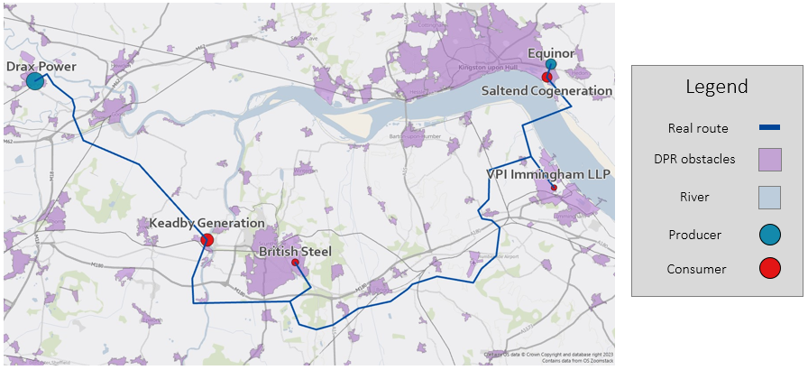

Figure 1: Humber region with planned pipeline route outlined by the National Grid (2022). Hydrogen sites are sized proportionally according to their production/consumption.

Soft obstacles are used to represent densely populated regions (DPRs) and the river Humber, which is the most significant geographical obstacle. The obstacles are represented by polygons, with a total of 406 corners. The weightings for the soft obstacles are literature-based terrain factors; however, due to a lack of literature on the terrain factors concerning hydrogen, we assume CO2 infrastructure values will be satisfactory. The spread of the terrain factor values is broad, so the assumption is not presumptuous. We assume that DPRs and rivers require two times and four times the standard investment, respectively (van den Broek et al., 2013).

**4. Results and Discussion**

The topological results are presented in Figure 2. The GA-generated route is compared to the real pipeline route. The GA’s route reflects a pathway previously considered by National Grid (Geels et al., 2023). The routes share the same interconnections between terminals but differ in structure. The most significant deviation is around Scunthorpe; the GA’s route takes a shorter route between Keadby and British Steel. The real network’s manoeuvre around the bottom of Scunthorpe could be due to obstacles not considered here, such as the crossing of significant roads, terrain, land permissions, etc. or further network considerations such as anticipated connections. Table 1 presents the total network lengths, total costs (capital + operating), and the difference in cost from the real pipeline route’s values, sized using the same technique. An MST configuration is similarly costed without consideration of obstacles for comparison to an existing method.

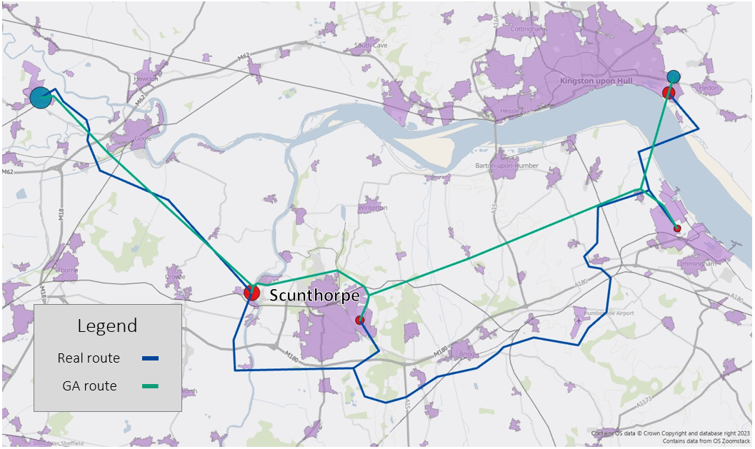

Figure 2: Humber region with the GA-generated route and real pipeline route.

Table 1: Infrastructure summary with calculated costs based on the derived pipeline lengths and diameters.

|  |  |  |  |
| --- | --- | --- | --- |
| Scenario | Total length (km) | Total cost (£million) | Cost difference from real (%) |
| Real | 101 | 79.1 | - |
| GA | 72 | 58.5 | 26 |
| MST | 69 | 38.8* | 51* |

*Calculated without consideration of obstacles.

**5. Conclusion**

In this work, we tackled hydrogen pipeline design, focused mostly on improving the topological arrangement. The consideration of soft obstacles allows the model to operate more flexibly and compromise the length on behalf of reducing costs. We have shown that this technique leads to more realistic route proposals and lengths that coincide with real networks. Furthermore, it opens the possibility of backwards analysis to understand the heuristic judgements that experts make on the costs and risks of traversing areas of interest. Future work should expand on the obstacles considered here, increase the interconnectedness between the design stages to avoid sub-optimal decisions and increase the temporality in the short- and long-term to understand how the design stages are altered with the prospect of network evolution.

**References**

André, J., Auray, S., Brac, J., Wolf, D., Maisonnier, G., Ould-Sidi, M., Simonnet, A., 2013. Design and dimensioning of hydrogen transmission pipeline networks. European Journal of Operational Research, Vol. 229, No. 1, p. 239-251.

Baufumé, S., Grüger, F., Grube, T., Krieg, D., Linssen, J., Weber, M., Hake, J.-F., Stolten, D., 2013. GIS-based scenario calculations for a nationwide German hydrogen pipeline infrastructure. International Journal of Hydrogen Energy, Vol. 38, No. 10, p. 3813-3829.

DESNZ, Department for Energy Security and Net Zero, 2023. Hydrogen transport and storage infrastructure: government response. UK.

Ejeh, J. O., Blazejewski, T., Martynov, S., Brown, S., 2023a. AENI: Agent-based energy network infrastructure design and operation. AlChe Annual Meeting 2023.

Ejeh, J. O., Marynov, S., Brown, S., 2023b. An MINLP model for the optimal design of CO2 transportation infrastructure in industrial clusters. 33rd European Symposium on Computer Aided Process Engineering (ESCAPE33).

Geels, F., Sovacool, B., Iskandarova, M., 2023. The socio-technical dynamics of net-zero industrial megaprojects: Outside-in and inside-out analyses of the Humber industrial cluster. Energy Research & Social Science.

Heijnen, P. W., Ligtvoet, A., Stikkelman, R. M., Herder, P. M., 2013. Maximising the worth of nascent networks. Networks and Spatial Economics, Vol. 14, No. 1, p. 27-46.

National Grid, 2022. Humber low carbon pipelines project: Section maps of the proposed route for consultation. Available at: https://www.nationalgrid.com/our-businesses/national-grid-ventures/humber-low-carbon-pipelines/documents (Accessed: 13 September 2023).

NREL, National Renewable Energy Laboratory, 2018. H2A: Hydrogen Analysis Production Models Version 3. Available at: https : / / www . nrel . gov / hydrogen / h2a - production-models.html.

Parolin, F., Colbertaldo, P., Campanari, S., 2022. Development of a multi-modality hydrogen delivery infrastructure: An optimization model for design and operation. Energy Conversion and Management, Vol. 266.

Reuß, M., Welder, L., Thürauf, J., Linßen, J., Grube, T., Schewe, L., Schmidt, M., Stolten, D., Robinius, M., 2019. Modeling hydrogen networks for future energy systems: A comparison of linear and nonlinear approaches. International Journal of Hydrogen Energy, Vol. 44, No. 60, p. 32136-32150.

Robinius, M., Schewe, L., Schmidt, M., Stolten, D., Thürauf, J., Welder, L., 2019. Robust optimal discrete arc sizing for tree-shaped potential networks. Computational Optimization and Applications, Vol. 73, No. 3, p. 791-819.

Rosenberg, M., French, T., Reynolds, M., While, L., 2021. A genetic algorithm approach for the Euclidean Steiner tree problem with soft obstacles. Genetic and Evolutionary Computation Conference (GECCO’21), p. 618-626.

van den Broek, M., Mesquita, P., Carneiro, J., Silva, J. R., Berghout, N., Ramírez, A., Gouveia, J. P., Seixas, J., Cabal, H., Martinez, R., Rimi, A., Zarhloule, Y., Sardinha, M., Boavida, D., Tosato, G. C., 2013. Region specific challenges of a CO2 pipeline infrastructure in the West Mediterranean sea. Energy Procedia, Vol. 37, p. 3137-3146.

Welder, L., Ryberg, D. S., Kotzur, L., Grube, T., Robinius, M., Stolten, D., 2018. Spatio-temporal optimization of a future energy system for power-to-hydrogen applications in Germany. Energy, Vol. 158, p. 1130-1149.