Development of an inferential control system of hydrogen concentration of exhaust gas in fuel cell systems
Taisei Izawaª, Sanghong Kim^{a*}, Miyuki Matsumotoª, Shigeki Hasegawa^{b,c}, Motoaki Kawase^{b}
ªDepartment of Applied Physics and Chemical Engineering, Tokyo University of Agriculture and Technology, Tokyo 184-8588, Japan
^{b}Department of Chemical Engineering, Kyoto University, Kyoto 615-8510, Japan
^{c}Hydrogen Fundamental Development Div., Hydrogen Factory, Toyota Motor Corporation, Aichi, 471-8571, Japan
Corresponding Author’s E-mail:sanghong@go.tuat.ac.jp
Abstract
Although controlling the H₂ mole fraction in exhaust gas is important to ensure the safety of FC system because H₂ gas has high explosion risk, there are few papers on it. In addition, it is difficult to measure the H₂ mole fraction in real FC systems. Therefore, a PLS model for predicting the H₂ mole fraction and a control system for manipulating the air flow rate at the air bypass valve are newly developed. The increase in power consumption with the implementation of the control system was calculated using a comprehensive FC system simulator. As a result, the H₂ mole fraction was kept below the legal limits with an average increase in power consumption by 25 %.
Keywords: Inferential control; Soft sensor; Fuel cells; Hydrogen; Exhaust gas
  - Introduction
Fuel cells (FC), which do not emit CO₂ when generating electric power, are attracting attention as one solution to environmental problems. FC vehicles such as "MIRAI" and "SORA," and household FC systems such as "ENE FARM" have been commercialized. The development of FC systems requires advanced technology and a lot of cost and time, and more efficient development is necessary to make FC systems much more widespread.
The introduction of model-based development (MBD) is expected to solve these problems ⁽¹⁾ ⁽²⁾. This will increase the speed of development of a variety of product FC systems. To promote the widespread use of these products, it is also important to ensure that developed FC systems meet the international standards established in 2013 ⁽³⁾. In this standard, to prevent H₂ explosion, the H₂ mole fraction in exhaust gas must be lower than 0.08 instantaneously and 0.04 averaged over 3 seconds. To meet these standards, a system to control the H₂ mole fraction in exhaust gas and a hydrogen sensor are required. However, the response speed of the current hydrogen sensors is low. Leonardi et al. developed a dual sensor with a Co-doped SnO₂ layer that has a response time of shorter than 14 s for 0–100% hydrogen concentration and a MO_{x} layer that has a response time of shorter than 3 s for 2,000 ppm of H₂ ⁽⁴⁾. Although this sensor is simple, inexpensive, and has a wide sensing range, further improvement in response time is needed to comply with legal limits on H₂ mole fraction. Therefore, this study developed an inferential control system to keep the H₂ mole fraction in exhaust gas below the legal limits and a soft sensor to predict the H₂ mole fraction.
  - Method
    - Soft sensor for H₂ mole fraction
FC-DynaMo is a dynamic simulator developed based on the FC system of Toyota’s MIRAI, which calculates the temperature, pressure, flow rate, and gas composition inside the FC system based on the set points of net power $P_{net, set}$ [kW], ambient pressure, ambient temperature, and wind speed. Net power is the difference between the gross power of the FC system and the power consumption of the auxiliary systems.

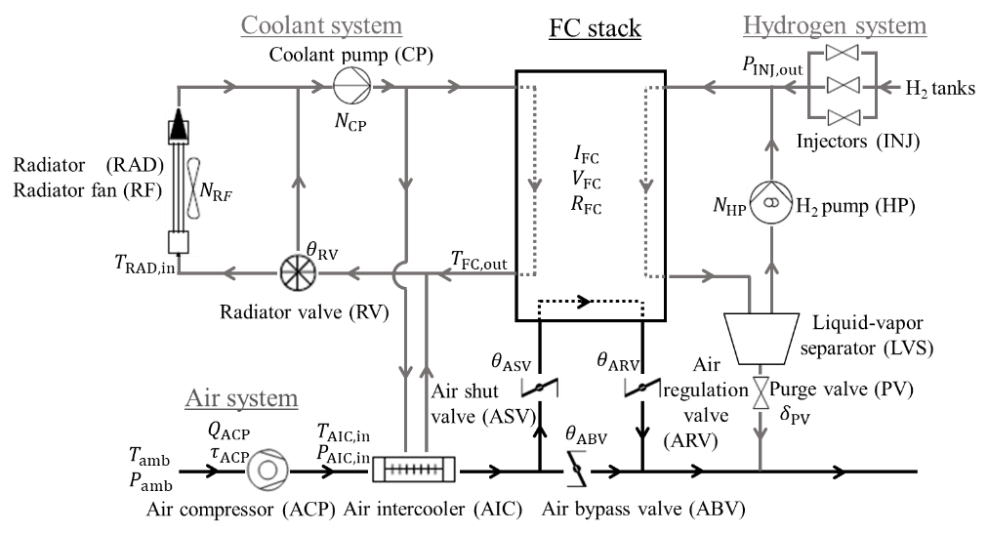
Figure 1 Schematic diagram of the FC system
Table 1 Variables used to develop the soft sensor
No. | Variables | Explanation | Cases  1-1 to 1-3 | Cases  1-4 to 1-6
1 | $$T_{amb}$$ | Ambient temperature [℃] | - | -
2 | $$P_{amb}$$ | Ambient pressure [kPa] | - | -
3 | $$I_{FC}$$ | FC stack current [A] | ✓ | ✓
4 | $$V_{FC}$$ | FC stack voltage [V] | ✓ | ✓
5 | $$R_{FC}$$ | FC stack resistance [$Ω$] | ✓ | ✓
6 | $$P_{INJ, out }$$ | Total pressure at INJ outlet [kPa] | ✓ | ✓
7 | $$N_{HP}$$ | Rotational speed of HP [rpm] | ✓ | ✓
8 | $$δ_{PV}$$ | PV state (0: close / 1: open) [-] | ✓ | ✓
9 | $$Q_{ACP}$$ | Volumetric air flow rate at ACP [NL/min] | ✓ | ✓
10 | $$τ_{ACP}$$ | Motor torque of ACP [N m] | ✓ | -
11 | $$T_{AIC, in}$$ | Temperature at AIC inlet [℃] | ✓ | -
12 | $$P_{AIC, in}$$ | Total pressure at AIC inlet [kPa] | ✓ | ✓
13 | $$θ_{ASV}$$ | Opening angle of ASV [degree] | ✓ | -
14 | $$θ_{ARV}$$ | Opening angle of ARV [degree] | - | -
15 | $$θ_{ABV}$$ | Opening angle of ABV [degree] | - | -
16 | $$T_{RAD, in }$$ | Temperature at RAD inlet [℃] | ✓ | -
17 | $$N_{CP}$$ | Rotational speed of CP [rpm] | ✓ | -
18 | $$N_{RF}$$ | Rotational speed of RF [rpm] | ✓ | -
19 | $$θ_{RV}$$ | Opening ratio of RV [%] | ✓ | -
20 | $$T_{FC, out}$$ | Temperature of coolant at FC outlet [℃] | ✓ | -

Figure 1 shows a schematic of the FC system, and the definition of the variables is listed in Table 1. In the FC system, a mixture of gas from the FC anode and FC cathode outlets is discharged as exhaust gas. Since the H₂ in exhaust gas is mainly from the FC anode outlet, a soft sensor was developed to predict the H₂ mole fraction in the liquid-vapor separator (LVS).
The procedure of soft sensor design is as follows: firstly, model construction data and model validation data were generated. To generate model construction data, $P_{net, set}$ was set to 0 to 100 kW with the change rate of –100 kW/s to 100 kW/s to cover the wide range of operation as shown in Figure 2 (a). $P_{net, set}$ of model validation data was set for various conditions as shown in Figure 2 (b).
Secondly, input variables of a PLS model were selected from Table 1. Figure 1 shows the location of each sensor. In Cases 1-1 to 1-3 and 1-4 to 1-6, different sets of input variables were used.
Thirdly, the delay time between change of input and that of output was determined by considering process dynamics. Figure 3 shows the difference between static and dynamic models. The static model uses only current values of inputs $x_{1}=\left\{x_{11}, …, x_{1M}\right\}$ when predicting $y_{1}$. In a dynamic model, in addition to current values, past values of input variables are used to predict output variables. For example, $\left\{x_{3}, …, x_{N}\right\}=\left\{x_{31}, …, x_{3M}, …,x_{N1},…, x_{NM}\right\}$ are used to predict $y_{N}$. In this study, the time delay of the input variables was determined based on space time of the LVS. Table 2 shows space time of LVS for each net power setpoint. The space time depends on $P_{net, set}$ and gas flow rate into LVS.
Finally, the PLS model was constructed under 6 conditions with different sets of input variables and delay time.

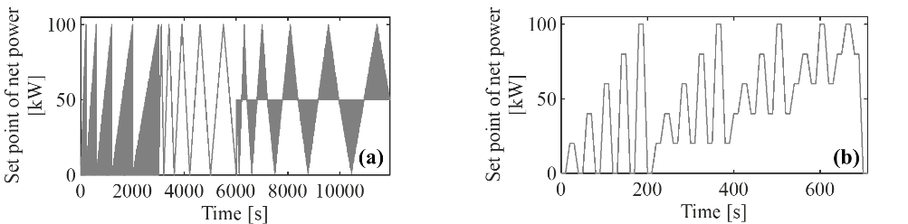
Figure 2 $P_{net, set}$ for (a) model construction data and (b) model validation data

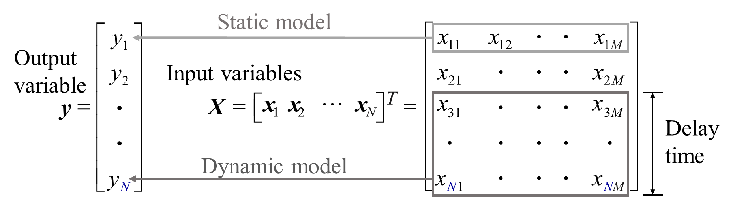
Figure 3 Static model and dynamic model

Table 2 Space time of LVS for $P_{net, set}$
$$P_{net, set}$$[kW] | Temperature at LVS [℃] | Total pressure at LVS [kPa] | Molar flow rate into LVS [mol/s] | Space time of LVS [s]
1 | 45 | 108 | 0.04 | 0.6
100 | 104 | 228 | 0.38 | 0.1
    - Control system for H₂ mole fraction in exhaust gas
Figure 4 shows an overview of the developed control system. H₂ mole fraction at FC cathode outlet $x_{H_{2},cFC, out}$ [-], molar flow rate of gas at FC cathode outlet ${\dot{n}}_{cFC, out}$ [mol/s], set point of molar concentration of H₂ in exhaust gas $x_{H_{2}, exh, set}$ [-], molar flow rate of gas at PV outlet ${\dot{n}}_{HEV, out}$ [mol/s] and the predicted value of H₂ mole fraction by the soft sensor at PV outlet ${\hat{x}}_{H_{2}, PV}$ [-] are input to the controller of volumetric flow rate at ABV $Q_{ABV,set}$. In the air system, the air is taken from outside the FC system by an ACP and sent to the FC stack to supply the oxygen for power generation. The controller of ABV manipulates the air flow rate which directly goes to the outside of the FC system. The developed controller controls the H₂ mole fraction in exhaust gas $x_{H_{2}, exh}$ [-] by manipulating the air flow rate through ABV. $Q_{ABV,set}$ is calculated as follows.
- Receive the inputs: $x_{H_{2},cFC, out}, {\hat{x}}_{H_{2},PV}{, \dot{n}}_{cFC,out}, {\dot{n}}_{PV}$ , and $x_{H_{2}, exh,set}$ .
- Calculate the molar flow rate of air in exhaust gas ${\dot{n}}_{0,exh}$ [mol/s] and the predicted H₂ mole fraction in exhaust gas ${\hat{x}}_{{0,H}_{2,exh}}$ [-] of by Eqs. (1) and (2) assuming the molar flow rate of air at ABV is 0 mol/s.
$${\dot{n}}_{0,exh} = {\dot{n}}_{cFC, out}+{\dot{n}}_{PV}$$ | (1)
$${\hat{x}}_{0,H_{2},exh}=\frac{x_{H_{2},cFC, out } {\dot{n}}_{cFC, out}+ {\hat{x}}_{H_{2},PV} {\dot{n}}_{PV}}{{\dot{n}}_{0,exh}}$$ | (2)
- Calculate the set point of molar flow rate of air in ABV ${\dot{n}}_{ABV, set}$ [mol/s] by Eq. (4) so that predicted H₂ mole fraction in exhaust gas ${\hat{x}}_{{ H}_{2},exh}$ is equal to its set point $x_{H_{2},exh, set}$.
$${\hat{x}}_{H_{2},exh} = \frac{{\hat{x}}_{0,H_{2},exh}{\dot{n}}_{0,exh}}{{\dot{n}}_{0,exh}+ {\dot{n}}_{ABV}}$$ | (3)
$${\dot{n}}_{ABV,set} = \frac{{\hat{x}}_{0,H_{2},exh}-x_{H_{2},exh,set}}{x_{H_{2},exh,set}}{\dot{n}}_{0,exh}$$ | (4)
- Convert ${\dot{n}}_{ABV, set}$ calculated in step 3 to $Q_{ABV,set}$ by using the ideal gas law.

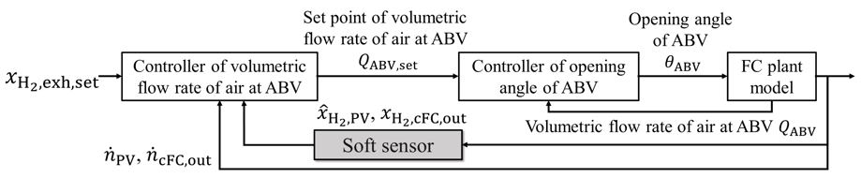
Figure 4 Schematic diagram of the control system
  - Results and discussions
    - Soft sensor of H₂ mole fraction
Table 3 shows the mean absolute error (MAE) and the mean absolute relative error (MARE) of the PLS models for Cases 1-1 to 1-6. Different input variables were used in Cases 1-1 to 1-3 and Cases 1-3 to 1-6, as shown in Table 1. The number of latent variables used in the PLS model was set to 5. Prediction accuracy was improved when variables in the coolant system were used in addition to those in the FC stack, air system, and hydrogen system, and when input variables with the time delay were used. Figure 5 shows the prediction result of Case 1-3, in which the prediction accuracy was best.
Table 3 Prediction result of the soft sensor of H₂ mole fraction
Case | Delay time [s] | MAE [-] | MARE [%]
1-1 | 0.0 | 0.049 | 10.3
1-2 | 0.1 | 0.045 | 9.8
1-3 | 0.6 | 0.045 | 9.7
1-4 | 0.0 | 0.084 | 18.6
1-5 | 0.1 | 0.076 | 17.7
1-6 | 0.6 | 0.077 | 17.9

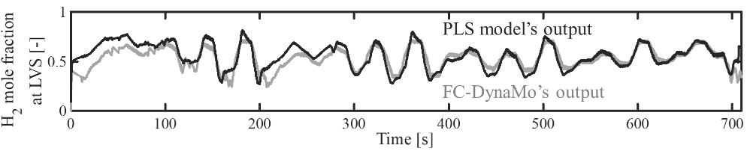
Figure 5 Prediction result of H₂ mole fraction at LVS in Case 1-3

    - Control system of H₂ mole fraction in exhaust gas
To determine the optimal $x_{H_{2}, exh, set}$ and to check the increased power consumption when a controller is introduced into the FC system, calculations were performed using FC-DynaMo under the conditions in Table 4. In Case 2-1, neither the soft sensor nor the control system was used. In Case 2-2, it was assumed that an ideal hydrogen sensor exists. The results of Cases 2-2 and 2-3 are compared by the additional power.
Table 5 shows the calculation result of the H₂ mole fraction in exhaust gas in Case 2-1. The violation rates in Table 5 indicate the percentage of time when $x_{H_{2},exh}$ exceeded the legal limit relative to the simulation time. Legal limits were violated when $P_{net, set}$ was 1, 2, 3, and 10 kW, and not violated in the other values of $P_{net, set}$.

Table 4 Calculation conditions
Calculation conditions | Unit | Case 2-1 | Case 2-2- | Case 2-3
Initial value of H₂ mole fraction at the FC anode | - | 0.99 | 0.99 | 0.99
Initial value of temperature of the air and gas in hydrogen system | ℃ | 55 | 55 | 55
Initial value of temperature of the coolant | ℃ | 25 | 25 | 25
$$P_{net, set}$$ | kW | 1 to 100 | 1 to 100 | 1 to 100
With/without controller (0: without / 1: with) | - | 0 | 1 | 1
With/without soft sensor (0: without / 1: with) | - | 0 | 0 | 1
$$x_{H_{2}, exh,set}$$ | - | - | 0.015 to 0.035 | 0.015 to 0.035

Table 5 Violation rate and power consumption at ACP
Case | $$P_{net, set}$$[kW] | Violation rate of the instantaneous value [%] | Violation rate of 3-sec. average [%] | Power consumption  at ACP [W]
2-1-1 | 1 | 100 | 100 | 81.1
2-1-2 | 2 | 100 | 100 | 85.1
2-1-3 | 3 | 100 | 100 | 88.1
2-1-4 | 4 | 0 | 0 | 90.9
2-1-5 | 5 | 0 | 0 | 93.7
2-1-6 | 10 | 0 | 100 | 107.4
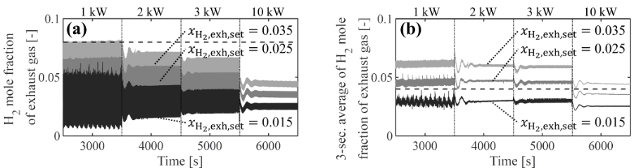
Figure 6 Control results of (a) instantaneous H₂ mole fraction and (b) 3-sec. average H₂ mole fraction in exhaust gas

Table 6 Comparison of additional power due to control system implementation of ideal sensor and developed soft sensor
$$P_{net, set}$$[kW] | Additional power [W] / relative power consumption to those in Table 5 [-] |  | Average of $x_{H_{2},exh}$ [-]
 | Case 2-2 | Case 2-3 | Case 2-2 | Case 2-3
1 | 17.7 / 1.22 | 11.5 / 1.14 | 0.030 | 0.032
2 | 22.1 / 1.26 | 23.2 / 1.27 | 0.030 | 0.030
3 | 21.5 / 1.24 | 27.1 / 1.31 | 0.029 | 0.028
10 | 17.8 / 1.17 | 28.2 / 1.26 | 0.030 | 0.025

Figure 6 shows $x_{H_{2,}exh}$ when $P_{net, set}$ was 1, 2, 3, and 10 kW in Case 2-3 and relative rate of power consumption to those in Table 5. In Figure 6, legal limits: the instantaneous value of 0.08 and the 3-second average value of 0.04 are displayed with a dotted line. From Figure 6 (a) and (b), it was found that the violation rate becomes 0 when $x_{H_{2} exh, set}=$0.015. Table 6 shows the additional power consumption in Case 2-2 with $x_{H_{2}, exh set}=$ 0.030 and Case 2-3 with $x_{H_{2}, set}=$0.015. The developed control system was able to keep $x_{H_{2}}$ below the legal limit with an average increase in power consumption of 22.5 W. The control system also consumes an average of 2.7 W more power than the controller with an ideal sensor. 2.7 W is not significant in FC systems; thus, the accuracy of the developed soft sensor is high enough.
  - Conclusions
The soft sensor with MAE of 0.045 and MARE of 9.7 % was successfully developed. The control system using the developed soft sensor was able to keep the H₂ mole fraction in exhaust gas below the legal limits. An average increase in power consumption of air compressor was 22.5 W, from 81.1-107 to 92.6-136 W, with set point of H₂ mole fraction in exhaust gas at 0.015. These results show that a control system that meets the regulation on H₂ mole fraction in exhaust gas can be created without the need to develop a new hydrogen sensor having a high response time.
References
1. S. Hasegawa et al., “Model-based development of fuel cell stack and system controllers,” PSE 2021+, Jun. 19–23 (2022).
2. S. Hasegawa et al., “Modeling of the dynamic behavior of an integrated fuel cell system including fuel cell stack, air system, hydrogen system, and cooling system,” ECS Trans., 109, 9 (2022).
3. United nations, “Global technical regulation on hydrogen and fuel cell vehicle, ” ECE Trans, 180, Add.13 (2013)
4. S. G. Leonardi et al., “Development of a hydrogen dual sensor for fuel cell applications,” Hydrogen Energy, 43, 11896–11902 (2018).

