Strategic Decision-Making in Duopolistic Energy and Water Markets: Examining Competition versus Cooperation for Farm Siting Optimization

Sarah Namany, Maryam Haji, Mohammad Alherbawi, Tareq Al-Ansari *College of Science and Engineering, Hamad Bin Khalifa University, Qatar Foundation, Doha, Qatar*

*\*talansari@hbku.edu.qa*

Abstract

The purpose of this paper is to delve into the intricate dynamics of duopolistic energy and water markets, wherein the main players are represented by a set of energy technologies inclusive of combined-cycle gas turbines power plants competing with photovoltaics plants. Considering the water sector, competition is happening amongst desalination plants and wastewater treatment plants. Both sectors are feeding an agricultural farm producing a diversified food basket. The first stage of the proposed framework aims to investigate the complex interactions between technologies by means of game theoretic models that simulate scenarios of both competition and cooperation amongst energy technologies and water technologies. Insights are unveiled on how these strategies impact the minimum profitable supply of each technology. This information is then integrated in the second stage of the study where a multi-objective optimisation framework is formulated to determine the optimal farm sites based on soil quality indicators and supply data. The optimisation results are represented by suitability maps that offer a comprehensive view of the interplay between resource supply, environmental conditions, and technology dynamics, aiding in the identification of optimal locations for agricultural farms. By combining economic and environmental considerations, this research paves the way for more sustainable farming practices. Ultimately, this study contributes to a deeper understanding of the strategic decision-making process in duopolistic energy and water markets. It offers a framework for stakeholders to navigate the complexities of these markets, leading to more efficient decisions with regards to farm siting and resource allocation.

**Keywords**: Duopolistic Markets, Game Theory, Cooperation, Competition, Farm Siting Optimization.

* 1. Introduction

Ensuring a continuous and sufficient supply of food products is one of the goals that all countries are determined to sustain and improve. However, the ever-increasing internal food system’s challenges and the external pressures imposed by the surrounding environment such as political instabilities, market turmoil and climate change are rendering the process of growing nutritious and sufficient food quantities very strenuous (Namany et al., 2022). These challenges do not impact the food system exclusively, yet the influence is also affecting the water and energy sectors which represent the major enablers of the food provision system. In fact, the reliance on these two resources exposes the food system to the risks impacting these sectors as well which further hampers the food security target. Competition and cooperation are some of the behaviors that influence the performance of sectors and their productivity. In the context of the energy and water resources, the market structure is constantly changing due to the frequent emergence of new technologies and volatilities of resources prices such as oil and gas for the energy sector and precipitation for the water system, leading to uneven supply patterns which pose multiple pressures on the provision of food products (Gielen et al., 2019). In order to account for the influence of competitive and cooperative behaviors on food systems performance, game theory approaches are deployed to determine the payoffs and strategies of water and energy industries contributing to food production. In this regard,

Yan *et al.* (2023) investigated the oligopoly of the soybean market in China and the influence of monopolistic behaviors on trade activities. Dianat *et al.* (2022) analysed the impact of competitiveness of the renewable energy market on the energy sector’s performance based on game theory, agent-based modeling and system dynamics. In this paper, cooperative and non-cooperative games are used to determine the minimum quantities that a set of energy and water technologies should supply for the provision of a diversified perishable food basket such that their economic profits are maximised. The equilibrium payoff amounts generated by the games is then used as capacity constraints deployed in a farm sitting optimisation model. The framework, based on geographic information system (GIS) determines the most appropriate farm locations given land suitability, energy and water technologies dynamics that drive their supply patterns. This paper is structured such that the following section 2 describes the data and methods used to develop the suggested framework while section 3 presents the major findings of the study and finally section 4 concludes and paves the way for future research.

* 1. Data and Methods

The methodology developed in this paper aims to design a framework that assists decision-makers in the food sector in determining the optimal locations of crop-producing farms given the competitive and cooperative behavior of multiple energy and water technologies. Two different scenarios are developed to represent these behaviors wherein the first scenario assumes a competitive set up between energy technologies and amongst water sources while the second scenario implies their cooperation. For the energy sector, a mix of renewable and non-renewable plants are considered, counting combined-cycle gas turbine (CCGT) and photovoltaics (PV), as for water, the contributing technologies consist of reverse osmosis (RO) and multi-stage flash (MSF) desalination plants and treated sewage effluent (TSE) as a water treatment plant. Tables 1 and 2 summarises the set of technologies utilised in this study along with their geospatial locations. Results of the games are used to locate the optimal farms that supply a range of perishable food products counting vegetables and fruits. The following section 2.1 describes the games adopted to determine the payoff of every contributing technology.

* + 1. Game theory to model competitive and cooperative markets

Industries or sectors can adopt different strategies as means to maximise their profits. Profit maximisation is generally enabled by either raising the quantities produced or increasing the selling prices. In order to model competition, the Cournot non-cooperative game is adopted wherein industries that produce to the same product compete and act independently and simultaneously to produce their targeted quantities then the market price is set.

**Table 1**. Locations of electricity power plants.

|  |  |  |  |
| --- | --- | --- | --- |
|  |  | **Latitude** | **Longitude** |
| **CCGT Power Plants** | **Messaid (E1)** | 24.989 | 51.577 |
| **Rass Laffan B (E2)** | 25.924 | 51.548 |
| **Rass Laffan C (E3)** | 25.935 | 51.526 |
| **PV Power Plant** | **Al kharsaah (E4)** | 25.22305 | 51.0182 |

**Table 2**. Locations of water treatment and desalination plants.

|  |  |  |  |
| --- | --- | --- | --- |
|  |  | **Coordinates** | |
|  |  | **Latitude** | **Longitude** |
| **MSF Desalination Plants** | **Ras Abu Fontas A (W1)** | 25.207 | 51.61646 |
| **QEWC A1 (W2)** | 25.210 | 51.61613 |
| **Ras Laffan A (RLPC) (W3)** | 25.889 | 51.438 |
| **Umm al-Houl (W4)** | 25.112 | 51.612 |
| **RO Desalination Plants** | **Ras Abu Fontas A3 (W5)** | 25.213 | 51.586 |
| **Ras Abu Aboud (W6)** | 25.287 | 51.561 |
| **TSE** | **TSE Pumping station (W7)** | 25.233 | 51.523 |
| **TSE Pumping station Markhiya (W8)** | 25.021 | 51.158 |
| **Lusail Sewage Treatment (W9)** | 25.408 | 51.473 |

In this case, the water technologies and the energy power plants compete within the water and energy markets, respectively, and their best response function can be described by the following equation (Eq.1) (Namany et al., 2023), wherein $q_{i}^{*}$ is the Nash equilibrium quantity wherein *i* is the set of water or energy technologies, *a* and *b* are derived from the inverse market demand equation while *c* is the unit production cost.

$q_{i}^{*}=\frac{a-c_{i}}{2b}-\frac{\sum_{i≠j}{q_{j}}}{2}$ (1)

The second scenario describes a case of cooperation between water technologies and energy production systems. This collaboration is represented by a Cartel game which implies an agreement to collude given a set of predetermined quotas that restrict the quantities to be produced. In this case, technologies form a water monopoly and an energy monopoly wherein the contribution of each plant is in accordance with the agreed upon percentages that are influenced by the current market presence. The optimal Cartel quantity can be depicted by the following equation (Eq. 2), such that $p_{i}$ is the predetermined Cartel quota of the technology studied and $p_{j}$ is the quotas of the remaining involved technologies:

(2)

* + 1. Farm Siting Using Geospatial Information Technology

Initially, the soil types of Qatar were mapped in ArcGIS. Where four types of soil have been identified, including lithosol, sandy, sabkha and rawdha soils. Meanwhile, restricted regions were also mapped including natural reserves, built-up areas, and Qatar Petroleum reserved areas. These restricted areas are excluded from the farms siting process. Then, nodes network layer with (3x3 km) inter-nodes distance is created in ArcGIS, covering all the Qatar’s map. The nodes where then shortlisted based on their locations on the maps. Where only nodes they overlay the most fertile soil (rawdha) and away from restricted areas were selected as candidate farm sites.

The concluding step in the optimization process for site selection is determined through the application of ArcGIS's location-allocation function. This involves assessing the identified candidate sites in relation to existing energy and water supply locations, considering the associated expenses associated with water transportation and power transmission to these candidate sites. The purpose of the location-allocation function within the network analyst module is to identify a site capable of efficiently handling supply/demand points. The algorithm systematically assesses various candidate sites to determine one or more locations that optimize the specified objective. In this particular scenario, the goal is to minimize the total travel distance and, consequently, transportation/transmission costs. Thus, the problem aligns with the p-Median Problem (PMP), defined by the mathematical model presented in Eq (3-7):

Min $\sum_{i}{\sum_{j}{(Q_{i}* D_{ij}*C_{ij}*X_{ij})}}$ (3)

Subject to:

$X_{ij}≤Y_{j} ∀i,j$ (No allocation occurs unless a farm is selected) (4)

$\sum_{j}{Y_{j}}=5$ (Only 5 farm sites to be selected) (5)

$X_{ij}≤\{0,1\} ∀i,j$ (Integer requirement) (6)

$Y_{j}≤\{0,1\} ∀j$ (Integer requirement) (7)

Decision variables:

Yj = $\left\{\begin{aligned}1, if candidate farm site "j" is selected \\ 0, otherwise \end{aligned}\right.$

Xij = $\left\{\begin{aligned}1, if utility supply "i" is alloocated for farm site "j" \\ 0, otherwise \end{aligned}\right.$

Where,

i: is the set of initial farming candidate sites.

j: is the set of utilities supply sites.

Qi: is the supplied quantity of water (m3) or energy (MWh) at site “i”.

Dij: is the distance between the supplying sites “i” to the farming candidate site “j”.

Cij: cost of utility delivering from site “i” to the farming candidate site “j”.

An allocation model is developed and solved by Excel Solver to allocate 2 Mm3 and 300 MWh for each of the selected 5 farming sites, based on Eq (3), and the upper and lower bounds created through game theory in the previous section. Every technology is allowed in the contributing mix if the contribution amount outweighs its payoff quantity.

**Figure 1.** From left to right: soil map, restricted areas, energy and water technologies distribution and preferred farm locations.

**Table 3.** Energy and water mix under the Cartel case.

|  |  |  |  |  |  |  |  |  |  |  |  |  |  |
| --- | --- | --- | --- | --- | --- | --- | --- | --- | --- | --- | --- | --- | --- |
|  | **E1** | **E2** | **E3** | **E4** | **W1** | **W2** | **W3** | **W4** | **W5** | **W6** | **W7** | **W8** | **W9** |
| **Site1** | 46% | 33% | 8% | 13% | 0% | 0% | 73% | 0% | 0% | 0% | 0% | 0% | 27% |
| **Site2** | 33% | 33% | 33% | 0% | 0% | 0% | 100% | 0% | 0% | 0% | 0% | 0% | 0% |
| **Site3** | 41% | 24% | 13% | 21% | 0% | 0% | 100% | 0% | 0% | 0% | 0% | 0% | 0% |
| **Site4** | 45% | 27% | 27% | 0% | 22% | 0% | 4% | 25% | 4% | 0% | 28% | 18% | 0% |
| **Site5** | 54% | 24% | 23% | 0% | 57% | 19% | 0% | 0% | 0% | 25% | 0% | 0% | 0% |

* 1. Results and discussion

After modelling the competition and cooperation between the different energy power plants and water resources, two different scenarios were run to determine the impact of

these behaviors on the distribution of resources to the 5 selected farms. Two maps were generated illustrating the allocation networks, wherein figure 2 presents the Cournot case and is also representative of the formed Cartels. Under both scenarios, the energy supply is granted by all energy power plants, with a significant monopoly of CCGT Mssaid under both scenarios. These results can be explained by the proximity of the plant in addition to its large capacity and relatively low cost. PVs contribution to the mix is relatively limited in the Cartel compared to Cournot as it is not economically profitable for it to supply all farms. Considering water technologies, all water sources are supplying the farms with the required amount of water, with a large contribution of desalination in the Cartel case and a more diversified mix in the Cournot scenario. This can be explained by the flexibility of the production and supply under the Cournot competition wherein quantities are not restricted in advance by market leaders (Table 3-4).

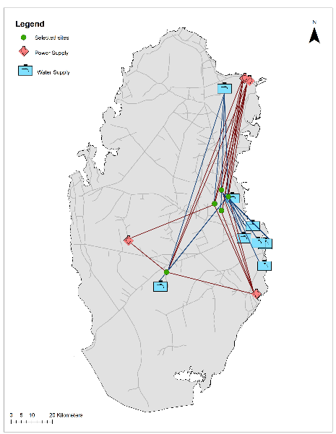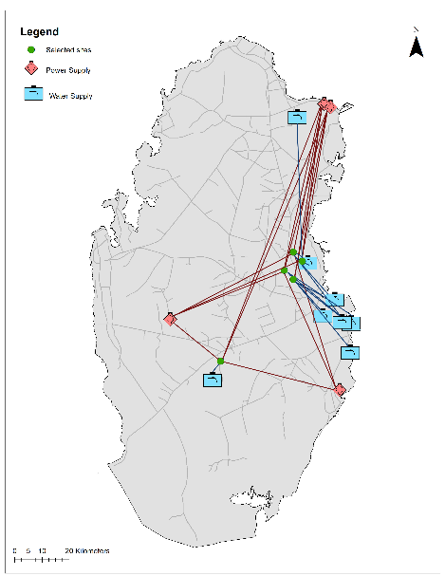

**Figure 2.** Left to right: Cournot and Cartel network of energy and water technologies.

|  |  |  |  |  |  |  |  |  |  |  |  |  |  |
| --- | --- | --- | --- | --- | --- | --- | --- | --- | --- | --- | --- | --- | --- |
|  | **E1** | **E2** | **E3** | **E4** | **W1** | **W2** | **W3** | **W4** | **W5** | **W6** | **W7** | **W8** | **W9** |
| **Site1** | 78% | 8% | 9% | 6% | 0% | 0% | 0% | 0% | 0% | 0% | 0% | 100% | 0% |
| **Site2** | 0% | 64% | 36% | 0% | 0% | 0% | 0% | 71% | 14% | 0% | 15% | 0% | 0% |
| **Site3** | 24% | 31% | 22% | 23% | 67% | 6% | 0% | 27% | 0% | 0% | 0% | 0% | 0% |
| **Site4** | 0% | 30% | 52% | 18% | 0% | 10% | 0% | 0% | 0% | 13% | 0% | 0% | 77% |
| **Site5** | 44% | 26% | 0% | 31% | 0% | 0% | 82% | 0% | 0% | 0% | 0% | 0% | 18% |

**Table 4.** Energy and water mix under the Cournot case.

* 1. Conclusion

Optimally locating crop producing farms is a multifaceted problem especially in areas with limited land and scarce water resources. Several factors such as the soil quality and the proximity of the water and energy sources are factors amongst others that influence the selection of suitable farms ‘sites. Market dynamics is also a critical risk that needs consideration while addressing farms siting due to the variation of water and energy resources supplies. In this paper, the interactions between resources technologies are factored into the selection of optimal farms locations through considering the competition and cooperation of energy and water systems. Result of the games are integrated as constraints in a geospatial optimisation combining soil quality, proximity, and cost. Findings of the study asserts that competitive environments allow more diverse contribution from both the energy and water sectors while collaboration gives a preferential supply to market leader due to the restriction of quantities produced.

* 1. Acknowledgement

The research is funded by the Qatar National Research Fund (MME01-0922-190049).

* 1. References

Dianat, F., Khodakarami, V., Hosseini, S. H., & Shakouri G, H. (2022). Combining game theory concepts and system dynamics for evaluating renewable electricity development in fossil-fuel-rich countries in the Middle East and North Africa. Renewable Energy, 190, 805–821. https://doi.org/10.1016/j.renene.2022.03.153

Gielen, D., Boshell, F., Saygin, D., Bazilian, M. D., Wagner, N., & Gorini, R. (2019). The role of renewable energy in the global energy transformation. *Energy Strategy Reviews*, *24*, 38–50. https://doi.org/10.1016/j.esr.2019.01.006

Namany, S., Govindan, R., Di Martino, M., Pistikopoulos, E. N., Linke, P., Avraamidou, S., & Al-Ansari, T. (2022). Developing intelligence in food security: An agent-based modelling approach of Qatar’s food system interactions under socio-economic and environmental considerations. *Sustainable Production and Consumption*, *32*, 669–689. https://doi.org/https://doi.org/10.1016/j.spc.2022.05.017

Namany, S., Haji, M., Alherbawi, M., & Al-Ansari, T. (2023). Food security in an oligopolistic EWF nexus system: a cooperative vs a non-cooperative case. In *Computer Aided Chemical Engineering* (Vol. 52, pp. 1427–1432). https://doi.org/10.1016/B978-0-443-15274-0.50227-4

Yan, J., Xue, Y., Quan, C., Wang, B., & Zhang, Y. (2023). Oligopoly in grain production and consumption: an empirical study on soybean international trade in China. *Economic Research-Ekonomska Istrazivanja* , *36*(2). https://doi.org/10.1080/1331677X.2022.2142818