Power system planning integrating hydrogen and ammonia pathways under uncertainty

Georgios L. Bounitsis,a Vassilis M. Charitopoulosa,*

*a The Sargent Centre for Process Systems Engineering, Department of Chemical Engineering, University College London, Torrington Place, London WC1E 7JE, UK*

[v.charitopoulos@ucl.ac.uk](mailto:v.charitopoulos@ucl.ac.uk)

Abstract

High penetration of renewable technologies, heat electrification and integration of dense energy carriers on power systems is promising towards decarbonisation. However, a lot of uncertainty sources render the efficient solution of such planning problems challenging. This work aims to investigate a nationwide power system planning problem with integration of hydrogen and ammonia under uncertain wind availability. The proposed snapshot model aims to determine optimal capacity mix in a future year under uncertainty. A risk-neutral two-stage stochastic programming approach is adopted along with a novel data-driven scenario generation technique to efficiently capture the uncertain set and alleviate the computational complexity. The proposed framework is examined on a case study concerning strategic planning of deep decarbonised coupled power and heat systems in Great Britain (GB) and the quality of stochastic solutions is highlighted.

**Keywords**: Power System Planning, Net Zero, Ammonia, Stochastic Programming, Scenario Generation.

* 1. Motivation & literature review

UK leads the race towards Net Zero to vitally reduce carbon emissions. Towards the decarbonised power system planning high penetration of renewable technologies is imperative (Dangoumas & Koltsaklis, 2019). However, as renewable generation increases, intermittency of renewable sources impose volatility to the power system. The exploitation of excessive renewable energy is feasible via battery energy storage systems (BESS) or storage via dense energy carriers (DECs) such as hydrogen (H2) or ammonia (NH3). Pellow et al. (2015) indicated the benefits of H2 compared to BESS for cost-efficient energy storage on grid. Moreover, Wu et al. (2022) proposed that NH3 can complement H2 for long-term energy storage towards decarbonisation, as NH3 is more inexpensive for long-term storage and transportation.

DECs are recently included in studies regarding optimal power system planning. For instance, He et al. (2021) showcased the role of H2 as an energy carrier in power system planning towards decarbonisation in a case study in Noertheast US. Beyond H2 utilisation, Ganzer et al. (2022) integrated a power-to-methane pathway for grid-scale storage in the capacity expansion planning of GB indicating the role of DEC for inter-seasonal storage. Bounitsis and Charitopoulos (2023) studied the optimal power system planning and operation in GB integrating H2 and NH3 pathways towards coupled power and heat systems decarbonisation and NH3 role for long-term storage was highlighted.

Even though capacity expansion planning under uncertainty is a topical field of study (Roald, 2023), the investigation of complex energy planning problems integrating DECs and considering uncertainty is a quite unexplored topic. In this work, we extend the snapshot LP model by Bounitsis and Charitopoulos (2023) to a two-stage stochastic programming (TSSP) problem. Uncertainty is considered on wind availability as it is critical for power systems operation and its quantification has been heavily studied in the literature (Li et al., 2020). Here we capture uncertainty by employing the novel scenario generation framework by Bounitsis et al. (2022) and exploiting wind historical data. Finally, a case study of GB power system planning towards decarbonisation in 2040 is considered to evaluate the value of DECs pathways for the system. The remainder of the article is organised as follows: in Section 2 the problem is outlined, and mathematical modelling is presented. In Section 3, scenario generation and results regarding GB’s case study are presented. Finally, conclusions are drawn in Section 4.

* 1. Optimal power system planning integrating DECs under uncertainty
     1. Problem description

Power system planning and operation under uncertainty is investigated. Along with conventional technologies, pathways of H2 and NH3 are integrated in the problem. Moreover, residential and commercial heat sectors are coupled to power sector due to their high energy consumption and carbon intensity (Charitopoulos et al., 2023). Beyond natural gas, heat can also be satisfied by electricity and H2. Thus, heat demand mix is determined offering flexibility and electricity peak demand is optimised. The goal of proposed TSSP is to determine power system’s capacity planning in a future year (first-stage decisions) before the realization of uncertain wind availability. Then, second-stage scenario-dependent system’s operation is optimised on the first-stage capacity decisions.

This work focuses on GB’s future decarbonised power system and capacity expansion decisions are taken considering GB as a node (whole system). On the operational level, full year hourly ($h∊H,\left|H\right|=8760 hours$) data profiles for demands and renewable availability are exploited to define a reduced fine-grained time resolution ($H'$) via Chronological Time-Period Clustering (CTPC) (Pineda and Morales, 2018). This time aggregation method maintains the chronological order of the data capturing the short- and long-term dynamics. We formulate a new version of the Priority CTPC by García-Cerezo et al. (2022) (NPCTPC) which respects the attribute specific extreme events. In Fig. 1 is shown that proposed NPCTPC better captures the extreme events for total power demand.

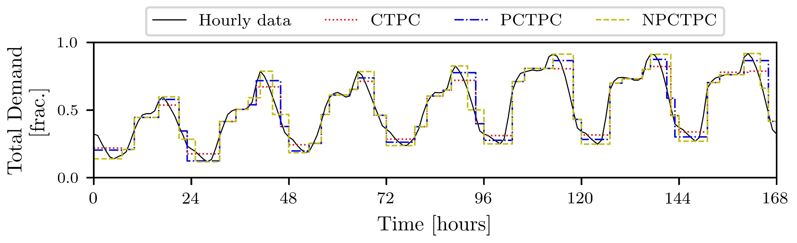

***Figure 1:*** *Chronological clustering methods comparison from 8,760 hours to 2,190 clusters.*

Regarding the superstructure of the problem (visualised in Fig. 2), energy carriers ( $a∊A=\left\{elec,H_{2},{NH}_{3}\right\})$ are generated by technologies ($j∊J$) to fulfill system’s demands. Storage options are also available for them and especially for electricity bidirectional interconnections to third countries ($i∊I$) are considered. Regarding electricity generation, well-established renewable and conventional technologies are included. DECs introduce alternative generation and storage options via gas turbines (GT) and liquid storage. H2 can be produced via biomass gasification (BG), natural gas reforming (SMR) or water electrolysis (WE). Developing technologies are considered coupled with Carbon Capture and Storage systems (CCS) to reduce their carbon footprint. Then, NH3 is produced using H2 and electricity through Haber-Bosch (HB) process. HB process assumptions include the accompanied air separation units for nitrogen (N2) production.

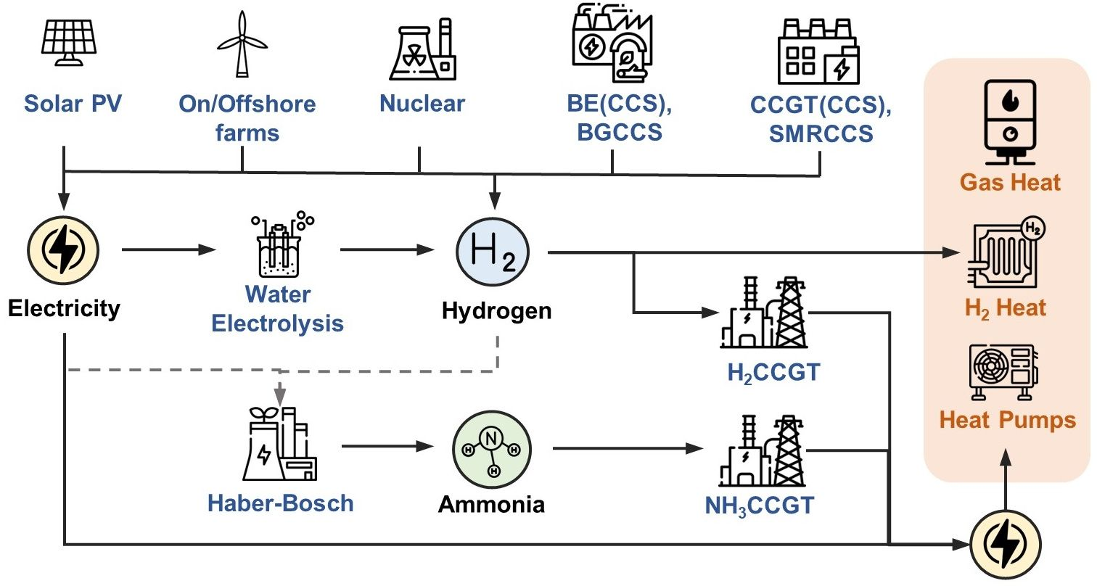

***Figure 2:*** *Superstructure of power and heat systems.*

* + 1. Mathematical modelling via Stochastic Programming

An LP TSSP total cost minimisation model is formulated based on the model by Bounitsis and Charitopoulos (2023). Wind availability uncertainty is realised through scenario set $s∈S$. TSSP determines capacity planning via here-and-now decisions ${Cap}_{j}$, while rest operational decisions are wait-and-see (scenario-dependent). System’s power and heat demands (${DEM}_{h}^{heat}$, ${DEM}_{h}^{elec}$) are satisfied. Heat demand can be supplied by all available heating options ($Q_{hs}^{*}$), and so electricity demand ($D_{hs}$) is optimised over the time horizon:

|  |  |
| --- | --- |
| $${DEM}_{hs}^{heat}=\frac{Q_{hs}^{elec}}{{COP}_{h}}+\frac{Q_{hs}^{H2}}{η^{H2,boiler}}+\frac{Q_{hs}^{NG}}{η^{gas,boiler}} ∀h∈H,s∈S$$ | (1) |
| $$D_{hs}=\left(1+DL\right)·\left({DEM}_{hs}^{elec}+Q_{hs}^{elec}\right) ∀ h∈H,s∈S$$ | (2) |

In particular, $DL$ accounts for the distribution losses on the electricity grid and is set equal to 6.5% according to historical data (DUKES, 2023). Then, resources balances in Eq. (3) account for generation or consumption of resources ($P_{jhs}$), storage charging (${CH}_{ajhs}$) and discharging (${DC}_{ajhs}$). Additionally, only for electricity, interconnections (${PIM}_{ihs}$), renewable curtailment (${LC}_{hs}$) and penalisation of unmet demand (${LS}_{hs}$) is considered.

|  |  |
| --- | --- |
|  | (3) |

Previous operational decisions are scenario-dependent as uncertainty is revealed via the availability profiles of renewable sources (${AV}_{jhs}$), particularly for on/offshore wind:

|  |  |
| --- | --- |
| $$P_{jhs}={AV}_{jhs}⋅Cap_{j} ∀j∊J^{res},h∈H,s∈S$$ | (4) |

Towards the adequacy of the system, the de-rated capacity (by factors ${DF}_{j}$) must suffice the peak demand ($D^{peak}$, equal to maximum value of $D_{hs}$) increased by a reserve margin factor (assuming $RM=7\%$) as shown in Eq. (5) (National Grid ESO, 2023a):

|  |  |
| --- | --- |
| $$\sum_{j∊({ST}_{elec,j}⋃{PR}_{elec,j})}{{DF}_{j}}·{Cap}_{gj}≥D^{peak}·\left(1+RM\right)$$ | (5) |

In the proposed model, constraints regarding capacity build rates, land availability for renewables, technologies’ operation, fuel consumption and storage operation are further included. Finally, an ultimate carbon emission goal towards Net Zero must be met. Ultimately, the total system cost ($TSC$) includes capital costs ($CAPEX$), $O\&M$ costs and the expected value regarding the scenario-dependent operational costs ():

|  |  |
| --- | --- |
|  | (6) |

* 1. Case study: Power and heat decarbonisation in the UK under uncertainty
     1. Preliminaries

Proposed TSSP is tested for GB’s power system planning in 2040. Infrastructure as by 2020 (DUKES, 2023) and data on climate year 2015 are used as input. While electricity demand is derived from historical data by National Grid ESO, heat demand profiles are obtained from the UK gas distribution companies. Both demand profiles are projected to the target year 2040 based on predicted demand values of Future Energy Scenarios (FES) by National Grid ESO (2023b). Renewables availability profiles by Renewables.Ninja platform and interconnection prices data by ENTSO-E are calibrated to the real historical data of climate year 2015 (Staffel & Pfenninger, 2016, ENTSO-E, 2023). Finally, carbon budget goals for year 2040 are set cumulatively in line with the UK’s Sixth Carbon Budget report (CCC, 2020). Techno-economic parameters predictions for technologies in 2040 can be retrieved from recent governmental reports (BEIS, 2023).

* + 1. Scenario Generation for uncertainty quantification

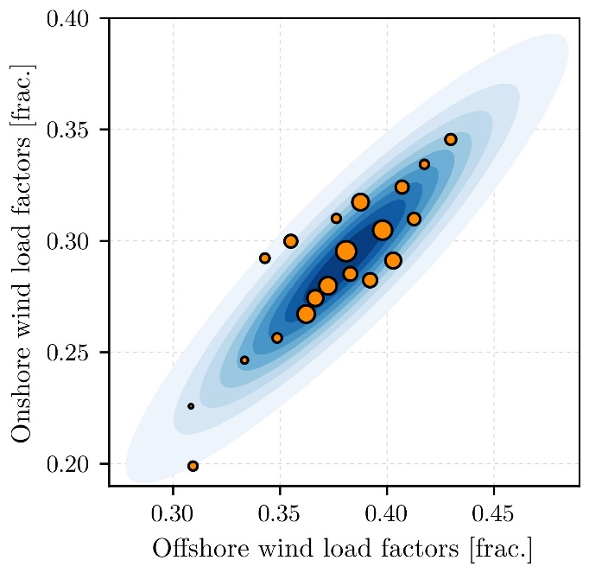In this work, uncertainty is considered for the total availability of the renewable sources in the target year of 2040. Renewable sources hourly availability data for GB from 1980 to 2019 are obtained by Renewables.Ninja platform and annual load factors are estimated. Wind load factors display variability while solar are more stable and thus neglected from the uncertain set. Scenarios of annual wind load factors are generated using the methodology by Bounitsis et al. (2022). As data are scarce, synthetic data are simulated exploiting the statistics and copula sampling (density plot depicted in Fig. 3). Then, the MILP model for Distribution and Moment Matching Problem (DMP) generates scenarios by selecting from 1,000 copula samples. 20 final scenarios for wind load factors are generated (visualised in Fig. 3) that are forced to match in the statistical sense the original distribution. Finally, original availability profiles are calibrated in order uncertain parameters ${AV}_{jhs}$ to include the load factors uncertainty.

***Figure 3:*** *20 generated scenarios for wind load factors.*

* + 1. Results and discussion

Two instances of the power system are investigated: (i) with conventional technologies only (‘PS’) and (ii) with integration of H2 and NH3 pathways (‘PS+NH3’). The Certainty Equivalent Problem (CEP, deterministic using the mean values of the uncertain parameters) and the proposed TSSP using 20 scenarios are solved for each instance. The here-and-now decisions are obtained and their induced expected results on the problem over the reference set of 1,000 copula-based scenarios are estimated. Optimisation models are solved using solver GUROBI 9.5 in optimisation suite GAMS 45.1. Results from Fig. 4 indicate that the integration of DECs pathways to PS lead to a £1.1b reduction on the total cost. Moreover, the stochastic solutions by TSSP can drive a reduction to expected cost of approximately £800m for both instances compared to the solutions of CEP.

|  |  |
| --- | --- |
| ***Figure 4:*** *Expected total system cost.* | ***Figure 5:*** *Cost breakdown for ‘PS+NH3’.* |

Then, from Fig. 5 is indicated that for ‘PS+NH3’ system this reduction is mainly imposed by the expected value of OPEX, which is dependent on scenarios. Using CEP solutions, OPEX may increase owed to penalisation of unmet demand. This result indicates the system’s adequacy issues when using CEP deterministic solutions for planning. In particular, the expected value of Expected Energy Unserved (EEU) is equal to 48 MWh and 43 MWh for ‘PS’ and ‘PS+ NH3’ systems, respectively. However, EEU equal to 0 MWh and so a lower expected OPEX is achieved using the TSSP stochastic solutions.

Regarding capacity mix for electricity generation, TSSP for ‘PS+NH3’ system optimally determines high heat electrification of around 84.4% and so higher investments are necessary. Results from Fig. 6 show that TSSP results to increased Nuclear capacity and decreased intermittent Wind Onshore and Solar capacities compared to CEP.

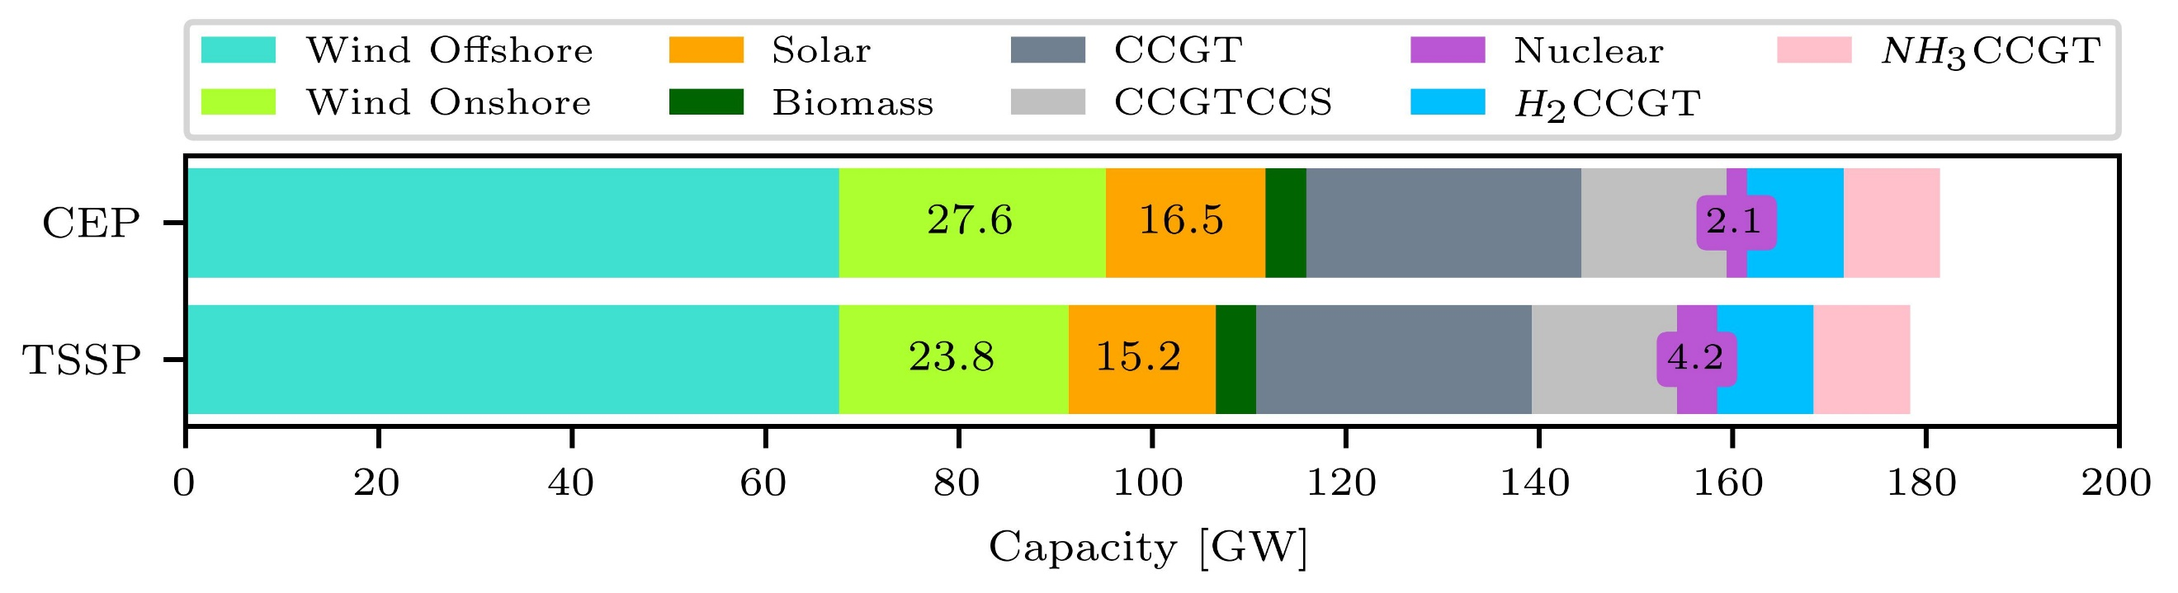

***Figure 6:*** *Capacity mix for electricity generation in 2040 according to CEP and TSSP solutions.*

|  |  |
| --- | --- |
| ***Figure 7:*** *DEC capacity mix.* | ***Figure 8:*** *DEC production load factors using TSSP solutions over uncertainty.* |

Furthermore, DEC capacity mix changes significantly using TSSP. H2 production merely depends on BGCCS, while WE contributes smaller amounts particularly for scenarios of high wind availability, when electricity is cheaper. Regarding NH3 production, installed HB capacity is reduced when using TSSP. The same stands for the Liquid NH3 storage capacity, from 2.43 TWh to 1.99 TWh. However, HB production load factor ranges constantly from 55 to 65% and it slightly increases for high wind availability. Finally, electricity imports up to 50 TWh for scenarios of low wind availability play a vital role for demand satisfaction. Ultimately, the CCC’s Net Zero goal for 7.87 MtCO2 is met.

* 1. Conclusions

The proposed TSSP approach integrating scenario generation method offers safer and cost-efficient optimal power system planning revealing the unsuitability of deterministic approaches to serve system’s adequacy over extreme scenarios of wind uncertainty. Moreover, TSSP seems to avoid the overestimation of needs for renewable technologies capacity or energy storage and further indicate the importance of conventional technologies and interconnections for system’s security. Future work within our group aims to account for more sources of uncertainty via high fidelity scenario generation towards the solution of stochastic power system planning and scheduling problems.

**Acknowledgements:** Financial support from the EPSRC (under projects EP/T022930/1 & EP/V051008/1) is gratefully acknowledged.

References

BEIS, 2023. Electricity generation costs, Department of Business, Energy & Industrial Strategy.

G.L. Bounitsis, L.G. Papageorgiou, V.M. Charitopoulos, 2022. Data-driven scenario generation for two-stage stochastic programming. Chem. Eng. Res. Des. 187, 206–224.

G.L. Bounitsis, V.M. Charitopoulos, 2023. Optimal capacity planning integrating ammonia storage for power and heat decarbonisation. Comput. Aided Chem. Eng. 52, 3049–3054.

CCC, 2020. The Sixth Carbon Budget. The UK’s path to Net Zero, Climate Change Committee.

V.M. Charitopoulos, M. Fajardy, C.K. Chyong, D.M. Reiner, 2023. The impact of 100% electrification of domestic heat in Great Britain. iScience 26, 108239.

A.S. Dagoumas, N.E. Koltsaklis, 2019. Review of models for integrating renewable energy in the generation expansion planning. Appl. Energy 242, 1573–1587.

DUKES, 2023. Digest of UK Energy Statistics (DUKES) 2023 – National Statistics.

ENTSO-E, 2023. European Network of Transmission System Operators for Electricity.

C. Ganzer, Y.W. Pratama, N. Mac Dowell, 2022. The role and value of inter-seasonal grid-scale energy storage in net zero electricity systems. Int. J. Greenh. Gas Control 120, 103740.

G. He, D.S. Mallapragada, A. Bose, C.F. Heuberger-Austin, E. Gençer, 2021. Sector coupling via hydrogen to lower the cost of energy system decarbonization. Energy Environ. Sci. 14, 4635–4646.

A. García-Cerezo, R. García-Bertrand, L. Baringo, 2022. Priority Chronological Time-Period Clustering for Generation and Transmission Expansion Planning Problems with Long-Term Dynamics. IEEE Trans. Power Syst. 37, 4325–4339.

J. Li, J., Zhou, B. Chen, 2020. Review of wind power scenario generation methods for optimal operation of renewable energy systems. Appl. Energy 280, 115992.

National Grid ESO, 2023a. Electricity Market Reform. Capacity Market.

National Grid ESO, 2023b. Historical data & Future Energy Scenarios.

M.A. Pellow, C.J.M. Emmott, C.J. Barnhart, S.M. Benson, 2015. Hydrogen or batteries for grid storage? A net energy analysis. Energy Environ. Sci. 8, 1938–1952.

S. Pineda, J.M. Morales, 2018. Chronological time-period clustering for optimal capacity expansion planning with storage. IEEE Trans. Power Syst. 33, 7162–7170.

L.A. Roald, D. Pozo, A. Papavasiliou, D.K. Molzahn, J. Kazempour, A. Conejo, 2023. Power systems optimization under uncertainty: A review of methods and applications. Electr. Power Syst. Res. 214.

I. Staffell, S. Pfenninger, 2016. Using bias-corrected reanalysis to simulate current and future wind power output. Energy 114, 1224–1239.

S. Wu, N. Salmon, M.M.J. Li, R. Bañares-Alcántara, S.C.E. Tsang, 2022. Energy Decarbonization via Green H2 or NH3? ACS Energy Lett. 7, 1021–1033.