Harvesting the Wind - Assessment of Offshore Electricity Storage Systems
Jan F. Wiegner,ª Inge M. Ossentjuk,ª Robbert M. Nienhuis,^{b} Antonis I. Vakis,^{b} Madeleine Gibescu,ª and Matteo Gazzani^{a∗}
ª Utrecht University, Princetonlaan 8a, 3584 CB Utrecht, The Netherlands.
^{b} University of Groningen, Nijenborgh 4, 9747 AG Groningen, The Netherlands
* m.gazzani@uu.nl
Abstract
Offshore wind energy will comprise a significant share of the future European electricity supply. This, however, comes with the challenge of intermittency of the wind resource, and the threat of energy droughts. Energy Storage Systems (ESSs) are needed to tackle this challenge; integrating storage within offshore wind farms instead of onshore can provide additional benefits to the power system and enable large-scale integration of wind energy. To this end, we investigate a subsea pumped-hydro storage system utilizing the pressure difference between the seabed and the atmosphere to store electricity in the form of potential energy of a working fluid in two reservoirs. To optimize the design of the storage system in terms of energy and power capacity installed, we introduce a mixed-integer linear program (MILP). The system’s design and operation is optimized to maximize profits over a period of one month accounting for both investment and operational cashflows. Results show that the system can have high round-trip efficiencies (~70%) comparable to conventional pumped-hydro storage (70-80%) with a storage size of up to 32 MWh for a sea depth of 50 m. In our case study, the system runs up to 4 full cycles per day. When participating in the day-ahead market exclusively, the system becomes profitable for electricity price fluctuations with standard deviations of at least double the 2019 values (in the Netherlands), which are likely to materialize in the future.
Keywords: energy storage, subsea pumped-hydro, offshore wind, mixed integer linear program, mathematical optimization

Variables
$$V$$ | Volume [m³]
$$\dot{Q}$$ | Flow rate [m³/h]
$$P$$ | Power [MW]
$$x$$ | Binary variable for design formulation.
$$y$$ | Binary variable for (part-load) performance formulation.
$$Π$$ | Profit [€]
Parameters
$$α$$ | Parameters of P-Q design fitting
$$β$$ | Parameters of P-Q part-load fitting
$$p$$ | Price [€/MWh]
$$c$$ | Cost Factor [€/unit of size]
$$ϵ$$ | Dead volume as fraction of reservoir size
$$\underline{Q}$$ | Lower bound of piecewise defined function on $Q$ [m³/h]
$$\overline{Q}$$ | Upper bound of piecewise defined function on $Q$ [m³/h]
Indices
$$u ∈U$$ | Pump u in set of pumps U
$$t ∈T$$ | Turbine t in set of turbines T
$$i ∈I$$ | Timestep i in set of timesteps I
$$w ∈W$$ | Segment w in set of segments for design fitting W
$$v∈V$$ | Segment v in set of segments for part-load fitting V
Subscripts
$$r$$ | Reservoir
$$des$$ | Design
$$out$$ | Output/outflow
$$in$$ | Input/inflow

  - Introduction
Offshore wind energy is expected to play a crucial role in the future low-carbon power system. In Europe alone, targets are set to install 60 GW of offshore wind capacity by 2030, and 300 GW by 2050 (European Commission, 2020). The intermittent nature of wind energy, however, poses challenges for system integration and supply-demand balancing (Laugs et al., 2020). Energy storage systems (ESSs) are presented as key solutions to overcome these challenges, thereby reducing curtailment and improve reliability. Additional benefits are realized when energy is stored offshore at the production site (Li & DeCarolis, 2015): It can increase the utilization of offshore transmission cables; reduce stress on the grid (both offshore and onshore at the landing points); provide additional revenues for wind park operators; and reduce onshore spatial requirements for storage systems.
This study investigates a novel offshore pumped-hydro storage system as described by Lazdanaite et al. (2022). The technology can store electricity taking advantage of the pressure difference between a reservoir at atmospheric pressure and a second reservoir under hydrostatic pressure. The two reservoirs are connected with pumps and turbines powered by this pressure difference. Designing such a system entails choosing the number and size of pumps and turbines, i.e., the power capacity, as well as the reservoir volume, i.e., the energy capacity. To this end, we introduce a mixed-integer linear program (MILP) approach including the proposed pumped-hydro storage system and subsequently optimize its configuration for different electricity price profiles and cost assumptions to maximize economic profit over a period of one month.
  - Modelling Framework
Figure 1 illustrates the working principles of the offshore pumped-hydro storage system and its representation in the process model. The lower reservoir is connected to the sea surface thereby storing the working fluid at atmospheric pressure. The upper reservoir stores the pumped working fluid at a constant hydrostatic pressure that scales linearly with the depth of deployment. For each turbo-machinery type, up to six units of equal design can be installed. However, the operation for each individual machine can vary.
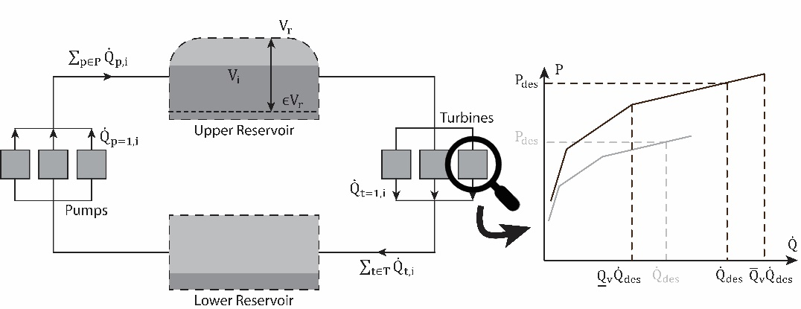
Figure 1. Illustration of the offshore pumped-hydro storage system. The left side shows the overall system with variables used in the model. The right side shows an exemplary turbine performance for two different turbine designs (gray and black). A similar function holds for the pump performance.
    - Detailed Model of the Offshore Pumped-hydro Storage System
The state of charge of the upper reservoir is given by the fill-volume in the previous timestep $V_{i-1}$ with respective inflows and outflows (Eq. 1). Additionally, the volume is limited by an upper bound, i.e. the reservoir size $V_{r}$, and a lower bound, being the dead-volume as a fraction of total reservoir size:
$V_{i}=V_{i-1}+\sum_{u∈U}{{\dot{Q}}_{u,i}}Δi-\sum_{t∈T}{{\dot{Q}}_{t,i}}Δi$ | (1)
$ϵV_{r}≤V_{i}≤V_{r}$ | (2)
For the pumps and turbines, we assume that the performance in each timestep is a function of nominal head, design flow and actual flow. As such, we also take into account part-load behaviors of pumps and turbines. The head is assumed to be constant during operation, neglecting changes in head due to tidal or wave effects, as well as due to different states of charge and pressure losses, as these effects are expected to be very small.
The relationship between design flow rate and design power of both pumps and turbines is modelled with a piecewise affine function with a set of segments $W$ (Eq. 3). The available head provides an upper and lower bound to the design flow rate. For readability, we refrain from indexing the variables and parameters for pumps and turbines. The equations hold for both turbomachinery types.
$P_{des}=\sum_{w∈W}{\left[x_{w}\left(α_{w,1}{\dot{Q}}_{des}+α_{w,2}\right)\right]}$ | (3)
$\sum_{w∈W}{\left[x_{w}{\underline{Q}}_{des,w}\right]}≤{\dot{Q}}_{des}≤\sum_{w∈W}{\left[x_{w}{\overline{Q}}_{des,w}\right]}$ | (4)
$\sum_{w∈W}{x_{w}}=1$ | (5)
$x_{w}∈\{0,1\}$ | (6)
The part-load performance of the pumps and the turbines are modelled with another piecewise affine function. The relationship of different design flow rates ${\dot{Q}}_{des}$, actual flow rates ${\dot{Q}}_{i}$ and power $P_{i}$ is also illustrated in Figure 1.
$P_{i}=\sum_{v∈V}{\left[y_{v,i}\left(β_{v,1}{\dot{Q}}_{i}+β_{v,2}{\dot{Q}}_{des}\right)\right]}$ | (7)
$\sum_{v∈V}{\left[y_{v,i}{\underline{Q}}_{v}{\dot{Q}}_{des}\right]}≤{\dot{Q}}_{i}≤\sum_{v∈V}{\left[y_{v,i}{\overline{Q}}_{v}{\dot{Q}}_{des}\right]}$ | (8)
$β_{v,2}=\left({\underline{P}}_{v}- β_{v,1}{\underline{Q}}_{v}\right) for v≠1$ | (9)
$β_{v,2}, β_{v,1}, {\underline{Q}}_{v},{\overline{Q}}_{v}=0 for v=1$ | (10)
$\sum_{v∈V}{y_{v,i}}=1$ | (11)
$y_{v,i}∈\{0,1\}$ | (12)
It is possible for (part) of the equipment to be switched off (see Eq. 10). Eq. 3, 7 and 8 contain bilinearities that were transformed to a MILP formulation using the hull reformulation of the python library Pyomo. The parameters $α_{w,1}$, $α_{w,2}$, ${\underline{Q}}_{des,w}$, ${\overline{Q}}_{des,w}$, $β_{v,1}$, ${\underline{P}}_{v}$, ${\underline{Q}}_{v}$, and ${\overline{Q}}_{v}$ are fitted to respective pump and turbine performances for a given nominal head determined by the sea depth. The total electricity in- and output in each timestep is given by the sum of pump and turbine energy of all slots respectively:
$P_{in,i}=\sum_{u∈U}{P_{u,i}}$ | (13)
$P_{out,i}=\sum_{t∈T}{P_{t,i}}$ | (14)
To prevent symmetry in the resulting MILP we deploy constraints giving priority to pumps/turbines with lower indices (for design and operation):
$P_{u,i}≤P_{u-1,i},$ $P_{t,i}≤P_{t-1,i}$ | (15)
$P_{des,u}≤P_{des,u-1},$ $P_{des,t}≤P_{des, t-1}$ | (16)
We optimize the design and operation of the offshore pumped-hydro storage to maximize profits over one month of operation with an hourly resolution, i.e., $Δi=1h$. As such, the objective function is the sum of electricity revenues over the time horizon minus total system cost. Cost factors for the equipment ($c_{u}$, $c_{t}$ and $c_{r}$) are recalculated to a monthly cost:
$\max{Π}=\sum_{i∈I}{ΔiP_{out,i}p_{i}}-\sum_{i∈I}{ΔiP_{in,i}p_{i}}-$ $\sum_{u∈U}{c_{u}{\dot{Q}}_{u,des}}-\sum_{t∈T}{c_{t}{\dot{Q}}_{t,des}}-c_{r}V_{r}$ | (17)
Note that it is also possible to not install the storage system. In this case, reservoir, pump and turbine sizes are zero. The optimization model is formulated with the Python library Pyomo and solved with Gurobi 10.0.3.
    - Input data
To obtain the design performance parameters of the hydraulic machines, we used Balje ($D_{s}, ω_{s}$) and efficiency ($η, ω_{s}$) diagrams from Cornetti & Millo (1989) for centrifugal pumps and Francis turbines. Part-load operation curves were taken from Kumar et al. (2011) for the turbines, and for the centrifugal pump it was retrieved from an open-source Simscape Block (Centrifugal Pump (IL), 2023).
The cost of electro-machinery can be estimated by a function of the following form: $C=aP^{b}H^{c}$. After comparison to the cost values of other studies (Aggidis et al., 2010; Ogayar & Vidal, 2009) we used the values from Alzohbi (2018) to determine the costs for a 1 MW pump/turbine. We then used the work by Aggidis et al. (2010) for size-scaling, which showed a trend highly similar to those of the other relevant literature. The resulting data was fitted with a linear function and is reported in Table 1.
Day-ahead market prices for the Dutch bidding zone in 2019, retrieved from ENTSO-E (2023), were used as price profiles for the optimization scenario. This price profile has a mean price of 58.33 EUR/MWh and a standard deviation (SD) of 13.83 EUR/MWh.
Table 1. Value assumptions used in the model. Pump and turbine values are for a nominal head of 47.5m.
Parameter | Unit | Value
CAPEX turbines | € | CAPEX = 324000 ∙ P [MW] + 189300
CAPEX pumps | € | CAPEX = 322100 ∙ P [MW] + 110900
CAPEX reservoir | €/m³ | 4.2 – 84
  - Results
We optimized the pumped-hydro design and operation over a one-month period with hourly resolution considering different combinations of reservoir costs and electricity price profiles. The electricity prices for May 2019 were therefore scaled to have different standard deviations. The optimal size for the reservoir and total installed capacities for pump and turbine of 204 optimization runs are shown in Figure 2. Detailed results for the three points indicated in the Figures are shown in Table 2.
Design. For high reservoir costs and low electricity price volatility (low SD), the storage system is unprofitable, leading to zero sizes for both pump, turbine, and reservoir (upper-left region). Conversely, an increase in electricity price volatility (high SD) coupled with lower reservoir costs makes the storage system profitable, with the optimal configurations featuring the largest possible reservoir size of 250,000 m³ resulting in a capacity of 32 MWh and a pump power rating of around 4.5 MW. Only for high reservoir costs and high SDs (upper right corner), it is optimal to reduce the reservoir size and thus pumps and turbines are relatively large compared to the reservoir size. One reason to select large pumps for the system, especially for high SDs, is the occurrence of negative electricity prices: During periods of negative prices, the storage operator is paid for using electricity, and as such, it is profitable to pump water to the upper reservoir and use a bypass of the turbines in case the upper reservoir is full. As a result, the pumps generally have a higher load factor than the turbines, especially for high price volatility scenarios.
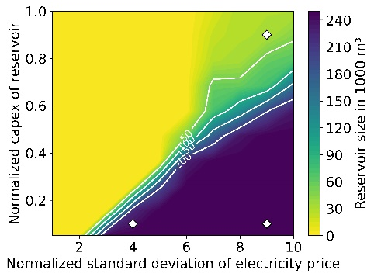
(a) Reservoir size
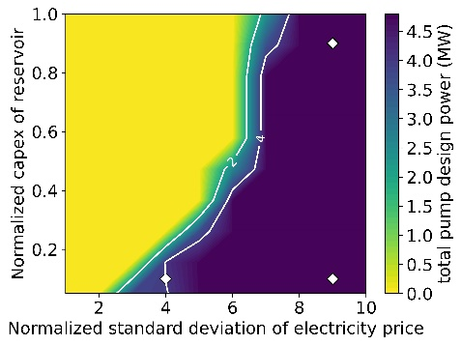
(b) Total pump power
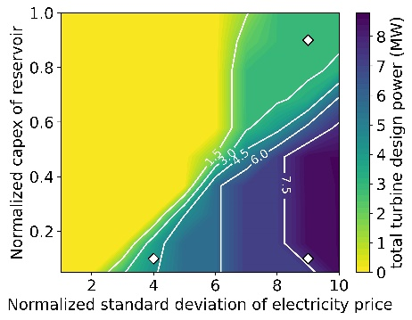
(c) Total turbine power
Figure 2. Equipment size for different electricity price profiles and reservoir cost assumptions. Reservoir capex was normalized to 84 EUR/m³, SD of electricity prices to the SD of the electricity prices in May 2019.
Operation. As the flow rate varies in each timestep, also the efficiency of turbo-machinery varies over time. In Table 2 we reported the average efficiencies alongside the minimum and maximum efficiencies that occurred over the time horizon for three electricity-price-capex combinations. The round trip efficiency aligns well with conventional pumped-hydro systems and is consistent with findings from previous reports on offshore pumped-hydro systems (Nienhuis et al., 2023). Notably, adding the load factors for pumps and turbines indicates that the system is almost in continuous operation. This also suggests that the system, at least from a purely economic perspective, is suitable for short-term storage. The storage system is thus constantly charged and discharged, reaching up to 4 full cycles per day. The system capitalizes on the modularity of pumps and turbines: Rather than operating all available machines at part-load it is optimal to switch some machines off and operate the remaining ones at a higher flow rate to achieve improved overall efficiency.
Table 2. Performance and cost results of three highlighted scenarios.
Scenario |  | Performance |  |  | Economics |  |  | Load Factor
Reservoir  CAPEX | SD | Pump efficiency (mean) | Turbine efficiency  (mean) | Average roundtrip efficiency | Monthly costs [k€] | Monthly revenues [k€] | Upfront costs  [k€/MWh] | Pumps | Turbines
0.05 | 4 | 0.80 – 0.92  (0.92) | 0.75 – 0.78  (0.78) | 0.71 | 47 | 71 | 155 | 0.40 | 0.26
0.05 | 9 | 0.44 – 0.92  (0.91) | 0.51 – 0.83  (0.77) | 0.70 | 63 | 225 | 209 | 0.52 | 0.19
0.9 | 9 | 0.20 – 0.92  (0.89) | 0.72 – 0.83  (0.78) | 0.69 | 56 | 92 | 1,552 | 0.42 | 0.10
  - Conclusion
This paper proposes a mixed-integer linear formulation of an offshore pumped-hydro storage system, capable of optimizing the sizes of pumps, turbines and reservoir as well as their operation. We have applied the model in a case study with a number of scenarios for electricity prices and investment costs. As with any other storage system, higher variations in electricity prices make the system more profitable. The system has high round-trip efficiencies comparable to conventional pumped-hydro storage (~70%) with a storage size of up to 32 MWh for a sea depth of 50 m. In our case study, the system runs up to 4 full cycles per day. If the storage system participates in the day-ahead market exclusively, it is unprofitable for 2019 electricity prices in the Netherlands. However, participating in e.g. balancing or capacity markets, could change this finding. To study this, it would be insightful to include the participation in additional markets. Additionally, optimizing the combined sizing and operation of a wind farm with storage and transmission to shore could provide insights into other system benefits. In future works, the offshore pumped-hydro system will be compared to other storage technologies, such as lithium-ion batteries or hydrogen storage in its potential for emission and cost reduction in an offshore context and with regards to aging. Additionally, its environmental impact during construction and operation as well as spatial requirements will be investigated.
Acknowledgements
During the preparation of this work the authors used ChatGPT 3.5 to enhance readability and refine clarity of the first draft. After using, the authors reviewed and edited the content as needed and take full responsibility for the publication. This work was supported by DOSTA (project number WIND.2019.002) of the NWO research program PhD@Sea, (partly) financed by the Dutch Research Council (NWO). We are grateful to Ocean Grazer B.V. for providing support and the opportunity for collaboration.

References

Aggidis, G. A., Luchinskaya, E., Rothschild, R., & Howard, D. C. (2010). The costs of small-scale hydro power production: Impact on the development of existing potential. Renewable Energy, 35(12), 2632–2638.
Alzohbi, G. (2018). The cost of electromechanical equipment in a small hydropower storage plant. Journal of Energy Systems, 2(4), 238–259.
Centrifugal Pump (IL) (R2023a). (2023). The Mathworks, Inc. https://nl.mathworks.com/help/hydro/ref/centrifugalpumpil.html#responsive_offcanvas
Cornetti, G., & Millo, F. (1989). Macchine idrauliche. Il Capitello.
ENTSO-E. (2023). ENTSO-E Transparency Platform. https://transparency.entsoe.eu/
European Commission. (2020). An EU Strategy to harness the potential of offshore renewable energy for a climate neutral future. In Communication from the commission to the European parliament, the council, the European economic and social committee and the committee of the regions.
Kumar, A., Schei, T., Ahenkorah, A., Caceres Rodriguez, R., Devernay, J.-M., Freitas, M., Hall, D., Killingtveit, A., & Liu, Z. (2011). Hydropower. In IPCC Special Report on Renewable Energy Sources and Climate Change Mitigation. Cambridge University Press.
Laugs, G. A. H., Benders, R. M. J., & Moll, H. C. (2020). Balancing responsibilities: Effects of growth of variable renewable energy, storage, and undue grid interaction. Energy Policy, 139.
Lazdanaite, E., Nguyen, P., Tran, M.-Q., Bliek, F., & van Rooij, M. (2022). Integration of Pump-Storage Batteries in Offshore Wind Farms: Evaluation of Effects on Power Exchange. 2022 IEEE PES Innovative Smart Grid Technologies - Asia (ISGT Asia), 210–214.
Li, B., & DeCarolis, J. F. (2015). A techno-economic assessment of offshore wind coupled to offshore compressed air energy storage. Applied Energy, 155, 315–322.
Nienhuis, R. M., Van Rooij, M., Prins, W. A., Jayawardhana, B., & Vakis, A. I. (2023). Investigating the efficiency of a novel offshore pumped hydro energy storage system: Experimental study on a scale prototype Journal of Energy Storage, 74, 2352–152.
Ogayar, B., & Vidal, P. G. (2009). Cost determination of the electro-mechanical equipment of a small hydro-power plant. Renewable Energy, 34(1), 6–13.

