**Systematic Analysis of Energy Transition Pathways for Emission Reduction in the Flat Glass Industry Using MILP Formulation**

Muhammad Salmana*, Daniel Flórez-Orregob, Juan Correa-Lagunac, François Maréchalb, Grégoire Léonarda

aChemical Engineering, University of Liège, Liège Sart Tilman, 4000, Belgium.

bFederal Polytechnic School of Lausanne, IPESE group, Sion, Switzerland.

cEnergyVille, Thor Park 8310-8320, 3600 Genk, Belgium.

*m.salman@uliege.be / Tel:+32465671822

Abstract

A systemic methodology was developed, employing key performance indicators (KPIs): specific total annual cost (TAC) (€/tglass), specific emissions (tCO2/tglass) and specific energy consumption (MWh/tglass) to analyse various energy transition routes for flat glass production, such as NG oxy-combustion, H2 and hybrid furnaces, and full electrification, along with glass recycle and carbon capture (CC). A Blueprint (BP) model, including steady-state values for mass and energy balance, as well as investment and operating costs, is developed. To determine the optimal route, the OSMOSE Lua optimization framework was employed, which solves the mixed integer linear programming (MILP) problem using the TAC as the objective function. Additionally, three scenarios, namely Central, Electrification and Clean Molecules were implemented, influencing costs of natural gas (NG), H2, electricity, and CO2 emission, for years 2030, 2040 and 2050. For 2030, the hybrid furnace becomes the most cost-effective route across all scenarios. However, considering a balance between emissions and cost, pathways such as the H2 furnace, all-electric furnace, or NG furnace with CC suit moderate emissions target. For higher targets, hybrid with CC is the optimal choice, effectively combining cost efficiency with significant emissions reduction. In 2040, electrification with CC dominates in electrification scenario, achieving significant emissions and TAC reductions, while the hybrid with CC prevails in other scenarios, with 93% emission and 15-16% TAC reductions. By 2050, lower commodity costs and higher CO2 favour CC-equipped routes of all-electric, H2, and hybrid, reducing TAC by 34-39% and emissions by 93-95%. In conclusion, for the energy transition in glass sector, an excellent trade-off between all KPIs is required, based on future energy perspectives, to make the right investment decisions.

**Keywords**: Energy transition, Process integration, Mixed-Integer Linear Programming (MILP), Industrial decarbonisation, Glass Industry

* 1. Introduction

The glass sector stands out as one of the high-energy-intensity industries, primarily utilizing energy for high-temperature process heat (ranging from 1400 to 1650°C) to melt raw materials (Joint Research Centre, 2013). According to the EU Emissions Trading Scheme (ETS) database, the glass sector contributes 8.5% (0.696 Mt/year) to the total Belgian industrial emissions and 67% of it alone comes from flat glass production. While CO2 emissions in industrialized nations have consistently decreased (Lindig, 2009), the glass industry has experienced a staggering 165% increase (Hertwich, 2021). Hence, it is imperative to have a comprehensive analysis of energy transition in this sector. Although essential process parameters, such as energy consumption, cullet utilization, or energy sources, vary considerably across different countries, all types of glass products share significant similarities in crucial aspects like furnace type, capacity, and forming processes (Schmitz et al., 2011). Hence, this study is centred around flat glass to develop a generalized methodology to study the energy transition pathways of other glass products as well. Numerous studies have explored technical strategies to decarbonize the glass industry, with a focus on improving energy efficiency and fuel switching. Frassine et al., 2016 developed a predictive model estimating energy requirements for European glass melting furnaces from 2015 to 2030, considering factors like aging, cullet recycling, and energy efficiency measures. (Springer & Hasanbeigi, 2017) examined 16 technologies enhancing energy efficiency in glass production, covering batch preparation, preheating, process control, burner technologies, and combustion. (Galitsky et al., 2008) provided a comprehensive set of technical options for energy efficiency in the glass industry at various levels, including components, processes, systems, and organizations, quantifying the impact of energy management systems. (Papadogeorgos & Schure, 2019) focused on decarbonization pathways for Dutch container glass and tableware, addressing feedstock substitution, fuel switching, process design, recycling, and product design, and briefly exploring carbon capture (CC), storage, and utilization options. Despite extensive studies, research lacks exploration of how energy transition pathways impact CO2 emissions amid evolving climate policies, particularly in Belgium and globally. The capital-intensive, competitive glass industry faces unique challenges due to its energy intensity and quality emphasis. Moreover, long-term investments significantly shape future CO2 footprints. A crucial need thus exists for a comprehensive study on energy transition economics, emissions reduction, and energy intensity in the glass production sector. This study systematically analyses innovative pathways—oxy-combustion, H2, hybrid, and all-electric furnaces with CC—assessing key performance indicators (KPIs) like total annual cost, emissions reduction, and energy consumption. Moreover, it will lay the foundation for the development of a generalized methodology to study the decarbonisation routes in the industries, which is one of the objectives of the TRILATE project.

* 1. Model Description and Methodology
     1. Model Description

To analyze the different production routes, a Blueprint (BP) model of flat glass production is developed, which includes various production routes, as depicted in Figure 1. Energy and mass consumption data from open literature (Joint Research Centre, 2013) have been adopted and validated together with industrial plants. Modelling and simulations of other relevant utility systems are also performed in Aspen HYSYS software, using Peng-Robinson and NRTL fluid packages. The main process steps are ⅰ) raw materials and cullet batch preparation and preheating at around 25 – 200°C. ⅱ) Melting by introducing batch in the furnace, heated by combustion flames. The main chemical reactions occur here. The fining process removes the impurities and flue gases aided by agents like Na2SO4 at high temperatures. ⅲ) Forming, where the molten glass is guided onto a molten tin bath. Temperatures range from 1200 – 600°C further along the process. ⅳ) Lastly, in the post-forming stage, finishing and cooling of flat glass product is done at around 600 – 100°C, which involves annealing and gradual cooling to relieve stress. In the base case, the furnace operates on natural gas (NG) (with 37% efficiency), releasing fossil emissions into the environment due to fossil fuel use as well as decarbonation of glass raw materials. However, to align with recommendations from literature on glass decarbonization (Correa Laguna et al., 2022; Elia, 2022), several additional routes are incorporated into the superstructure: 1) An all-electric furnace with 50% efficiency 2) Partial electrification using a mix of NG oxy-combustion and electric boosting, denominated as “hybrid” route 3) NG oxy-combustion furnace, aiming to decrease fuel consumption by 20%, and 4) H2 furnace, with same efficiency as base case, but leveraging carbon-neutral fuel to reduce emissions. Each route offers the option of utilizing MEA chemical absorption for CC, capable of a 90% capture rate with a capture cost of 76 €/tCO2. An auxiliary heating system is used to supply energy to the CC unit, however, its own emissions are not captured, when using NG as energy source. Moreover, in all routes, 26% of the total raw material batch is comprised of cullet. For the given scenarios, detailed mass and energy balances of each route are formulated in OSMOSE Lua, a mixed integer linear programming (MILP) optimization framework for industrial process integration and analysis. A detailed superstructure including all routes is depicted in Figure 1.

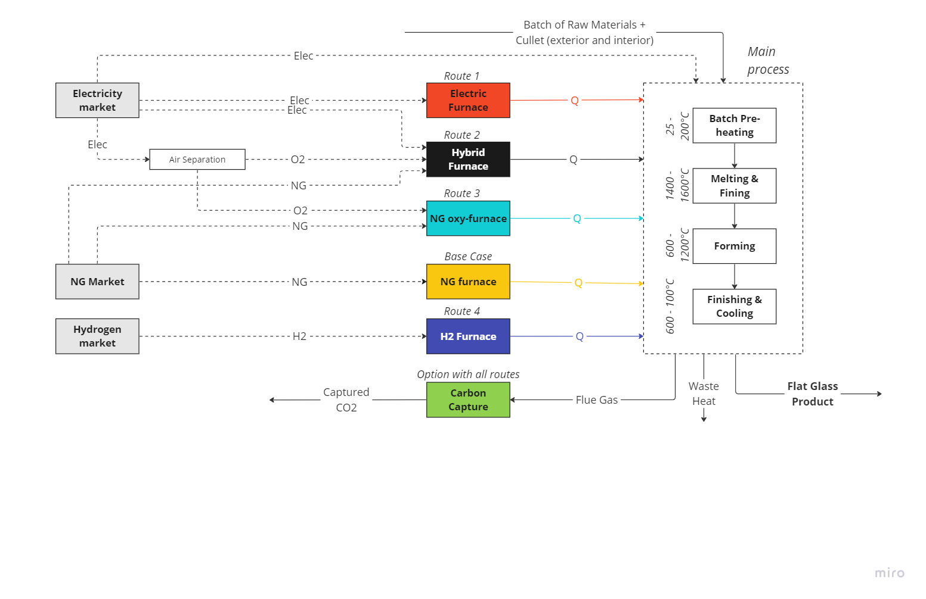

Figure 1. Superstructure of different routes for flat glass production

* + 1. Scenarios Description

To evaluate proposed pathways, three scenarios—electrification, clean molecules, and central—are implemented for 2030, 2040, and 2050. These scenarios are named after the favored energy vector and they include electricity, H2, NG, as well as emission costs assumptions, serving as decision variables to minimize the objective function. These costs are merely assumptions and being used as weights, whose main purpose is to map the decision space. Each scenario operates on specific assumptions influencing these costs. Using the TIMES-BE model which offers adaptable spatial and temporal resolutions, marginal production costs for electricity and H2 are calculated for Belgium for 10 typical days, totaling 8760 hours, reflecting supply and demand variations over specific yearly periods. Table 1 displays the average costs of electricity and H2 for all days. Additionally, NG cost is arbitrarily set at 0.37 €/kWh overall. CO2 emission costs stand at 150, 250, and 350 €/tCO2 for 2030, 2040, and 2050, respectively. For a comprehensive understanding of the TIMES model, scenario assumptions, and detail cost assumptions, please refer to (Correa Laguna et al., 2022).

Table 1. Costs of electricity and H2 (lower heating value) based on an average of 10 representative days for different years and scenarios

|  |  |  |  |  |  |  |  |  |  |  |  |  |  |  |  |  |  |  |
| --- | --- | --- | --- | --- | --- | --- | --- | --- | --- | --- | --- | --- | --- | --- | --- | --- | --- | --- |
| €/ kWh | 2030 | | | | | | 2040 | | | | | | 2050 | | | | | |
|  | Elec. | | Central | | Molecules | | Elec. | | Central | | Molecules | | Elec. | | Central | | Molecules | |
| H2 | EL. | H2 | EL. | H2 | EL. | H2 | EL. | H2 | EL. | H2 | EL. | H2 | EL. | H2 | EL. | H2 | EL. |
| Avg. | 0.1 | 0.086 | 0.1 | 0.101 | 0.076 | 0.100 | 0.064 | 0.068 | 0.079 | 0.079 | 0.064 | 0.076 | 0.043 | 0.049 | 0.064 | 0.079 | 0.057 | 0.073 |

* + 1. Optimization Problem Definition and Performance Indicators

To evaluate the performance of each route depicted in Figure 1, a systemic approach is established, leveraging the OSMOSE Lua optimization framework. The goal is to identify the route with the lowest total specific cost (TAC) (€/ton of product) in each scenario, by resolving a MILP problem outlined in equations (1-3). In equation 1, (u) stands for unit, (S) for size of unit, (ref) for the reference unit in CAPEX calculations, and CBM for the bare module cost factor encompassing direct and indirect expenses. For CAPEX annualization, a 40-year lifetime (n) and a 3% discount rate (i) are considered. In equation (2) (C) is for specific cost, $(\dot{Q})$ and $(\dot{m}$) for energy and mass flow rates, respectively, (em) for emissions, TD for typical days and (W) for total power.

$CAPEX{(u_{s})}_{n,i} =\left(CAPEX\left(u_{ref}\right)∙{\left(\frac{S_{0}}{S_{ref}}\right)}^{0.6}∙C_{BM}∙\frac{{CEPCI}_{2022}}{{CEPCI}_{ref}}\right)∙i∙\frac{{(i+1)}^{n}}{{(i+1)}^{n-1}}$ (1)

$OPEX= \sum_{D∈TD}{\left[\sum_{u∈units}{\left(\sum_{e∈energy}{\left({C_{e}}_{u}∙{{\dot{Q}}_{e}}_{u}\right)}+\left({C_{em}}_{u}∙{{\dot{m}}_{em}}_{u}\right)+\sum_{m∈material}{\left({C_{m}}_{u}∙{{\dot{m}}_{m}}_{u}\right)}\right)∙}{hrs}_{D}\right]}$ (2)

$\min{TAC (\frac{€}{t of glass})}=\frac{OPEX+CAPEX}{ton of product}$ (3)

The TAC acts as one of the three KPIs for the evaluation of the production routes. The other two KPIs are the total specific emissions (tCO2/tglass) and specific energy consumption (MWh/tglass), associated with each route.

* 1. Results and Discussions

The energy transition routes for flat glass production, as depicted in Figure 1, are assessed across the different scenarios for 2030, 2040, and 2050. For 2030 (Figure 2), the hybrid furnace is cheapest, with 30% less energy consumption compared to the base case (1.33 MWh/tglass), reducing TAC by 6%, 4%, and 4% compared to the NG base case (TAC of 195, 198, and 198 €/tglass for the base case in scenarios electrification, clean molecules and central, respectively. The hybrid system uses NG oxy-combustion, cutting fuel usage by 20%. However, emissions are only 32% lower than the base case (0.40 tCO2/tglass). Adding CC to the hybrid case reduces emissions by 93% with 1.7%, 5.3%, and 5.3% higher TAC than the base case. NG with CC reduces emissions by 70% but increases TAC by 6% and energy consumption by 32%. This makes it suboptimal. Instead, NG oxy-combustion reduces emissions by 12% but increases TAC by 6% due to additional costs (such as CAPEX for a large air separation unit). The H2 furnace becomes viable only under the clean molecules scenario with low H2 costs and it offers a 55% emissions reduction with a slight TAC increase. All-electric route results in a slight TAC increase of 0.5%, 6%, and 6% for each scenarios respectively, achieving a 55% decrease in emissions compared to the base case with similar energy consumption. However, the implementation of CC to reach 95% emissions reduction is economically feasible only for the electrification scenario where electricity cost is cheaper. For 2030, choices depend on balancing factors. Moderate emissions reduction could favour H2, all-electric or NG-with-CC furnaces, offering 55-70% emissions reduction with slight TAC increases. For higher targets, the hybrid with CC remains optimal, while H2 and electric furnaces with CC suit scenarios clean molecules and electrification, respectively. For 2040 (Figure 3), lower electricity and H2 costs, combined with higher CO2 emissions costs, significantly raise base case TAC to 228, 231, and 232 €/tglass for the three scenarios respectively. Introducing CC cuts TAC by 7% across scenarios, achieving a 70% emissions reduction. These changes in commodities costs trigger a change in each route. In Electrification scenario, all-electric with CC yields a 19.5% lower TAC and a 95% emissions reduction. Similarly, a hybrid furnace with CC reduces emissions by 93% and TAC by 18%. NG oxy-combustion remains viable only when paired with CC. For the clean molecules scenario, the H2 furnace with CC cuts TAC by 15%, but the hybrid with CC becomes optimal, offering a 16% lower TAC and a substantial 93% emissions reduction. This trend persists in scenario 3, where the hybrid with CC delivers a 15% TAC reduction.

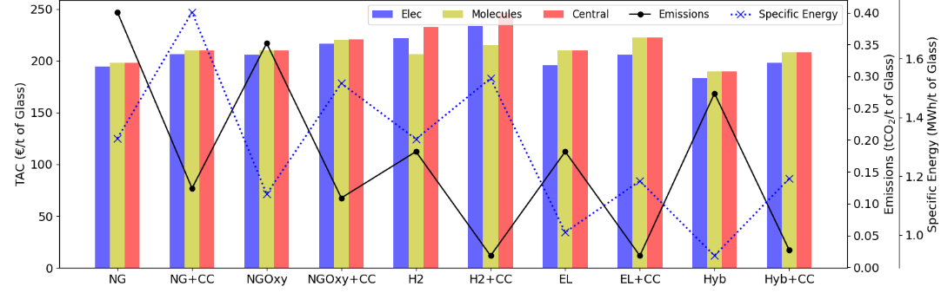

Figure 2. Comparison of all production routes based on given scenarios for the year 2030

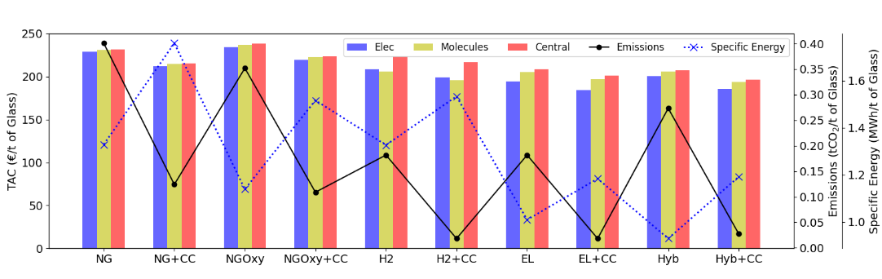

Figure 3. Comparison of all production routes based on given scenarios for the year 2040

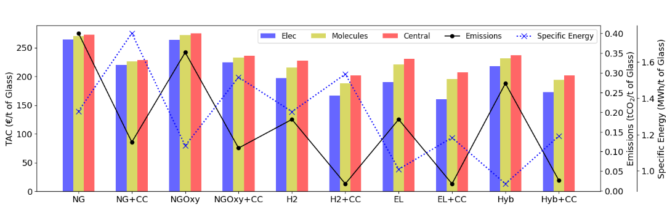

Figure 4. Comparison of all production routes based on given scenarios for the year 2050

For 2050 (Figure 4), reduced commodity costs and higher CO2 expenses favor the hybrid, H2, and all-electric furnace routes with CC. Base case TAC increases to 264, 270, and 272 €/tglass for the three scenarios respectively. For electrification scenario, the all-electric with CC remains optimal, offering a substantial 39% lower TAC than the base case. Following closely are the H2 furnace and hybrid furnace with CC routes, presenting 37% and 34% lower TAC and 95% and 93% emissions reductions compared to the base case, respectively. In the clean molecules scenario, low H2 cost makes the H2 furnace with CC the most optimal, delivering a 30% lower TAC compared to the base case. Finally, in the central scenario, the hybrid furnace with CC emerges as the most suitable option, presenting a 26% lower TAC. With lower electricity costs, improved fuel efficiency, and capturing 93% of emissions, it becomes the optimal choice for this scenario. Regarding the specific energy consumption, two main observations can be made. First, the technology using the least energy are not those with the lowest TAC, evidencing the role of the CAPEX in the TAC KPI. Second, it appears that the hybrid and then the electrical routes show the lowest specific energy consumption in all cases.

* 1. Conclusions

This study conducts a comprehensive analysis of energy transition routes for flat glass production, exploring NG oxy-combustion, hybrid, all-electric, and H2 furnace pathways, each potentially integrated with CC. An optimization framework uses TAC as the primary objective function and evaluates specific emissions and energy consumption (depicting the important role of CAPEX in TAC) as additional KPIs, under three scenarios which dictate the costs of the commodities. The latter are selected as decision variables in the optimization process. As a result, for 2030, the higher assumed costs of electricity and H2 makes the hybrid furnace an optimal choice in terms of TAC for all scenarios. However, for a trade-off with emissions, pathways like the H2 furnace, all-electric furnace, or NG furnace (with CC) cater well to moderate emissions reduction target and the hybrid with CC emerges as the feasible route for higher targets, aligning cost efficiency with substantial emissions reduction. In 2040, all-electric with CC excels in electrification, while hybrid with CC prevails in others. By 2050, lower commodity and higher CO2 costs support CC-equipped routes. The cheapest technologies vary from all-electric with CC in electrification scenario to H2 furnace with CC in clean molecule scenario, and hybrid with CC in the central scenario, all achieving about 93% emissions reductions. To conclude, optimal route selection entails a trade-off between TAC and CO2 emissions. The specific energy consumption may also be a useful indicator to make up for the high uncertainty regarding energy carriers costs. When commodity costs are high, routes with moderate emission targets and no CC can be optimal. However, as commodity costs decrease, routes emphasizing high emission reductions, like hybrid, H2, or all-electric furnaces with CC, become preferable. Future research will explore directions such as effect of cullet flow and options for inter- and intra-plant heat recovery to enhance efficiencies in the glass sector. Additionally, in the TRILATE project, systemic studies for similar enhancements in other industrial sectors will be performed.

* 1. Acknowledgment

This research is supported via the Energy Transition Fund project ‘TRILATE’ organized by the FPS economy.

References

Correa Laguna, J., Moglianesi, A., Vingerhoets, P., & Lodewijks, P. (2022). *Perspective 2050*. https://perspective2050.energyville.be/

Elia. (2022). *Powering Industry Towards Net Zero*. https://www.elia.be/-/media/project/elia/shared/documents/elia-group/publications/studies-and-reports/2022/20221118_visionpaper_en.pdf

Frassine, C., Rohde, C., & Hirzel, S. (2016). Energy saving options for industrial furnaces–the example of the glass industry. *ECEEE Industrial Summer Study Proceedings*.

Galitsky, C., Worrell, E., Masanet, E., & Graus, W. (2008). *Energy Efficiency Improvement and Cost Saving Opportunities for the Glass Industry. an Energy Star Guide for Energy and Plant Managers*. Lawrence Berkeley National Lab.(LBNL), Berkeley, CA (United States).

Hertwich, E. G. (2021). Increased carbon footprint of materials production driven by rise in investments. *Nature Geoscience*, *14*(3), 151–155. https://doi.org/10.1038/s41561-021-00690-8

Joint Research Centre. (2013). *Best available techniques (BAT) reference document for the manufacture of glass – Industrial emissions Directive 2010/75/EU: integrated pollution prevention and control*. Publications Office. https://doi.org/doi/10.2791/70161

Lindig, M. (2009). An Improved Solution for Oxy‐Fuel Fired Glass Melting Furnaces. *69th Conference on Glass Problems: Ceramic Engineering and Science Proceedings, Volume 30, Issue 1*, 121–131.

Papadogeorgos, I., & Schure, K. . M. (2019). *Decarbonisation options for the dutch container and tableware glass industry*. PBL Netherlands Environmental Assessment Agency.

Schmitz, A., Kamiński, J., Maria Scalet, B., & Soria, A. (2011). Energy consumption and CO2 emissions of the European glass industry. *Energy Policy*, *39*(1), 142–155. https://doi.org/https://doi.org/10.1016/j.enpol.2010.09.022

Springer, C., & Hasanbeigi, A. (2017). Emerging energy efficiency and carbon dioxide emissions-reduction technologies for the glass industry. *Energy Analysis an d Environmental Impacts Division, Lawrence Berkeley National Laboratory [LBNL], University of California, Berkeley, CA, USA*.