**Aiding Modular Plant Design by Linking Capability and Transformation Models**

Amy Koch*, Florian Kunkel, Louise Theophile, Veronica De la Vega Hernandez, Jonathan Mädler, Leon Urbas

*Chair of Process Control Systems & Process Systems Engineering Group,*

*TU Dresden, Dresden 01062, Germany*;

amy.koch@tu-dresden.de

Abstract

The specialty chemical and pharmaceutical industries require faster time-to-market, and more flexible production. Modular Plants built from Process Equipment Assemblies (PEAs) and designed according to VDI 2776 are suitable to address these challenges. Since PEAs are designed independently of the products they produce, this creates a problem of exchange of information between the Owner/Operator (O/O) and the PEA vendors. In this paper, an information model that links information about the products from the O/O (transformation model) to the information about the PEA from the PEA vendors (capability model) is introduced. Although, the necessary information from these two parties is contained and distributed amongst existing standards for information models such as DEXPI and OntoCAPE, these standards must be connected and extended to support modular plants. The application of this information model is illustrated for connecting a neutralization process with a reactor PEA.

**Keywords**: digital twins, information model, modular plants, knowledge distribution

* 2. Motivation

Modular Plants (MP) built from Process Equipment Assemblies (PEA) can be used to address the challenges of faster time-to-process and increased flexibility facing the specialty chemical and pharmaceutical industries. Additional benefit can be achieved from the integration of a Digital Twin (DT) of these PEAs to facilitate with process planning, scale-up, and validation (Mädler et al. 2022; Koch et al. 2023). Compared to conventional production plants, Modular Plants require adapted engineering workflows as information must be exchanged across different domains throughout different lifecycles and lifecycle phases. This highlights the increasing importance of information management and seamless data exchange between software tools. Here, information models can be used to support the digital data exchange and semantic connections as part of a Digital Twin Concept. For modular plants, significant challenge stems in matching a product specification and process, described in a transformation model, to the necessary PEA assets described by capability models. In this work we intend to propose a new information model to match simulation-based transformation models with equipment datasheet-based capability models based on existing standards of OntoCAPE and DEXPI[1]. This paper is structured as follows: first the challenges of knowledge distribution in modular plants are presented. Next, the relevant submodels of the Digital Twin are aligned with the OntoCAPE ontology and the resulting architecture of the information model based on the Digital Twin workflow is presented. Finally, the use case of a neutralization process is used to evaluate the results followed by a critical discussion and conclusion.

* 1. Background
     1. Knowledge Distribution and Digital Twin Workflows for Modular Plants

To address matching Owner/Operator (O/O) knowledge with PEA vendor knowledge, first the relationship between the partial models of the Digital Twin to the relevant workflows and lifecycle phases must be understood. Bamberg et al. (2021) describe the Digital Twin as a Product-Process-Resource model. Mädler et al. (2022) applied the model of Bamberg et al. (2021) to modular plants and illustrated how the knowledge distribution in a Digital Twin is divided between the PEA manufacturers and the Owners. For this purpose, the **capability model** is a product independent description of a PEA containing structural, operational and behavioral information about the PEA, independent of a concrete process. The **transformation model** is a plant independent and product specific description of the process and is used to derive information e.g., residence times. To leverage this knowledge distribution in modular plants, information regarding the product and process has to be compared and matched with equipment specific capabilities. Currently, this process is carried out using vendor specific toolsets or by exchange of non-machine-readable documentations between both parties and all participating domains. The transfer of documents between different parties increases the risk of potential loss of important information. This highlights the need for seamless data exchange using information models. Supporting this with suitable digital representation would not only make this exchange more efficient, but also creates the potential to automate the interaction of different parties and enable an automated selection of PEAs.

* + 1. Vendor-Independent Standards for Information Models

To support the semantic connection between submodels in a Digital Twin, existing vendor-independent standards for information models and ontologies are needed. Koch et al. (2023) evaluated the suitability of OntoCAPE, DEXPI, among others, across the lifecycle phases relevant to the modular plant and PEA assets; here, DEXPI and OntoCAPE were demonstrated to be most suitable to address describing the lifecycle phases for a Digital Twin, where information from the transformation model must be matched to the capability model. DEXPI is a vendor-independent standard which can be used to describe the data in Piping & Instrumentation Diagrams (P&ID) for exchange between Computer Aided Engineering (CAE) systems such as COMOS (Wiedau et al., 2019). As of 2023, the DEXPI P&ID has been supplemented with the DEXPI Process specification to describe the functional requirements phase in the asset lifecycle of Wiedau et al. (2019) and describe the information covered in block flow diagram (BFD) and process flow diagram (PFD) as outlined by the ISO 10628 standard. However, for the remainder of this paper DEXPI refers to the DEXPI P&ID standard. OntoCAPE is an ontology used for chemical process and the engineering of chemical plants (Marquart et al. 2010). The suitability of these standards for the domain of modular plants is well validated in literature: Mädler et al. (2022) introduce a linked data information model for Digital Twins where DEXPI is used to describe structural models. Rahm et al. (2021) has illustrated how different data models, specifically DEXPI and VDI/VDE/NAMUR 2658, can be synchronized.

* 1. Methodology
     1. Requirements

The goal of the information model is to match the information documented in the transformation model (product specification + gPROMS flowsheet) with the comparative information in the capability model (COMOS). The seamless transfer of the information is a crucial aspect in supporting Digital Twin workflows for modular plants. To develop the information model the OntoCAPE ontology (Marquart et al. 2010), which describes the domain of chemical engineering and has broad applicability, was chosen due to the suitability of OntoCAPE to describe both the transformation model as well as the capability model (Koch et al., 2023). In addition to OntoCAPE, DEXPI (Wiedau et al., 2019) is used to expand some the design attributes of the equipment class, as this information model is already used for the P&ID domain. However, the aforementioned attributes might not necessarily be sufficient to describe all of the technical criteria and might potentially need to be further extended with custom attributes to describe all relevant technical criteria for each equipment class.

* + 1. OntoCAPE

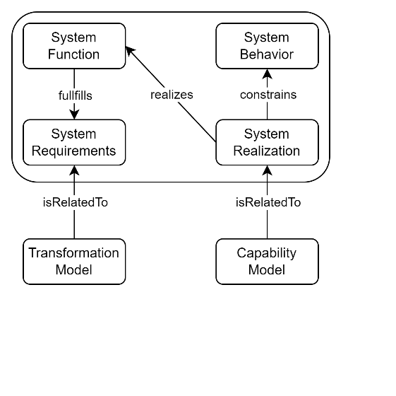Athough direct equivants of the transformation model and capability model are not directly described with OntoCAPE, a releationship between these models and aspects of systems of the OntoCAPE model *technical system* module can be identified (see Figure 1). Here, aspects of the **transformation model** are described by the *system requirements* and *system function*. The **capability model** can be related to the *system realization* and *systems behavior*. In OntoCAPE the *system realization* constrains the *system behavior* which is true of the capability model as well. For the transformation model, literature such as Koch et al. (2023) and Mädler et al. (2022) have indicated that a direct result of the transformation model is a list of capability requirements, which the capability model of the PEA asset must fulfil. By understanding this relationship, a connection between the transformation model and capability model can be made using the OntoCAPE ontology.

Figure 1. Transformation models and capability models in OntoCAPE.

* + 1. Information Model

As a first step in modular plant engineering, it is necessary to match the product specific transformation model with a PEA asset specific capability model. For this purpose, we suggest to use linked data to describe the connections (cf. Mädler et al. 2022; Rahm et al. 2021). We propose that the transformation model and capability model be connected using the relationship *realizes.* This is an approach which is consistent with examples shown in OntoCAPE (Marquardt et al., 2010). The transformation model is modelled exclusively using the OntoCAPE terminology. For the capability model we propose that the description of the PEA be extended with the corresponding DEXPI class, enabling a clear connection to the descriptive design data provided in the DEXPI specification such as the upper and lower design limits for temperature and pressure as well as aspects relevant to substance class such as material of construction.

* 1. Use Case

In order to explain the information exchanged between the transformation model and the capability model, we propose the use case of a neutralization reaction which must be matched to a set of PEAs. Here, the considered reaction is:

|  |  |
| --- | --- |
| *NaOH (aq) + HCl(aq) 🡪 NaCl (aq) + H2O (aq)* |  |

This specific reaction is chosen due to its simplicity and suitability to explain certain technical criteria from the product model which must be transferred. A block flow diagram with the relevant process parameters is shown in Figure 2.

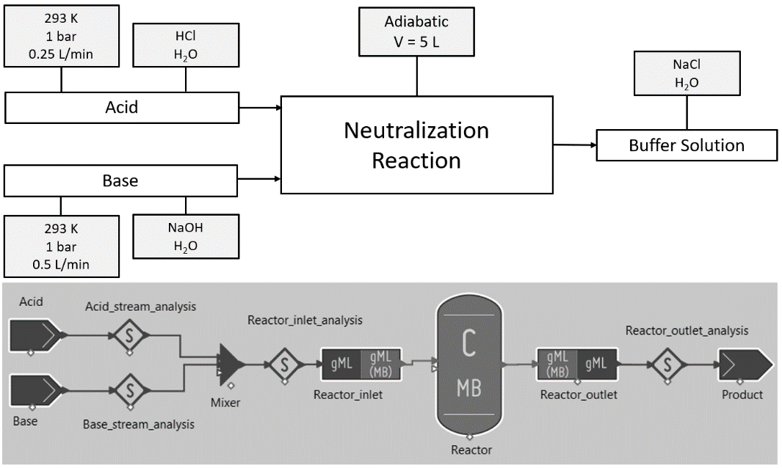

Figure 2. Neutralization process description as a block flow diagram (top) and gPROMS flowsheet simulation (bottom).

From this example, a list of system requirements from the transformation model can be derived which must be matched to a set of capabilities described in the capability model of the reactor. Therefore, in addition to the block flow diagram in Figure 2 and the reaction equation, an example PEA is also required. For this purpose, a stirred tank reactor, whose capabilities are listing in Table 1, is provided. A selected list capability requirements and capabilities is presented in Table 1.

Table 1: List of capability requirements derived from the neutralization process transformation model and the corresponding capabilities described by the capability model of the reactor PEA.

|  |  |
| --- | --- |
| Capability Requirements  from the Transformation model | Reactor Module Capabilities  from the Capability model |
| required reaction volume of 5 L | > 5 L available reaction volume |
| 293K reaction temperature | upper design temperature > 293 K > lower design temperature |
| 1 bar reaction pressure | upper design pressure > 1 bar >  lower design pressure |
| material of construction suitable for corrosive materials | material of construction suitable for corrosive materials |

* + 1. Linked Data Representation

To illustrate this connection between the transformation model and capability model, a linked data representation based on the neutralization process and reactor PEA is provided in Figure 3. For the neutralization use case, the connection between transformation model and capability model is demonstrated between a Reactor (*PlantItem*) which realizes a Chemical Reaction (*ProcessStep*). The transformation model is modelled exclusively using the OntoCAPE terminology. Here, the key information is related to the chemical reaction class. Then, corresponding reactants and products are described with the substance class, which is important information for connecting material of construction suitability. Additionally, the thermodynamics properties of the chemical reaction are provided such as temperature, pressure, and reaction volume using the *hasProperty* connector. This information is shown in an exemplary way and is not an exhaustive list of all information which would be required to link transformation and capability model. To describe the capability model, the class plant item is selected. OntoCAPE suggests that additional information describing the real equipment can be implemented using the *hasDesignProperty* descriptor. Here, the capability requirement of reaction temperature is connected to the upper and lower temperature design limits of the reactor PEA. Additionally, we suggest that the material of construction be constrained by substance class. This enables a direct connection between the transformation and capability models.

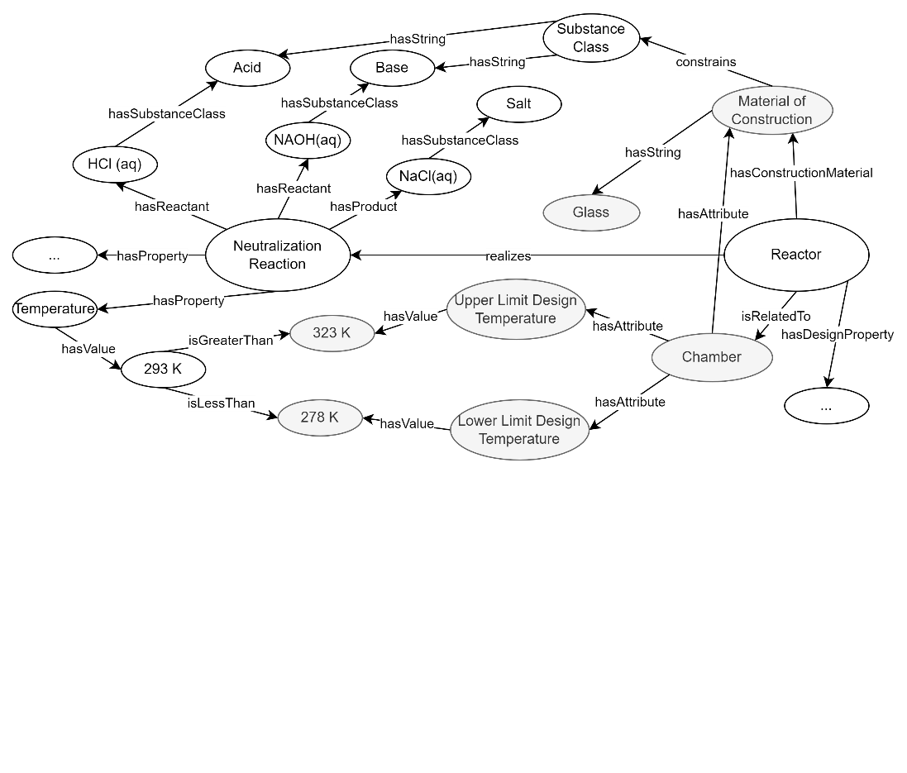

Figure 3. Connection of the transformation and capability models using linked data.

* + 1. Implementation

To test the developed information model, a manual implementation is carried out for the neutralization reaction use case. Information from the gPROMS flowsheet isas extracted and combined with additional technical criteria from the product specification. To simplify the scope, only basic information from gPROMS (temperature, pressure, volumetric flowrate, density, and viscosity) and the most relevant information product specification (pH, substance) are considered. However, challenge came when trying to match this information between the relevant models in the different software tools. In gPROMS, only information regarding the material stream and process parameters is available from this kind of simulation model. However, some information regarding the unit operation is missing. This is potentially problematic when trying to match between the gPROMS and COMOS domains. Here, mathematical relationships are needed to compare aspects such as residence time from the simulation model to required reactor volume in the capability model. This suggests that some of the information from the gPROMS simulation file must be adapted to connect it to a capability model in COMOS.

* 1. Discussion

The information model presented in this work and exemplified for the neutralization reaction and reactor module use case illustrates that it is possible to directly connect the transformation model and the capability model. This enables a direct connection between the information contained in the Digital Twin submodels needed to enable a semantic connection. Furthermore, the implementation in gPROMS and COMOS highlights that certain information requires adaption or was missing from gPROMS to directly connect it to the reactor model in COMOS. Although the results presented in the work are a significant first step, the information model and case study are limited in scope and do not consider all aspects of the modular plant domain. In particular, aspects such as suitability of services and safety aspects must also be considered. Additionally, other types of data models might be advantageous over linked data.

* 1. Conclusion

In this work, a linked data information model was presented for the specific purpose of matching a transformation model from a gPROMS simulation with a capability model of a PEA in COMOS. The presented information model was based on OntoCAPE and extended with DEXPI P&ID attributes. While the presented results are indicative that connecting transformation and capability models is a significant first step towards integrated data flows that are required in a Digital Twin concept, further work is needed. The next step is to extend the information model to support the exchange of information at specific handover points during the engineering and design of modular plants.

**References**

A. Bamberg, L. Urbas, S. Bröcker, M. Bortz, and N. Kockmann, 2021. The Digital Twin – Your Ingenious Companion for Process Engineering and Smart Production. Chemical Engineering & Technology 44, 954–961. https://doi.org/10.1002/ceat.202000562

A. Koch, N. Hamedi, L. Furtner, T. Kock, A. Klose, & J. Mädler, 2023. Standards for Information Models Considering Knowledge Distribution in Modular Plants. 2023 IEEE 21st International Conference on Industrial Informatics (INDIN), 1–7. https://doi.org/10.1109/INDIN51400.2023.10218218

J. Mädler, J. Rahm, I. Viedt, and L. Urbas, 2022, A digital twin-concept for smart process equipment assemblies supporting process validation in modular plants. In L. Montastruc & S. Negny (Eds.), Computer Aided Chemical Engineering (Vol. 51, pp. 1435–1440). Elsevier. https://doi.org/10.1016/B978-0-323-95879-0.50240-X

W. Marquardt, J. Morbach, A. Wiesner, and A. Yang, 2010. OntoCAPE: A re-usable ontology for chemical process engineering. Springer.2010. doi: 10.1007/978-3-642-04655-1

J. Rahm, M. Hanselmann, and L. Urbas, 2021, Synchronization network of data models in the process industry. 2021 26th IEEE International Conference on Emerging Technologies and Factory Automation (ETFA ), 1–8. https://doi.org/10.1109/ETFA45728.2021.9613647.

VDI/VDE/NAMUR, 2019, VDI/VDE/NAMUR 2658-Automation engineering of modular systems in the process industry-General concept and interfaces – Part 1, Beuth Verlag GmbH.

VDI 2776-1:2020, “Process engineering plants - Modular plants - Fundamentals and planning modular plants - Part 1 (VDI 2776:2020-11).” Beuth Verlag, Nov. 2020.

M. Wiedau, L. von Wedel, H. Temmen, R. Welke and N. Papkonstantinous, 2019. ENPRO Data Integration: Extending DEXPI Towards the Asset Lifecycle. Chemie Ingenieur Technik, 91(3), 240–255. <https://doi.org/10.1002/cite.201800112>

1. DEXPI = Data Exchange in the Process Industry.