Ethanol Increase in Gasoline and its Impacts in Manufacturing and Supply Chains

Mahmoud Ahmednooh,a,b,c Brenno C. Menezes,a,c*

aDivision of Engineering Management and Decision Sciences, College of Science and Engineering, Hamad Bin Khalifa University, Qatar Foundation, Doha, Qatar

bProduction Planning and Scheduling, Um Said Refinery, Qatar Energy, Doha, Qatar

cBlend-Shops Company, Qatar Science and Technological Park, Qatar Foundation, Doha, Qatar

bmenezes@hbku.edu.qa

Abstract

Biofuels, such as ethanol (CH3-CH2-OH), remain significantly underutilized globally, despite their potential to mitigate environmental effects associated with fossil-fuels' combustion in light fleet vehicles. Ethanol can be seamlessly blended with petroleum-derived gasoline. In regions like the United States and Europe, ethanol finds its place in the market as E5-E10 gasoline (gas or petrol), a blend consisting of 5-10% ethanol (anhydrous) and 90-95% mineral gasoline. Beyond, Brazil mixes 27% of ethanol in gasoline and holds the largest fleet of flex-fuel vehicles, fueled by any combination of both. However, in several Asian and Middle Eastern countries, where solely petroleum-refined gasoline is sold in fuel stations, octane number (ON) boosters such as methyl tert-butyl ether (MTBE) are still necessary. Additionally, in nations overproducing naphtha from refining of petroleum condensates, investments in extra carbon-chain rearrangement units can be an outlet since they produce high-ON streams. This paper proposes a simulation of scenarios of gasoline recipes considering supply chain (SC) dimensions in pure petroleum-refined gasoline (PPRG) manufacturing. These SC dimensions are ethanol, utilization of ON booster, and installation of extra reforming unit for carbon-chain rearranged components, all towards sustainable gasoline value chain worldwide.

**Keywords:** Biofuels, ethanol, gasoline, sustainability, petroleum refinery.

* 1. Introduction

Ethanol is an alternative fuel to fossil-fuel products such as gasoline, in its complete replacement or, partially, when mixing ethanol (anhydrous) to mineral gasoline. This can be also an alternative to octane number (ON) additive boosters such as methyl tertiary butyl ether (MTBE) since ethanol (ETH) boasts a typical research octane number (RON) of 108 (Foong et al., 2014) (around 10 points below MTBE, but 40 points above raw naphtha, one of the main precursors of petroleum-refined gasoline). Besides, ETH has the capacity to be blended to petroleum-refined gasoline at concentrations of up to 25% without causing damage to automobile cycle Otto engines (Menezes et al., 2014). Hence, the incorporation of ethanol into gasoline blends contributes to enhancing the octane rating of the fuel (increasing the performance of the motor engine by promoting antiknock or avoidance of spontaneous ignition before the electrical spark) while acting in the reduction of greenhouse gases (GHG) emissions, since it was mostly sequestered during the biomass raw material growth.

Furthermore, for gasoline production in petroleum refineries, naphtha reforming units play a pivotal role in transforming distilled or straight-run raw naphtha into reformate streams to be added in the gasoline pool among the main components for octane rating boosting (not considered as an additive booster of ON as MTBE, but as main component purposed for enhancement of ON). The integration of ethanol to the gasoline recipe provides flexibility in plant operations, which may involve moderating the severity of the reformate process unit since the carbon-chain cycling transformation inside this process reduces the volume of the output reformate stream by producing hydrogen (H2) as a by-product. Also, a complete shutdown of the reformate unit can be decided, if ON is not an issue in the gasoline production, or this can be extended for BTX (Benzene, Toluene, and Xylene) operational mode given its higher market value (Quintino et al., 2019). This is also valid when a nation has naphtha excess (when processing light crude-oils or condensates) since from a long-term perspective, can be put in place, the installation of an extra reformate unit, avoiding exports of such low-price commodity stream.

* 1. Manufacturing and supply chain impacts by adding ethanol in gasoline

The integration of ethanol into gasoline blends offers a spectrum of advantages for petroleum refineries. These encompass (1) increased production (by reducing reformate stream losses if in low-ON); (2) enhanced profitability (since the ethanol price is lower than gasoline); (3) mitigated CO2 emissions by the incorporation of a sustainable fuel component, and (4) the potential to cease the utilization of ON boosters such as MTBE.

The intriguing interplay among gasoline manufacturing, ethanol supply chains, and national policies towards sustainable liquid fuels on gasoline recipes inspires the connection of these additional gasoline component dimensions to the pure petroleum-refined gasoline (PPRG) manufacturing within their degrees-of-freedom to elucidate ethanol increase in gasoline worldwide. There are several trade-offs in the production of PPRG. The reformate unit increased and decreased severity is the most prominent since operational maneuverings in the spatial velocity and temperature in the carbon-chain cycling reactors can increase the conversion of the reactions resulting in more aromatic molecules (therefore higher ON quality) at a cost of higher production of H2 as a side-effect. It reduces the quantity of the reformate and boosts its ON quality. Other factors such as the selection of the petroleum (and given yields in the distillation columns), ATR routes, CC modes of operations, also play a role in gasoline production. These diverse manufacturing scenarios (endogenous factors), interplaying with outside refinery walls or exogenous choices on supply chain such as ethanol imports for gasoline blending and the banning of MTBE for sustainable liquid fuels, are the object of our study.

The petroleum refinery in the proposed study represents a typical refinery showing the processes and streams related to gasoline production as in Figure 1, whereby 64 possible primary PPRG production solely based on manufacturing-made scenarios are possible. These are generated by the permutation of the two options of the main variations (petroleum crude-oils, ATR routes, CC modes, and REF modes), yielding 24 combinations (16 scenarios). A secondary level of the manufacturing-made scenarios creates 3 additional scenarios (ISO, POLY, and both) for each of the 16 previous ones. Therefore, a total number of 64 scenarios are formed, considering 16 without the secondary ones and 48 scenarios when including isomerization (ISO) unit, polymerization (POLY) unit, and both together, to the 16 mains or primary PPRG scenarios, then modifying the gasoline production from 16 to 64 possible scenarios.

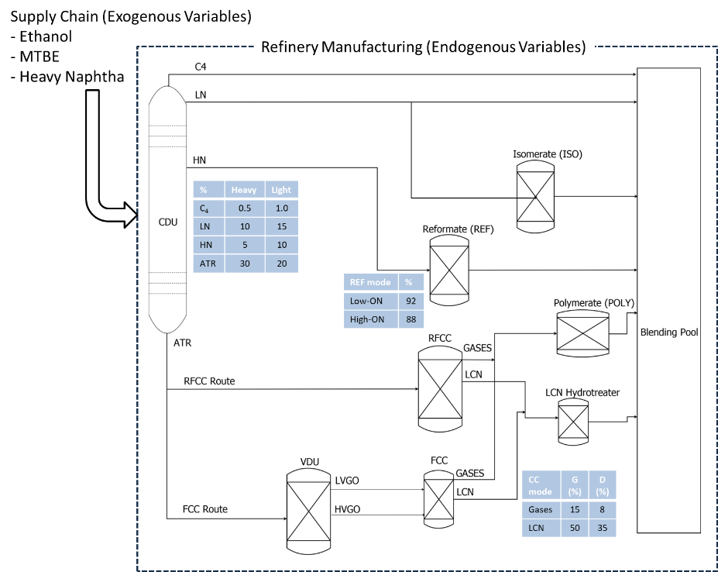

Figure 1. Petroleum refinery network for pure refined gasoline.

To this processing site, supply chain (or outside refinery walls) components like MTBE (ON booster) and ethanol are introduced, along with the construction or installation of another reformate unit, if overproducing of heavy naphtha by processing light petroleum or condensate exists. The refinery involves a distillation column with a capacity of 100,000 barrels per day (BPD), and the focus is on the streams that can be blended into the gasoline pool as seen in Figure 1. Other products such as jet-fuel and diesel are excluded from this discussion. In the reformate unit, an increase (in high-ON) or decrease (in low-ON) of 1.5 point in RON (research octane number) and 0.75 point in MON (motor octane number) is observed to the baseline of typical values. Similarly, for the CC unit, modes in gasoline or diesel, an increase (in gasoline) or decrease (in diesel) of 0.5 point in RON and 0.25 point in MON is found to the baseline of typical values. These typical values can be found in Ali et al. (2022) as well as the equations for the blended gasoline product, used as in a simulation of scenarios as proposed in this study.

* 1. Results
     1. Primary manufacturing-made (endogenous) scenarios

In Figure 2, the 16 primary manufacturing-made scenarios for gasoline production, conversion or yield over 100 KBPD are defined on the variations of crude-oils, ATR routes, CC modes, REF modes. As per the scenario tree, the higher conversion is achieved when in light crude-oil (scenarios 1-8) because of the higher amounts of light distillates (15% of LN and 10% of HN, respectively), since these streams can be completely added, directly or indirectly (if processed), in gasoline. Considering ATR stream as 20-30% of the petroleum feed, 50% of VDU converted to FCC feed, and the yields of the RFCC/FCC modes, as in Figure 1, one can calculate the pure petroleum-refined gasoline (PPRG) yields of the 16 primary manufacturing scenarios (seen in Figure 2).

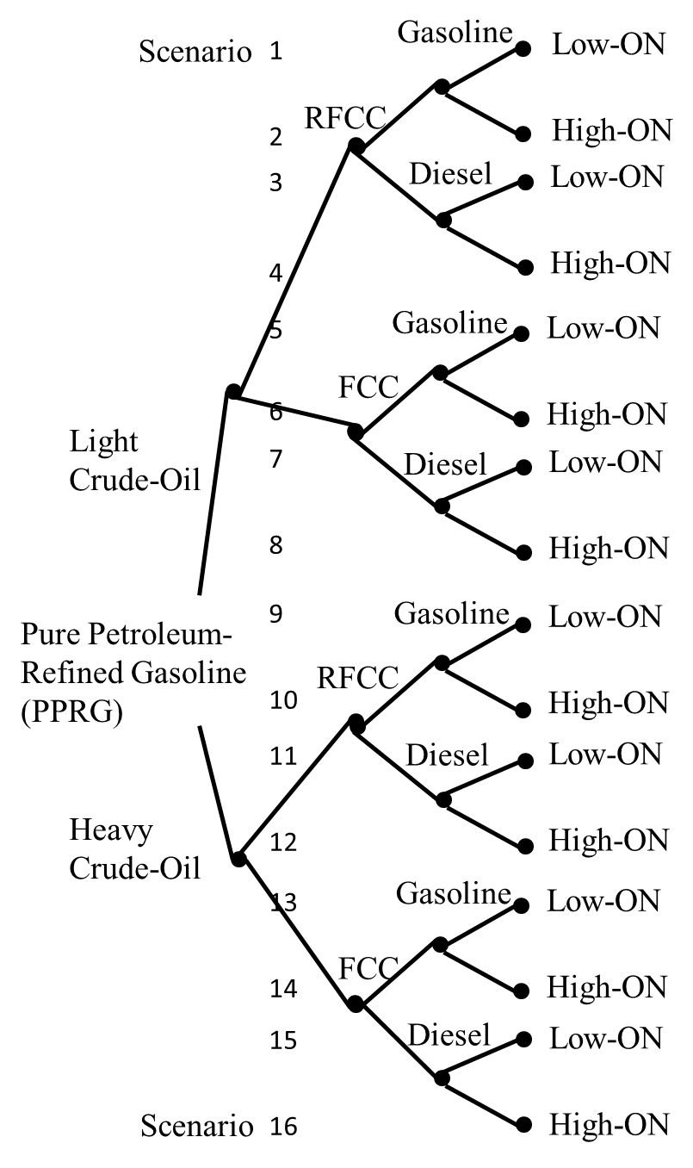

Figure 2. Gasoline yields (%) in the primary manufacturing-made scenarios for PPRG.

In terms of properties, the main concern on any gasoline mix is the ON since it reflects the performance of the motor engine by promoting antiknock or avoidance of spontaneous ignition before the electrical spark. Figure 3 shows the gasoline production/yield and the calculated RON for the 16 scenarios split in groups of 4. The 4 groups (with 4 scenarios in each) have light/RFCC selections in group 1 (scenarios 1-4) and light/FCC in group 2 (scenarios 5-8). Group 3 (scenarios 9-12) has heavy/RFCC and group 4 (scenarios 13-16) has heavy/FCC. These 4 groups are formed by distillation streams on CDU’s light/heavy yields and ATR routes (RFCC or FCC). In group 1, the variations on CC and REF modes creates, for example, scenarios 1-2 (CC mode in gasoline) and scenarios 3-4 (CC mode in diesel). The differences in yields and RON between 1-2 and 3-4 are the due to the REF modes. The same CC and REF variations and results apply to the other groups.

Comparing the 4 groups, the higher yields of gasoline are in light petroleum by the high production of light and heavy naphtha (LN and HN), considering all LN is added to the gasoline pool. HN is the feed of REF units, and the low- and high-ON modes are reflected in the 8 pairs of 16 scenarios. Always the first scenario has higher gasoline yield and lower ON when compared to the counterpart in the pair. Within the same pair, the only difference between is the REF mode since the petroleum, ATR route, CC mode are equal.

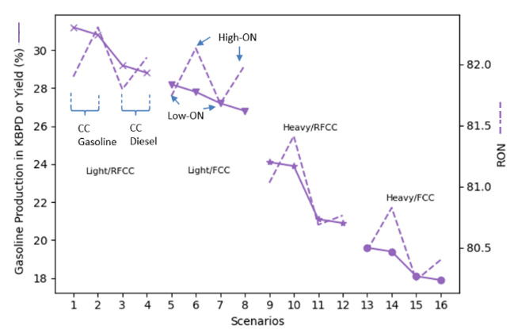

Figure 3. Yield and RON in the primary manufacturing-made scenarios for PPRG.

* + 1. Secondary manufacturing-made (endogenous) scenarios

Figure 4 shows the gasoline production/yield and RON for the 16 primary manufacturing-made scenarios by adding the ISO and POLY units (the secondary manufacturing-made selections). These units promote increased ON streams by rearranging linear to ramified naphtha molecules in the ISO or grouping of C2-C3 olefins in the POLY. For the ISO, since it uses LN as feed, no difference is found in gasoline yields. What is fed of LN into the ISO, the same is reduced in the final gasoline pool, as in Figure 1. Due to both the reduction of a low ON stream as LN and the addition of the isomerate stream (higher ON), it increases RON by roughly 5 points in all scenarios. For the POLY, gasoline yield increases by adding a new stream from the GASES feed. It increases RON by 0.25-0.5 points in scenarios 1-8 and 0.5-1.0 points in scenarios 9-16. This is expected to occur since the more spherical conformation on the polymers from POLY has more effect is non-linear molecules in the gasoline with higher concentrations of CC streams as in scenarios 9-16. It is considered 30% of LN feeds the ISO and 50% of GASES to POLY.

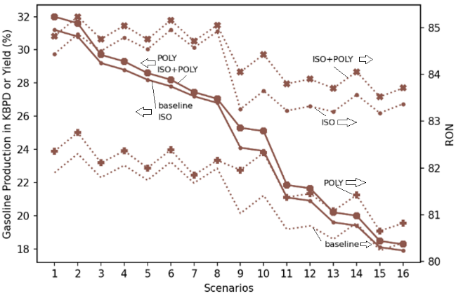

Figure 4. Yield and RON in the secondary manufacturing-made scenarios (Full PPRG).

* + 1. Supply chain-related (exogenous) scenarios

Figure 5 shows the RON for the 16 scenarios with ISO and POLY units (full PPRG) by adding 5% and 15% of MTBE and 10% and 25% of ETH to the full PPRG. These MTBE and ETH values are found in the literature or are practices in the nations and are used to evaluate the influence of MTBE and ETH (exogenous SC variables) in the full pure refined gasoline (primary and secondary manufacturing-made or endogenous variables).

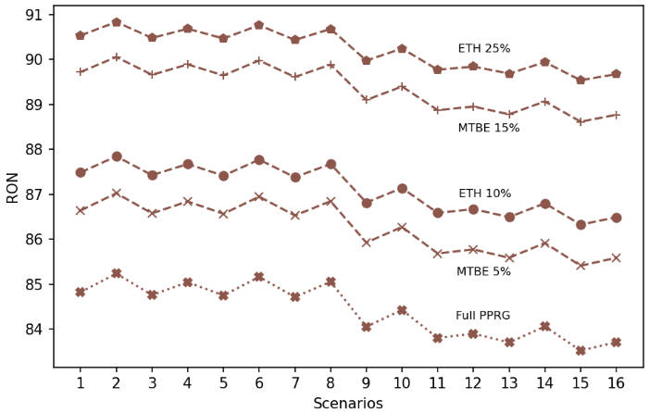

Figure 5. RON in the full PPRG, adding MTBE at 5-15% and ETH at 10-25%.

* + 1. Full PPRG, MTBE, ETH, and Extra Reformate (REF2) unit

To reach regular gasoline RON at 91, a gasoline production may consider MTBE at 5% and ethanol (ETH) at 10%. Another SC variable can be an extra reformate unit added up to 15% in volume of the gasoline until it reaches the aromatic content limit at 25% in volume, which is the typical maximum allowed content, as seen in Figure 7. Considering the variations of 91 to 95 RON, for a petroleum refinery producing fuels as gasoline, in a process scheduling perspective, the production of higher grades of gasoline as 95-98 RON is possible by reducing the LN content in the gasoline pool.

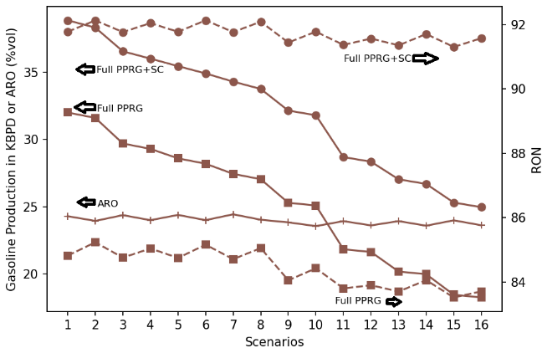

Figure 7. RON in the blend of the full PPRG, ETH at 10%, MTBE at 5%, and extra reformate stream at 15% in volume.

* 1. Conclusion

Among the nations several reasons are the causes of their current state of ethanol content in gasoline. They are arable land for ethanol production, public policies towards renewables and de-risking dependence on fossil-fuels, overproduction of light petroleum (crude-oil and condensate streams), and the banning MTBE from the gasoline pool. Considering all manufacturing and supply chain variations as presented in this work to reach the octane number (ON) required for antiknock or avoidance of spontaneous ignition before the electrical spark in the gasoline motor engines (Otto cycle), there are several ways (from strategic to operational) to meet the requirements of ON. The primary manufacturing-made gasoline includes crude-oil raw materials (light or heavy), ATR routes (if RFCC or FCC), RFCC/FCC modes in gasoline and diesel, and reformate units in low- or high-ON. Besides, strategic, tactical, operational decisions can include ISO and POLY units by their installation or operation (turn on or off) can be put in place. Limits of supply chain related variations as MTBE, ETH, and extra reformate must be accounted for in this gasoline recipe towards sustainable liquid fuels worldwide.

References

B. C. Menezes, L. F. L. Moro, W. O. Lin, R. A. Medronho, F. L. P. Pessoa, 2014, Nonlinear Production Planning of Oil-Refinery Units for the Future Fuel Market in Brazil: Process Design Scenario-Based Model, Industrial & Engineering Chemistry Research, 53, 11, 4352-4365.

T. M. Foong, K. J. Morgant, M. J. Brear, G. da Silva, Y. Yang, F. L. Dryer, 2014, The octane numbers of ethanol blended with gasoline and its surrogates, Fuel, 115, 727-739.

A. Quintino, M. Catalão-Lopes, J. C. Lourenço, 2019, Can switching from gasoline to aromatics mitigate the price risk of refineries?, Energy Policy, 134, 110963.

T. H. M. Ali, R. E. Franzoi, B. C. Menezes, 2022, Surrogate modeling for nonlinear gasoline blending operations, Computer Aided Chemical Engineering, 49, 1783-1788.