Small-scale ammonia production: a superstructure approach

Alonso Martíneza, Thien. A. Huynhb, C. Varelac, J. Fariaa, E. Zondervana*

aTwente University, Drienerlolaan 5, Enschede 7522 NB, The Netherlands

bAvebe, Prins Hendrikplein 20, Veendam 9641 GK, The Netherlands

cEscuela Superior Politécnica del Litoral, km. 30.5 Via Perimetral, Guayaquil, P.O. Box 09-01-5863, Ecuador

e.zondervan@utwente.nl

Abstract

Ammonia is an important chemical for the energy transition as it can serve as a hydrogen carrier. Small-scale ammonia can be produced from decentralized or waste resources thereby integrating and expanding its use by delivering the product directly to the site of consumption. Nonetheless, the cost of small-scale ammonia is usually higher than large-scale ammonia due to the lack of economy of scale even though new technologies for H2 and NH3 synthesis are available. This work presents a superstructure (SE) as a decision-making tool to select the best set of technologies delivering the lowest ammonia cost. The SE is formulated as a mixed-integer linear program (MILP) comparing three different routes: electrolysis, gasification, and thermal decomposition of methane (TDM). The optimal route for a base case of 1000 kgNH3/h is electrolysis with a cost of 1067 $/t of NH3. The capital expenditure (CAPEX) of electrolysis and ammonia synthesis, as well as the electricity cost, are the main contributors to this cost. The electrolysis route is the most promising for small-scale ammonia since it envisions the highest potential for cost reduction from lower electrolyzer and electricity prices. Gasification can also become competitive if the price of biomass is low but the cost of carbon capture and storage (CCS) needs to be considered. The TDM route is not suited for small scale due to large CAPEX contribution. The presented tool advances the spread and use of small-scale ammonia.

**Keywords**: Ammonia, superstructure, optimization, MILP.

* 1. Introduction

Ammonia has gained interest as an energy storage molecule for renewable hydrogen since it does not require a CO2 cycle to release H2. In addition, it has a mature infrastructure in current supply chains (Faria, 2021). Moreover, ammonia can be used to produce electricity in a fuel cell (Jeerh et al., 2021), and it is being researched for direct combustion applications (Kobayashi et al., 2019). Ammonia is produced in large scale plants with capacities of 1200 - 2000 t/d (Appl et al., 2011) using the Haber Bosch process. Large scale production is often centralized around cheap natural gas or coal resources. Therefore, its production is sensitive to disturbances in feedstock prices or disruptions in supply chains caused by geopolitical or environmental conditions. These disturbances can increase transportation costs, carbon footprint and shipping times. Small-scale ammonia production is an alternative to tackle these concerns as it excels at:

* **Flexibility and decentralization**. Ammonia can be produced from renewable energy sources (RES), waste streams (biogas or biomass) or stranded resources (Vrijenhoef, 2017). Since small scale operates at milder conditions, variable loads can be handled, thus enhancing integration with intermittent RES (Rouwenhorst et al., 2020).
* **Supply chain design**. The reduction in transportation distance can lower the price of ammonia in remote locations by 100-150 $/t (Vrijenhoef, 2017) and the CO2 emissions. Therefore, localized production improves resilience in current supply chains and reduces the need for storage technologies.

Downscaling the conventional Haber Bosch process is not straightforward as the energy losses and capital expenditures increase as the plant capacity is reduced. Rouwenhorst et al. (2021) evaluated different ammonia synthesis configurations for small scale (3 t/d) based on electrolysis. These configurations included conventional high-pressure Haber Bosch (HB) with condensation, absorbent enhanced Haber Bosch (AEHB) process and a novel single-pass ammonia synthesis where reaction and separation occur in the same vessel. They found that single pass ammonia can be produced at a lower cost than conventional ammonia due to higher conversion of the Ru catalyst supported in activated carbon (AC) and lower cost of the NH3 synthesis loop. Arora et al. (2016) evaluated the production of 63 t/d of ammonia from biomass employing a Leading Concept Ammonia (LCA) process suited for small scale. The NH3 cost comes at 1172 $/t. They also found the biomass price and discount rate are the two major factors influencing the ammonia price. Osorio et al. (2022) performed a sustainability analysis of a novel methane-to-hydrogen-to-ammonia process, which can use either natural gas or biogas as feedstocks. The authors found that the ammonia price cannot compete with current fossil-based ammonia due to low yields. However, future reductions in electricity price and higher energy efficiencies have a great potential to make the process cost competitive. Moreover, selling carbon black as a byproduct is important to make this process economically attractive.

Current studies on small-scale ammonia production preselect the feedstock and ammonia production technologies. However, the integration and synergies between conventional and non-conventional technologies are overlooked. Though one could design several individual processes, this is a time-consuming endeavor. To address these challenges, a superstructure optimization approach is selected. In a SE, all the alternative technologies and feedstocks are compared, and the best possible process layout is chosen according to an objective function that minimizes costs or environmental impact. Superstructures for process synthesis have been developed since 1972. Two relevant superstructure representations are State Task Network (STN) (especially for scheduling operations) and State Equipment Network (SEN). The SE in this work falls within the scope of STN which consists of states and tasks. A state represents the physical condition of a stream while a task represents an operation executed to transit from one state to another (Mencarelli et al., 2020).

* 1. Problem statement and model formulation

The most relevant assumptions and considerations are:

* The scale of ammonia production has been set between 0 and 50 tpd. This is because the use of stranded energy sources rarely exceeds 20-30 MW (Vrijenhoef, 2017).
* Aggregate models are used to reduce complexity given the number of alternatives.
* Reaction and separation of NH3 are coupled to resemble a real operation and to eliminate the modelling of recycles.
* Literature is the main source of data. For technical or economic data of a process that is not available, the process is simulated in Aspen Plus to generate such data.

A diagram of the proposed superstructure where forty possible routes are evaluated is shown Figure 1. A description of the different blocks is given in Table 1.

Figure 1. Superstructure for small-scale ammonia production. Triangles pointing to the left represent separation whereas the ones pointing to the right represent reactions. Before the NH3 synthesis section, dashed lines represent electrolysis based H2, solid lines gasification based H2, dash-dot lines TDM based H2 and dotted lines represent N2. For number description see Table 1.

Table 1. Technology and index description for blocks in the superstructure.

|  |  |
| --- | --- |
| **Block** | **Index** |
| Deionizer | 5 |
| Alkaline electrolyzer (AE) | 6 |
| Proton exchange membrane (PEM) electrolyzer | 7 |
| Solid oxide electrolyzer (SOEC) | 8 |
| High-pressure Fe catalyst w/ condensation | 9 |
| Medium-pressure Ru/AC w/absorption | 10 |
| Medium-pressure Ru/AC w/condensation | 11 |
| Low-pressure Ru/Ba-Ca(NH2)2/ w/absorption | 12 |
| Pressure swing adsorption (PSA) | 13 |
| Membrane air separation unit (ASU) | 14 |
| Drying | 15 |
| Gasification | 16 |
| Desulfurization | 17 |
| TDM | 18 |

Given a set of technologies for H2, N2 and NH3 production along with different feedstocks (sets and parameters); the SE decides mass flows, technologies and feedstock type (variables); while minimizing the ammonia production cost (objective function). Mass balances per component must be satisfied and a certain ammonia demand is met.

Sets

|  |  |  |  |  |
| --- | --- | --- | --- | --- |
| i | Feedstock or block | | | |
| k | Chemical component | | | |
| ν | Chemical reaction | | | |
| u | Utility | | | |
| b | Breakpoint (used in piecewise linearization) | | | |
| Parameters | | | Variables | | |
| $${SF}_{i,k}$$ | | Separation factor | $${\dot{m}}_{i,k}^{F}$$ | Feed mass flow | |
| $$ɛ_{ν,i}$$ | | Extent of reaction | $${\dot{m}}_{i,k}^{R}$$ | Reactant mass flow | |
| $$S_{ν, k}$$ | | Stoichiometric coefficient | $${\dot{m}}_{i,k}^{P}$$ | Product mass flow | |
| $$M_{k}$$ | | Molar mass | $$y_{i}$$ | Equipment switch | |
| $$EC$$ | | Bare equipment cost | $$x_{i,b}$$ | Lambda | |

Objective function

|  |  |
| --- | --- |
| $$AC=\frac{APC}{AP}$$ | (1) |

Constraints

|  |  |
| --- | --- |
| $${EC}_{i} =\sum_{b}^{B}{x_{i,b}}{EC}_{i,b} ∀ i$$ | (2) |
| $${\dot{m}}_{i, k}^{P}={SF}_{i,k}\left({\dot{m}}_{i, k}^{F}+{\dot{m}}_{i, k}^{R}+ɛ_{i,ν}S_{ν,k}M_{k}\right) ∀ i ∀ k ∀ ν$$ | (3) |
| $$y_{2}=\sum_{i=5}^{6}{y_{i}}$$ | (4) |
| $${\dot{m}}_{2,k}^{P} = \sum_{i=5}^{6}{{\dot{m}}_{i,k}^{F}}∀ k$$ | (5) |
| $$\sum_{i=9}^{13}{{\dot{m}}_{i,k }^{P}} ={\dot{m}}_{i,k }^{D}∀ k="NH_{3}"$$ | (6) |

The objective function in Eq. (1) is the ammonia cost (AC) which is a function of the annualized plant cost (APC) and the ammonia production (AP) over a year. APC is a function of the Annualized Operating Cost (AOC) and Annualized Investment Cost (AIC). These are ultimately dependent on the equipment cost Eq. (2) and the mass balance Eq. (3). The piecewise- and big-M linearizations have been applied to remove nonlinearities. Each block *i* has a binary decision variable *yi* denoting whether the block is selected or not. This also introduces logic in between sections of the SE. For instance, if water is chosen for H2 production (block 2 in Figure 1), its flow must be distributed only to the desalination or alkaline electrolysis blocks Eq. (4) and Eq. (5). Finally, a certain ammonia production is enforced in the last section of the SE by Eq. (6). The resulting MILP problem is solved using the Pyomo library within Python. A base case is defined considering data within common ranges. These are: electricity price 30 $/MWh; biomass price 100 $/t; natural gas price 0.1905 $/kg; ammonia production 1000 kg/h; operational hours 8400 h.

* 1. Results

From Figure 2, the electrolysis route has the lowest NH3 cost of 1067 $/t. The major contributors to this cost are the NH3 production CAPEX, followed by electricity consumption and H2 production CAPEX. The use of biomass and natural gas has been enforced in separate cases to compare against the best solution.

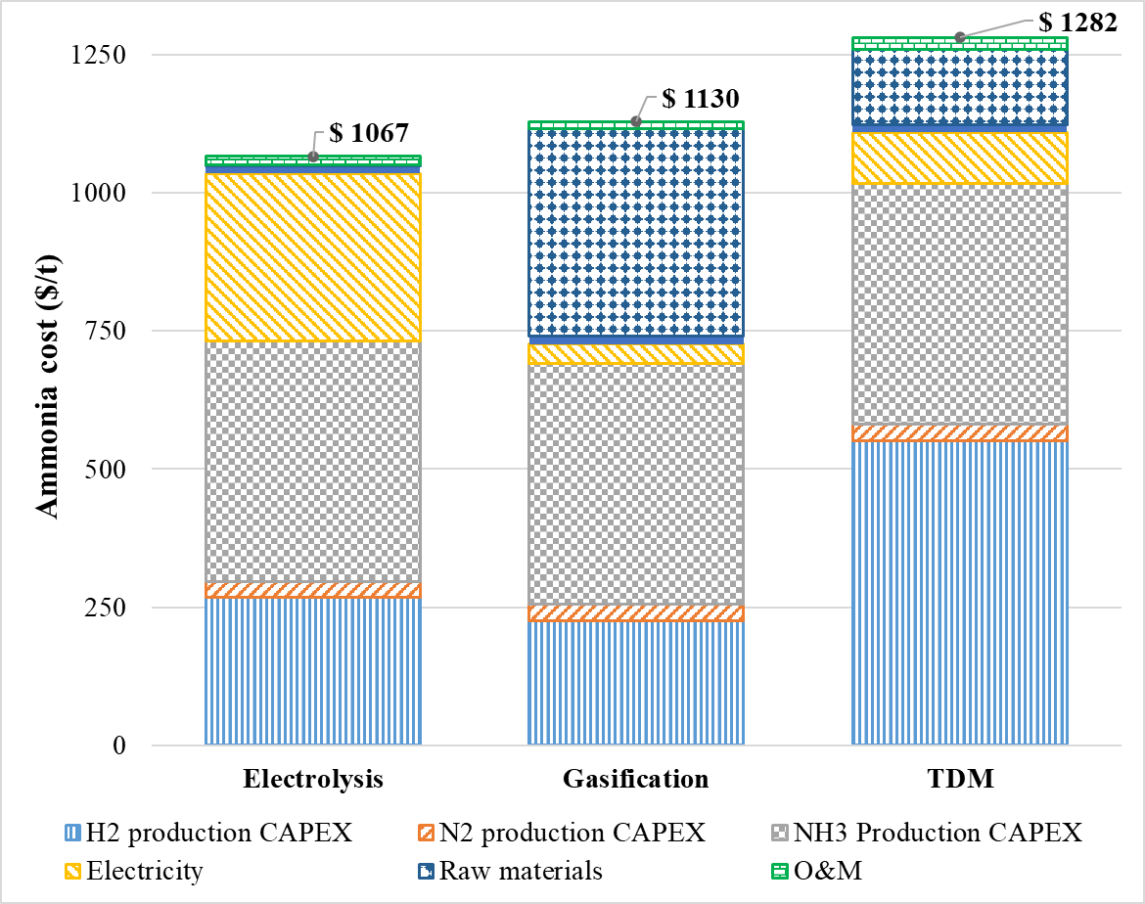

Figure 2. Ammonia cost breakdown for different routes. Electrolysis: indexes 2, 5, 7, 11 and 14 in Figure 1. Gasification: indexes 4, 15, 16, 11 and 14 in Figure 1. TDM: indexes 3, 17, 18, 11 and 14 in Figure 1. O&M: operation and maintenance.

In the case of gasification, the dominating factors are the CAPEX of the NH3 production section and the cost of biomass. In the case of TDM, the dominating factors are the NH3 production section and the cost of the pyrolysis reactor. To measure the effect of changes in certain parameters in the ammonia cost, a sensitivity analysis has been conducted (Figure 3). The sensitivity factor S is introduced as the ratio between a change in ammonia price due to a change in a certain parameter. The ammonia price taken as reference for each parameter is that of its corresponding route using the data from the base case.

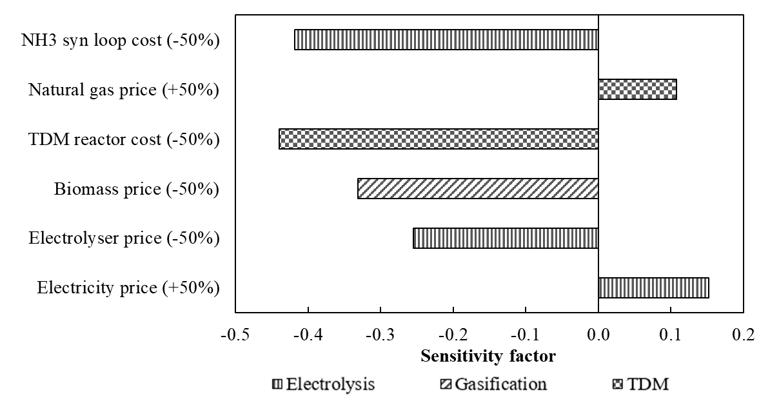

Figure 3. Sensitivity factor.

The cost of the NH3 synthesis loop has a high impact at low scale. The electrolysis route can reduce costs in terms of electrolyzer type and electricity price. Moreover, O2 sales could further increase the profitability of this route. Reduction in biomass prices can lower the cost of ammonia in the gasification route. However, CCS is needed to prevent direct CO2 emissions. The TDM route is more sensitive to the TDM reactor cost than to natural gas prices and thus technological developments should focus in this area.

* 1. Conclusions

A superstructure to evaluate forty possible routes for small-scale ammonia production was developed as a tool to screen different alternatives and scenarios. Thus, advancing the spread and use of small-scale ammonia. The optimal route for a base case is PEM electrolyzer for H2 production, a medium pressure HB ammonia synthesis loop using a Ru/AC catalyst with condensation and a membrane ASU. The electrolysis route is the best suited option and has further potential for ammonia cost reduction with lower electrolyzer and electricity prices. Gasification can also become competitive if the price of biomass is low, but the cost of CCS needs to be considered. The TDM route is not suited for low scale due to the large CAPEX contribution. Data collection for the SE remains a time-consuming step. Linearization techniques such as big M and piecewise linear are useful to avoid nonlinearities and reduce problem complexity.

Future work can consider the impact in ammonia price of byproduct valorization (O2, carbon black, waste). Address the intermittency of RES by including a time index and include the cost of ammonia storage. Downstream processing of ammonia into further value-added products such as H2 (from NH3 cracking), electricity (from a fuel cell) and fertilizers.

References

G. Jeerh, M. Zhang, S. Tao, 2021. Recent progress in ammonia fuel cells and their potential applications. Journal of Materials Chemistry A, 9, 727-752.

H. Kobayashi, A. Hayakawa, K. D. K. A. Somarathne, E. C Okafor, 2019. Science and technology of ammonia combustion. Proceedings of the Combustion Institute, 37, 109-133.

J. A. Faria, 2021. Renaissance of ammonia synthesis for sustainable production of energy and fertilizers. Current Opinion in Green and Sustainable Chemistry, 29, 100466.

J. Osorio, K.Van't Veer, N. Long, N. Tran, L. Fulcheri, B. Patil,A. Bogaerts,V. Hessel, 2022. Sustainability analysis of methane-to-hydrogen-to-ammonia conversion by integration of high-temperature plasma and non-thermal plasma processes. Energy Conversion and Management, 269, 116095.

J. P. Vrijenhoef, 2017, Opportunities for small scale ammonia production. Proceedings of the International Fertiliser Society, 801, ISBN 978-0-85310-438-4.

K. H. R. Rouwenhorst, P. M. Krzywda, N. E. Benes, G. Mul, L. Lefferts, 2020.Ammonia, 4. Green Ammonia Production. Ullmann's Encyclopedia of Industrial Chemistry. Wiley-VCH , Wiley Online Library.

K. H. R. Rouwenhorst, A. G. J. Van der Ham, L. Lefferts, 2021. Beyond Haber-Bosch: The renaissance of the Claude process. International Journal of Hydrogen Energy, 46, 41, 21566-21579

L. Mencarelli, Q. Chen, A. Pagot, I.E. Grossmann, 2020. A review on superstructure optimization approaches in process system engineering. Computers & Chemical Engineering, 136, 106808.

M. Appl , 2011. Ammonia, 3. Production Plants. Ullmann's Encyclopedia of Industrial Chemistry. Wiley-VCH , Wiley Online Library.

P. Arora, A. F. A. Hoadley, S.M. Mahajani, A. Ganesh, 2016. Small-Scale Ammonia Production from Biomass: A Techno-Enviro-Economic Perspective. Industrial & Engineering Chemistry Research, 55, 22, 6422-6434.