Learning reduced-order models for dynamic CO2 methanation using operator inference

Luisa Petersona, Pawan Goyala, Ion Victor Goseaa, Jens Bremerb,  
Peter Bennera,c, Kai Sundmachera,c,*

aMax Planck Institute for Dynamics of Complex Technical Systems, Sandtorstraße 1, Magdeburg, 39106, Germany

bClausthal University of Technology, Leipnizstraße 17, Clausthal-Zellerfeld, 38678, Germany

cOtto von Guericke University, Universitätsplatz 2, Magdeburg, 39106, Germany

*sundmacher@mpi-magdeburg.mpg.de

Abstract

The efficient modeling of dynamic systems in process engineering is becoming increas­ingly important in the modern industrial landscape. Our study addresses this challenge by employing reduced-order modeling and model order reduction techniques, with a focus on the non-intrusive operator inference method. This method excels at handling the com­plexity of nonlinear dynamics, a key factor in ensuring both computational efficiency and accuracy of approximations. We demonstrate the potential of operator inference by applying it to a CO2 methanation reactor model within the power-to-x framework. The results show the ability of the reduced-order model to provide an accurate yet streamlined solution, which is essential for the analysis of dynamic systems in the Industry 4.0 era.

**Keywords**: Dynamic systems, Model order reduction, Operator inference, Reactor modeling, Power-to-X, Methanation, Model identification.

* 1. Introduction

The emergence of Industry 4.0, along with increasing sustainability demands, is driving industrial plants toward dynamic operations. The rapid technological advances of Industry 4.0 require flexible, real-time process control, which aligns well with sustain­ability demands for resource-efficient, environmentally friendly operations. Despite a his­torical preference for steady-state operation due to its economic and safety benefits (Fischer and Freund, 2020), industry is increasingly adopting dynamic control systems to meet these evolving demands. A prime example of this shift is Power-to-X (PtX), a family of processes that convert renewable energy into a spectrum of green chemicals. These chemical products have a wide range of applications, serving as green fuels and platform chemicals, or even being converted back to electricity. However, there are significant challenges in effectively managing the dynamics of renewable energy sources (Güttel et al., 2013). Given these challenges, the development of robust models for real-time optimi­zation and control becomes critical to ensure operational efficiency and reliability. Tradi­tional models based on differential equations have been instrumental in understanding dynamic processes. These models face the challenge of dealing with uncertain parameters and large state spaces that include dimensions such as temperature, pressure, and chemi­cal concentrations. In addition, dealing with nonlinearities and the dynamic behavior of industrial processes requires the control of time-varying process variables. Integral to these models is the incorporation of real-time data, a critical factor in adapting to chang­ing operating conditions. Spatial resolution in these models is achieved through discreti­zation into finely spaced elements, either in two or three dimensions, a process that is computationally intensive but essential to accurately represent the multidimensional nature of these systems. The need for dynamic system models that are not only computa­tionally efficient but also maintain high accuracy, especially in scenarios with frequent model evaluations, becomes apparent (Benner et al., 2021).

Reduced-Order Models (ROMs) and Model Order Reduction (MOR) serve as an effective strategy to meet computational demands. They simplify dynamical models by reducing the number of variables and equations while preserving the core dynamics. Order reduction typically involves the projection of system state variables into a lower dimensional subspace. Such a projection uses a different coordinate system, allowing for a more efficient computational representation that preserves the essential dynamics of the original system (Benner et al., 2021). ROMs fall into two main categories: "intrusive" (Bremer et al., 2017), which refine high-fidelity models, and "non-intrusive" (Bremer et al., 2021), which generate simplified models from data when detailed equations are not available. Among the non-intrusive methods, sparse identification of nonlinear dynamical systems (SINDy), dynamic mode decomposition (DMD), and operator inference (OpInf) are notable for their utility in systems with complex or unknown equations. In particular, OpInf (Peherstorfer and Willcox, 2016) is distinguished by its ability to develop models that are consistent with the structural principles of the original partial differential equations. It encapsulates nonlinear dynamics within the ROM framework, often including terms up to second order. In the following, we will explore the use of OpInf to develop efficient ROM for CO2 methanation reactor models. Our goal is to demonstrate how these models capture the dynamics of the system and thereby effectively address the computational challenges of process engineering.

* 1. Methodology

The proposed methodology consists of two steps: First, we collect detailed data from a full-order model (FOM) of a methanation reactor. This provides a solid basis for our study. Second, we build a reduced-order model (ROM) that simplifies these data.

* + 1. Full order reactor model

We use a one-dimensional full-order reactor model as described by Zimmermann et al., 2022. This model consists of a system of coupled PDEs that encapsulate an energy balance (expressed in terms of temperature, $T$) and a mass balance (focused solely on the conversion of CO2, ), while intentionally ignoring axial mass dispersion. We have adapted this model to our research objectives by assuming a catalyst efficiency factor of 1, as a simplification of the original work. The operating and design parameters are consistent with an industrial packed-bed reactor, which enhances the practical relevance of our research. The equations governing the evolution of $X$ and $T$ with respect to the axial coordinate ($z$) over time ($t$) are as follows:

|  |  |
| --- | --- |
| $ε_{R}\frac{∂X}{∂t}=-u\frac{∂X}{∂z}+\frac{M_{\text{C}{\text{O}}_{\text{2}}}}{ρy_{\text{C}{\text{O}}_{\text{2}}\text{,in}}}\left(1-ε_{R}\right)ζσ_{\text{eff}}$, | (1) |
| $${\left(ρc_{\text{p}}\right)}_{\text{eff}}\frac{∂\text{T}}{\text{∂t}}=-u_{\text{in}}ρ_{\text{in}}c_{\text{p}}\frac{∂T}{∂z}+\frac{∂}{∂z}\left[Λ_{\text{a}\text{x}}\frac{∂T}{∂z}\right]+\frac{4U}{D}\left(T-T_{\text{cool}}\right)-{ΔH}_{\text{r}}\left(1-ε_{\text{R}}\right)ζσ_{\text{eff}}.$$ | (2) |

The model incorporates constants such as heat capacity ($c_{\text{p}}$), packed-bed reactor void fraction ($ε_{R}$), coolant temperature (), CO2 molar mass (), inlet CO2 mass frac­tion ($y_{\text{C}{\text{O}}_{\text{2}}\text{,in}}$), catalyst particle fraction ($ζ$), and tube diameter ($D$). For details on the non-constant quantities, we refer to the work of Zimmermann et al., 2022. These parameters include reaction rate ($σ_{eff}$), axial heat conductivity ($Λ_{\text{ax}}$), heat transfer coefficient ($U$), enthalpy of reaction (${ΔH}_{\text{r}}$), gas mixture density ($ρ$), and surface gas velocity ($u$). The initial and boundary conditions can be summarized as follows, taking into account the reactor length ():

|  |  |
| --- | --- |
| , | (3) |
| . | (4) |

The reactor in our study is modeled by discretizing its governing equations into 200 equally-sized control volumes using the finite volume method. This approach, chosen to deal with the significant nonlinearity of the equations and to ensure an accurate represen­tation of the reactor's behavior, results in a large system of ODEs. While this granularity captures the dynamics with high fidelity, it also significantly increases the computational requirements. To solve this intricate system, we use the Kvaerno5 integrator from the diffrax library in Python (Kidger 2021).

* + 1. Operator inference (OpInf)

The used methodology employs ROMs to approximate the high-dimensional FOM (dimen­sion $n$ ) with a significantly lower dimension ($r)$, thereby reducing computational complexity. The ROM formulation with the inferred reduced operators $\hat{A}∈R^{r×r}$ (linear), $\hat{H}∈R^{r×r^{2}}$ (quadratic), and $\hat{B}∈R^{r×1}$ (constant) is as follows:

|  |  |
| --- | --- |
| $$\dot{\hat{x}}\left(t\right)=\hat{A}\hat{x}\left(t\right)+\hat{H}\left(\hat{x}\left(t\right)⊗\hat{x}\left(t\right)\right)+\hat{B}, \hat{x}\left(0\right)={\hat{x}}_{0}$$ | (5) |

The reduced states and their derivatives are denoted by $\hat{x}∈R^{r}$ and $\dot{\hat{x}}∈R^{r}$, respectively. The symbol $⊗$ represents the Kronecker product, which repre­sents the quadratic approach of our model. This quadratic formulation balances compu­tational simplicity with the ability to capture essential nonlinear behavior.

|  |  |
| --- | --- |
| **Algorithm 1: Operator inference (OpInf) approach** | |
|  | **Input:** State snapshots matrix $X=\left[x_{1},x_{2} ... x_{m}\right]∈R^{n×m}$, derivative data $\dot{X}=\left[{\dot{x}}_{1},{\dot{x}}_{2} ... {\dot{x}}_{m}\right]∈R^{n×m}$ , user-specific-tolerance **tol** |
| **1** | **Construct a reduced basis, $V_{r}∈R^{m×r}$:** The basis $V$ is derived from the principal right singular vectors of ***X***, obtained by PCA via SVD. Based on **tol** the first $r$ columns are selected to form the reduced basis $V_{r}$. |
| **2** | **Project the snapshots and derivatives**: The snapshots and derivatives are projected onto the **r-dimensional** subspace spanned by $V_{r} .$ This results in the reduced state snapshot matrix $\hat{X}$ and its derivatives $\dot{\hat{X}}$**.** |
| **3** | **Define the structure of the ROM:** The structure of the ROM is defined based on the characteristics of the system being modelled. |
| **4** | **Solve the optimization problem:** Address the optimization problem of ob­taining the stable reduced operators $\hat{A}$, $\hat{H}$, $\hat{B}$ using the parameterization method recommended by Goyal et al. (2023), which ensures global asymptotic stability. |
|  | **Output:** Operators of the ROM for the defined model structure. The model leads to trajectories of the reduced state variables $\hat{x}$ over time. |

Our dimensionality reduction procedure employs Singular Value Decomposition (SVD) for Principal Component Analysis (PCA) on the state snapshot matrix $X$. In SVD, $X$ is decomposed into its singular vectors and values, represented as $X=UΣV^{T}$, where $U$ and $V$ are matrices of left and right singular vectors, respectively, and $Σ$ is the diagonal matrix of singular values. The first $r$ columns of $V$ are selected to form $V_{r}$**,** effectively capturing the key dynamics for PCA, while maintaining computational efficiency and the integrity of the original model’s dynamics. Using $V_{r}$, the reduced states $\hat{x}$ and their derivatives $\dot{\hat{x}}$ are then constructed as approximated by the equation $\hat{x}\left(t\right)≈V_{r}^{T}$***x***(t). This projection of $x$ onto a lower-dimensional space through $V_{r}$ results in the derived reduced trajectories, $\hat{x}$***.*** In the next phase of the proposed methodology, these reduced operators are inferred using a gradient-based optimization method, specifically the Adam optimizer. This approach facilitates the effective tuning of the model parameters. Furthermore, to ensure a global asymptotic stability of our inferred quadratic models, we adhere to the parameterization guidelines proposed by (Goyal et al. 2023). The presented algorithm outlines the steps involved in determining a ROM using the OpInf approach.

* 1. Results and Discussion

To account for rapid variations in the control parameters, especially the cooling tem­perature $T_{cool}$, we first solve equations (1) and (2) in the start-up phase. This involves setting the initial conditions $X{\left.​\right|}_{t=0}=0$ and $T{\left.​\right|}_{t=0}=T_{cool}$. At the end of this phase, steady-state profiles are obtained for the reactor. These profiles are then used as the basis for the next phase, where $T_{cool}$ is abruptly increased from $270$ to $280 °C$. This sudden increase induces a hotspot in the reactor, resulting in an abrupt and intense perturbation in the behavior of the system. It is important to recognize that this rapid increase in $T_{cool}$ is an atypical, extreme case, demonstrating its computationally challenging nature. More commonly, cooling temperature changes occur gradually. Nevertheless, this extreme sce­nario is critical for investigating the effectiveness of OpInf under severe scenarios. The full-order state trajectory is captured in snapshots, which are then compiled into a state snapshot matrix $X(t)∈R^{n}$ encompassing conversion and temperature data across all vol­umes. These data are normalized by subtracting the final value of each trajectory to set the equilibrium point to 0, aligning with the data centering requirement for PCA via SVD. We also obtain the derivatives by using the right-hand side of the equilibrium equations. If direct access to these equations is not available, numerical approximations can be used, however this may introduce numerical errors.

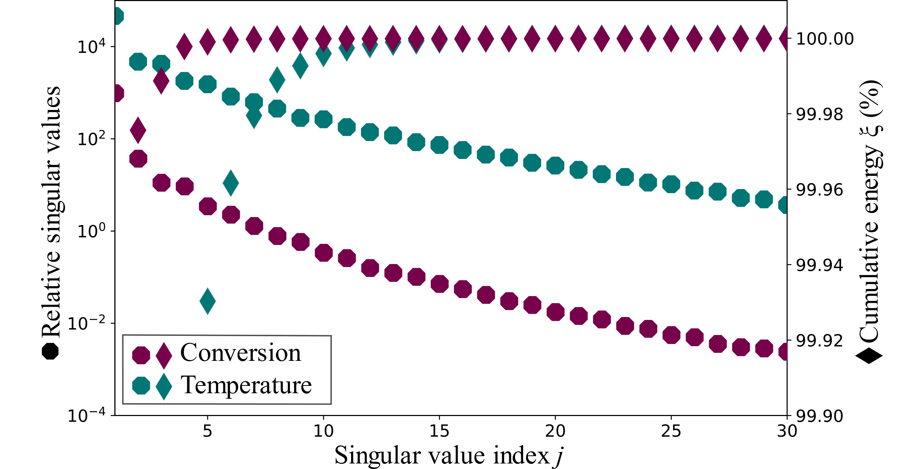

Figure 1: The decay of singular values (shown as hexagons) and cumulative energy captured by the initial dominant modes (shown as rhombi). Data are shown for the conversion (in red) and temperature (in green).

Next, for analyzing dynamic reactor changes, we apply PCA using SVD to the state snap­shot matrix $X(t)$, initiating the OpInf procedure. Figure 1 illustrates the singular value decay resulting from this transformation. The decay's pattern, which is rather gradual than steep, indicates a complex distribution among the singular values. This suggests the com­plex and highly nonlinear nature of our application. To capture the dynamics of the sys­tem, we derive reduced models over dimensions $r$ with the goal of capturing 99.9 % to 99.99 % of the total energy present in the data. This is measured by the cumulative sum of squared singular values, which reflects the information content of the system state. The number of singular values required to meet this threshold is determined by their cumu­lative proportion to the total.

We construct the low-dimensional data and its derivatives by projecting high-dimensional data onto dominant modes using a reduced-order basis. By treating temperature and conversion separately, the projection matrix $V_{r}$**,** is formed by combining left leading singular vectors from separate PCAs of these data subsets. Using the Adam optimizer, in accordance with the stability parameterization of Goyal et al., 2023, we infer the reduced operators $\hat{A}$, $\hat{H}$ and $\hat{B}$. Figure 2 presents a 3D plot comparing the actual data with a ROM that captures 99.9 % of the energy for both conversion and temperature. This model, selected with a rank of $r=7$ ( $r_{\text{X}}=2$ and $r_{\text{T}}=5$), is chosen because increasing the energy threshold beyond this point does not significantly improve the ROM's performance. The ROM shows a high degree of agreement with the actual data, effectively capturing the dynamics of the system with accepted accuracy for the application. However, we observe minor variations in temperature and conversion at the hotspot location. These significant discrepancies provide valuable insight for future improvements in the accuracy of the model. A quantitative evaluation using the Frobenius norm shows a remarkably small deviation of only 0.43 % from the original model. In addition, the reduced model achieves a significant speedup, solving the initial value problem in only 0.44 % of the time required by the mechanistic model. Specifically, the ROM completes 100 iterations in a cumulative time of only 2.47 s, compared to 553.74 s for the mechanistic model, underscoring a significant improvement in the computational efficiency. This efficiency not only demonstrates the effectiveness of the ROM, but also expands its potential applications in complex chemical engineering scenarios. With its quadratic nonlinearity and an optimized rank of $r=7$, the ROM manages to reproduce the true system's dynamics excels both efficiently and accurately, promising significant advances in dynamic system analysis.

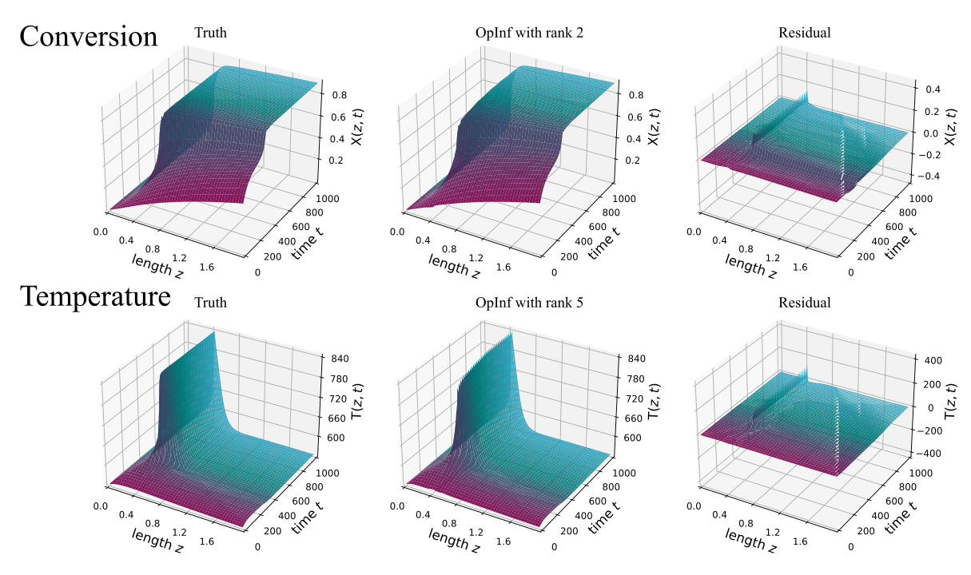

Figure 2: 3D representation comparing true reactor response with the inferred model, highlighting deviations in both conversion and temperature.

* 1. Conclusion

Our study successfully demonstrates the ability of the ROM to capture complex system dynamics with significant computational efficiency. In future work, we aim to apply the "lift-and-learn" approach, which uses auxiliary variables to simplify nonlinear system interactions and make them more computationally tractable. This method will allow us to efficiently model the dynamics as quadratic systems. In the future, our goal is to further extend the versatility of the model by integrating variable parameters. This extension, exemplified by our case study of CO2 methanation, includes adaptation to variable input loads that affect species volume flow. In addition, the incorporation of specific control terms, such as $T_{cool}$, into our model will enhance its adaptability. These advancements will not only refine the ROM's adaptability and precision across different parameters and control settings, but also solidify its role as a versatile and accurate tool for complex challenges in dynamic system analysis and a variety of computational scenarios.

Acknowledgment

This contribution is funded by the Bundesministerium für Bildung und Forschung (BMBF) and Project Management Jülich (PtJ) under grant 03HY302R. This work is part of the research initiative “SmartProSys: Intelligent Process Systems for the Sustainable Production of Chemicals” funded by the Ministry for Science, Energy, Climate Protection and the Environment of the State of Saxony-Anhalt.

References

P. Benner, T. Breiten, H. Faßbender, M. Hinze, T. Stykel, and R. Zimmermann, (Eds.), *Model reduction of complex dynamical systems*. Springer International Publishing AG, 2021.

J. Bremer, P. Goyal, L. Feng, P. Benner, and K. Sundmacher, "POD-DEIM for efficient reduction of a dynamic 2D catalytic reactor model." *Computers & Chemical Engineering* 106 (2017): 777-784.

J. Bremer, J. Heiland, P. Benner, and K. Sundmacher, "Non-intrusive Time-POD for Optimal Control of a Fixed-Bed Reactor for CO2 Methanation." *IFAC-PapersOnLine* 54.3 (2021): 122-127.

K.L. Fischer, and H. Freund, "On the optimal design of load flexible fixed bed reactors: Integration of dynamics into the design problem." *Chemical Engineering Journal* 393 (2020): 124722.

P. Goyal, I.P. Duff, and P. Benner. "Guaranteed Stable Quadratic Models and their applications in SINDy and Operator Inference." *arXiv preprint arXiv:2308.13819* (2023).

R. Güttel, "Study of unsteady‐state operation of methanation by modeling and simulation." *Chemical Engineering & Technology* 36.10 (2013): 1675-1682.

P. Kidger, *On Neural Differential Equations*. University of Oxford, PhD thesis, 2021.

B. Peherstorfer, and K. Willcox, "Data-driven operator inference for nonintrusive projection-based model reduction." *Computer Methods in Applied Mechanics and Engineering 306* (2016): 196-215.

W.I.T Uy, D. Hartmann, and B. Peherstorfer, "Operator inference with roll outs for learning reduced models from scarce and low-quality data." *Computers & Mathematics with Applications* 145 (2023): 224-239.

R.T. Zimmermann, J. Bremer, and K. Sundmacher, "Load-flexible fixed-bed reactors by multi-period design optimization." *Chemical Engineering Journal 428* (2022): 130771.