Industrial EP(D)M Polymerization Reactor Simulation: Process Dynamics and Control

Franco Scagliaa, Giovanni Regattieria, Gianni Marchettia,*

aBasic Chemicals and Plastics Research Centre, Versalis S.p.A., via G. Taliercio 14, 46100, Mantova, Italy

gianni.marchetti@versalis.eni.com

Abstract

Ethylene-Propylene-(Diene) rubber, also referred to as EP(D)M, is one of the most globally used polymers and has many applications due to its durability and flexibility. Versalis produces EP(D)M rubber via suspension copolymerization, without solvent, initiated by metallorganic component (Ziegler-Natta catalysts).

Scaglia et al. (2023) recently introduced a first-principle model and implemented it in a steady-state Aspen Polymer® simulation; both model calibration and cross-validation were performed using Versalis plant data. In this work, the dynamic behaviour of the polymerization reactor is explored: the model is tested for unsteady plant conditions; open-loop responses to step-change in input variables are investigated, and possible control strategies to maintain rubber quality within specification ranges are postulated. Dynamic simulations can successfully be employed to improve process understanding, to troubleshoot upset conditions, to monitor plant performance, and to explore future process/product developments.

**Keywords**: modelling, simulation, dynamics, control, polymerization.

* 1. Introduction

EP(D)M elastomers are synthetic rubbers prepared by polymerization of ethylene, propylene, and optionally a non-conjugated diene. They are amorphous, random polymers with excellent resistance to ageing, weather, ozone and high temperatures due to their saturated backbone structure. Primary applications include automotive parts, single-ply roofing, appliance parts, modification of other polymers (thermoplastic olefins), wire and cable, hoses, and Viscosity Index Improvers (VII) for lubricating oils. Two forms of ethylene-propylene elastomers are currently produced: (i) Ethylene-Propylene Copolymers, which contain a saturated chain and necessitate vulcanization via free radical generators such as organic peroxides or a combination of sulphur and peroxides, and (ii) Ethylene-Propylene Terpolymers, which are essentially ethylene-propylene-diene terpolymers with a saturated chain and a diene in the side chain.

The first Versalis EP(D)M production plant with suspension technology (60 kt/y) was built at Versalis site in Ferrara (Italy) in 1974; in 1991 the plant was expanded with the construction of a new line, increasing the plant capacity up to 100 kt/y, and recently (2018) a further line with a capacity of 48 kt/y was started-up. Two more lines, with a total capacity of 96 kt/y, are on stream since 2017 in the Far East (Versalis, 2022).

In the following sections, EP(D)M polymerization and industrial plant are briefly described, along with the main features of the first-principle model proposed by Scaglia et al. (2023).

* + 1. EP(D)M Polymerization

EP(D)M rubbers are created by polymerizing ethylene and propylene with a small quantity (3-12%w) of a nonconjugated diene; the most employed diene is ethylidene norbornene (ENB) (NexantEAC, 2022). Common systems used to produce EP(D)M are Ziegler-Natta and Metallocene catalyst ([Baldwin](javascript:;) and [Ver Strate](javascript:;), 1972). Ziegler-Natta catalysts involve a transition metal salt and an organometallic compound, also known as a co-catalyst. The interaction between these species leads to the formation of the active site for reactions. Polymerizations studies are mainly focused on titanium catalyst, because precursors components are easily separated and identified; fewer vanadium-based systems are fully disclosed ([Ver Strate](javascript:;), 1986). Vanadium-aluminum alkyl halide combinations produce complexes soluble in non-polar hydrocarbons; multiple vanadium-aluminum alkyl halide combinations can be drawn; the presence of multiple species affects the Molecular Weight Distribution (MWD) and the compositional distribution of the polymer.

There are several Ziegler-Natta combinations, each of which offers varying degrees of performance. The scientific and patent literature discloses methods of synthesizing catalysts with enhanced characteristics such as higher activity and improved control of molecular weight ([Baldwin](javascript:;) and [Ver Strate](javascript:;), 1972; [Ver Strate](javascript:;), 1986).

Versalis has recently introduced an improved, novel, vanadium-based Ziegler-Natta catalyst system; the new catalyst system was scaled-up to the industrial plant and employed in Versalis proprietary slurry process to obtain new EP(D)M grades (Perretta and Vallieri, 2013).

* + 1. EP(D)M Industrial Plant

Ethylene, propylene and propane are fed to the polymerization reactor (see Figure 1) along with the catalyst system (pre-catalyst, co-catalyst and activator). ENB is employed in case of Terpolymer production. Hydrogen is fed as a Molecular Weight (MW) controller.

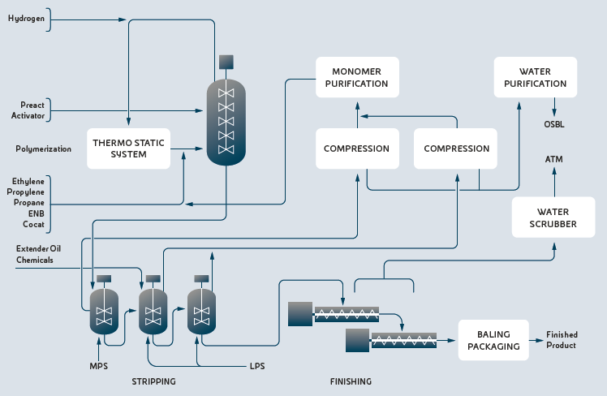

Figure 1: EP(D)M industrial plant process scheme (Versalis, 2022).

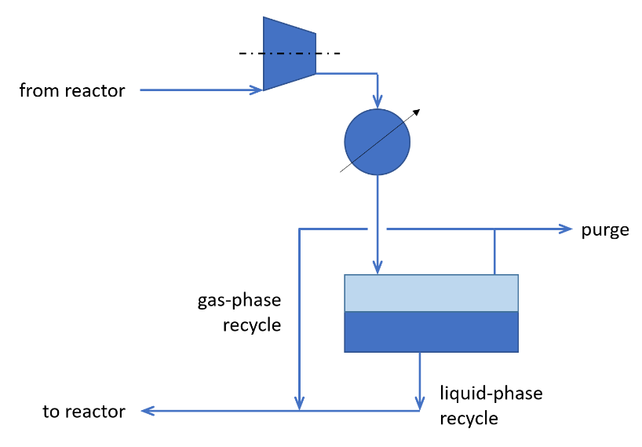

Figure 2: Thermostatic system scheme.

Since the reaction is exothermic and temperature and pressure are kept constant in the reactor, a direct thermostatic system (Figure 2) based on compression and recycle of reaction vapours is provided: vapours from reactor are compressed and partially condensed; liquid condensate is totally recycled back to the reactor, while non-condensable fraction is partially recycled and partially purged from the system.

Ethylene conversion in reactor discharge reaches about 99%, while propylene conversion is around 30% and depends on production rate and grade. Reaction behaviour is controlled by a proprietary Advanced Process Control (APC) system, based on gas chromatograph analysers on the reactor vapour phase for continuous control of the concentration of the monomers. The polymer slurry discharged from the reactor is transferred to the stripping section: steam is injected to remove the unreacted monomers, recycled water from finishing section is fed to the stripper to keep constant the watery slurry concentration. The crumb slurry is finally fed to the finishing section for drying, baling and packaging of the finished product. Further details can be found elsewhere (Versalis, 2022).

* + 1. First-Principle Model

A novel first-principle model for an industrial EP(D)M production plant was developed by Scaglia et al. (2023) and implemented in a steady-state Aspen Polymer® simulation. The polymerization scheme used in the simulation includes the phases of (i) catalyst activation, (ii) polymer chain initialization, (iii) polymer chain propagation, and (iv) polymer chain termination. During the catalyst activation phase, pre-catalyst and co-catalyst interaction leads to the formation of multiple active sites. Once the active sites are formed, the polymerization chain may start with the initialization phase. After the first ethylene monomer reacts with the active site, polymer chain propagation may take place; restrictions on the chain propagation apply based on the last monomer in chain. Two mechanisms were considered for polymer chain termination: a thermal (spontaneous) chain termination and hydrogen chain termination. After termination, the reaction site is no longer active, but may be turned on again by the activator.

Further model details, along with model calibration and validation strategies, can be found in the referenced paper by Scaglia et al. (2023).

* 1. Steady State Analysis

The model introduced by Scaglia et al. (2023) was calibrated and cross-validated using steady state industrial plant data; errors were well below 10%, assessing an acceptable model accuracy. In this section, a steady state model analysis is presented, that goes beyond available industrial plant data and leads to noteworthy general considerations. Analysis was limited to one polymer grade, namely Grade A from Scaglia et al. (2023).

The thermostatic system depicted in Figure 2 is not peculiar to EP(D)M process; analogous schemes can be found in literature whenever heat removal is required for vapour-phase streams with low boiling point. Variations may include multiple-stage condensers and recycle/bypass for compressor control, along with knock-out drums, filters and other ancillaries. The purge stream from the condensate drum shown in Figure 2 may be included to control the condensate drum pressure. However, purging the non-condensable phase would increase the heavy fraction of the stream returning to the reactor and, for the EP(D)M case where hydrogen is used as a chain termination agent, purging may also affect both polymer composition and MWD. Finally, it goes without saying that any purged quantity represents a material (and hence economic) loss.

Nonetheless, there is at least another way to somehow affect the condensate drum pressure that does not involve purging. The gas-phase recycle stream may be regulated (manually or automatically) with a control valve: with a gas-phase recycle flowrate decrease the non-condensable fraction tends to accumulate inside the condensate drum, thus rising its pressure, and vice versa. Since this stream represents an internal recycle to the reactor, any change in the gas-phase recycle flowrate will not affect the steady state of the reactor itself but will affect the Vapour-Liquid Equilibrium (VLE) in the condensate drum and hence its steady state pressure. This phenomenon was explored in a steady state simulation sensitivity analysis, whose main results are reported in Figure 3: condensate drum pressure is plotted against gas-phase flowrate; due to confidentiality, both variables are normalized with reference to the central steady state operating condition.

Figure 3 Steady state simulation sensitivity analysis: normalized condensate drum pressure against normalized gas-phase recycle flowrate.

* 1. Unsteady State Analysis

In Section §2 some general considerations about the steady state behaviour of the system were presented; in this Section, the analysis is extended to the unsteady state condition.

* + 1. Open-Loop Response

First, some open-loop responses are investigated, namely a step-response to fresh hydrogen feed flowrate and a step-response to gas-phase recycle flowrate. As previously described, hydrogen is employed as a polymer MW regulator; thus, a step-change in fresh hydrogen feed flowrate is expected to affect the polymer MW, and hence Mooney viscosity. As mentioned in Section §2, gas-phase recycle flowrate affects condensate drum pressure without affecting steady state reactor performance; however, it may introduce a significant transient shift in the system performance, whose recovery may take a substantial time, leading to temporary off-spec production.

In Figure 4 the open-loop response to a step-change in fresh hydrogen feed flowrate is reported (step-change occurs at t = 0); both 50 % increase (solid line) and decrease (dashed line) are plotted. Due to confidentiality, values are normalized with reference to initial steady state condition. As can be inferred, the input step change generates a prolong, sluggish transient response that eventually leads to a new steady state condition i.e., the production of a polymer with significant modified properties.

In Figure 5 the open-loop response to a step-change in gas-phase recycle flowrate is reported (step-change occurs at t = 0); both 90 % increase (solid line) and decrease (dashed line) are plotted. Due to confidentiality, values are normalized with reference to initial steady state condition. As can be inferred, the step change generates a sharp, quick transient response that is eventually recovered to the initial steady state. Basically, the condensate drum acts as a hydrogen reservoir in a recycle loop, and the gas-phase recycle stream temporarily releases (or retains) that hydrogen to the reactor.

Figure 4 Transient Mooney viscosity response (normalized) to a step-change in fresh hydrogen flowrate: 50 % increase (solid) and 50 % decrease (dashed).

Figure 5 Transient polymer Mooney response (normalized) to a step-change in gas-phase recycle flowrate: 90 % increase (solid) and 90 % decrease (dashed).

* + 1. Control

As described in Section §3.1, a change in the hydrogen feed induces a slow transient response that leads to a new steady state; on the other hand, a change in the gas-phase recycle induces a quick transient response, that eventually is recovered. This suggests that a model-based control strategy, that involves an optimal combination of both changes, may be developed to accomplish an effective advanced process control.

* 1. Conclusions

A first-principle model for an industrial EP(D)M plant was employed to extend steady state analysis beyond available plant data. Unsteady state analysis highlighted the transient behaviour to possible step-changes, suggesting the future investigation for a model-based control strategy. Generalization to analogous process systems may apply.

References

F. P. [Baldwin](javascript:;), G. [Ver Strate](javascript:;), 1972, Polyolefin Elastomers Based on Ethylene and Propylene, Rubber Chemistry and Technology, 45 (3), 709–881.

NexantECA, 2022, Market Analytics: Ethylene Propylene Diene Monomer (EPDM).

C. Perretta, A. Vallieri, 2013, Process for the preparation of a copolymer of ethylene, Patent EP2782940B1.

F. Scaglia, A. Mazzini, C. Perretta, G. Regattieri, G. Marchetti, 2023, Industrial EP(D)M Rubber Production Process: a First-Principle Data-Driven Modelling Approach, Chemical Engineering Transactions, 100, 163-168.

Versalis, 2022, <versalis.eni.com/assets/documents/versalis/it/documentazione/licensing/

elastomeri/EP(D)M.pdf> accessed 11.10.2022.

G. [Ver Strate](javascript:;), 1986, Ethylene Propylene Elastomers, Encyclopedia of Polymer Science and Engineering, 522-564.