Development of a Strategy for the Analysis of the Fluid Dynamic Behavior of Sieve Trays for Distillation
Jose Alfredo Paredes-Ortiz ª , Mario Alberto Rodríguez-Angeles ^{b} , Vineet Vishwakarma ^{c} , Markus Schubert ^{d,e} , Uwe Hampel ^{e,f} , Fernando Israel Gómez-Castro ^{a*}, Mayra Margarita May-Vázquez ^{g} .
ª Departamento de Ingeniería Química, División de Ciencias Naturales y Exactas, Campus Guanajuato, Universidad de Guanajuato, Noria Alta S/N Col. Noria Alta, Guanajuato, Guanajuato, Mexico 36050.
^{b} Universidad Politécnica de Juventino Rosas, Departamento de Metalúrgica, Hidalgo No. 102, Comunidad de Valencia, Juventino Rosas, Guanajuato, Mexico 38253.
^{c} University of Michigan, Department of Nuclear Engineering & Radiological Sciences, 2355 Bonisteel Boulevard, Ann Arbor, Michigan 48109, USA.
^{d} Chair of Chemical Process Engineering, Technische Universität Dresden, 01062 Dresden, Germanye.
^{e} Institute of Fluid Dynamics, Helmholtz-Zentrum DresdenRossendorf, Bautzner Landstraße 400, 01328 Dresden, Germany
^{f} Chair of Imaging Techniques in Energy and Process Engineering, Technische Universit ̈at Dresden, 01062 Dresden, Germany
^{g} Unidad Académica de Educación Virtual, Dirección General de Desarrollo Académico, Universidad Autónoma de Yucatán, Benito Juárez 421 Cd. Industrial, Mérida, Yucatán, Mexico 97288.
fgomez@ugto.mx
Abstract
An Eulerian-Eulerian model was applied to simulate the two-phase flow behaviour in a sieve tray column, i.e., typically used for distillation. Following grid independence, the phase fraction was simulated, which exhibit good agreement with experimental data, especially in the liquid-dominant zones of the two-phase dispersion. In the upper gas-dominant dispersion regions, a slight deviation of less than 10% was observed in the gas fraction data. The results demonstrate that the proposed modeling strategy can adequately predict the fluid dynamic behaviour in tray-equipped distillation columns.
Keywords: Sieve tray, CFD, Eulerian-Eulerian model, Two-phase flow, Hydrodynamics.
  - Introduction
Tray distillation columns are the cornerstone of the chemical industry, and they are employed extensively for the separation of fluid mixtures. The intricate fluid dynamics of the gas-liquid interactions in these columns, however, pose a significant challenge in their numerical modeling (Yang Kong et al., 2022). Two-phase gas-liquid flows in tray columns have complex interfacial dynamics due to the interplay of phenomena such as coalescence, breakup, turbulence, and so forth.
Despite recent advancements in Computation Fluid Dynamics (CFD), an accurate prediction of the fluid dynamics in distillation columns has not been fully achieved. This holds even for the sieve trays, which are the most common column internals. Sieve trays are nothing but perforated plates that promote interfacial contact between gas and liquid phases thereby improving the efficiency of the separation process (Vishwakarma et al., 2021). However, the fluid dynamics related to these trays are influenced by a multitude of factors, including tray design, operating conditions, and physical properties of the fluids, to name but a few. The interplay of these factors leads to a range of flow regimes and conditions, which makes the accurate prediction of the fluid behaviour in tray columns incredibly challenging. The inadequate selection of design variables as the tray diameter, the width and length of downcomers, among others, may lead to operational as flooding or weeping. Therefore, a robust modelling and simulation strategy is desired to address this challenge, which is the scope of the present proposal. This work emphasizes on validating the applied CFD model using high-fidelity experimental data from a sieve tray column (recently reported by Vishwakarma et al. (2021)). The work aims to provide valuable insights of the fluid dynamics in a sieve tray column and encourages CFD application for the design and analysis of high-performance trays in the future.
  - Modeling methodology
The Euler-Euler approach is popular in CFD for modeling multiphase flows such as for gas-liquid interactions in distillation columns (Drumm et al., 2010). This approach treats each phase as a separate interpenetrating continuum with its own set of conservation equations for mass and momentum (Alzyod et al., 2018).

The conservation equation for the mass of phase $i$ is given by Eq. (1)

$\frac{∂(α_{i}ρ_{i})}{∂t}+∇⋅(α_{i}ρ_{i}u_{i})=0$, | (1)

where $α_{i}$​ is the phase fraction, $ρ_{i}$ is the density, and $u_{i}$​ is the velocity of the phase $i$. The sum of the fractions for all phases is unity, which is Eq. (2) as

$\sum{α_{i}}=1$. | (2)

The momentum equation for the phase $i$ is given as

$\frac{∂(α_{i}ρ_{i}u_{i})}{∂t}+∇⋅\left(α_{i}ρ_{i}u_{i}u_{i}\right)=-α_{i}∇p+∇⋅T_{i}+α_{i}ρ_{i}g+\sum{R_{ij}}$, | (3)
where $p$ is the pressure, $T_{i}$ is the stress tensor for phase $i$, $g$ is the gravitational acceleration, and $R_{ij}$ is the interphase momentum transfer from phase $j$ to phase $i$. Solving these conservation equations lead to the prediction of the phase distribution and velocity profiles that are directly related to the column performance.
  - Column geometry and boundary conditions
In this work, the Euler-Euler approach was implemented in FLUENT 23R1 to solve the Eqs. (1-3). The geometry used in this work corresponds to a sieve tray column, directly derived from the experimental work of Vishwakarma et al. (2021). The dimensions of the tray column facility are summarized in Table 1, and its CAD drawing is shown in Figure 1.

Table 1. Specifications of the tray column derived from Vishwakarma et al. (2021).

Particulars | Dimensions
Internal column diameter | 800 mm
Inlet weir (L × W × H) | 532 mm × 2 mm × 35 mm
Outlet weir (L × W × H) | 465 mm × 2 mm × 20 mm
Flow path length | 620 mm
Active tray area | 0.44 m²
Hole specifications | 3052 × 5 mm Ø, pitch: Δ × 12 mm
Fractional free area | 13.55%
Downcomer clearance | 20 mm
Tray spacing | 365 mm
Tray thickness | 15 mm
Calming zone | 36 mm (inlet), 30 mm (outlet)

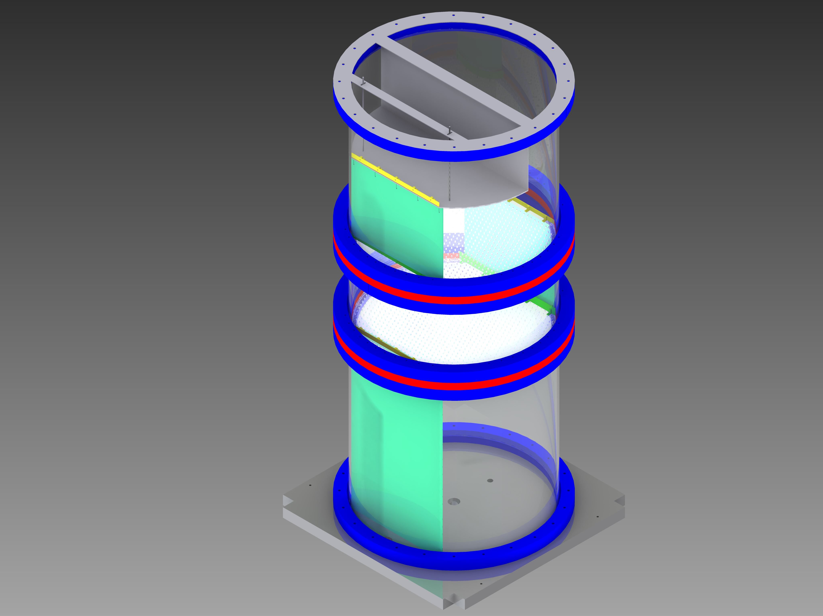
Figure 1. CAD drawing of the tray distillation column.

For the shown experimental setup, Vishwakarma et al. (2021) recently reported the distributions of effective froth height, phase fraction and liquid residence time at several weir loadings and F-factors. These data were obtained in their work based on the application of a multiprobe conductivity sensor and novel data processing algorithms (Vishwakarma et al., 2020, 2021). The availability of the aforesaid high-resolution data along with other information pertaining to setup, operating conditions, and physical properties make them ideal for CFD model validation. From their work, the data corresponding to 1.77 Pa^{0.5} F-factor and 2.15 m³m⁻¹h⁻¹ and 4.30 m³m⁻¹h⁻¹ weir loading are considered for CFD simulation.

To solve the proposed equations and systems, a specific solution method was employed. The turbulence modeling was carried out using the k-ε model with the RNG sub-model, which allows for a more precise modeling of the turbulent behavior with high vorticity (Rodríguez-Ángeles et al., 2015). Furthermore, air and water were the two phases in the simulation (just like in the reported experimental campaign). Based on the selected operating conditions, a coupled resolution approach was used due to the nonlinearity of the model. Likewise, the resolution parameters were configured to be second order. The phase solution parameter was Modified HRIC due to its affinity in multiphase resolution models as well as due to greater precision at the water-air interface, which reduces its probability of divergence.
To achieve stability in the models, an F-Cycle approach was used, supported by the BCGSTAB stabilization method. This was due to the high nonlinearity of system’s model, which generates floating points in situations where turbulent viscosity reaches very high values.
  - Model validation and assessment
Figure 2 compares the average liquid phase fraction ($α$) obtained experimentally at different heights above the tray with the CFD model predictions for the considered loadings. This Figure also shows the CFD-based liquid phase distribution at given heights above the tray for the given weir loadings. Good agreement in the holdup values from CFD and experiments in the Figure validates the modeling approach used here. The analysis of the CFD data suggests an increase in the average liquid phase with height until the gas jets have enough momentum to keep the liquid suspended. Afterwards, the liquid phase tends to reduce and rightfully becomes nil above the two-phase dispersion. The observations from the CFD data analysis comply with those from the experimental data.
The simulation results reveal that higher loadings lead to an increase in the liquid phase downstream, particularly around 50 mm above the tray. In contrast, under lower loading conditions, the average value is much higher, occurring around 40 mm above the distillation tray. This suggests that the liquid phase distribution is significantly influenced by the loading conditions, with higher loadings promoting a more downstream liquid phase distribution.
Interestingly, very similar behavior was observed between the average liquid phase values from the experimental data and the simulations at most heights above the tray. However, between 40-60 mm elevation above the deck, a higher deviation in the average liquid phase was observed between the two. Further, at heights greater than 60 mm, the CFD predicted the average liquid phase again similar to the experimental data.

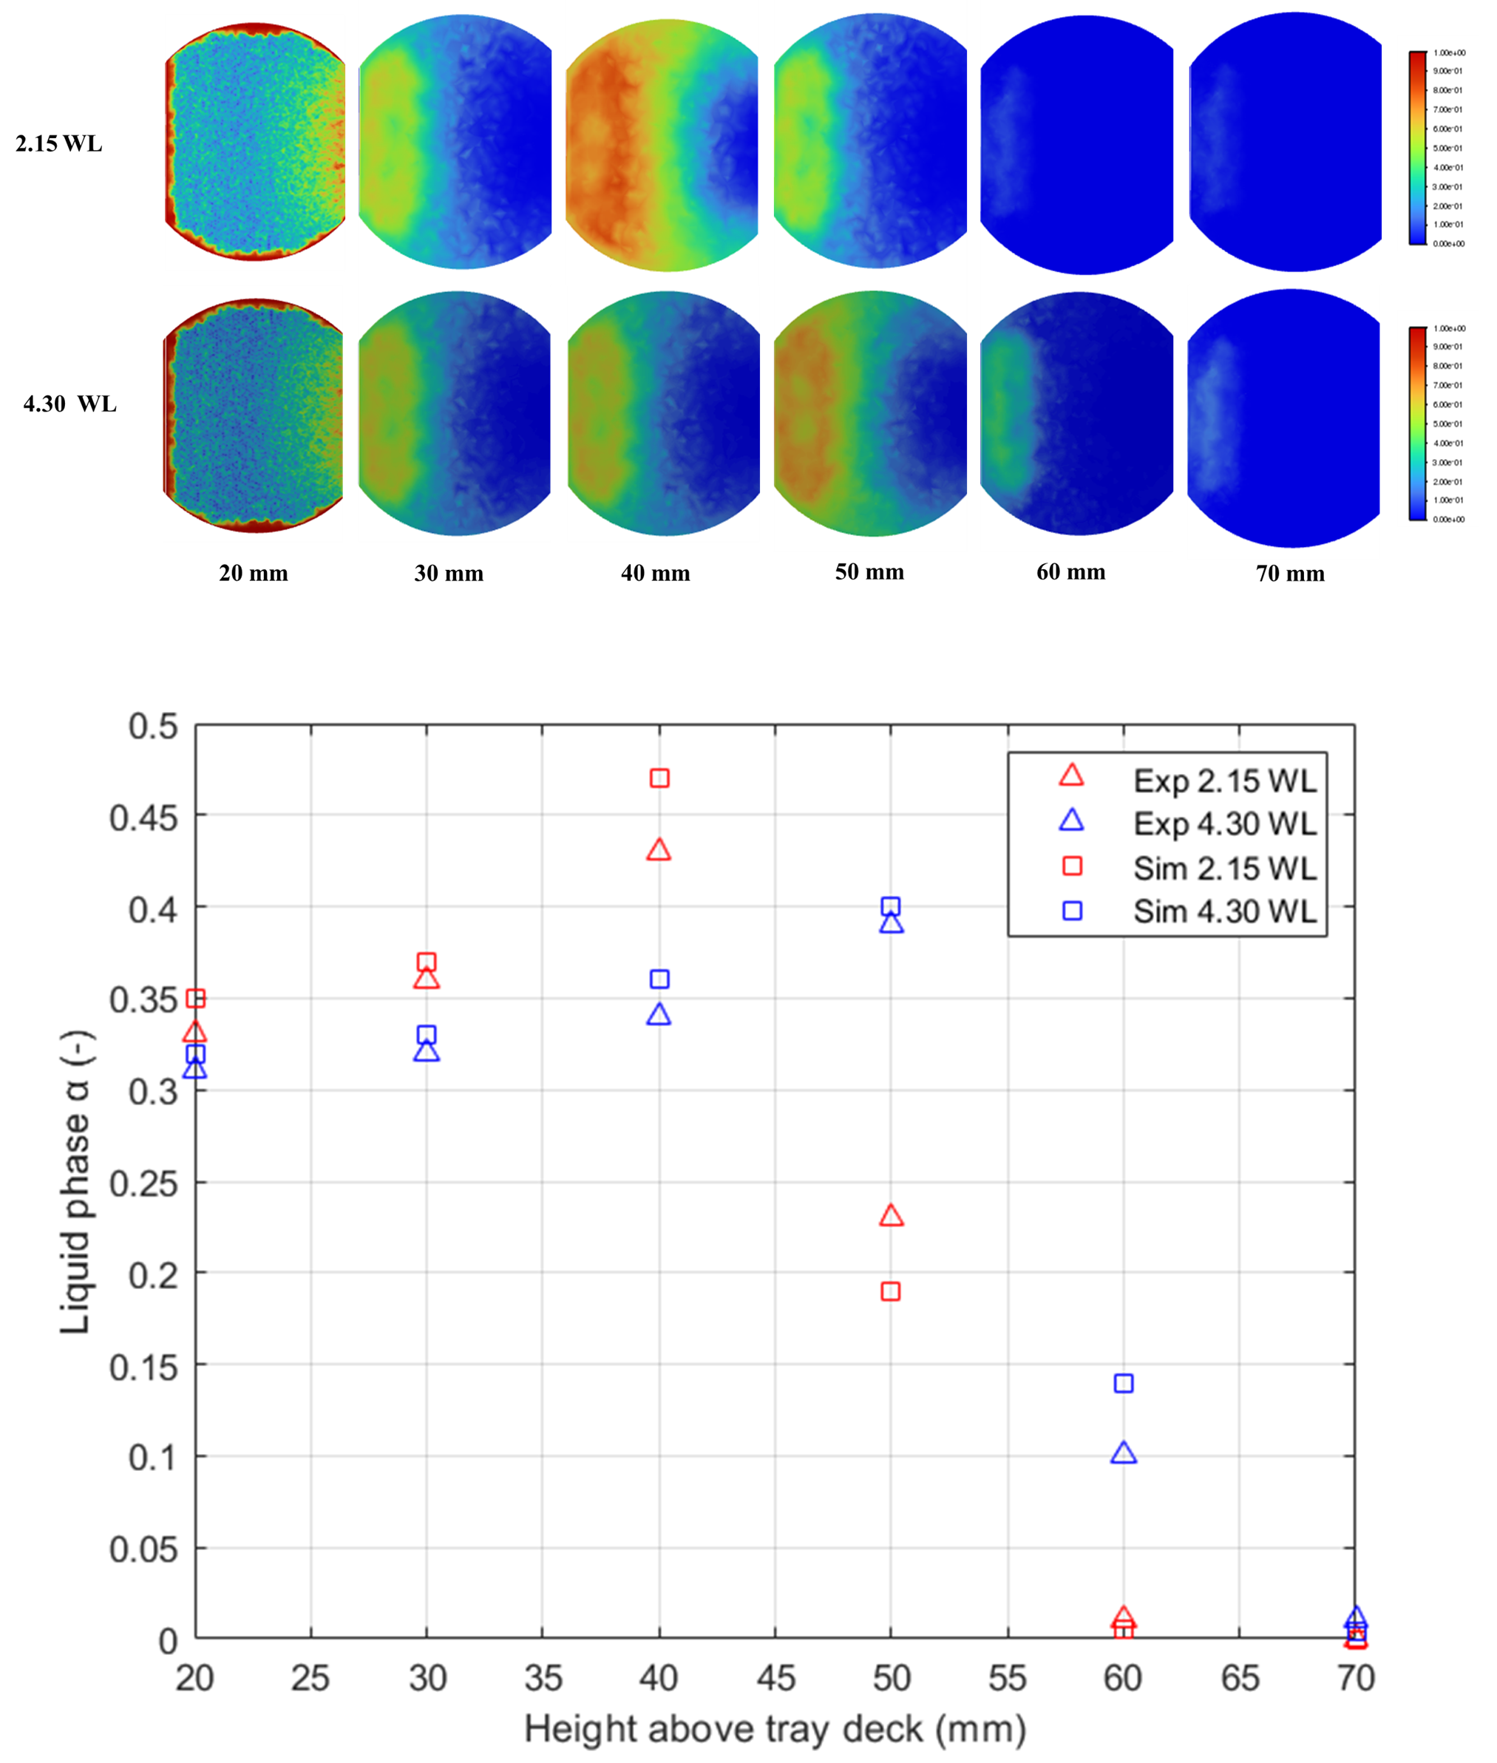
Figure 2. Comparison of experimental and simulated average liquid phase versus height above tray deck for the loadings (lower), and CFD-led phase fraction distribution at different heights above the deck (upper).

  - Conclusions
The computational fluid dynamics (CFD) model used in this study has demonstrated its effectiveness in accurately predicting the liquid phase distribution in a sieve tray column under two loading conditions (2.15 m³m⁻¹h⁻¹ and 4.30 m³m⁻¹h⁻¹). The model predictions align very well with the experimental data except at few heights above the tray deck indicating the scope for further model refinement. Particularly, as unidirectional liquid velocities based on tracer-based experimental data are reported only for one height, the CFD-based velocity data requires post processing to make it suitable for comparison. The study also revealed that the loading conditions significantly influence the liquid phase distribution on a sieve tray. Higher weir loading was found to promote elevation-specific liquid phase in the tray downstream.
These findings validate the use of the CFD model and highlight its potential for optimizing trays in distillation processes. The proposed analysis strategy will contribute to the development of more efficient and effective distillation processes, and ultimately leading to significant energy and cost savings in the chemical industry.
References
S. Alzyod, M. Attarakih, H.-J. Bart, 2018. CFD modelling of pulsed sieve plate liquid extraction columns using OPOSPM as a reduced population balance model: hydrodynamics and mass transfer. Comput. Aided Chem. Eng., 43, 451–456.
C. Drumm, M. Attarakih, M. W. Hlawitschka, H.-J. Bart, 2010, One-group reduced population balance model for CFD simulation of a pilot-plant extraction column, Ind. Eng. Chem. Res., 49, 3442–3451.
M.A. Rodríguez-Ángeles, F.I. Gómez-Castro, J.G. Segovia-Hernández, A.R. Uribe-Ramírez, 2015. Mechanical design and hydrodynamic analysis of sieve trays in a dividing wall column for a hydrocarbon mixture, Chem. Eng. Process., 97, 55-65.
V. Vishwakarma, S.A Haq, E. Schleicher, M. Schubert, U. Hampel, 2021. Experimental analysis of the hydrodynamic performance of an industrial scale cross-flow sieve tray, Chem. Eng. Res. Des., 174, 294-306.
V. Vishwakarma, E. Schleicher, A. Bieberle, M. Schubert, U. Hampel, 2021, Advanced flow profiler for two-phase flow imaging on distillation trays, Chem. Eng. Sci., 231, 116280.
V. Vishwakarma, P. Wiedemann, E. Schleicher, M. Schubert, U. Hampel, U., 2021, A new approach for estimating the effective froth height on column trays, Chem. Eng. Sci., 231, 116304.
V. Vishwakarma, E. Schleicher, M. Schubert, M. Tschofen, M. Löschau, 2020, Inventors; Helmholtz Zentrum Dresden Rossendorf eV, assignee. Sensor zur Vermessung von Strömungsprofilen in großen Kolonnen und Apparaten. German patent DE1020181245012020.
Z. Yang Kong, H. Yeh Lee, H., J. Sunarso, 2022, The evolution of process design and control for ternary azeotropic separation: Recent advances in distillation and future directions, Sep. Purif. Technol., 284, 120292.

