Scoping and Identifying Data-Driven Optimization Prospects in the Danish Processing Industry
Adem R.N. Aouichaoui,ª Brynjolf B. Ernstsson, ª Peter Jul-Rasmussen,ª Nicklas H. Iversen, ^{b} Laurent Vermue, ^{c} Jakob K. Huusom^{a*}
ª Dept. of Chemical and Biochemical Engineering, Technical University of Denmark, Søltofts Plads 228A, 2800 Kgs. Lyngby, Denmark
^{b} Viegand Maagøe A/S, Nørre Søgade 35, 1370 København K, Denmark.
^{c} BioLean ApS, Søndre Jernbanevej 32, 3400 Hillerød, Denmark.

*jkh@kt.dtu.dk
Abstract
Increased investment in various technological upgrades (sensors and IT infrastructures) in the processing industry has resulted in large data lakes over the last decade. These can be leveraged for various purposes such as gaining further process insight and optimization through advanced analytics and data-driven modelling. Nevertheless, this potential is rarely fulfilled due to the required wide range of expertise and time constraints. This work presents an extended framework towards bridging the gap between data availability and data utilization for the process and energy optimization within the Danish processing industry. The overall project aims to produce a real-world implementation of data-driven methods on-site at five different industries to highlight the potential, opportunities, and barriers of such endeavours. The multifaceted nature of the project requires multi-disciplinary teams with various expertise and a revised systematic framework to cover the complete life cycle of a data-driven model, from scoping the problem and model development to the on-site deployment and contentious maintenance. The core phases of such a framework are proposed herein.
Keywords: Optimization, Modelling, Framework, Digitalization
  - Introduction
The increased technological development and digitalization witnessed over the last decade has heralded the fourth industrial revolution also referred to as Industry 4.0 (Cannavacciuolo et al., 2023). One important catalyzer is the increased data availability and quality enabled through improved sensor technologies and IT infrastructures (A. Udugama et al., 2021). These developments are expected to play an important role in reducing the current industrial carbon footprint and producing more sustainable processes through the efficient use of various resources. As such, there is an increased interest from industry, policymakers, and governments to implement measures to accelerate and realize the full potential of Industry 4.0. This should be seen in light of the ever-increasing concerns about resource consumption and the negative effects of anthropological emissions. Efforts to mitigate these effects differ across countries and industries. In Denmark, the overshoot day in the year 2023 was around the 28th of March, making it among the top 15 fastest countries to reach overshoot day (Wackernagel and Lin, 2023). Despite reducing greenhouse gas (GHG) emissions by almost 23% (from 69.3 to 51.9 million t CO2e) between 2005 to 2018, it is mainly driven by the energy sector. Meanwhile, the Danish processing industry accounts for almost 15% of the total CO₂e in GHG emissions (Danish Agency of Energy, 2023). Consequently, efforts have been made to publicly fund endeavours aiming to improve industrial energy efficiency and reduce GHG emissions. Yet, Despite this, a survey revealed few companies reported using data-driven approaches in plant operations (A. Udugama et al., 2021). Such projects require a wide range of expertise across disciplines ranging from project management, process engineering, operation, data science, and IT expertise. An important factor is that data-driven solutions must be integrated with on-site systems to allow for data input from users and systems (automatically and manually). It should also provide a means to display information and insights generated by the solution. This results in additional considerations including organizational impact on existing procedures, which requires the development of a framework encapsulating the entire process of problem scoping to model implementation and evaluation.

The development and use of systematic frameworks are not foreign in the field of process systems engineering (PSE), with various frameworks developed for process design and product design (Cignitti et al., 2018). However, most of these frameworks only focus on the analysis, synthesis, and validation steps. As such, few available frameworks focus on data-driven modelling. Hwangbo et al., (2020) proposed a framework that covers four steps: data pipeline (including data collection augmentation and reconstruction), model development (including data splitting and model training), model validation (model testing and optimal model selection) and global sensitivity analysis to provide an interpretable aspect to the data-driven model. InfoQ is another framework developed for assessing the quality of information in data-driven applications for Industry 4.0 (Reis, 2018). This framework is made of four components: analysis goal, data management, empirical analysis, and utility function evaluation. Common for both methods is that they are both model-centric rather than user-centric. Therefore, they omit important elements such as problem scoping, model deployment and maintenance. Model deployment is a crucial step and is often overlooked when developing a model whether it is based on mechanistic knowledge or machine learning (ML). A survey among data scientists revealed that only 13% see their models get deployed (Davenport and Malone, 2020). Another survey has reported that the deployment phase takes between 8 to 90 days with over 18% stating that longer deployment time is rather common (Paleyes et al., 2023). Therefore, the inclusion of a deployment step is vital for any systematic framework intended for developing models for production.
  - Machine Learning for Energy and Process Optimization (MLEEP)
    - Introduction
“Machine Learning for Energy and Process Optimization (MLEEP)” is a publicly funded cross-industry project with the main objective of identifying the potential, opportunities, and barriers to leveraging ML for optimization purposes across various industries in the Danish processing ecosystem. This is done through the direct development and implementation of such tools at the production sites of a series of companies from different industries. The selected companies cover a wide range of industries including the food and beverage industry in the form of malt and whey protein production, the oil industry in the form of a refinery of used lubrication oil, a utility company providing district heating as well as the paint and coating industry. This variety is intentional and aims to broaden the applicability of the solution approach and findings. The project involves four stakeholders: a consultancy company (Viegand Maagøe A/S) specialising in project management and providing services within energy and utility optimization, an academic research centre in process systems engineering (DTU Chemical Engineering) at the Technical University of Denmark (DTU), an IT service and solution provider within data-driven modelling and digitalization (BioLean ApS) and the selected companies. The schematic of the central actors in the project is shown in Figure 1. Such a project involves many steps and in order to handle the complexity characterizing this project, a systematic framework was developed and is described in the following.
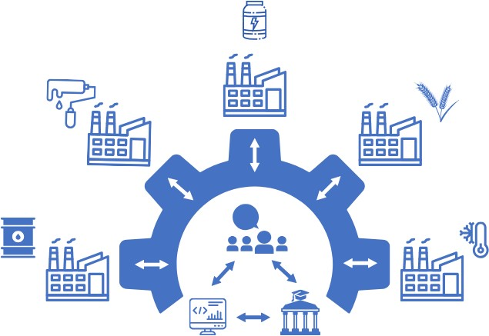
Figure 1: MLEEP involved stakeholders; inner circle (core) representing Viegand Maagøe A/S, DTU, and BioLean ApS, outer circle representing selected companies.
.
    - Systematic framework for model development and production deployment
The following presents the various steps and the activities associated with each phase of the framework. Figure 2 provides an overview of these steps and activities.

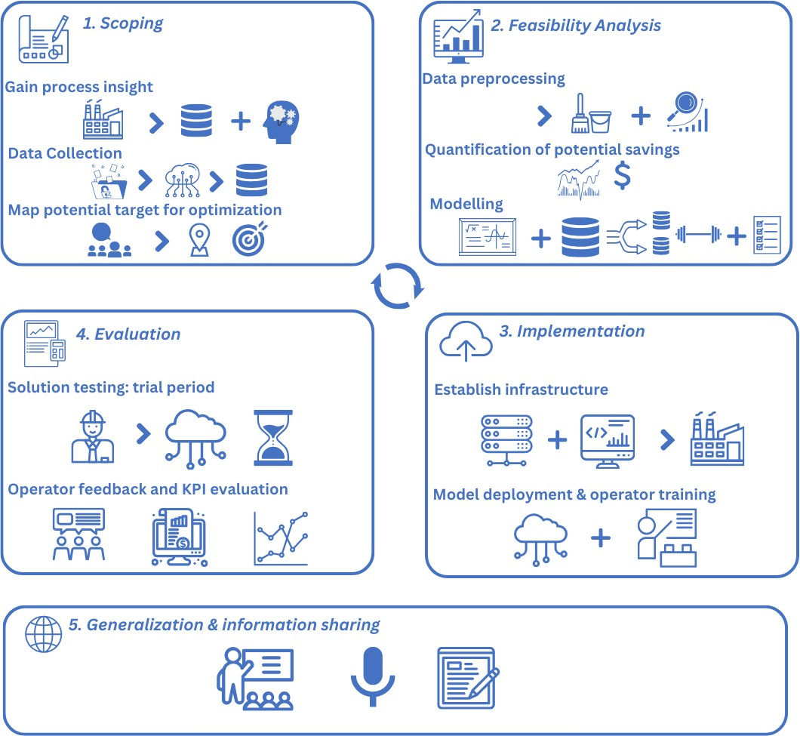
Figure 2: Main phases of the proposed framework and the major activities involved.
      - Scoping
The first phase of the framework is the scoping process which involves the core project partners. This step consists of gaining as much insight as possible into the industrial processes present in the company. This knowledge covers available measurements (amount, frequency, quality, format etc.), the various units (PIDs, technical drawings, etc.), the structure of the control system (manipulated variables, controlled variables, any manual intervention etc.) as well as operator experience concerning challenging aspects of running the plant. This contributes to narrowing down the potential case studies, which are selected based on a set of criteria i) does not interfere with ongoing projects at the company, ii) is relevant for the industrial stakeholder, iii) data availability, iv) the process is operator dependent and v) it exhibits a noticeable variance. Accordingly, and with agreement between all parties, a scope for the optimization is defined covering which process and which parameters (energy, time, throughput, etc.). Based on this, a concrete optimization potential is defined along with a suitable key performance indicator (KPIs). An important constraint is that only existing measurements are leveraged for this purpose. This is an important prerequisite to investigate the potential of ML to build upon existing optimization efforts and provide further improvements as such, the aim is to produce the best solution given the available data and installation.

      - Feasibility Analysis
The second phase consists of a feasibility analysis. This phase covers i) data preprocessing, ii) data analysis, iii) base case calculation, and iv) modelling activities. The data preprocessing aims to unify the various measurements provided by storing them in a single source enabling easy access to them. Further processing includes aligning timestamps, filling gaps in the data, denoising the data, and rationalizing measurements with physical laws (negative valve openings, flows or pressures). The latter is usually a product of slight miscalibration or signal noise. The data analysis consists of investigating potential correlations in the data, visualizing the data, and selecting the data relevant to the modelling process. The latter is based on the defined optimization objective. The base case calculations aim to quantify the theoretical energy-saving potential or increased capacity of the defined optimization problem. This can be done through a “back-of-the-envelope” calculation using annual average flows. The modelling activities consist of identifying the most promising approach to describing the process and solving the problem at hand. This can be done either through i) mechanistic modelling using first principles (mass/energy conservation), ii) data-driven approaches using ML (black box) or iii) a combination of the two approaches resulting in a hybrid modelling approach.

The choice of modelling approach is highly dependent on the available process understanding and the quality and availability of data. Mechanistic (white-box) modelling requires a complete understanding of the phenomena occurring during the process in addition to the availability of data. Data-driven modelling using ML aims to tune a non-parametric model that best describes the target output. These models require minimal process understanding, they are prone to domain shift and might be sensitive to the quality of data (noise). Furthermore, they are considered “black box” as they do not offer any interpretable aspect to the relationship between input and output. Hybrid modelling provides a compromise between the two aforementioned approaches. The aim is to describe the process as much as possible using mechanistic modelling (parametric) and then complement it using data-driven modelling (non-parametric) to either describe unknown quantities or to correct the output of the mechanistic model. A benefit of hybrid modelling is the added aspect of interpretability and explainability compared to purely data-driven modelling which contributes to the broader acceptance and adaptation of data-driven approaches, especially in fields that historically have been relying on mechanistic modelling or semi-empirical correlations. It is important to note that multiple approaches can be used to solve a given problem, this provides the opportunity to benchmark the various approaches. The selected models are then trained on available historical data and validated using a hold-out portion of the data. All modelling approaches are considered initially, and a final model is selected considering various criteria such as accuracy, simplicity, speed and required data input.

      - Implementation
When a model has achieved satisfactory accuracy on historical data, it is implemented at the plant. An important aspect of this implementation is that the solution is not directly implemented into the currently existing set-up but rather considered as an add-on where the operators are provided with suggestions on how to change the process conditions in real-time through a dashboard. This solution includes establishing the necessary infrastructure on-site to collect the data, deploy the model and provide real-time suggestions for the operators. As part of the implementation, the operators are instructed on how to use the tools they have at their disposal to ensure wide usage and acceptance.

      - Evaluation
After successful implementation of the model on-site, a trial period commences. During this, operators are encouraged to use the implemented solution and report their experience with it as a part of qualitative assessment. This aims to i) unravel aspects such as user-friendliness, ii) compare model output with operator experience, iii) evaluate the defined steps of the framework and revise any missing elements and iv) evaluate the communication between stakeholders. A quantitative assessment of the solution is done by revisiting the selected KPIs.

The continuous development and maintenance of the implemented solution is an important step in the life cycle of a data-driven model in production. The established infrastructure enables online retraining of the model whenever a deterioration of the performance is detected, a phenomenon also known as temporal quality degradation, which is expected to occur when operator response changes (Vela et al., 2022). Furthermore, the existence of several case studies allows for revisiting the proposed framework and developing further on it as required.

      - Generalization
An important aspect of the project is to disseminate the findings and experiences gained throughout the project. This includes whether the framework adopted was sufficient and any recommendation on how to extend and revise it and how to adapt it to cover the different elements to overcome the challenges faced in each industry. The aim of this step is also to highlight the successes and failures and more importantly, the elements that contributed to each. With this step, the aim is also to motivate and encourage the processing industry to adopt measures to become more energy efficient by presenting real-life applications.
  - Conclusion
Leveraging the increasing availability of data in the process industry requires a multi-disciplinary effort that ranges from project management, process engineering, data scientists and software architects. Existing systematic frameworks within the field of process systems engineering mainly focus on model development and testing and do not include surrounding activities. In this work, we proposed a framework that addresses missing elements and consists of five phases: problem scoping, feasibility analysis, implementation, evaluation, and generalization. An added value of the framework is the further focus on the on-site implementation of data-driven models throughout its life cycle (development, training, validation, deployment, and retraining). Future work will aim to incorporate empirical validation of the proposed framework and a comparative analysis between the various case studies.
Acknowledgements
This study was financially supported by the Danish Energy Agency. ELF221-496435: Machine Learning til Energi- og Proces-optimering (MLEEP).
References
A. Udugama, I., Öner, M., Lopez, P.C., Beenfeldt, C., Bayer, C., Huusom, J.K., Gernaey, K.V., Sin, G., 2021. Towards Digitalization in Bio-Manufacturing Operations: A Survey on Application of Big Data and Digital Twin Concepts in Denmark. Frontiers in Chemical Engineering 3.
Cannavacciuolo, L., Ferraro, G., Ponsiglione, C., Primario, S., Quinto, I., 2023. Technological innovation-enabling industry 4.0 paradigm: A systematic literature review. Technovation 124, 102733.
Cignitti, S., Mansouri, S.S., Woodley, J.M., Abildskov, J., 2018. Systematic Optimization-Based Integrated Chemical Product–Process Design Framework. Ind. Eng. Chem. Res. 57, 677–688.
Danish Agency of Energy, 2023. Klimastatus og -fremskrivning 2023.
Davenport, T., Malone, K., 2020. Deployment as a Critical Business Data Science Discipline. Harvard Data Science Review 3.
Hwangbo, S., Al, R., Sin, G., 2020. An integrated framework for plant data-driven process modeling using deep-learning with Monte-Carlo simulations. Computers & Chemical Engineering 143, 107071.
Paleyes, A., Urma, R.-G., Lawrence, N.D., 2023. Challenges in Deploying Machine Learning: A Survey of Case Studies. ACM Comput. Surv. 55, 1–29.
Reis, M.S., 2018. A Systematic Framework for Assessing the Quality of Information in Data-Driven Applications for the Industry 4.0. IFAC-PapersOnLine 51, 43–48.
Vela, D., Sharp, A., Zhang, R., Nguyen, T., Hoang, A., Pianykh, O.S., 2022. Temporal quality degradation in AI models. Sci Rep 12, 11654.
Wackernagel, M., Lin, D., 2023. Earth Overshoot Day, in: Wallenhorst, N., Wulf, C. (Eds.), Handbook of the Anthropocene. Springer International Publishing, Cham, pp. 569–572.

