Optimization of Heat Pump and Vapor Recompression Technologies for wide-boiling Mixtures

Armin Rix,a* Niklas Paul,b Lea Wessner, a Daniel Murrenhoffa

aEvonik Operations GmbH, Paul-Baumann-Str.1, 45772 Marl, Germany

bEvonik Oxeno GmbH & Co KG, Paul-Baumann-Str.1, 45772 Marl, Germany

armin.rix@evonik.com

Abstract

The application of vapor recompression and heat pump technologies to recycle waste heat to the process is straightforward in close-boiling mixtures. Especially in distillation systems with high feed rate and reflux ratio, high energy cost and large compressor cost degression potentials enhance the economic attractiveness. In wide-boiling systems, on the other hand, a high compression ratio may lead to a low coefficient of performance and high cost for electrical energy. In this paper, alternative designs are presented, paving the way to the economic application of vapor recompression and heat pump technology to wide-boiling systems. The design of smart electrification strategies will be a core element on the path to net zero production in the process industries.

**Keywords**: vapor recompression, heat pump, heat integration, distillation, electrification.

* 1. Introduction

There are many examples in literature of the successful application of vapor recompression (VR) and heat pump (HP) technologies to recycle waste heat in columns separating close-boiling mixtures. A good overview is given by Jana (2014). Economic designs are possible even in vacuum systems (Rix et al., 2023). To achieve the CO2-saving goals of the process industries and society as whole, these technologies for effective heat recycling need to be extended to wide-boiling systems. Here, however, large obstacles need to be overcome. Due to the high temperature difference between top and bottom of the column, a high compression ratio, a high compressor duty and a low coefficient of performance (COP) result at first glance. Therefore, new, creative solutions need to be developed, enabling industry to exploit the full potentials of mechanically assisted heat recovery. A simple exchange of existing fossil fueled steam generators by electric boilers would neither be cost-effective, nor could the energy grid supply the vast amounts of still scarce green electricity.

Using practical examples, we show how VR and HP technologies can play an important role in the smart electrification of the process industries even in challenging wide-boiling separations. The guiding principle we follow in this paper is to find creative ways to (at least partially) reduce the temperature lift required for heat recirculation.

To handle the high compression ratios required in wide-boiling systems, multi-stage compressors are employed. A smart utilization of vapors from intermediate compressor stages to heat pre-evaporators, side- and bottom reboilers may substantially reduce the compressor duty. Thus, VR or HP systems may be employed at substantially lower compression ratio and higher COP. However, these interventions are not without consequences on the separation task (Soares Pinto et al., 2011). Sensitivity analysis is employed to evaluate possible advantages of the use of the additional degrees of freedom opened in the design of multi-stage compressors.

* 1. Wide-boiling distillation systems
     1. Vapor recompression and heat pump systems for large temperature lift

The compressor duty of any VR or HP system is directly proportional to the temperature lift to be overcome. In columns, this is the temperature difference between bottom and top of the column plus any driving temperature differences for heat transfer. In wide-boiling systems, the large temperature difference leads to compression ratios often exceeding 3. Therefore, two-stage compressor designs as shown in Figure 1 are required to heat the bottom reboiler. Although multi-stage compressor designs require higher capital expenditure, they also offer additional degrees of freedom. We will show, how these may be exploited to optimize the system design and performance.

* The high-pressure condensate formed in the bottom reboiler flashes when its pressure is reduced. Flashing and recycling it to the pressure level of an intermediate compressor stage will lower the flowrate to the first stage and thus the total compressor power.
* Each compressor stage elevates the suction pressure to a certain value, corresponding to a defined condensation temperature. If this temperature is sufficiently high, a part of this intermediate-pressure vapor may be used to heat a side reboiler at a convenient location in the stripping section. A substantial fraction of the total energy demand of the column may thus be recycled at significantly lower temperature lift, lower compression ratio and higher COP than is required for heating the bottom reboiler.
* Most hydrocarbons have hanging log(p),h-diagrams and require super­heating to avoid partial condensation during compression. Individual superheating for each stage is recommended.
* Working fluids like methanol or water have a bell-shaped log(p),h-diagram and superheat during compression. To reduce the degree of superheating, high-temperature condensate can be injected into the feed of the second compression stage, reducing its volumetric flowrate, the stage compressor duty, and increasing the overall COP.

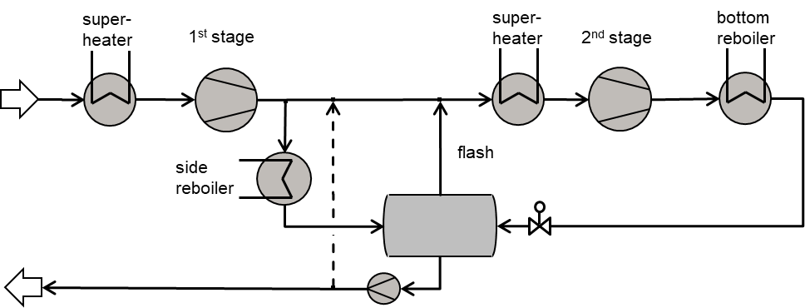

Figure 1: Two-stage compressor with intermediate flash recycle and potential de-superheating.

* + 1. Methanol-water separation

Shahandeh et al. (2015) describe a column in operation in a world-scale methanol plant with a capacity of 1 million t/y. The column has 85 trays, operates at 1.2 bar, and is fed with 4,968 kmol/h of a mixture of 69.81 mol-% methanol and 30.19 mol-% water and has a reboiler duty of 107.4 MW. The feed has a vapor fraction of 12 %. Fitting an ASPEN model using NRTL-RK method to plant data, Shahandeh et al. (2015) estimate a tray efficiency of 30 % and use this model for an extended investigation of five different vapor recompression and internally heat-integrated column schemes.

Energy optimization studies should always start with a near-optimum simple column (Rix et al., 2019). There is ample industrial evidence, that well-designed modern trays should reach efficiencies of 70% and higher in the methanol-water system (Yang et al., 2003). Consequently, a sensitivity analysis in ASPEN using 70 % efficiency and 85 trays shows an optimum feed location on tray 75, reducing the energy demand by more than 40 % to 60.3 MW, see Figure 2a).

A next obvious step to further decrease the energy demand is the design of a double-effect heat-integrated column system (Rix et al., 2019). This technology is well established in the Lurgi methanol process (Ott et al., 2012). The light-split reverse (LS-R) configuration (Figure 2b) is chosen. The first column T-20 operates at 1.2 bar, separates almost 60% of the MeOH as overhead product at low reflux ratio and feeds its water-enriched bottom product to the high-pressure column T-30. The pressure of T-30 is raised to 2.8 bar, shifting its condensation temperature to 9 K above the bottom boiling temperature of T-20. It has been shown that this configuration allows heat-integration with the lowest pressure difference between the two columns, thus achieving good thermodynamic efficiency while offering good controllability (Chiang and Luyben, 1988). The energy demand is 35.5 MW, more than 40% lower than the optimized simple column.

Electrification of this separation process is possible using vapor recompression, see Figure 2c. The overhead vapor is fed to a two-stage compressor, which increases its pressure so far, that its condensation temperature is sufficiently high to heat the reboiler. In the base case with a driving temperature difference of 8 K, the COP is 4.6 and the compression ratio of each stage is 2.5 resulting in a total compressor duty of 13.1 MW.

Introduction of the hot condensate flash and de-superheating at the intermediate pressure as shown in Figure 1 raises the COP to 5.0 and reduces compressor duty by 1 MW.

We will use this design as a base case and investigate further optimization options.

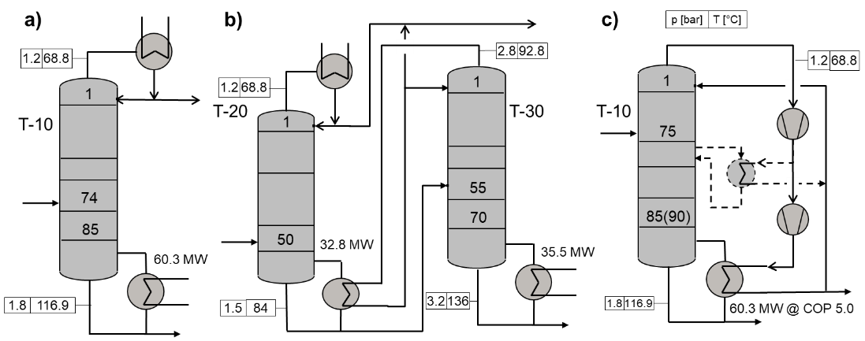

Figure 2: Flow schemes of a) simple column, b) heat-integrated LS-R system and c) vapor recompression with optional side reboiler (broken lines). Pressures and temperatures are given in boxes, relevant tray numbers in columns and heat duties near reboilers.

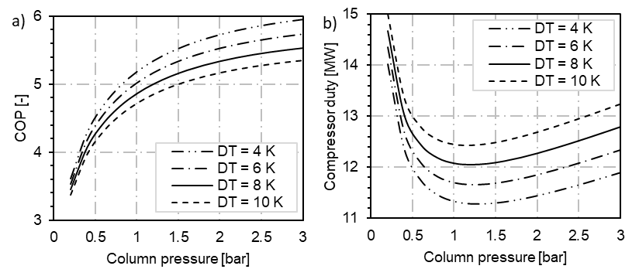

Figure 3:Impact of pressure on performance of VRC. a) Coefficient of performance (COP); b) Total compressor duty (both stages).

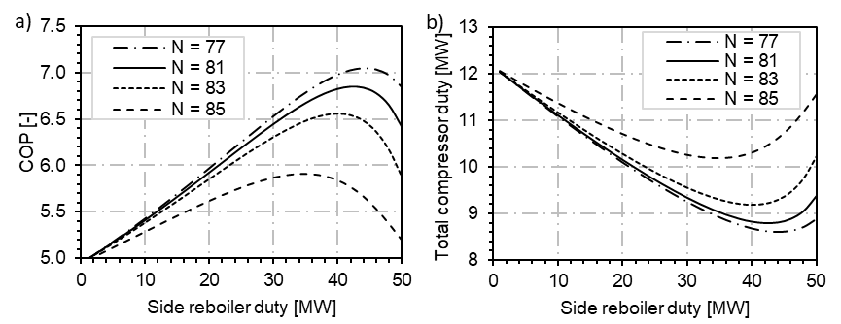

Figure 4:Impact of side reboiler location and duty on performance of VR. a) Coefficient of performance (COP); b) Total compressor duty (both stages).

Figure 3 shows results for a pressure variation at different driving temperature differences DT for heat transfer. Although the COP rises monotonously with pressure, there is a clear minimum of the compressor duty at a column pressure near 1.2 bar. These seemingly conflicting trends are due to the fact, that the separation becomes more difficult at higher pressures, and the energy demand of the reboiler increases. The required compression ratio, on the other hand, decreases, but not fast enough to compensate the first effect. At column pressures lower than ~1 bar, the suction side volumetric flowrate increases drastically, resulting in higher compressor duty. These results show that it is not sufficient to focus on performance indicators alone to judge the merits of design alternatives.

The benefit of introducing the side reboiler shown in broken lines in Figure 2c at different locations is shown in Figure 4. In the columns' stripping section, 5 trays have been added to compensate for changing operating lines (Soares Pinto et al., 2011), increasing the number of trays to 90. The driving temperature difference has been set to 8 K and all calculations have been performed at 1.2 bar.

The closer the side reboiler is located to the feed stage, the higher is its effectiveness. This is due to the distinctive temperature profile below the feed requiring a higher compression ratio in the first compressor stage. The total compressor duty decreases as more duty is shifted from the bottom to the side reboiler. As more methanol is evaporated in the side reboiler, however, the boiling temperature and thus the first stage compression ratio increases. For each side reboiler location, a clear optimum duty can be seen in Figure 4b. Locating the reboiler at stage 77, 2 trays below the feed, up to 45 MW (i.e., ~75 % of the total energy demand) can be supplied at lower temperature and pressure, thus reducing the compressor duty by almost 40 % from 12 to 8.6 MW. In this operating point, the COP rises from 5.0 to more than 7.0.

Using fossil-based emission factors of 0.2 and 0.366 2 t CO2/MWh (BAFA, 2023) for steam and electricity, the CO2-emissions of the three variants shown in -Figure 2 considering 8.600 operating hours/year are a) 103, b) 61 and c) 38 kt/y and are reduced to 27 kt/y using a side reboiler. VR enables the application of green electricity, which results in CO2-emissions close to zero. A column with vapor recompression designed according to the guidelines given above is currently under construction, enabling the first CO2-neutral Evonik process. CO2-savings of up to 30 kt/y are anticipated.

* + 1. Debutanizer column

As a further practical example, the debutanizer presented by Luyben (2013) is simulated in ASPEN Plus using the SRK method. The number of stages has been increased from 30 to 40 trays to reduce the basic energy consumption. Figure 5 shows results of a sensitivity analysis varying column pressure from 3 to 9 bar. For VR, there is a clear trend of COP decreasing with pressure, while compressor duty increases. At the optimum operating pressure of 3 bar, the top temperature is only 26 °C, foreclosing the use of cheap cooling media. However, this operating point is made accessible by VR, since the trim condensation can be completely shifted to the pressure side (Luyben, 2019). Increasing the temperature difference from 4 to 12 K increases the compressor duty by 15 to more than 30 %. This large effect clearly shows the strong incentive to employ column internals of low pressure drop and highly efficient heat exchangers in VR and HP systems.

The thick lines in Figure 5 show results for a two-stage HP system with intermediate flash using iso-pentane as the working fluid at 8 K driving temperature difference in both heat exchangers. For column pressures exceeding 4.5 bar, the COP of HP systems exceeds the one of VR systems at the same temperature difference. The strong decline of VR system performance with pressure is due to the fact, that the overhead vapor, a mixture of butanes, approaches its critical pressure more closely at condensation conditions. Consequently, the choice between VR or HP systems depends on the suitability of the thermodynamic properties of the overhead vapor as a good HP working fluid.

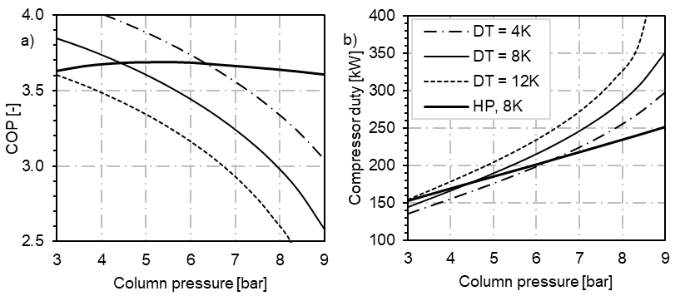

Figure 5: Performance of VR (thin lines) and HP (thick solid line) in the Debutanizer example. a) Coefficient Of Performance (COP), b) compressor duty. Driving temperature difference DT in the integrating heat exchangers as parametric variable.

* 1. Conclusions

VR and HP technologies are core elements on the path to net zero production in the process industries, increasing the effectiveness of the use of green electricity substituting fossil-based steam. Applying VR and HP to columns separating wide-boiling mixtures faces severe obstacles. To overcome these challenges, creative approaches combining pre-evaporators, side- and bottom reboilers using compressed vapors from intermediate stages of multi-stage compressors may substantially reduce the compressor duty.

VR and HP technologies have been successfully applied to two industrially relevant example columns separating wide-boiling mixtures. Energy optimization studies should start from a soundly designed simple column. Next, options to integrate available waste heat from the site should be considered. Once these low-cost options are exploited, it is time to tackle further optimization using VR and HP systems. To exploit their full potential, they should not be merely treated as an end-of-pipe addition to a pre-existing design. Instead, it is worthwhile to investigate the wider range of operating pressures now attainable. A large effect of driving temperature difference in the integrating reboiler / condenser has been observed. This clearly proves the strong incentive to employ column internals of low pressure drop and highly efficient heat exchangers. In VR and HP systems, internals and equipment design are much more interdependent than in simple columns. An inherent disadvantage of HP systems is, that they need to overcome two driving temperature differences. They should be considered, whenever the direct compression of the overhead vapor has serious drawbacks. These might be close approach to critical conditions at condensation, low suction side density (vacuum), corrosiveness or thermal instability. While challenging in their nature, wide-boiling systems may be successfully tackled using VR and HP systems.

References

BAFA 2023: Bundesamt für Wirtschaft und Energie: Informationsblatt CO2-Faktoren: https://www.bafa.de/DE/Energie/Energieeffizienz/Energieeffizienz_und_Prozesswaerme/Modul4_Energiebezogene_Optimierung/modul4_energiebezogene_optimierung_node.html (accessed December 2023)

T. Chiang, W. L. Luyben, 1988, Comparison of the dynamic performances of three heat-integrated distillation configurations, Ind. Eng. Chem. Res., 27, 99-104

A. K. Jana, 2014, Advances in heat pump assited distillation column: A review, Energy Conservation and Management, 77, 287-297

W.L. Luyben, 2013, Control of a train of distillation columns for the separation of natural gas liquid, Ind. Eng. Chem. Res., 52, 10741-10753

W.L. Luyben, 2019, High-pressure versus low-pressure auxiliary condensers in distillation vapor recompression, Computers Chem. Eng., 125, 427-433

J. Ott, V. Groenemann, F. Pontzen, E. Fiedler, G. Grossmann, D. Kersebohm, W. Weiss, C. Witte, 2012, Methanol, In: Ullmann’s Encyclopedia of industrial chemistry.

A. Rix, C. Hecht, N. Paul, J. Schallenberg, 2019, Design of heat-integrated columns: Industrial practice, Chem. Eng. Res. Dev., 147, 83-89

A. Rix, M. Schröder, N. Paul, 2023, Vapor recompression: An interesting option for vacuum columns?, Chem. Eng. Res. Dev., 191, 226-235

H. Shahandeh, M. Jafari, N. Kasiri, J. Ivakpour, 2015, Economic optimization of heat pump-assisted distillation columns in methanol-water separation, Energy, 80, February, 496-508

F. Soares Pinto, R. Zemp, M. Jobson, R. Smith, 2011, Thermodynamic optimisation of distillation columns, Chem. Eng. Science 66, 13, 2920-2934

N. S. Yang, K. T. Chuang A. Afacan, M. R. Resetarits, M. J. Binkley, 2003, Improving the efficiency and capacity of Methanol-Water distillation trays, Ind. Eng. Chem. Res., 42, 6601-6606