Design optimal experiments for parameter identification of a dynamic model with perturbed inputs

Ran Wang,a Antonio Armaou,a,b,c*Robert Rioux,a,d

aDepartment of Chemical Engineering, Pennsylvania State University, University Park, PA 16802, USA

bDepartment of Mechanical Engineering, Pennsylvania State University, University Park, PA 16802, USA

cDepartment of Chemical Engineering, University of Patras, Patras, 26504, Greece

dDepartment of Chemistry, Pennsylvania State University, University Park, PA 16802, USA

armaou@psu.edu

Abstract

An optimization approach for sensor placement and input sequences to improve parameter identifiability in spatiotemporally dependent experiments, modelled by partial differential equations, is developed. Robust design criteria using bilevel optimization are applied in the approach. The determinant (D-optimality), the smallest eigenvalue (E-optimality) or the inverse of condition value (modified E-optimality) of the Fisher information matrix are applied as criteria. A greedy algorithm is used in the optimization procedure to avoid extremely long calculation time. The developed approach is illustrated towards the identification of kinetic parameters in a transient axial dispersion reactor model with perturbed inlets. Improvement of the parameter identifiability for the model is investigated fitting synthetic data generated by high-fidelity simulations with preset kinetic parameters. The performance of the three objective functions is also compared.

**Keywords**: parameter identification, robust design, perturbed inputs.

* 1. Introduction

To adequately model chemical processes using first principles, experimental observations or their combination, we often need to consider both the spatial and temporal codependencies of the desired variables (such as species concentrations, temperature, etc.). Parameters in the time and space-varying partial differential equations (PDEs) of the resultant dynamic model can be more accurately identified using measured time-varying output profiles (observations) under persistently perturbed inputs. (Narendra and Annaswamy, 1987) In such cases, the locations of sensors for data collection and the time distribution of the perturbed inputs are important for parameter identifiability. (Uciński and Patan, 2007) Model-based design of experiments (MBDoE) is widely used to maximize the information potential from the collected data. Optimization criteria based on information are widely applied in MBDoE for accurate parameter identification. (Franceschini and Macchietto, 2008) Initial model parameters may have a strong effect on the performance of MBDoE if objective functions are directly optimized in the criteria. However, little information is usually provided for the initial parameters. This effect of the initial parameters can be mitigated using a robust design criterion, which has been applied in lumped parameter system. (Asprey and Macchietto, 2002)

In this study, a robust design procedure for optimization of sensor location and perturbed input to improve parameter identifiability of appropriate models for distributed parameter systems is proposed. The sensor location and the input sequence leading to a maximum of the objective function for the worst set of parameters are regarded as the optimal design, which aims to maintain acceptable parameter identification accuracy in a wide range of the model parameters. Different optimality criteria are compared in the study. The procedure is tested in transient kinetic study cases with pseudo-random binary sequence (PRBS) perturbations at the reactor inlet. The parameter identifiability is investigated using synthetic data.

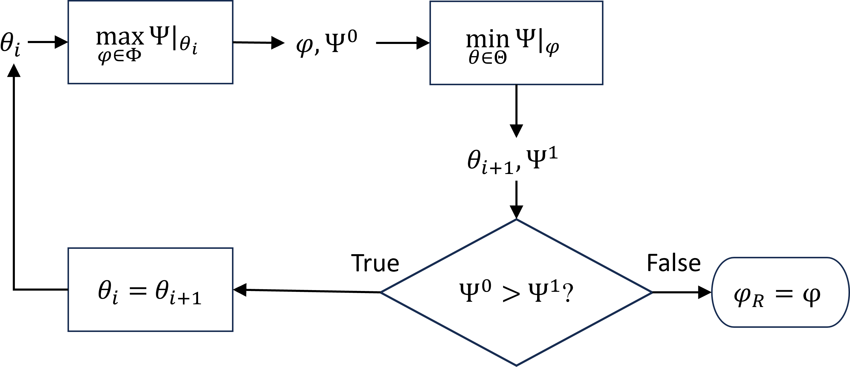

**Figure 1** Schematic of robust design method for accurate parameter identification.

* 1. Method
     1. Design of experiments for parameter identifiability

The sensor location, *xs*, or the perturbed input at the boundary condition, *uin*(*t*), are optimized by a robust design procedure using a max-min criterion on the Fisher information matrix (FIM) as shown in Eq 1. (Asprey and Macchietto, 2002). The optimized experimental conditions from robust design, *φR*, are optimized through searching the experimental conditions, *φ*, which maximize the objective function, *Ψ*, at worst set of model parameters, *θ*. The determinant, the smallest eigen value and the inverse of 2-norm condition number of FIM are used as objective functions, *Ψ*, for a D-optimality, an E-optimality and a modified E-optimality design (Balsa-Canto et al., 2008), respectively. The FIM is determined by Eq. 2, where *y* is the observation of the experiment and W is its diagonal weight matrix. Though a better design may be obtained using Newton-based and global search algorithms, a greedy algorithm (Asprey and Macchietto, 2002) demonstrated in Figure 1 is applied to avoid significantly longer time to identify the global optimal solution of the problem for the bilevel optimization problem. In the algorithm, the experimental condition, *φ*, is first optimized for the maximal objective function value at certain model parameters, *θi*. Then, model parameters for the smallest objective function value are searched at the optimized experimental condition, *φi*. If the objective function value decreases between the two steps, the iteration continues. Otherwise, the optimized experimental condition is regarded as the result of the robust design. The determinant of FIM may be extremely large or small if there are too many observation points. Therefore, the natural logarithm of the determinant is used as the objective function. An upper limit of 1000 and a lower limit of -1000 are set to the objective function to avoid the occurrence of infinite value. The interior-point method in function fmincon of MatLab is used to solve the optimization in each iteration.

|  |  |
| --- | --- |
|  | (1) |
|  | | (2) |

* + 1. Investigation of practical parameter identifiability of the model

The practical identifiability of the model parameters is investigated using synthetic data as shown in Figure 2. The synthetic data is generated by high-fidelity simulations with preset parameters, where white Gaussian noise with a signal to noise ratio (SNR) of 35dB is added to emulate real experiments. Then, the same model (denoted as *M* in Fig.2) will be used to fit these synthetic data and derive fitted parameter values and their 95% confidence intervals. If the deviation between fitted and preset parameters’ values is small and the corresponding confidence interval is narrow, the parameter is practically identifiable. To quantitively evaluate the deviation and the confidence interval respectively, we propose two criteria, $E_{1}=\left|\log_{10}{\frac{θ_{f}}{θ_{s}}}\right|$, and $E_{2}=\frac{δ}{θ_{f}}$, where *θf* denotes the fitted model parameter, *θs* is the preset parameter, and *δ* represents the half width of the confidence interval. Therefore, if values of both *E*1 and *E*2 are small, parameters are practically identifiable. Conversely, if *E*1 or *E*2 is large, parameters are unidentifiable. In the following test case, parameters are regarded as accurately identified if *E*1<0.12 and *E*2<0.25.

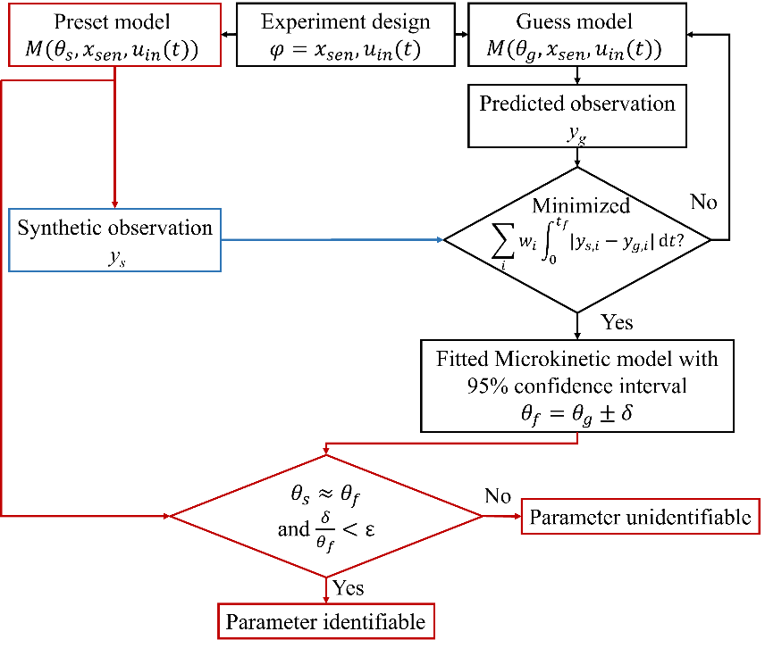

**Figure 2** Schematic of investigation procedure for practical identifiability of parameters.

* 1. Results

**Figure 3** Schematic of emulated experimental apparatus for synthetic transient kinetic study.

* + 1. Transient kinetic study case for test of the robust design

The proposed MBDoE and parameter identifiability investigation procedures are tested in a transient kinetic study for general reaction $2\text{A+}{\text{B}}_{2}⇌2\text{AB}$, where two reactants are simultaneously pulsed into the reactor under a molar ratio of 2 for A and B2 with PRBS perturbation as demonstrated in Figure 3. Inert gas is constantly fed intro the reactor. Other operation conditions are summarized in Table 1. Kinetic constants, *k*, and total concentration of active sites, *Ct*, are estimated using the objective function of sum of squared errors of concentration profiles as shown in Eq. 3; *Cs* and *Cg* denote the synthetic time-varying concentration profiles at the sensor location generated by preset parameters and corresponding estimated profiles. The total number for observation points in the time-varying concentration profiles, *nt*, is set as 1001. An isothermal axial dispersion model assuming ideal gas is used for the reactor model (Yang et al., 2018). Material balance equations are shown as Eq. 4 to Eq. 6, where *C* represents concentration, *t* denotes time, *x* is axial coordinate. The superficial velocity in the gas phase is calculated according to mass balance of an inert component. The surface reaction rate, *rsurf*, is calculated by microkinetic model as shown in Table 2. The kinetic constants’ values are constrained by the thermodynamic equilibrium of overall reaction. The axial dispersion coefficient, *DL*, is calculated by Ruthven's (1984) correlation, and diffusion coefficient are estimated by Fairbanks and Wilke's (1950) equation.

**Table 1** Operating conditions for kinetic study

|  |  |
| --- | --- |
| Operation conditions | Value |
| Pulsing gas flow rate, *QP* | 10 mL/min |
| Carrier gas flow rate, *Qc* | 100 mL/min |
| Temperature, *T* | 423.15 K |
| Total Pressure, *PT* | 1.06 atm |
| Length of packed bed, *Lb* | 10 mm |
| Inner diameter of reactor, *Di* | 3.9 mm |
| Bed void fraction, *ε* | 0.57 |
| Mass of packed catalyst, *mc* | 67 mg |
| Diameter of catalyst, *dp* | 0.1 mm |
| Concentration of total active sites, *Ct* | 0.4mol/kg |

**Table 2** Microkinetic model of surface reactions and preset values for synthetic study

|  |  |  |  |  |
| --- | --- | --- | --- | --- |
| Step | Elementary steps | Kinetic equations | Preset values |  |
| S1 | $$\text{A+*}⇌\text{A*}$$ | $$r_{1}=k_{1}P_{A}θ_{v}-k_{-1}θ_{A}$$ | $$r_{1}=1.75×10^{-4}P_{A}θ_{v}-0.5θ_{A}$$ |  |
| S2 |  |  |  |  |
| S3 |  |  |  |  |
| S4 |  |  | a |  |
| S5 |  |  |  |  |

ahere, ,where *Kr* is the equilibrium factor for overall reaction.

|  |  |  |
| --- | --- | --- |
| $$\min{f}=\sum_{i}{\sum_{j}^{n_{t}}{\frac{{C_{max,{a}ll}}^{2}}{{C_{max,{i}}}^{2}}}}(C_{s,i,j}-C_{g,i,j})^{2}+\frac{{C_{max,{a}ll}}^{2}}{{C_{max,{i}}}^{2}}(C_{s,i,j+1}-C_{s,i,j}-(C_{g,i,j+1}-C_{g,i,j}))^{2}$$ $$C_{max,{i}}=\max{(}C_{s,i});C_{max,{a}ll}=\max\left(\max\left(C_{s,i}\right)\right);i=\text{A,AB,}{\text{B}}_{2}$$ | (3) |  |
| $$\frac{∂C_{i}}{∂t}=D_{L,i}\frac{∂^{2}C_{i}}{∂x^{2}}-\frac{1}{ε}\frac{∂u_{S}C_{i}}{∂x}-\frac{1}{ε}r_{surf}(k,C_{i},θ_{m});i=\text{A,AB,}{\text{B}}_{2};m=\text{A,AB,}{\text{B}}_{2},B$$ | (4) |
| $$\frac{∂θ_{m}}{∂t}=\frac{r_{surf}(k,T,C_{i},θ_{m})}{C_{t}}$$ | (5) |
| $$C_{i}\left(x,0\right)=0,x≠0;θ_{m}\left(x,0\right)=0; C_{i}\left(0,t\right)=u_{in,i}\left(t\right), \frac{∂C_{i}}{∂x}(L_{b},t)=0$$ | (6) |

All the model parameters’ values are in SI units. The PDEs are discretised in space using the method of lines in the form of the second order upwind scheme into 101 points. Function lsqnonlin and ode23tb in MatLab are used for fitting and solving the ordinary differential equations derived from the discretization.

* + 1. Practical identifiability improvements of different optimality

Practical identifiability improvements of robust designs are tested in cases when optimizing sensor locations alone or together with input perturbations. For input perturbations, there are assumed to be totally 8 pulses. Therefore, the time interval of each pulse in a PRBS perturbation can be optimized for robust design. The initial guess position of sensor for MBDoE is at *xs*=0.07*Lb*. Then, 16 time intervals for 8 pulses are randomly generated, creating a perturbation at the reactor inlet and result in the collection of concentration profiles by the sensor in Figure 4. When perturbations are being optimized, these generated time intervals also perform as initial guesses for robust design. An optimized density function for the PRBS perturbation will be derived in the design.

**Figure 4** Perturbations at the reactor inlet (a) and corresponding synthetic outlet concentration profiles (b) collected by sensor at *x*=0.07*Lb*

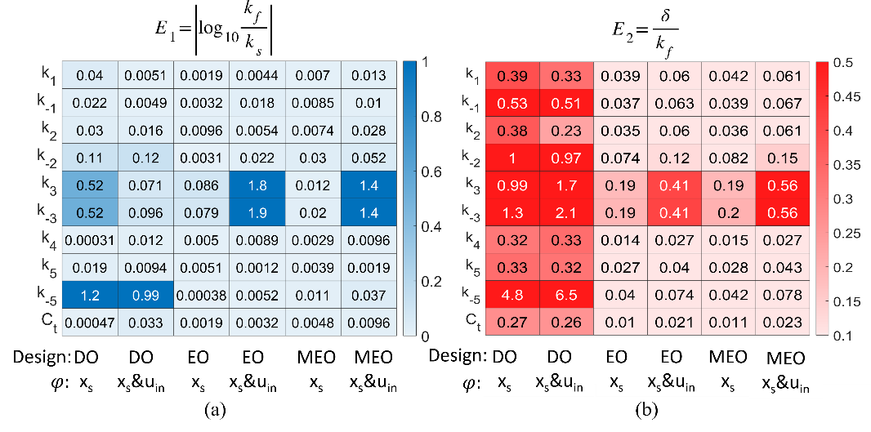

**Figure 5** Heat maps for (a) deviations between preset and estimated parameters’ values and (b) ratio of half width of 95% confidence intervals and corresponding estimated parameters in different robust designs.

The Investigation for practical parameter identifiability is summarised in Figure 5. When the D-optimality is applied, the derived optimal time intervals and sensor location are at the initial value because the calculated objective function is easy to reach the set lower limit. However, almost all the model parameters are not identifiable according to *E*2 values in Figure 5(b). When sensor location alone is optimized, the result *xs* is 0.955*Lb* for E-optimality, and 0.885*Lb* for modified E-optimality. All the parameters are practically identifiable in these two cases. The E-optimality criterion will provide the experimental conditions for more accurate parameter identification owing to narrower confidence intervals as shown in Figure 5(b).

When time intervals of perturbations are optimized together with sensor location, their optimal values are close to the initial guesses though they are not exactly the same. Therefore, the shape of the perturbation will not change too much from the initial guess. The optimized sensor locations change to 0.517*Lb* for E-optimality and 0.500*Lb* for modified E-optimality. Parameter *k*3 and *k*-3 are no longer identifiable in these cases. However, other parameters are still accurately identified. The greedy algorithm still provides proper designs for parameter identification though it does not reach the global optimal solution. The E-optimality still perform little better than the modified E-optimality. Therefore, E-optimality is the most proper criterion in our given case. A proper design for parameter identification can be selected after comparing the results of the three optimality criteria via the use of synthetic data.

* 1. Conclusions

Robust design procedures to improve parameter identifiability of spatially varying processes modelled by PDEs by optimizing sensor locations and perturbed inputs under different optimality criteria are developed and compared with each other. The practical parameter identifiability is investigated using synthetic data. The proposed procedures are tested in transient kinetic studies with PRBS perturbation at the reactor inlet. In this study, E-optimality and modified E-optimality criteria can provide improved experimental conditions for accurate parameter identification when the sensor location is optimized alone or together with the input sequence. Furthermore, the use of E-optimality criteria results a minor performance enhancement compared to modified E-optimality.

Acknowledge

The authors are grateful for the support from National Science Foundation (Grant #2053826) and the University of Patras, Medicus program (No. 81816).

References

Asprey, S.P., Macchietto, S., 2002. Designing robust optimal dynamic experiments. J. of Process Control 12, 545-556.

Balsa-Canto, E., Alonso, A.A., Banga, J.R., 2008. Computing optimal dynamic experiments for model calibration in predictive microbiology. J. Food Process Eng. 31, 186-206.

Fairbanks, D., Wilke, C., 1950. Diffusion coefficients in multicomponent gas mixtures. Ind. & Eng. Chem. 42, 471-475.

Franceschini, G., Macchietto, S., 2008. Model-based design of experiments for parameter precision: State of the art. Chem. Eng. Sci. 63, 4846-4872.

Narendra, K.S., Annaswamy, A.M., 1987. Persistent excitation in adaptive systems. Int. J. Control 45, 127-160.

Ruthven, D.M., 1984. Principles of adsorption and adsorption processes. Wiley.

Uciński, D., Patan, M., 2007. D-optimal design of a monitoring network for parameter estimation of distributed systems. J. Global Optim. 39, 291-322.

Yang, M., Wang, L., Kamali Shahri, S.M., Rioux, R.M., Armaou, A., 2018. Investigation of CO2 Sorption Mechanisms in Isothermal Columns via Transient Material and Energy Balance PDE Models. Ind. Eng. Chem. Res. 57, 10303-10314.