Digital Twin Technology In The Thermal Processing Industry Of Granular Material Based On The Extended Discrete Element Method (XDEM)

Bernhard Petersa, Prasad Adhava, Daniel Louwa, Navid Aminniaa, Xavier Besserona

University of Luxembourg,

bernhard.peters@uni.lu

Abstract

Granular material is ubiquitous in our day-to-day environment and is dealt with in a variety of industries such as mineral, pharmaceutical, chemical, agriculture, biochemical and food to name a few. Apart from the storage and transport of granular material, it requires often thermal treatment in conjunction with a chemical conversion. Already the dynamics of granular material are complex, and the thermal conversion of particulate material in contact with a fluid phase poses an additional level of complexity. Being aware of the fundamental mechanisms and the interactions is a key factor for producing the optimal process and product. An understanding is effectively accomplished via research on a particle scale for which the Extended Discrete Element Method (XDEM) is a perfectly suited simulation platform. It evaluates the dynamic and thermodynamic state of individual particles of granular matter being processed. Each particle exchanges momentum, mass and heat with the surrounding fluid for which the state is predicted with Computational Fluid Dynamics (CFD). In order to achieve utmost flexibility, particles are assigned specific material properties and a variety of processes may be attached to a particle covering heat-up, arbitrary chemical reactions or reaction mechanisms and phase changes e.g. drying coating or melting. Innovative and fast algorithms that are enhanced with a hybrid parallelisation strategy based on OpenMP and MPI reach industrial scales. Thus, applications are feasible on medium-sized workstations but also on high-performance computers within reasonable computational times.

**Keywords**: particulate matter, thermal processing, CFD-XDEM coupling, digital twin

* 1. Introduction

Numerous engineering challenges in processing industry, agriculture and food industry, pharmaceutical industry, construction, raw material processing and renewable energies to name a few involve a particulate phase with its thermo- dynamics and a fluid phase. Some predominant examples are the production or processing of sand, coal, fertilizer, corn, coffee, nuts, renewable fuels e.g. biomass. Simulating such industrial processes with computers allows for optimising the design of factories, production units, waste management plants, etc. and are therefore of strategic interest. Indeed, these impacts, for example, the quality of the products, the energy, the efficiency and the time required to produce and process them or the amount of waste generated. However, as stated above, such simulation involves multi-physics phenomena (particle mechanics and thermo-dynamics, fluid dynamics structural analysis). Although they can be treated by pure continuous approaches such as multi-phase flows, current computer resources and recent advances in research by Krause et al. (2017); Mahmoudi et al. (2016); Mohseni et al. (2019); Pozzetti et al. (2018); Pozzetti and Peters (2017); Peters and Pozzetti (2017) allow now describing the particulate phase by a discrete method and thus, provide a deeper insight into the underlying physics. Hence, it is now conceivable that each part of the multi-physics simulation is performed by the most suited approach, executed concurrently and then coupled. It follows almost naturally an evolution in design tools: starting from computer-aided design (CAD) and engineering (CAE) in the beginnings and boosting virtual reality (VR) to the next level of sophistication of virtual prototyping as depicted in Figure 1. Adding the multi-physics aspect to virtual prototyping creates a digital twin for smart virtual prototyping as the final target in Figure 1.

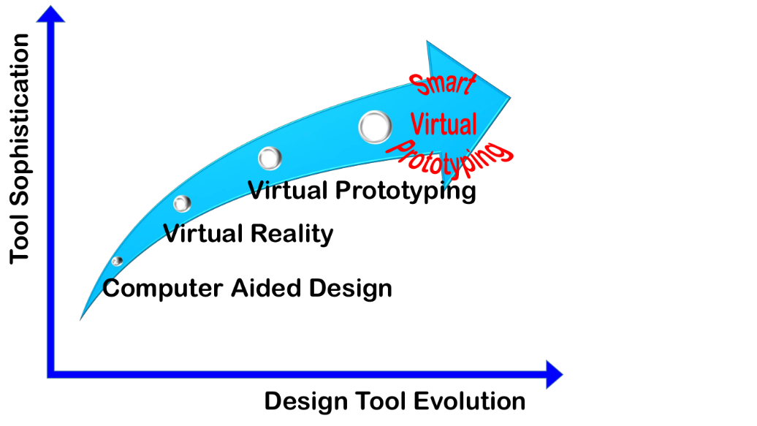

Figure 1: Evolution of design tools to reach smart virtual prototyping

In addition to engineering requirements, societal needs demand digital twin technology i.e. virtual prototyping that allows a shift from current empirical- based practice to an advanced multi-physics simulation technology. Often, engineers opt for "copy & paste technology" of already proven components and systems from previous generations. It results in a conservative design with little potential for innovative ideas. These limitations are removed by virtual prototyping that is among "Gartner's Top 10 Strategic Technology Trends for 2017" as stated by Gartner. While already single-physics software platforms for computational fluid dynamics (CFD) as mentioned by Phuc et al. (2016) and discrete element method (DEM) including thermodynamics of the particulate phase, referred to as extended discrete element method (XDEM) summarised by Peters et al. (2018) exist, an integrating framework for executing discrete and continuous single-physics modules in a highly scalable parallel mode does not exist. A deployment of a highly performing multi-physics framework is hindered by the fact that a simple coupling of two or more parallelised modules ends in a sequential application because data between individual modules is not exchanged. Rather than developing an "all-in-one" multi-physics software platform within a single code, a coupling of "best-of-the-class" single-physics software modules in a multi-physics coupling framework for engineering applications is preferred. Consequently, the modules of the XDEM software consist of a DEM module for the motion of particles and a thermodynamic module for the thermodynamic state of particles, OpenFOAM describing fluid dynamics, and Calculix representing the structural analysis. This methodology paves the path towards virtual prototyping that comprises a particulate phase in contact with a fluid phase and walls. It closes a technological gap and has the potential to revolutionise design and operation of plants and factories impacting heavily on society.

* 1. Simulation Platform

As above-mentioned, the methodology relies on a seamless integration of "best-of-the-class" software modules into a framework that allows a smooth interaction between the individual packages as depicted in Figure 2. Currently, the advanced multi-physics simulation platform (AMST) couples the discrete element method (DEM) to describe motion of a granular media, finite element analysis (FEM) for structural analysis, extended discrete element method (XDEM) representing the thermodynamic state of particles and computational fluid dynamics (CFD) evaluating the fluid-/thermodynamics of a single or multi-phase flow. This coupling concept has ultimate flexibility because it is easily extendible by additional modules e.g. electromagnetics and existing modules are simply replaced by alternative modules for fitting the requirements to a better degree. Each of the modules is equipped with an interface to the remaining modules of the simulation platform so that a correct exchange of relevant data between all modules is provided. In general, the data is exchanged in a bi-directional way which ensures a full two-way coupling between each of the two modules leading to an 8-way coupling for all modules in Figure 2 involved. However, a one-way coupling or less interactions between modules may also be applicable under certain conditions if the effect of one module on the other is negligible or even non-existent.

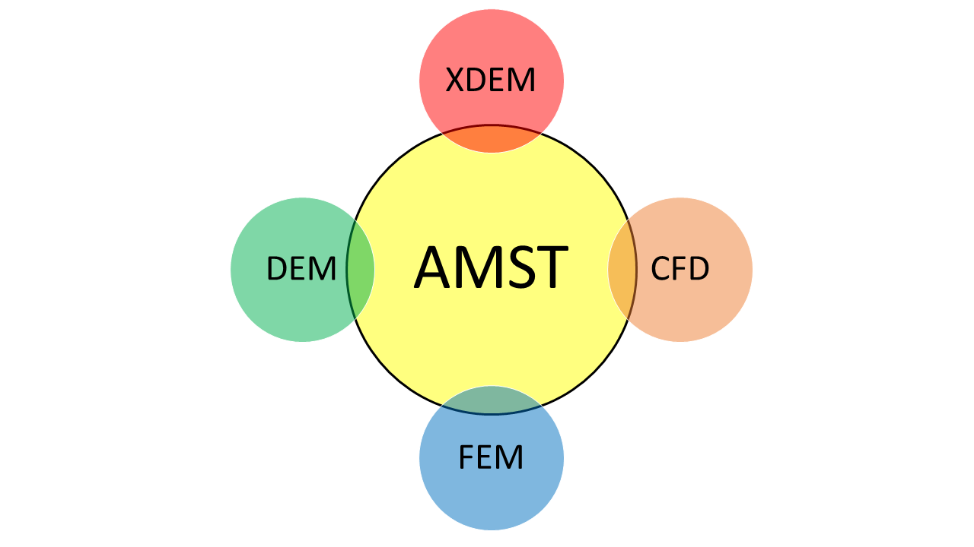

Figure 2: A framework for integrating "best-of-the-class" software modules to from the advanced multi-physics simu-lation technology (AMST).

* 1. Results and Discussion

The versatility of the multi-physics simulation platform is represented by a variety of application addressing material processing in a blast furnaces, combustion of biomass, a tool analysis of an abrasive water cutting nozzle and additive manufacturing.

For blast furnace operation as shown for the cohesive zone in Figure 3, a hot blast enters the reactor through the tuyeres where it burns coke to produce energy for heating the incoming ore and coke and to form carbon monoxide as a reducing agent for the iron bearing particles. The carbon monoxide enriched blast flows upward through the packed bed indicated by the velocity vectors in the Figure 3. The reduction process of iron oxides namely, hematite, magnetite and wustite is described by reversible reactions including a forward and backward reaction rate. Thermodynamic equilibrium for the magnitude of forward and backward reaction rates being equal depends on the temperature and gas composition. Carbon monoxide is formed as a product of the reduction that is transferred into the gas phase. It will be in contact with the next upper coke layer where the Boudouard reaction (C + CO2 ↔ 2 CO) generates carbon monoxide. It flows into the upper ore layer where it is available to continue the reduction process. This mechanism repeats itself over the alternating ore and coke layers, however, with decreasing intensity due to falling temperatures. After iron oxides are reduced by carbon monoxide and the particle temperature reaches the melting temperature, iron melts and forms a liquid phase on the particle surface. These particles appear in the Figure 3 as ore layers of which the position coincides with the mass source of liquid iron. The particle size is reduced for better visualisation. The liquid material is transferred into the respective phase of the multi-phase Euler solver, for which it appears as a source term in the relevant conservation equation. These mass sources are shown as an iso-surface on which the gas temperature is projected. It varies over the cohesive zone by app. 900 K indicating that the gas temperature is not suited to identify the location of the cohesive zone by continuum approaches e.g. two-fluid model.

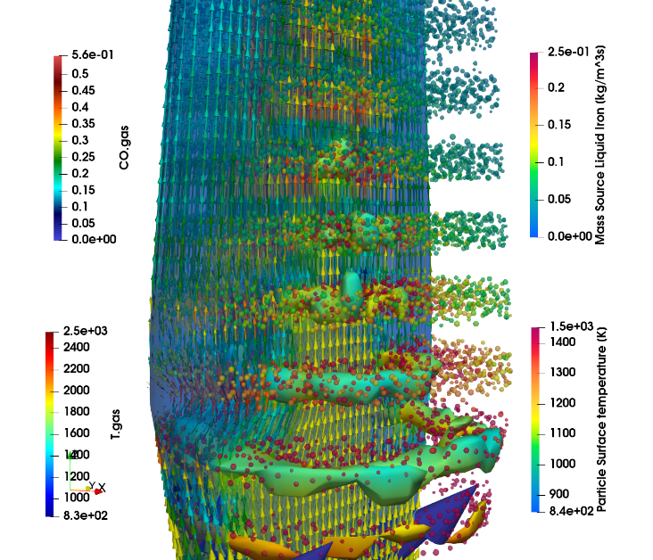

Figure 3: Formation and shape of the cohesive zone

Heated up by radiation, depicted by the temperature distribution in Figure 4, the pellets for biomass combustion undergo drying, pyro-lysis and gasification along distinct regions of the grate. The gaseous products of pyrolysis i.e. methane, carbon monoxide, carbon dioxide, hydrogen and vapour are transferred into the gas phase shown in Figure 4 as the distribution of tar and are transported towards the boiler indicated by the streamlines coloured by temperature. These products burn under the influence of secondary air and flue gas injection to form carbon dioxide and vapour. Char as a solid product of pyrolysis burns with primary air by a heterogeneous reaction until ash leaves the furnace.

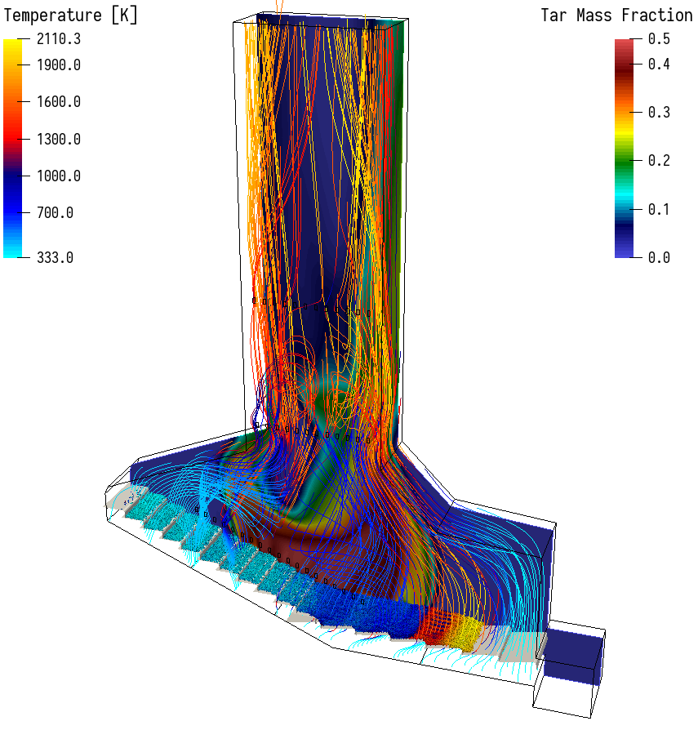

Figure 4: Distribution of tar, gas and particle temperature in a biomass furnace. Wood pellets enter the furnace and move over the forward acting grate.

An extended and complex 6-way-coupling in shown in Figure 5 for an abrasive water jet cutting nozzle. Sand particles entering the mixing chamber are accelerated by a water jet of app. 200 m/s. A multi-phase mixture consisting of air, water and particle streams through the focussing tube and interacts heavily with the inner wall of the housing. The solid structure is excited by these impacts and deforms which is shown as displacements.

The fitness and capabilities of the XDEM platform is underlined by applying it for additive manufacturing in Industry 4.0 as depicted in Figure 6, for which a high-energy laser beam scans over a layer of metal power and, thus, melting it for fusion with the solid build part. It allows investigating into the operation parameters such as laser power, speed, hatch size and powder properties and layer preparation.

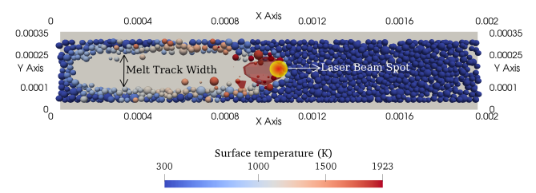

Figure 6: Formation of a melt pool through melting of powder by a laser beam

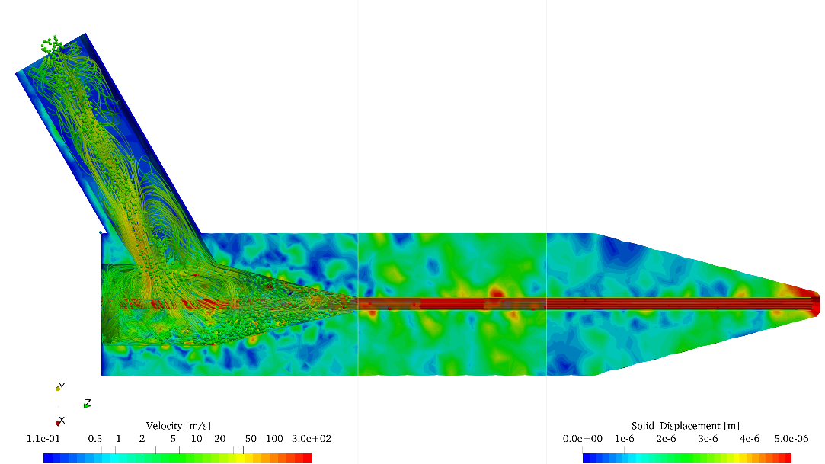

Figure 5: Performance of an abrasive water cutting nozzle obtained from a 6-way momentum coupling between fluid (CFD), particles (DEM) and nozzle housing (FEM).

Rather than resolving the flow around particles and inside the interstitial space as done by Saraei and Peters et al. (2023), which requires enormous computational resources already for small computational domains, the current approach applies space-averaging to estimate relevant fluid dynamics variables. Consequently, transfer for heat, mass and momentum is estimated by well known correlations such as Nusselt or Schmidt numbers that has proven to be sufficiently accurate in numerous applications.

* 1. Conclusions

The current contribution addresses a flexible technology to build an advanced multi-physics simulation platform (AMST) by integrating "best-of-the-class" software modules into a coupled simulation framework. This technology allows for an extension depending on the multi-physics requirements and for easy replacement of one or more individual modules for a better representation of the physics in question. Results presented provide a deep insight into the underlying physics and their interactions that lead to thorough understanding of the process. Applying advanced and innovative partitioning algorithms allows for moderate computational resources so that the technology is readily applicable without super-computing frameworks.

* 1. References

Edoardo Copertaro, Paolo Chiariotti, Alvaro Antonio Estupinan Donoso, Nicola Paone, Bernhard Peters, and Gian Marco Revel. XDEM for Tuning Lumped Models of Thermochemical Processes Involving Materials in the Powder State. Engineering Journal, 20:187-201, 2016. ISSN 01258281. doi: 10.4186/ej.2016.20.5.187.

Gartner. Top 10 Strategic Technology Trends for 2017. https://www.gartner.com/newsroom/id/3482617. Accessed: 2018-02.

Bastian Krause, Birk Liedmann, Jens Wiese, Patrick Bucher, Siegmar Wirtz, Hannes Piringer, and Viktor Scherer. 3D-DEM-CFD simulation of heat and mass transfer, gas combustion and calcination in an intermittent operating lime shaft kiln. International Journal of Thermal Sciences, 2017. ISSN 1290-0729. doi: https://doi.org/10.1016/j.ijthermalsci.2017.03.017.

Shibo Kuang, Zhaoyang Li, and Aibing Yu. Review on modelling and simulation of blast furnace. Steel research international, 89(1):1700071n/a, 2018. ISSN 1611-3683.

A. H. Mahmoudi, X. Besseron, F. Hoffmann, M. Markovic, and B. Peters. Modelling of the biomass combustion on a forward acting grate using XDEM. Chemical Engineering Science, 142:32-41, 2016. doi: 10.1016/j.ces.2015.11.015.

Mohammad Mohseni, Alex Kolomijtschuk, Bernhard Peters, and Marc Demoulling. Biomass drying in a vibrating fluidized bed dryer with a Lagrangian-Eulerian approach. International Journal of Thermal Sciences, 138:219-234, 2019. ISSN 1290-0729. doi: https://doi.org/10.1016/j.ijthermalsci.2018.12.038. URL http://www.sciencedirect.com/science/article/pii/S1290072917314011.

B. Peters and G. Pozzetti. Flow characteristics of metallic powder grains for additive manufacturing. EPJ Web of Conferences, 13001:140, 2017. URL http://hdl.handle.net/10993/31734.

Bernhard Peters, Maryam Baniasadi, Mehdi Baniasadi, Xavier Besseron, Al- varo Estupinan Donoso, Mohammad Mohseni, and Gabriele Pozzetti. XDEM multi-physics and multi-scale simulation technology: Review of DEM-CFD coupling, methodology and engineering applications. Particuology, 2018. ISSN 1674-2001. doi: https://doi.org/10.1016/j.partic.2018.04.005. URL http://www.sciencedirect.com/science/article/pii/S1674200118301706.

Pham Van Phuc, Shuichi Chiba, and Kazuo Minami. Large scale transient CFD simulations for buildings using OpenFOAM on a world's top-class supercomputer. In 4th OpenFOAM User Conference 2016, 2016.

G. Pozzetti and B. Peters. Evaluating erosion patterns in an abrasive water jet cutting nozzle using XDEM. Advances in Powder Metallurgy & Particulate Materials, pages 191-205, 2017. URL http://hdl.handle.net/10993/31360.

G. Pozzetti, X. Besseron, A. Rousset, and B. Peters. A parallel multiscale DEM-VOF method for large-scale simulations of three-phase flows. Proceedings of ECCM-ECFD 2018, 2018. URL <http://hdl.handle.net/10993/35831>.

Sina Hassanzadeh Saraei and Bernhard Peters. Immersed boundary method for considering lubrication effects in the CFD-DEM simulations. Powder Technology, page 118603, 2023.