Pioneer Options for Sustainable Energy Storage: A Comparative Study of 25 Alternatives Using Data Envelopment Analysis

Fatemeh Rostami, Richard Cabrera, Laureano Jiménez, Carlos Pozo*

Departament d’Enginyeria Quimica, Universitat Rovira i Virgili, Av. Països Catalans 26, 43007 Tarragona, Spain

*corresponding author: [carlos.pozo@urv.cat](mailto:carlos.pozo@urv.cat)

Abstract

This work examines 25 energy storage alternatives, categorized into medium and long-term options. We evaluate their sustainability level considering economic, environmental, and social aspects, including crucial indicators, such as the levelized cost of energy, energy and water usage, global warming potential, and employment opportunities. We employ Data Envelopment Analysis to rank these options based on their efficiency score. Among medium-term options, nickel-cadmium battery stands out as the most efficient choice, while in the long-term options, green hydrogen and green ammonia, powered by renewable sources, take the lead. The study provides improvement targets for alternatives deemed inefficient. The results offer valuable guidance for policymakers and energy planners seeking the most promising options for energy storage.

**Keywords**: Data Envelopment Analysis, Energy Storage, Grid Flexibility, Sustainability.

* 1. Introduction

Historically, electricity, an essential part of modern lifestyle, came from reliable grids relying on dispatchable sources like fossil fuels and nuclear energy. However, increasing environmental awareness has shifted the focus to cleaner yet intermittent and unpredictable energy sources, such as solar and wind, which challenge grid stability if extensively used. Energy storage offers a promising solution to bridge the gap between intermittent renewables and energy demand.

Energy storage technologies convert, store, and release electricity, boosting grid efficiency and reliability. These technologies differ in function, duration, and stored energy form, with “*no one-option-fits-all need*”. These technologies need to meet economic, environmental, and technical criteria to foster their development.

Several studies have assessed energy storage technologies, focusing solely on economic, technical, or environmental aspects. For example, some studies examined life cycle costs, highlighting the impact of power conversion components (Zakeri and Syri, 2015). Others evaluated storage technologies based on energy density, cycle efficiency, and lifetime (Akram et al., 2020), while the rest shifted the attention to environmental concerns through a life cycle assessment approach (Fernandez-Marchante et al., 2020).

This contribution aims to comprehensively evaluate a range of energy storage alternatives considering all the economic, environmental, and social dimensions. We employ Data Envelopment Analysis (DEA) to combine these dimensions and report a single efficiency score. To do so, we first categorize storage alternatives as medium-term and long-term options and then fairly compare them in separate analyses. The findings identify preferred options within each category and present improvement targets for the less efficient ones.

* 1. Methodology

Initially, we categorize energy storage options into medium-term and long-term groups, as detailed in Table 1.

Table 1. Energy storage alternatives and their classifications.

|  |  |  |  |
| --- | --- | --- | --- |
| Medium-term | | Long-term | |
| Alternatives | Symbol | Alternatives | Alternatives |
| Lead acid | LA | H2, Hydropowergr  H2, Solargr  H2, Windgr  NH3, Hydropowergr  NH3, Solargr  NH3, Windgr |
| Lithium-ion | Li-ion |
| Lithium iron phosphate | LiFePh | H2, CG4, g  H2, Grid mixg  H2, SMR4, g  H2, WSCL3, g  H2, CG-CCS2, 4, g  NH3, Grid mixg  NH3, SMR4, g |
| Lithium nickel manganese cobalt | LiNiMnCo |
| Nickel-cadmium | NiCd |
| Sodium nickel chloride | NaNiCl |
| Sodium sulphide | NaS | H2, SMR-CCS1, 2, b  NH3, SMR-CCS1, 2, b  NH3, WSCL3, b |
| Vanadium redox flow battery | VRFB |
| Zinc bromine flow battery | ZBFB |

1: Steam methane reforming, 2: Carbon capture and storage, 3: Water splitting by chemical looping, 4: Coal gasification.

gr: Green, the used energy source is from renewable energies, b: Blue, the used energy source is from fossil fuels combined with carbon capture and storage, g: Grey, the energy source is from fossil fuels (or the grid, sometimes referred to as yellow).

We then employ DEA to assess the sustainability performance of energy storage alternatives. DEA is a linear programming method that helps evaluate the relative efficiency of a set of so-called Decision-Making Units (DMUs) by comparing their ability to convert inputs into outputs. It assigns an efficiency score to each DMU: higher efficiency achieves when more outputs are generated with fewer inputs (Fernández et al., 2018). Note that when there are specific undesirable outputs, attaining lower levels of these outputs is preferable. DMUs with an efficiency score of one are considered efficient, while inefficient DMUs receive a score between 0 and 1.

In this context, we consider energy storage technologies as DMUs, which consume inputs and yield both desired and undesired outputs. We evaluate five indicators for each group. Additionally, we consider energy density as an input for medium-term technologies due to their size sensitivity, particularly in portable applications. These indicators, covering the three sustainability pillars, are:

* Energy consumption [GJ] (*input*): represents emissions and is viewed as an environmental indicator (Mukelabai et al., 2021).
* Energy density [GJ/kg] (*input*): provides insights into material requirements and the size of the technology. It is used for medium-term alternatives. Note that we use its inverse term (i.e., 1/energy density) as an input to be minimized (Zakeri and Syri, 2015).
* Employment [FTEJ] (*desired output*): it reflects the creation of full-time equivalent jobs needed to develop the options within each group. It serves as a social indicator (Rostami et al., 2022).
* Global warming potential, GWP [CO2-eq emissions] (*undesired output*): it is an environmental indicator that reflects the CO2-eq emissions resulting from the development of storage alternatives (Siddiqui and Dincer, 2019).
* Levelized cost of energy, LCOE [€] (*input*): for medium-term options, it reflects initial, variable, and end-of-life costs (Zakeri and Syri, 2015). For long-term options, it presents the cost of producing one kilogram of hydrogen or ammonia (Thengane et al., 2014).
* Water usage [m3] (*input*): it is used as an environmental indicator, representing the water used for the development of each medium-term option, or one kg H2 or NH3 (Chisalita et al., 2020).

Finally, a non-oriented, undesired output slack-based model combines these indicators and returns a single efficiency score for each technology within each group (i.e., medium-term, or long-term), as presented in Eqs. (1) – (6).

|  |  |
| --- | --- |
| $${\text{τ}}^{\text{*}} \text{=} \text{min}{\text{t}}\text{-}\frac{\text{1}}{\text{m}} \sum_{\text{i=1}}^{\text{m}}{\frac{{\text{S}}_{\text{i}}^{\text{-}}}{{\text{x}}_{\text{io}}}}$$ | $$\text{(1)}$$ |
| $$\text{s.t. 1} \text{=} \text{t} \text{+} \frac{\text{1}}{{\text{s}}_{\text{1}}\text{+}{\text{s}}_{\text{2}}}\left(\sum_{\text{r=1}}^{{\text{s}}_{\text{1}}}{\frac{{\text{S}}_{\text{r}}^{\text{g}}}{{\text{y}}_{\text{r}\text{o}}^{\text{g}}}}\text{+}\sum_{\text{r=1}}^{{\text{s}}_{\text{2}}}{\frac{{\text{S}}_{\text{r}}^{\text{b}}}{{\text{y}}_{\text{r}\text{o}}^{\text{b}}}}\right)$$ | $$\text{(2)}$$ |
| $${ \text{x}}_{\text{o}}\text{t} \text{=} \text{X}\text{Λ}\text{+}{\text{S}}^{\text{-}}$$ | $$\text{(}\text{3}\text{)}$$ |
| $${\text{y}}_{\text{o}}^{\text{g}}\text{t} \text{=} {\text{Y}}^{\text{g}}\text{Λ}\text{-}{\text{S}}^{\text{g}}$$ | $$\text{(}\text{4}\text{)}$$ |
| $${ \text{y}}_{\text{o}}^{\text{b}}\text{t} \text{=} {\text{Y}}^{\text{b}}\text{Λ+}{\text{S}}^{\text{b}}$$ | $$\text{(}\text{5}\text{)}$$ |
| $${\text{S}}^{\text{-}} \text{≥} \text{0, }{\text{S}}^{\text{g}} \text{≥} \text{0, }{\text{S}}^{\text{b}} \text{≥} \text{0, Λ} \text{≥} \text{0, }\text{t} \text{>} \text{0.}$$ | $$\text{(}\text{6}\text{)}$$ |

Here, ${\text{τ}}^{\text{*}}$ represents the efficiency score of DMU under assessment. Variable *t* denotes the Charnes-Cooper linear transformation coefficient, which is necessary to convert the original nonlinear undesired output SBM model into a linear model like the one presented above. Also, m, s1, and s2 represent the numbers of inputs, desired outputs, and undesired outputs, respectively, for DMUs in that cluster. Subscript *i* refers to inputs, while subscript *r* relates to outputs. Slack variables *Si−*, *Srg*, and *Srb* quantify the distance from each DMU to the efficient frontier. For efficient DMUs, these values will be zero, while for inefficient DMUs, they provide the improvements required for this DMU to become efficient. Parameters xio, yrog, and yrob refer to the input, the desired output, and the undesired output of DMU *o*, respectively. X is the inputs matrix, while Yg and Yb are the corresponding matrices for desired and undesired outputs. Λ represents weights that combine efficient DMUs to form the so-called virtual DMU of the assessed DMU. The virtual DMU is an efficient version of the evaluated DMU, obtained by projecting the inefficient DMU onto the efficient frontier. We also used a super-efficiency model that allows efficiency scores above one and ranking efficient DMUs in case that there is more than one efficient DMU. Due to space constraints, the details of the super-efficiency model are not presented here, but they can be found elsewhere (Fang et al., 2013) .

Additionally, we employed uncertainty distributions to handle data variability arising from simplifications and regional differences among storage options. These distributions, generated through Monte Carlo sampling, produced one hundred scenarios for each indicator (Frutiger et al., 2018). This approach broadens the range of potential values, enhancing the robustness of our findings.

* 1. Results and discussion
     1. *Efficiency scores and ranking of technologies in each group*

Figures 1 and 2 display the distribution of efficiency scores for each medium-term and long-term energy storage alternative across the scenarios considered. The lowest score in this set represents the DMU's worst-case scenario, while the highest indicates its best performance. In each violin plot, the wider sections correspond to efficiency scores that are more likely to occur.

Among medium-term options, NiCd, Li-ion, NaS, and LiFePh batteries have median efficiencies above one. NiCd and NaS technologies are promising because of their job creation potential (i.e., employment indicator). However, deploying them in high-wage regions may pose challenges to their LCOE. Li-ion and LiFePh also benefit from the employment along with the energy density indicator to ensure their efficiency. Lithium-ion batteries have varying efficiency, with some scenarios below 0.5 for LiNiMnCo and LiFePh. However, their median efficiency is close to or above one, indicating acceptable sustainability levels for these batteries. In contrast, VRFB, ZBFB, LA, and NaNiCl have median efficiencies below 0.5, needing further improvements.

Among the long-term options, green ammonia from solar energy consistently exhibits high efficiency (i.e., above one) due to employment and energy consumption indicators. It is followed by green hydrogen from solar and wind, and green ammonia from hydropower and wind, all with median efficiencies higher than one. While they all rely on the employment indicator to get their relatively high efficiency score, green hydrogen from solar is also strongly benefited by its relatively lower energy consumption, and green ammonia from wind is partially benefited by its relatively lower LCOE. In contrast, grey and blue options have lower median efficiencies due to high global warming potential and energy consumption.

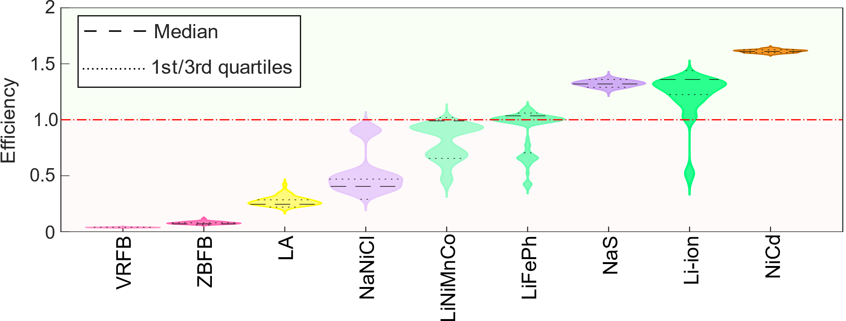

Figure 1. Distribution of efficiency score for medium-term energy storage technologies. Technologies are sorted in increasing order of their median efficiency score.

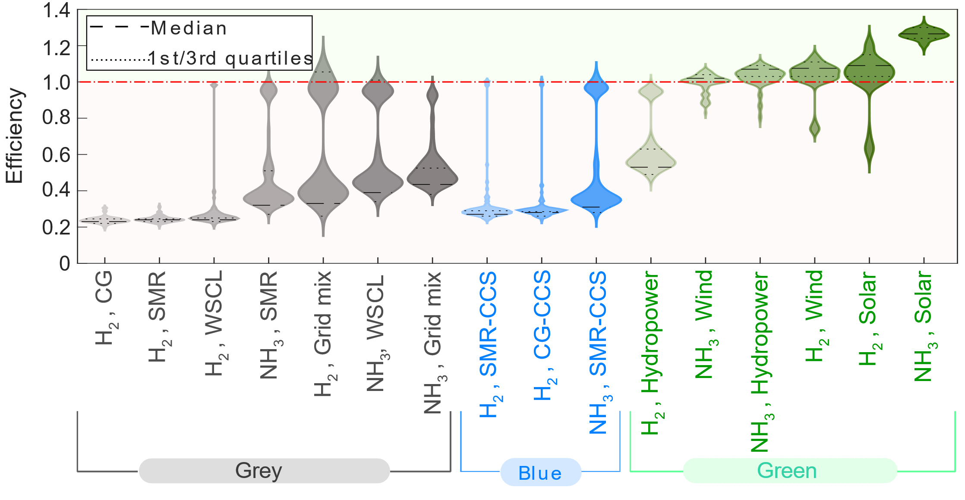

Figure 2. Distribution of efficiency score for long-term energy storage options. Technologies in each group are sorted in increasing order of their median efficiency score. A dashed line is added in efficiency equal to one to facilitate the comparison.

* + 1. *Improvement targets*

In Figure 3, we provide improvement targets for inefficient medium-term and long-term energy storage alternatives by comparing the value of their indicators with those of their corresponding virtual DMU.

Flow batteries need over 80 % improvement to become efficient, i.e., a reduction in their input or undesired output indicators. Lead acid batteries require a 100 % reduction in water use and about 40-60 % improvement in other input indicators and GWP. NaNiCl needs around an 80 % decline in water use and GWP. All these alternatives need further research and development to become competitive, and it will require time.

Two lithium battery types, LiFePh and LiNiMnCo, efficient in 70 % and 50 % of the 100 scenarios, have low average improvement targets of 8.5 % and 13.5 %. Similarly, Li-ion batteries, efficient in 93 % of the scenarios, have small improvement targets. NaS and NiCd batteries are always efficient (Figure 1) and have a zero-improvement target.

Figure 3 also highlights that while the levelized cost of energy is not critical for long-term alternatives, energy consumption, water use, and GWP need attention, especially for grey and blue options. Grey hydrogen alternatives like coal gasification, water splitting using chemical looping, and steam methane reforming have high improvement targets in energy consumption (over 80 %), water use (over 95 %), and GWP (over 80 %). This shows the need for significant improvements in these options to enhance efficiency.

Ammonia alternatives have lower improvement targets, with ammonia from steam methane reforming requiring 60-75 % improvements and ammonia produced by water splitting using chemical looping needing less than 80 % improvements.

As expected, blue alternatives have smaller improvement targets on GWP compared to grey options (less than 70 % compared to more than 80 %). While CCS can reduce environmental impacts, it presents challenges in other areas, such as energy consumption and cost-effectiveness. Technologies relying on renewable energy sources like solar, wind, and hydropower have lower average improvement targets, indicating their relative efficiency or fewer required enhancements in the indicators used in this study.

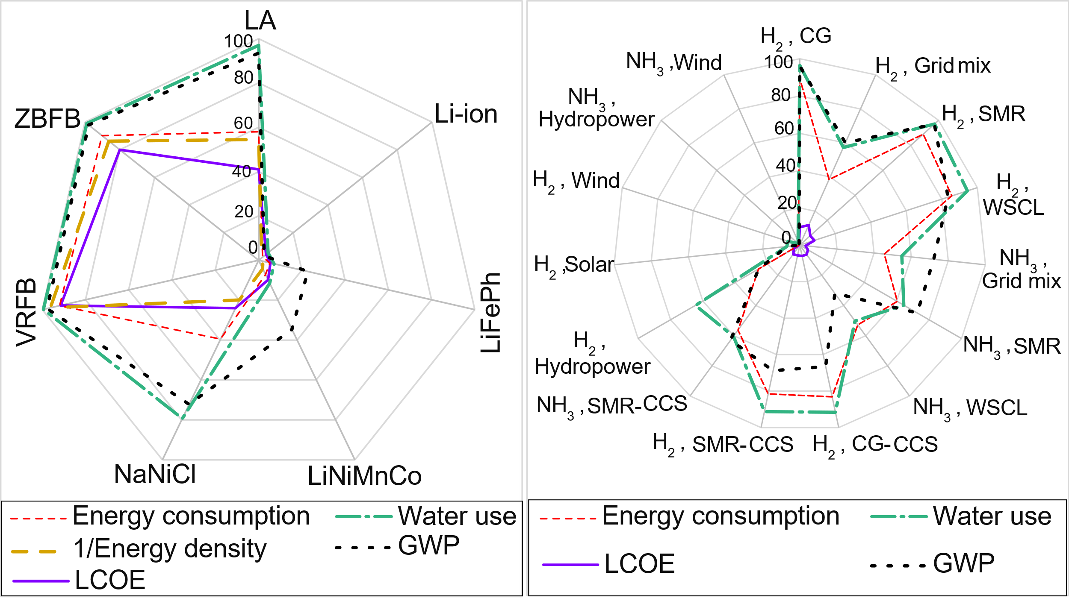

Figure 3. Improvement targets obtained for inefficient medium-term (left-side) and long-term (right-side) energy storage alternatives. Note that the values are in percentage. LCOE: levelized cost of energy, GWP: global warming potential.

* 1. Conclusions

This study assessed 25 energy storage alternatives, categorizing them as medium-term and long-term options. Employing Data Envelopment Analysis, we evaluate their economic, environmental, and social sustainability. The findings emphasize the importance of sustainability assessment in transitioning to renewable energies.

Medium-term options like NiCd and NaS batteries demonstrate potential in sustainability, while others, such as VRFB batteries need significant improvements. In the long-term category, renewable energy-powered options are efficient and sustainable, while grey and blue alternatives need important improvements. Variations in efficiency scores indicate the importance of considering regional factors such as the availability of renewable energy resources.

Noteworthy, even an inefficient option may be irreplaceable in some applications. Furthermore, many of these options are still evolving, and further innovation can help reduce their need for drastic improvements. In this regard, the reported improvement targets provide insights into making energy storage technologies more efficient. For example, flow batteries stand out, requiring 90 % reduction in input indicators to enhance efficiency. Researchers can use these results to identify the extent to which efforts should be concentrated to improve the overall efficiency of each energy storage option.

References

U. Akram, M. Nadarajah, R. Shah, F. Milano, 2020, A review on rapid responsive energy storage technologies for frequency regulation in modern power systems, Renewable and Sustainable Energy Reviews, 120**,** 109626, <https://doi.org/10.1016/j.rser.2019.109626>.

D.A. Chisalita, L. Petrescu, C.C. Cormos, 2020, Environmental evaluation of european ammonia production considering various hydrogen supply chains, Renewable and Sustainable Energy Reviews, 130**,** 109964, [10.1016/j.rser.2020.109964](https://doi.org/10.1016/j.rser.2020.109964).

H.H. Fang, H.S. Lee, S.N. Hwang, C.C. Chung, 2013, A slacks-based measure of super-efficiency in data envelopment analysis: An alternative approach, Omega, 41**,** 4, 731-734, <https://doi.org/10.1016/j.omega.2012.10.004>.

D. Fernández, C. Pozo, R. Folgado, L. Jiménez, G. Guillén-Gosálbez, 2018, Productivity and energy efficiency assessment of existing industrial gases facilities via data envelopment analysis and the Malmquist index, Applied Energy, 212, 1563-1577, 10.1016/j.apenergy.2017.12.008.

C. Fernandez-Marchante, M. Millán, J. Medina-Santos, J. Lobato, 2020, Environmental and Preliminary Cost Assessments of Redox Flow Batteries for Renewable Energy Storage, Energy Technology, 8**,** 11, 1900914, [10.1002/ente.201900914](https://doi.org/10.1002/ente.201900914).

J. Frutiger, M. Jones, NG. Ince, G. Sin, 2018, From property uncertainties to process simulation uncertainties – Monte Carlo methods in SimSci PRO/II process simulator, Computer Aided Chemical Eng., 44, 10.1016/B978-0-444-64241-7.50243-3.

M.D. Mukelabai, JM. Gillard, K. Patchigolla, 2021, A novel integration of a green power-to-ammonia to power system: Reversible solid oxide fuel cell for hydrogen and power production coupled with an ammonia synthesis unit, International Journal of Hydrogen Energy, 46, 35.

F. Rostami, Z. Kis, R. Koppelaar, L. Jiménez, C. Pozo, 2022, Comparative sustainability study of energy storage technologies using data envelopment analysis, Energy Storage Materials, 48, 412–438, https://doi.org/https://doi.org/10.1016/j.ensm.2022.03.026.

O. Siddiqui, I. Dincer, 2019, A well to pump life cycle environmental impact assessment of some hydrogen production routes, International Journal of Hydrogen Energy, 44**,** 12, 5773-5786.

S.K., Thengane, A. Hoadley, S. Bhattacharya, S. Mitra, S. Bandyopadhyay, 2014, Cost-benefit analysis of different hydrogen production technologies using AHP and Fuzzy AHP, International Journal of Hydrogen Energy, 39, 28, 15293-15306.

B. Zakeri, S. Syri, 2015, Electrical energy storage systems: A comparative life cycle cost analysis, Renewable and Sustainable Energy Reviews, 42**,** 569-596, [10.1016/j.rser.2014.10.011](https://doi.org/10.1016/j.rser.2014.10.011).