**The benefits of a multi-software approach for implementing complex kinetic models in process simulators**

Viktória Flóra Csendesa*, Attila Egedyb, Alex Kummerb, Sébastien Leveneura

a INSA Rouen Normandie, Univ Rouen Normandie, Normandie Univ, LSPC UR 4704, F-76000 Rouen, France  
bDepartment of Process Engineering, University of Pannonia, Egyetem st. 10, H-8200 Veszprém, Hungary

*viktoria_flora.csendes@insa-rouen.fr

Abstract

Limitations regarding process design, optimization, and control often occur when using particular process simulators. A single software tool could not provide models of such a large application range and perform properly without making compromises in some areas (Pistikopoulos et al. (2021)). With the implementation of connection methodologies, integrated tools could be made by coupling popular process simulation software with each other or with external programming environments. These hybrid systems can handle complex user-defined problems and can be used for decision support, performing custom unit operations, operator training, process optimization, building control systems, and developing digital twins (Khan et al. (2021)).

Sustainable practices are more and more desired in the industry, and the development of technologies based on recycled and/or nature-derived feedstocks is in demand. For example, biomass valorization requires a more complex reaction system with unique components and kinetic models, which is often a rather time-consuming and complex task to implement into current process simulators (Alshehri et al. (2020)).

This work presents an example of an application where the shortcomings of commercial process simulators with restricted reaction kinetic structures can be solved (Csendes et al. (2023)). We proposed using the process simulator Aspen HYSYS linked with a MATLAB optimization algorithm to solve a reaction kinetic parameter identification problem regarding the production of γ-valerolactone in a dynamic simulation setting. A co-simulation setup was chosen to solve this MIMO problem, as the integration of the two software gives us the ability to run several simulation models, perform parameter identification, and validate the data at the same time from a main program, and that way obtain results in ’one-go’ and organize data in one place.

**Keywords**: software linking, co-simulation, kinetic parameter identification, multi-software engineering

* 1. Multi-Software Engineering

Modelling chemical equipment, processes and reactions is a complex task, engineers and researchers highly rely on powerful software to solve these problems. Commercial process simulators are a great tool to perform simulation, where the mathematical equation systems are behind easy-to-use graphical interfaces. However, the manipulation or customization of the deeper mathematical correlations are often come with limitations, or simply restricted by the programs (Csendes et al. (2023)).

Multi-software engineering is used to overcome this problem, by using different parts of one or two software to complement each other. Programming environments for example have the advantage of containing more complex numerical methods, and this means that optimization algorithms and response surface methodology can also be used to achieve a wider application range (Rangaiah et al. (2020)). Building user-defined equation systems and utilising algorithms created in numerical solvers can be used via built-in toolboxes or native integration with commercial process simulators (Furda et al. (2020)). Like this, integrated tools can complement each other providing a more robust and complex system for modelling, parameter estimation, data regression, sensitivity analysis, optimization and control.

Multi-software engineering is a novel tool for connecting a priori and a posteriori models to keep up with the evolution of information technology.

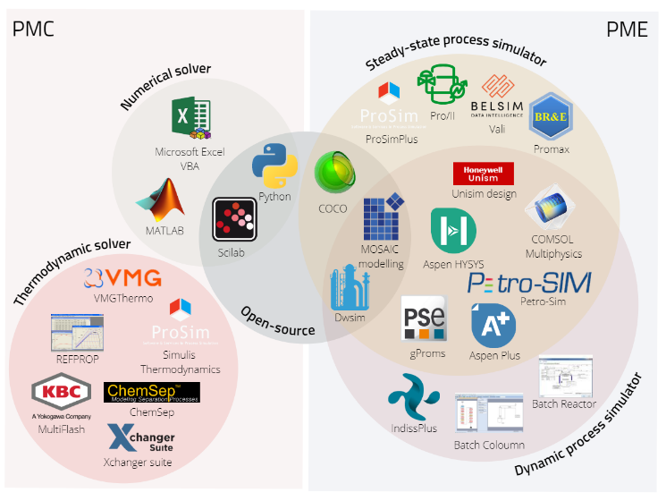

**Figure 1.** Categorization of popular process modelling components and environments.

* 1. Case study

Our case study showcases a kinetic parameter identification with software linking for the production of γ-valerolactone (GVL) from butyl-levulinate (BL) in a two-step hetero-catalytic reaction over Ru/C catalyst.

* + 1. Simulator Development of the Case Study

A detailed description of the characteristics of the components as well as the setup used for the experiments is written in the works of Capecci and Wang (Capecci et al. (2021), Wang et al. (2020)). Four dynamic HYSYS simulation files were built according to the experimental setup. When generating the simulation in Aspen HYSYS, kinetics were simplified to Arrhenius type for the three reactions present in the system, where the pre-exponential factors and the activation energies could be reached via an internal HYSYS spreadsheet. The unit design contains a batch reactor equipped with a temperature controller to operate in an isotherm mode. Isobaric conditions were obtained with a high-pressure H2 inlet stream, similar to the experimental conditions.

* + 1. Multi-Software Based Identification Framework for Kinetic Parameter Identification

The kinetic parameters were identified by linking the HYSYS simulator to the MATLAB environment, where the latter acted as the main program. The HYSYS models were run from MATLAB, where kinetic parameters were modified directly through the HYSYS spreadsheets. The identification framework within the MATLAB environment calculates the kinetic parameters of the HYSYS files, where their values were varied in each iteration step to achieve better fitting to the experimental data sets in each case based on the objective function, which is a minimum search with a quadratic error function.

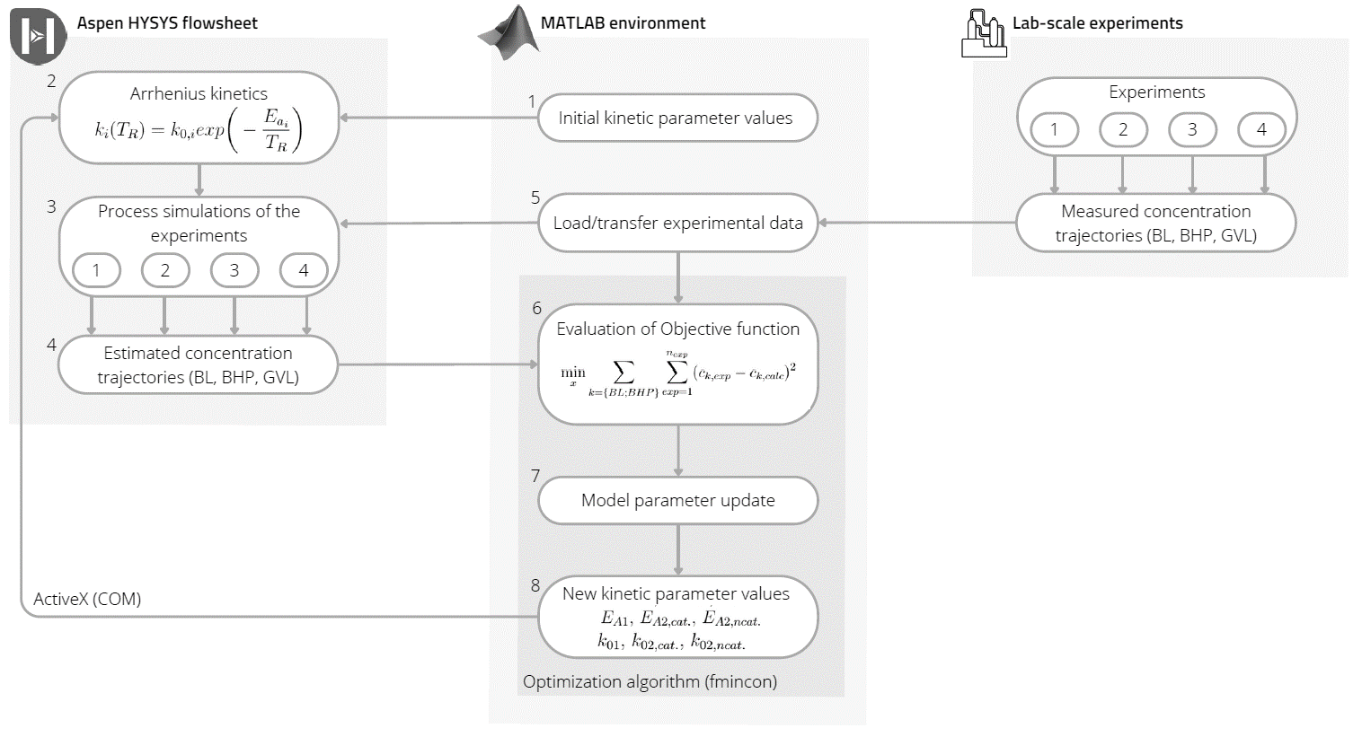

**Figure 2.** Outline of the identification framework connecting Aspen HYSYS and MATLAB.

* 1. Results

It can be seen in Figure 3. that the calculated concentration trajectories fit the experimental data well. The predictive ability of our simpler kinetic model is comparable with Capecci’s model based on the R2 indicator, their fitting to the concentration trajectories is 0.976 while ours is 0.952.

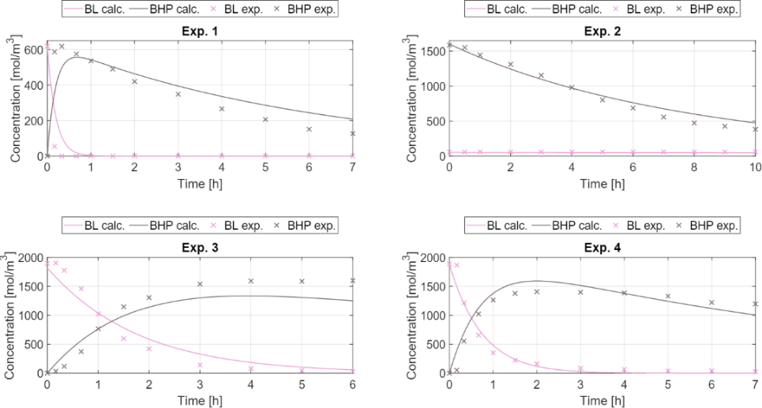

**Figure 3.** The concentration curve fittings resulting from the identification.

* 1. Conclusion

In a case study, parameter identification with multi-software engineering was performed to showcase one of the many application aspects of the technique. In our case, the lack of kinetics definition was crucial for model building inside the simulator. Therefore, a link between the dynamic process simulator Aspen HYSYS and the coding environment MATLAB was made utilizing an ActiveX connection. We found that the method provided good results and performed well in fitting the available experimental data.

References

A. S. Alshehri, R. Gani, F. You, 2020. Deep learning and knowledge-based methods for computer-aided molecular design—toward a unified approach: State-of-the-art and future directions. Computers & Chemical Engineering 141, 107005.

V. F. Csendes, A. Egedy, S. Leveneur, A. Kummer, 2023. Application of multi-software engineering: A review and a kinetic parameter identification case study. Processes 11 (5), 1503.

F. Khan, P. Amyotte, S. Adedigba, 2021. Process safety concerns in process system digitalization. Education for Chemical Engineers 34, 33–46.

E. N. Pistikopoulos, A. Barbosa-Povoa, J. H. Lee, R. Misener, A. Mitsos, G. V. Reklaitis, V. Venkatasubramanian, F. You, R. Gani, 2021. Process systems engineering–the generation next? Computers & Chemical Engineering 147, 107252.

P. Furda, M. Variny, Z. Labovská, T. Cibulka, 2020. Process drive sizing methodology and multi-level modeling linking MATLAB® and Aspen Plus® environment. Processes 8, 1495.

G.P. Rangaiah, Z. Feng, A.F. Hoadley, 2020. Multi-objective optimization applications in chemical process engineering: Tutorial and review. Processes 8, 508.

S. Capecci, Y. Wang, J. Delgado, V. Casson Moreno, M. Mignot, H. Grénman, D.Y. Murzin, S. Leveneur, 2021. Bayesian Statistics to Elucidate the Kinetics of g-Valerolactone from n-Butyl Levulinate Hydrogenation over Ru/C. Ind. Eng. Chem. Res. 60, 11725–11736.

Y. Wang, I. Plazl, L. Vernières-Hassimi, S. Leveneur, 2020. From calorimetry to thermal risk assessment: γ-Valerolactone production from the hydrogenation of alkyl levulinates. Process Saf. Environ. Prot. 144, 32–41.