Development of a fast-charging protocol considering degradation using high-fidelity lithium-ion batteries
Chanho Kimª, Minsu Kim^{b}, Junghwan Kim^{a, *}
ªDepartment of Chemical and Biomolecular Engineering, Yonsei University, 50 Yonsei-ro, Seoul, 03722, Republic of Korea
^{b}Department of Chemical Engineering, Massachusetts Institute of Technology, Cambridge, MA, 02139, USA
kjh24@yonsei.ac.kr
Abstract
As demand for electric vehicles and grid stability increases, optimizing lithium-ion batteries (LIB) usage has become crucial. To address this, advanced battery management systems are spotlight as continuously monitor battery internal phenomena. Fast charging of LIB is one of the challenges for advanced battery management. Applying high current can reduce charging time, but it also accelerates battery degradation. Therefore, development of fast-charging protocol considering degradation condition is crucial. Porous electrode theory (PET) models can suggest high fidelity battery model. However, due to the wide design space and numerous complex degradation mechanisms, limitations exist using PET model. Using model-free approach, such as genetic algorithm (GA), can handle this problem. In this study, we applied GA for parameter identification and fast-charging protocol development. Identified parameters are applied to the PET model and we employed GA to minimize charging time while considering voltage and temperature constraints. Using the optimal charging protocol achieved by model-free approach, charging performance can be compared with experiments to identify the improvement.

Keywords: Lithium-ion battery, Parameter estimation, Fast-charging protocol, Degradation, Porous electrode theory
  - Introduction
Intercalation-based batteries are attracting attention with the advancement of industries such as electric vehicles, mobile devices, and energy grids. Among various materials, lithium-ion batteries (LIBs) are the most widely used due to their high energy density and low self-discharge. However, long charging times and reduced performance by degradation are remaining challenges. They can be overcome by charging under conditions that suppress degradation. According to battery chemistry, high temperatures and voltages accelerates battery degradation (Kumar et al., 2023). Charging under high current can reduce charging time, but it also increases temperature and voltage. Thus, designing a charging strategy reducing charging time and suppressing degradation is crucial. However, since experimenting cycling behavior of LIBs is a time-consuming and expensive task, it can be handled inexpensively by numerical battery model.
Various numerical modeling approaches exist to describe the charging/discharging behavior of LIBs. Each model is divided into equivalent circuit model (ECM) and electrochemical model (EM). EM is preferred because it can depict internal phenomena such as concentration and temperature distribution. The most widely used EM approach is the porous electrode theory (PET) model, and widely used modeling tools include PyBaMM (Sulzer et al., 2021), LIONSIMBA (Torchio et al., 2016), and PETLION (Berliner et al., 2021). However, model-based charging strategy development has limitations due to hundreds or thousands of complex degradation mechanisms. Complex degradation mechanisms make charging strategy development a large-scale optimization problem (Jiang et al., 2022). Developing an optimization-based model-free approach can solve the challenges (Ouyang et al., 2015).
In this research, we build a high-fidelity battery model and develop a charging strategy to suppress degradation. The parameters of PET model are estimated to depict battery behavior. This improves efficiency of optimization since experiments can be handled inexpensively. However, complex relationships of parameters can cause undesirable result like local optimum. To solve it, we divided 17 parameters to three sets and conducted one main and two fine optimization steps. Parameters were selected by sensitivity analysis (Li et al, 2020). First optimization with six parameters depicts main charging tendency. Then, after fixing first optimization results, secondary optimization with other six parameters were conducted for fine tuning. Likewise, last optimization was executed while preceding results are applied. Several studies have been conducted to identify current level in the multistage constant current (MCC) stage. Voltage and SOC are used as charging switching criteria. Liu et al. (2018) consistently reduce current of the MCC stage by randomly selected voltage and analyze effect on degradation. Jiang et al. (2022) divided SOC into 20 % intervals and propose a charging considering temperature and voltage constraints. We focus on the criteria for distinguishing between current levels and charging strategies in MCC stage. As a result, by SOC-based charging design and optimal current level, charging conditions don’t accelerating degradation are obtained.
  - Methodology

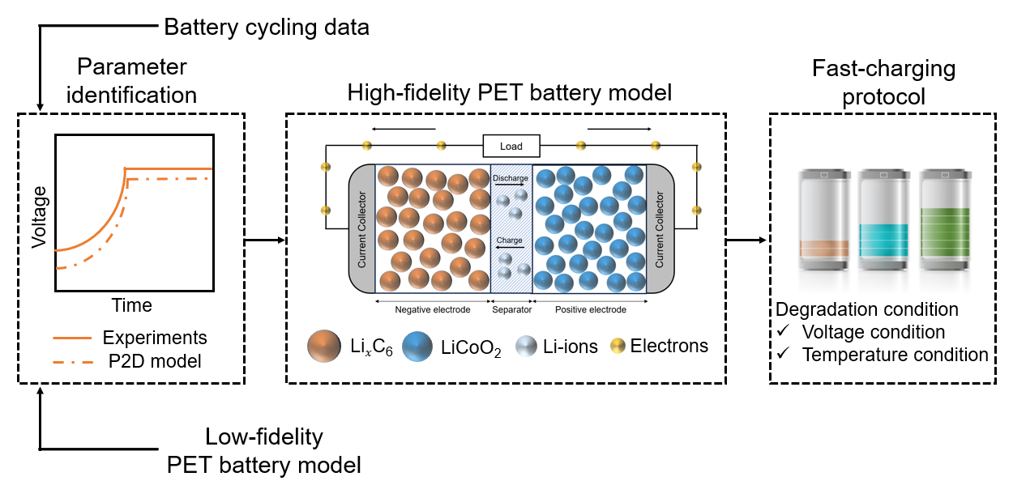
Figure 1. Schematic of fast-charging protocol development using high-fidelity LIBs model
Fig. 1 depicts a schematic diagram of generating a high-fidelity PET model by parameter estimation and designing fast-charging protocol with it. This section discusses theoretical description, parameter estimation, and fast-charging protocol problem.

    - Porous electrode theory (PET) model

PET is a mathematical modeling method that describes cycling behavior of LIBs and depicts internal phenomena with high accuracy based on study of Newman et al. (1975) and Fulller et al (1994). PET model consists of partial differential equations for mass and charge conservation at cathode, separator, and anode and describes the electrochemical dynamics of solid particles and electrolytes. Many governing equations are linked through ion flux by Bulter-Volmer equation in eqn (1).
$$j\left(z,t\right)=2\frac{i_{0}}{F}\sinh\left[\frac{F}{2RT(z,t)}η\right]$$ | (1)
Where $j$ is the ionic flux, $i_{0}$ is the exchange current density, $F$ is the Faraday constant, $η$ is the electrode overpotential. The diffusion of lithium ions inside each solid particle is described by eqn (2), where eqn (3) is the boundary condition.
$$\frac{∂}{∂t}c_{s}\left(z,t\right)=\frac{1}{z^{2}}\frac{∂}{∂z}\left[z^{2}D_{eff}^{s}\frac{∂}{∂z}c_{s}(z,t)\right]$$ | (2)
$$\frac{∂}{∂z}c_{s}\left(z,t\right)=0 \left(z=0\right), \frac{∂}{∂z}c_{s}\left(z,t\right)=-\frac{j(z,t)}{D_{eff}^{s}} \left(z=R_{s}\right)$$ | (3)
Where $c_{s}(z,t)$ is concentration of solid particles, $z$ is the radial direction of ion insertion to particle, t is time, $R_{s}$ is radius of particles, $D_{eff}^{s}$ is effective solid-phase diffusivity. SOC calculated as a function of average particle concentration is by eqn (4)
$$SOC\left(t\right)≔\frac{1}{L_{n}c_{s}^{max,n}}\int_{0}^{L_{n}}{c_{s}^{avg}\left(z,t\right)dz}$$ | (4)
$L_{n}$ is thickness of negative electrode, $c_{s}^{max,n}$ is maximum concentration of lithium-ions is the negative electrode, and $c_{s}^{avg}\left(z,t\right)$ is average concentration of solid-phase. The movement of electrons in electrode is described by Ohm's law described by eqn (5).
$$\frac{∂}{∂z}\left[σ_{eff}\frac{∂}{∂z}Φ_{s}(z,t)\right]=aFj(z,t)$$ | (5)
Where $σ_{eff}$ is the effective conductivity of the electrodes, $Φ_{s}\left(z,t\right)$ is the solid potential and $a$ is the ratio of particle surface area to volume. Voltage is expressed as eqn (6) by the difference in current collector solid potential of each electrode.
$$V\left(t\right) := Φ_{s}\left(0,t\right)-Φ_{s}(L,t)$$ | (6)
The heat transfer phenomenon inside the battery, such as the generation of various heat sources, is expressed as eqn (7).
$$ρC_{p}\frac{∂}{∂t}T\left(z,t\right)=\frac{∂}{∂z}\left[λ\frac{∂}{∂z}T(z,t)\right]+Q_{ohm}\left(z,t\right)+Q_{rxn}\left(z,t\right)+Q_{rev}\left(z,t\right)$$ | (7)
Where $ρ$ is the density, $C_{p}$ is the specific heat, $λ$ is the thermal conductivity, $Q_{ohm}(z,t)$ is a heat source caused by the movement of lithium ions, $Q_{rxn}(z,t)$ is caused by ionic flux and overpotential, and $Q_{rev}(z,t)$ is caused by the change in entropy of the electrode. A detailed description of the PET model is in reference (Newman et al., 1975)

    - Parameter identification

Since PET model has significant number of parameters, design space becomes excessively large to employ model mathematically. Thus, in this study we applied derivative-free optimization, especially genetic algorithm (GA), that doesn’t use mathematical data of objective functions. GA repeats cycle of selection, crossover, mutation, and evaluation until evaluation result reaches optimization tolerance. After optimization is finished, we achieve optimal parameters. GA has been used in various field like NCC feed composition (Kim et al, 2023) and plastic recycling (Lee et al., 2022)
As an objective function we used the sum of difference between experimental dataset (Gun et al., 2015) and simulation result of MATLAB-based LIONSIMBA. Constant power-constant voltage (CP-CV) step is conducted. Lower and upper bounds are 0 and 1 since we applied reverse min-max scaling expressed as eqn (8).
$$x_{i}=x_{scaled}\left(x_{max}-x_{min}\right)+x_{min}$$ | (8)

    - Fast-charging protocol

SOC has been used as charging stage distinction criteria, but no exact guideline what % to start and how much intervals to separate exists (Attia et al., 2020). To discuss SOC section split mechanism, we split SOC more finely with 10 % intervals from 20 % to 80 % and applied GA to find out best combination. After 80 % SOC, CV charging protocol is executed, but the result won’t be considered in objective function.
We designed objective function considering charging time and degradation constraints. Upper and lower bound is 5 and 1 C-rate. Objective function is expressed as eqn (9).

$$Obj=Charge time+penalty*\left(violation counts\right)+CV stop penalty$$ | (9)
Temperature constraint is 313.15 K and voltage constraint is 4.1 V. Number of constraint violation are counted during the simulation. If CV step stopped before 95 % SOC, it is considered as problematic charging and penalty is added. After optimization is finished, objective function result and best C-rate combination are returned.
  - Results
    - Parameter identification
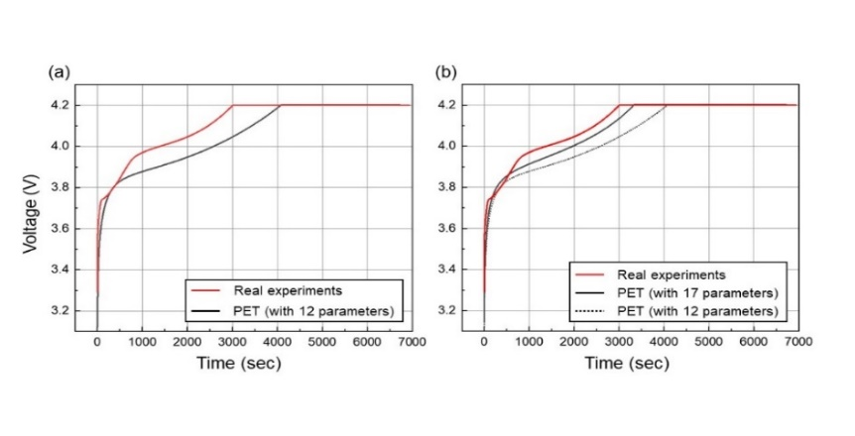
Figure 2. Parameter identification result (a) With 12 parameters (6 for main + 6 for fine fitting) (b) Final results with 5 additional parameters
In this study, we started identification process with top twelve parameters from the sensitivity analysis by Li et al (2020). From Li et al.’s study, we selected six parameters, thickness and active material volume fraction of cathode and anode, anode reaction rate coefficient, and cathode maximum ionic concentration for main curve fitting. Then, fine optimization is conducted with the other six parameters, which are particle radius and diffusion coefficient of cathode and anode, cathode reaction rate coefficient, and anode maximum ionic concentration. Result until this procedure is illustrated in Fig. 2(a).
After a few cycles of main and fine fitting process is done, we conducted analysis about relationship between parameter change and CV step beginning time to the rest of parameters from Li et al.’s study by changing one parameter while fixing the others. As a result, Bruggeman coefficient and particle surface area for positive and negative electrode, and transference number are selected for secondary fine optimization. Then, final optimization with five extracted parameters to achieve the result of Fig. 2(b).
Fig. 2(b) shows the voltage plot of both parameter identification using simulation and experimental data. As figure illustrates, simulation result using identified parameters have similar charging tendency with experimental curve. Since identified parameters can imitate the battery charge behavior, we can use simulation results instead of experiments.

    - Fast-charging protocol

Table 1. Fast-charging protocol result
SOC section | C rate (1C = 2.6A) | Time (s)
20 ~ 30 % | 5.8569 C | 65
30 ~ 40 % | 3.2568 C | 109
40 ~ 50 % | 2.4387 C | 145.5
50 ~ 60 % | 2.2436 C | 161
60 ~ 70 % | 1.7594 C | 203.5
70 ~ 80 % | 1.2478 C | 298.5
Total time |  | 982.5 s

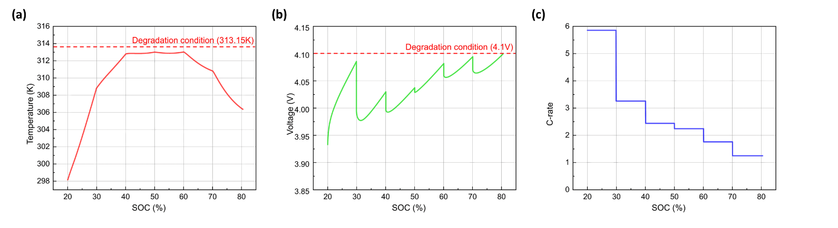
Optimal C rate for each SOC sections and total time required is shown in the Table 1. According to Table 1, C rate decreases per each interval during the charge MCC protocol.
Figure 3. Battery behavior plot for optimal charge strategy. (a) X-axis: SOC, Y-axis: Temperature (K) (b) X-axis: SOC, Y-axis: Voltage (V) (c) X-axis: SOC, Y-axis: C-rate
As Fig. 3 illustrates, optimal output minimizes charging time while obeying both 4.1 V and 313.15 °C degradation constraints. MCC protocol is known for a fast-charging and difficulty in temperature control (Jiang et al, 2022). However, Fig. 3 shows that apply high current at the beginning then decrease per interval can stably control temperature. Moreover, Fig. 3(a) depicts temperature is main constraint until SOC reaches 60%. After 60%, Fig. 3(b) shows that voltage regulates the charge current of the rest part.

  - Conclusion
To minimize the time cost and degradation, optimal charging strategy is required. Repetitive experiments, however, takes immense times and expenses. Therefore, numerical simulation with optimization can be appropriate alternative. In this study, we used GA to identify battery parameters and determine the optimum MCC combination. The results suggest GA could find out parameters that imitate the charge tendency and find out best charging protocols efficiently. Thus, this research demonstrates suggested charge protocol search method can be a proper solution for the situation. We propose that cyclic optimization of parameters for better imitation and discrete optimization using MCC interval as variable can be considered as follow-up research.
References
Jiang, Berliner, Lai, Asinger, Zhao, Herring, Bazant, Braatz, 2022, Fast charging design for Lithium-ion batteries via Bayesian optimization, Applied Energy, 307
Ouyang, Chu, Lu, Li, Han, Feng, Liu, 2015, Low temperature aging mechanism identification and lithium deposition in a large format lithium iron phosphate battery for different charge profiles, Journal of Power Sources, 286
Liu, Zou, Li, Wik, 2018, Charging Pattern Optimization for Lithium-Ion Batteries With an Electrothermal-Aging Model, IEEE Transactions on Industrial Informatics, 14(12)
Kumar, Sathyamurthy Kim, Panchal, Ali. Et al, 2023, A state-of-the-art review on advancing battery thermal management systems for fast-charging, Applied Thermal Engineering, 226
Sulzer, Marquis, Timms, Robinson, Chapman, 2021, Python Battery Mathematical Modelling (PyBaMM), Journal of Open Research Software, 9
Torchio, Magni, Gopaluni, Braatz, Raimondo, 2016, LIONSIMBA: A Matlab Framework Based on a Finite Volume Model Suitable for Li-Ion Battery Design, Simulation, and Control, Journal of The Electrochemical Society, 163(7)
Berliner, Cogswell, Bazant, Braatz, 2021, Methods—PETLION: Open-Source Software for Millisecond-Scale Porous Electrode Theory-Based Lithium-Ion Battery Simulations, Journal of The Electrochemical Society, 168(9)
Newman, Tiedemann, 1975, Porous-electrode theory with battery applications, AIChE Journal
Fuller, Doyle, Newman, 1994, Simulation and Optimization of the Dual Lithium Ion Insertion Cell, Journal of The Electrochemical Society, 141(1)
Kim, Joo, Kim et al., 2023, Multi-objective robust optimization of profit for a naphtha cracking furnace considering uncertainties in the feed composition, Expert Systems With Applications
Lee, Lim, Kim et al., 2022, Multiobjective Optimization of Plastic Waste Sorting and Recycling Processes Considering Economic Profit and CO2 Emissions Using Nondominated Sorting Genetic Algorithm II, ACS Sustainable Chemistry & EngineeringVolume 10, Issue 40
Gun, Perez, Moura, 2015, Fast Charging Tests [Dataset], Dryad https://doi.org/10.6078/D1MS3X
Attia, Grover, Jin, Serverson et al., 2020, Closed-loop optimization of fast-charging protocols for batteries with machine learning, Nature, 397-402
Li, Cao, Jöst, Ringbeck, Kuipers et al., 2020, Parameter sensitivity analysis of electrochemical model-based battery management systems for lithium-ion batteries, Applied Energy, 269

