On the development of hybrid models to describe delivery time in autoinjectors
Andrea Frisoª, Mark Palmer^{b}, Gabriele Bano^{c}, Federico Galvanin^{a*}
ª Department of Chemical Engineering, University College London, Gower Street, London WC1E6BT, United Kingdom
^{b} GlaxoSmithKline, Park Road, Ware, SG120DP, United Kingdom
^{c} GlaxoSmithKline, 1250S Collegeville (PA) 19426, United States
*Correspoding author e-mail: f.galvanin@ucl.ac.uk
Abstract
Autoinjector (AJ) devices are medical devices that enable subcutaneous self-administration of medicines. A key challenge for AJs is the evaluation of injection time because in can impact on the usability of the autoinjector. Several models have been presented in literature to describe the injection time in AJs with different grade of complexity and accuracy. The limitation of the existing models is that they depend only on geometrical properties of the AJs, rheology of the fluid injected and the speed of the plunger. However, these models do not consider the dependence of friction on the distance travelled by the piston. In this paper a new hybrid model is developed to describe the injection time in AJs, integrating physics-based elements from the literature with data driven components. Results show that the proposed model is able to predict in an accurate way the experimentally measured friction force acting on the plunger.
Keywords: mathematical modelling, hybrid models, Gaussian processes.
  - Introduction
The use of autoinjectors (AJs) has grown in recent years due to the ease of use of these devices and the fact that they can be used without the intervention of medical personnel. AJs are used to deliver the drug necessary to treat various diseases such as diabetes and arthrosis, and for each treatment the characteristics of the AJ change (Vijayaraghavan 2012). The key parameter of these devices is the injection time, i.e., the time required to inject all the drug. This parameter is crucial for the use of autoinjectors. In fact, very long delivery times have the potential to usability because the patient may not be able to hold the injector in place for the required period of time. This could lead to early removal of the autoinjector which would result in an incomplete dose. Very short delivery times may also be undesirable if this leads to an increase in injection pain. For this reason, the accurate design, i.e., geometry of AJs, is pivotal. One tool that can be useful in the design of AJs are mathematical models to describe the forces acting on the AJs. The use of mathematical models, in the form of differential and algebraic equations (DAEs), plays an important role in the design and optimization of operating conditions of injection devices. Different models to describe the forces involved in AJs operation have been proposed in the literature (Rathore et al., 2011, Zhong et al. 2021). These models describe the movement and the behavior of the drug as it flows through the various components of the device such as the syringe barrel and the needle. These forces are:
- Driving force: this force is the force that pushes the plunger of the syringe making the injection process possible;
- Hydrodynamic force: this force is classified as resistance force because it is opposed to the driving force. This force refers to the fluid dynamic effects of the medication inside the barrel;
- Friction force: this force, as the hydrodynamic one, is classified as resistance force because it opposes the movement of the piston. This force is generated by friction due to the contact between the barrel and the piston sliding in the syringe.
In Fig. (1) a schematic representation of an AJ with the forces acting on the system is reported.
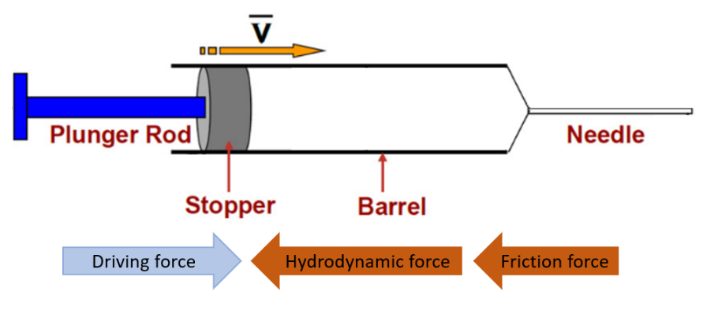
Figure 1: Schematic representation of the structure and forces acting on the autoinjector (Rathore et al. 2011)
Models proposed in literature manage to describe in an accurate way the friction force and the driving force, but so far there are no adequate models to describe the dynamics of the friction force. According to the literature the friction force should only depend on the velocity of the plunger. Instead, from the measured friction force, it is observed that the friction force depends also on the travelled distance. This project aims to propose a hybrid model capable of predicting the values of the friction force obtained from experimental measurements at different conditions of plunger speed. The hybrid model will combine a mechanistic model with a Gaussian process (Rasmussen and Williams, 2006) to represent the model mismatch to obtain a model that can predict the variable value of the friction forces in AJs at different operating conditions.
  - Proposed framework and methodology
    - Mathematical models – Mechanistic models
In this section the proposed framework to develop the hybris model is presented and explained. Mechanistic models of AJs are usually described by a system of differential and algebraic equations (DAEs) expressed in the following general form:
$$\left\{\begin{aligned}f\left(\dot{x}\left(t\right), x\left(t\right), u\left(t\right), θ, t\right)=0 \\ \hat{y}=g\left(x\left(t\right)\right)\end{aligned}\right.$$ | (1)
In Eq. (1) x is the array of the N_{x} state variables, $\dot{x}$ is the array of the state variables derivatives, u is the N_{u} $×$ 1 array of the experimental inputs,$θ$ is the $N_{θ}$-dimension array of the model parameters, t is the time, $\hat{y}$ is the $N_{\hat{y}}$-dimensional vector of predicted outputs for the measured variables in the system under analysis. Every system that is governed by physics laws theoretically has a model that can describe accurately its behavior, but this “true” AJ model involves phenomena in the definition of friction forces that are too complex to be identified and for this reason it is necessary to use an approximated model. When an approximate model described by Eq. (1) is used to obtain output predictions these will be different from the output of an ideal “true” model. This difference is called model mismatch and can be expressed in the following form:
$$ε^{M}=y^{true}- \hat{y}$$ | (2)
In Eq. (2), $ε^{M}$ is the model mismatch, $y^{true}$is the true model prediction and $\hat{y}$ is the approximate model prediction described by Eq. (1). Given this expression the set of experimental measurements y can expressed as sum of the model prediction and the prediction mismatch:
$$y= \hat{y}+ε^{M}+{ε_{y}}^{2}$$ | (3)
where ${ε_{y}}^{2}$ is the vector of measurement errors, here assumed to be normally distributed with zero mean and variance matrix $σ^{2}$. If the model mismatch is high, this means that the adopted mechanistic model is unable to describe the data adequately and therefore its fitting must be improved. The method proposed in this case is not to directly improve the fitting of the model by acting on the approximate model itself and refining its structure but to use a data-driven model to directly model the mismatch between approximate model prediction and measurement. Combining the data driven model with the mechanistic model will result in a hybrid model able to predict the output adequately.
    - Mathematical models – Gaussian processes
Hybrid models refer to a category of models that combine different models or techniques to describe a system. In this case the two used models are a mechanistic model, capable of describing the physics of the system and an empirical model, used to describe the model mismatch. The selected data-driven model selected to model the mismatch is the Gaussian process (GP). GPs are a particular class of non-parametric models that can be used both for classification and regression. GPs extend the concept of a multivariate Gaussian distribution to create a distribution over an infinite-dimensional vector of functions, such that every finite sample of function values is Gaussian distributed. GPs aim to model an unknown set of functions, $f_{i}$, given a set of measurements. In this case study the set of functions will be used to describe the model mismatch. These models are fully specified with the prior mean function, $μ\left(∙\right)$, and the kernel function, $k\left(∙, ∙\right)$:
$$f_{i}\sim GP\left(μ_{i}\left(∙\right), k_{i}\left(∙, ∙\right)\right)$$ | (4)
The mean function gives information about the mean of the test points prior to observing data and the kernel function returns the covariance between points. Given a dataset, the posterior distribution of a point $x^{*}$is determined using the available noisy data and their distribution: $D_{i}≔\left\{X, y_{i}\right\}$, where $X=\left[x_{1},..,x_{N}\right]$. At this point the posterior mean ($m_{i})$ and variance ($Σ_{i})$of $x^{*}$ are determined:
$$m_{i}\left(x^{*}\right)=E\left(f_{i}^{*}\left|x^{*},D\right.\right)=k_{i}\left(x^{*}, X\right){\left[K_{i}\left(X,X\right)+σ_{i}^{2}\right]}^{-1}\left(y_{i}-μ_{i}\left(x^{*}\right)\right)+μ_{i}\left(x^{*}\right)$$ | (5)
$$Σ_{i}\left(x^{*}\right)=V\left(f_{i}^{*}\left|x^{*},D\right.\right)=k_{i}\left(x^{*}, x^{*}\right)k_{i}\left(x^{*}, X\right){\left[K_{i}\left(X,X\right)+σ_{i}^{2}\right]}^{-1}K_{i}\left(X,x^{*}\right)$$ | (6)
Where $E$ is the expectation, $V$ is the variance, K is the covariance matrix and $σ_{i}^{2}$ is the noise. At this point the posterior mean and the variance can be used:
$$f\left(x^{*}\right)\sim N\left(m\left(x^{*}\right),Σ_{i}\left(x^{*}\right)\right)$$ | (7)
There are several options for the function to use to describe the kernel. For this application the radial basis function (RBF) kernel has been selected. This kernel is parameterized using a length scale, $l>0$, that can either be scalar or a vector with the same dimensions of the input. This kernel is given by the expression in Eq. (8).
$$k\left(x_{i},x_{j}\right)=σ^{2}exp\left(-\frac{{d\left(x_{i},x_{j}\right)}^{2}}{2l^{2}}\right)$$ | (8)
where $l$ is the length scale of the kernel, $d\left(∙,∙\right)$ is the Euclidian distance and $σ^{2}$ the output variance. Once the GP is defined it is possible to define the output using Eq. (3) where $ε^{M}$ is obtained using the GP
  - Case study
The proposed framework has been tested on the prediction of the friction force in the AJs devices using a dataset obtained running real experiments.
    - Dataset
The available data were obtained from experiments conducted with a constant plunger speed such that the total balance of forces was zero. To maintain a constant piston speed and to measure the force necessary for movement, a dynamometer was used. To obtain the value of the friction force throughout the experiment, the fact that the summation of the acting forces was zero was exploited (the acceleration of the system is equal to zero):
$$F_{driving}=F_{hydrodynamic}+F_{friction}$$ | (10)
This was followed by the assumption that the hydrodynamic model used to calculate the hydrodynamic force, Eq. (11) (Rathore et al. 2011), was correct and thus using Eq. (10) it was possible to estimate the friction force.
$$F_{hydrodynamic}=\frac{8πd_{s}^{4}μL}{d_{n}^{4}}{\overline{v}}_{s}+\frac{3}{2}ρ\frac{πd_{s}^{6}}{4d_{n}^{4}}{\overline{v}}_{s}^{2}$$ | (11)
In the following table the nomenclature and the values of all the parameters are reported.
Table 1: Variables nomenclature – Hydrodynamic model
Parameters name | Physical meaning
$$d_{s}$$ | Syringe diameter
$$d_{n}$$ | Needle diameter
$$μ$$ | Formulation viscosity
$$ρ$$ | Formulation density
$$L$$ | Needle length
$${\overline{v}}_{s}$$ | Mean velocity of the plunger

The experiments, run with the same type of AJ but at different velocities of the piston, are repeated four times to evaluate the variance of the total force, the measured output of the system.
    - Mechanistic model
The mechanistic model selected to describe the physics law behind the friction force is the model proposed by Rathore et al. (2011):
$$F_{friction}=\left(\frac{2πμ_{oil}r_{s}l_{stop}}{d_{oil}}\right){\overline{v}}_{s}$$ | (12)
In this model there are parameters related to the AJ geometry and parameters used to describe the rheology of the lubrication layer in the inner wall of the barrel.
Table 2: Variable nomenclature - Friction model
Parameters name | Physical meaning
$$r_{s}$$ | Syringe radius
$$l_{stop}$$ | Stopper length
$$d_{oil}$$ | Thickness of the lubrication layer
$$μ_{oil}$$ | Oil viscosity
    - Gaussian process
A GP on the form described in Section 2.2.1 has been implemented and trained using the data of 8 experiments. Once the data-driven model had been trained, the predictive capabilities of the empirical model were validated using the experimental data of the last experiment.

  - Results
In this section the results obtained using the proposed framework are shown. In Fig. (1) the profile of the measured friction force is reported.
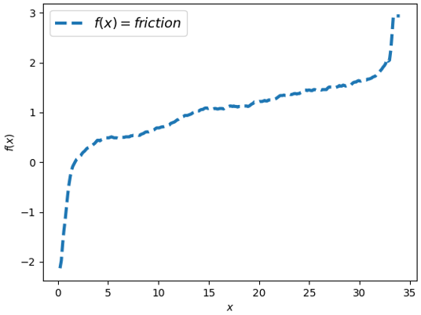  Figure 2: Profile of the measured friction | 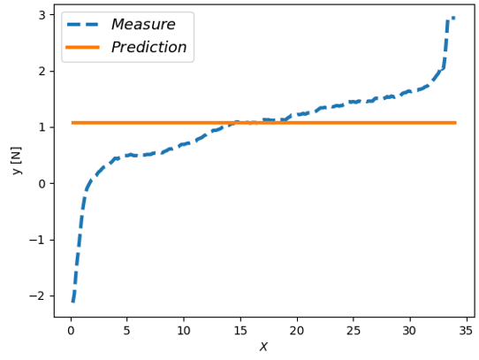  Figure 3: Comparison of the profiles of the predicted friction and of the measured friction
From Fig. (3) it is possible to notice that the mechanistic model is not capable to describe the profile of the friction in an adequate way. Fig. (2) shows that the friction force depends on the position of the piston (x) and this variable is not included in the model. At this point using Eq. (2) $ε^{M}$ was evaluated. The prediction mismatch obtained was used to train the GP, Fig. (4). Fig. (4) shows the profile of predictions mismatch the function obtained using the GP and the observation used to derive the function. In Fig. (4) the predicted mean of the GP (μ) is obtained using only two observations. The predicted function in this case is not accurate, in fact the 95% confidence interval is very high, so it is necessary to increase the number of observations used. In Fig. (5) the function obtained using 8 experimental observations is reported. From this figure it can be seen that using more observation the GP managed to create a function able to describe in an adequate way the profile of the prediction mismatch. At this point it is necessary to assess whether the GP is also capable to predict the value of $ε^{M}$. In Fig. (6) the predicted $ε^{M}$ and the measured mismatch comparison is reported. From this figure it can be noticed that the GP can model the prediction mismatch in an accurate way when the system is in steady state conditions (between the two red dotted lines). Fig. (7) shows the friction force measured from the experiment and the friction force predicted using the hybrid model.
  - Conclusion and future work
In this project an alternative approach to combine mechanistic models and data-driven models (GPs) for the description of friction forces in AJ devices has been presented. The novelty of the approach is that the role of the data-driven part is not to improve the performance of the mechanistic model but is to model the difference between the experimental data and the model predictions.
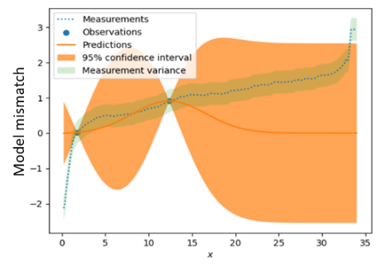  Figure 4: GP predictions with 2 observations | 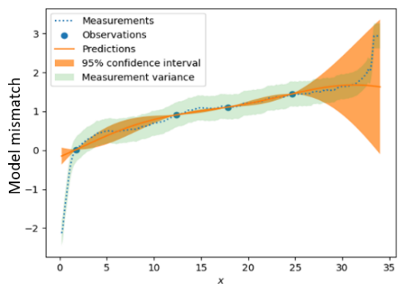  Figure 5: GP predictions with 4 observations
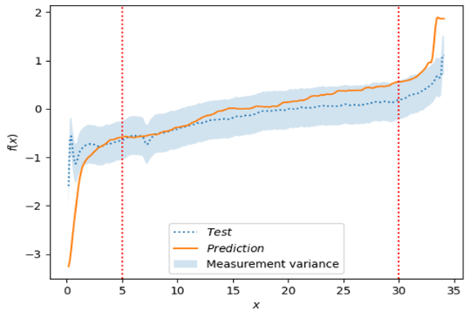  Figure 6: Comparison between the predicted $ε^{M}$ and the measured $ε^{M}$ | 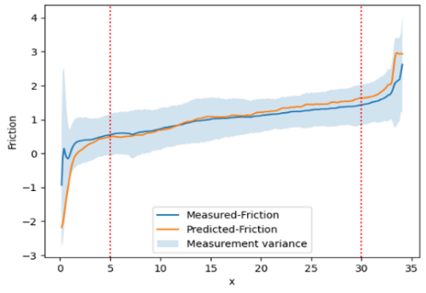  Figure 7: Comparison between the measured friction and that predicted by the hybrid model.
The results show that this hybrid model manages to predict in an accurate way the measured friction in case of homoscedastic variance. The future evolution of this work will include i) the comparison of the proposed approach with state estimation methods based on extended Kalman filters in order to be able to consider the variability in the hybrid model prediction; ii) the analysis of results considering different variance models to describe the distribution of measurement errors. Repeated experiments, in fact, showed that in some cases the variance from repeated runs is not constant in time but heteroscedastic.
Acknowledgements
The authors gratefully acknowledge the support of the Department of Chemical Engineering, University College London, UK, and GSK
References
Rathore N., Pranay P., Eu B., Ji W., Walls E. "Variability in syringe components and its impact on functionality of delivery systems." PDA Journal of Pharmaceutical Science Technology, Volume 65, 2011.
Zhong X., Guo T., Vlachos P., Veilleux J.C., Huaiqiu S. G., Collins D.S., Ardekani A.M., "An experimentally validated dynamic model for spring-driven autoinjectors.", International Journal of Pharmaceutics, Volume 594, 2021.
Rasmussen C.E., Williams C.K.I., “Gaussian processes for machine Learning”, The MIT Press, 2006.
Vijayaraghavan, R., Autoinjector Device for Rapid Administration of Life Saving Drugs in Emergency (Review Paper). Defence Science Journal, 62(5), 307-314, 2012.

