Modeling Substrate Degradation in Upflow Anaerobic Sludge Blanket Reactors
Federico Moretta, Luisa Carbone, Giulia Bozzano
Politecnico di Milano, Dipartimento di Chimica, Materiali ed Ingegneria Chimica, p.zza Leonardo da Vinci, 32, 20133, Milano (MI), Italy.
giulia.bozzano@polimi.it
Abstract
Anaerobic digestion concerns the conversion of organic resources into biogas, providing clean energy. The upflow anaerobic sludge blanket (UASB) reactor, known for its efficiency in wastewater treatment, utilizes biomass as granules, enhancing efficiency and reducing costs. However, the understanding around its substrate-biomass reactivity and interaction is limited, leading to complex and scarce modeling for biogas production and morganic matter remotion prediction. This work develops a dynamic model for UASB reactors, using a tanks-in-series model to better treat the hydrodynamic complexity. A lumped kinetic mechanism identifies key components: substrate, active biomass, inactive biomass, and methane. Emphasis is on granule dynamics, considering reaction-diffusion equations. Diffusion through particle boundary layers is analyzed for a realistic substrate concentration profile. Granule kinetics use the Monod equation, solved numerically through python programming language. The model, validated against literature and industrial data, enhances understanding of UASB reactor substrate degradation, aiding in system optimization for wastewater treatment.

Keywords: Anaerobic Digestion, Sludge, Mathematical Modelling, Transport Phenomena.
  - Introduction
Anaerobic digestion (AD) is an established technology in the wastewater treatment field which, through the metabolization of organic matter, can recover energy by producing biogas, a mixture of methane and carbon dioxide.
    - The process
The upflow anaerobic sludge blanket (UASB) is an anaerobic digester in which the microorganisms, that perform the digestion, are in granular form. This determines the capability of treating higher organic loading rates (OLR), a higher efficiency, compact volumes, and lower costs. It is comprised of two sections: a cylindrical column and a gas-solid separator. The influent wastewater enters at the bottom and flows upwards. The first section that it passes through is the sludge bed at the bottom of the reactor, which consists of very active biomass in the form of dense granules and heavy and sedimentable flocs. Here is the region in which the digestion proceeds at the highest rate. The next layer is the sludge blanket, where the microorganisms are present in the form of a suspension of lighter flocs. The various reactions keep going, but at a significantly slower pace. Finally, the three-phase separator divides the gas from the effluent wastewater, while most of the biomass is retained in the reactor.
    - The problem and purpose of the work
The aim of this work is to develop a generalized dynamic model to describe the behavior of the reactor, both at the particle scale and at the reactor level. The result proposed is highly innovative, as there is an evident lack of research focus on this type of reactor, despite being one of the most used technologies in its field (Mainardis et al., 2020). Furthermore, a focus is reserved for the dynamics of the granules, considering both kinetics and mass transfer, resulting in a model able to estimate their growth during operations using typical computational fluid dynamics techniques. No kinetic constant and transport parameters regression have been made but derived from common mathematical relations. Most models proposed in the literature are extremely complex, resulting in too high computational times and the necessity of complex input data, thus making them unsuitable for industrial purposes (Boiocchi et al., 2022; Michalopoulos et al., 2018).
    - Model key points
The problem under study presents complexities from several points of view: the hydrodynamics are non-ideal, with the fluid behavior being in between that of a plug-flow reactor (PFR) and a continuous stirred tank reactor (CSTR); the biochemical reactions are not describable with simple kinetics due to the inability to identify all the species that participate in the reactions. Finally, mass transport phenomena need to be taken into consideration, because of the heterogeneous nature of the system. Many methods can be identified to describe the fluid dynamics of the process, and the one used for this is the tanks-in-series models. This is considered as one-parameter model, since the variable that describes the flow is respectively the number of tanks in series (N) used to model the real reactor. This indicates how close the flow is to either a plug flow or a completely mixed regime, as it is linked to the Peclet (Pe) number. The kinetics are usually expressed by the Monod equation, the most used expression to model the growth of microorganisms. For the transport phenomena, some authors propose to neglect the external mass transfer due to the relatively high upflow velocities in the reactor, while others conclude that it may have a relevant impact on the system. Conversely, the internal mass transfer should not be disregarded.
  - Model description
The model here developed has been called GRANULE (generalized diffusion sludge particle model). It takes into consideration the non-ideal hydrodynamics of the reactor using a tanks-in-series (TIS) model. The core of the work can be identified in the reaction-diffusion equation, solved with the Finite Difference Method. Because of the focus on particle dynamics, a better understanding of the internal and external mass transfer phenomena affecting the granules can be achieved. To have comprehensive knowledge of the behavior of the main components present in the reactor environment, a lumped approach for the kinetics is chosen, with mass balance equations for the substrate, the active and inactive biomass, and the methane produced during the reactions. Because of the impossibility of solving analytically this type of problem, the model was implemented in Python and solved with numerical techniques. The model automatically select the amount of TIS needed for the simulation; through an iterative approach, until steady states conditions are reached.
    - Transport Phenomena
To model the particle dynamics, a mass balance of the substrate concentration is written, based on the following hypotheses:
- The granules can be assumed to be spherical in shape and uniform in size.
- The problem is spherically symmetric, meaning that considering a spherical polar system with r as the radial coordinate, θ as the polar angular coordinate and φ as the azimuthal angular coordinate, the only gradient is in the radial direction, making the problem one-dimensional.
- The convective term can be neglected, as it is assumed that the transport due to diffusion is much higher with respect to this (Rodríguez-Gómez et al., 2013).
- A quasi-steady state is assumed to simplify the ODE resolution.
- The biomass concentration inside the particle is uniform.
- The reaction term can be described using the Monod equation.
- The diffusion flux is expressed by Fick’s law, and to evaluate the diffusion coefficient $D$ the Wilke-Chang correlation is used, assuming that the physical characteristics of both the substrate and the wastewater can be approximated with the water ones.
- The external mass transfer coefficient is evaluated using the Kolmogorov theory for turbulent flows.
The resulting expression is:
$D\frac{1}{r^{2}}\frac{d}{dr}\left(r^{2}\frac{{dS}_{P}}{dr}\right)-\frac{μ_{MAX}}{Y}\frac{X}{K_{S}+S_{P}}S_{P}=0$ | (1)
Where S_{P} is the substrate concentration inside the particle [kg/m³], X is the biomass concentration [kg/m³], $μ_{MAX}$[d⁻¹] and K_{S} [kg/m³]are respectively the maximum growth rate of the microorganisms and the half-saturation constant, and Y is the stoichiometric yield. With the boundary conditions:
${\left.\frac{{dS}_{P}}{dr}\right|}_{r=0}=0$ | (2)
$D{\left.\frac{dS_{P}}{dr}\right|}_{r=R}\text{= }k_{m}\left(S-{\left.S_{P}\right|}_{r=R}\right)$ | (3)
Where Equation (2) is the condition of symmetry at the center of the granule, and Equation (3) states that the diffusive flux at the surface of the particle must be equal to the external convective transport, expressed as the product of the external mass transfer coefficient $k_{m}$[m/s] and the difference between the bulk concentration S [kg/m³] and the concentration on the surface of the particle. S_{P} is the substrate concentration inside the particle, which differs from S because of the resistance to the transport of the substrate given both by the wastewater (external resistance) and by the particles themselves (internal resistance). Because of this difference, it is more accurate to use S_{P} in the model.
Equation (1) does not have an analytical solution; therefore, the Finite Difference Method was utilized to solve it. The first order derivative was discretized using a first-order forward difference scheme and the second derivative was discretized with a second-order central difference scheme.
    - Kinetic system and mass balances
To take into consideration the non-ideal hydrodynamics of the UASB, a tanks-in-series model has been utilized. The reactor is thus divided into a N number of CSTRs, each of equal volume V_{j} [m³]
$V_{j}=\frac{V}{N}$ | (4)
For each j-th reactor it is possible to write:
$\frac{dS_{j}}{dt}=\frac{Q}{V_{j}}\left(S_{j-1}-S_{j}\right)-{ηR}_{j}$ | (5)
$\frac{dX_{j}}{dt}=\frac{Q}{V_{j}}\left(X_{j-1}-X_{j}\right)+ηR_{j}Y-K_{d}X_{j}$ | (7)
$\frac{dE_{j}}{dt}=\frac{Q}{V_{j}}\left(X_{j-1}-X_{j}\right)+K_{d}X_{j}$ | (8)
These are the mass balances respectively for the concentration of substrate S [kg/m³], the active biomass X [kg/m³], and the inactive E [kg/m³]. The latter is an indication of how much biomass dies during operations. The microbial decay is an inevitable phenomenon due to several factors, especially the lack of nutrients. It is assumed that it can be modeled with a first order kinetic expression, depending on the biomass concentration, and described by the decay constant K_{d} [d⁻¹]. The reaction term R_{j} at the macro scale is different with respect to the Monod kinetics, because it needs to consider what is occurring to the particles. It is defined as the diffusion flux, multiplied by the surface that it traverses, i.e., the surface of the particle, and by the number of particles present in the reactor (N_{p}).
$R_{j}= -D ∇S_{P}⋅ 4πR^{2}N_{p}$ | (8)
It is assumed that no new granules are formed, hence the microbial growth manifests itself simply as the growth of the already-formed particles. N_{p} is calculated at the start of the simulation through the formula:
$N_{p}= \frac{X_{0}+E_{0}}{ρ_{biomass}}\frac{1}{\frac{4}{3}πR_{0}^{3}}$ | (9)
Where X₀ and E₀ are the entirety of the biomass that enters the first CSTR, ρ_{biomass} is the density of the biomass and R₀ [m] is the initial average radius of the particles. From Equation (9), because of the assumption of constant N_{p}, it is then possible to calculate the new radius of the particles, after the ODE system is solved. Furthermore, η is the internal mass transfer efficiency, defined as follow:
$η=\frac{\int{RdV}}{R_{surface}V}= \frac{3D{\left.\frac{dS_{P}}{dr}\right|}_{r=R_{P}}}{\frac{μ_{MAX}}{Y}\frac{X}{K_{S}+S_{P}\left(r=R_{P}\right)}S_{P}\left(r=R_{P}\right){ R}_{P}}$ | (10)
In each reactor the same flowrate Q enters, and it is assumed that the inlet one is equal to the outlet (steady conditions). To describe the concentration of methane calculated, Equation 11 is considered. It is assumed that in each CSTR no methane enters, as it is only formed in the reactor through the reaction, and the methane formed exits each reactor.
$\frac{dM_{j}}{dt}=-\frac{Q}{V_{j}}M_{j}+{ηR}_{j}$ | (11)
Where M is the methane concentration [kg/m³]. Finally, the number of reactors into which the UASB is divided is chosen by the user.
  - Results and Discussion
To validate the model, it was compared to two other works proposed in the literature: the model presented by Bolle et al. (1986) and by Pontes and Pinto (2006). In both models the UASB is divided into two CSTRs to describe respectively the bed and the blanket, and one PFR to represent the settler, in which it is assumed that no reactions take place. In the bed there is the presence of dead volumes, while two short circuiting flows are defined. Consequently, two different simulations were performed: the first one (Scenario 1, Figure 1a) was done in batch mode, meaning in an ideal situation in which the reactor was assumed to not have input and output flows; while the second simulation (Scenario 2, Figure 1b) the UASB is in continuous mode. The results are represented in Figure 1a-b, with the GRANULE trend described by the continuous line, and the literature models expressed by their main values, reported respectively by the red and blue dots.
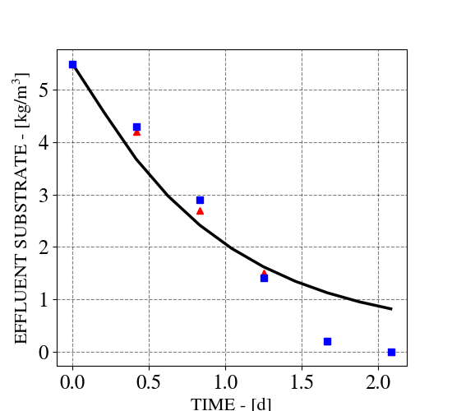  (a) | 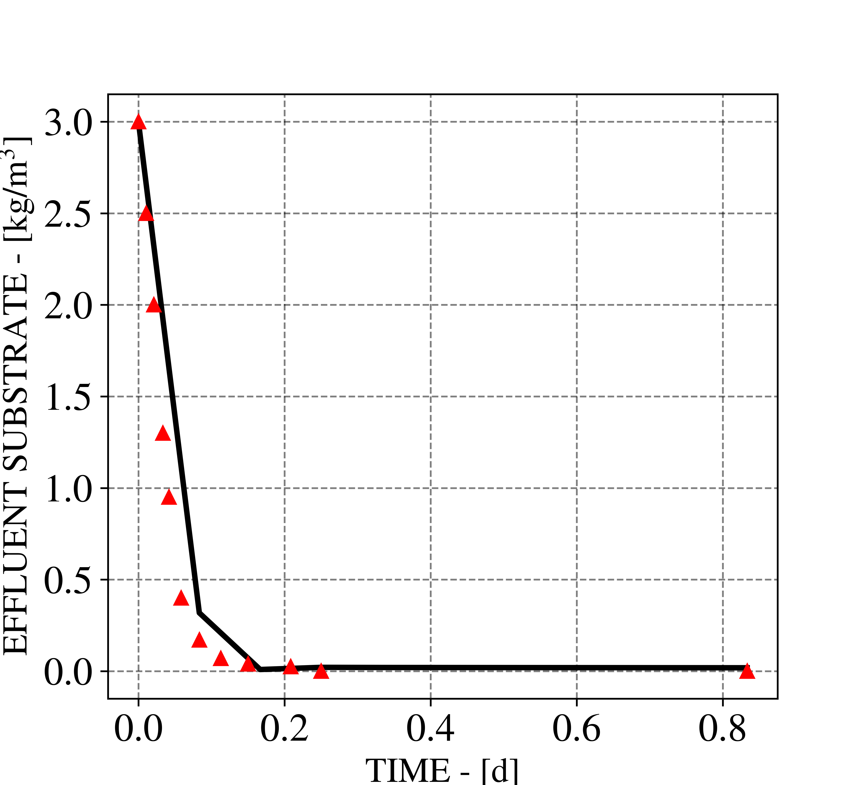  (b)
Figure 1. Effluent substrate comparison between model (black line) simulation in (a) Scenario 1, with Bolle et al. (red triangles) and Pinto ed al. (blue squares) data; and (b) Scenario 2 with Pinto et al. data.
As is it possible to see, the model adequately describes the trend of both the literature models, with negligible discrepancy. This may be due to the differences in the kinetics used in the models. Other experimental data set were taken from the work of Leitão et al., (2005), and from Shanmugam and Akunna (2008); which comparison is shown in Figure 2a and 2b respectively.
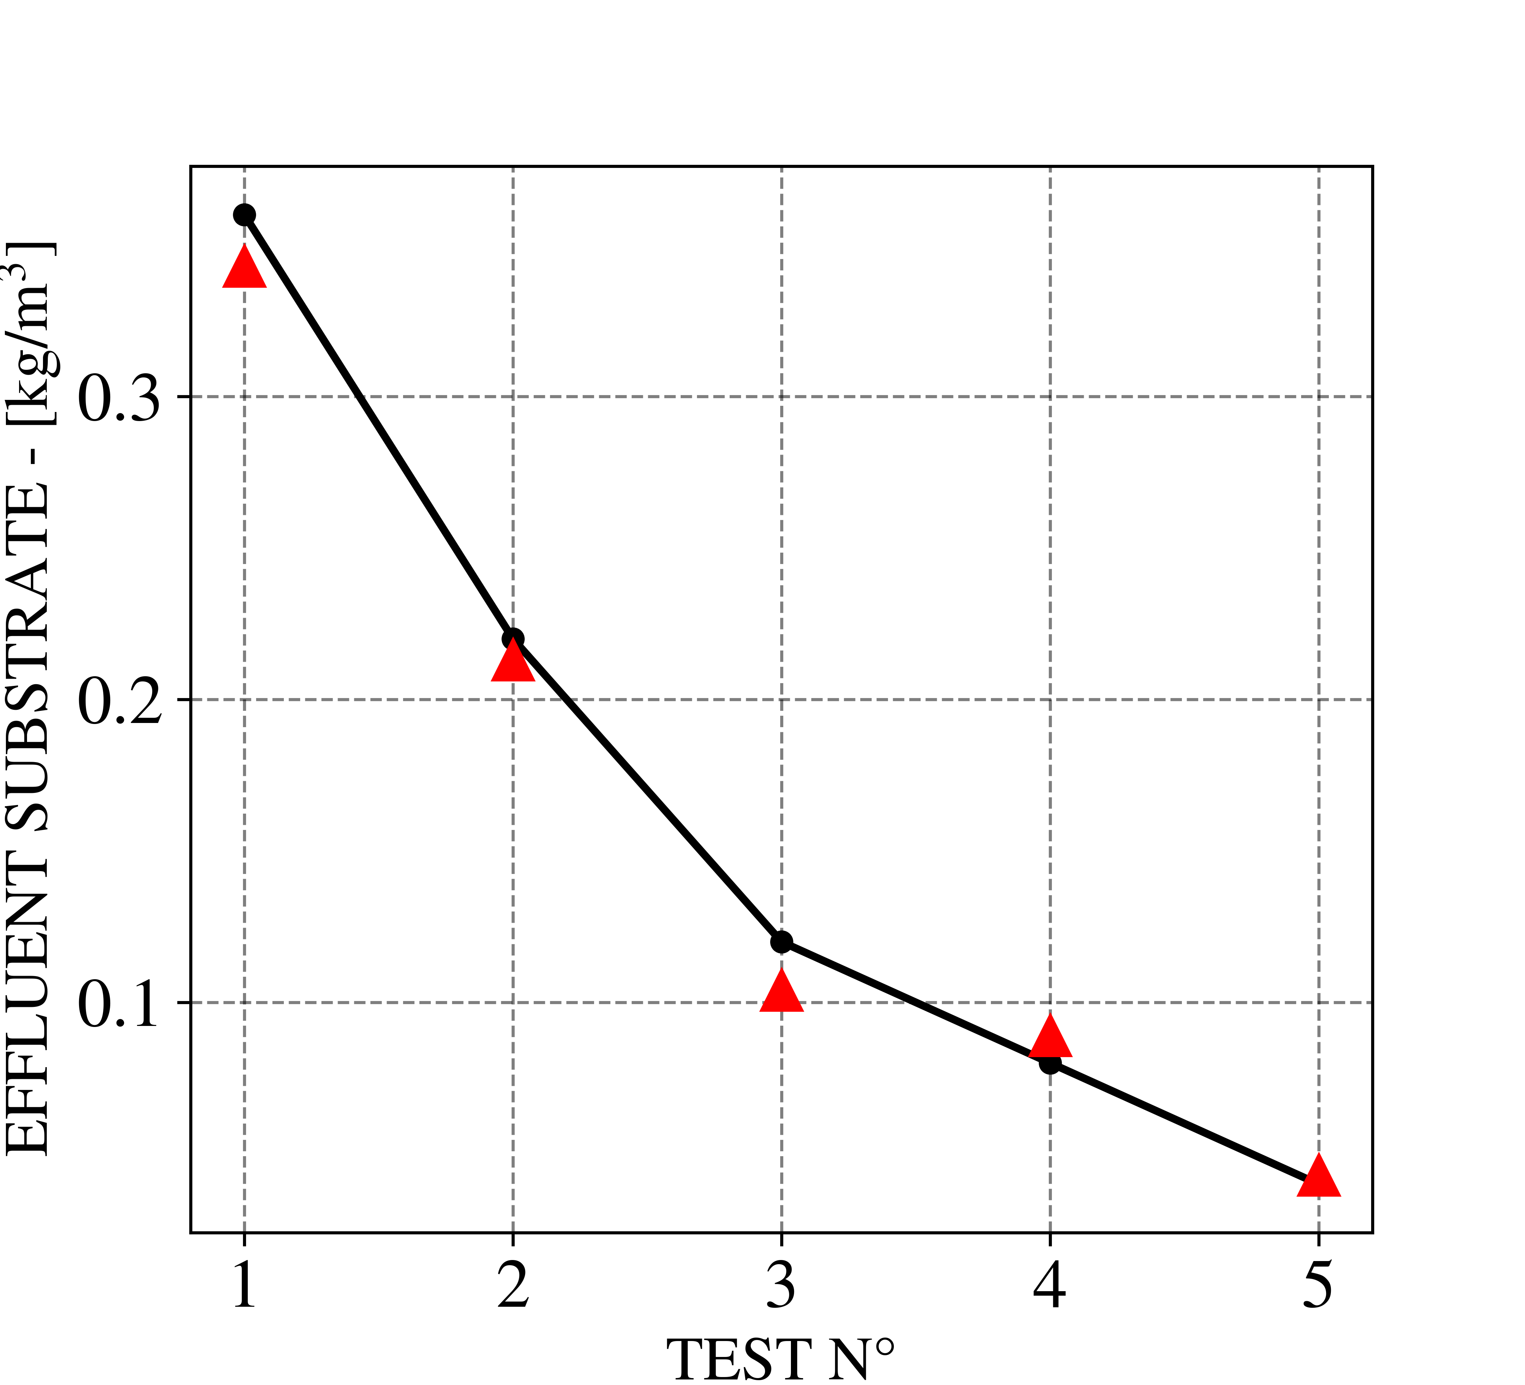  (a) | 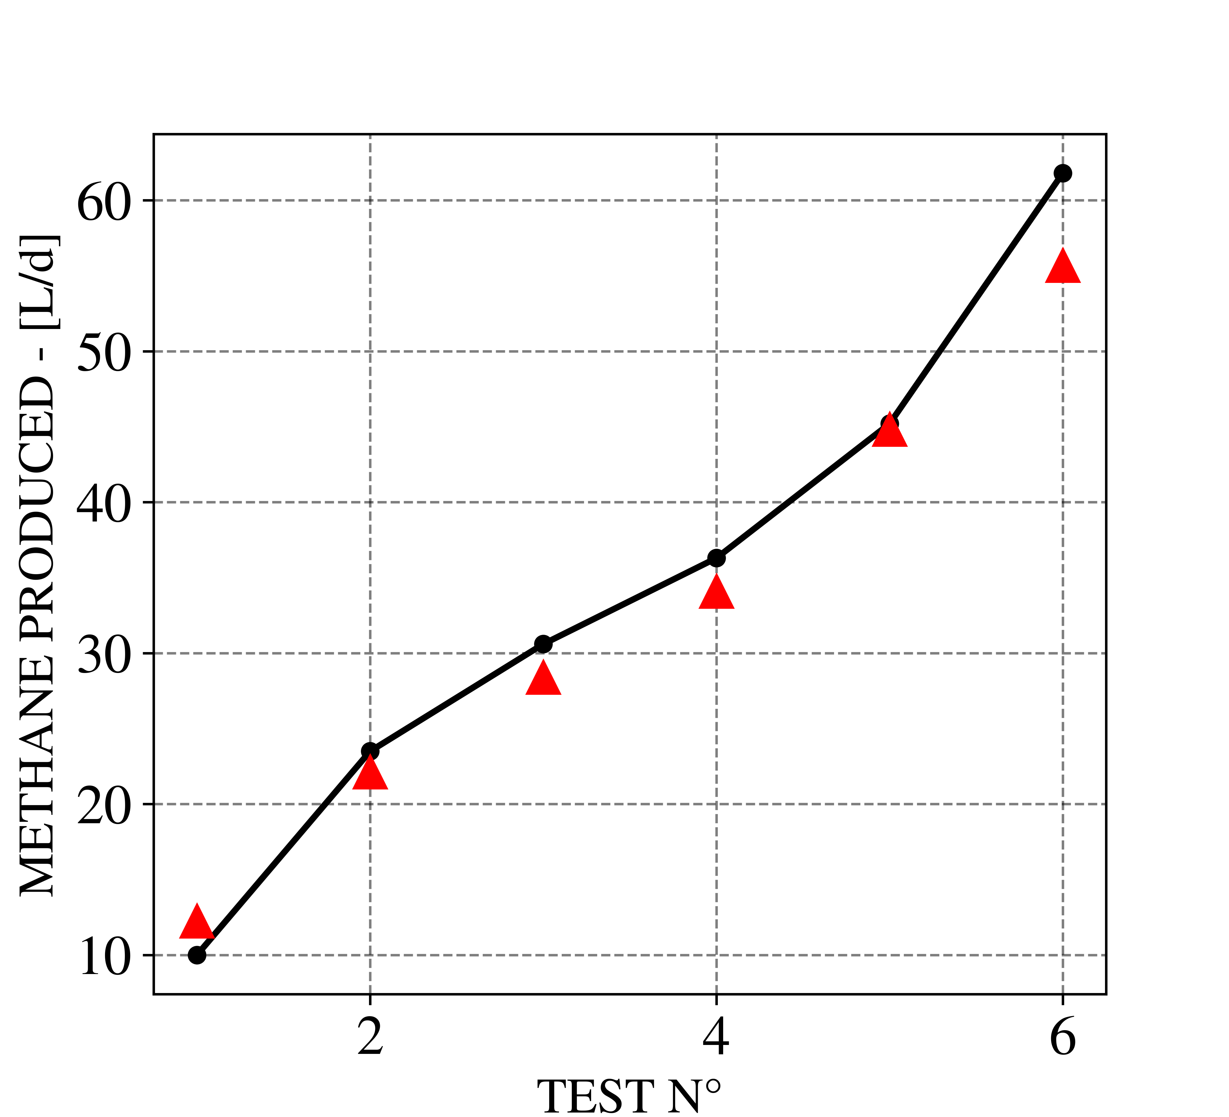  (b)
Figure 2. Results of comparison of model (line with mark) with experimental data from (a) Leitao et al. and (b) Shanmugam & Akunna data (red triangles).
As it is possible to see, the model adequately describes methane production too. It is possible to confirm that in all cases, the model can describe properly the trends delineated by the experimental data.
  - Conclusions
This work successfully brings to the development of a dynamic UASB reactor model, which has a significantly low computational time, and correctly describe the dynamics of an extremely complex process, despite its simplicity. As confirmation to this, comparison done with simulation and experimental data from the literature has been made, bringing successful results.
However, improvements are suggested, such as refining lumped kinetics to distinguish substrate types and bacterial species. Specifically, modeling volatile fatty acids and differentiating microbial species (acidogenic, acetogenic, and methanogenic) would enhance its accuracy. For kinetic parameters, calibration using more data and regression analysis is proposed, since here phenomenological approach have been used. Despite these possible enhancements, the presented work marks great progress in modeling UASB reactors, with the potential to become a valuable tool in wastewater treatment.
References
Boiocchi, R., Zhang, Q., Gao, M., Liu, Y., 2022. Modeling and optimization of an upflow anaerobic sludge blanket (UASB) system treating blackwaters. J. Environ. Chem. Eng. 10, 107614. https://doi.org/10.1016/j.jece.2022.107614
Bolle, W.L., van Breugel, J., van Eybergen, G.C., Kossen, N.W., van Gils, W., 1986. An integral dynamic model for the UASB reactor. Biotechnol. Bioeng. 28, 1621–1636. https://doi.org/10.1002/bit.260281106
Leitão, R.C., Silva-Filho, J.A., Sanders, W., van Haandel, A.C., Zeeman, G., Lettinga, G., 2005. The effect of operational conditions on the performance of UASB reactors for domestic wastewater treatment. Water Sci. Technol. J. Int. Assoc. Water Pollut. Res. 52, 299–305.
Mainardis, M., Buttazzoni, M., Goi, D., 2020. Up-Flow Anaerobic Sludge Blanket (UASB) Technology for Energy Recovery: A Review on State-of-the-Art and Recent Technological Advances. Bioengineering 7, 43. https://doi.org/10.3390/bioengineering7020043
Michalopoulos, I., Kamperidis, T., Seintis, G., Pashos, G., Lytras, C., Papadopoulou, K., Boudouvis, A.G., Lyberatos, G., 2018. Experimental and numerical assessment of the hydraulic behavior of a pilot-scale Periodic Anaerobic Baffled Reactor (PABR). Comput. Chem. Eng. 111, 278–287. https://doi.org/10.1016/j.compchemeng.2018.01.014
Pontes, R., Pinto, J., 2006. Analysis of integrated kinetic and flow models for anaerobic digesters. Chem. Eng. J. - CHEM ENG J 122, 65–80. https://doi.org/10.1016/j.cej.2006.02.018
Rodríguez-Gómez, R., Renman, G., Moreno, L., Liu, L., 2013. A model to describe the performance of the UASB reactor. Biodegradation 25. https://doi.org/10.1007/s10532-013-9656-z
Shanmugam, A.S., Akunna, J.C., 2008. Comparing the performance of UASB and GRABBR treating low strength wastewaters. Water Sci. Technol. J. Int. Assoc. Water Pollut. Res. 58, 225–232. https://doi.org/10.2166/wst.2008.338

