Modelling and Simulation of a Forward  
Osmosis Process

Matej Ružičkaa, Ingrid Helgelandb and Radoslav Paulena

aFaculty of Chemical and Food Technology, Slovak University of Technology in Bratislava, Bratislava, Slovakia

bAquaporin A/S, Lyngby, Denmark

xruzickam@stuba.sk

Abstract

Forward osmosis (FO) is an effective alternative to a more established reverse osmosis (RO) process, which is used mainly for water extraction and concentration of aqueous solutions. This work is focused on modelling of the FO process to understand its behaviour, characteristic features required for its subsequent optimisation. We develop the mathematical model of the process based on mass balances and theoretical foundations from mass transfer theory. We then fit the model using the experimental data. We study the appropriateness of using white, grey, and black box modelling principles. The results favour the grey-box strategy as it accounts for common over-simplifications of the model on mass transfer effects, yet it respects the fundamental laws.

**Keywords**: Membrane Processes, Forward Osmosis, Reverse Osmosis, Mathematical Models

* 1. Introduction

Membrane technology is well established in process industry mostly for purification and concentration of aqueous solutions. A popular membrane process, e.g., for seawater desalination is reverse osmosis (RO). Compared to RO, the forward osmosis (FO) process is less popular (Kucera, 2015). Its potential is though vast in water purification and solutions concentration. While in RO, a high external hydraulic pressure is applied to the feed solution, in FO, the separation is based on a natural osmotic pressure. This enables various benefits such as harmlessness to feed solutions and promising energy savings.

To stand up to the expectations, the FO plants need to be optimally designed and operated (Ali et al., 2021). For this purpose, mathematical modelling is needed to reveal characteristic (static and dynamic) behaviour of the process under different design and operational decisions. One of the biggest challenges in membrane process modelling is to reliably predict the membrane flux given system state (temperature, pressure, species concentrations, etc.). Although mass transfer theory provides several well understood mechanisms and theoretical foundations, it is often indicated that the experimenters encounter deviations from the ideal (theoretical) behaviour (Khan et al., 2023).

In this paper, we employ white (first-principles model derived from literature), grey (first-principles model combined with a regression model fitted with experimental data), and black box modelling (simple regression model) principles to identify a mathematical

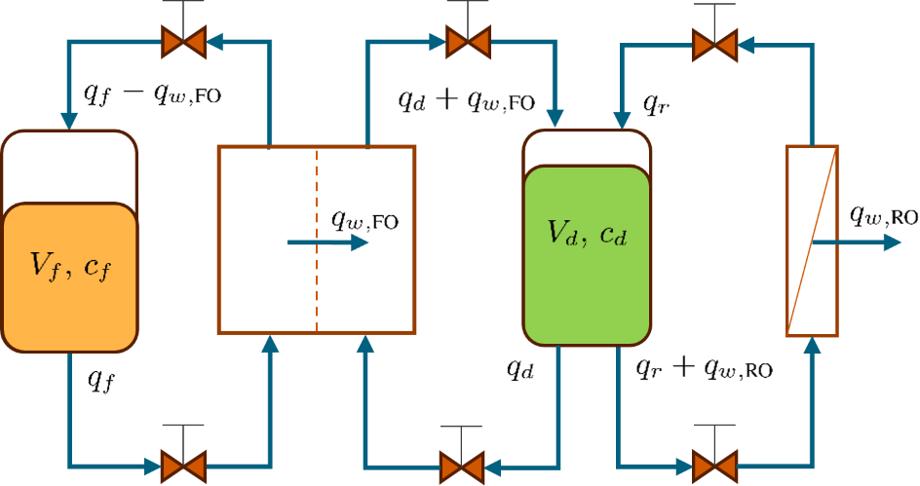

Figure 1: Scheme of the forward osmosis process.

model of an FO process. The achieved results indicate that the grey box modelling is the best alternative as the obtained model is the most reliable one.

* 1. Problem Description

The FO process essentially consists of feed and draw tanks and membrane modules (FO and RO). The process system is schematically depicted in Figure 1. The draw solution is prepared such that its osmotic pressure is much higher than the osmotic pressure of the feed solution. This gives a prerequisite for establishing a driving force for the separation of water from the feed, i.e., osmotic pressure difference. An FO membrane module, which involves a functional layer (made of aquaporin in our case), provides an interface between the feed and draw solutions. By design and thanks to the natural phenomena, water passes from the feed to the draw solution. As a result, the feed solution gets concentrated. Consequently, draw solution gets diluted and needs to be recovered for the effective continuation of the process. For this purpose, an RO membrane module with a similar or same type of membrane as in FO module is placed in the system. For the separation of water to occur through the RO membrane, external pressure is required that be supplied by a pump. Final products of the process are the purified water and concentrated feed. If the materials of the used membranes and composition of the draw tank are selected appropriately, the separation of water from the draw solution (regeneration of the draw solution) is more energy efficient than using the RO directly for the feed solution.

It is, however, not only the design of the process chemical side (the used membrane and draw solution materials) that contributes to the overall energy efficiency. The process should be designed (decisions should be made on types and sizes of membrane modules and used pumps) and operated in an optimal manner. The optimal operation should take into account dynamic behaviour of the system. One should decide whether the draw tank should be kept in a steady-state condition (water removal through the RO module equal to the water flow through FO module) or whether the system should operate in some form of a cyclic regime (e.g., switching the separation through the RO membrane on/off periodically). For this purpose, a mathematical model of the process is developed here.

* 1. Process Modelling

For the development of a mathematical model, we assume perfect mixing in the tanks, fully developed hydraulic profiles, ideal membrane rejection (perfect passage of water and no passage of other substances), and common and constant temperature and density of all streams. We use the following notation. Indexes *w*, *f* , *d*, FO, and RO stand for water, feed, draw, forward and reverse osmosis, respectively. *V* stands for the volume (in L), *q* for flowrate (in L/h), *J* for permeate flux (in LMH, i.e., L/m2/h), *A* for the area of a membrane (in m2), Δ*P* for the transmembrane pressure (in bar), and *c* for the concentration (in kg/L). Mass balance of the system in Figure 1 then reads as:

The commonly used models for water flux through forward and reverse osmosis membranes can be obtained from the literature (Khan et al., 2023) as:



where *kw* stands for water permeability. The osmotic pressure *π* can be modelled as (Foley, 2013):



where *i* is the van’t Hoff factor, *R* is the gas constant, and *T* is the temperature.

The mathematical model presented in Eqs. (1)–(4) is a first-principles model. Using a white-box modelling principle, one can plug in the parameter values to obtain a final instance of the model ready for simulation, optimisation, etc. A common situation in practice is that the simplifications made by the process modelling assumptions result in inadequacies when model simulation results are compared to the experimental measurements. To counteract these, a grey box modelling approach (Cozad et al., 2015) is an alternative. This amounts to selecting an altered functional form of certain phenomena in the developed model while respecting the fundamental laws such as mass balances. In the case of FO process modelling, we opt for parameterising the permeate flux by a polynomial in *cf(t)* and *cd(t)*. A black box approach is another alternative, when the mass balance cannot be constituted reliably, e.g., due to missing information on system inflows and outflows. In such a case, one could form the prediction model of the water flux through a membrane similarly to the grey box approach, yet mass balance equations would not be included in the model fitting procedure.

* 1. Model Fitting

Assuming an experiment conducted over a certain time period with the permeate fluxes, volumes, and concentrations measured, one can train the grey box model via:

where *N* is the number of experimental measurements, upper index exp denotes the measured values and σ is the standard deviation of the measurement noise. Conditions (5b) involve mass balance equations as well as initial conditions of the states, which can also be estimated. Equations (5c) and (5d) represent polynomials of an appropriate order, whose parameters p are to be estimated. Due to the presence of Eqs. (1a)–(1d), (5) results in a dynamic optimisation problem.

The black box approach is much simpler in our studied case. It involves solving:

Problem (6) represents a simple regression. This approach can be regarded to be of static nature as any consequence of taking measurements in subsequent time steps is neglected.

* 1. Results

The experimental measurements were gathered using a setup similar to Figure 1 with an FO membrane module containing hollow fibre Aquaporin RO/FO membrane and using orange juice as the feed solution and K-lac as a draw solution. K-lac is used as it offers high values of osmotic pressure. The temperatures of the streams were kept constant during the experiment. The main difference of the experimental setup, compared to Figure 1, was the absence of RO membrane, thus no draw solution regeneration took place. The experiment took 4 hours and 25 minutes, after the initial period with full recycle regime for the process start up. The starting volume in the feed tank was 250 L. The corresponding sucrose concentration of the orange juice was 11.2 Brix.

Throughout the experiment, fresh draw solution has been used and thus its concentration was kept constant. Three different concentrations were used consecutively: 20% w/w for the first hour of the experiment, 40% w/w in the following 84 minutes, and 60% w/w for the rest of the experiment duration. After 45 minutes of the experiment run, feed volume was too low. Therefore, 36 L of fresh water was added over a period of 10 minutes.

Measurements of concentration and volume in the feed tank as well as FO membrane water flux were measured every ten seconds, yielding 1,590 data points for each measured output. Volume (concentration) measurements were not recorded for one interval (two intervals) with duration of 10 minutes, which slightly reduces the dataset cardinality. The conditions of the experiment, i.e., the absence of the RO part, simplify the problem (5), making the Eqs. (1b), (1d) and (3) (and consequently Eqs. (5d) and (6c)) unnecessary.

We implemented the problems (5) and (6) in CasADi (Andersson et al., 2019) via python interface. We considered linear and quadratic forms of polynomials in Eq. (5c). We have estimated the values of standard deviations of measurement errors using the experimental data. The results of fitting the black box model are shown in Figure 2 for the best fit A comparison of a graph
obtained that is by the quadratic form of Eq. (6b), which showed the smallest lack-of-it using the statistical p-value test. We show the exact result of fitting (left hand plot, Figure 2a) and the performance of the fitted model in dynamic simulation of the experiment according to the model (1) (right hand plot, Figure 2b).

Based on the experimental data, we can conclude that higher the feed concentration, higher flux measurements variations. We thus cannot expect any of the trained models to be particularly suitable for accurate prediction in such conditions. From the fitting results of the black box model (Figure 2a), it is apparent that the fit is best for the data in the first hour of the experiment with low concentrations of feed and draw solutions. The fit gets evidently worse already for the values *cd* = 40%w/w. For the last part of the experiment (with high feed concentrations), one cannot reliably conclude appropriateness of the fit. Looking at the Figure 2b, one can observe that the model performs even worse and if used for further purpose, e.g., process design or optimisation, its results would be unsatisfactorily when compared with reality. This is caused by the model being fitted with the experimental values of concentrations that did not respect the mass balance (lacking data reconciliation), resulting in the unrealistic predictions.

When fitting the grey box model, the best form of the flux equation (5c) turned out to be linear, which already shows a large difference between black box and grey box models. We can highlight that the grey box modelling approach results in a simpler model. At this point, we can also assess the appropriateness of the white box model. If the white box model was appropriate, i.e., if the FO flux can be described by Eqs. (4) and (2), the grey box model would turn out to contain similar coefficients multiplying feed and draw concentrations. This is not the case that we observe here. The difference in the magnitude of the coefficients is a factor of 50. We thus conclude that the white box model is unsuitable in this application.

The results of the grey box modelling are depicted in Figure 3 that compares it simultaneously with black box model under the dynamic simulation of the conducted experiment. As we can see, the grey box model represents measured data more accurately. This is especially true when observing the values of volume in the feed tank, which is the output variable measured most accurately. We can also observe the already expected trend that the model cannot produce reliable predictions for higher values of the feed concentrations. Another experiment would be necessary to improve it.

* 1. Conclusions

We studied modelling of a forward osmosis process as a prerequisite for process optimisation. We compared three approaches to model building: white, grey, and black box. The results show that grey box approach is superior as it can account for nonideal behaviour of the membrane (as compared to what white box model would assume based on simplified mass transfer theory) and, at the same time, it respects the mass balances during the training (compared to the black box approach that neglects such information).

References

S. M. Ali, S.-J. Im, A. Jang, S. Phuntsho, H. K. Shon, 2021. Forward osmosis system design and optimization using a commercial cellulose triacetate hollow fibre membrane module for energy efficient desalination. Desalination 510, 115075.

J. A. E. Andersson, J. Gillis, G. Horn, J. B. Rawlings, M. Diehl, 2019. CasADi – A software framework for nonlinear optimization and optimal control. Mathematical Programming Computation 11 (1), 1–36.

A. Cozad, N. V. Sahinidis, D. C. Miller, 2015. A combined first-principles and data-driven approach to model building. Computers & Chemical Engineering 73, 116–127.

G. Foley, 2013. Membrane Filtration: A Problem Solving Approach with MATLAB. Cambridge University Press.

M. A. W. Khan, M. M. Zubair, H. Saleem, A. AlHawari, S. J. Zaidi, 2023. Modeling of osmotically-driven membrane processes: An overview. Desalination, 117183.

J. Kucera, 2015. Reverse osmosis. John Wiley & Sons, Ltd.