A hierarchical selection and decision matrix for energy-efficient intensified distillation technologies
Qing Li,ª Ana Somoza-Tornos,ª Anton A. Kiss^{a*}
ªDepartment of Chemical Engineering, Delft University of Technology, Van der Maasweg 9, Delft, 2629 HZ, The Netherlands
A.A.Kiss@tudelft.nl
Abstract
Distillation is widely used for separation in chemical industries, but accounts for a half of operational costs and 40% of the energy usage due to its low energy efficiency. Process intensification could effectively enhance the energy efficiency and reduce the energy requirement of the distillation processes by integrating unit operations or functions. However, there is no general methodology that enables to choose the best intensified distillation technologies among all available choices for a given separation task. This study generates a conceptual de-composed selection and decision approach by first identifying the process bottlenecks and intensification targets, and then select the most promising intensified techniques via a selection framework and decision matrix based on the identified bottlenecks and intensification targets. Two separation cases are illustrated to demonstrate the developed methodology, and the outcomes are verified with conceptual designs reported in the literature.
Keywords: Distillation; process intensification; energy efficiency; process optimization
  - Introduction
Distillation is the most widely used separation technology in chemical industries. However, because of its relatively low thermodynamic efficiency, distillation accounts for around half of the operational costs of chemical plants (Kiss et al., 2012). To reduce the operational costs as well as the capital costs, advanced distillation techniques based on process intensification (PI) principles are considered highly competitive in terms of enhancing the energy efficiency and economic performance. However, matching suitable intensified distillation techniques – such as heat pump assisted distillation (HPAD), heat integrated distillation (HIDiC), membrane assisted distillation, high gravity (HiGee) distillation, cyclic distillation (CyDist), thermally coupled distillation systems (TCD), dividing wall column (DWC), extractive distillation and azeotropic distillation – with given separation tasks based on a wide range of application cases (e.g., a variety of mixtures, a wide range of feed flowrates and concentrations, and different products purities) remains a crucial problem. Currently, to the best of our knowledge, there is only one paper that developed a framework for choice of intensified reaction equipment (Commenge and Falk, 2014), but no general methodology that allows the selection of the most promising PI technologies for different fluid separation tasks, and screening the PI opportunities for process design becomes a challenge.
To address this decision-making problem, this work is the first to develop a knowledge-based methodology that provides a list of most promising intensified distillation techniques for given separation tasks via a novel PI matrix. The first step of the methodology consists in analyzing the given separation task in terms of selection criteria (e.g., volatile difference between key components, the type of separation tasks, feed and product flow, product specifications at different target purity levels, operating pressure, reboiler duty and its temperature level, reflux ratio, heat of vaporization). Subsequently, the methodology relates the selection criteria to process bottlenecks and promising intensified distillation techniques, through a connection matrix, in order to effectively address the identified bottlenecks. Finally, each selected techniques are scored and the potential solutions are compared against the task specifications.
The PI matrix proposed in this work aims to yield a short list of appropriate solutions to be designed and economically assessed, proposing a screening framework for separating binary and ternary mixtures in order to make a rapid selection at an early stage, applying to both ideal and non ideal separation systems. Two case studies related to methanol-water and benzene-toluene-xylene mixture (BTX) separation are carried out to illustrate the application of the proposed methodology. The proposed CAPE methodology may also help reduce the search space before carrying out rigorous optimization for the synthesis and design of the distillation.
  - Problem statement
The selection of promising intensified distillation techniques among possibilities (i.e., heat pump assisted distillation, HIDiC, membrane assisted distillation, HiGee, cyclic distillation, thermally coupled distillation systems, DWC, extractive distillation and azeotropic distillation) is challenging for given tasks (e.g., variety of mixtures, a wide range of feed flowrates and concentrations, and different products purities). This work develops a decision matrix to select promising intensified distillation technologies before carrying out detailed process design, based on the different separation bottlenecks and intensified targets, aiming to provide a generate user-friendly and easy-to-understand selection method.
  - Results and discussion
This section describes the proposed research approach and supporting case studies. Two case studies of industrial relevance are used to demonstrate the application of the new approach: non-ideal binary separation (methanol-water), and an ideal ternary mixture, benzene (B)/toluene (T)/xylene (X) separation.
    - Key benefits and disadvantages of the intensified distillation technologies
Table 1 lists the intensified distillation techniques considered in this study, including intensification targets, features, key advantages and disadvantages of each technology. Binary and ternary separation are defined base on the number of products.
    - Identification of limitations and criteria
For a given separation task, three sets of data are first extracted: the basis of the tasks (feed composition, key components and separation requirements), thermodynamics and kinetics, as shown in Figure 1. Next, the following steps show the proposed approach.

Step 1. Special components identification in the mixture: The non-condensable components, which result in low condenser temperature; components with the risk of solidification (freezing); thermo-sensitive components, e.g., thermal denaturation, polymerizing or decomposing are identified by following the high level questions, which are proposed in Figure 1, as well as the recommended distillation techniques.

Table 1. Features and performances of intensified distillation technologies
Type | Key feature | Remarks on design and performance
Ternary | 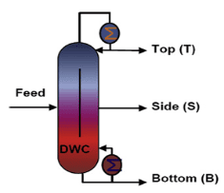 | Dividing wall column (DWC)  + Low re-mixing effects  + Highly purified side products  + CAPEX reduction  + Reduced energy demands  – Less degree of freedom on operating pressure  – Complex column structure and control
Ternary | 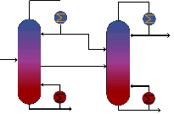 | Thermally coupled distillation (TCD)  + Low re-mixing effects  + Highly purified side products  + Reduced energy demands  – Operation complexity  – Complex control
Binary | 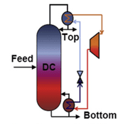 | Heat pumps assisted distillation (HPAD)  + Upgrading energy level  + Reduced energy demands  – High Capex of large heat pumps  – High Capex of large temperature lifts
Binary | 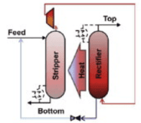 | Heat integrated distillation columns (HIDiC)  + High energy savings  + Size reduction  – Vacuum column not applicable  – Operation and design complexity  – Complex process and control
Binary | 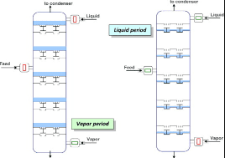 | Cyclic distillation (CyDist)  + No liquid remixing or flooding on the stage  + High product purities  + High mass transfer efficiency  + Reduced energy demands  + Adjustable residence time  – Operation complexity  – Vacuum column not applicable  – Complex column structure and control
Binary /  Ternary | 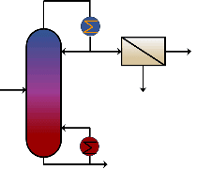 | Membrane assisted distillation (MAD)  + Size reduction  + Reduced energy demands  + Facilitated separation process  + Enhanced product purities  – Increased rotation devices for compression  – High Capex  – Short lifetime
Binary | 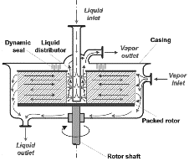 | HiGee  + High mass transfer efficiency  + Reduced energy demands  + Size reduction  – Difficult to scale up  – Complex process design and control  – Aversion to long-periodic operation

Step 2. Phase equilibrium limitation identification: separations are categorized as azeotropic mixture and very close boiling point mixture separation (ΔT_{b}≤10°C); close boiling point mixture separation (10°C<ΔT_{b}<20°C); and (near)ideal mixture separation (ΔT_{b}≥20 °C) based on the normal boiling point difference (ΔT_{b}) and relative volatilities (RV). High heat of vaporization, high recovery or high purity products can also lead to high energy requirements even for (near)ideal mixture separations.

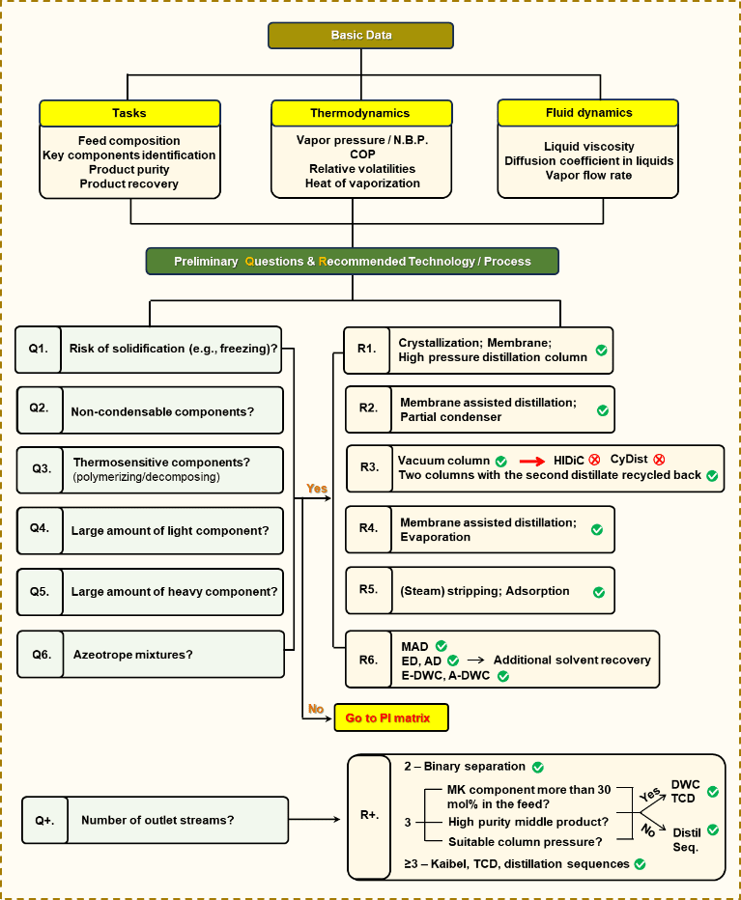
Figure 1. Conceptual framework of the intensified distillation techniques selection

Step 3. Mass transfer limitation identification:
Mass transfer could be limited by high viscosity (dimensionless correlating to Reynolds number), which causes difficulties to create turbulence and achieve high gas/liquid interface; low liquid phase diffusion coefficient leads to inefficient vapor liquid mass transfer; high vapor flow rate, which leads to liquid foam, flooding, and liquid mixing on the tray; and low vapor flow rate could also limit the mass transfer of the separation.

The criteria from Step 2 and Step 3 are composed in an intensification matrix for advanced distillation technologies, as shown in Figure 2. The column lists the advanced distillation technologies, and the row lists the decision criteria. The check mark means the specific technology is recommended when meeting the criteria; the exclamation mark represents the technology is good to be considered, but further check is needed; while a cross mark represents the technology is not good to be used according to that specific criteria. No marks means the criteria is not relevant to the decision of the specific technology. Taking the first column as an example, if ΔTb≤10°C, conventional column is possible to achieve the separation requirement, while further check of the reflux ratio and the energy requirement are needed, HPAD and HIDiC are recommended, cyclic distillation is not applicable in this case. With this intensification matrix, both the relevance (i.e., whether the criteria has an influence on the selection of the specific technique), and the recommendation level of the techniques are suggested.
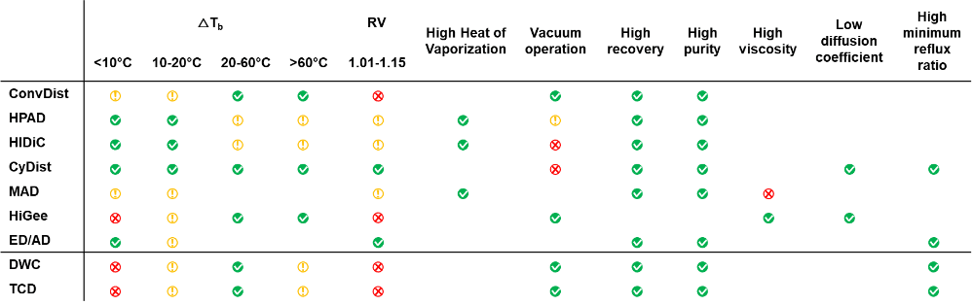
Figure 2. Process intensification matrix for advanced distillation technologies
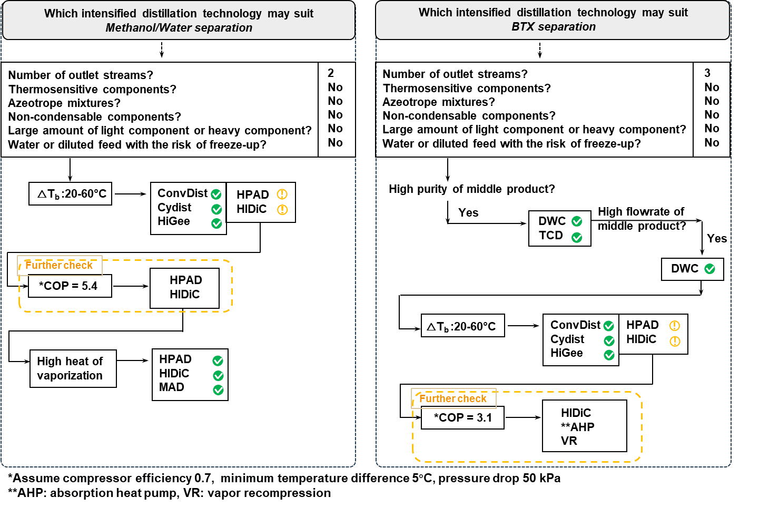
Figure 3. Decision making approach and outcomes for methanol/water separation (left), and BTX separation (right)
    - Case study: Methanol-water separation
Feed consists of 69.81 mol% methanol and 30.19 mol% water (Shahandeh et al., 2015), N.B.P. difference 35.3 °C (N.B.P water 100 °C, methanol 64.7 °C), RV 3, heat of vaporization methanol 1273.4 kJ/kg, water 2265.6 kJ/kg. Methanol product purity 99.99 mol%, recovery 99.98%, RRmin 0.87 (under atmospheric pressure), and it is a large scale separation with the capacity of 1,100 ktpy feed. As shown in Figure 3 left, HIDiC and heat pumps are recommended for methanol water separation, cyclic distillation and membrane assisted distillation are promising, and conventional distillation column can also achieve the separation target. This is also inline with the reports from literature (Shahandeh et al., 2015; Pribic et al., 2006; Pătruţ et al., 2014). However, note that although HiGee distillation is also recommended and there are also research on this (Wang et al., 2011), HiGee is limited by the difficulty to manufacture large-size high-speed rotator. The annual production capacity is usually smaller than 10 ktons. Practically, most cases are running with the annual scale less than 5 ktons.
    - Case study: Benzene (B)/Toluene (T)/Xylene (X) separation
The feed consists of 33.3 mol% benzene, 33.4 mol% toluene and 33.3 mol% m-xylene (Gupta and Kaistha, 2015), ΔTb = 59.0°C (N.B.P.: benzene 80.1°C; toluene 110.7 °C and m-xylene 138.4 °C), RV_{B/T}=2.39, RV_{T/X}=2.19. Heat of vaporization: benzene 395.9 kJ/kg; toluene 365.1 kJ/kg; m-xylene 347.0 kJ/kg. The purities of BTX products are 99.0 mol%, and the recoveries are 99.8%, 98.0 %, and 99.1 %, respectively. The RRmin of B/TX separation is ~1.90, and 1.92 for T/X separation. The viscosity (cP at 20°C) are 0.652, 0.590 and 0.620. As shown in Figure 3 right, dividing wall column is recommended for BTX separation, and by checking the coefficient of performance (COP), heat pumps could also be applied. These recommendations are supported with the studies about DWC (Gupta and Kaistha, 2015), HIDiC (Iwakabe et al., 2006), and heat pump assisted DWC (Chew et al., 2014).
    - Case study: Ethanol-water separation
In case of the ethanol-water separation there is a binary azeotrope (95.63 wt % ethanol) that must be taken into account. For Q6, the answer is yes, thus membrane separation, extractive distillation, azeotropic distillation are recommended to break the azeotrope. Due to the additional solvent that may be needed (leading to a ternary system) E-DWC and A-DWC are also recommended. The boiling point difference of ethanol and water is 22 °C, so HPAD and HIDiC can be considered upon further checks. COP is 16 (Tr=100, Tc=78 °C) in this case, thus HPAD is highly recommended (Luo et al., 2015), while using HIDiC for the ethanol-water separation has been also reported (Ponce et al., 2015).
  - Conclusions
The newly proposed decision making framework based on the intensification matrix is useful to make rapid and reliable selection of most promising distillation techniques at an early stage for fluid separation tasks. The features and performances of intensified distillation technologies are assessed and exploited to support the intensification matrix. The two industrially relevant case studies successfully demonstrate the use of the proposed methodology and the results align with the PI techniques reported in the literature. This screening could act as a decision making tool in the pre-selection stage of our recently reported work (Li et al. 2023) regarding the synthesis and optimisation of advanced energy integration distillation techniques.
References
Chew, J.M., Reddy, C.C.S. and Rangaiah, G.P., 2014. Improving energy efficiency of dividing-wall columns using heat pumps, Organic Rankine Cycle and Kalina Cycle. Chemical Engineering and Processing: Process Intensification, 76, pp.45-59.
Commenge J.M., Falk L., 2014, Methodological framework for choice of intensified equipment and development of innovative technologies, Chemical Engineering and Processing: Process Intensification, 84, 109-127
Gupta R., Kaistha N., 2015, Role of nonlinear effects in benzene-toluene-xylene dividing wall column control system design, Ind. Eng. Chem. Res., 54, 9407-9420
Iwakabe, K., Nakaiwa, M., Huang, K., Nakanishi, T., Røsjorde, A., Ohmori, T., Endo, A. and Yamamoto, T., 2006. Energy saving in multicomponent separation using an internally heat-integrated distillation column (HIDiC). Applied thermal engineering, 26(13), pp.1362-1368.
Kiss A.A., Landaeta S.J.F., Ferreira C.A.I., 2012, Towards energy efficient distillation technologies–Making the right choice, Energy, 47, 1, 531-542
Li Q., Finn A. J., Doyle S. J., Smith R., Kiss A. A., 2023, Synthesis and optimization of energy integrated advanced distillation sequences, Separation and Purification Technology, 315, 123717.
Luo, H., Bildea, C.S. and Kiss, A.A., 2015. Novel heat-pump-assisted extractive distillation for bioethanol purification. Industrial & Engineering Chemistry Research, 54(7), pp.2208-2213.
Pătruţ, C., Bîldea, C.S., Liţă, I. and Kiss, A.A., 2014. Cyclic distillation–Design, control and applications. Separation and Purification Technology, 125, pp.326-336.
Ponce, G.H.S.F., Alves, M., Miranda, J.C., Maciel Filho, R. and Maciel, M.R.W., 2015. Using an internally heat-integrated distillation column for ethanol–water separation for fuel applications. Chemical Engineering Research and Design, 95, pp.55-63.
Pribic P., Roza M., Zuber L., 2006, How to improve the energy savings in distillation and hybrid distillation-pervaporation systems, Separation science and technology, 41, 2581-2602.
Shahandeh, H., Jafari, M., Kasiri, N. and Ivakpour, J., 2015. Economic optimization of heat pump-assisted distillation columns in methanol-water separation. Energy, 80, pp.496-508.
Wang, G.Q., Xu, Z.C. and Ji, J.B., 2011. Progress on Higee distillation—Introduction to a new device and its industrial applications. Chemical engineering research and design, 89(8), pp.1434-1442.

