Data-driven robust hydrogen infrastructure planning under demand uncertainty using a hierarchical-based decomposition method

Xu Zhou, Margarita E. Efthymiadou, Lazaros G. Papageorgiou and Vassilis M. Charitopoulos*

Department of Chemical Engineering, The Sargent Centre for Process Systems Engineering, University College London (UCL), Torrington Place, WC1E 7JE, UK

*[v.charitopoulos@ucl.ac.uk](mailto:v.charitopoulos@ucl.ac.uk)

Abstract

Strategic planning of national hydrogen infrastructure constitutes a prominent topic within the “Net-zero” agenda. Nevertheless, uncertainty surrounding future hydrogen supply chains could lead to significant economic loss and even jeopardise the security of energy systems. This work aims to provide an uncertainty-resilient scheme to alleviate these disadvantages. We propose a data-driven adaptive robust mixed-integer linear programming (MILP) optimisation framework with 5-year steps 2035-2050 and hourly resolution by explicitly accounting for demand uncertainty typically introduced in energy planning models through the introduction of representative days. To solve this complex MILP problem, we propose an enhanced column-and-constraint generation algorithm based on a hierarchical method that can significantly reduce the computational effort.

**Keywords**: Hydrogen infrastructure planning, Decomposition method, Polyhedral uncertainty set, Adaptive robust optimisation, Column-and-constraint generation.

* 1. Introduction

In light of the increasing number of countries committing to “Net-zero” by 2050, hydrogen as a low-carbon alternative to natural gas plays a significant role towards the decarbonisation of the heat sector (Lowes and Woodman, 2020). Towards the optimisation of hydrogen infrastructure planning, many uncertainties such as the hydrogen demand and renewable energy generation are inherent to underlying problem. Despite the plethora of research works examining this problem only a handful consider risk-averse decision-making (Câmara et al., 2019). For the case of power sector only decarbonisation, Lara et al. (2018) proposed a nested decomposition algorithm to solve this class of multi-scale MILP problems, but it focused on the deterministic minimisation problem. Hou et al. (2021) developed a modified decomposition algorithm based on stochastic dual dynamic integer programming for large-scale renewable electricity planning. Furthermore, energy-planning models typically involve representative days in order to alleviate the computational complexity due to their multi-scale nature (Vaes and Charitopoulos, 2023). The issue of systematically accounting for the uncertainty introduced through the deployment of representative days within these models remains largely unexplored. To this end, we employ a two-stage data-driven adaptive robust optimisation (ARO) model.

ARO has been widely applied in network/transportation problems and power system scheduling problems (Baringo et al., 2018) and has shown to mitigate the overly conservative issue of a single-stage robust optimisation. However, two-stage ARO problems even in simple cases are NP-hard (Ben-Tal et al., 2004). The two most widely used methods in the literature to overcome the computational burden of ARO are the Benders-dual cutting plane algorithm and column-and-constraint generation (CCG) algorithm (Zeng and Zhao, 2013), both of which involve solving an MILP master problem and a bilinear sub-problem. In most cases, the inner max-min problem is reformulated as a single-level max problem through duality and the introduction of big-*M* constraints (Baringo et al., 2018; Ning and You, 2018). Nonetheless, finding the right values for big-*M* parameters in this case is a notoriously difficult problem. Motivated by the aforementioned problems, the contribution of this work is two-fold: (i) we propose a data-driven ARO-based way to explicitly account for the demand uncertainty introduced in energy planning models through the deployment of representative days; (ii) we develop an enhanced CCG-based hybrid solution scheme that reduces significantly the computational time of the resulting multi-scale and multi-level problem. In Section 2, we briefly discuss the hydrogen-planning problem we study, Section 3 details the proposed hybrid solution scheme while in Sections 4 & 5 results and conclusions are provided respectively.

* 1. Model Formulation

The hydrogen infrastructure planning problem considering demand uncertainties is formulated as an adaptive robust MILP optimisation problem. It involves choosing the optimal investment strategy for each region over the 5-year steps 2035-2050, and hourly operating strategy over a number of representative days (*c*) to meet the uncertain hydrogen demand. The total production rate of production technologies *p* in each region 𝑔, year 𝑡, cluster 𝑐 and hour ℎ is denoted by $Pr_{pgcht}$, and the flowrates of all transportation modes 𝑙 from region $g^{'}$ to 𝑔 is denoted by $Q_{lgg^{'}tch}$. The number of investments of the new production technologies *p* and new transportation units of type *l* for hydrogen transportationin region *g* and time *t* by $IP_{pgt}$ and $ITU_{lgg^{'}t}$, are denoted respectively. The uncertain hydrogen demand is ${TD}_{gtch}$ which is modeled following the polyhedral uncertainty sets convention. The total cost *TOC* consists of the production capital & operational cost *PCC* & *POC*, the road transportation capital cost *RCC* and operating cost *ROC*, the carbon emissions cost *CEC*, fuels costs *FC* for the natural gas and biomass consumption (Efthymiadou et al., 2023). More specifically, we have

$TOC=PCC\left(IP_{pgt}\right)+POC\left(Pr_{pgcht}\right)+RCC\left(ITU_{lgg^{'}t}\right)+ROC\left(Q_{lgg^{'}tch}\right)$ $+ CEC(Pr_{pgtch}) + FC(Pr_{pgtch})$. (1)

The hydrogen energy demand-generation balance constraint is as below:

$\sum_{p∈P}{Pr_{pgtch}} +\sum_{l∈L}{\sum_{g^{'} ∈N_{gg^{'}}}{Q_{lg^{'}gtch}}}≥\sum_{l ∈L}{\sum_{ g^{'} ∈N_{gg^{'}}}{Q_{lgg^{'}tch}}}+TD_{gtch}$ (2)

for all $g∈G, t ∈T, c ∈C, h ∈H.$ The hydrogen production constraints are:

$Pr_{pgtch}≤cap_{p}^{max}⋅NP_{pgt}, ∀p∈P,g∈G,t∈T,c∈C,h∈H$ (3)

$NP_{pgt}=NP_{pg,t-1}+IP_{pgt} ∀p∈P,g∈G,t∈T$*.*  (4)

Similarly, we have road transportation constraints:

$Q_{lgg^{'}tch}≤cap_{l}^{T}⋅NTU_{lgg^{'}t} ∀l∈L,\{g,g^{'}\}∈N_{gg^{'}},t∈T,c∈C,h∈H$ (5)

$NTU_{lgg^{'}t}=NTU_{lgg^{'},t-1}+ITU_{lgg^{'}t} ∀l∈L,\{g,g^{'}\}∈N_{gg^{'}},t∈T$ (6)

where $NP_{pgt}$ and $NTU_{lgg^{'}t}$ denote the total number of available production technologies *p* and transportation units of type *l* in region *g* and time *t*, respectively. The total carbon emissions should satisfy an upper limit, which is formulated as the following constraint:

$\sum_{p∈P}{\sum_{g∈G}{\sum_{c∈C}{\sum_{h∈H}{y_{ptc}^{e}}}}}⋅Pr_{pgtch}≤et_{t} ∀t∈T$*.*  (7)

Concisely, the resulting data-driven adaptive robust optimisation (ARO) for the above hydrogen planning problem is formulated as the following compact form:

$$\min_{x}{{ c}^{⊤}x}+ \max_{d∈D}{\min_{y∈Ω\left(x,d\right)}{b^{⊤}}}y$$

s.t. ***Ax = B***, $Ω\left(x,d\right)=\left\{y: Wy≥ h -Tx -Md\right\}$,

$D=\left\{d | \begin{matrix}d=d_{0}+Pξ, ξ=\underline{ξ}∘z^{-}+\overline{ξ}∘z^{+} \\ 0≤z^{-},z^{+}≤1,{ z}^{-}+z^{+}≤1, { 1}^{T}\left(z^{-}+z^{+}\right)≤Φ\end{matrix}\right\}$ (8)

where the variable ***x*** is the first-stage integer variable including decision variables $IP_{pgt}$, $ITU_{lgg^{'}t}$, $NP_{pgt}$ and $NTU_{lgg^{'}t}$, which is made prior to the uncertainty realisation. The variable ***y*** is thesecond-stage continuous variable including $Pr_{pgcht} and Q_{lgg^{'}tch}$, which is made after the uncertainty is realised. $D$ is the data-driven polyhedral uncertainty set derived from the historical demand data by using principal component analysis and kernel smoothing methods (Ning and You 2018) for modeling uncertain demand ***d***, i.e., $TD_{gtch}$ in (2), where vectors $\underline{ξ}$ and $\overline{ξ}$ define the confidence interval of latent uncertainties, and parameter Φ is an uncertainty budget describing the conservatism of uncertainty sets.

* 1. Enhanced CCG Algorithm for Adaptive Robust MILP Problems

The data-driven ARO problem is a complex tri-level optimisation that cannot be directly solved using off-the-shelf solvers. The CCG algorithm can decompose the adaptive robust MILP into a master problem and a sub-problem. The master problem passes the solved integer decision variables to the sub-problem, and then the sub-problem continuously generates scenarios for the master problem. The above process iterates until the gap between the upper and lower bounds satisfies a certain optimality tolerance. Its master problem is the relaxation of the original problem (8), and the sub-problem is a bilevel max-min problem determining the worst-case uncertainty realisations.

**CCG-MP:** **CCG-SP:**

$TC=\min_{x,η,y^{k}}{c^{⊤}x+η}$ $Ξ\left(x\right)=\max_{d∈D}{\min_{y}{b^{⊤}}}y$

s.t. ***Ax = B***, s.t. $Wy≥ h -Tx -Md$

$η≥b^{⊤}y^{k}$, $k =1,⋯,r$

$Tx+Wy^{k}≥h-Md^{k}$

Note that the above CCG-MP is an MILP problem and its constraints and variables will grow as the iteration *k* proceeds. If the optimisation problem is large-scale and needs more iterations to obtain a feasible solution, like the planning problem proposed in this paper, the CCG-MP can become prohibitively large and needs more computing time to be solved. Therefore, we apply the Benders decomposition (Geoffrion, 1972) to decompose the large-scale CCG-MP into a small MILP problem and a large LP problem. The Benders decomposition process for CCG-MP is as follows:

**Benders-MP: Benders-SP:**

$\min_{x,θ}{c^{⊤}x+θ}$ $\min_{η,y^{k}}{η}$

s.t. ***Ax = B***, s.t. $η≥b^{⊤}y^{k}$, $k =1,⋯,r$

$θ≥\sum_{k}{π_{ik}\left(h-Md^{k}-Tx\right)} ∀i=1,⋯s$ $Tx+Wy^{k}≥h-Md^{k} : π_{sk}$

The Benders-SP is solved with the given ***x*** from the Benders-MP and then it passes the sensitivity parameter $π_{sk}$ at iteration step *s* to the Benders-MP to generate an optimality cut. When the Benders algorithm converges, the obtained ***x*** is the optimal solution for the CCG-MP and then is given to the CCG-SP to calculate the worst scenario $d^{k+1}$. We can observe that the CCG-SP is an NP-hard problem and cannot be solved directly. We use a block coordinate descent (BCD) method (Minguez et al., 2018) to solve the CCG-SP, which overcomes the aforementioned challenges. The BCD method involves solving two linear programs alternatively until convergence:

**BCD-Lower Level:** **BCD-Middle Level:**

$C(x)=\min_{y}{b^{⊤}}y$ $\max_{d∈D}{ C{\left(x\right)}^{v}+μ^{v}\left(d-d^{v}\right)}$

s.t. $Wy≥ h -Tx -Md$

$$d=d^{v} :{ μ}^{v}$$

The lower level problem is solved with a fixed scenario $ⅆ^{v}$ at iteration *v* of the BCD method and iteration *k* of CCG algorithm. The operating cost is maximised in the middle level of BCD method with the sensitivities $μ^{v}$ obtained from the lower level. It is built upon the first-order approximation of the operating cost ${C(x)}^{v}$ around the uncertainty realisations of the previous iteration.

To summarise, the above algorithms form the Enhanced CCG (ECCG) algorithm developed in this paper, which has one outer loop associated with CCG and two inner loops related to Benders decomposition & BCD method. It comprises the following steps:

1. Initialisation of the outer loop: Set the iteration counter *k* to 1 and tolerance $ϵ$.
2. Initialisation of the Benders inner loop: Set the iteration counter *i* to 1, and select initial values for $ⅆ^{1}$ and $x^{1}$.
3. Solve problems Benders-SP and Benders-MP, and increase the iteration counter *i $←$ i*+1. If converged, then set $x^{k}←$ $x^{i}$.
4. Initialisation of the BCD inner loop: Set the iteration counter *v* to 1.
5. Solve problems BCD-Lower Level *C*($x^{k}$) and BCD-Middle Level, and increase the iteration counter *v $←$ v* + 1. If the given tolerance is satisfied, set $d^{k+1}←$ $d^{v}$.
6. Outer loop convergence checking: If $\left|{TC}^{k}- C(x^{k}) -c^{⊤}x^{k}\right|∕{TC}^{k}≤ϵ$, the algorithm stops; otherwise, go to step 2).

Note that even though the ECCG algorithm has two inner loops and needs iterations for each of them, it is typically faster to solve the original MILP problem (8) than the CCG algorithm without inner loops, as illustrated in the next computational experiments.

* 1. Results & Discussion

The performance of the proposed ECCG method is evaluated on the hydrogen infrastructure planning for domestic heating in Great Britain (GB) from 2035 to 2050. GB is divided into 13 regions based on the local gas distribution zones of the incumbent natural gas network. In order to reduce the model size, we perform clustering on hydrogen demand data points by K-Medoids clustering method (Charitopoulos et al. 2022). We treat the highest demand day as one cluster and perform the polyhedral uncertainty set for other remaining clusters. The model is implemented in GAMS Studio 1.13.4 and solved by Gurobi 9.5.1. The relative tolerances for the Benders and BCD methods are ${1×10}^{-6}$ and ${1×10}^{-8}$, respectively. The optimality tolerance of outer ECCG algorithm is 0.1%.

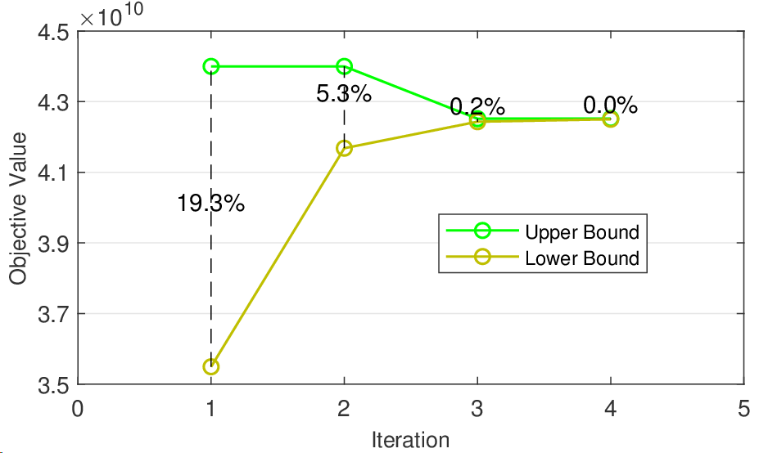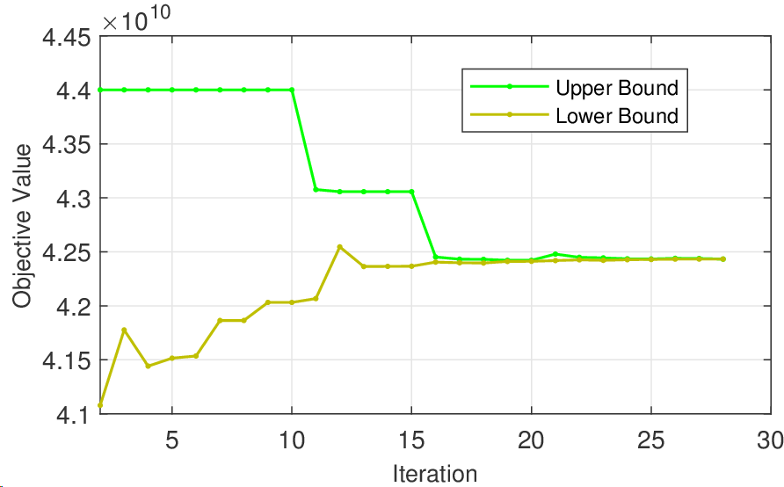

**Figure 1:** (Left) Upper and lower bounds of outer ECCG algorithm; (Right) Upper and lower bounds of inner Benders decomposition method when the iteration step of ECCG *k* = 3.

Fig. 1 shows the convergence of ECCG (outer loop) and Benders decomposition at iteration step *k* = 3 of ECCG for 4 clusters with uncertainty budget Φ = 15 introduced in problem (8). In general, the ECCG can converge within typically 5 iterations, and its inner Benders loop converges within up to 40 iterations regardless of the number of clusters. BCD method can converge within 30 seconds because it only solves two simple LPs. In Table 1, we compare the final optimal objective values, i.e. the total system cost of the planning problem, and the total CPU execution time with and without Benders method in the ECCG under 6 Clusters and uncertainty budget Φ = 10. As we can see, using Benders can sharply reduce the CPU time compared with using monolithic way to solve the CCG-MP directly. At the same time, it makes around 3% gap between the two converged values, which is acceptable in large-scale optimisation problems.

**Table 1:** Computational performance comparison of ECCG algorithm with and without Benders.

|  |  |  |  |
| --- | --- | --- | --- |
|  | Total Cost (£b) | CPU time (min) | Gurobi Optimality Tolerance |
| With Benders | 41.978 | 22 | 0.01% |
| Without Benders | 40.757 | 185 | 3% |

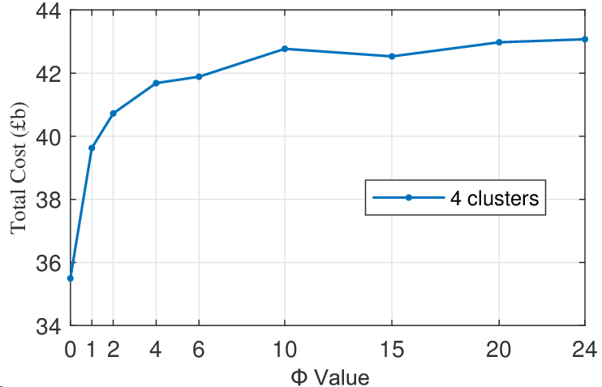 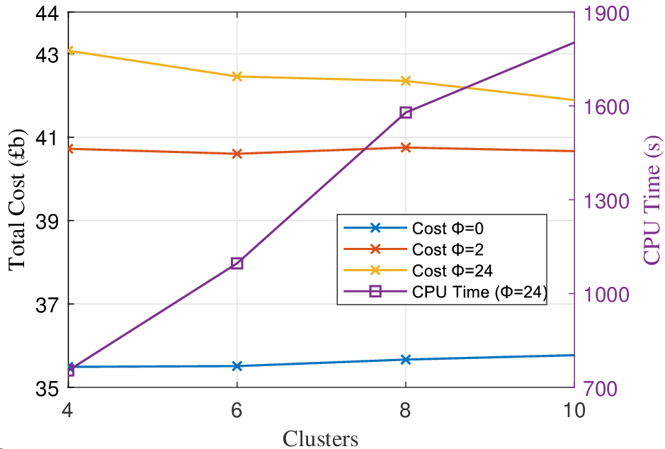

**Figure 2:** (Left) Total cost for 4 clusters with different uncertainty budgets; (Right) Total cost and CPU time with different clusters and uncertainty budgets.

The conservatism of robust solutions depends on the uncertainty budgets which are chosen by decision makers. Fig. 2 (left) displays a robust solution profiles for 4 clusters with different uncertainty budgets. We can see that the overall trend of costs rises as the uncertainty budget increases. When the value of Φ is low, the increase in cost is significantly large, because the datasets in each cluster are relatively concentrated after performing clustering. In Fig. 2 (right), we compare the total cost difference with different number of clusters under a fixed uncertainty budget. When Φ = 0, i.e., the demand of each cluster is the average value, the total cost increase at a slow rate. This shows that the greater the number of clusters, the larger their mean values will be in some clusters. The total costs of different clusters become almost the same when Φ = 2. When Φ = 24, i.e., the robust solution is overly conservative, which considers the worst case, the total cost is decreasing since the weight days of each cluster are decreasing. At the same time, we can notice that the total CPU time increases linearly with the number of clusters.

* 1. Conclusions

We propose an ECCG algorithm coupling Benders decomposition and BCD methods to handle the two-stage adaptive robust optimisation problem of large-scale hydrogen infrastructure planning under demand uncertainty. The proposed algorithm can reduce the computational time up to 80% as the experimental result shows. Furthermore, it can also be flexibly extended to deal with other uncertainties like the renewables uncertainty and other complex large-scale systems such as transportation systems. Ongoing research focuses on modifications to Benders decomposition to reduce the resulting optimality gap and apply it to the planning problems of coupled heat and power sectors.

Acknowledgements

Financial support from the Engineering & Physical Sciences Research Council (EPSRC) under the projects EP/T022930/1 and EP/V051008/1, is gratefully acknowledged.

References

A. Ben-Tal, A. Goryashko, E. Guslitzer, A. Nemirovski, 2004, Adjustable robust solutions of uncertain linear programs, Math. Program., 99, 2, 351-376.

L. Baringo and A. Baringo, 2018, A stochastic adaptive robust optimization approach for the generation and transmission expansion planning, IEEE Trans. Power Syst., 33, 1, 792-802.

D. Câmara, T. Pinto-Varela, A. P. Barbósa-Povoa, 2019, Multi-objective optimization approach to design and planning hydrogen supply chain under uncertainty: A Portugal study case, Comput. Aided Chem. Eng., 46, 1309-1314.

V.M. Charitopoulos, M. Fajardy, C.K. Chyong, D.M. Reiner, 2023, The impact of 100% electrification of domestic heat in Great Britain, Iscience, 26, 11, 1-12.

M. E. Efthymiadou, V. M. Charitopoulos, L. G. Papageorgiou, 2023, Hydrogen infrastructure planning for heat decarbonisation in Great Britain, Comput. Aided. Chem. Eng., [52](https://www.sciencedirect.com/bookseries/computer-aided-chemical-engineering/vol/52/suppl/C), 3025-3030.

[A. M. Geoffrion](https://link.springer.com/article/10.1007/bf00934810?utm_source=getftr&utm_medium=getftr&utm_campaign=getftr_pilot#auth-A__M_-Geoffrion-Aff1), 1972, Generalized benders decomposition. J Optim. Theory Appl., 10, 4, 237-260.

S. Hou, Y. Fan, B. Yi, 2021, Long-term renewable electricity planning using a multistage stochastic optimization with nested decomposition, Comput. Ind. Eng., 161, 1-13.

C. L. Lara, D. S. Mallapragada, D. J. Papageorgiou, A. Venkatesh, I. E. Grossmann, 2018, Deterministic electric power infrastructure planning: Mixed-integer programming model and nested decomposition algorithm, Eur. J. Oper. Res., 271, 1037-1054.

R. Lowes, B. Woodman, 2020, Disruptive and uncertain: policy makers’ perceptions on UK heat decarbonization, Energy Pol., 142, 1-12.

R. Minguez, R. Garcia-Bertrand, J. M. Arroyo, N. Alguacil, 2018, On the Solution of Large-scale robust transmission network expansion planning under uncertain demand and generation capacity, IEEE Trans. Power Syst., 33, 2, 1242-1251.

C. Ning, F. You, 2018, Data-driven decision making under uncertainty integrating robust optimization with principal component analysis and kernel smoothing methods, Comput. Chem. Eng., 112, 190-210.

J. Vaes, V. M. Charitopoulos, 2023, A data-driven uncertainty modelling and reduction approach for energy optimisation problems, Comput. Aided Chem. Eng., 52, 1161-1167.

B. Zeng, L. Zhao, 2013, Solving two-stage robust optimization problems using a column-and-constraint generation method, Oper. Res. Lett., 41, 5, 457-461.