Optimization of biomass-to-green methanol production: Techno-economic and environmental analysis
Chanmok Kim,ª Chanhee You,ª Hyeon Yang,ª Jiyong Kim^{a,*}
ª School of Chemical Engineering, Sungkyunkwan University, Suwon 16419, Republic of Korea
*Corresponding Author’s E-mail: jiyongkim@skku.edu
Abstract
To address the problem of global warming, environmental pollution, and energy source depletion, the transition to renewable and sustainable energy source from fossil fuels is so critical. Biomass is one of promising renewable and sustainable energy sources that can replace existing fossil fuels. In the chemical industry, methanol is used as an important intermediate for producing synthetic hydrocarbons and regarded as a future energy carrier. Recently, green methanol production from biomass is a promising alternative for green and sustainable methanol production compared to traditional methanol synthesis from fossil fuels. Since the syngas derived from biomass gasification does not meet the optimal syngas composition for methanol synthesis, the syngas composition needs to be adjusted by injecting hydrogen into the syngas. This study aims to identify the optimal design and operation strategy of green methanol production system. To achieve this goal, we developed process simulation model for green methanol production from biomass by using commercial process simulator Aspen plus to obtain the sizing and equipment costing data, and mass and energy flow data. Then, we developed sequential quadratic programming optimization model implemented in Aspen plus based on these data. The objective function of the optimization model is to minimize the unit production cost of the produced green methanol considering various constraints such as hydrogen price, and biomass price. As a result, we identified the optimal system configuration and operation strategy for green methanol production from biomass. In addition, the identified optimal system by optimization model is analyzed with technical, environmental, and economic metrics.
Keywords: biomass, green methanol, optimization, optimal design, operation strategy
  - Introduction
In response to the problems of global warming, environmental pollution and the depletion of energy sources, the transition to renewable and sustainable energy source from conventional fossil fuels is crucial. Biomass is recognized as an alternative energy source for producing sustainable liquid fuels, including methanol and Fischer-Tropsh fuels (Ostadi et al., 2023). Methanol is an important feedstock in the chemical industries and a key component in the production of synthetic hydrocarbons. Green methanol production from biomass not only replaces conventional fossil fuels in the transportation sector, but also reduces air pollution and greenhouse gas emissions (Ostadi et al., 2023, and Sollai et al., 2023). Therefore, transitioning to green methanol from biomass is not an innovative approach but a necessary step towards a sustainable and environmentally conscious energy future. In this work, we aim to identify the optimal design and operation strategy for green methanol production system. To achieve this goal, the technology overview, analysis method and methodology are presented in Section 2. In Section 3, the optimal design and operation strategy of the process proposed by the developed optimization model are presented. The optimal design includes the split ratio for the water gas shift (WGS), injected hydrogen amount, equipment size, and process configuration. The operation strategy includes biomass gasification temperature, WGS temperature, and WGS steam-to-carbon monoxide ratio. In addition, a techno-economic-environmental evaluation including the unit production cost, net CO_{2eq} emissions, and process energy efficiency was performed.
  - Technology overview and methodology
    - Technology overview
Fluidized biomass gasification: Gasification converts solid biomass into syngas at high temperatures through controlled reactions with gasification agents, involving stages such as drying, pyrolysis, partial combustion, and reduction. Fluidized bed gasifiers (FBG) enhance this process through fluidization, which involves transforming a bed of solid particles into a fluid-like state using gas. This technique ensures uniform temperatures due to excellent gas-solid mixing, achieves high carbon conversion rates, and produces low amounts of tar. (De et al., 2019).

Table 1. Ultimate and Proximate analysis (Güleç et al., 2022)
Material | Ultimate analysis (wt.%) |  |  |  |  | Proximate analysis (wt.%) |  |  | HHV
 | N | C | S | H | O | Ash | VM | FC | kJ/g
Eucalyptus chips | 0.14 | 44.77 | 0.15 | 6.33 | 48.6 | 1.9 | 79 | 19.1 | 16.49

In this study, the feedstock to the biomass-to-green methanol is 111.26 t/h eucalyptus chips biomass. The biomass characteristics including composition and heating value are provided in Table 1.

Water-gas shift (WGS): In WGS process, CO reacts with H₂O to produce CO₂ and H₂.

$CO+H_{2}O ↔CO_{2}+H_{2}, ∆H_{298K}=-41 kJ/mol (1)$

This WGS process is conducted in two stages: high and low temperature stage. The high-temperature stage employs Fe₂O₃/Cr₂O₃/CuO catalysts, operating within a temperature range of 250 to 400℃ and a pressure range of 1 to 20 bar. For the low-temperature stage, Cu/ZnO/Al₂O₃ catalysts are utilized, with operational parameters set between 170℃ and 250℃ for temperature and maintaining the pressure within the 1 to 20 bar range (Do et al., 2023).

Acid gas removal (AGR): For the acid gas removal unit process, CO₂ capture is efficiently achieved using the MEA-based chemical absorption-desorption process, recognized as the most mature technology. In this method, CO₂ is absorbed in the absorber through a counter-current flow of the gas mixture and MEA solvent, facilitating enhanced interaction and CO₂ capture. Subsequently, in the stripper, reverse reactions release CO₂ and regenerate the solvent, allowing for its recirculation and maintaining an optimal system efficiency for CO₂ removal (Do et al., 2023, and Zhang et al., 2020).
Methanol synthesis (MS): Methanol is synthesized from syngas with the Cu/ZnO/Al₂O₃ catalysts at 250℃ and 50 bar. The reaction appears as follows.

$CO+{2H}_{2} ↔CH_{3}OH, ∆H_{298K}=-90.5 kJ/mol (2)$
$CO_{2}+{3H}_{2} ↔CH_{3}OH+H_{2}O, ∆H_{298K}=-49.5 kJ/mol (3)$
$CO_{2}+H_{2} ↔CO+H_{2}O, ∆H_{298K}=41 kJ/mol (4)$

The stoichiometric number SN (defined as (H₂-CO₂)/(CO+CO₂)) of the syngas injecting into the methanol reactor needs to be slightly above 2.
    - Analysis method
In this work, the proposed process was evaluated in various criteria such as unit production cost (UPC), net CO_{2eq} emission (NCE), and energy efficiency (EEF).
In evaluating the economic feasibility of green methanol production, the UPC serves as a pivotal metric. The UPC calculation includes both the total capital investment cost (TCI) and total operating cost (TOC) of the process. TCI is derived from equipment costs obtained via the Aspen Process Economic Analyzer and reference values using the Lang factor for accurate estimation. The annualized capital investment cost (ACI) is then computed considering the TCI, along with the applicable interest rate (i) and plant lifespan (l). The ACI is expressed in Eq. (5). As shown in Eq. (6), TOC is the sum of variable operating costs (VOC) related to raw materials and utilities, and fixed operating costs (FOC) such as labor, maintenance, and overheads. The final UPC for green methanol is determined by dividing the total production cost by the annual production rate (APR) of methanol as shown in Eq. (7).
$$ACI=TCI×\frac{i×{(1+i)}^{l}}{{(1+i)}^{l}-1} \left(5\right)$$
$$TOC=VOC+FOC (6)$$
$$UPC= \frac{ACI+TOC}{APR} (7)$$
In assessing the environmental impact of green methanol production, the NCE is crucial. The NCE calculation includes three main components: 1) the CO_{2eq} of raw material inventory (RM); 2) direct CO_{2eq} emissions (DCE) from the process such as vent-out or purge gas; and 3) indirect CO_{2eq} emissions (ICE) derived from the use of conventional utilities. The overall NCE for green methanol production provides a comprehensive measure of its environmental footprint, considering both direct and indirect carbon emissions associated with the production process (Do et al., 2022, and Do et al., 2023). In the technical evaluation of process efficiency, the EEF is critical metric. The EEF assesses how efficiently the energy utilized in the process is converted within the products.
    - Optimization methodology
Minimize {UPC of methanol}
$x,y∈R^{n}$
Subject to:
Limits of operating conditions (T, P)
$h\left(x,y\right)=0$ Mass and energy balance
$g\left(x,y\right)≤0$ Split fraction for purge (8)
The optimal stoichiometric number
Non-negative constraints
$$x∈ R^{n}, y∈ R^{n}$$
The optimal design and operation strategy were identified via an optimization model developed to minimize UPC of green methanol, as given in equation (8), which is subjected to the set of quality ($h\left(x, y\right)=0$) and inequality ($g\left(x, y\right)≤0$) constraints. The operation variables ($x, y∈R^{n}$) are determined to obtain the optimal value of the objective function within the constraint boundaries.
  - Results and discussion
    - Optimal configuration
Table 2. Summary of results for optimal design and operation strategy
Design |  | Operation strategy
Split ratio for WGS | Injected H₂  (kmol/h) | Gasification temperature (℃) | HT-WGS temperature (℃) | LT-WGS temperature (℃) | Steam/CO ratio
0.36 | 89 | 840 | 289 | 170 | 1.03

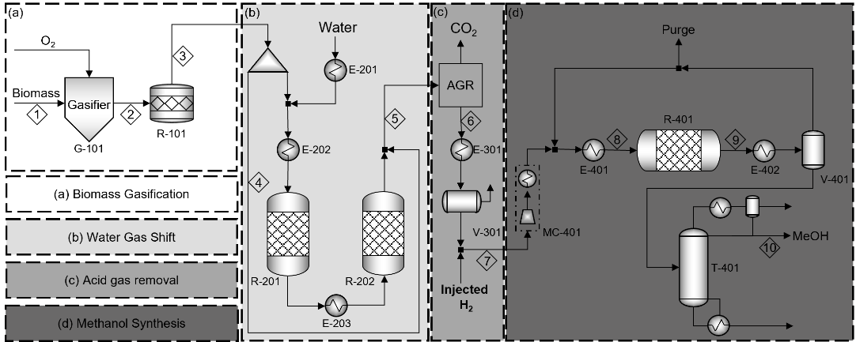
Figure 1. Process flow diagram identified by the optimization
The proposed biomass-to-green methanol process was modeled and simulated using Aspen Plus V.12 software. In this study, we assumed that the price and the CO_{2eq} inventory of renewable hydrogen were 2 $/kg and 0 kg CO_{2eq}/kg H₂, respectively. Then, we developed an optimization model for identifying optimal design and operation strategy. Note that decision variables for the design and operation strategy include the split ratio for WGS process, injected amount of H₂, gasification temperature, WGS reactor temperature, and steam-to-CO ratio.
With developed optimization model, we could identify the optimal design variable and operation strategy, as summarized in Table 2. The process flow diagram which is identified by the optimization model is provided in Figure 1. The SN of the syngas produced after biomass gasification is not suitable for methanol production. Additional hydrogen must be supplied to adjust SN to be 2. There are two main strategies for supplementing hydrogen in this process: producing hydrogen through the WGS process, or externally injecting hydrogen. Here, the two strategies are simultaneously used to minimize the UPC of green methanol in this study. For example, the split ratio for the WGS process is set at 0.36, meaning that 36% of the syngas from biomass gasification undergoes the WGS process, while the remaining stream is bypassed and directed into the AGR process. Moreover, 89kmol/h of renewable hydrogen is injected externally. It is also identified that the optimal operation strategy includes the high temperature operation of gasification process. For instance, the optimal operating condition is determined to be operating the gasification temperature at 840℃. This is because the high operating temperature of the gasification process reduces the formation of tar, thereby increasing the hydrogen ratio in the syngas.
    - Techno-economic and environmental analysis
Table 3. Process energy flow and energy efficiency
Energy flow (MWy)
(a) Feed (MWy)
Biomass | 411,740
H₂ | 56,341
(b) Utility (MWy)
Fired heat | 25,716
High-pressure steam | 34,819
Medium-pressure steam | 46,610
Low-pressure steam | 40,067
Electricity | 32,568
(c) Product (MWy)
Methanol | 383,002
Energy efficiency (EEF-%)
EEF (=(c)/((a)+(b))) | 59
We analyzed the energy efficiency of the optimal process as summarized in Table 3. As shown in Table 3, the proposed process requires various utilities from electricity to different steams. When analyzing energy consumed by utilities, there is no significant difference between the consumed amounts. Especially, huge requirement of MPS is due to CO₂ separation in the AGR to adjust the proper syngas ratio, followed by LPS mostly used in methanol purification. Overall, the energy efficiency of the process is analyzed to be 59%.
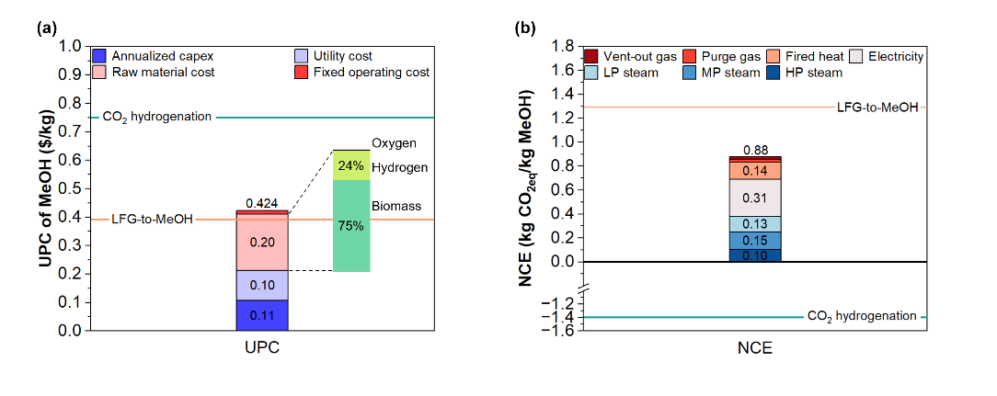
Figure 2. (a) UPC and (b) NCE of produced green methanol
To evaluate the economic feasibility of the optimal process, we analyzed the breakdown in UPC of green methanol as shown in Fig. 2 (a). UPC is broken down into annualized capex and operating cost contributions of utility costs, raw material costs, and fixed operating costs. It is identified that the UPC of optimal process exhibits 0.424 $/kg. The raw material cost is the main cost driver of UPC, accounting for 47% of the total cost. The biomass cost is the dominant cost component in raw material costs. This is because the substantial amount of biomass is required to produce green methanol due to the low carbon efficiency of the process. Which means that the biomass cost and the carbon efficiency are sensitive to the UPC of green methanol produced in the process.
To evaluate the environmental impacts, we conducted an environmental analysis as depicted in Fig. 2 (b). The NCE is broken down into ICE from the consumed utilities (e.g., fired heat, electricity, low-pressure steam, medium-pressure steam, and high-pressure steam), and DCE involving vent-out gas and purge gas. It is identified that ICE has become a major contributor, accounting for 95% of the NCE. This is because the biomass-to-green methanol process operates under high temperatures and pressures, leading to considerable utilization of heat and electricity as utilities.
Figure 2 also shows the UPC and NCE of other resources-based methanol production processes, namely CO₂ and landfill gas (LFG). The UPC of biomass-to-green methanol is slightly higher than that of LFG-to-methanol but lower than that of direct CO₂ hydrogenation. This is because LFG contains a large amount of CH₄, hydrogen can be produced inexpensively via steam methane reforming (SMR), thereby reducing the UPC of methanol. In contrast, significant amounts of renewable hydrogen are required to synthesize green methanol via the direct CO₂ hydrogenation, resulting in higher UPC compared to biomass-to-green methanol.
The biomass-to-green methanol shows higher NCE compared to the direct CO₂ hydrogenation that the feed inventory is represented as negative metrics due to the direct utilization of CO₂ as a feedstock. On the other hand, the NCE of biomass-to-green methanol is lower than that of LFG-to-MeOH. This is attributed to the SMR process used in LFG-to-MeOH, which operates at temperatures exceeding 800℃ and utilizes fired heat as a utility.
  - Conclusions
In this study, we developed biomass-to-green methanol simulation model and an optimization model with an objective function of min UPC of green methanol. Then, we identified the optimal design and operation strategy of biomass-to-methanol system. Furthermore, we conducted techno-economic-environmental evaluation. The energy efficiency of the optimal process was 59%. In the economic evaluation, the UPC of green methanol was 0.424 $/kg, and the main cost driver was raw material cost due to the low carbon conversion to green methanol. In the environmental assessment, the NCE was 0.88 kgCO₂/kgMeOH and ICE was the major contributor.
  - References
M. Ostadi, L. Bromberg, D.R. Cohn, E.Gençer, 2023, Flexible methanol production process using biomass/municipal solid waste. Fuel, 334, 126697
S. Sollai, A. Porcu, V. Tola, F. Ferrara, A. Pettinau, 2023, Renewable methanol production from green hydrogen and captured CO₂: A techno-economic assessment. Journal of CO2 Utilization, 68, 102345
S. De, A.K. Agarwal, V.S. Moholkar, B. Thallada, Coal and Biomass Gasification Recent Advances and Future Challenges. 2019, Springer Nature, 69-70
F. Güleç, D. Pekalsan, O.Williams, E.Lester, 2022, Predictability of higher heating value of biomass feedstocks via proximate and ultimate analyses – A comprehensive study of artificial neural network applications. Fuel, 320, 123944
TN. Do, YG. Hur, H. Chung, J. Kim, 2023, Potentials and benefit assessment of green fuels from residue gas via gas-to-liquid. Renewable and sustainable Energy Reviews, 182, 113388
H. Zhang, L. Wang, M. Perez-Fortes, J.V. Herle, F. Maréchal, U. Desideri, 2020, Techno-economic optimization of biomass-to-methanol with solid-oxide electrolyzer. Applied Energy, 258, 114071
TN. Do, YG. Hur, HE. Jeong, JW. Chung, W. Won, J. Kim, 2022, Rethinking of conventional Gas-to-liquid via dimethyl ether intermediate incorporating renewable energy against Power-to-Liquid. Energy Conversion and Management, 261, 115643
TN. Do, H. Kwon, M. Park, C. Kim, YT. Kim, J. Kim, 2023, Carbon-neutral hydrogen production from natural gas via electrified steam reforming: Techno-economic-environmental perspective. Energy Conversion and Management, 279, 116758

