Transparent Design Platform for Flexible Integration and Operation of Waste-to-X Systems

Julie Dutoit*,a,b, Jaroslav Hemrleb, Manuela Goulart Maiab, François Maréchala

*a École Polytechnique Fédérale de Lausanne, Industrial Process Energy Systems Engineering (IPESE), Sion, 1951, Switzerland*

*b Hitachi Zosen Inova AG, Zürich, 8005, Switzerland*

*\* julie.dutoit@hz-inova.com*

Abstract

The design and operation of the next generation of waste management and energy supply systems should ensure the industrial Global Warming Potential (GWP) reduction targets agreed internationally and enable transition towards a circular economy of materials. To that end, quantitatively rigorous assessment of industrial decarbonization and value recovery pathways is critical, while many challenges stem from the range and complexity of involved technologies and engineering domains, variety of possibly conflicting performance criteria, and interaction potential within the system as well as with external interfaces, in the context of uncertain energy supply markets. In this contribution, a versatile simulation and decision support platform is developed for the design and scheduling of municipal solid waste (MSW) treatment technologies from an industrial point of view, including short to long-term energy storage capacity and renewable energy production to offer flexibility in the integration of such systems. The methods aim at simultaneous financial, environmental, and thermodynamic simulation and optimization of modularly complex system models, evaluating unsteady operations and uncertain, time-variant input data. The inferred transparency is reinforced by joining all functionalities into a unique workflow, improving technology development consistency and reliability. This work presents the modeling structure and platform features, demonstrated for the design and system integration of a specific multi-energy case of oxy-enhanced MSW incineration plant.

**Keywords**: Waste-to-X, Co-optimization, Decision Support Platform, OpenModelica

* 1. Introduction

Although waste treatment systems have been extensively studied (Niziolek et al., (2017), Puchongkawarin et al., (2020)), a large range of alternative integration strategies, recovery products, and performance criteria specifically for environmental indicators remains to be studied, including uncertainties assessment. Particularly when including intermittent renewable energy production as energy utilities and power grid integration potential, dynamic control and flexible operation of Waste-to-X systems become essential (Abdelghany et al., (2021)). Consequently, industrial waste treatment projects require robust computational tools covering both short-term variability and long-term aspects (cycling effects, seasonal storage, etc.) to support investment planification via validated digital twins.

This work proposes a flexible and transparent framework for simultaneous process integration and optimal control, detailed financial analysis, and Life-Cycle Impact Assessment (LCIA). A typical system flowsheeting interface is displayed in Figure 1 for the analysis of a specific Waste-to-X system, including oxy-enhanced MSW combustion with flue gas recirculation, flue gas treatment technologies, post-combustion carbon capture, alkaline water electrolysis (AEL), catalytic CO2 methanation and a selection of heat, cold and power utilities.

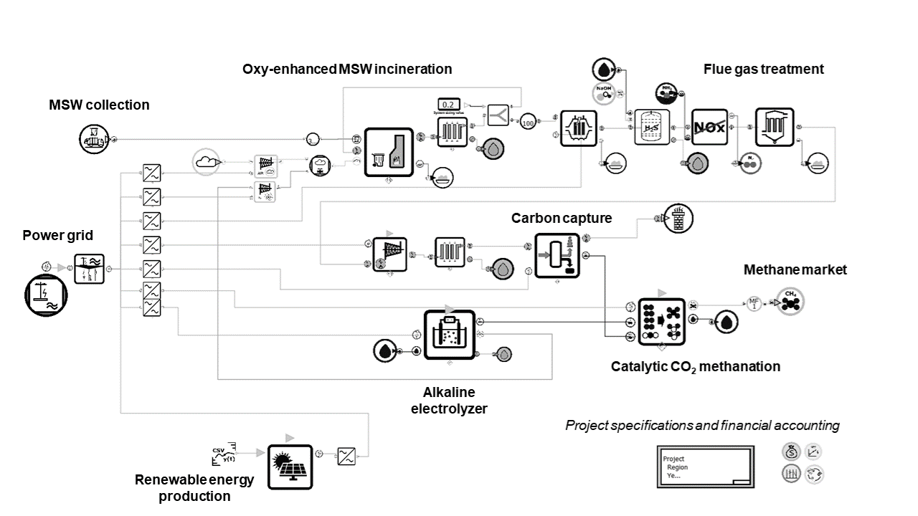

Figure 1: MSW incineration system integrated with carbon capture, alkaline electrolysis, and catalytic CO2 methanation.

* 1. Methods

Technology modeling is done primarily in the open-source software OpenModelica (OM) (Fritzson et al., (2020)), implemented in the object-oriented modeling language Modelica for equation-based modeling. A new library of stream definitions and technology models is developed following a set of defined conventions for variable naming, model versioning and documentation (scope, level of abstraction, following Eddy et al., (2012)), and database links. Systematic modeling structures include class attributes of streams, control and energy (heat, exergy) flow structures, as well as consistent accounting and inventory of cash-flows and life-cycle flows. Since the simulation platform is focused on processes and recovery of resources in waste treatment systems, all involved stream definitions include physical state and detailed chemical composition. This respectively enables the understanding of energy flows and contaminants propagation through the system, which is critically important for design of cleaning and feedstock pre-processing stages shown in Figure 1, as well as for evaluation of economic (e.g. quality of products) and environmental impact of the resulting system.

OpenModelica technology models are wrapped in a Python-written environment, forming an interface for input data selection, model compilation and simulation, and selected results retrieval. Figure 2 leads through these assessment stages, constituting the platform workflow. A single record sheet is used throughout for full traceability of input data, model assumptions and meta-data, including analysis results storage. Workflow functionalities include LCIA, for which the methods follow the ISO14040 norms and use external life-cycle inventory databases for cradle-to-gate activities and End-of-Life assessments.

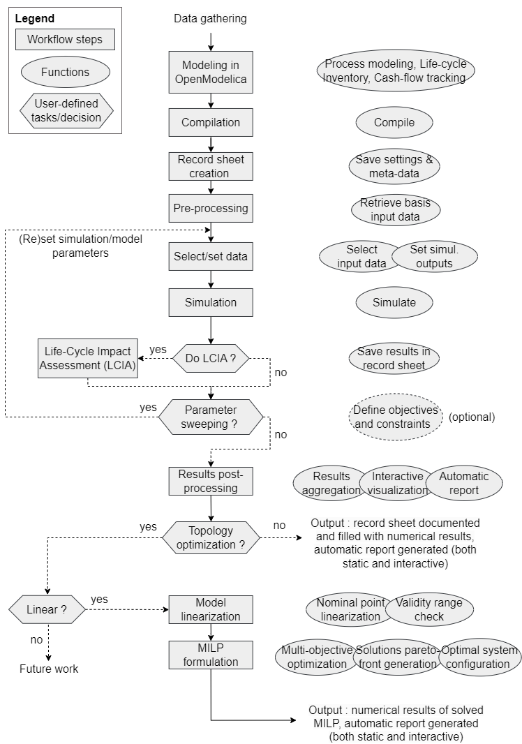

Figure 2: Simulation and optimization workflow functionalities of the computational platform.

The workflow includes 2 functionalities for optimization of the analyzed system based on any combination of thermodynamic/process, economic or environmental indicators (included in Figure 2):

* The model/system parameter sweep modifies simulation input data to evaluate a set of different process conditions or design. Optionally, objectives or constraints on the process characteristics or performance indicators may be formulated, to optimize the system in a derivative-free approach with a genetic, evolutive algorithm (currently implemented with NSGA-II).
* The system topology optimization takes as input a set of technology models from the platform library. Each model in the set is linearized around selected nominal operating point(s), thereby verifying the validity range of the linearization, and generating a new library of black-box technology models. The Mixed-Integer Linear Program (MILP) formulation described by Kantor et al., (2020) is applied to generate Pareto-optimal system configuration solutions through multi-objective optimization.

Computational runtime bottlenecks of the platform are identified and tackled through efficient data handling and software interfacing, avoided model re-compilation, solver outputs selection, and other measures.

* 1. Illustrative case: extract of typical results

This section illustrates several steps and types of analyses enabled by the workflow. As an example of unit model implementation in the platform, process modeling and validation is demonstrated for the alkaline electrolysis stack model, sub-system of the example case of Figure 1. An electrochemical model of the alkaline electrolyzer stack is built in OM based on the work of Sakas et al., (2022). The parameter sweep optimization workflow is applied to tune model parameters of a proportional-integral (PI) controller of the electrolysis feed lye mass flow, fitting the stack measured temperature reported in literature data. After validation of the AEL stack model with literature data, the input parameters are modified to correspond to the characteristics of an existing demonstration plant stack. The measured stack temperature is compared to the fitted model simulated results in Figure 3, varying in time between hot standby mode and nominal operation temperature as a result of flexible operation.

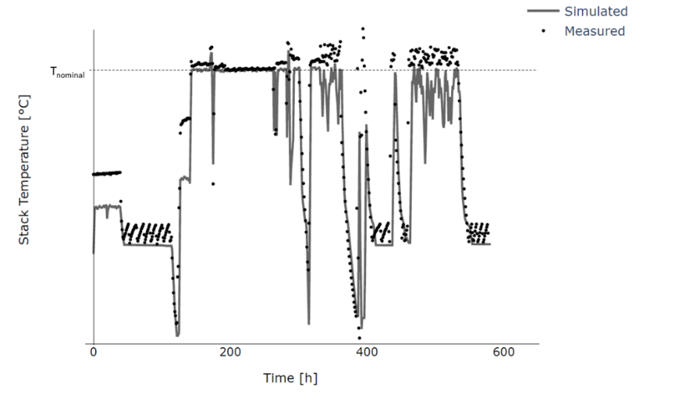

Figure 3: Measured (on an existing demonstration facility) and simulated AEL stack temperature.

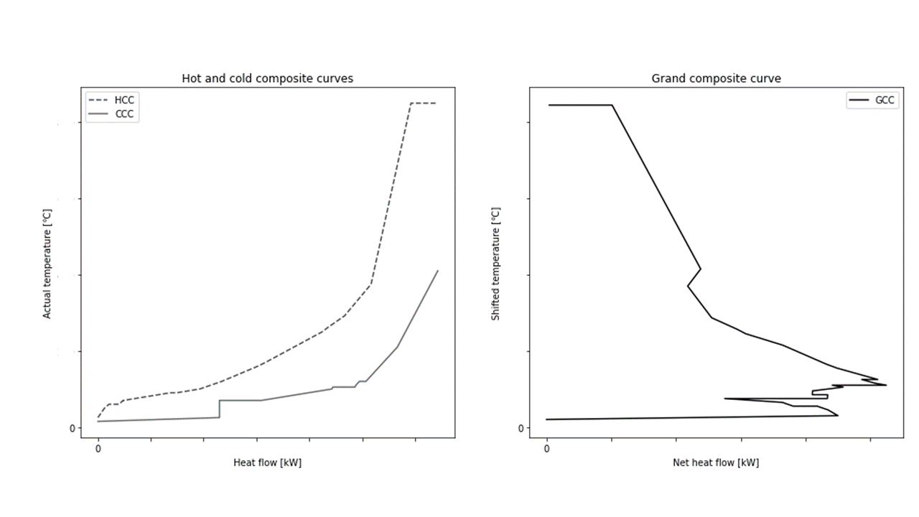

Figure 4: Composite curves for the Waste-to-X system of Figure 1 at nominal operation, equipped with an air-cooling tower. Axis values are kept confidential.

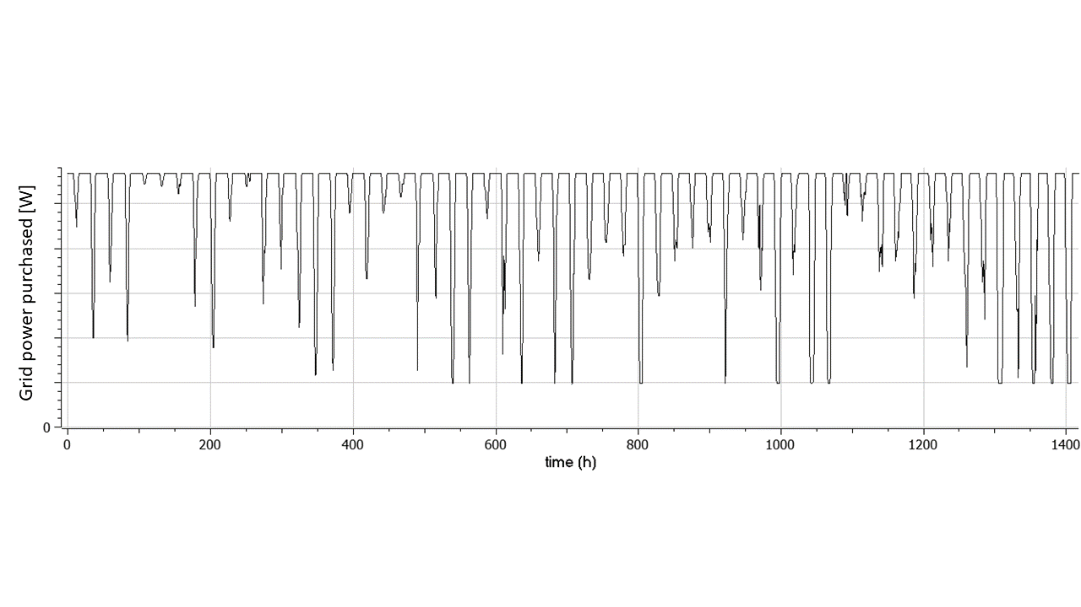

Figure 5: Typical power exchange profile at the power grid connection for 2 months of winter operation.

Systemic analysis of cases such as in Figure 1 includes typically optimal resources integration for the technology system, as well as with external interfaces. As part of the heat and power utilities integration, the results presented here include District Heating Network (DHN) and Water Steam Cycle (WSC). Figure 4 displays the pinch analysis results for heat recovery assessment, with hot and cold composite curves for the entire system of the Figure 1 at nominal operation. It is a snapshot of the heat flows at a given time of the year and does not represent an optimized design. The Minimum Energy Requirement (MER) of the plant in this configuration is composed of cooling requirements only, for which an air-cooling tower is correspondingly sized. The system interaction with the power grid is illustrated with the power exchange at the connection node in Figure 5.

* 1. Conclusions and perspectives

At current development stage, the described platform has been applied on practical industrial cases, with the benefit of a unique environment covering all aspects of system design and operational strategy optimization in a consistent workflow. Transparency is harnessed in the different analysis stages by systematic modeling practices and structures, documentation and validation, and holistic approaches providing decision-makers with comprehensive performance indicators. Flexibility of assessment is provided both through the large portfolio of technologies modeled and integration possibilities, and the workflows developed around the simulations to optimize the complex and interlinked systems.

For the specific case study analyzed, further work is needed to modify setpoints on the controllers, but overall accuracy of the simulated results is promising. On the system integration, the potential for improved seasonal integration of heat and power needs to be further investigated to optimize year-round performance for longer term planification of the industrial infrastructure. Forecast capabilities on a range of input (power supply, price and time-dependent emission factor, heat demand, waste composition) may be harnessed to improve the system performance, implementing predictive control in the system operations, and evaluating robustness against deviations. To evaluate a larger technology integration potential via the topology optimization, the model set of Waste-to-X technologies will grow to include more synthetic fuels generation processes, storage units, and other more novel technologies. The MILP formulation will be adapted to include typical days chronology (Blanke et al., (2022)) for more accurate resolution, and a strong focus will be put on the development of algorithms handling the operational strategy within the topology optimization problem, including input parameter uncertainties and model complexity (including surrogation strategies).

References

Abdelghany, M. B., Shehzad, M. F., Liuzza, D., Mariani, V., & Glielmo, L., 2021. Optimal operations for hydrogen-based energy storage systems in wind farms via model predictive control. International Journal of Hydrogen Energy, 46(57), 29297–29313.

Blanke, T., Schmidt, K. S., Göttsche, J., Döring, B., Frisch, J., & van Treeck, C., 2022. Time series aggregation for energy system design: Review and extension of modelling seasonal storages. Energy Informatics, 5(1), 17.

Eddy, D. M., Hollingworth, W., Caro, J. J., Tsevat, J., McDonald, K. M., & Wong, J. B., 2012. Model Transparency and Validation: A Report of the ISPOR-SMDM Modeling Good Research Practices Task Force-7. Value in Health, 15(6), 843–850.

Fritzson, P., Pop, A., Abdelhak, K., Ashgar, A., Bachmann, B., Braun, W., Bouskela, D., Braun, R., Buffoni, L., Casella, F., Castro, R., Franke, R., Fritzson, D., Gebremedhin, M., Heuermann, A., Lie, B., Mengist, A., Mikelsons, L., Moudgalya, K., . . . Östlund, P., 2020. The OpenModelica Integrated Environment for Modeling, Simulation, and Model-Based Development. Modeling, Identification and Control: A Norwegian Research Bulletin, 41(4), 241–295.

ISO, 2006. ISO 14040:2006: Environmental management — Life cycle assessment — Principles and framework. Retrieved August 23, 2023.

Kantor, I., Robineau, J.-L., Bütün, H., & Maréchal, F., 2020. A Mixed-Integer Linear Programming Formulation for Optimizing Multi-Scale Material and Energy Integration. Frontiers in Energy Research, 8. Retrieved December 20, 2022.

Niziolek, A. M., Onel, O., & Floudas, C. A., 2017. Municipal solid waste to liquid transportation fuels, olefins, and aromatics: Process synthesis and deterministic global optimization. Computers & Chemical Engineering, 102, 169–187.

Puchongkawarin, C., & Mattaraj, S., 2020. Development of a superstructure optimization framework for the design of municipal solid waste facilities. Sustainable Environment Research, 30(1), 27.

Sakas, G., Ibáñez-Rioja, A., Ruuskanen, V., Kosonen, A., Ahola, J., & Bergmann, O., 2022. Dynamic energy and mass balance model for an industrial alkaline water electrolyzer plant process. International Journal of Hydrogen Energy, 47(7), 4328–4345.