CFD-based investigation of the efficiency enhancement due to microstructure reorientation in structured packing

Christopher Decherta*, Iris M. Baumhöggera, Eugeny Y. Kenig a

a Chair of Fluid Process Engineering, Paderborn University. Pohlweg 55, D-33098 Paderborn, Germany

christopher.dechert@upb.de

Abstract

Wetting quality is one of the deciding factors for the efficiency of separation columns. In this work the computational fluid dynamics (CFD) technique is applied to examine the impact of liquid-phase physical properties and surface structuring on wetting in structured packings. The simulation results demonstrate a substantial impact of both factors on the interfacial area. Under certain conditions, a smooth packing surface can perform better than a microstructured surface. The orientation of the microstructure has a strong impact on its performance. Furthermore, the average liquid flow angle is not solely dependent on the packing macrostructure.

**Keywords**: structured packings, microstructure, wetting, CFD.

* 1. Introduction

Structured packings are column internals widely used in gas-liquid separation operations. Their specific geometry largely determines the fluid flow and hence the overall performance of separation columns. This is why it has been a focus of numerous studies toward enhanced mass transfer and reduced pressure drop. Computational fluid dynamics (CFD) is an ideal tool to investigate local flow phenomena within structured packings. However, simulations of a complete column or even a packing stack remain numerically unfeasible. Petre et al. (2003) were among the first to suggest a small representative elementary unit (REU) of the packing geometry that allowed application of CFD for the investigation of local flow phenomena. This idea was later used by several groups to simulate two-phase flow dynamics (e.g., Olenberg and Kenig, 2017; Hill et al., 2019). The results of these studies revealed that the wetted area of structured packing is often lower than the surface area of the packing material and that the gas-liquid interfacial area strongly depends on the liquid load and contact angle. Up to now, REUs with smooth surfaces have been analyzed, while surface structuring (used in real packings) has only been accounted for by modifying contact angles (Bertling et al., 2023). Our recent study (Dechert and Kenig, 2022) revealed that this way cannot guarantee sufficient accuracy in representing the microstructure impact on liquid flow. For this reason, in the present study, REUs of single packing sheets with explicitly geometrically represented microstructures are investigated to determine the influence of microstructures on liquid flow. Different properties of the liquid phase, e.g., liquid load, density, viscosity, surface tension, and contact angle are varied independently and the influence on the gas-liquid interfacial area, liquid flow morphology, liquid holdup, and effective flow angle in the packing is analyzed. The results provide a comprehensive view on the wetting in structured packings as well as an evaluation of the impact of different flow parameters.

* 1. Microstructure

This investigation is based on the structured packing Mellapak 250Y. Fabricated by Sulzer Chemtech, this packing is available with different surface structuring, namely, without microstructures, with wavy microstructures, and with hilly microstructures. In this work, only the smooth and wavy surface structures were investigated. Our analysis of the shape of the wavy microstructure (l-grooved) was performed using optical and laser microscopes. From the image obtained with the optical microscope (Figure 1), the dimensions of the wavy shape of the microstructure were estimated, namely, a height of approximately 0.0002 m and a wavelength of 0.0015 m. The structure was represented with a sinusoidal shape for CAD modeling.

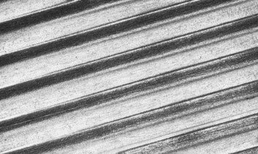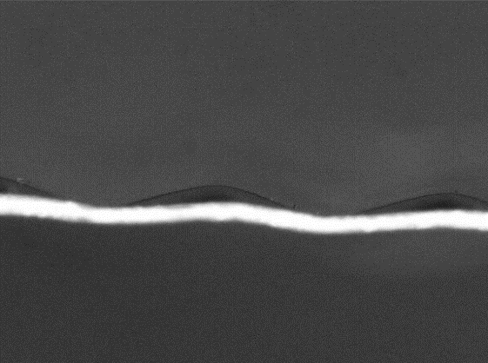

Figure 1: Sulzer packing microstructure captured by an optical microscope. Left: top view, right: side view.

* 1. Modeling
     1. Governing Equations

This work focuses on the liquid wetting and follows the approach of Olenberg and Kenig (2017) in which a quasi-stagnant gas phase is assumed. The movement of the gas phase is thus solely influenced by its interaction with the liquid phase. Further assumptions include incompressible and isothermal flow with Newtonian behavior. The continuity and momentum equations describing the two-phase fluid system are as follows:

|  |  |
| --- | --- |
| $$∇∙u=0$$ | (1) |
| $$ρ\frac{∂u}{∂t}+ρ∇∙\left(uu\right)=-∇p+ρg+η∇^{2}u+f_{σ}$$ | (2) |

where *ρ* is density, *t* is time, ***u*** is velocity vector, *p* is pressure, ***g*** is gravity, *η* is dynamic viscosity and ***fσ*** is a source term, which acts as a volume force and accounts for the surface tension effects at the free phase interface (Brackbill et al., 1992). The volume-of-fluid method (VOF) proposed by Hirt and Nichols (1981) was selected to resolve the free surface movement. In the original VOF formulation, the interface is resolved with a finite thickness and its exact location is not known. This leads to inaccurate calculations of interfacial normal vectors and interfacial fluxes. To determine the exact location and to increase the accuracy of the simulations, the piece-wise linear interface calculation (PLIC) method originally proposed by Youngs (1982) was applied. To govern turbulence within the Reynolds-averaged Navier-Stokes (RANS) modeling, the Reynolds stress term is implemented in Equation (2) and the k-omega SST model is employed.

* + 1. Modification for Fully Periodic Flow

For a fully periodic simulation, all values and gradients at the faces of the periodic boundaries must have the same value. For the velocity, this is straightforward because the fluids are incompressible. However, pressure is not periodic. It consists of two parts, the dynamic pressure *pdyn* and the static pressure *pstat*:

|  |  |
| --- | --- |
|  | (3) |

The dynamic pressure is, again, periodic due to incompressibility. The static pressure is affected by the driving forces, in this case, gravity. Therefore, the pressure is only periodic at the boundaries orthogonal to gravity. To achieve a periodic pressure at the other boundaries, the static pressure difference caused by gravity is excluded from the overall pressure field. This is realized by substituting Equation (3) in Equation (2):

|  |  |
| --- | --- |
| $$ρ\frac{∂u}{∂t}+ρ∇∙\left(uu\right)=-∇p_{dyn}+ρg+η∇^{2}u+f_{σ}+f_{stat}$$ | (4) |

For a stagnant gas phase, ***fstat*** reads as follows:

|  |  |
| --- | --- |
|  | (5) |

* + 1. Computational Domain and Boundary Conditions

In this work, the liquid flow over single packing sheets of a Mellapak 250Y packing was investigated. The REU was designed following Olenberg and Kenig (2017). The computational domain (Figure 2) has a quadratic shape with side lengths of 0.032 m and a height of 0.004 m.

Ein Bild, das Design, Hebel enthält.
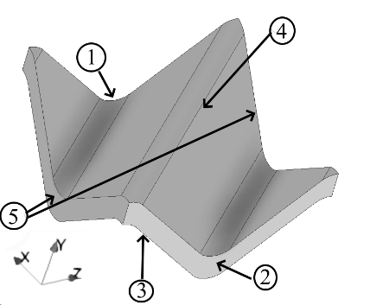

Figure 2: Computational domain for the flow over the packing sheet. Left: complete region with numbered boundaries, right: liquid film for the idealized liquid inlet (boundary number 1)

Two different flow conditions were investigated in this work. The first one is the idealized inlet condition, i.e., a liquid film covering the packing at the inlet and having a constant velocity and a constant film thickness. This corresponds to an ideal liquid-phase distribution. The second flow condition is the fully periodic flow, representing the liquid distribution for a perfectly developed flow inside a packing element. For the ideal flow condition, the boundary conditions including volume fraction *α* and contact angle *θ* are given in Table 1. For the fully periodic flow, boundaries number 1 and 2 are periodically coupled, the other boundaries remain unchanged. The velocity ***u*** and the film thickness *δ* of the liquid at the idealized inlet are determined using Nusselt film theory (Nusselt, 1916) and hence depend on the liquid load. As initial condition for the idealized inlet, the whole domain is filled with stagnant gas (***u***=0, *α*=0). Since there is no real inlet in case of fully periodic flow, the liquid load is set using a corresponding amount of liquid in the packing foldings.

Table 1: Boundary conditions of the idealized inlet (numbers according to Figure 2

|  |  |  |
| --- | --- | --- |
| boundary number | physical meaning | mathematical formulation |
| 1 | inlet | ***u***=f(*y*), ∇*p*=0, *α*=f(*y*) |
| 2 | outlet | ∇***u***=0, ∇*p*=0, ∇*α*=0 |
| 3 | bottom wall/packing sheet | ***u***=0, ∇*p*=0, *α*=f(*θ*) |
| 4 | gas phase | ∇***u***=0, *p*=0, ∇*α*=0 |
| 5 | sides open to neighbor REUs | periodic |

* + 1. Implementation

For the solution of the model equations, the interFoam solver from the open-source software package OpenFOAM 10 was utilized. This tool is based on the finite volume discretization. The equations and methods presented in Section 3.1 as well as the k-omega SST turbulence model are parts of the software package used. We extended the package by implementing the pressure adjustment described in Section 3.2. Furthermore, a calculation method to determine the size of the interfacial area based on the PLIC method and a method to evaluate the average liquid flow angle were implemented. In all simulations, the time step was adjusted automatically, to maintain the Courant number below 1 and its value near the interface below 0.5.

* 1. Model Validation

For the validation of our setup, the results obtained by Olenberg and Kenig (2017) with the commercial software tool STAR-CCM+ were used. They studied the Montz B1-250 packing, with dimensions similar to those of Mellapak 250Y, and varied the contact angle between 10 and 70° and liquid load between 10 and 90 m³/(m²·h). The system studied consisted of water and air with constant fluid characteristics estimated at 25 °C. Our simulation results revealed a good optical agreement with those of Olenberg and Kenig (2017) in terms of the liquid flow morphology, number of rivulets and film thickness. The average difference between the values of the resulting interfacial area was 10 %. The deviations are mostly encountered for small contact angles and high liquid loads, e.g., complete wetting in our simulations vs. incomplete wetting by Olenberg and Kenig (2017). Therefore, the model presented in our work can be judged as validated.

* 1. Parametric Studies
     1. Influence of liquid load and contact angle

Bertling et al. (2023) found out that inlet effects in a Mellapak 250Y packing are negligible after the flow length of just one REU. Comparing the height of one REU of 0.03182 m to the height of one packing element, which is typically between 0.2 and 0.3 m (Kister, 1992), it is evident that the fully periodic flow is more appropriate for describing the flow dynamics within structured packings then the idealized inlet. Therefore, for the parametric studies, the fully periodic flow was chosen. The liquid morphologies shown in Figure 3, were obtained by performing the parametric study within the limits given in Section 4 using the REU with fully periodic flow.

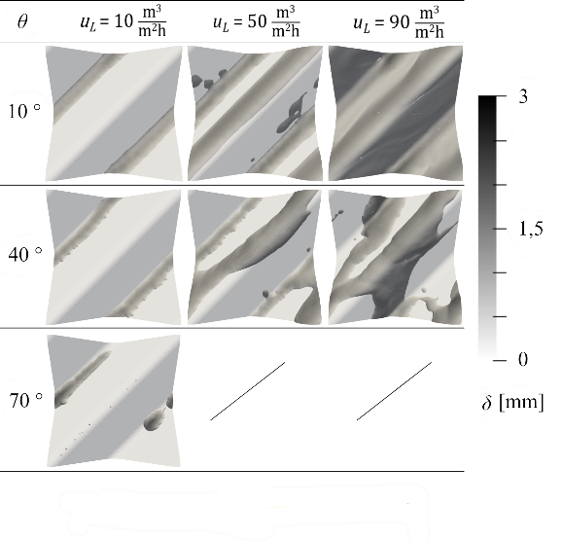

Figure 3: Liquid flow morphologies for the fully periodic flow

The study discriminates three distinct flow regimes below the loading point. At low liquid loads and contact angles, the liquid strictly follows the macrostructure of the packing sheet. The average liquid flow angle aligns with the corrugation angle of the packing. Increasing either the liquid load or the contact angle results in thicker films and some liquid spilling over the macrostructure, shifting the liquid flow angle towards the vertical. For contact angles or liquid loads exceeding certain threshold values, some liquid drains off the packing surface. In this arrangement, the drained liquid trickles out of the computational domain (out of the boundary number 4, Figure 2), making the intended liquid load unattainable. This drainage point was reached at higher flow rates of the 70 ° contact angle.

* + 1. Variation of density, viscosity, and surface tension

Along with liquid load and contact angle, physical properties of the liquid phase may also significantly affect wetting behavior. We varied these properties individually within the limits determined according to the typical values encountered in separation processes. Density was varied between 500 and 2000 kg/m³, viscosity between 1·10-4 and 1 Pa·s, and surface tension was varied between 0.015 and 0.072 N/m. With increasing density, decreasing viscosity or decreasing surface tension, the liquid flow pattern more and more deviates from the path dictated by the packing macrostructure toward overflow and drainage. Similarly, these trends in physical properties result in a higher average liquid flow angle, reduced liquid hold-up and an increase in interfacial area. Varying density, viscosity, and surface tension within the limits mentioned above changes the flow pattern significantly, from strictly following the macrostructure to liquid drainage. Such large physical system property variations can result from significant concentration changes over the column height (typical in e.g. distillation processes). Taking this effect into account can thus be beneficial for the choice of packing enhancing the column efficiency.

* + 1. Surface Structuring

The l-grooved microstructure described in Section 2 is horizontally oriented in Sulzer packings (see Figure 4). For a comparison, the microstructure was rotated by 90 ° to investigate the effect of its orientation on liquid wetting. The parametric study shown in Section 5.1 was now performed for the l-grooved and the rotated l-grooved microstructures. Figure 5 demonstrates that the preferred surface structure for achieving the highest interfacial area depends on the liquid load. At low liquid loads, the rotated l-grooved microstructure resulted in the highest interfacial area, but reached the drainage point at nearly 40 m³/(m²·h). Thus, in contrast to a smooth surface, this microstructure destabilizes liquid flow. On the contrary, the drainage point of the l-grooved microstructure is reached at a liquid load of 140 m³/(m²·h), what indicates a stabilizing effect of this microstructure. For intermediate liquid loads, surface structuring seems to have little reason, as the wet pressure drop is increased by draining liquid.

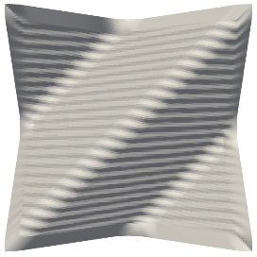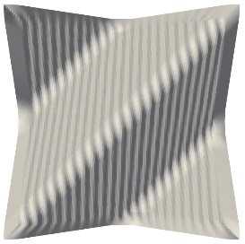

Figure 4: Top view of l-grooved microstructure. Left: horizontal orientation, right: 90 ° rotated

Figure 5: Interfacial area vs. liquid load for a contact angle of 40° in REUs with smooth, l-grooved, and rotated l-grooved surface

* 1. Conclusions

The influence of liquid-phase physical properties and surface structuring on the wetting of single structured packing sheets was investigated using CFD methods. The flow phenomena were analyzed based on a single REU. Three flow regimes below the loading point with different liquid morphologies were identified. Each of the physical properties of the liquid-phase studied has an impact on the morphology. Large variations can even lead to a change in the flow regime. Surface structuring also strongly influences the wetting conditions and existence of the three flow regimes. It was found that the l-grooved microstructure shifts the drainage point toward higher liquid loads, potentially reducing the pressure drop compared to smooth packing surface. In contrast, reorienting the l-grooved microstructure can enhance interfacial area under low liquid loads, but also shifts the drainage point to low liquid loads. Under some conditions, smooth packing surface can perform even better than the microstructured surface. The obtained results demonstrate the strong influence of the liquid phase physical properties and the surface structuring on the wetting in structured packing and consequently on the efficiency of the whole column. Future work will be focused on the integration of these properties into the CFD-based development of correlations for liquid hold-up and interfacial area.

References

R. Bertling et al., 2023, Simulation of liquid flow in structured packings using CFD-methods, Chemical Engineering Science, 269, 118405

J. U. Brackbill et al., 1992, A continuum method for modeling surface tension, Journal of Computational Physics, 100, 335-354

C. Dechert, E. Y. Kenig, 2022, CFD-based investigation of the packing microstructure influence on droplet behavior and film flow, Proc. 12th Conf. Distillation & Absorption, Toulouse, 2022

S. Hill et. al., 2019, Quantifizierung der Trenneffizienz einer strukturierten Packung mittels numerischer Simulation, Chemie Ingenieur Technik, 91, 12, 1833-1841

C. W. Hirt, B. D. Nichols, 1981, Volume of fluid (VOF) method for the dynamics of free boundaries, Journal of Computational Physics, 39, 201-225

H. Z. Kister, 1992, Distillation Design, Mc Graw Hill, Boston

W. Nusselt,1916, Die Oberflächenkondensation des Wasserdampfes, VDI-Zeitschr., 60, 541-546

A. Olenberg, E. Y. Kenig, 2017, Numerical simulation of two-phase flow in representative elements of structured packings, Computer Aided Chemical Engineering, 40, 2089-2094

C. F. Petre et. al., 2003, Pressure drop through structured packings: Breakdown into the contributing mechanisms by CFD modeling, Chemical Engineering Science, 58, 163-177

D. L. Youngs, 1982, Time-Dependent Multi-material Flow with Large Fluid Distortion, in Numerical Methods for Fluid Dynamics, Academic Press, 273-285