Physics-Informed Neural Networks in Model Predictive Control for Regulating Density in Polymer Blending
Po-Chun Mao, Yu-Ting Liu, Yuan Yao*
Department of Chemical Engineering, National Tsing Hua University, Hsinchu, 30013, Taiwan, ROC
*Corresponding Author’s E-mail: yyao@mx.nthu.edu.tw
Abstract
Traditional model predictive control (MPC) often relies on linear models, leading to potential inaccuracies when implemented in real-world scenarios with marked nonlinearity, such as grade transitions in chemical processes. In this research, we utilize a physics-informed neural network (PINN) for the dynamic modeling within MPC. By integrating constraints from physical laws during deep neural network training, this method reduces the dependency on vast datasets. Simultaneously, it ensures that the resulting dynamic model possesses a clear physical interpretation and a correct sign of process gain which is essential for the stability of the control system. In the case study, we examine a blending process of two polymer materials. Our proposed method efficiently creates a dynamic and nonlinear process model, even when faced with limited density data for model training. We use this model to virtually regulate density during grade transitions using an MPC strategy, illustrating the its feasibility.
Keywords: model predictive control, physics-informed neural network, deep learning.
  - Introduction
Model predictive control (MPC) is a sophisticated method for process control, designed to manage systems within specific constraints. It has been widely used in chemical industry. However, traditional MPC, based on linear models, often falls short in accuracy, particularly when dealing with nonlinearities common in processes such as grade transitions in chemical plants. To overcome this, integrating neural networks into MPC has been proposed for enhanced nonlinear modelling (Draeger et al., 1995). But the conventional neural networks, while powerful, require extensive training and result in models that lack clear physical interpretation, limiting their practical industrial application.
Our research tackles this challenge by employing physics-informed neural networks (PINN) (Raissi et al., 2019) to build a dynamic model within MPC, using actual factory data. Given the limited availability of data, mostly from steady-state processes, PINN is particularly advantageous. It reduces the amount of data required for training and improves the model’s extrapolation capabilities by incorporating physical laws, making it a more practical solution for real-world industrial applications.
In our case study, we investigate a blending process involving two polymer materials. Here, the key focus is on controlling the post-mixing density, which is regulated by adjusting the ratio of two feed flow rates. This task presents a significant challenge in typical factory settings, where continuous and real-time measurement of product density is difficult. Consequently, during transitions between various product grades, adjustments in the feed flow rate ratio are often based on empirical methods. We established a PINN model, used in conjunction with an MPC strategy, to forecast and virtually regulate density during grade transitions. The results illustrate the feasibility of the proposed method, showcasing its potential to be implemented in real industrial processes.
  - Introduction of the blending process
In this study, our objective was to predict the blending density in a thermoplastic elastomer (TPE) manufacturing process and to establish an PINN-based MPC system. A key goal was to demonstrate the real-world viability of this approach in actual process environments.
The study examines a blending process where two polymer fluids, Component A and Component B, are combined in a mixing tank (as shown in Figure 1). The mixture then passes through a series of reactors before the final density is measured. Due to the lack of real-time density monitoring and adjustment capabilities, operators traditionally rely on their experience to regulate the feed rates of Components A and B during transitions between different product grades.
Table 1 outlines the parameters of the blending process. These include $X_{in_A}$ as a process variable, representing the feed flow rate of Component A (high density), which is determined by the operator, and $X_{in_B}$ as a manipulated variable, denoting the feed flow rate of Component B (low density). $X_{out}$ represents the output flow rate from the mixer. The output density, ρ, is the controlled variable. PR indicates the production quantity, while L refers to the level in the mixer. $Y_{1}$ denotes mass, calculated from L. $Y_{2}$ represents the ratio of Component A in the mixer, which can be converted into density using empirical formulas.
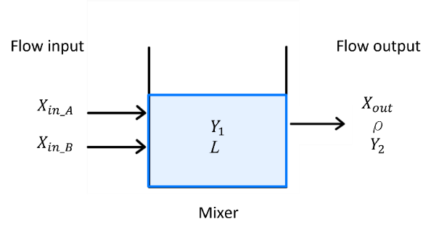
Figure 1. Diagram of blending process in the TPE plant
Table 1. Parameters of the blending process
Parameters | Units | Descriptions
$$X_{in_A}$$ | Kg/hr | Process variable
$$X_{in_B}$$ | Kg/hr | Manipulated variable
$$X_{out}$$ | Kg/hr | Process variable
ρ | Kg/$m^{3}$ | Controlled variable
PR | Kg/hr | Process variable
L | % | Process variable
$$Y_{1}$$ | Kg | Process variable
$$Y_{2}$$ | no unit | Process variable
  - Dynamic process model base on PINN
During process modelling, we faced a challenge: the density of the mixture, a crucial product quality variable in the TPE manufacturing process, cannot be measured continuously, resulting in limited label data. Traditional machine learning methods, including most deep neural networks, struggle under such data constraints, often leading to unreliable performance. To overcome this, we chose to employ an PINN, which is designed for supervised learning while adhering to physical laws expressed through differential equations. This approach is particularly suited to addressing data scarcity issues and ensuring physical interpretation of the obtained model.
Figure 2 illustrates the structure of the PINN model. The inputs to this model are $\{X_{in_{A}},X_{in_{B}}, PR, t, ρ_{0}\}$, where $t$ is the time index and $ρ_{0}$ is the initial density at time $t$= 0. The corresponding outputs are $\{Y_{1}, ρ\}$. The PINN model is designed to involve four hidden layers, each containing 60 neurons. The model was trained using a dataset comprising a small number of on-site data points and 25,000 collocation points, the latter of which were chosen using Latin hypercube sampling (Stein, 1987). The design space was determined by the historical maximum and minimum values of the five input variables. Specifically, the parameter $ρ_{0}$ is set to lie within the range of the historical minimum and maximum values of ρ. The utilization of collocation points is particularly effective in reducing the number of required training data points. For the model’s architecture, the hyperbolic tangent (tanh) function was selected as the activation function, while the Adam algorithm was used for optimization.
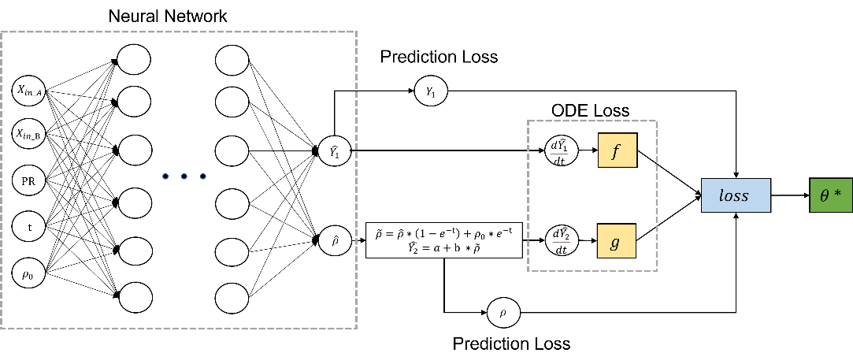
Figure 2. Framework of the proposed PINN model
To define the physical constraints in our PINN model, we formulated a series of ordinary differential equations (ODEs) grounded in the law of mass conservation. (1) represents the overall mass balance, while (2) specifically addresses the mass balance of Component A. (3) is then derived by substituting (1) into (2). We employ equations (1) and (3) to calculate the ODE losses for the PINN, ensuring that our model adheres to fundamental physical principles. These equations are structured as follows:
$\frac{dY_{1}}{dt}=X_{inA}+X_{inB}-X_{out}$ |  | (1)
$\frac{dY_{1}Y_{2}}{dt}=Y_{1}\frac{dY_{2}}{dt}+Y_{2}\frac{dY_{1}}{dt}=X_{inA}-Y_{2}X_{out}$ |  | (2)
$\frac{dY_{2}}{dt}=\frac{\left(1-Y_{2}\right)X_{inA}-Y_{2}X_{inB}}{Y_{1}}$ |  | (3)
Furthermore, the density (ρ) can be converted to the component ratio (Y_{2​}) using an empirical formula, where a and b are known constants.
$$Y_{2}=a+b * ρ$$ |  | (4)
The loss function of the PINN is composed of four components: two prediction losses and two ODE losses, as depicted in (5) to (11). In these equations, the caret symbol (^) denotes predicted values, i signifies the index of individual sample points, N_{R} represents the count of on-site data points included in the model training, and N_{T} indicates the total size of the training set, encompassing both on-site data points and collocation points. The terms $f^{i}$ and $g^{i}$ are derived from (1) and (3), respectively. It is noted that the output flow rate values (${X_{out}}^{i}$) are only utilized for the calculation of $f^{i}$ in (9) and are not incorporated into the inputs of the PINN model. To compute the differentials, the automatic differentiation techniques can be employed.
Loss = Prediction loss 1+ Prediction loss2 +λ₁*ODE loss1 +λ₂*ODE loss2 |  | (5)
Prediction loss 1 = $\frac{1}{N_{R}}\sum_{i=1}^{N_{R}}{{(({{\hat{Y}}_{1}}^{i}-{Y_{1}}^{i})}^{2}}$ |  | (6)
Prediction loss 2 = $\frac{1}{N_{R}}\sum_{i=1}^{N_{R}}{{(({\tilde{ρ}}^{i}-ρ^{i})}^{2}}$ |  | (7)
ODE loss 1 = $\frac{1}{N_{T}}\sum_{i=1}^{N_{T}}{(f^{i})^{2}}$ |  | (8)
$$f^{i}=\frac{d{{\hat{Y}}_{1}}^{i}}{dt}-{X_{in_A}}^{i}-{X_{in_B}}^{i}+{X_{out}}^{i}$$ |  | (9)
ODE loss 2 = $\frac{1}{N_{T}}\sum_{i=1}^{N_{T}}{(g^{i})^{2}}$ |  | (10)
$$g^{i}=\frac{d{{\hat{Y}}_{2}}^{i}}{dt}-\frac{\left(1-{{\hat{Y}}_{2}}^{i}\right){X_{in_A}}^{i}-{{\hat{Y}}_{2}}^{i}{X_{in_B}}^{i}}{{{\hat{Y}}_{1}}^{i}}$$ |  | (11)
where the model prediction of $ρ$ is modified from $\hat{ρ}$ to $\tilde{ρ}$ as:
$\tilde{ρ}=\hat{ρ}*\left(1-e^{-t}\right)+ρ_{0}*e^{-t}$ |  | (12)
This modification is crucial to ensure that the predicted density is consistent with the initial condition at t = 0. λ₁ and λ₂ serve as weighting factors that balance the different types of loss functions. Specifically, we have set λ₁ to 0.001 and λ₂ to 1, ensuring an optimal equilibrium between these loss components.
  - PINN-based MPC
Figure 3 presents the layout of the PINN-based MPC. In this setup, the prediction horizon (P) of the MPC is fixed at 6, and the control horizon is set at 1, with each control interval lasting 0.5 hours. At the onset of each grade transition, operators set the desired production quantity and product density targets, denoted as ${PR}_{sp}$ and $ρ_{sp}$ , respectively. The value of $X_{in_A}$ is then calculated using an empirical formula and held constant with a zero-order hold. During each control interval k, the predicted product density is represented as $\tilde{ρ}\left(k+i\right)=PINN(X_{in_{A}},{\hat{X}}_{in_{B}}\left(k+i\right),{ PR}_{sp},t\left(i\right),{\check{ρ}}_{0}\left(k\right))$, where i ranges from 1 to P. Here, ${\check{ρ}}_{0}\left(k\right)=PINN(X_{in_{A}},X_{in_{B}}\left(k\right), { PR}_{sp},t\left(1\right),{\check{ρ}}_{0}\left(k-1\right))$ for k ≠ 0, and ${\check{ρ}}_{0}\left(k\right)=ρ_{0}$ for k = 0, with $ρ_{0}$ being the product density measured before the transition . The variable ${\hat{X}}_{in_{B}}$ is the manipulated variable determined by the optimization function (13). During grade transitions, we aim to minimize the Integrated Squared Error, formulated as:
$$X_{in_{B}}(k+i)=\underset{{\hat{X}}_{inB}}{argmin}\sum_{i=1}^{P}{{\left[ρ_{sp}-\tilde{ρ}(k+i)\right]}^{2}}$$ |  | (13)
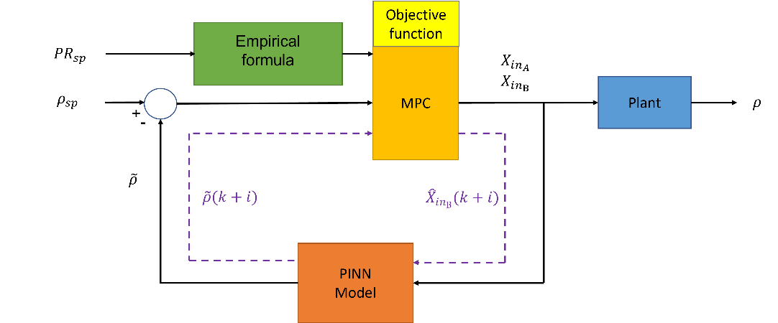
Figure 3. Framework of PINN-based MPC
  - Results and Discussions
Figure 4 displays the coefficient of determination (R²) and the root mean squared error (RMSE) of each on-site data point utilized in the training, validation, and test phases of the PINN model. A total of 150 on-site data points were gathered and distributed across these three subsets in a ratio of 7:1:2.
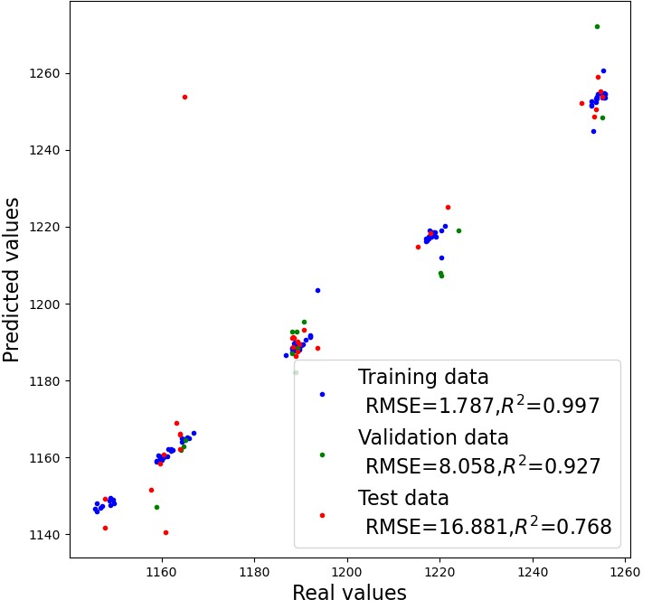
Figure 4. Parity plot between true values and predicted values of product density
Prior to implementing the MPC, control in the case study was executed through a one-step adjustment of both $X_{in_A}$ and $X_{in_B}$. $X_{in_A}$ was determined using the empirical formula discussed previously, while $X_{in_B}$ was calculated based on the final steady-state mass balance. This approach often led to extended transition times and a considerable production of off-quality products. Figure 5 illustrates how the proposed PINN-based MPC strategy significantly improves this process. Initially, there is a substantial increase in $X_{in_B}$, followed by gradual fine-tuning to prevent overshooting and stabilize the control value at its set point. It is evident from the data that our proposed control algorithm notably reduces the transition period and enhances product quality.
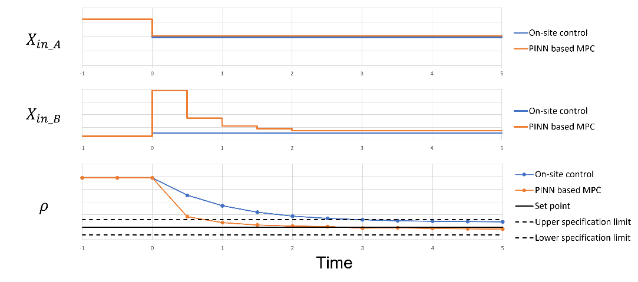
Figure 5. Comparison between the on-site control strategy and the PINN-based MPC in a grade transition
  - Conclusions
In this study, we leveraged a limited dataset of on-site process data to model a blending process using a PINN. The primary objective of this model was to predict product density, serving as a cornerstone for MPC. By integrating physical laws articulated through ODEs and generating collocation points, the PINN model attains commendable predictive accuracy. Comparing to using the mechanistic model only, PINN achieves better predictions by incorporating process measurements in model training. When applied to MPC, this PINN-based control strategy markedly decreases the time needed for grade transitions, thereby enhancing both productivity and product quality.
Acknowledgment
This work was supported in part by the National Science and Technology Council, ROC under project numbers NSTC 112-2221-E-007-015.
References
Draeger, A., Engell, S., & Ranke, H. (1995). Model predictive control using neural networks. IEEE Control Systems Magazine, 15(5), 61-66.
Raissi, M., Perdikaris, P., & Karniadakis, G. E. (2019), Physics-informed neural networks: A deep learning framework for solving forward and inverse problems involving nonlinear partial differential equations, Journal of Computational Physics, 378, 686-707.
Stein, M. (1987), Large sampling properties of simulations using Latin hypercube sampling, Technometrics, 29(2), 143-151.

