Regional Capacity Expansion Planning of Electricity and Hydrogen Infrastructure: A Norwegian Case Study

Kang Qiua, Espen Flo Bødala, Brage Rugstad Knudsena

aSINTEF Energy Research, Sem Sælands vei 11, Trondheim 7034, Norway

kang.qiu@sintef.no

Abstract

The impact of hydrogen production, transmission, and storage is examined for a regional energy system in Norway. To this end, the optimal investment decisions are determined using a combined electricity and hydrogen capacity expansion model, which is expanded to include hydropower production. A case study of a regional energy system located in the Haugaland region of southwestern Norway is presented. This study analyses the driving factors behind the investment decisions of hydrogen production, storage, and transmission. Results of the case study indicate that hydrogen storage investments are influenced by varying hydrogen demand, while the locality of hydrogen production is influenced by the location of hydrogen demand, electric generation and the transport cost of both electricity and hydrogen.

**Keywords**: Hydrogen, Capacity expansion planning, Energy systems optimization.

1. Introduction

Hydrogen (H2) can play a crucial role in abating CO2 emissions in hard-to-abate sectors, such as industry and transportation. Flexible H2 production is often mentioned to enable more cost-efficient integration of variable renewable energy (VRES) in the energy system as it can be used to balance variations in energy availability, thus reducing energy curtailment and increasing utilization of energy system infrastructure (Lange et al., 2023). Flexible H2 demand in hard-to-abate sectors can deliver much of the same flexibility for the power system as H2 storage systems for large-scale electricity storage, without the low round-trip efficiency of reconverting H2 to electricity in fuel cells or H2 gas turbines. The causes and effects of renewable power generation, transmission, the production of H2, and the projected end-use demands of a regional energy system are tightly coupled. This necessitates a detailed analysis of the driving factors behind investment decisions. This paper investigates the role of green H2 in the regional energy system using a linear capacity expansion planning model of the combined H2 and electricity system. Production, storage, and transport of both energy carriers are modelled with the same level of detail, including energy storage in H2 tanks and hydropower reservoirs which will become increasingly important as the shares of variable renewable energy of the total energy production increases.

The case study proposed is the regional energy system in Haugalandet, Norway. Haugalandet is a region in south-western Norway with significant industrial activity in the gas and metal sectors resulting in a potential local H2 demand (Voldsund et al., 2021). Furthermore, Haugalandet has large hydropower capacities and significant potential for both on- and offshore wind generation. The export of power out of the region is considered through both onshore and offshore interconnectors. The locality of H2 production facilities and their driving factors are analyzed, in particular, whether and when capacity expansion close to demand or close to energy source is optimal. Additionally, the resulting needs for storage and transport investments are analyzed as a part of assessing the needed H2 infrastructure to supply potential demand from varying renewables.

1. Method

In this work, a capacity expansion model is used to determine the cost-optimal electricity and H2 infrastructure. The modelling framework optimizes the investment capacity of production and conversion technologies, and transport infrastructure. Investment limitations due to resource limitations are included. Balance constraints keep track of production, demand, conversion, storage, and curtailment in every node for the energy carriers.

Electricity is generated from existing hydropower and wind power plants. Furthermore, offshore, and onshore wind capacities are given as an investment option. New storage technologies for the electricity side are modelled as batteries. Power is transported via transmission lines. Proton exchange membrane (PEM) electrolyzers produce H2 while PEM fuel cells convert H2 to electricity. They represent the coupling between the electricity and the H2 system. H2 storage is modelled as an investment option in the H2 system. The joint electricity and H2 optimization presented in (Bødal et al., 2020) is extended to model hydropower. The storage constraint is updated to include hydropower by adding regulated ($I_{tin}^{reg}$) and unregulated inflow ($I_{tin}^{ureg}$) and allowing for spillage ($e_{tin}^{spill}$) of water, modelled as

$$s_{tin}=s_{\left(t-1\right)in}+η_{i}^{in}e_{tin}^{in}-\left(\frac{1}{η_{i}^{out}}\right)e_{tin}^{out}+I_{tin}^{reg}+I_{tin}^{ureg}-e_{tin}^{spill}, ∀i∈S.$$

Where $s_{tin}$ is the storage level, $e_{tin}^{in}$ or $e_{tin}^{out}$ is the energy added to or subtracted from the storage at efficiencies $η_{i}^{in}$ and $η_{i}^{out}$ respectively. Indices are $t$ for time, $i$ for unit and $n$ for node. In addition, there is a minimum production limit that is only active for hydropower storage. This states that water used for energy production and spilled water is at least equal to the unregulated inflow:

$$\left(\frac{1}{η_{i}^{out}}\right)e_{tin}^{out}+e_{tin}^{spill}≥I_{tin}^{ureg}$$

1. Case study

The case study investigates the joint, optimal electricity and H2 planning for the Haugaland region in Norway towards 2030[1]. Only regional demand and transport are considered for H2, while power can be exported out of the region through offshore interconnectors abroad, or through onshore transmission lines into different market regions in Norway. The transmission capacity of the electrical grid is modelled from NVE atlas (NVE, 2023) and Statnett plans for the Haugaland area (Statnett, 2015). Investment costs for electrical transmission are determined from costs estimates by Statnett for new 420 kV transmission line Blåfalli-Gismarvik in the area (Statnett, 2020), while for the H2 system compressed gas truck transport is assumed (Mintz et al., 2006).

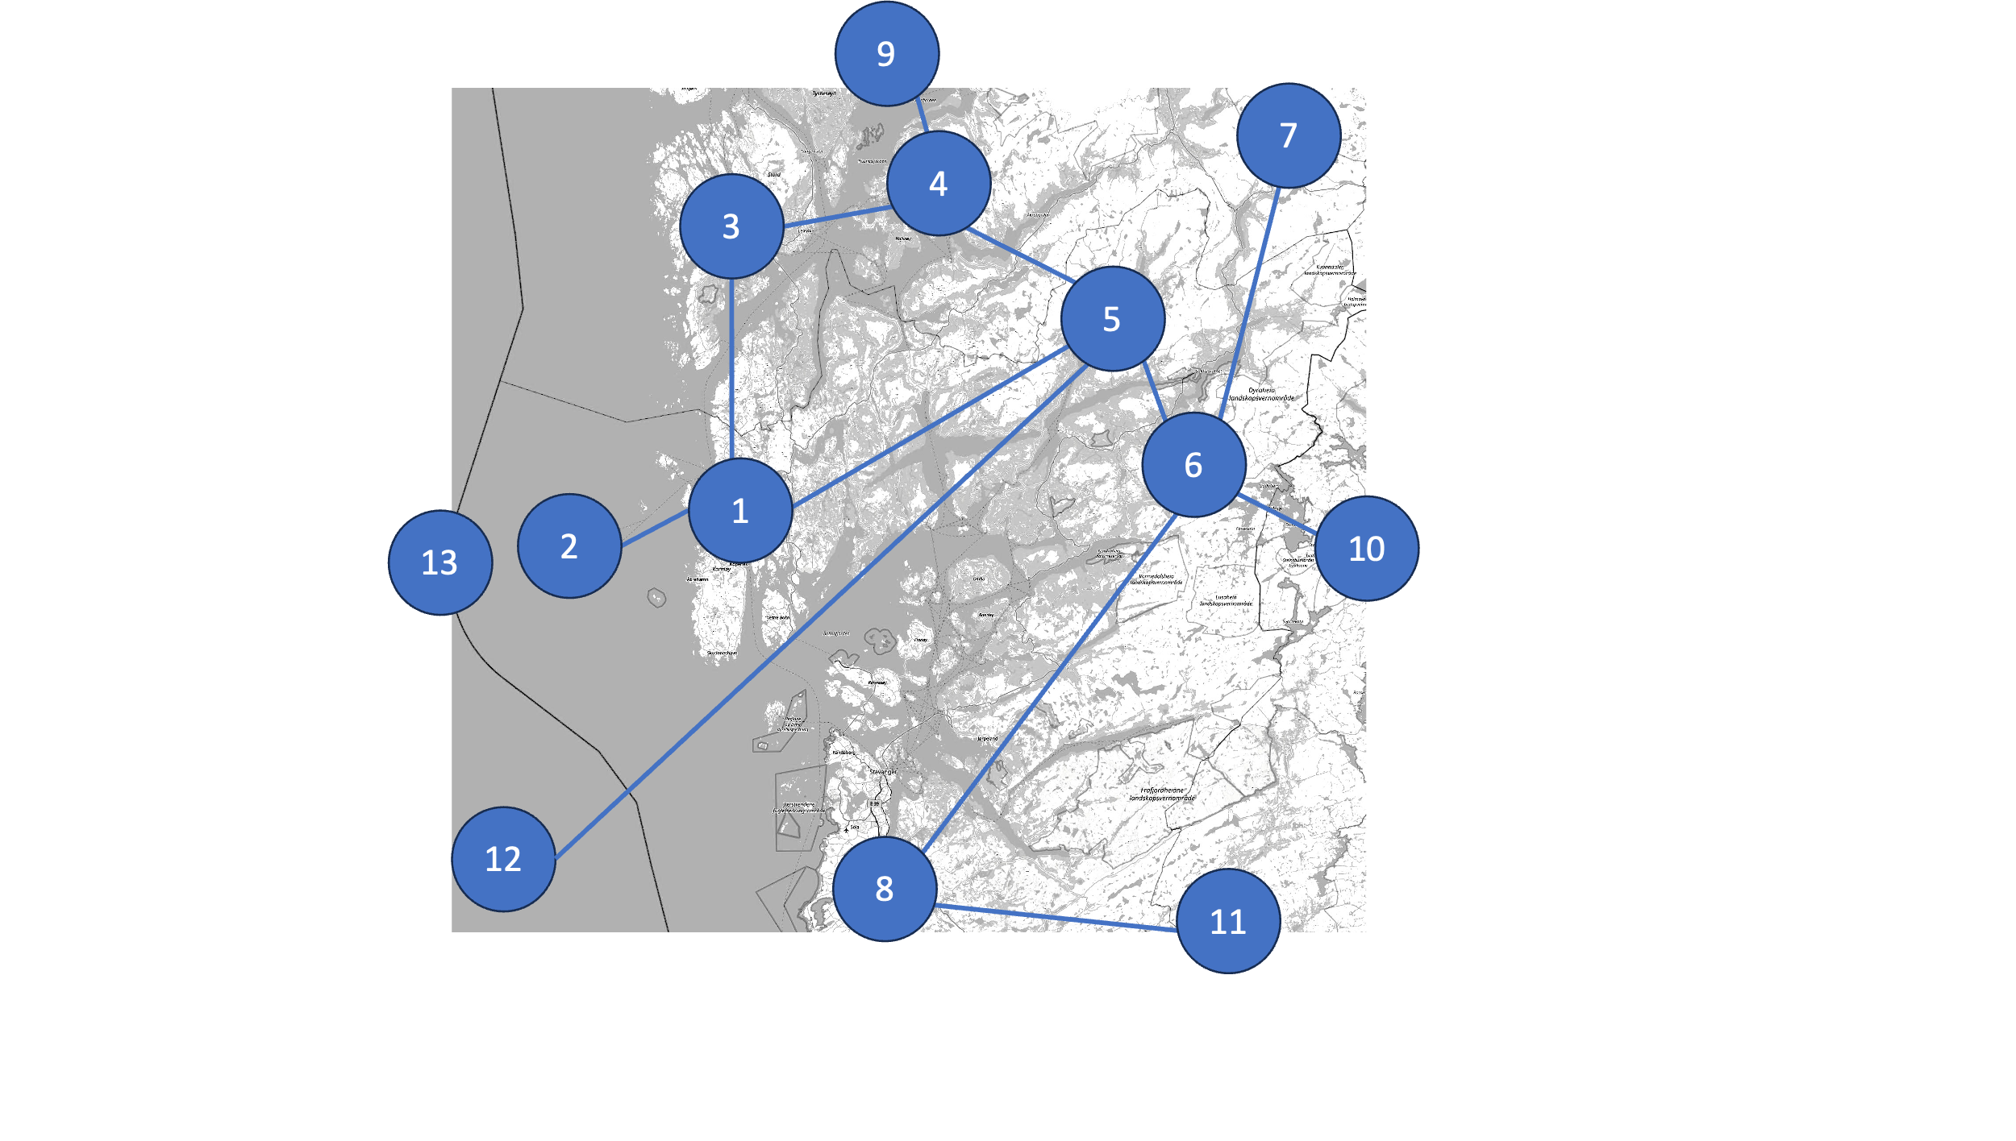Figure 1: Left: Proposed case study of the Haugaland region. The region is modelled in eight nodes (node 1-8) and four market nodes (node 9-12). Right: Average electricity and H2 demand per node.

Figure 2: Hydropower, installed wind, and potential wind investment capacity per node. Node 13 represents possible offshore wind investment, while nodes 1-8 describe onshore wind installations and investment potential.

Both investment and operating decisions are determined in an integrated optimization within a planning horizon of one year. The case study has a geographical resolution modelled in thirteen nodes (Figure 1, left), whereof nine are joint electric and H2 nodes and four are market nodes that enable electricity import and export out of the region. The joint electric and H2 nodes (nodes 1-8, node 13) have a specified energy demand (Figure 1, right), hydropower capacities, and existing and potential wind generation (Figure 2).

The H2 demand is based on a case study for decarbonizing local industry and transport (Voldsund et al., 2021), which includes local metal production and a ferry. While the future H2 demand in existing industries and transport is limited, there exist opportunities for large-scale H2 demand in node 1. This H2 demand can arise from fuel-switching of existing offshore gas turbines, transport to Europe through existing pipelines or new industries, such as green steel production at the local industry area (Voldsund et al., 2021, p. 2). In this case, we assume that new green steel production is established and results in an H2 demand of 90,000 (t H2)/y.

We investigate five permutations of the case study. First, with constant and variable H2 demand profiles in 4.1. Then, the effect of limitations in transmission investments and new wind power is analyzed in 4.2. and 4.3 respectively.

1. Results and Discussion

Figure 3: Effect of H2 demand on the system. The green bar plot shows investments under constant H2 demand while the blue bar plot shows investments under fluctuating H2 demand.

4.1. Effect of H2 demand profiles

The capacities and location of PEMEL investments are shown in Figure 3 for both constant and fluctuating H2 demand profiles, where the average demand corresponds to Figure 1. In this case, no wind investments are allowed.

With constant H2 demand profiles, the system invests in PEM electrolyzers (PEMEL) with capacities corresponding to the local H2 demand. Investments in extra PEMEL and H2 storage are triggered by fluctuating H2 demand. In node 1, the extra PEMEL and H2 storage capacity is 43 MW and 44 MWh respectively, which corresponds to around 8% of the local H2 demand for one hour.

Transport of energy carriers from nodes where power is mostly generated (nodes 6,7, and 8) to where most of the demand for H2 and electricity is located (node 1) is handled via expanding the electric transmission grid capacity by 9.1%. The levelized cost of H2 (LCOH) with constant demand results in a unit cost of H2 of 2.25 €/(kg H2). When H2 demand fluctuates the LCOH rises to 2.30 €/(kg H2). Here, the LCOH is calculated by dividing the added investments and operational costs for the entire system due to H2 production by the quantities of H2 produced. The added costs are found by calculating the increased total system costs for a case with H2 demand to a case without H2 demand, where all other parameters are the same. Thus, the LCOH includes all costs related to the H2 supply, incl. production, storage, and transportation in both the electricity and H2 system.

4.2. Constrained electricity transmission system

While previous results indicate that the most cost-optimal way of providing H2 to the system is to transport electricity by expanding the grid and producing H2 at the demand site. Transmission grid development is becoming a bottleneck to the global energy transition due to prohibitively long construction times of 5-15 years and regulations that needs modernization (International Energy Agency, 2023). Lack of transmission capacity are restricting renewable generation and electrification projects that are important for emission reduction. This section discusses scenarios where investments in the electrical grids are not possible.

Figure 4 shows investments in the H2 system technologies without and with constraints on grid investments, respectively, leading to expansion of the H2 transport system. H2 transport is modelled as compressed gaseous trucks with limited transport capacity per branch. The investments costs in the required capacity of trucks, trailers, and terminal are determined with a techno-economic assessment model of the H2 infrastructure (Mintz et al., 2006). With constrained electricity transmission, the PEMEL investments shift from node 1 to node 5. PEMEL investment in node 1 is reduced to 270 MW and only can serve 51% of the local H2 demand, while node 5 is increased to 301 MW. Node 5 is a preferred location for H2 conversion as it lies between nodes with high hydropower capacities (nodes 4-8) and the site of the highest H2 demand in node 1. Subsequently, new investments are made in H2 transport capacity between nodes 5 and 1 that are equal to the amount of PEMEL capacity in node 5. In total, only 2% (12 MW) of additional PEMEL investments are observed compared to the previous case with unconstrained grids.

Figure 4: Investments into PEMEL and H2 storage without and with limited grid investments.

Investments in H2 storage capacity in node 1 rise significantly to 114 MW, which is 22% of the local H2 demand for one hour and an increase of 161%. Negligible amounts of H2 storage are seen in node 5. H2 storage is co-located with the variable H2 demand in node 1 on the energy-deficit side of the transmission constraint to reduce the investments in truck transport capacity. In node 5, H2 can be produced and transported at a constant rate with a steady electricity supply from hydropower. The rest of the H2 system remains largely the same as before because H2 is produced locally at the demand sites. The LCOH is 2.50€/(kg H2) when grid investments are disallowed.

4.3. Effects on wind power

In this section, we discuss what happen to the previous cases when options to invest in wind power is added. The capacity expansion planning model invests in high capacities of onshore wind, which are located at nodes 1, 3, and 8 (shown in Figure 5). Onshore wind is particularly lucrative in this case study, as it is located close to nodes of high demand.

The new wind investments increase the capacity for electricity generation by 26.4% with and without modelled H2 demand. As wind power is generated at locations with already high energy demands, the grid capacity does not need to be expanded to accommodate wind power investments. In the case of H2 demand, wind investments are not shown to impact the electric transmission capacity. In the case of constrained transmission grids, adding investments in variable wind power results in 144 MW (+20.7 %) H2 storage capacity, which is 26% of the local H2 demand for one hour. Therefore, fluctuating wind power generation is compensated by making H2 production more flexible. In the grid-constrained case, higher onshore wind capacities can reduce the capacity of H2 transport by 10.5% between nodes 1 and 5. The LCOH is 2.30€/(kg H2)with wind power investments and increases to 2.48€/(kg H2) if grid investments are disallowed.

Figure 5: Existing onshore wind power capacities and optimal investments

While the optimization is presented with the option to invest in offshore wind power, that option is not chosen in this case study due to higher capital expenditure.

1. Conclusions

The combined electricity and H2 capacity expansion planning model with an extension to model hydropower has been presented and applied to a case study of a Norwegian regional energy system. The results indicate the impact of H2 demand, electricity transmission, and renewable wind generation on the production, storage, and transport of H2. Fluctuating local H2 demand incentivizes flexibility in H2 productionand investments in H2 storage. If further investments in electric transmission are allowed, the cost-optimal way to provide H2 to the system is to produce at the location of demand. In this case, transmitting electricity is preferred over transporting H2. When grid investments are prohibited, the production of H2 moves to nodes which are closer to the hydropower capacities in the system while H2 is transported to the demand site. Wind power does not increase the need for grid capacity investments, indicating that the transmission capacity in the case study can handle the integration of VRES. H2 storage investments increase due to new fluctuating wind power generation, while H2 transport capacities decrease due to the co-location of H2 demand and wind power production. The LCOH ranges from 2.25-2.50 €/(kg H2), where the main cost driver is electricity grid capacity.

Acknowledgement

This publication has been funded by the project Hydrogen pathways 2050, coordinated by IFE. The authors gratefully acknowledge the financial support from the Research Council of Norway (grant 326769) and the user partners Gassco, Equinor and Statkraft.

References

Bødal, E.F., Mallapragada, D., Botterud, A., Korpås, M., 2020. Decarbonization synergies from joint planning of electricity and hydrogen production: A Texas case study. Int. J. Hydrog. Energy.

International Energy Agency, 2023. Electricity Grids and Secure Energy Transitions: Enhancing the Foundations of Resilient, Sustainable and Affordable Power Systems. OECD.

Lange, H., Klose, A., Lippmann, W., Urbas, L., 2023. Technical evaluation of the flexibility of water electrolysis systems to increase energy flexibility: A review. Int. J. Hydrog. Energy 48.

Mintz, M., Gillette, J., Elgowainy, A., Paster, M., Ringer, M., Brown, D., Li, J., 2006. Hydrogen Delivery Scenario Analysis Model for Hydrogen Distribution Options. Transp. Res. Rec. 1983, 114–120.

Statnett, 2020. Konsesjonssøknad: Ny 420 kV-forbindelse Blåfalli-Gismarvik.

Statnett, 2015. Forsyning av økt kraftforbruk på Haugalandet. Statnett.

The Norwegian Water Resources and Energy Directorate, n.d. NVE Atlas

Voldsund, M., Straus, J., Jordal, A.B.K., Knudsen, B.R., 2021. CO2-fangst fra hydrogenproduksjon ved Haugaland Næringspark : rapport fra CLIMIT idéstudie “Haugaland CCS,” 31. SINTEF Energi AS.

1. The model and data are available at: <https://github.com/espenfb/HEIM/tree/master/case_haugaland>.