Optimizing circular economy levers to achieve global sustainability

Shubham Sonkusarea , Yogendra Shastria*

a Department of Chemical Engineering, Indian Institute of Technology Bombay, Mumbai 400076, India

* yshastri@iitb.ac.in

Abstract

Circular economy (CE) adoption can contribute towards the sustainable development goal of responsible consumption and production. Understanding the broader implications of CE adoption and optimizing different levers of CE such as reduce, reuse, and recycle is required. A global integrated planetary model has been used in this work to address these needs. This model represents the global ecosystem in a compartmental form, resembling a complex food web. The industrial sector within this model incorporates the crucial elements of reuse and recycling associated with the CE concept. In this work, optimization theory is used to develop time-dependent policies for implementing CE to achieve long term sustainability. Sustainability is quantified here using Fisher information (FI), and the objective function is minimization of FI variation along a desired trajectory. Result shows that if product reuse time can be increased by five times, sustainability is achieved even with "business as usual" scenario. Furthermore, as reuse time increases, there is less variation in decision variable profiles, indicating a policy that is easier to implement for sustainable system. Overall, the research provides valuable insights into the adoption, strategies, and limitations in the implementation of CE.

**Keywords**: Sustainability, Circular Economy, Reuse, Recycle, Reduce, Optimal control

* 1. Introduction

The consumption pattern and population growth in today’s world are matters of concern. There are various examples of consumption increase in various fields. Since 1950, the production of plastic has increased by 200-fold reaching 381 million tonnes in 2015. The rate of fossil fuel consumption has doubled since 1980 (Sonkusare et al. (2023)). There are many such examples of consumption increases that exploit the ecosystem. The reason for this exploitation is a linear model of resource consumption. The solution to one-way linear resource consumption is the implementation of a circular economy (CE). CE has gained importance in policy formulation, advocacy, consultancy, and natural sciences in the past decade. In the CE model, waste becomes valuable resources through recovery using reuse and recycling. CE implementation can balance between the economy, environment, and society (Sehnem et al. (2019)). The study by the Ellen MacArthur Foundation and Mckinsey for Business and Environment (2015) shows that CE implementation could increase the total annual productivity by 3% by 2030, turning to a total annual benefit of 1.8 trillion at the EU level, which could increase GDP by 7% (Rizos et al. (2017)). To effectively address CE challenges and benefit from the implementation of CE at the global level, the imperative lies in adopting a comprehensive and cooperative strategy that encompasses the principles CE. To understand CE, a systemic global model is needed. To this end, Hanumante et al. (2019) studied the implementation of circular economy in a global planetary model. Their work, however, did not consider reuse aspect of CE. Moreover, optimal combinations of different CE options were not studied. This work addresses those limitations. First, reuse of industrial goods is modeled in an integrated planetary model. Second, combination of reduce-recycle-reuse has been optimized to develop a strategy for the implementation of a circular economy at a global level.

The paper is arranged as follows. Section 2 briefly describes the selected model and details how CE aspects are incorporated—section 3 deals with the Fisher Information index and optimization problem formulation, followed by scenario planning. Section 4 looks into the results and discussion related to optimization.

* 1. Integrated planetary model

The Integrated planetary model has some features, such as being closed to mass and energy, incorporating a legal foundation, and coupling economic and ecological sectors via price setting model. There have been various studies on a model to study global sustainability. Hanumante et al. (2019) worked on implementing a circular economy, particularly, incorporating the recycle and reduce aspect of circular economy.

**2.1 Model Description**

The integrated planetary model (Figure 1) is a predator-prey model with multiple trophic levels and mass distributed to various compartments. P1, P2, and P3 represent agriculture, open grassland, and forest, while H1 represents livestock. H2 and H3 represent feral herbivores, and C1 and C2 are feral carnivores. HH denotes human households, IS stands for the industrial sector, and EP represents energy production. RP and IRP refer to the resource pool and Inaccessible resource pool, respectively.

In the model, the higher trophic level provides nutrients to the lower trophic level. Primary producers P1, P2, and P3 take nutrients from the resource pool (RP) and make resources available to the rest of the food web. The model includes five value creation compartments, namely P1, H1, TI, CLI, and EP. TI produces valuable industrial goods with the resources available from P1, RP, and EP. These industrial goods are consumed by human households and are discarded to an inaccessible resource pool (IRP). This is linear economy. However, with the implementation of the recycling aspect of circular economy, post-consumption, industrial goods are recycled through the circulation industry in the purple loop. The circular economy has been incorporated in the circulation industry (CLI), which recirculates post-consumption waste back to human households.

The Integrated planetary model in Figure 1 shows the model with the recycle aspect of CE. This work deal with modeling of the reuse aspect along with recycle where goods will be used for ‘k' time step. It is assumed here that the reuse of goods happens through a change in the behavior of consumers. Thus, a fraction of the population (consumers) who are more concerned about sustainability challenges change their behavior patterns and decide to use goods for multiple time steps. This is incorporated for modeling by splitting the human compartment into two parts: HH-SU (SU-single use) and HH-RU (RU-Reuse). Consumers categorized as HH-SU continue to use goods for one-time step only. In contrast, consumers in HH-RU use these goods for *k* time steps. It may be noted that the goods produced by traditional industry for both HH-RU and HH-SU are the same. The rest of the model does not change.



Figure 1: Integrated planetary model. Ecological trophic levels are shown on the left-hand side. Compartments corresponding to that trophic level are shown in the central part.

Implementing behavioral change in human household is coupled with the recycling industry. Post consumption the goods will be recycled in circulation industry. Here, $τ$ gives total amount of goods required for a particular timestep $(n)$ by the whole population. $Q$ represents different flows in the model. The subscript to flow represents the name of the source followed by the destination. For example, flow from traditional industry (TI) to reuse compartment (RU) is represented by ($Q_{TI-RU})$. Reuse option is modeled using Eq. (1-6).

$Q_{TI-RU}\left(n\right)= τ\left(n\right)×f$ (1)

$Q_{CLI-RU}\left(n\right)= τ\left(n\right)×f- {RU}_{stock}(n)$ (2)

$Q_{TI-SU}\left(n\right)= τ\left(n\right)×(1-f)$ (3)

$Q_{CLI-SU}\left(n\right)=τ\left(n\right)×(1-f)$ (4)

$Q_{HH-IRP}\left(n\right)=Q_{TI-SU}\left(n\right)+ Q_{CLI-SU}\left(n\right)+ Q_{TI-RU}\left(n-k\right)+ Q_{CLI-RU}\left(n-k\right)$ (5)

${RU}_{stock}={RU}_{stock}\left(n\right)+Q_{TI-RU}\left(n\right)+ Q_{CLI-RU}\left(n\right)-Q_{TI-RU}\left(n-k\right)-Q_{CLI-RU}\left(n-k\right)$ (6)

Here, ‘ $n$‘ and ‘ $n+1$‘ represents two consecutive time steps. $Q_{HH-IRP}\left(n\right)$ represents the flow discarded from both human compartments. ‘ $k$’ represents the number of time-steps the good is reused in reuse compartment. ${RU}_{stock}$ represents the stock of goods in the HH-RU compartment that can be used in the next time step. The model is coded in Python programming community version 2023.2. Libraries such as mathplotlib, pandas, and numpy are used to solve the model. The following section describes the optimization problem formulation.

* 1. Optimization model formulation

In this work, information theory-based index known as Fisher Information (FI) has been used to formulate the objective function. FI is interpreted as a measure of the ability to estimate a parameter, as the amount of information that can be extracted from a set of measurements. Fisher Information is given as

$I=\int{\frac{1}{p\left(x\right)}{\left(\frac{dp\left(x\right)}{dx}\right)}^{2}dx}$ (7)

where, p is the probability density function, x is the variable. Fisher Information is a local property as it has a derivative of probability distribution function. The Fisher Information index is used for this purpose and has been shown to be successful in predicting the sustainability in the predator-prey model (Cabezas et al. (2006) and complex system. Shastri et al. (2008) have used FI to solve optimal control problem in complex systems where minimization of FI variance over time as a possible objective function.

**3.1 Optimization model**

Optimal Control methodology is a mathematical optimization approach employed in policy and decision-making processes, where parameters vary with time. Nisal et al. (2022) studied optimal control theory, study recommended emission reduction strategies, such as transitioning to energy-efficient alternatives and adopting low-carbon energy sources, through the utilization of optimal control techniques.

In this work, we combined the FI with the integrated planetary model to identify the optimal combination of CE options to achieve sustainability. Based on one of the sustainability hypothesis, minimization of Fisher Information variation around a target trajectory has been used as the objective function. The objective function is defined as:

$J= min\int_{0}^{T}{{(I\left(t\right)- Ic\left(t\right))}^{2}dt}$ (8)

where, $I\left(t\right)$ is the current FI profile, $Ic\left(t\right)$ is the targeted FI profile for a stable system which is sustainable, and T is the total time horizon under consideration. The model offers various potential decision variables that can be directly or indirectly adjusted. The parameters associated for decision variables are linked to CE elements: reuse, recycle, and reduce. They encompass metrics like circulation fraction $(CF)$, human resource consumption rate $(C)$, population reuse fraction $(f)$, and reuse time $(s)$. Policies like regulations, subsidies, and taxes can more feasibly influence by $CF$ and $f$. Therefore, we opt for these as the time-dependent decision variables. The next section deals with the scenario planned to solve the optimization problem.

**3.2 Scenario planning**

The objective here is to optimize the problem with circulation fraction and fraction of population as controlled variable and get dynamically stable system. For that the following scenarios are formulated:

* Business-as-usual uncontrolled case: This scenario represents the "business as usual" approach, focusing solely on the recycling of industrial goods. Currently, the recycling rate for industrial goods stands at approximately 8%, as per the circularity gap report.
* Static and dynamic circulation fraction and fraction of population reusing: In this scenario, both recycling and reuse are considered, with different reuse time ranging from 1 to 5. The options with static decision variable implies that the decision variables 'CF' and 'f' remain fixed throughout time step. In dynamic scenarios, 'CF' and 'f' can change over the course of the time horizon. The results presented here are for static scenario; outcomes from dynamic scenarios are not included.

All simulations maintain a consistent consumption level of 6, which increases industrial goods' consumption over a total time horizon for 200 years by six times, with each time step representing one week. The next section reports the results and discussion.

* 1. Results and discussion

Figure 2 represents a comparison between 'business-as-usual' and constant circulation fraction and fraction of population reusing industrial goods. In 'business-as-usual' the uncontrolled scenario, system failure occurs at the 111-year, characterized by the decrease in mass of the agricultural sector (P1) to zero. The result represents five different cases, each corresponding to a distinct reuse time ranging from 1 to 5. In evaluating all reuse time options, a consistent pattern emerges: each shows a delayed system collapse in comparison to the uncontrolled case. Specifically, for a reuse time of 1, the agricultural sector (P1) survives until the 191 year. For reuse time extending from 2 to 5 years, the system remains both sustainable and stable. Among these, the reuse time of 5 time step is the optimal solution as it gives minima when compared to all other scenarios. The uncontrolled case leads to a decline in human population due to system collapse, while it does not fall in controlled scenarios. For controlled cases with reuse times of 1 and 2, the human population not only stabilizes but also experiences growth.

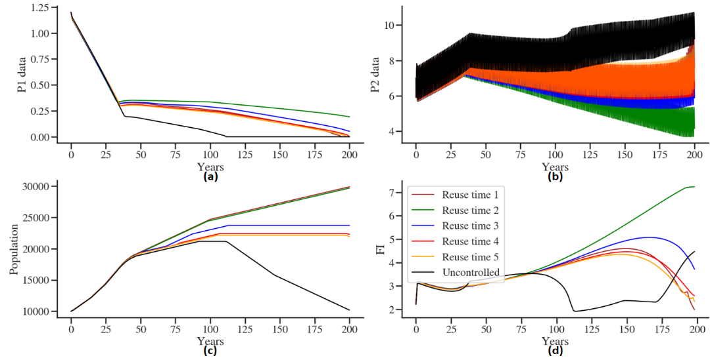

Figure 2: Controlled system compared for different reuse time for a constant circulation fraction and fraction of population reusing.

**4.1 Discussion**

The trend of decision variables for the above optimized problem is shown in Figure 3. It is found for static CF, f gives an optimal solution for reuse time of five time steps when compared to reuse time ranging from 1 to 5. This suggests that the higher the reuse time, the better the system from a sustainability viewpoint, which can be seen from Figure 2d, a stable Fisher information profile. The circulation fraction and fraction of the population reusing goods keeps reducing as the reuse time increases (Figure 3). By doubling the reuse time, both fractions can be reduced to half. Interestingly, increasing the reuse time to five is sufficient to achieve system sustainability with a current circulation rate of 8%. It is worth noting that there is an inverse relationship between reuse time and circulation and reuse fraction.

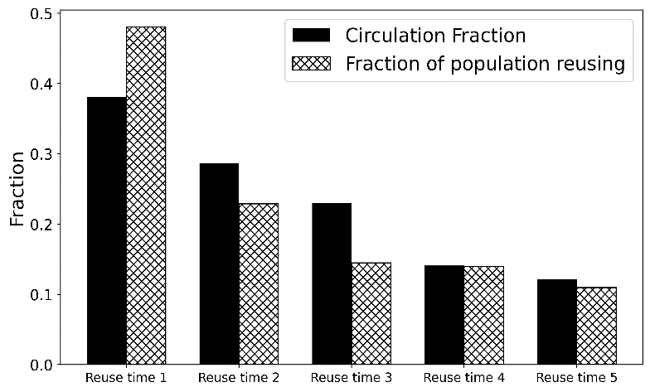

Figure 3: Optimal CF and fraction of population reusing for different reuse time

* 1. Conclusions

Longer reuse times result in fewer fluctuations and reduce the need for time-based controls to achieve sustainability. Higher reuse time is better for the system to be sustainable than a single use, which will consume more resources to produce industrial goods. This minimizes the number of parameters to manage when implementing sustainability policies. More parameters to control make achieving global sustainability less efficient and more challenging. This can also be understood as a call to eliminate single-use products in today's world and promote the incorporation of reusable products into the economy. Implementing a circular economy on a global scale is a broad and interdisciplinary concept. This study highlights the advantages of implementing a circular economy to promote both environmental and economic sustainability

References

* Sonkusare, S., Hanumante, N. and Shastri, Y., 2023. Optimization-based Development of a Circular Economy Adoption Strategy. In Sustainability Engineering (pp. 83-99). CRC Press.
* Sehnem, S., Vazquez-Brust, D., Pereira, S.C.F. and Campos, L.M., 2019. Circular economy: benefits, impacts and overlapping. Supply Chain Management: An International Journal, 24(6), pp.784-804.
* Rizos, V., Tuokko, K. and Behrens, A., 2017. The Circular Economy: A review of definitions, processes and impacts. CEPS Papers, (12440).
* Hanumante, N.C., Shastri, Y. and Hoadley, A., 2019. Assessment of circular economy for global sustainability using an integrated model. Resources, conservation and recycling, 151, p.104460.
* Cabezas, H. and Fath, B.D., 2002. Towards a theory of sustainable systems. Fluid phase equilibria, 194, pp.3-14.
* Shastri, Y., Diwekar, U., Cabezas, H. and Williamson, J., 2008. Is sustainability achievable? Exploring the limits of sustainability with model systems. Environmental science & technology, 42(17), pp.6710-6716.
* Nisal, A., Diwekar, U., Hanumante, N., Shastri, Y. and Cabezas, H., 2022. Integrated model for food-energy-water (FEW) nexus to study global sustainability: The main generalized global sustainability model (GGSM). PloS one, 17(5), p.e0267403.