Absolute Sustainability Assessment of Novel Biobased Chemicals and Materials

Marie J. Jonesa,b*, Lorenz P. Mankerb, Zezhong John Lib, Anastasiia O. Komarovab, Jeremy S. Luterbacherb, François Maréchala

a*Industrial Energy Systems Laboratory, École Polytechnique Fédérale de Lausanne (EPFL)*, *Valais*-*Wallis*, *1950 Sion, Switzerland*

b*Laboratory of Sustainable and Catalytic Processing, École Polytechnique Fédérale de Lausanne, 1015 Lausanne, Switzerland*

[marie.jones@epfl.ch](mailto:marie.jones@epfl.ch)

Abstract

Biomass is a promising feedstock to source renewable carbon needed to produce biobased chemicals and materials. Whilst the focus has mostly been the development of processes for drop-in replacements of petrochemicals, there is a shift towards the design of new molecules which retain as much biogenic atoms as possible. The Aldehyde-Assisted Fractionation (AAF) of biomass yields functionalized xyloses with high biomass utilization efficiencies. By changing the functionalization of the aldehyde, the properties can be tuned to produce a wide range of products. In this work, we perform an early assessment of the environmental impacts of producing a green solvent and two bioplastics, starting from pure xylose or agricultural wastes. Process inventories, retrieved from Aspen Plus® simulations, are the basis of a cradle-to-grave life cycle analysis, which is further complemented by evaluating the transgression levels of Planetary Boundaries. Whilst a significant reduction of CO2 footprint compared to petrochemical alternatives can be achieved, especially when starting from non-edible biomass, can be achieved, the absolute sustainability analysis revealed that we remain far from the ecological budget. Our results highlight that a transition to a biobased economy requires changes across the whole chemical industry to decarbonise the utility systems and all the reagents. Prolonged use-phase and efficient recycling are included in the necessary measures to go hand in hand with the development of new molecules designed to improve biomass utilization efficiency.

**Keywords**: Sustainability, biorefinery, bioplastics, planetary boundaries.

* 1. Introduction

To keep global warming below 2 ºC above pre-industrial levels, greener production schemes starting from renewable carbon sources have to be adopted by the chemical industry. Lignocellulosic biomass is a promising feedstock to produce biobased fuels, chemicals and materials. A major focus so far has been the development of technologies towards the fractionation and conversion of cellulose into direct petrochemical replacements. However, biomass is a highly oxygenated feedstock which must undergo several processing steps to yield conventional, carbon-rich, building blocks. Retrofitting biobased molecules to fossil-based molecules thus results in complex processes with low biomass utilisation efficiencies (Manker *et al.,* 2023a). An alternative biorefining strategy is to design molecules retaining as much native-atoms as possible and tune their properties to become functionality substitutes of petrochemicals. One such innovative strategy, relying on aldehydes to stabilize reactive intermediates during the fractionation of lignocellulosic biomass, has recently emerged. In addition to producing a highly digestible cellulose pulp and an uncondensed acetal-stabilized lignin which can be efficiently depolymerized, Aldehyde-Assisted Fractionation (AAF) yields acetal-stabilized xyloses. By using a carboxylic acid-functionalized aldehyde, we can also directly produce a bioplastic precursor, dimethylglyoxylate xylose (DMGX) (Manker *et al.,* 2022), which could substitute petro-based monomers in various polymers, such as PA-8,DGX polyamides (Manker *et al.,* 2023b). Diformylxylose (DFX), a new polar aprotic solvent (Komarova *et al.,* 2021), can be produced in a single-step from agricultural wastes.

To determine the ability of those novel biobased products to be sustainable substitutes to existing petrochemical products, we must assess early the environmental impacts of their production process. Life cycle analysis (LCA) is a necessary starting point but it does not assess the absolute sustainability of a product. The Planetary Boundary (PB) framework offers this possibility, by defining global limits which should not be crossed to avoid destabilising the Earth system. Guillén-Gosálbez and co-workers developed a methodology to link process synthesis with the estimation of the PB transgression levels (Vázquez and Guillén-Gosálbez, 2021) using characterisation factors and economic downscaling. Recent studies on CO2 utilisation (Ioannou *et al.,* 2023) and the plastic industry (Bachmann *et al.,* 2023) provide guidelines towards absolute sustainability but did not take into consideration new bio-based molecules. In this work, we build upon a comparative LCA of three xylose-derived molecules to assess their transgression levels of PBs, depending on whether they are produced from pure xylose sugars or from raw corn cobs.

* 1. Materials and Methods
     1. Process Descriptions

Two alternative feedstocks can be used to obtain 3 products, for which five different processes have been modelled (Fig. 1): (1) DMGX from xylose, (2) DMGX from corn cobs, (3) PA-8,DGX from DMGX, (4) DFX from xylose and (5) DFX from corn cobs.



**Figure 1** | Block flow diagram of the five processes modelled with Aspen Plus®. Dashed lines indicate streams only for the processes starting from pure xylose.

*(1) DMGX from xylose* - The production of the bioplastic follows five main steps: the protection of xylose with glyoxylic acid; the esterification of the di-acid with methanol to produce the easily distillable DMGX platform; the separation of DMGX via distillation coupled with solvent recycling and glyoxylic acid recovery by esterification, distillation and hydrolysis; the crystallization of DMGX in ethanol; and the polymerization with a diamine (Manker *et al.,* 2022 and 2023b). Xylose, 50 wt% aqueous solution of glyoxylic acid and sulfuric acid are reacted under reduced pressure to remove the water formed during the reaction, which favors the deprotection reaction. Complete esterification with methanol is then reached and the excess glyoxylic acid is converted with a selectivity of 60 % and 40 % respectively to methyl glyoxylate and methyl dimethoxyacetate. Following neutralization, the methanol is distilled to be recycled. The methyl glyoxylate, methyl dimethoxy acetate, and water are subsequently flashed off using two vacuum flash drums in series. To recover the aldehyde, the vaporised glyoxylates are condensed and hydrolyzed with sulfuric acid as catalyst. The methanol produced during the reaction is stripped to be recycled to the esterification section. The glyoxylic acid and sulfuric acid mixture is also recycled to the protection step. The final polishing steps consist in removing xylose degradation products under high vacuum, and crystallizing DMGX at -20 ºC with ethanol fed at 60 ºC.

*(2) DMGX from corn cobs* - To produce DMGX from corn cobs, biomass is first fractionated at 110 ºC in a mixture with glyoxylic acid and sulfuric acid. Upon filtration, the solid fraction (51 wt% cellulose) is filtered out. Further washing and neutralisation steps were excluded from this model. Water is added to the filtrate to precipitate the lignin which is also recovered through filtration. To drive the protection reaction, water must be removed in an evaporator with vapour recompression to reduce the heating duty. Xylose protection can then proceed. The evaporated water from the reaction is mixed with the vapour of the feed dryer before recompression. The recovered water is cooled down to be recycled for lignin precipitation. The product stream of the protection reactor then undergoes the same steps as the process developed starting from xylose. Yields up to 83 % based on initial xylan content have been achieved experimentally by Manker *et al.* from which the loading ratios are retrieved (Manker *et al.,* 2022).

*(3) PA-8,DGX from DMGX -* DMGX can then be polymerized with 1,8-diaminooctane in two steps, the second under vacuum to fully evaporate the methanol released by the condensation reaction. PA-8,DGX, obtained with a yield >98 % from DMGX, is finally extruded and pelletized.

*(4) DFX from xylose -* DFX is obtained from xylose through acetal protection with paraformaldehyde in 2-methyltetrahydrofuran (2-MeTHF) with sulfuric acid as catalyst. The reactor outlet is neutralized with sodium hydroxide and salts are filtered out. The solvent and produced water are evaporated leading to the crystallization of DFX. Those crystals are further washed with ethanol. Ethanol and residual 2-MeTHF are separated in three distillation columns prior to recycling. The evaporated protection solvent is led to phase separation and then purified in two distillation columns and a flash drum.

*(5) DFX from corn cobs -* The production of DFX from raw corn cobs requires a biomass pretreatment step where sulfuric acid is substituted by HCl. The solid cellulose is filtered out first. No neutralization of the reaction liquor is needed and instead di-n-butyl ether is added as an anti-solvent to precipitate functionalized lignin. The remaining HCl is evaporated and DFX crystallizes upon removal of the solvent via distillation. Washing with ethanol proceeds similarly to the xylose process but only two distillation columns and four flash drums are used for purification of ethanol and 2-MeTHF. Overall, isolated DFX yields of 71 mol % and 78 % could be achieved experimentally from pure xylose and corn cobs respectively (Komarova *et al.,* 2021).

* + 1. Sustainability Assessment
       1. Cradle-to-grave Life Cycle Analysis

The environmental impacts of the AAF biorefineries are evaluated following the ISO 14040/44 standards. The functional unit is defined as 1 kg of xylose-based product. Emissions are assigned by mass allocation across the by-products (lignin and cellulose pulp). A cradle-to-grave system boundary is adopted following a cut-off attributional approach, where waste treatment is included in the LCA-scope. Data for the background system, including all upstream activities, are retrieved from the Ecoinvent v3.9.1 database using the Python extension Brightway2. We assumed the use of biobased ethanol and methanol. We consider the usage of an electricity mix based on renewable energy sources. The foreground system is modelled using the material and energy flows of the processes simulated with Aspen Plus®, considering heat integration. Two scenarios are developed: a short-term scenario (‘Xylose’) using purified xylose from edible biomass and a mid-term scenario (‘Corn cob’) where a supply chain for raw corn cobs is established. The carbon neutrality principle is applied: no carbon credits are assigned to the carbon sequestrated by photosynthesis during the growth of the wood feedstock, but at the end-of-life, the emissions from combustion are set to zero. Since corn cobs are a waste from maize production, its impact is also set to zero. To fill data gaps in the background data, we resort to proxy where available (*e.g.* xylose is modelled as glucose), or we create inventories from Aspen Plus® simulations of upstream activities, such as for 2-MeTHF manufacturing from sugarcane bagasse (Leal Silva *et al.,* 2018).

* + - 1. Transgression Levels of Planetary Boundaries (PB)

Through the EF methodology recommended by the European commission, we quantify 18 LCA indicators, which were related to the 9 PBs and 5 Sustainable Development Goals (SDG) by Sala *et al.* (2020). The transgression level is calculated as the ratio between the estimated impact value and the ecological budget dictated by the PBs. The ecological budget allocated to the product – the safe operating space (SOS) - is estimated via economic downscaling (Vázquez and Guillén-Gosálbez, 2021): we assume that the usefulness of a product is proportional to its market value, therefore to maximize welfare, a product with a higher market size is allocated a bigger share of the global ecological budget. In practice, the SOS is defined as the ratio of market size divided by the world Gross Value Added. In future work, we aim at exploring different downscaling methods, in response to the lack of consensus in the scientific literature. Since xylose-based chemicals do not have a market yet, we assume complete substitution of petrochemicals with similar properties: the polyamide could replace Nylon 6 and DFX is a polar aprotic solvent similar to Dimethylformamide (DMF).

* 1. Results and Discussions

Designed to reduce CO2 emissions, the xylose-based products obtained via AAF exhibit a significant reduction in global warming potential (GWP) compared to their fossil-based equivalents (Fig. 2), on a mass basis. More specifically, DFX and DMGX produced from corn cobs could decrease the GHG emissions of their fossil-based counterpart (DMF and PTA) by 67 % and 42 %, respectively. Whilst the protection aldehyde of DMGX (glyoxylic acid) represents the main environmental burden, formaldehyde is less of a driver in DFX production. Instead, utilities, especially heating, are the main contributor to CO2 emissions. Through further heat integration and optimisation of the utility system, those energy related emissions are expected to decrease. Using waste lignocellulosic biomass instead of xylose crystals obtained from edible sugars equally plays an important role in decreasing the CO2 footprint of the process.

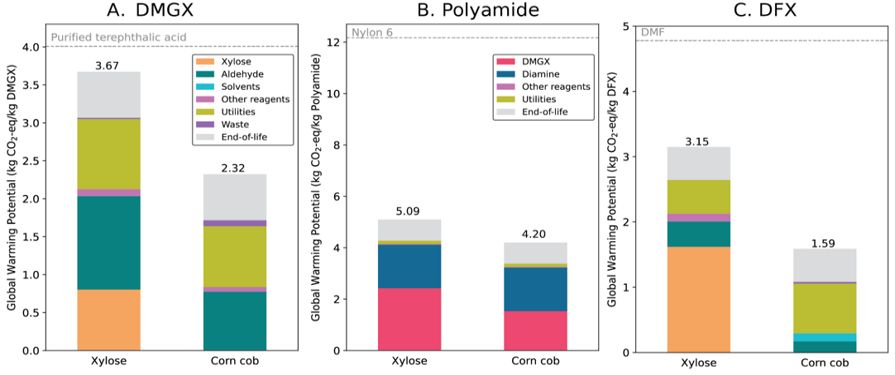

**Figure 2** | Cradle-to-grave global warming potential for three xylose-based products.

Despite a significant reduction in the GWP of biobased alternatives, the comparison to fossil-based alternatives tells little about the absolute sustainability of new products. In the case of DFX from corn cobs, the GHG emissions exceed by 20-fold the safe operating space assigned based on the market size of DMF. With biobased chemicals, we also notice a higher transgression level for land and water use, and particulate matter formation due to farming. The effect is even stronger for the process starting from edible sugars. Surprisingly, the route from corn cob leads to the largest transgression, for freshwater ecotoxicity because of the use of di-n-butyl ether as solvent. By identifying it as a burden of high concern, alternative lignin precipitation solvents should be explored.

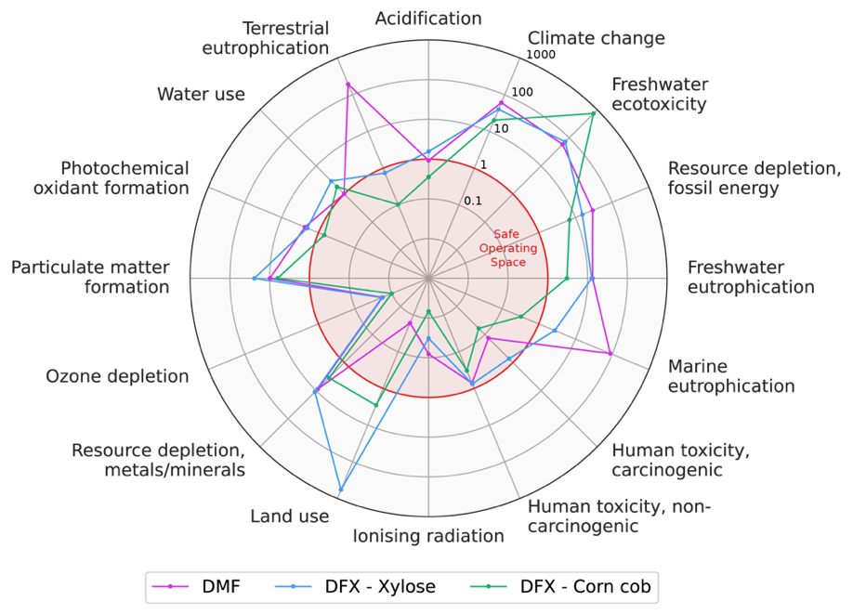

**Figure 3** | Transgression levels of the Safe Operating Space for DMF and DFX.

In addition to decarbonization of the whole chemical industry, starting by the utility generation, one of the only technical solutions to stay within the ecological budget is to effectively recycle the products to prolong their life-time and reduce demand. Internalizing the cost for the environmental damages would improve the accuracy of the downscaling method. Introducing mass equivalents for the comparison of different molecules with similar properties or basing the analysis on other functional units (e.g. solvent intensity) would be an interesting area for further investigation.

* 1. Conclusions

This work aimed at standardizing the sustainability assessment of xylose-based products obtained via acetal-protection. Those novel molecules could enable a significant reduction of CO2 footprint compared to petrochemical alternatives with similar properties, especially when using waste non-edible biomass as feedstock. However, the absolute sustainability analysis revealed that we remain far from the Safe Operating Space. In addition to decarbonizing both the feedstocks and the utility systems of the chemical industry, prolonged use-phase and efficient recycling appear as necessary measures to stay within our ecological budget. Despite the longer commercialisation times for non-drop-in products due to the inexistence of supply chains, designing new molecules with higher biomass utilization efficiency is a promising avenue to target zero transgression levels of planetary boundaries.

References

M. Bachmann *et al.*, “Towards circular plastics within planetary boundaries”, *Nat Sustain*, vol. 6, no. 5, Art. no. 5, 2023.

I. Ioannou, Á. Galán-Martín, J. Pérez-Ramírez, and G. Guillén-Gosálbez, “Trade-offs between Sustainable Development Goals in carbon capture and utilisation”, *Energy & Environmental Science*, vol. 16, no. 1, 2023.

A. O. Komarova, G. R. Dick, and J. S. Luterbacher, “Diformylxylose as a new polar aprotic solvent produced from renewable biomass”, *Green Chem.*, vol. 23, no. 13, 2021.

L. P. Manker *et al.*, “Sustainable polyesters via direct functionalization of lignocellulosic sugars”, *Nat. Chem.*, 2022.

L. P. Manker, M. J. Jones, S. Bertella, J. Behaghel de Bueren, and J. S. Luterbacher, “Current strategies for industrial plastic production from non-edible biomass”, *Current Opinion in Green and Sustainable Chemistry*, vol. 41, 2023.

L. P. Manker *et al.*, “Performance polyamides built on a sustainable carbohydrate core”, *Nat. Sustain.* (in press).

J. F. Leal Silva, A. P. Mariano, and R. Maciel Filho, “Economic potential of 2-methyltetrahydrofuran (MTHF) and ethyl levulinate (EL) produced from hemicelluloses-derived furfural”, *Biomass and Bioenergy*, vol. 119, 2018.

S. Sala, E. Crenna, M. Secchi, and E. Sanyé-Mengual, “Environmental sustainability of European production and consumption assessed against planetary boundaries”, *Journal of Environmental Management*, vol. 269, 2020.

D. Vázquez and G. Guillén-Gosálbez, “Process design within planetary boundaries: Application to CO2 based methanol production”, *Chemical Engineering Science*, vol. 246, p. 116891, 2021.