Vulnerability of Microbial Communities to Dishonest Signals: A biology driven complexity reduced model.
Jian Wang, Ihab Hashem, Satyajeet S. Bhonsale, Jan F.M. Van Impe*
BioTeC+ - Chemical and Biochemical Process Technology and Control, KU Leuven Ghent, Gebroeders de Smetstraat 1, 9000 Ghent, Belgium
*Email: jan.vanimpe@kuleuven.be
Abstract
In multispecies communities, bacteria are capable of coordinating population-level behaviour through a signalling mechanism termed quorum sensing (QS). However, these signals can be either 'honest,' mutually beneficial, or 'dishonest,' benefiting only the sender. This study performs the biology-driven complexity reduction on the system with two species to evaluate the vulnerability and adaptability of microbial communities to dishonest signalling. We corroborate the finding that sensitive bacterial species $S$ can gain advantages from early toxin production by a specific QS species $P$, even without detecting the signal. Adopting a dynamic analysis framework, we examine the potential dynamics of a bacterial community in relation to various physiological factors, focusing on the stability of different equilibria as a function of factors. Our analysis identifies the key QS-regulatory factors, such as toxin thresholds and signalling production costs, which critically determine the vulnerability of bacterial communities to dishonest signalling. By incorporating the effects of nutrient diffusion and stochastic elements, we verified the population level findings with individual based models. These obtained insights could extend our ecological understanding of microbial signalling and offer avenues for the development of quorum-quenching antibacterial and probiotic strategies.
Keywords: Quorum sensing; Biology-driven complexity reduction; Dynamic analysis; Stability and structure; Antibiotic strategy
  - Background
The original model consists of five state variables describing the dynamics of two bacterial strains, $P$ and $S$, and their interactions with nutrients $N$, toxin $T$, and another signalling molecule $Q$ . The system captures the complex interactions between different bacterial populations, toxin, nutrient, and quorum-sensing molecules; Quorum sensing enables species P to alter its behavior based on population density, influencing toxin production; The toxin $T$ acts as a control variable that affects the growth of sensitive bacteria $S$ but is also produced by $P$. The equations are given by (Bucci et al., 2011):

$$\frac{dP}{dt}=\left(1-f H\left(Q-G_{th}\right)-qp\right) μ_{max}\left(\frac{N}{N+K_{n}}\right)P$$
$$\frac{dS}{dt}=\left(1-qs\right)\left(μ_{max}\left(\frac{N}{N+K_{n}}\right)-K_{t}T\right)S$$
$$\frac{dT}{dt}=αf H\left(Q-G_{th}\right) μ_{max}\left(\frac{N}{N+K_{n}}\right)P-β_{T}T$$
$$\frac{dN}{dt} = -\frac{1}{Y} μ_{max} \left( \frac{N}{N + K_{n}} \right) \left(P + S\right)$$
$$\frac{dQ}{dt}=qp μ_{max}\left(\frac{N}{N+K_{n}}\right)P+qsμ_{max}\left(\frac{N}{N+K_{n}}\right)S$$
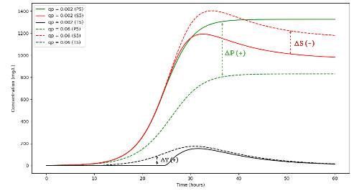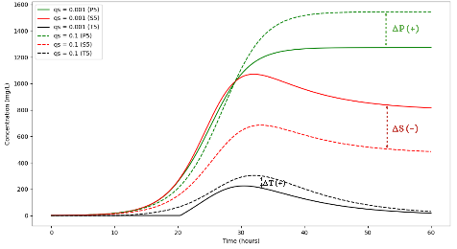
Figure 1: Growth dynamics of species P and S in response to variations in quorum sensing parameters $q_{p}$ and $q_{s}$

With $f$ the fraction of toxin produced, $H\left(Q-G_{th}\right)$ the step function, $μ_{max}$ the maximum specific growth rate, $K_{n}$ the nutrient half-saturation constant, $K_{t}$ toxin killing rate for sensitive bacteria,$α$the toxin production rate, $β_{T}$ the toxin decay rate, $Y$ the yield coefficient, $q_{p}$ the quorum sensing molecule production by toxin-producing species, $q_{s}$ the quorum sensing molecule production by sensitive bacteria, $G_{th}$ the quorum sensing threshold.
  - Complexity Reduction
    - Assumption
The quasi-steady assumption allows for a simplification of this system. This assumption is based on the idea that certain variables reach a quasi-steady state much faster than others. In the simplified model, we assume that the toxin concentration $T$ and the quorum sensing signal $Q$ reach a quasi-steady state quickly compared to the bacterial populations $P$ and $S$. This enables us to eliminate $T$ and $Q$ from the differential equations, reducing the system to a more tractable form for both mathematical analysis and computational simulations. Biologically, this simplification is valid under certain conditions:

- Rapid equilibration of metabolic processes compared to cellular division and death rates.
- Short time scales for nutrient uptake and release of metabolic by-products.
- Negligible time delays in regulatory responses within the cell.

    - Reduced models
Using the quasi-steady assumption, the equations for describing the dynamics of $P$ and $S$ simplified as:

$$\frac{dP}{dt}=\left(1-\frac{f}{1+\exp\left(-k\left(P-G_{th}\right)\right)}-qp\right) μ_{\text{max}}\left(\frac{N_{0}}{N_{0}+K_{n}}\right)P+aPS$$
$$\frac{dS}{dt}=\left(1-qs\right)\left(μ_{\text{max}}\left(\frac{N_{0}}{N_{0}+K_{n}}\right)-K_{t}\frac{α.f}{1+\exp\left(-k\left(P-G_{th}\right)\right)}\frac{μ_{\text{max}}}{β_{T}} P\right)S-bPS$$

In this above model, toxin $T,$ quorum sensing signal $Q$ and $N$ nutrient is explicitly incorporated into the $P$ and $S$ dynamics, the limiting effects of toxin producing strain to sensitive strain are captured by Lotka-Volterra competitive structure. Comparisons of parametric plots from both the original and reduced models, within a similar value range, demonstrate parallel evolutionary dynamics
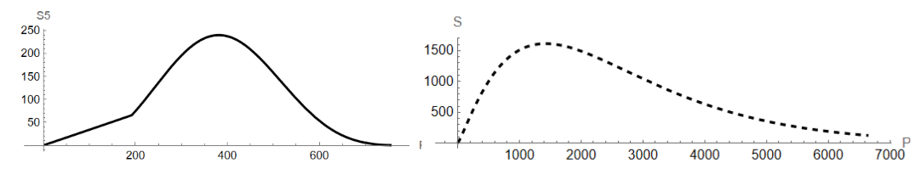
Figure 2: Comparative dynamics of species P and S in the reduced model

  - Model Analysis
    - Dynamic analysis of the models
To investigate the stability of the system, we begin by finding the equilibrium points, where $(\frac{dP}{dt}=0)$ and $(\frac{dS}{dt}=0), with certain parameters setting$. The Jacobian matrix $J$ of the system is given by:

$$\left[\begin{matrix}\frac{∂\left(\frac{dP}{dt}\right)}{∂P} & \frac{∂\left(\frac{dP}{dt}\right)}{∂S} \\ \frac{∂\left(\frac{dS}{dt}\right)}{∂P} & \frac{∂\left(\frac{dS}{dt}\right)}{∂S}\end{matrix}\right]$$

$$λ_{1}=\frac{μ_{max}×N_{0}×\left(1-q_{s}\right)}{Kn+N_{0}}$$
$$λ_{2}=\frac{μ_{max}×N_{0}×\left(-f-q_{p}×e^{Gth×k}-q_{p}+e^{Gth×k}+1\right)}{K_{n}×e^{Gth×k}+K_{n}+N_{0}×e^{Gth×k}+N_{0}}$$

Equilibrium points 1:
$$\left(P\left[t\right],S\left[t\right]\right)=\left(0,0\right)$$

In the biological realistic parameters settings , $λ_{1}$ is always positive, making this equilibrium point an unstable node regardless of the value of $k$. This implies that any small perturbation in the bacterial populations $P$ and$S$ will result in the system moving away from this equilibrium point. In the biological context, this indicates that a state with zero populations for both $P$ and $S$ strains is not sustainable and will naturally evolve to a state with non-zero populations.

Equilibrium points 2:
$$\left(P\left[t\right],S\left[t\right]\right)=\left(\frac{\ln\left(\frac{\left(1-q_{p}\right)\exp\left(Gth×k\right)}{f+q_{p}-1}\right)}{k},0\right)$$
$$λ_{1}=\frac{0.0009999×\left(0.1k-1000.1×\ln\left(-1.1×e^{1.4k}\right)\right)}{k}$$
$$λ_{2}=0.0009×\ln\left(-1.1×e^{1.4k}\right)$$
If both $(λ_{1})$ and $(λ_{2})$ are positive, the equilibrium point is an unstable node, meaning the system will move away from this state. If both $(λ_{1})$ and $(λ_{2})$ are negative, the equilibrium point is a stable node, and the system will naturally evolve towards this state. If $(λ_{1})$ and $(λ_{2})$ have opposite signs, the equilibrium point is a saddle point, which is unstable along one axis and stable along the other. This means that the system could approach this state from certain initial conditions but depart from it along a different trajectory.

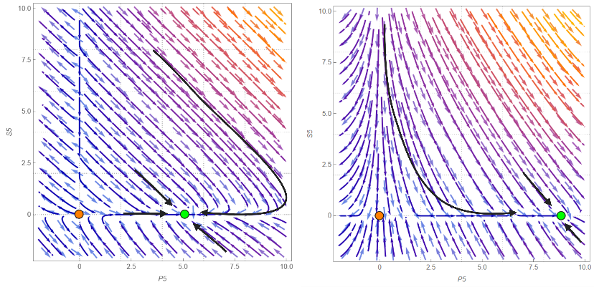
Figure 3: Phase plane analysis of the system’s equilibrium points by varying the value of $q_{p}$ and $q_{s}$.

3.2 Parameter sensitivity analysis of the reduced model

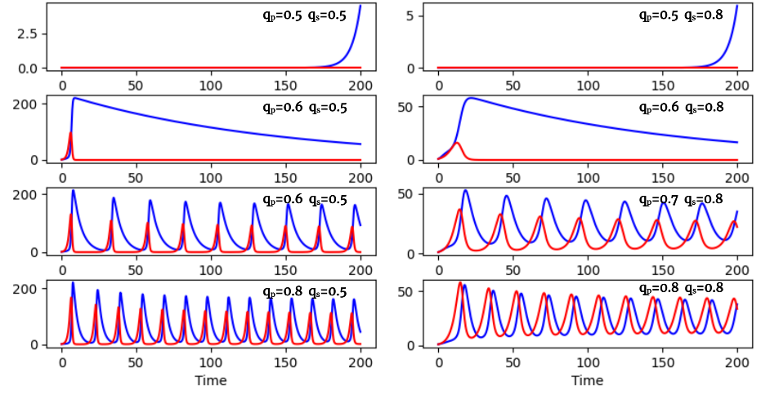
Figure 4: Sensitivity analysis of microbial communities to parameter variations. By increasing the $q_{p}$ and $q_{s}$ value, the system is gradually transitioning to the co-existence.

    - Design of Individual based model (IbM)

This IbM includes two types of entities: microbial cells and their environment. Cells, represented as disks in the graphical interface, are defined by their species, size, mass, spatial coordinates, and nutrient uptake rates, with their community structure indicated by the color intensity. The environment is a 40 mm by 20 mm section of 4 mm thick gel, divided into 10 mm square units, each with specific nutrient and toxin concentrations. The model encompasses various processes: intracellular activities like growth, maintenance, and division, managed in dense populations through cell shoving; intercellular and environmental interactions, including glucose uptake and toxin secretion affecting neighboring cells; and diffusion processes following Fick's second law, which dictate nutrient and toxin distribution. The simulation uses two time resolutions: a smaller time step $\left(Δt_{1} = 0.005min\right)$ for rapid dynamics like diffusion, nutrient uptake, cell growth, and toxin secretion, and a larger time step $\left(Δt_{2}=0.1min\right)$ for slower processes such as cell reproduction and shoving (Tack et al. 2015).

      - Physical and chemical sub-models
- Growth and Maintenance: cells uptake nutrients from their local environment and metabolize them for cell maintenance. When the maintenance requirements are fulfilled, the excess of assimilated glucose is directed toward increasing their mass and volume. The cellular glucose uptake from the environment is assumed to follow Monod kinetics:

$$\frac{dS_{\left(i,j\right)}^{k}}{dt_{1}}=v_{\left(i,j\right)}^{k}=q_{S,max}^{k}.\frac{C_{S,\left(i,j\right)}}{K_{S}+C_{S,\left(i,j\right)}}$$

where cell $k$ located at the at coordinates $\left(i,j\right)$; $C_{S,\left(i,j\right)}$ is the glucose concentration of the environmental unit.

- Shoving: The high density of cells in a colony result in spatial overlap of neighboring cells, which causes pressure between the cells. This pressure can be alleviated through a mechanism called cell shoving.

$$r_{o}=s.r_{k}+r_{n}-d$$

where $r_{k}$ and $r_{n}$ define the radius of cell$k$and its neighbor $n$, $d$is the distance between the centers of these two cells

- Nutrient Diffusion: The second law of Fick can be used to describe the movements of nutrients through 2D isotropic media. Simulated cells can sense the nutrient concentration of their immediate environment and adjust their nutrient uptake accordingly based on this local availability.

$$\frac{∂C_{i}}{∂t}=D_{i}.\left(\frac{∂^{2}C_{i}}{∂x^{2}}+\frac{∂^{2}C_{i}}{∂y^{2}}\right)$$
where $C_{i}$ represents the concentration of substance$i$, $D_{i}$ is the diffusion coefficient of substance $i$
- Toxin Secretion: Each species secretes toxins affecting neighbouring cells of other genres, modulating their growth rates.

$$μ_{s}=μ（1-q_{p}）-TK_{p}×T_{p}$$

where $TK_{p}$ represents the toxin killing rate of species $P$, $μ_{s}$ is the growth rate of species.
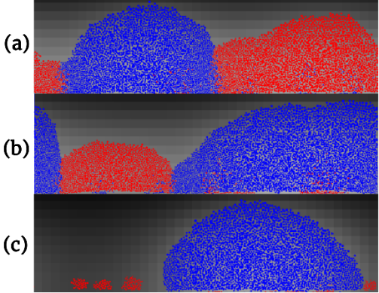

Figure 5: Patterns of two species competing by varying the toxin production costs from $0.15$, $0.30$to $0.50$.
  - Conclusions
This study presents a comprehensive examination of the interactions between toxin-producing $P$ and sensitive bacterial strains $S$. The primary aim is to understand the conditions that lead to either dominance of coexistence of these strains in microbial communities. To achieve this, we employ the biology-driven quasi-steady assumption to perform a nuanced equilibrium analysis. This analysis specifically identifies the biological and environmental factors that dictate whether $P$ strains dominate or coexist with $S$ strains in the microbial community. To capture the complexities not addressed by the deterministic model, we introduce Individual-Based Models (IbMs). These models allow us to incorporate stochastic elements and spatial heterogeneity, thereby offering a more comprehensive understanding of bacterial interactions. Our findings reveal that key parameters, such as toxin production costs, play a significant role in determining the stability and structure of bacterial communities. This has important practical implications, offering guidelines for the development of more effective antibacterial strategies and probiotic formulations.
Acknowledgement
This work was supported by the E-MUSE project funded by the European Union’s Horizon 2020 Research and Innovation Programme [MSCA grant 956126]
References
Bucci, V., Nadell, C. D., & Xavier, J. B. (2011). The evolution of bacteriocin production in bacterial biofilms. The American Naturalist, 178(6), E162-E173.
Strogatz, S. H. (2018). Nonlinear dynamics and chaos with student solutions manual: With applications to physics, biology, chemistry, and engineering. CRC press.
Hashem, I., & Van Impe, J. F. (2022). Dishonest signaling in microbial conflicts. Frontiers in microbiology, 13, 468.
Tack, I. L., Logist, F., Fernández, E. N., & Van Impe, J. F. (2015). An individual-based modeling approach to simulate the effects of cellular nutrient competition on Escherichia coli K-12 MG1655 colony behavior and interactions in aerobic structured food systems. Food Microbiology, 45, 179-188.

