Hydrogen strategic planning for heat decarbonisation under uncertainty

Margarita E. Efthymiadou, Vassilis M. Charitopoulos and Lazaros G. Papageorgiou*

The Sargent Centre for Process Systems Engineering, Department of Chemical Engineering, University College London (UCL), Torrington Place, London WC1E 7JE, UK

[*l.papageorgiou@ucl.ac.uk*](mailto:l.papageorgiou@ucl.ac.uk)

Abstract

Heat decarbonisation is indispensable to meet Net-Zero emission target by 2050. The UK, as a world leader in reducing greenhouse gas emissions, needs to explore alternative pathways and energy carriers for the heat sector such as hydrogen. In this concept, a multi-period spatially-explicit two-stage stochastic mixed-integer linear programming (MILP) optimisation framework for hydrogen infrastructure is proposed to meet hydrogen heating demand in Great Britain. The mathematical framework aims to minimise the total cost accounting for investment and operational decisions considering 10-year steps 2030- 2050 and typical days with hourly resolution. 10 scenarios are taken into account, which are selected using backward selection in GAMS-SCENRED. The results show that the stochastic approach provides a cost-efficient risk neutral infrastructure strategy to decarbonise the heat sector in the UK.

**Keywords**: Net-Zero; MILP Model; Two-stage Stochastic; Uncertainty; Hydrogen Infrastructure Planning;

* 1. Introduction

Over the last decade, there has been an important increase in the frequency of extreme weather events, largely attributed to climate change. Thus, there is a growing urgency to establish and pursue Net-Zero target, aimed at greenhouse gas emissions reduction and mitigation of adverse effects of climate change. Heating sector accounts for one third of the UK’s emissions while residential heating is responsible for 17% of the carbon footprint (Industrial Strategy Committee, 2022). Therefore, heat decarbonisation constitutes a key element to achieve Net-Zero target by 2050. Taking into account that the wide use of gas boilers is responsible for the majority of greenhouse gas emissions, the exploitation of low-carbon alternatives is crucial. In this concept, hydrogen boilers are considered as an efficient alternative low-carbon heat source (HM Government, 2021). Consequently, strategic decisions for the role of hydrogen in the heat sector will be required. Therefore, it is crucial to investigate hydrogen infrastructure planning and the uncertainties related to the energy transition in low-carbon hydrogen investments.

Over the last decades, the employment of uncertainty in hydrogen supply chain has received significant by the PSE community. Kim et al. (2008) introduced a two-stage stochastic spatially-explicit framework for hydrogen demand uncertainty. A three-stage stochastic multi-period spatial-explicit model with uncertainty in hydrogen transportation demand was proposed by Almansoori and Shah (2012). Dayhim et al. (2014) based their multi-period two-stage model in the aforementioned works adding emission, energy consumption and risk costs in the framework. A case study with hydrogen transportation uncertainty in the UK using a two-stage stochastic model was proposed by Nunes et al. (2015). Moreover, uncertainty in primary energy sources was studied by Camara et al. (2019). The authors developed a ε-constraint method with lexicography optimisation framework to minimize total system cost and global warming potential and meet hydrogen transportation demand in Portugal. A fuzzy programming multi-objective approach was suggested by Robles et al. (2020). In this work, uncertainty was incorporated in hydrogen demand while genetic algorithms are used for the multi-objective formulation. Yang et al. (2020) proposed a spatially-explicit hydrogen supply chain model for a typical day while uncertainty was introduced in hydrogen demand and wind availability. A five-stage stochastic multi-period spatially explicit model was demonstrated by Ochoa Bique et al. (2021). Their study included 81 scenarios for hydrogen transportation demand uncertainty in Germany. In his work, a multi-period spatially-explicit two-stage stochastic framework is developed for hydrogen infrastructure planning while uncertainty is considered in heat demand, natural gas price and technologies costs. The applicability of the model is demonstrated through a case study for residential heat demand in Great Britain.

* 1. Problem Statement

The goal of this work is to design optimal hydrogen supply chain investments over the planning horizon to meet hydrogen residential demand and satisfy GHG emission targets.

**Given:** (i) H2 heating demand and renewables availability in each region, year, cluster, hour and scenario, (ii) capital and operating costs for production technologies, storage sites, hydrogen and CO2 pipelines and road transportation modes, (iii) minimum and maximum capacity and ramp rates as well as the lifetime of production plants and storage sites, (iv) minimum and maximum flowrate in pipelines, (v) capacity of H2 caverns and CO2 reservoirs, (vi) H2 import price, (vii) carbon tax and capture rates for CO2 emissions as well as CO2 emission targets

**Determine the optimal:** (i) location and capacity of production technologies, storage sites and renewable farms, (ii) H2 production and storage rate in each region, year, cluster, hour and scenario, (iii) H2 and CO2 transmission investments between regions, (iv) H2 and CO2 flowrates between regions in year, cluster, hour and scenario, (v) hydrogen and natural gas penetration in each region, year and scenario, (vi) electricity generation of renewables (vii) H2 import rates in each year, cluster, hour and scenario

**So as** to minimise the total system cost and satisfy greenhouse gas emissions trajectory.

* 1. Optimisation Framework
     1. Problem Description

The proposed framework aims at the decarbonisation of residential heat sector taking into account two energy carriers (hydrogen and natural gas). Strategic decisions for hydrogen infrastructure are determined including hydrogen production, storage and transmission technologies as well as a carbon capture and storage (CCS) system. Fig. 1 illustrates the superstructure of the studied system. Hydrogen can be produced through Water Electrolysis (WE), Biomass Gasification (BG) with Carbon Capture and Storage (CCS) and Reforming with CCS including Steam Methane Reforming (SMR) and Autothermal Reforming (ATR). The electricity, which is required for WE, is generated from renewable technologies to reduce the environmental footprint of the system. Solar, Wind Onshore and Wind Offshore farms are considered in this work. Regarding hydrogen storage, two types of storage vessels, High Pressure and Storage Vessel (HPSV) and Medium Pressure Storage Vessel (MSPV), are incorporated. Hydrogen can be transmitted between regions through pipelines while 3 diameter options are available (0.5m / 0.8m /1.0m). CO2 emissions which are captured from the production units, are transmitted to CO2 reservoirs, located in North and Irish Sea. Finally, hydrogen and gas boilers can be used to satisfy the residential heat demand.

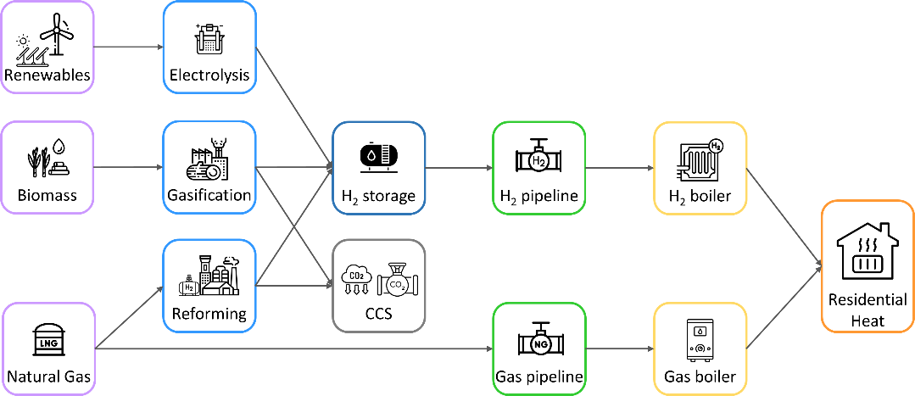

**Figure 1:** Model superstructure

The multi-period optimisation framework takes into consideration three 10-year time bins from 2030 to 2050. Hourly resolution is incorporated to explore operating decisions. Due to the high combinatorial complexity of the model, k-means clustering method is employed to reduce the model size. To preserve the peak heat day, it is excluded from clustering, and added in the final stage (Charitopoulos et al., 2023). In this study, 4 typical days which represent each season, and the peak demand day are considered. Moreover, Great Britain is divided into 13 regions according to local gas distribution zones (LDZ).

* + 1. Mathematical Modelling

The cost optimal hydrogen infrastructure planning framework is formulated as a multi-period spatially-explicit two-stage stochastic mixed integer linear programming (MILP) model based on the work of Efthymiadou et al. (2023). The objective function of the problem is the minimisation of the system cost (SC) formulated as in Eq. (1):

|  |  |
| --- | --- |
| $$\min{SC}=\sum_{k ϵK}{pb_{k}∙TC_{k}}$$ | (1) |

where *pbk­* is the probability of occurrence of each scenario *k* and *TCk* is the total cost in each scenario *k*. The total cost consists of hydrogen production, storage and transmission capital and operating costs, hydrogen boiler installation cost, hydrogen import cost, carbon emission cost and natural gas transmission cost. The objective function is minimised in respect with mass and energy balances, production, storage and transmission, emissions, renewable generation and import constraints.

The heat demand can be met by hydrogen or natural gas. The energy balances are demonstrated in the following Eq. (2)-(4):

|  |  |
| --- | --- |
| $$HD_{gtchk}=L_{gtk}^{H}∙TD_{gtchk}$$ | (2) |
| $$GD_{gtchk}=L_{gtk}^{G}∙TD_{gtchk}$$ | (3) |
| $$L_{gtk}^{H}+ L_{gtk}^{G}=1$$ | (4) |

where *TDgtchk* stands for the total demand for each region *g*, time period *t*, cluster *c*, hour *h* and scenario *k*. *HDgtchk* and *GDgtchk* are the hydrogen and gas demand for each region *g*, time period *t*, cluster *c*, hour *h* and scenario *k.* *LHgtk* and *LGgtk* constitute the demand penetration of hydrogen and natural gas, respectively.

* + 1. Uncertainty

In this work, uncertainty is modelled using a two-stage stochastic approach. First stage decisions, which are common in all scenarios, include the optimal capacity and location of production plant, storage sites as well as H2 and CO2 pipeline connections. On the other hand, all the other variables constitute second stage decisions (e.g. production rates, flowrate between regions). These variables are different from scenario to scenario.

**Figure 2:** Scenario reduction steps.

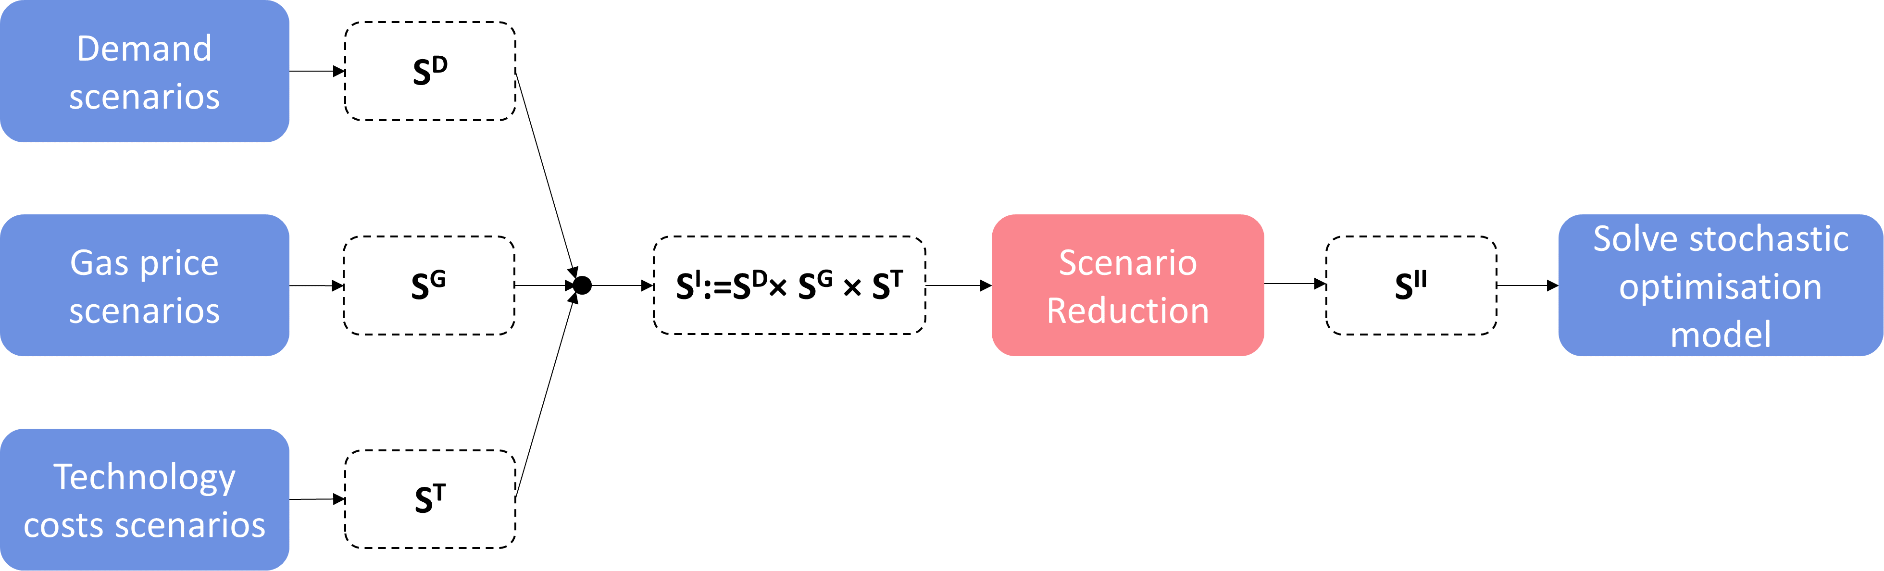

**Table 1:** Scenario probability

|  |  |
| --- | --- |
| **Scenario** | **Probability** |
| **(1)** | 0.060 |
| **(2)** | 0.060 |
| **(3)** | 0.100 |
| **(4)** | 0.100 |
| **(5)** | 0.300 |
| **(6)** | 0.100 |
| **(7)** | 0.085 |
| **(8)** | 0.055 |
| **(9)** | 0.085 |
| **(10)** | 0.055 |

Uncertainty is incorporated into heating demand, natural gas price and techno-economic data. More specifically, 3 (low, base, high) scenarios (ST) for Water Electrolysis, Solar, Wind Onshore and Wind Offshore capital and operating costs are obtained from BEIS (Department for Business, Energy & Industrial Strategy, 2021 & 2023). Moreover, 10 gas price scenarios (SG) are considered based on Future Energy Scenarios gas price (National Grid ESO, 2023). Future energy carriers for domestic heat are forecasted to be a mix of hydrogen, electricity and natural gas (National Grid ESO, 2023). In this study, only hydrogen and natural gas are taken into account and thus 4 different penetration rate scenarios (SD) of the total heat demand are considered varying from 10% to 50%. A combination of the aforementioned uncertainties results in 120 scenarios. Due to the combinatorial complexity of the model, scenario reduction to 10 scenarios is conducted through backward selection using GAMS-SCENRED (GAMS Documentation, 2023). Table 1 showcases the probability of the reduced scenarios.

* 1. Results & Discussion

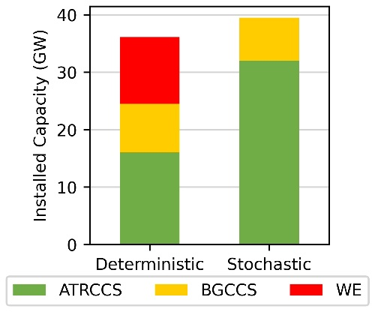

**Figure 3:** Technology mix.

The proposed model was implemented in GAMS 38.2.1 and solved in monolithic fashion with Gurobi 10.0.3, using a Dell workstation with Intel® Core™ i9-10980XE CPU @ 3.00 GHz and 128 GB RAM. Optimisation termination criteria were 18 h CPU time limit or 5% optimality gap.

Fig. 3 illustrates the optimal technology mix for the deterministic (mean case) and stochastic (10 scenario case) approaches. The installed capacity of deterministic approach is 36.1 GW consisting of ATRCCS, BGCCS and WE investments, while stochastic approach optimal design includes ATRCCS and BGCCS of 39.5 GW.

The optimisation results are summarised in Table 2. The quality of each solution is tested in the 120 scenarios set fixing the first stage decisions of each approach to get the expected system cost (ESC). As illustrated in Table 2, deterministic approach provides a lower system cost (SC) than the stochastic approach. However, there is a 33% increase in the ESC of the deterministic case when comparing to the corresponding SC. On the other hand, the stochastic approach provides a more realistic strategy as ESC is increased by 4% comparing to the stochastic SC.

**Table 2:** Computational statistics

|  |  |  |
| --- | --- | --- |
|  | **Deterministic Approach** | **Stochastic Approach** |
| **No. of continuous variables** | 119,801 | 1,155,694 |
| **No. of discrete variables** | 582 | 582 |
| **No. of equations** | 186,582 | 1,856,639 |
| **Optimality gap (%)** | 4.88 | 5.81 |
| **CPU time (h)** | 4 | 18 |
| **System Cost (£b)** | 34.1 | 37.9 |
| **Expected system cost (£b)** | 45.6 | 39.5 |

Fig. 4a demonstrates that stochastic solution results in a narrow distribution of ESC. Moreover, in most scenarios, stochastic approach grants a more cost-effective solution as illustrated in the Fig. 4b.

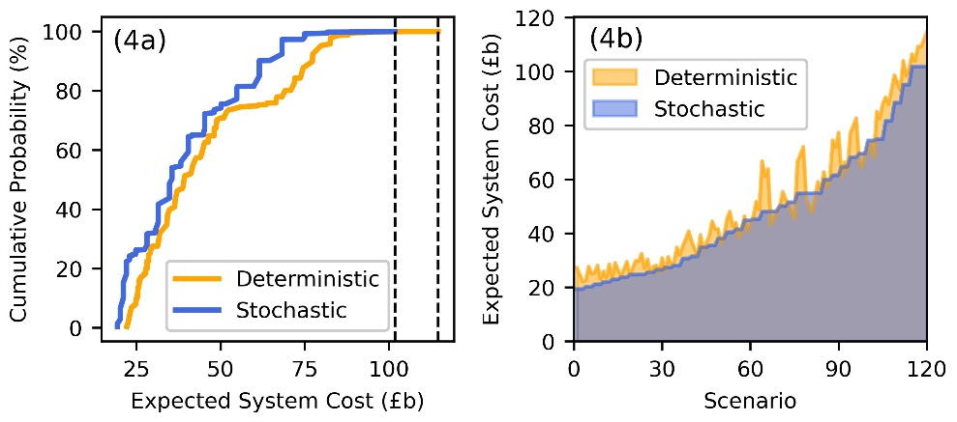

**Figure 4:** Expected System Cost.

A breakdown of the system costs and the expected system cost for the 120-scenario set is depicted in Fig. 5. ESC hydrogen facilities operating and production feedstock (gas, biomass) costs are significantly augmented for the deterministic approach while there is a slight increase in the stochastic approach. Moreover, hydrogen imports are surged comparing ESC and SC for the deterministic approach. Thus, stochastic case, which is more risk-neutral approach, reduces cost considering cost and demand uncertainties.

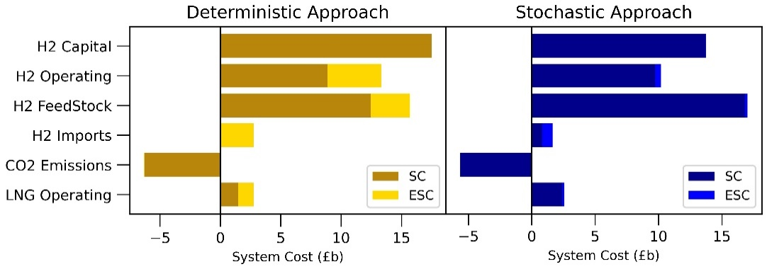

**Figure 5:** Cost breakdown.

* 1. Concluding Remarks

A stochastic, multi-period spatially-explicit MILP modelling framework is presented for the optimal design of hydrogen infrastructure applied to a case study for heat decarbonisation in the UK. Uncertainty in heat demand, gas price and technology costs is considered while a scenario reduction is used to reduce to decrease the combinatorial complexity of the stochastic model. The results indicate that the stochastic approach leads to a more cost-effective strategy. Future work includes the investigation of tailored solution approaches and integration of electrification and power sector in the framework.

Acknowledgements

The financial support from Engineering and Physical Sciences Research Council (EPSRC) under the project EP/T022930/1 is gratefully acknowledged. Authors appreciate collaborators Prof David Reiner, Dr Carmen Li and Dr Saheed Bello for providing gas price scenarios.

References

A. Almansoori, N. Shah, 2012, Design and operation of a stochastic hydrogen supply chain network under demand uncertainty, Int. J. Hydrogen Energy, 37, 3965–3977

D. Camara, T. Pinto-Varela, A. P. Barbosa-Povoa, 2019, Multi-objective optimization approach to design and planning hydrogen supply chain under uncertainty: A portugal study case. Comput. Aided Chem. Eng., 46, 1309–1314

V. M. Charitopoulos, M. Fajardy, C. K. Chyong, D. M. Reiner, 2023, The impact of 100% electrification of domestic heat in Great Britain, iScience, 26 , 108239

M. Dayhim, M. A. Jafari, M. Mazurek, 2014, Planning sustainable hydrogen supply chain infrastructure with uncertain demand, Int. J. Hydrogen Energy, 39, 6789–6801

Department for Business, Energy & Industrial Strategy, 2021, Hydrogen production costs 2021, https://assets.publishing.service.gov.uk/government/uploads/system/uploads/attachment_data/file/1011506/Hydrogen_Production_Costs_2021.pdf

Department for Business, Energy & Industrial Strategy, 2023, Electricity Generation Costs 2023, www.gov.uk/government/publications/electricity-generation-costs-2023

M. E. Efthymiadou, V. M. Charitopoulos, L. G. Papageorgiou, 2023, Hydrogen infrastructure planning for heat decarbonisation in Great Britain, Comput. Aided Chem. Eng., 52, 3025–3030

GAMS, 2023, SCENRED, www.gams.com/latest/docs/T_SCENRED.html

HM Governemnt, 2021, Heat and Buildings Strategy, assets.publishing.service.gov.uk/government/uploads/system/uploads/attachment_data/file/1044598/6.7408_BEIS_Clean_Heat_Heat___Buildings_Strategy_Stage_2_v5_WEB.pdf

Industrial Strategy Committee, 2022, Decarbonising heat in homes Seventh Report of Session 2021-22 Report. committees.parliament.uk/publications/8742/documents/88647/default/

J. Kim, Y. Lee, I. Moon, 2008, Optimization of a hydrogen supply chain under demand uncertainty, Int. J. Hydrogen Energy, 33, 4715–4729

National Grid ESO, 2023, Future Energy Scenarios, www.nationalgrideso.com/document/283101/download

P. Nunes, F. Oliveira, S. Hamacher, A. Almansoori, 2015, Design of a hydrogen supply chain with uncertainty, Int. J. Hydrogen Energy, 40, 16408–16418

A. Ochoa Bique, L. K. K. Maia, I. E. Grossmann, E. Zondervan, 2021, Design of hydrogen supply chains under demand uncertainty – a case study of passenger transport in germany, Phys. Sci. Rev., 6, 000010151520200052

J. O. Robles, C. Azzaro-Pantel. A. Aguilar-Lasserre, 2020, Optimization of a hydrogen supply chain network design under demand uncertainty by multi-objective genetic algorithms, Comput. Chem. Eng., 140, 106853

G. Yang, Y. Jiang, S. You, 2020, Planning and operation of a hydrogen supply chain network based on the off-grid wind-hydrogen coupling system, Int. J. Hydrogen Energy, 45, 20721–20739